Supplementary Files
Fig. S1. Comparison of (A) liver weight and fat accumulation (B) between HBV-positive and HBV-negative mice transplanted with human faeces


Hepatic fat accumulation
B

Fig. S2. Alpha diversity in human donors. Boxplot represents the α-diversity measure using (A) Observed, (B) Faith’s phylogenetic diversity (PD), (C) Shannon’s entropy, and (D) Pielou’s evenness at ASV level. A Mann-Whitney test was used to compare the microbial diversity between the two groups. *p < 0.05. Boxes indicate the interquartile range (IQR) of the 25th to 75th percentiles. The median value is shown as a line within the box, and the whiskers extend to the most extreme value within 1.5 × IQR.
Fig. S3. Longitudinal analysis of alpha-diversity. Volatility plots of (A) Shannon’s entropy and (B) Pielou’s evenness showing changes in alpha diversity in HBV-negative and HBV-positive mice over 4 weeks.
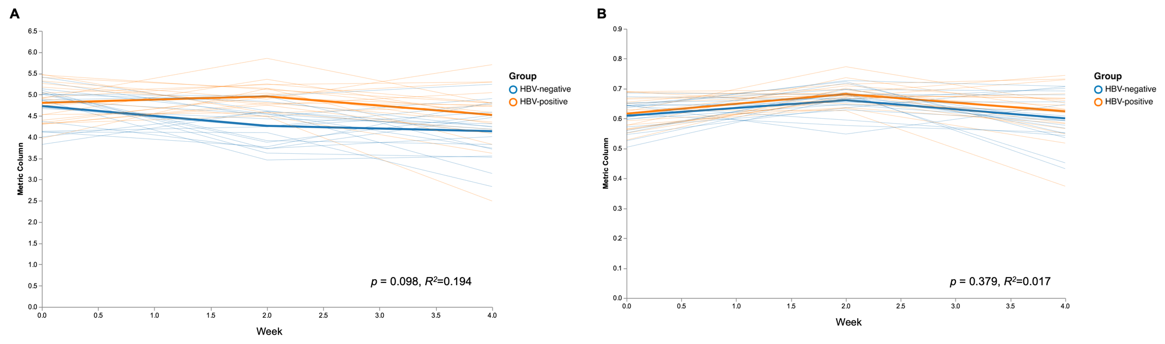
Fig. S4. Longitudinal changes of composition of genera which are observed to be significantly increased in HBV-positive mice compared to HBV-negative mice.
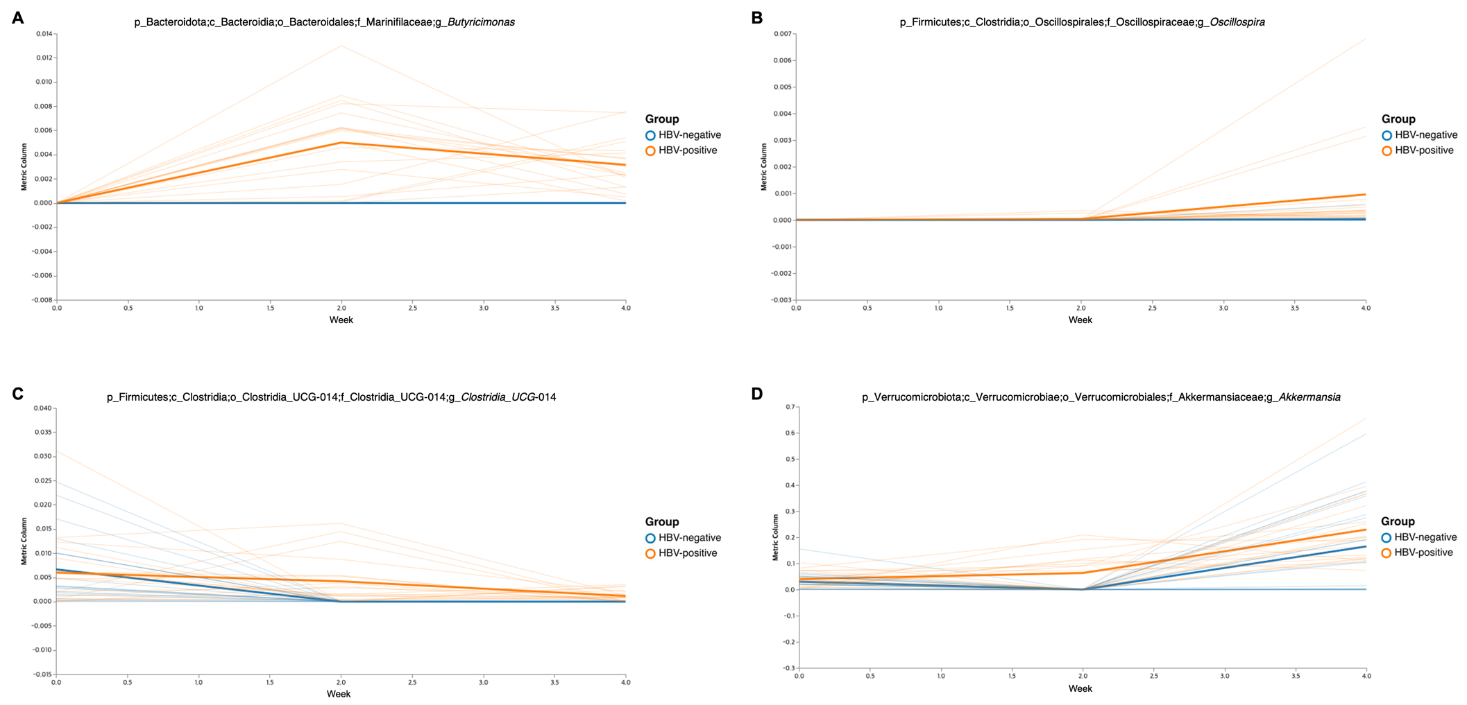

Fig. S5. Longitudinal changes of composition of species which are observed to be significantly decreased in HBV-positive mice compared to HBV-negative mice.
