Supplementary Materials

Supplementary Table 1. Characteristics of MPN patients

Median age | 65 years (range, 30-96)
Sex (female:male) | 46:43
Diagnosis (ET:PV:MFª) | 57:22:10
Median time since diagnosis | 30 months (range, 0-325)
Prior thrombosis | 27 (31%)
Arterial^{b} | 18
Venous | 7
Both | 2
Driver mutation type^{c}
JAK2 V617F | 60
CALR exon 9 | 15
MPL exon 10 | 1
Triple-negative | 9
Median platelet count | 452 x 10⁹/L (range, 80-1660)
Cytoreductive treatment | 56 (64%)
Hydroxyurea | 38
Anagrelide | 8
Other^{d} | 10
Anti-thrombotic treatment | 81 (93%)
Aspirin^{e} | 65
Anticoagulant^{f} | 12
Clopidogrel | 4

- Including PMF (n=8) and post-ET and post-PV MF (n=1 each).
- Including cardiac (n=10) or cerebrovascular (n=9) ischemia, and peripheral vascular disease (n=5). Some patients had involvement of multiple arterial territories.
- Mutation status unknown (n=2); JAK2 V617F negative without further testing (n=2)
- Other cytoreductive agents were ruxolitinib (n=5), interferon-α (n=4), and busulfan (n=1).
- Including 4 patients on a second anti-platelet drug.
- Including 4 patients on an anti-platelet drug as well as an anticoagulant.

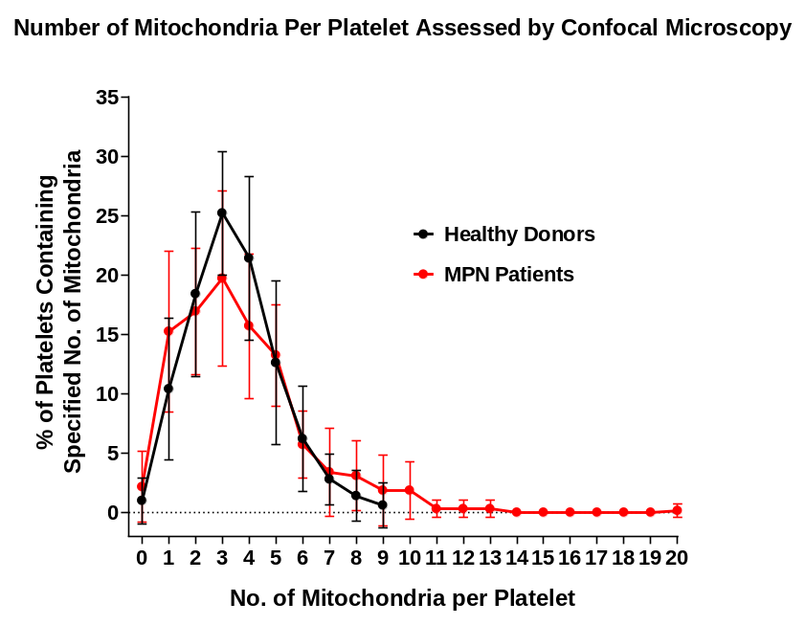
Supplmentary Figure 1: Confocal microscopy shows increased mitochondria in platelets of MPN patients. The number of mitochondria in 50 platelets was counted using MitoDR staining for each individual subject. A comparison between healthy donors (n=10) and MPN patients (n=13) of the number of mitochondria per platelet was done using categorized data ranging from 0-20 mitochondria/platelet. Error bars at each point represent differences between individuals.
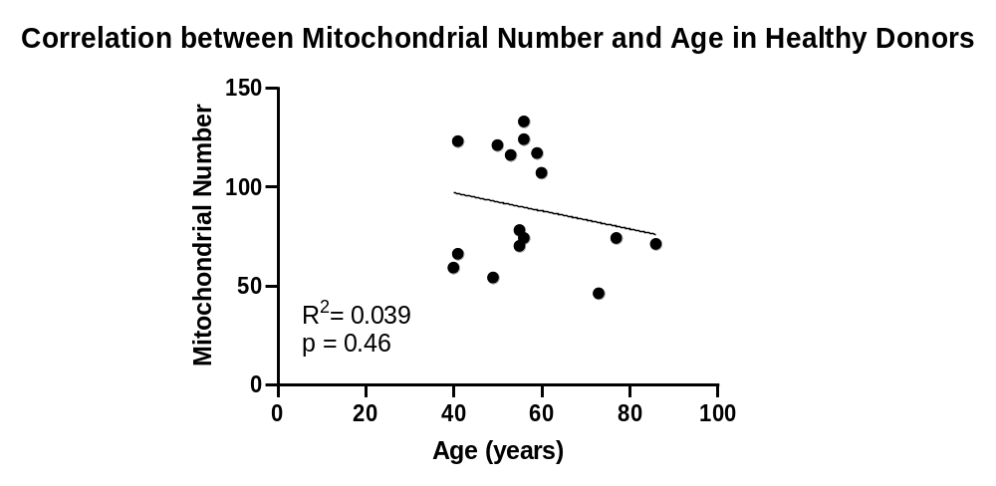
A

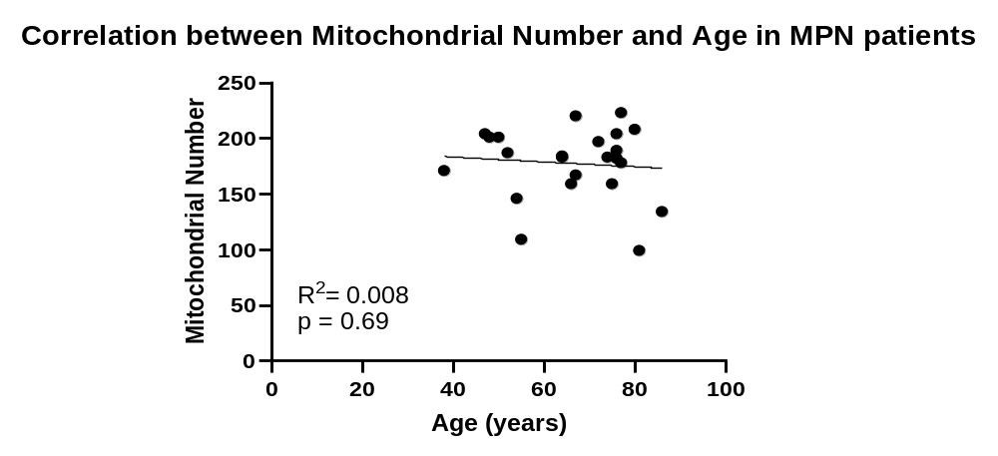
B

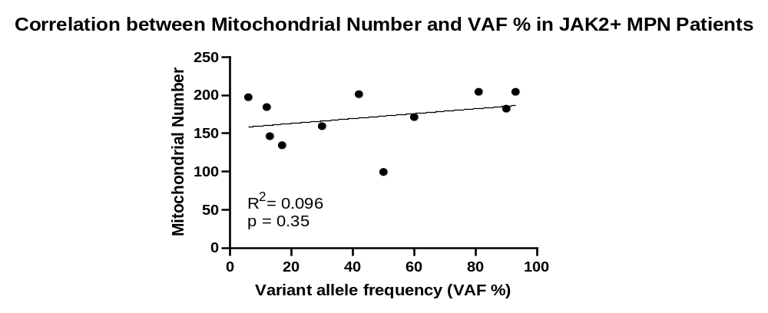
C

Supplementary Figure 2. TEM shows no correlation of mitochondrial number with age or JAK2 mutation VAF. The total number of mitochondria in 50 platelets was plotted against age in (A) healthy donors (n=16) and (B) MPN patients (n=23). (C) The total number of mitochondria in 50 platelets was plotted against leukocyte VAF of JAK2 V617F in MPN patients with that mutation (n=11).

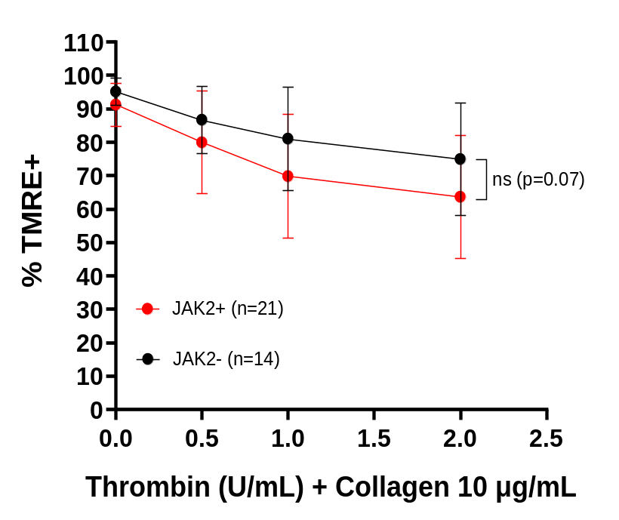
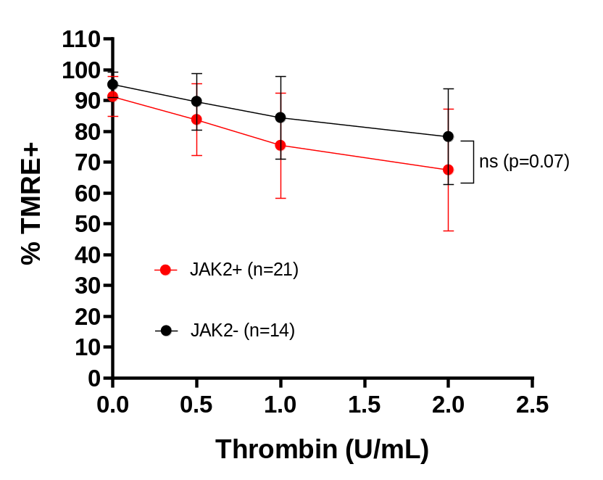
Platelet TMRE Loss following Thrombin Stimulation in JAK2+ and JAK2- MPN Patients
A
B

Supplementary Figure 3. Platelet TMRE loss following stimulation with thrombin was greater but not significantly different in JAK2+ MPN patients compared to JAK2- MPN patients. Dose-response curves derived from stimulation with various concentrations of thrombin (A) or thrombin with collagen (10 µg/mL) (B) in JAK2+ (n=21) and JAK2- (n=14) MPN patients. Error bars for each point represent differences between individuals. Data analysis was by a mixed-effects 2-way ANOVA followed by Tukey’s multiple comparisons test. ns = not significant.

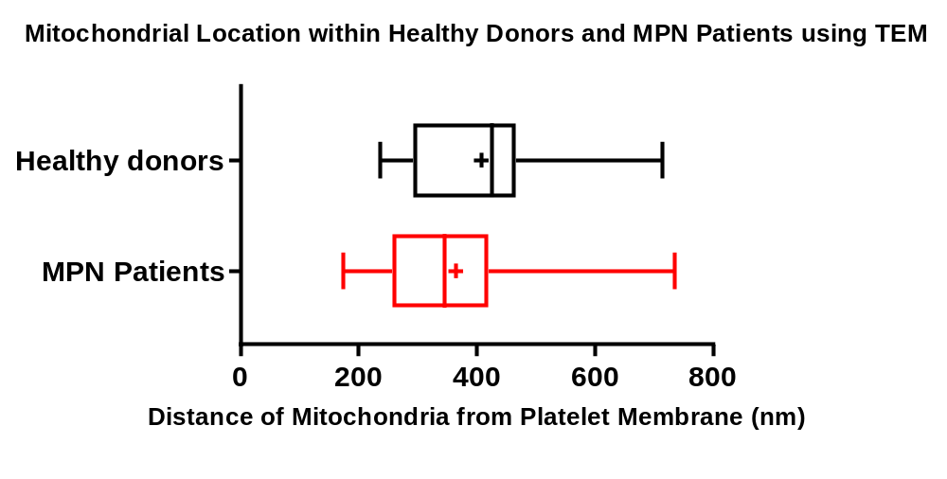
Supplementary Figure 4. Mitochondrial location within healthy donors and MPN patients using TEM. Absolute distance (nm) of mitochondria form platelet outer membrane assessed by TEM does not differ between healthy donors (n=16) and MPN patients (n=23). Bar-Whisker plots showing the max, min, interquartile range, mean. median and mean (+) represent individual subject means. Mann-Whitney Test, P = 0.20.

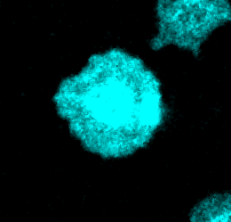

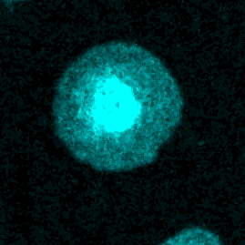

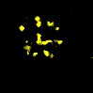
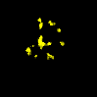
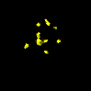
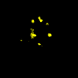
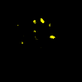
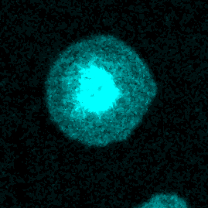
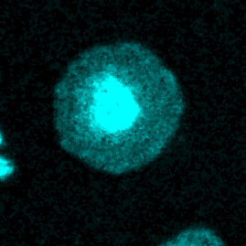
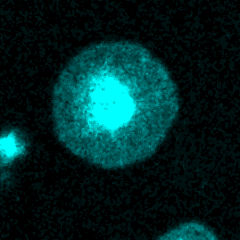
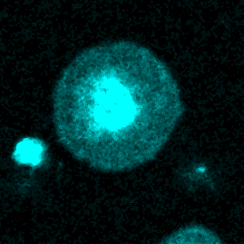
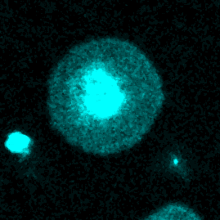

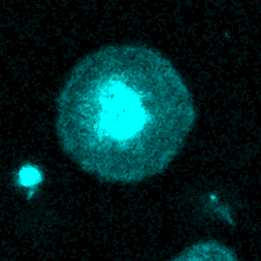
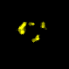
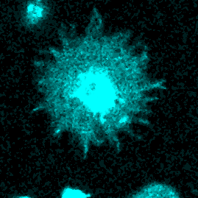

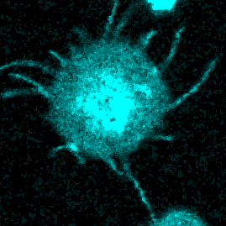

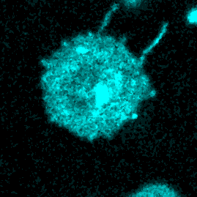
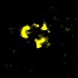
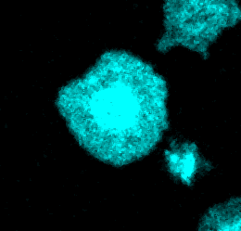
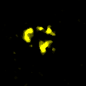
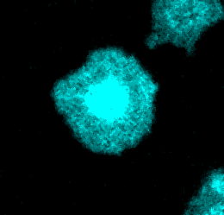
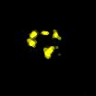
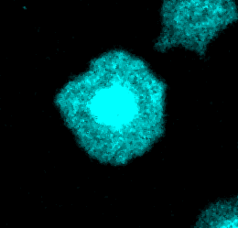
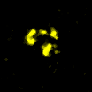
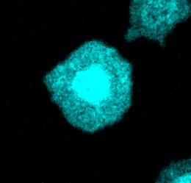
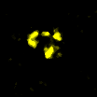
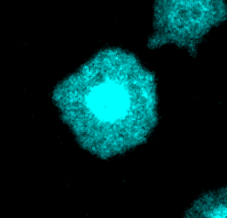
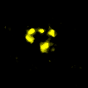
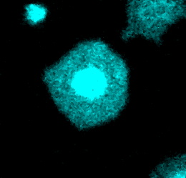
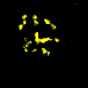


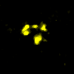
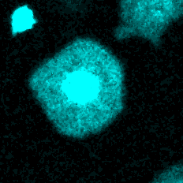
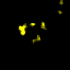
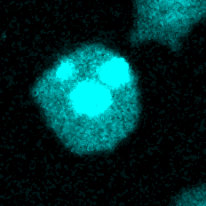
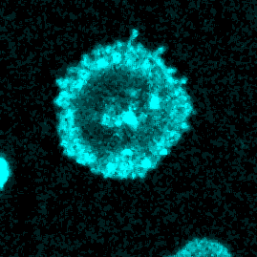

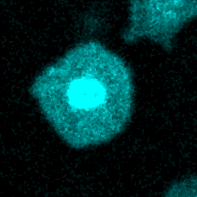
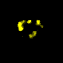
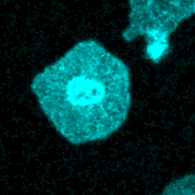
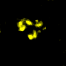
43 sec
59 sec
92 sec
100 sec
105 sec
108 sec
113 sec
154 sec
216 sec
A
B
CD41a
TMRE
CD41a
747 sec
391 sec
TMRE
Timelapse Images of Mitochondrial Depolarization in an MPN Patient Following Thrombin Stimulation

Supplementary Figure 5. High-resolution representative timelapse images of mitochondrial depolarization in an MPN patient following thrombin stimulation. (A) Timelapse images from live microscopy of a single representative platelet from an MPN patient showing sequential TMRE loss in adjacent mitochondria prior to balloon formation following the addition of agonist (thrombin 2U/mL + calcium 1mM). (B) Stable platelet from same field of view as (A) over the same time course showing no TMRE loss or ballooning. Initial timelapse imaging begins at 20 seconds after addition of agonists thrombin and calcium.
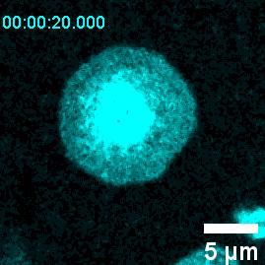
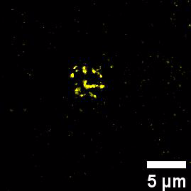
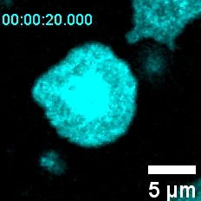
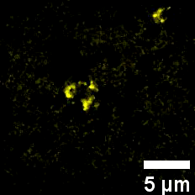
Video A
Video B
Supplementary video: Live video microscopy of platelets A and B from Supplementary figure 5.

Supplementary Video. Visualization by live microscopy of mitochondrial depolarization within a platelet from an MPN patient following thrombin stimulation. High-resolution videos of a platelet from an MPN patient at various stages of mitochondrial depolarization showing sequential TMRE loss in adjacent mitochondria prior to balloon formation following the addition of agonist (thrombin 2U/mL + calcium 1mM). Initial timelapse imaging begins at 20 seconds after addition of agonists thrombin and calcium.

