Endovascular thrombectomy for acute ischemic stroke in elderly patients with large ischemic cores

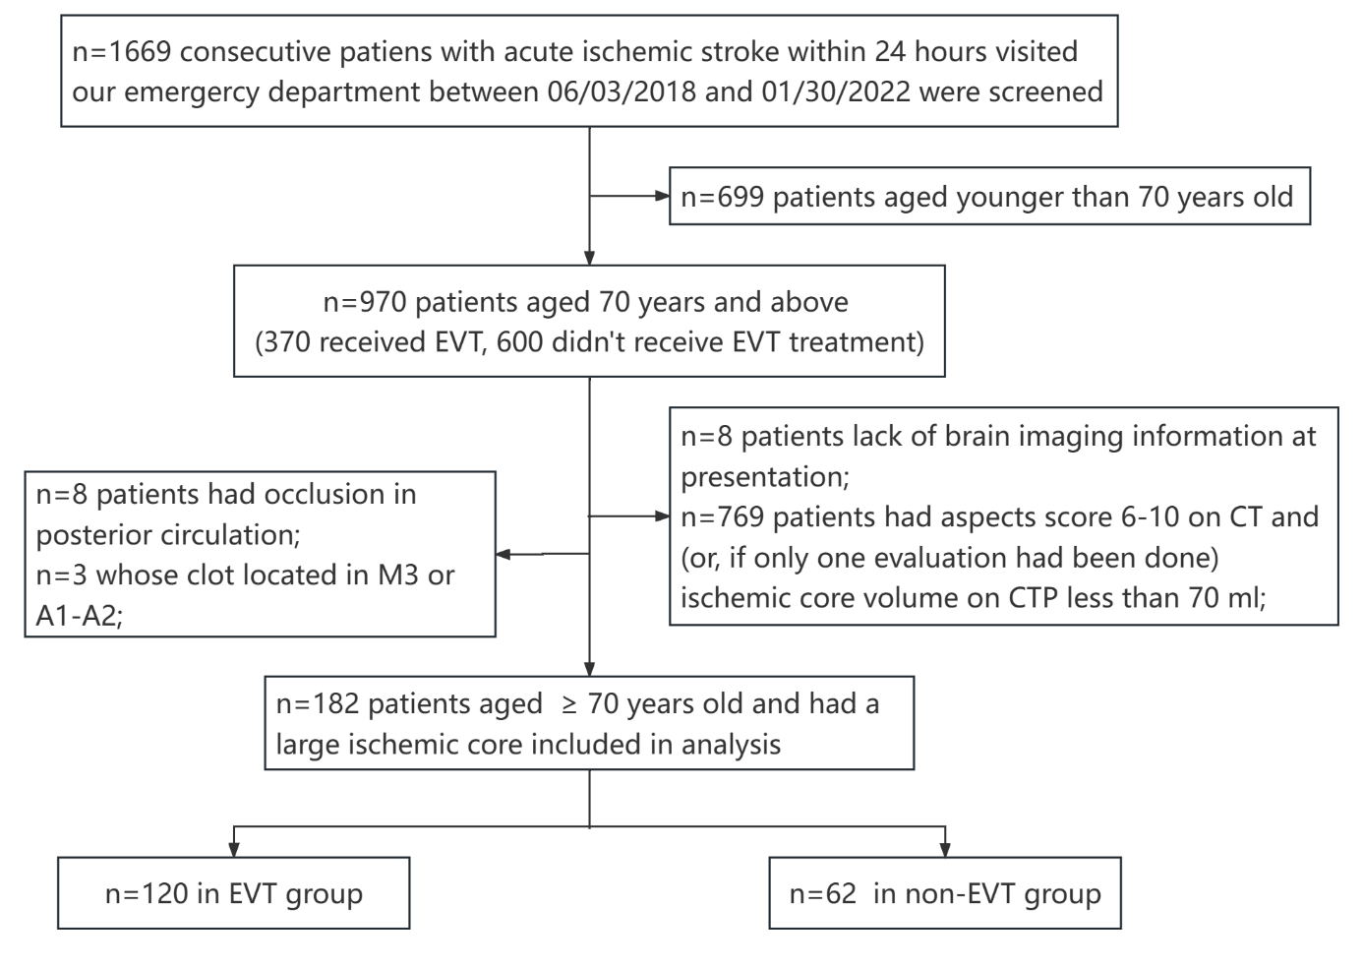
Figure S1. Study flow diagram
Abbreviations: EVT, endovascular thrombectomy; ASPECTS, Alberta Stroke Program Early CT Score; CT, Computed Tomography; CTP, CT perfusion.

Figure S2. Distribution of functional outcomes as measured by mRS at 90 days in patients aged 70-79 years old (upper panel) and patients ≥ 80 years old (lower panel). EVT, endovascular thrombectomy; mRS, modified Rankin scale.
.

Figure S3. (A) The association of ischemic core volume and age with the probability of a fair outcome (90-day mRs, 0-3) for elderly patients with a large ischemic core. (B) The association of ischemic core volume and age with the probability of a 90-day death for elderly patients with a large ischemic core.

Table S1. Association of EVT and clinical outcomes in patients aged 70-79 years with a large ischemic core
 | non-EVT Group (n=28) | EVT Group (n=72) | P value |  | Unadjusted analysis |  |  | Adjusted analysis #
 |  |  |  |  | OR | 95%CI |  | aOR | 95%CI
functional outcomes
mRS score 0–2 | 3(10.7) | 11(15.3) | 0.555 |  | 1.503 | 0.386-5.848 |  | 1.384 | 0.158-12.094
mRS score 0–3 | 5(17.9) | 18(25) | 0.446 |  | 1.533 | 0.508-4.627 |  | 1.249 | 0.201-7.779
mRS score 5–6 | 18(64.3) | 42(58.3) | 0.585 |  | 0.778 | 0.315-1.921 |  | 1.175 | 0.249-5.537
safety outcomes
death | 16(57.1) | 29(40.3) | 0.128 |  | 0.506 | 0.209-1.225 |  | 0.482 | 0.089-2.616
Any ICH | 5(18.5) | 32(44.4) | 0.018 |  | 3.52 | 1.199-10.33 |  | 3.327 | 0.769-14.4
Symptomatic ICH | 4(14.8) | 18(25.4) | 0.264 |  | 1.953 | 0.595-6.412 |  | 3.767 | 0.538-26.387
Adjusted covariables: EVT treatment, age, gender, pre-stroke mRS, NIHSS at presentation, Intravenous thrombolysis, onset-to-hospital, baseline ASPECT score, ischemic core volume (per 10ml) and mismatch volume (per 10ml).
.

Table S2. Association of EVT and clinical outcomes in patients aged ≥ 80 years with a large ischemic core
 | non-EVT Group (n=34) | EVT Group (n=48) | P value |  | Unadjusted analysis |  |  | Adjusted analysis #
 |  |  |  |  | OR | 95%CI |  | aOR | 95%CI
functional outcomes
mRS score 0–2 | 0(0) | 6(12.5) | 0.039 |  | - | - |  | - | -
mRS score 0–3 | 6(17.6) | 9(18.8) | 0.899 |  | 1.077 | 0.344-3.372 |  | 2.418 | 0.345-16.926
mRS score 5–6 | 21(61.89) | 35(72.9) | 0.285 |  | 1.667 | 0.651-4.267 |  | 7.12 | 0.565-89.751
safety outcomes
death | 19(55.9) | 26(54.2) | 0.878 |  | 0.933 | 0.386-2.257 |  | 0.949 | 0.212-4.253
Any ICH | 13(38.2) | 17(37) | 0.907 |  | 0.947 | 0.379-2.364 |  | 1.83 | 0.498-6.722
Symptomatic ICH | 7(20.6) | 10(21.7) | 0.901 |  | 1.071 | 0.361-3.178 |  | 5.117 | 0.806-32.498
Adjusted covariables: EVT treatment, age, gender, pre-stroke mRS, NIHSS at presentation, Intravenous thrombolysis, onset-to-hospital, baseline ASPECT score, ischemic core volume (per 10ml) and mismatch volume (per 10ml).

Table S3. Baseline characteristics of matched patients in non-EVT group and EVT group after propensity score matching
Characteristics | non-EVT Group (n=34) | EVT Group (n=34) | P value
Age, median (IQR), years | 80 (72-85) | 79 (74.75-85.25) | 0.722
Aged 80 years and above, n (%) | 18 (52.9) | 16 (47.1) | 0.628
Female, n (%) | 18(52.9) | 20 (58.8) | 0.625
Clinical history, n (%)
Hypertension | 22 (64.7) | 24 (70.6) | 0.604
Diabetics | 10 (29.4) | 8 (23.5) | 0.582
Ischemic heart disease | 4 (11.8) | 13 (38.2) | 0.012
Ischemic stroke | 1 (2.9) | 5 (14.7) | 0.087
Hemorrhagic stroke | 1 (2.9) | 0 (0) | 1.000
Atrial fibrillation | 6 (17.6) | 10 (29.4) | 0.253
Smoking | 8 (23.5) | 5 (14.7) | 0.355
Baseline medication, n (%)
Antiplatelet | 2 (5.9) | 3 (8.8) | 1.000
Anticoagulation | 2 (5.9) | 5 (14.7) | 0.427
pre-stroke mRS, median (IQR) | 0 (0-0) | 0 (0-0) | 1.000
pre-stroke mRS, n (%) |  |  | 1.000
0 | 33 (97.1) | 33 (97.1)
1 | 1 (2.9) | 1 (2.9)
Systolic BP, median (IQR), mmHg | 156.5 (132-184.75) | 144.5 (125-170.5) | 0.239
Diastolic BP, median (IQR), mmHg | 77.5 (69.75-98.25) | 85.5 (70.75-91) | 0.439
Serum glucose, median (IQR), mmol/L | 8.65 (6.31-11.10) | 7.85 (6.54-9.66) | 0.564
TOAST, n (%) |  |  | 0.172
Large artery atherosclerosis | 18 (52.9) | 12 (35.3)
Cardio-embolic | 15 (44.1) | 22 (64.7)
undetermined | 1 (2.9) | 0 (0)
Location of clot, n (%)
ICA , | 14 (41.2) | 18 (52.9) | 0.331
M1 or M2 | 28 (82.4) | 20 (58.8) | 0.033
Intravenous thrombolysis, n (%) | 15 (44.1) | 9 (26.5) | 0.128
onset-to-hospital , median (IQR), minutes | 180 (115.8-270) | 191.5 (115.8-240) | 0.459
NIHSS at presentation, median (IQR) | 15.5 (14-21.25) | 18.5 (15-22) | 0.117
Aspect score at admission, median (IQR) | 3.5 (1-5) | 3 (2-5) | 0.799
Ischemic core volume, median (IQR) | 85.5 (54.5-139) | 100 (58.75-139.5) | 0.589
Mismatch volume, median (IQR) | 68 (12.5-101.75) | 87.5 (21.25-119.75) | 0.404
Mismatch ratio, median (IQR) | 1.65 (1.15-2.55) | 1.81 (1.22-2.73) | 0.394

ICH: intracranial hemorrhage; TOAST: trial of ORG 10172 in acute stroke treatment; ICA: internal carotid artery; M1 or M2: M1 or M2 segments of middle cerebral artery; mRS: modified Rankin scale; NIHSS: National Institutes of Health Stroke Scale; SD: standard deviation; IQR: Interquartile Range.

Table S4. Association of EVT with clinical outcomes in elderly patients with a large ischemic core after propensity score matching
 | non-EVT Group (n=34) | EVT Group (n=34) | P value |  | Unadjusted analysis |  |  | Adjusted analysis #
 |  |  |  |  | OR | 95%CI |  | aOR | 95%CI
functional outcomes
mRS score 0–2 | 2(5.9%) | 4(11.8%) | 0.673 |  | 2.133 | 0.364-12.511 |  | 8.381 | 0.164-428.27
mRS score 0–3 | 6(17.6%) | 9(26.5%) | 0.38 |  | 1.68 | 0.524-5.388 |  | 5.609 | 0.812-38.75
mRS score 5–6 | 21(61.8%) | 23(67.6%) | 0.612 |  | 1.294 | 0.477-3.509 |  | 0.445 | 0.088-2.252
safety outcomes
death | 19(55.9%) | 16(47.1%) | 0.467 |  | 0.702 | 0.27-1.823 |  | 0.185 | 0.034-1.003
Any ICH | 11(33.3%) | 18(56.3%) | 0.063 |  | 2.571 | 0.941-7.031 |  | 5.131 | 1.167-22.553
Symptomatic ICH | 5(15.2%) | 11(34.4%) | 0.072 |  | 2.933 | 0.884-9.729 |  | 6.315 | 1.074-37.145

#: Adjusted for age, sex, admission NIHSS, pre-stroke mRS, ischemic or hemorrhagic stroke history, ischemic heart disease history, smoking, onset to hospital, TOAST, IVT use, clot location, ischemic core volume (per10ml) and mismatch volume (per10ml).

Table S5. Factors between fair and un-fair outcome groups after EVT and their association with 90-day fair outcome
Variables | fair outcome (n=27) | un-fair outcome (n=93) | p value* | aOR# | 95% CI
age, median (IQR) | 75 (74-82) | 78 (75-83) | 0.176 | 0.88 | 0.71-1.08
female, n (%) | 15 (55.6) | 60 (64.5) | 0.397 | 2.56 | 0.27-24.65
pre-mRS, median (IQR) | 0 (0-0) | 0 (0-0) | 0.989 | 0.00 | 0.00-na
NIHSS at presentation, median (IQR) | 16 (12-20) | 17 (14-20) | 0.234 | 0.91 | 0.73-1.13
onset-to-hospital interval, median (IQR), minutes | 180 (103-262) | 186 (126-240) | 0.915 | 1.00 | 0.98-1.02
onset-to-puncture interval, median (IQR), minutes | 292 (213-358) | 285 (232.5-329) | 0.828 | 0.99 | 0.98-1.01
puncture-to-recanalization interval, median (IQR), minutes | 65 (36-88) | 88 (54-120) | 0.004 | 0.97 | 0.93-1.02
number of stent retriever attempts | 1 (0-2) | 2 (1-3) | 0.005 | 0.35 | 0.07-1.85
number of aspiration attempts | 0 (0-1) | 0 (0-2) | 0.934 | 1.14 | 0.48-2.70
intravenous thrombolysis, n (%) | 6 (22.2) | 27 (29.0) | 0.485 | 0.10 | 0.01-1.67
successful reperfusion, n (%) | 26 (96.3) | 73 (78.5) | 0.042 | 2.18 | 0.02-222.67
ischemic core volume, mean (SD) | 70.9 (54.7) | 106.9 (56.8) | 0.026 | 0.99 | 0.97-1.01
mismatch volume, median (IQR) | 104 (89.5-139) | 72 (22-102) | 0.002 | 1.033 | 1.00-1.07
Any ICH | 7 (25.9) | 42 (46.2) | 0.061 | 0.68 | 0.07-6.83
Symptomatic ICH | 1 (3.7) | 27 (30) | 0.004 | 0.00 | 0.00-na
*: p value of comparison between fair outcome group or unfair outcome group after EVT treatment using Student’s t-test (or nonparametric Mann-Whitney U test) and Chi-square tests. Bold values indicate significant p-value < 0.05.
#: Adjusted variables in multivariable regression analysis were: age, gender, pre-mRS, NIHSS at presentation, time intervals (onset-to-hospital interval, onset-to-puncture and onset-to-puncture interval), number of retriever attempts (aspiration and stent), intravenous thrombolysis, rate of successful reperfusion, ischemic core volume and mismatch volume.
EVT, endovascular thrombectomy; NIHSS, National Institutes of Health Stroke Scale; mRS: modified Rankin scale; IQR, Interquartile Range; ICH: intracranial hemorrhage.

