Additional file 1
Supplementary Figure 1. The rarefaction curves (a) and Shannon diversity curves (b) of microbiota of 18 salinity alkali soil samples treated with viable/sterilized lactic acid bacteria preparation and water.
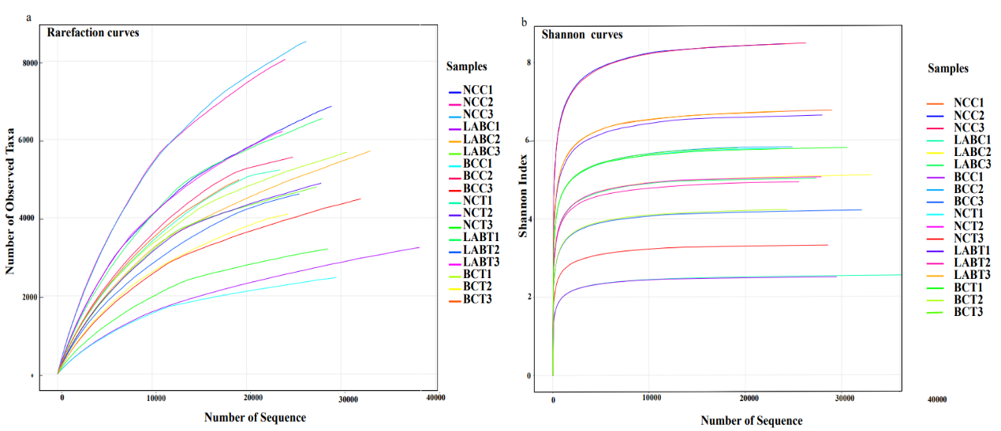
Supplementary Figure 1 The rarefaction curves (a) and Shannon diversity curves (b) of microbiota of 18 salinity alkali soil samples treated with viable/sterilized lactic acid bacteria preparation and water.
Supplementary Figure 2 Differences in air ratio; liquid ratio; solid ratio and porosity of saline-alkali soil post treatment.
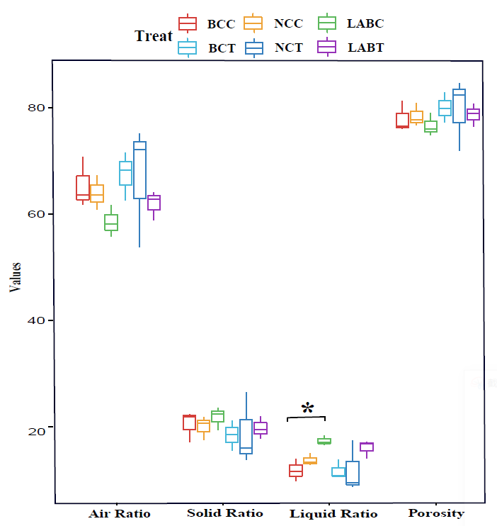

Supplementary Figure 2 Differences in air ratio; liquid ratio; solid ratio and porosity of saline-alkali soil post treatment.

Additional file 2:
Supplementary Table S1. Quality statistics results of raw reads
Supplementary Table S2. Comparison of pathway categories of saline-alkali soils after different treatments
Supplementary Table S3. Comparison of pathway abundance of saline-alkali soils after different treatments
Supplementary Table S4. Comparison of functional genes abundance of saline-alkali soils after different treatments
Supplementary Table S5. The abundance of all KO genes of saline-alkali soils after different treatments
Supplementary Table S6. The environmental factors of saline-alkali soils after different treatments

