Supplemental Information

Wildfire effects on aquatic host-parasite interactions

Emma C. Svatos, Landon P. Falke, Daniel L. Preston

Supplemental Methods and Results

Species accumulation curves – We used species accumulation curves to examine the expected number of observed trematode taxa as a function of sampling effort (i.e., snails dissected per site). We used data from a previous study, in which trematode infections were identified from 3,255 Juga snails sampled from second-order streams (Soap, Oak, and Plunkett Creeks) in the Willamette River Basin (Falke and Preston 2022). Juga snails were sampled from the three streams in August, 2020, using a 50-m transect-quadrat design, and all snails > 8 mm were dissected to quantify trematode infections. We included only snails > 10 mm in the species accumulation curves because this matched the sampling approach used in the current study. This resulted in sample sizes of dissected snails of 456 (Soap Creek), 1630 (Oak Creek), and 1183 (Plunkett); differences in samples size were a result of differences in densities of snails >10 mm at each site. Notably, the sites also differed in overall infection prevalence, which was highest in Plunkett (48.3%), intermediate in Soap Creek (38.6%), and lowest in Oak Creek (22.7%). We used the ‘vegan’ package and ‘poolaccum’ function in R to estimate trematode species richness for random ordering of sampling units (i.e., individual snails) with 1,000 permutations. We then plotted the resulting richness estimates and standard error to visually assess the expected efficiency of sampling effort in detecting new taxa (Figure S1).

References

Falke LP, Preston DL (2022). Freshwater disease hotspots: Drivers of fine‐scale spatial
heterogeneity in trematode parasitism in streams. Freshwater Biology, 67(3):487-497

Table S1. Summary of burn area percentage and severity within 500-m buffer of all survey sites (n=17) in 2021, one year after fire, grouped by sub-basin (McKenzie or Santiam). Data were sourced from the Monitoring Trends in Burn Severity (USGS, USFS) program and analyzed using ArcGIS Pro 3 (ESRI).

Location | Total Burn | Low | Med | High
All sites
BURN | 93.2% | 17.1% | 47.6% | 28.6%
CONTROL | 1.9% | 0.9% | 1.0% | 0%
McKenzie only
BURN | 87.3% | 22.3% | 48.4% | 16.6%
CONTROL | 3.8% | 1.8% | 2.0% | 0%
Santiam only
BURN | 99.1% | 11.9% | 46.7% | 40.5%
CONTROL | 0% | 0% | 0% | 0%
Table S2. Summary of Generalized Linear Models (GLM) analyses for trematode, snail, and environmental responses before and two years after fire (BACI; n=10 sites). Models tested for the significance of the interaction between burn history (“Burn status”) and time since fire (“Year”) as well as spatial differences (“Sub-basin”) of survey sites. Test statistic (“TS”) represents Z-values for Gamma and Negative Binomial models and t-values for Quasi-Poisson models.

Variable | Family | Fixed Effect | TS | p-value
Trematode
Richness | Quasipoisson | Burn*Year | -0.02 | 0.98
 |  | Sub-basin | -0.88 | 0.39
Shannon Diversity | Gamma | Burn*Year | 0.68 | 0.50
 |  | Sub-basin | -1.35 | 1.90
Evenness | Gamma | Burn*Year | 1.08 | 0.29
 |  | Sub-basin | -3.13 | <0.01
Snail
Biomass | Gamma | Burn*Year | -0.65 | 0.52
 |  | Sub-basin | -1.03 | 0.31
Density | Gamma | Burn*Year | -0.07 | 0.95
 |  | Sub-basin | -0.28 | 0.78
Environment
Canopy Cover | Negative | Burn*Year | -2.01 | 0.04
 | Binomal | Sub-basin | -2.41 | 0.02
Riparian Vegetation | Quasipoisson | Burn*Year | -2.65 | 0.01
 |  | Sub-basin | 0.0 | 1.00

Table S3. Summary of Generalized Linear Models (GLM) analyses for trematode, snail, and environmental responses one-year post-fire. Models tested for the significance of burn history (“Burn status”) and spatial differences (“Sub-basin”) of survey sites. Data were incorporated from all survey sites (n=17) in 2021 only. Test statistic (“TS”) represents Z-values for Gamma models and t-values for Quasi-Poisson models

Variable | Family | Fixed Effect | TS | p-value
Trematode
Richness | Quasipoisson | Burn status | 1.13 | 0.28
 |  | Sub-basin | -1.07 | 0.30
Shannon Diversity | Gamma | Burn status | 2.68 | 0.02
 |  | Sub-basin | 0.41 | 0.69
Evenness | Gamma | Burn status | 2.90 | 0.01
 |  | Sub-basin | -2.10 | <0.05
Snail
Biomass | Gamma | Burn status | -0.83 | 0.42
 |  | Sub-basin | -2.94 | 0.01
Density | Gamma | Burn status | -1.32 | 0.21
 |  | Sub-basin | -2.18 | <0.05
Environment
Canopy Cover | Negative | Burn status | -1.73 | 0.08
 | Binomial | Sub-basin | -2.34 | 0.02
Riparian Vegetation | Quasipoisson | Burn status | -6.07 | <0.001
 |  | Sub-basin | -2.22 | 0.04

Table S4. Summary of Generalized Linear Mixed Models (GLMM) analyses for infection status before and two years after fire (BACI; n=10 sites). Models were specified with a binomial distribution (0=uninfected; 1=infected) and included the random effect of site. Models tested for the fixed effects of the interaction between burn history (“Burn status”) and time since fire (“Year”), individual snail size (“Total length”), and spatial differences (“Sub-basin”) of survey sites.

Trematode | Fixed Effect | Z-value | p-value
All taxa | Burn*Year | -1.183 | 0.24
 | Total length | 19.36 | <0.001
 | Sub-basin | 0.19 | 0.85
Acanthatrium sp. 1 | Burn*Year | -2.22 | 0.03
 | Total length | 16.05 | <0.001
 | Sub-basin | -2.27 | 0.02
Acanthatrium sp. 2 | Burn*Year | -0.87 | 0.38
 | Total length | 4.42 | <0.001
 | Sub-basin | 0.135 | 0.89
Metagonimoides | Burn*Year | -1.04 | 0.30
oregonensis | Total length | 10.23 | <0.001
 | Sub-basin | 2.94 | <0.01
Metagonimus sp. | Burn*Year | 1.71 | 0.09
 | Total length | 3.88 | <0.001
 | Sub-basin | -0.55 | 0.58
Cardicola alseae | Burn*Year | -0.28 | 0.78
 | Total length | -0.94 | 0.35
 | Sub-basin | 0.31 | 0.75
Deropegus aspina | Burn*Year | 0.37 | 0.71
 | Total length | -0.63 | 0.53
 | Sub-basin | -1.35 | 0.18
Nanophyetus | Burn*Year | -0.52 | 0.60
salmincola | Total length | 8.99 | <0.001
 | Sub-basin | 1.90 | 0.06

Table S5. Summary of Generalized Linear Mixed Models (GLMM) analyses for snail infection status one-year post-fire. Models were specified with a binomial distribution (0=uninfected; 1=infected) and included the random effect of site. Models tested for the fixed effects of individual snail size (“Total length”), burn history (“Burn status”), and spatial differences (“Sub-basin”) of survey sites. Data were incorporated from all survey sites (n=17) in 2021 only.

Trematode | Fixed Effect | Z-value | p-value
Total infections | Burn status | -1.74 | 0.08
 | Total length | 13.39 | <0.001
 | Sub-basin | 1.07 | 0.28
Acanthatrium sp. 1 | Burn status | -0.89 | 0.38
 | Total length | 11.43 | <0.001
 | Sub-basin | -1.12 | 0.27
Acanthatrium sp. 2 | Burn status | 1.00 | 0.32
 | Total length | 4.04 | <0.001
 | Sub-basin | 1.85 | 0.06
Metagonimoides | Burn status | 0.60 | 0.55
oregonensis | Total length | 7.34 | <0.001
 | Sub-basin | 2.83 | <0.01
Metagonimus sp. | Burn status | 2.57 | 0.01
 | Total length | 3.87 | <0.001
 | Sub-basin | -0.08 | 0.94
Cardicola alseae | Burn status | 1.72 | 0.08
 | Total length | 1.44 | 0.15
 | Sub-basin | 0.81 | 0.42
Deropegus aspina | Burn status | -2.10 | 0.04
 | Total length | -0.64 | 0.52
 | Sub-basin | -1.49 | 0.14
Nanophyetus | Burn status | -1.34 | 0.18
salmincola | Total length | 4.98 | <0.001
 | Sub-basin | 2.30 | 0.02
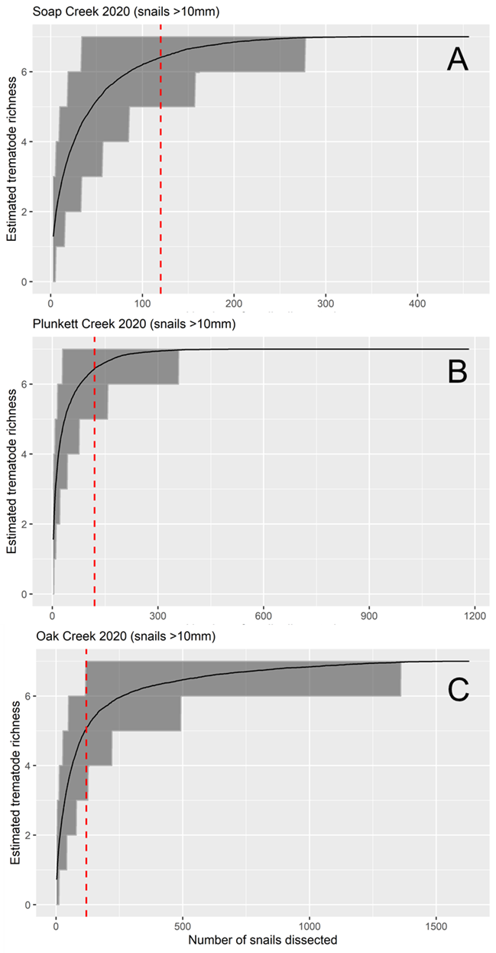
Figure S1: Species accumulation curve showing estimated trematode species richness by sampling effort in (A) Soap Creek, (B) Plunkett Creek and (C) Oak Creek, 2020. The grey-shaded area around the curves shows the 95% confidence interval based on standard deviation among permutations. The vertical-dashed red line represents a sampling effort of 120 dissected snails.
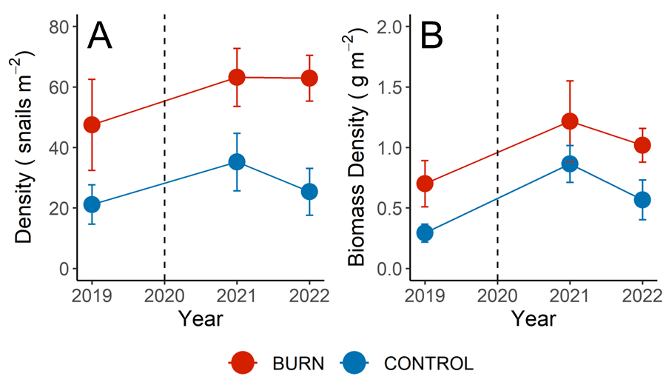
Figure S2: Before-After-Control-Impact response of (A) snail density and (B) snail biomass density in relation to wildfire. Points indicate mean density or biomass across burned (red) and unburned (blue) sites, with the vertical error bar indicating ± one SE. Timing of the 2020 wildfires is indicated by the dashed vertical line.

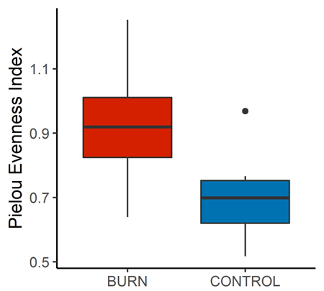

Figure S3. Boxplot showing differences in trematode community evenness between burned (red) and unburned (blue) survey sites one-year post-fire. Data were incorporated from all survey sites (n=17) in 2021 only.

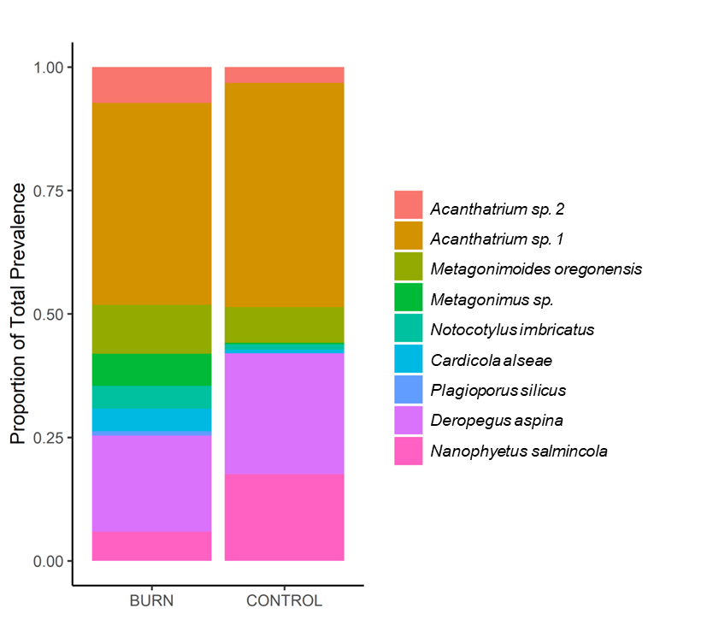
Figure S4. Stacked bar chart showing mean differences in trematode community composition between burned and unburned sites one-year post-fire. Each colored bar represents the individual taxon’s proportion of total infection prevalence. Data were incorporated from all survey sites (n=17) in 2021 only.

