Supporting Information
Contents
- Figure S1.
- Table S1
- Figure S2.
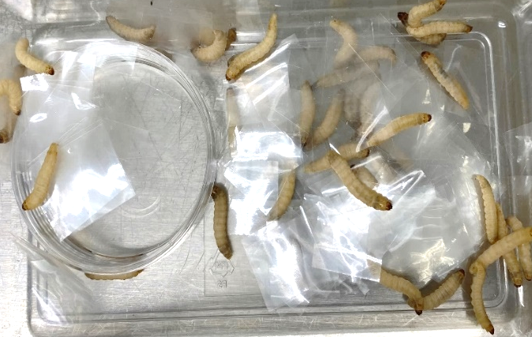
(A)

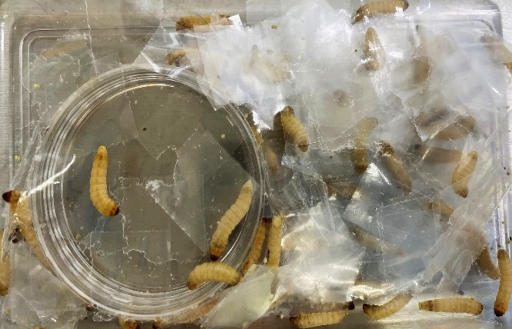
(B)

Figure S1. PP film feeding activity of the waxworms. (A) Before ingestion of PP (B) Day 6 after PP intake.

Table S1. Sequencing information from the 16S rRNA sequencing

Sample type | Total reads | Total bases | GC percent
Bran 1 | 225,964 | 68,015,164 | 53.85%
Bran 2 | 229,016 | 69,933,816 | 53.84%
PP 1 | 226,596 | 68,205,396 | 55.80%
PP 2 | 224,726 | 67,642,526 | 55.84%
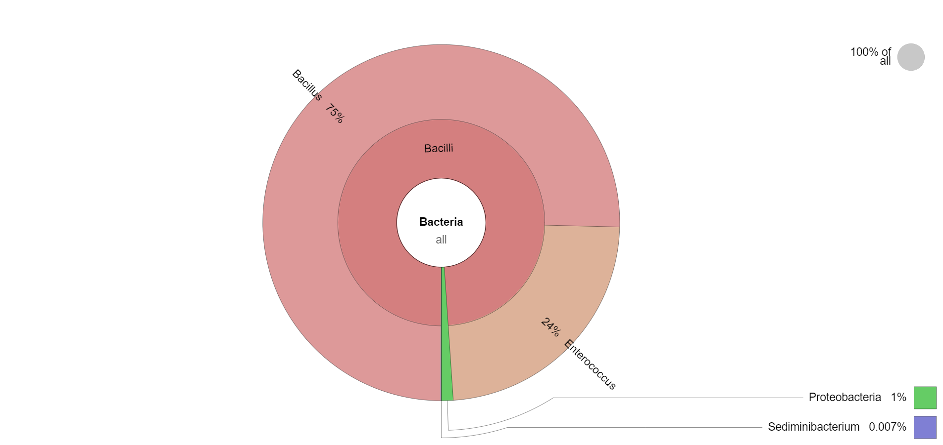
Bran 2

Figure S2. Krona chart representing the comparison of the taxonomic composition of the gut microbial community of waxworms associated with Bran feeding (A, B) and PP feeding (C, D), revealed by 16S rRNA sequencing.
Abbreviations: PET, polyethylene terephthalate; PHA, polyhydroxyalkanoate

