Number | tR/min | [M+H]+/  （m/z） | Formula | Ppm | Chemical  compound | Secondary mass  spectrometry fragment |  | Chemical structure
1 | 2.37 | 314.13846 | C₁₈H₁₉NO₄ | -0.7 | Laurolitsine | 58.0709,107.0514,151.0761,269.1169,  283.0833,299.1149,298.1072,314.1409 | 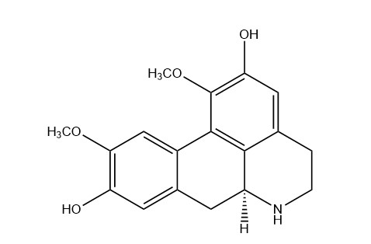
2 | 3.18 | 595.16575 | C₂₇H₃₀O₁₅ | -1.6 | Nicotiflorin | 134.0500,192.1060,271.1051,313.0671,  307.0617,321.0745,337.0689,355.0846,  379.0880,403.0765,421.0982,427.0971,  439.1092,457.1107,457.0887,481.0973,  475.0970,511.1251,541.1289,559.1499,  577.1477,595.2683
3 | 4.77 | 193.04891 | C₁₀H₈O₄ | -3.2 | Scopoletin | 56.9661,65.0432,75.0241,84.9566,92.8999,  103.0271,121.0286,133.9281,149.0820,  149.0208,150.0942,178.0855,178.0713,  193.0877,193.1057
4 | 4.87 | 257.08084 | C₁₅H₁₂O₄ | -0.2 | Liquiritigenin | 81.0359,91.0560,119.0491,137.0225,  147.0426,211.0732,257.0784
5 | 5.83 | 609.29542 | C₃₇H₄₀N₂O₆ | -0.7 | Fangchinoline | 367.1631,578.2507,609.2913
6 | 6.40 | 623.31112 | C₃₈H₄₂N₂O₆ | -0.7 | Tetrandrine | 623.308
7 | 6.41 | 287.09128 | C₁₆H₁₄O₅ | -0.1 | LicochalconeB | 65.0400,84.9648,113.0586,123.0406,  138.0282,147.0397,153.0561,167.0344,  170.0962,181.0633,204.8821,204.9010,  287.0903,287.1192
8 | 7.48 | 269.0808 | C₁₆H₁₂O₄ | -0.1 | Formononetin | 118.0416,170.0725,181.0641,197.0604,  213.0901,226.0617,237.0533,253.0508,  269.0809
9 | 7.49 | 431.13366 | C₂₂H₂₂O₉ | 0.3 | Ononin | 269.079
10 | 9.24 | 823.4104 | C₄₂H₆₂O₁₆ | -0.8 | Glycyrrhizic acid | 454.3450,453.3339,471.3460,647.3761
11 | 9.25 | 471.34659 | C₃₀H₄₆O₄ | -0.6 | 18β-Glycyrrhetinic Acid | 135.1192,173.1333,189.1631,235.1735,  317.2198,441.3193,453.3266
12 | 9.98 | 231.13742 | C₁₅H₁₈O₂ | -2.3 | Atractylenolide I | 77.0418,141.0012,157.1035,158.0265,  214.0888,231.1376
13 | 9.99 | 249.1481 | C₁₅H₂₀O₃ | -1.6 | Atractylenolide III | 55.9382,67.0588,69.0740,77.0429,79.0581,  83.0887,91.0569,95.0876,105.0713,119.0857,  128.0615,135.0451,149.0588,157.1032,161.0588,  163.0751,175.0755,189.0886,195.1209,203.1454,  213.1257,231.1364,231.1655
14 | 12.49 | 399.2166 | C₂₄H₃₀O₅ | -3 | Gancaonin T | 84.9687,122.9770,127.9993,141.9836,143.9942,  155.9973,158.0100,170.0082,172.0253,184.0262,  186.0462,214.0817,228.0954,258.8092,270.1388,  270.7608,294.2094,295.2148,312.8080,314.2000,  340.2157,358.2033,357.2024,399.3479
15 | 12.73 | 383.22169 | C₂₄H₃₀O₄ | -0.4 | Gancaonin R | 101.9517,314.1836,318.2111,320.2264,337.2006,  337.2144,383.2204

Figure S1. The main components' detailed information of Fangjihuangqi decoction

