B1 cells produce anti-phosphatidylserine antibodies via TLR-mediated Syk activation and contribute to lupus nephritis development

Supplementary Table and Figures
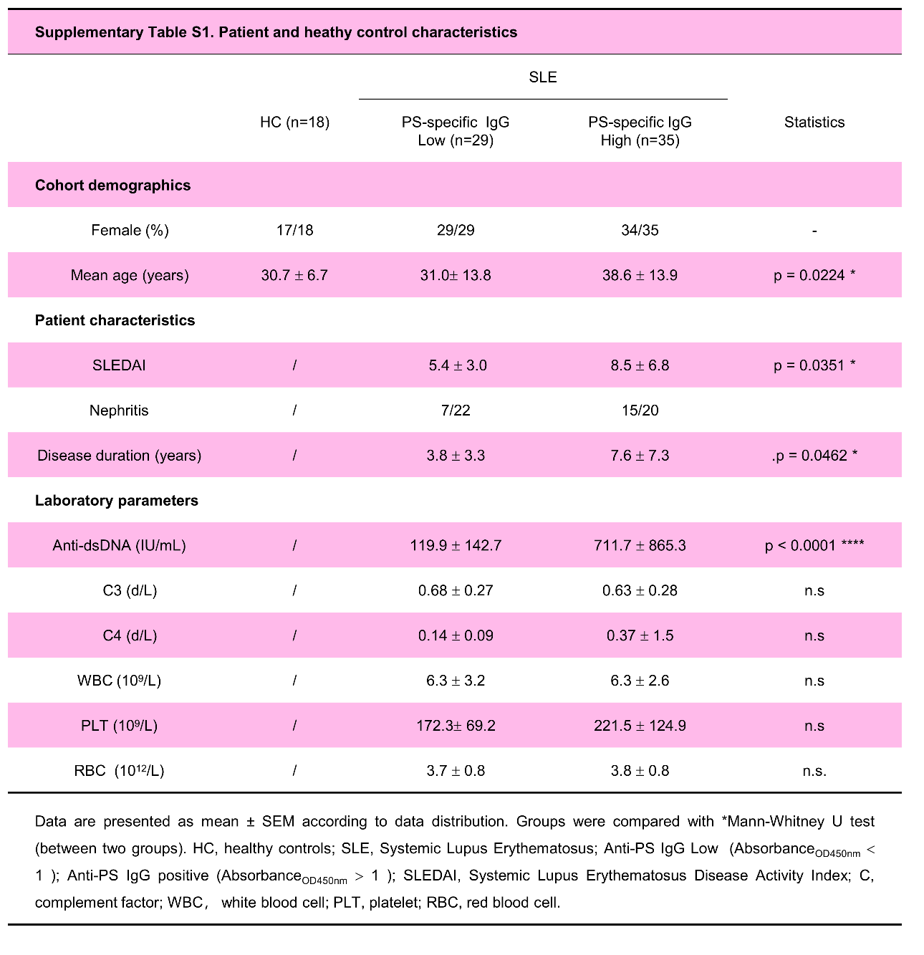

Supplementary figure S1. SLE PS-specific IgG effectively binding to the PS liposome with high affinity. Data plot shows the serum PS-specific IgG levels with active SLE serum (SLEDAI > 5, n = 3) by the competitive ELISA assay with preincubation PS antigen (PS liposome) or control antigen (PC liposome) for 1 h. Nonparametric Mann–Whitney U test, ****, P <0.0001.

Supplementary figure S2. Comparable levels of M3R- or collagenase II- specific IgG in mice with PS liposome immunization. Representative data plots show M3R-specific IgG (αM3R IgG) and collagenase II -specific IgG (αcollagenase II IgG) in serum samples (1:200 dilution) of control or PS immunized mice for 12 weeks (n = 6 per group). Unpaired two-tailed Student’s t-test, ns, no significance.

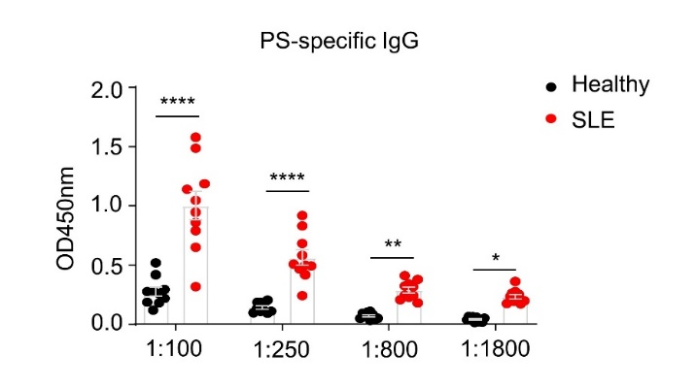

Supplementary figure S3. Elevated levels of serum PS-specific IgG in SLE patients. Data plot shows the serum PS-specific IgG levels using gradient diluted serum samples (1:100, 1:250, 1:800 and 1:1800) from active SLE patients (SLEDAI > 5, n =10) and healthy donors (n = 10). Nonparametric Mann–Whitney U test, *, P < 0.05; **, P < 0.01; ****, P <0.0001.

Supplementary figure S4. Positive correlation between serum levels of PS-specific IgG and dsDNA-specific IgG in SLE patients. Data plot shows the correlation between serum PS-specific IgG levels and dsDNA-specific IgG in SLE patients (n = 64). Spearman’s rank coefficient of correlation, ****, P <0.0001.

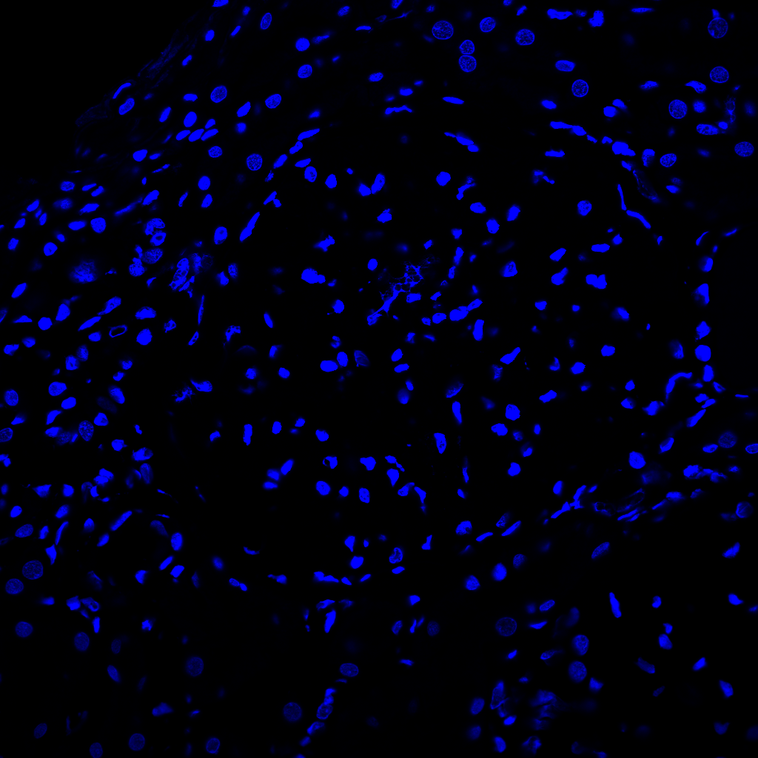


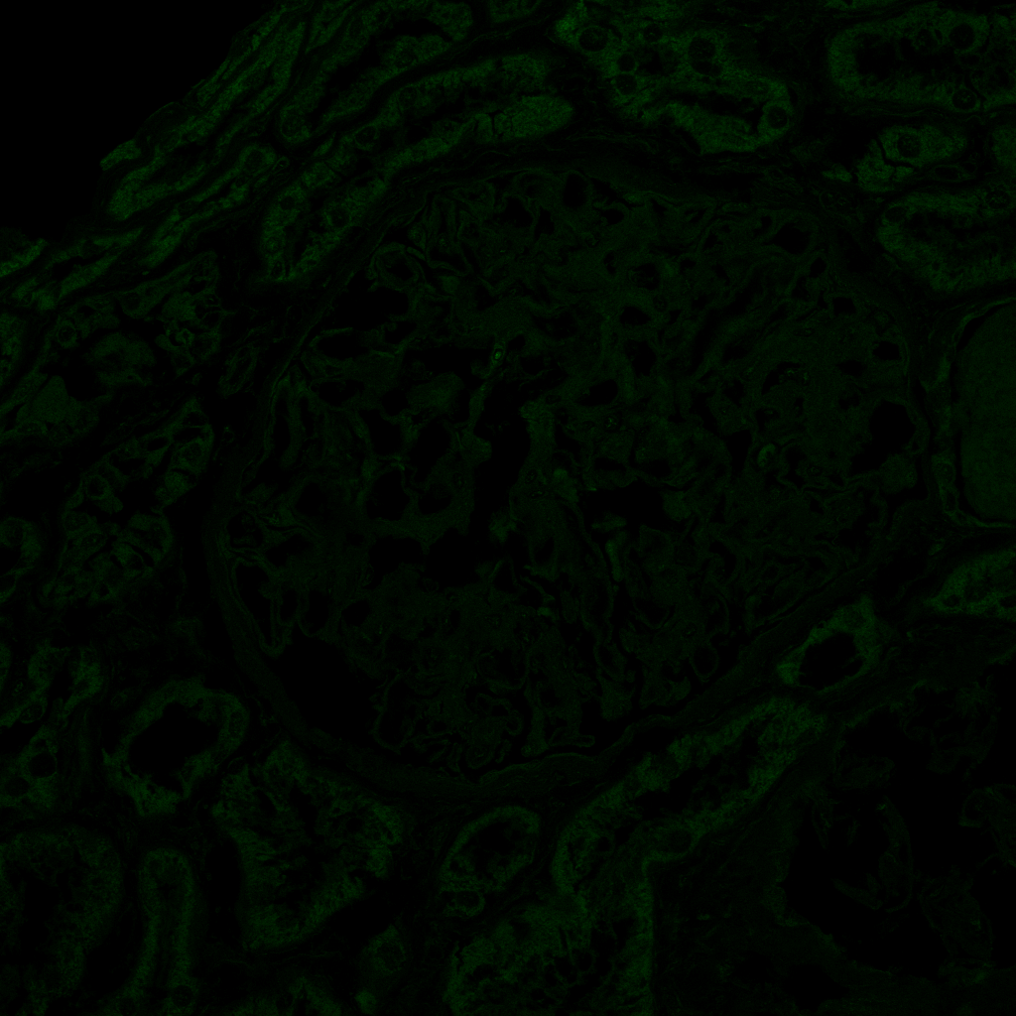
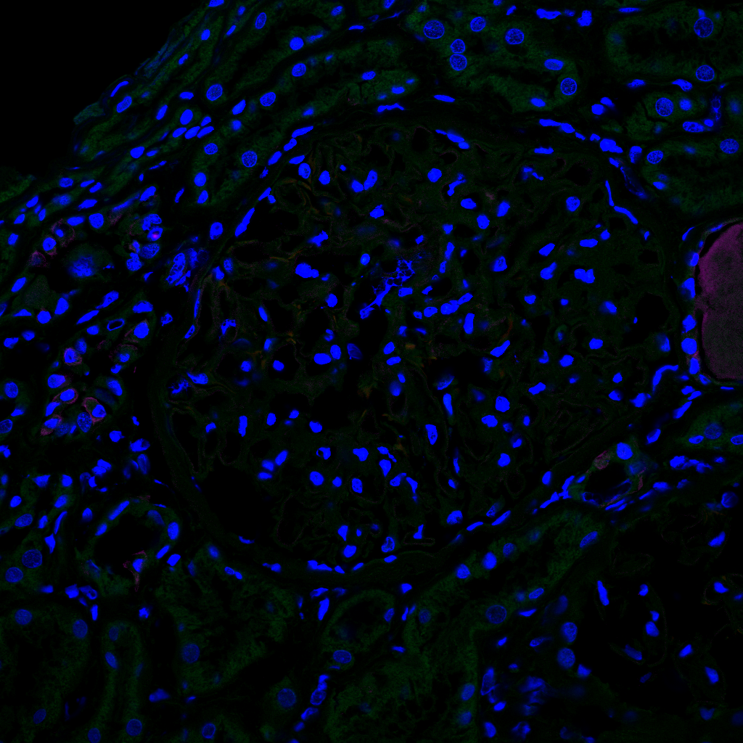
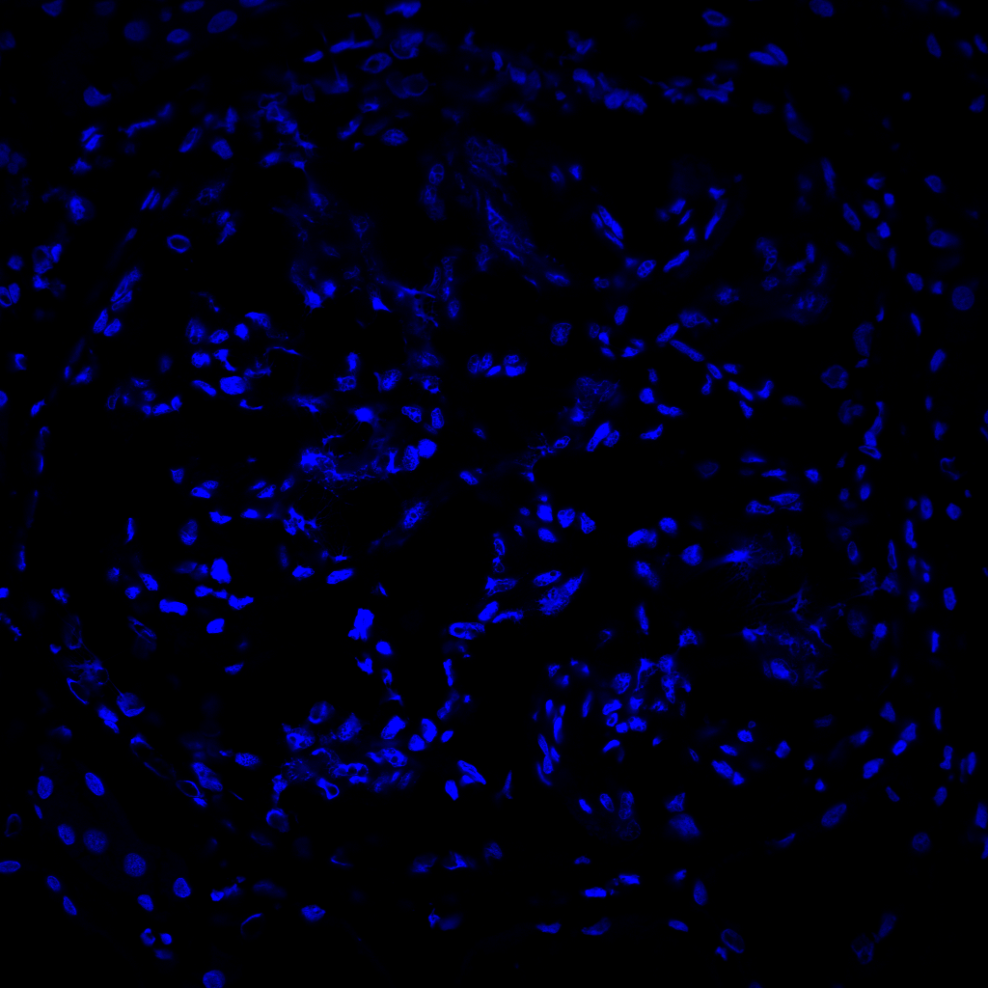
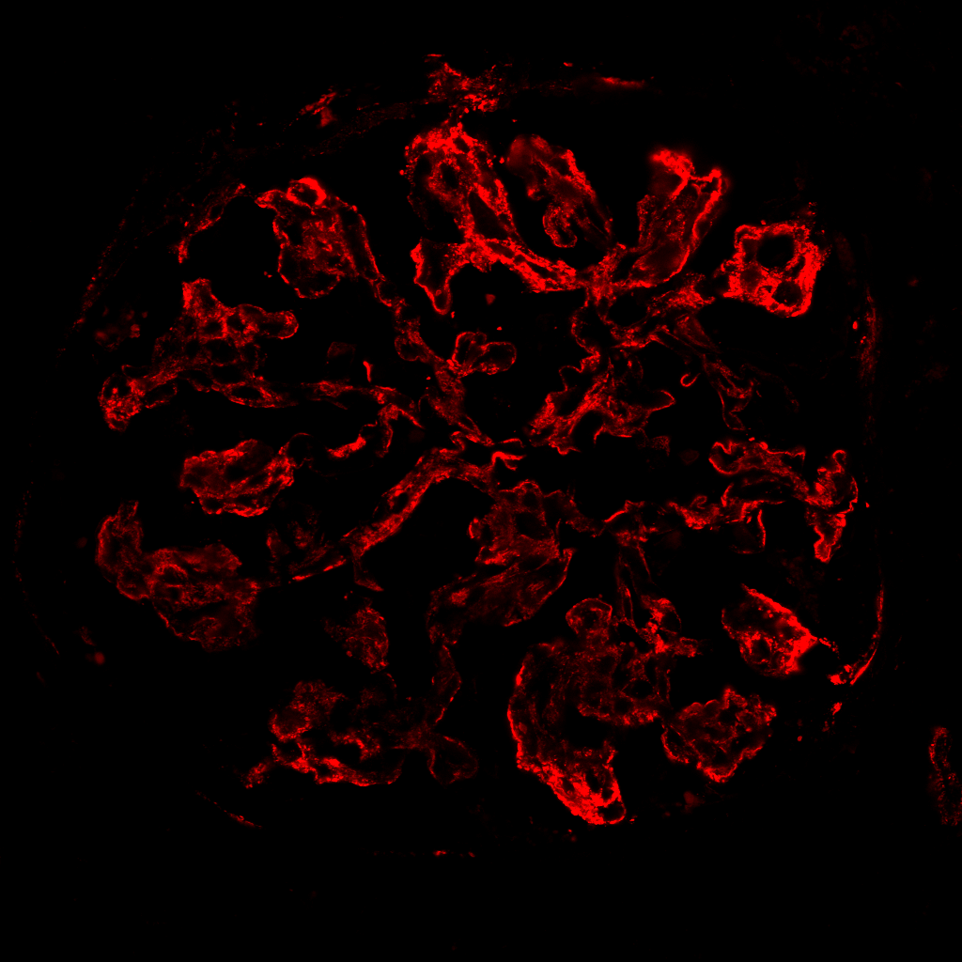
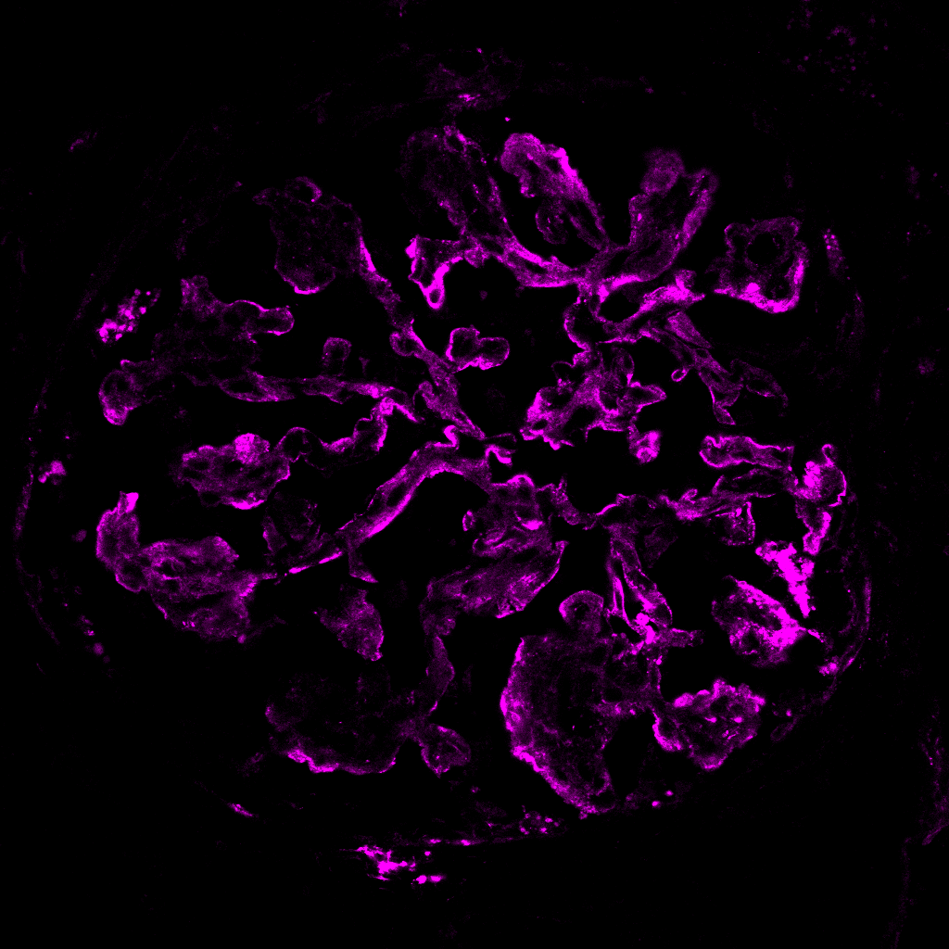
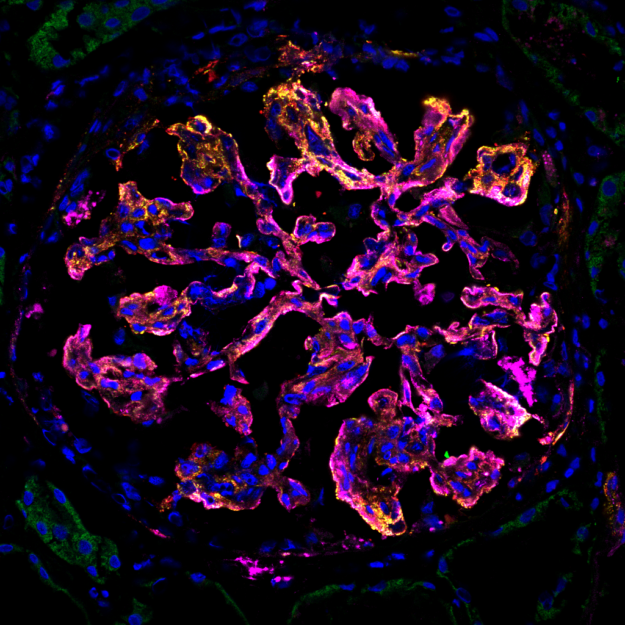
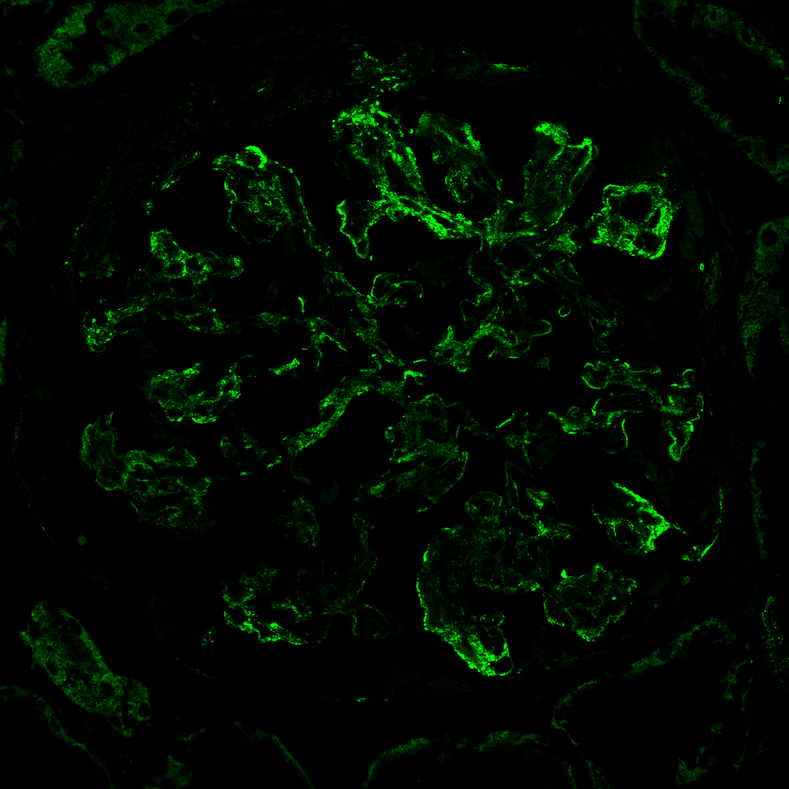
IgG
IgM
LN
Isotypes
Hoechst
Merge
PS-biotin
0 50 100 150 200 250 μm
0
10
20
30
40
Intensity ( x100 a.u.)
PS-biotin
IgG
IgM

Supplementary figure S5. Renal deposition of PS-reactive autoantibodies in patients with LN. Representative confocal images show the colocalization of PS-biotin (detected with Alex fluo 488-streptavidin), IgG and IgM in kidney biopsies of lupus nephritis patients.

Supplementary figure S6. Peritoneal B cells are the major source of PS-specific IgG in lupus mice. Representative ELISPOT detections and data plot show the PS-specific and dsDNA-specific IgG spots in splenic and peritoneal B cells from lupus mice (n = 3). Unpaired two-tailed Student’s t-test, ns, no significance; *, P < 0.05.

Supplementary figure S7. Sorting purity of B cell subsets. Representative flow cytometric images show the frequencies of peritoneal B1a, B1b, and B2 cells before and after cell sorting.

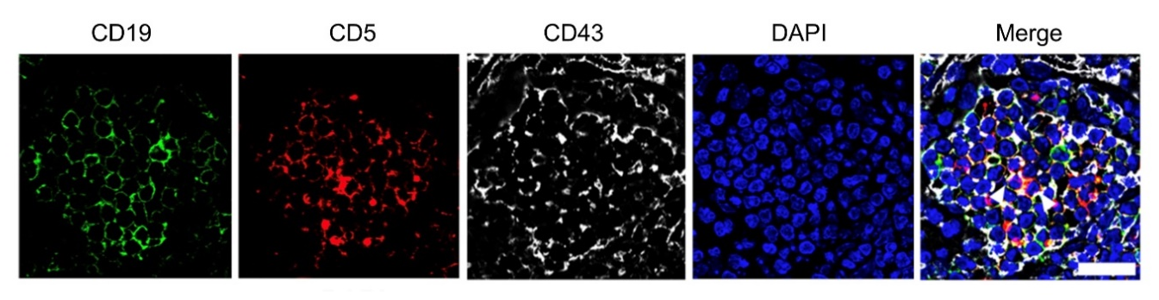

Supplementary figure S8. Renal infiltration of B1 cells in lupus mice. Representative confocal image shows CD43(white), CD5(red), and CD19 (green) triple-positive B1a cells in kidney sections of 24-week-old MRL/Lpr mice.

Supplementary figure S9. Efficacy of B1a depletion in MRL/Lpr mice. Representative flow cytometric profiles and data plot show B1a cells, B1b cells and B2 cells in peritoneal cavity of MRL/Lpr mice with control PBS or hypo-osmotic water treatment for successive 20 weeks (n = 4 per group). Unpaired two-tailed Student’s t-test, ***, P < 0.001.

Supplementary figure S10. B1a cells are the major compartment of PS-specific B subsets in lupus-prone MRL/Lpr mice. (A-C) Representative flow cytometric profiles (A), the data plot (B) and pie chart (C) show PS-specific B subsets within B1a cells, B1b cells and B2 cells in peritoneal cavity of MRL/Lpr mice at 24-week age (n = 3). One-way ANOVA, ***, P < 0.001.

