Supplementary Information

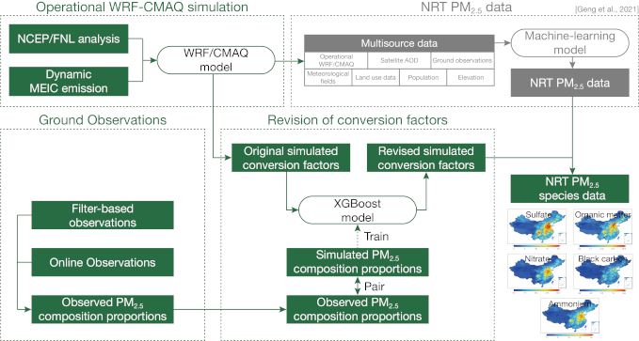
Fig.S1 The technical framework of PM_{2.5} chemical composition concentration

Table.S1 the statistical description of main socio-economic indicators
Variable | N | Mean | SD | Min | Median | Max
NE | 620 | 10396.51 | 12616.93 | 56 | 5368.00 | 65495.00
DI | 620 | 19739.45 | 12275.63 | 4724.11 | 16624.26 | 73848.51
GDP | 620 | 14725.61 | 16551.40 | 117.46 | 9299.13 | 107672.07
EC | 620 | 1306.95 | 1205.47 | 0 | 926.73 | 6695.85
PVO | 620 | 253.51 | 344.12 | 1.68 | 113.81 | 2092.39
SIS | 620 | 44.91 | 8.45 | 16.2 | 46.25 | 61.50
SO2 | 620 | 743667 | 622657 | 708 | 536537 | 3344257
NOx | 620 | 819297 | 584286\ | 31447 | 648825 | 2986546

Table.S2 Trends and significance tests of PM_{2.5} chemical fractions in 31 Chinese provinces from 2000 to 2019
Area | PM_{2.5} | SO₄²⁻ | NO₃⁻ | NH₄⁺ | OM | BC
Beijing | -1.88*** | -0.34*** | -0.04 | -0.05 | -0.80*** | -0.16***
Tianjing | -1.74* | -0.41** | -0.15 | -0.13 | -0.70** | -0.16***
Hebei | -0.70+ | -0.20* | 0.01 | -0.04 | -0.32** | -0.09***
Shanxi | -0.46 | -0.15 | 0.16* | 0.06 | -0.31* | -0.10**
Inner Mongolia | 0.00 | -0.01 | 0.03 | 0.01 | -0.01 | -0.01***
Liaoning | -0.58 | -0.09* | 0.01 | -0.03 | -0.23*** | -0.07*
Jilin | 0.03 | 0.02 | 0.11+ | 0.05 | -0.07+ | -0.02***
Heilongjiang | 0.17 | 0.04 | 0.10* | 0.06* | 0.02 | 0.00
Shanghai | -2.01** | -0.45** | -0.13 | -0.13 | -0.64*** | -0.16***
Jiangsu | -1.10* | -0.20* | -0.02 | -0.10 | -0.37*** | -0.10***
Zhejiang | -0.86*** | -0.19*** | -0.04 | -0.09* | -0.26*** | -0.08***
Anhui | -0.63 | -0.12 | 0.08 | 0.00 | -0.21+ | -0.08***
Fujian | -0.79** | -0.19** | -0.03 | -0.07+ | -0.27** | -0.08**
Jiangxi | -0.46+ | -0.12* | 0.10+ | 0.00 | -0.19* | -0.08***
Shandong | -1.01 | -0.27* | -0.07 | -0.12 | -0.42* | -0.12***
Henan | -1.05 | -0.27+ | 0.02 | -0.08 | -0.32* | -0.10***
Hubei | -0.22 | -0.11 | 0.19 | 0.03 | -0.11+ | -0.08**
Hunan | -0.39 | -0.12+ | 0.21* | 0.03 | -0.14+ | -0.08**
Guangdong | -1.07*** | -0.19** | -0.01 | -0.06 | -0.25** | -0.08**
Guangxi | -0.46* | -0.16** | 0.06 | -0.01 | -0.19** | -0.08***
Hainan | -0.34** | -0.06+ | -0.03 | -0.02 | -0.12** | -0.03*
Chongqing | -0.38 | -0.13 | 0.18+ | 0.06 | -0.21 | -0.10*
Sichuan | -0.14 | -0.07* | 0.12** | 0.05 | -0.10* | -0.05***
Guizhou | -0.17 | -0.10 | 0.13* | 0.04+ | -0.15+ | -0.06**
Yunnan | -0.12 | -0.01 | 0.04* | 0.04 | -0.03 | -0.01
Tibet | -0.02 | -0.00 | 0.02 | 0.01 | 0.01 | 0.00
Shaanxi | -0.09 | -0.07 | 0.14*** | 0.04 | -0.06 | -0.06***
Gansu | 0.014 | -0.01 | 0.08** | 0.05* | -0.01 | -0.01
Qinghai | -0.01 | 0.04 | 0.04* | 0.03+ | 0.05+ | 0.01
Ningxia | -0.13 | -0.06+ | 0.07* | 0.03 | -0.09* | -0.04***
Xinjiang | -0.03 | 0.01 | 0.04* | 0.02 | 0.00 | -0.01+
+, *, ** and *** indicate the significance level at 0.1, 0.05, 0.01 and 0.001, respectively.

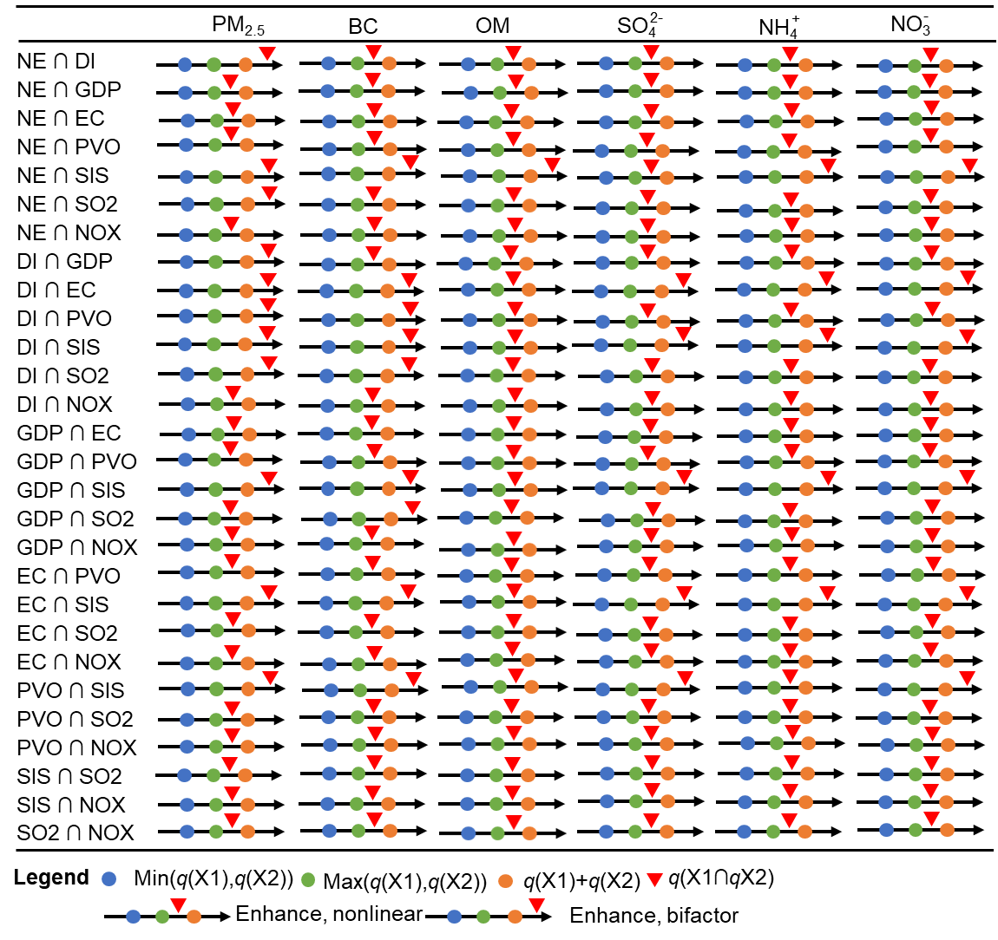
Fig.S2 The type of interaction detection between impact factors

MGWR model validation and quality control
Before conducting the regression analysis, we tested the multicollinearity between PM_{2.5} components and different socioeconomic factors in SPSS 22.0 software, and the analysis results showed that the variance inflation factor (VIF) between PM_{2.5} components and different socioeconomic factors were all less than 10, which means that there is no significant multicollinearity between PM_{2.5} components and different socioeconomic factors, and can proceed to the next regression analysis. The VIFs between PM_{2.5} components and different socioeconomic factors are shown in Table.S3.
Table.S3 The VIFs between PM_{2.5} components and different socioeconomic factors
Socio-economic factors | t | Sig. | VIF
Constant | 1.86 | 0.06
NOx | 32.44 | 0.00 | 8.33
SO2 | 0.84 | 0.40 | 2.36
NE | 4.02 | 0.00 | 6.52
DI | -0.98 | 0.33 | 4.26
SIS | 3.84 | 0.00 | 1.86
GDP | 2.22 | 0.03 | 5.99
PVO | -3.82 | 0.00 | 7.75
SP | 3.85 | 0.00 | 2.23

Then we explored the spatial differences in the effects of socioeconomic factors on PM_{2.5} components using the MGWR model. For the parameters in the MGWR model, we chose the default settings. The Kernel type defaults to FIXED, and the Bandwidth method defaults to the AICc index. Fig.S3 shows the results of this operation. We can find that the goodness of fit (R²) of socio-economic factors with PM_{2.5}, BC, OM, NH+ 4, NO– 3 and SO2– 4 ranges from 0.37 to 0.54, the residual sum of squares (RSS) ranges from 287.51μg/m³ to 391.72μg/m³, and AICc ranges from 1324.43 to 1514.00. The above regression results showed that MGWR could get a regression result closer to the real value with fewer parameters, which can be used to evaluate the relationship between PM_{2.5} components and socio-economic factors.

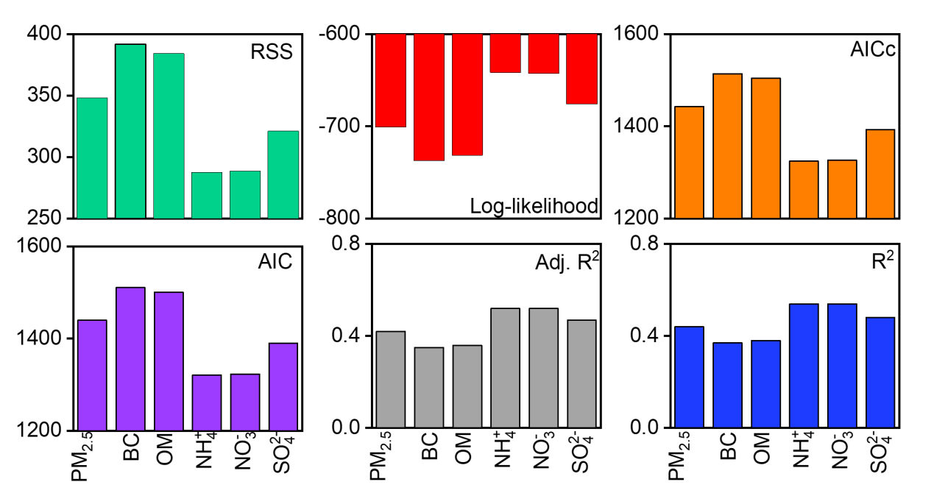
Fig.S3 Diagnostic parameters of MGWR

