Evaluation of vertical distribution characteristics of microplastics under 20 μm in lake and river waters in South Korea
Junho Lee¹, Seonghyeon Ju¹, Chaehwi Lim¹, Kyung Tae Kim¹, Homin Kye¹, Jiyoon Kim¹, Jihoon Lee¹, Hye-Won Yu², Ingyu Lee³, Hyunook Kim³, and Yeojoon Yoon^{1*}
¹Department of Environmental and Energy Engineering, Yonsei University, Wonju, 26493, Republic of Korea
²Department of Water Environmental Safety Management, Division of Environmental, K-water, Daejeon, 34350, Republic of Korea
³Department of Environmental Engineering, University of Seoul, Seoul, 02504, Republic of Korea
*Corresponding Author: Yeojoon Yoon
Telephone: +82 -10-8993-0744
E-mail: yajoony@yonsei.ac.kr

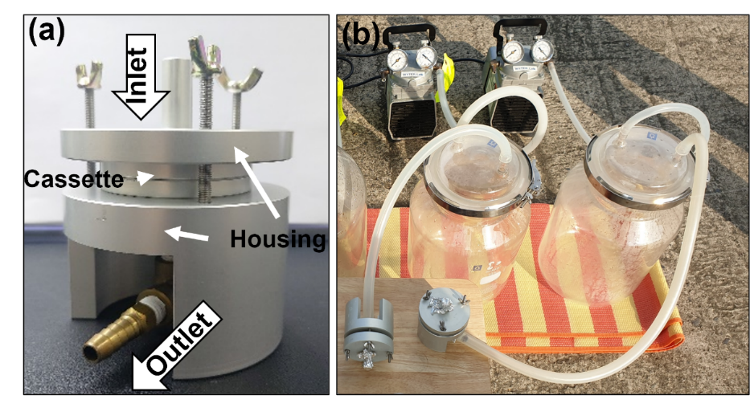
Fig. S1 Image of manufactured sampling device(a) and applied in field sampling(b)

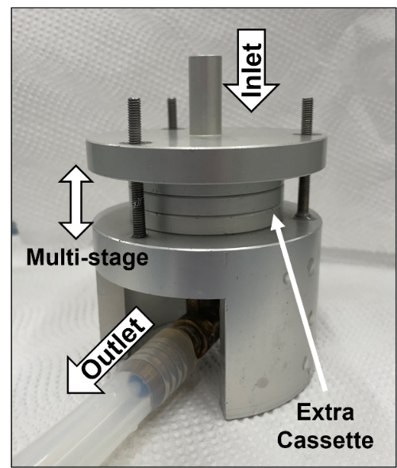
Fig. S2 Image of multi-staged size classification device using manufactured sampling and extra cassettes and STS filters

Table S1 Results of microplastic concentrations in field blank samples were analyzed μ-Raman spectroscopy
Species of microplastics | Concentration (particles/L)
Species of microplastics | P-Lake | N-River
PP | 0.25 | 4.25
PS | 0.00 | 0.50
PET | 0.50 | 0.00
PVC | 0.25 | 0.00
PE | 1.00 | 3.00

Table S2 Temperature, suspended solid (SS), flow rate, and precipitation recorded in sampling site
Site | Total depth (m) | Temperature of water (°C) | SS^{(a)}  (mg/L) | Flow rate ^{(a)} (m³/s) | Precipitation
 |  |  |  |  | Duration^{(b)} (days) | Amount  (mm)
P-Lake | 21.0 | 12.2 | 3.2 | 0.102 | 23 | 28.7
N-River | 9.8 | 13.46 | 6.56 | 62.945 | 25 | 39.7
(a) The result of SS concentration and flow rate was obtained from the Water Environment Information System of the Ministry of Environment in Republic of Korea. (b) The precipitation measurement duration for sampling sites is from November 1 to the sampling date (P-Lake = 23 November, N-River = 25 November).

