Supplementary materials for:
Diffuse deformation explains the magnitude-dependent coseismic shallow slip deficit
Solène L. Antoine^{(1*)}, Yann Klinger⁽¹⁾, Kang Wang⁽²⁾, Roland Bürgmann⁽²⁾
(1) Université de Paris, Institut de physique du globe de Paris, CNRS, Paris, France ; *now at Jet Propulsion Laboratory, California Institute of Technology, Pasadena, CA, USA. (2) Department of Earth and Planetary Sciences, University of California Berkeley, California, USA.

The following supplements first describe elements of methods on the joint inversion (choice of the data, model geometry, data weighting, regularization strategy, Figs. S1 to S4). Then results of the inversion, and residuals with the data are described and discussed (Figs. S5 to S10). Finally, Tables S1 to S4 and Fig. S11 present the data used for the discussion part of the manuscript.

Choice of the data
To constrain fault slip from 0 to 20 km depth, one needs both data close to the faults (<1 km), and data far from the faults (>10 km). In this study, we use GNSS and InSAR data that provide information at a regional scale, and optical image-offset data that provide information near the faults. Seismic data are also available for the Ridgecrest sequence, but their spatial resolution is lower, and hence it is not of interest for this study that aims at improving the characterization of the spatial distribution of shallow fault slip.

GNSS data come from the UNAVCO Network of the Americas (NOTA) continuous stations (96 stations with an average spacing of ~30 km; stations CCCC, P594, P595, and P580 are located within 20 km around the ruptures and used to compare with the model predictions). The GNSS ground displacements due to both the M_{w}6.4 and M_{w}7.1 ruptures were computed by the Scripps Orbit and Permanent Array Center (SOPAC). Sentinel-1 InSAR line-of-sight (LOS) data come from Wang and Bürgmann (2020), and are downsampled using an iterative quadtree-based scheme (Wang and Fialko, 2015). Optical imagery data include fault offsets extracted from high-resolution (0.5 m) displacement maps, derived from cross-correlating of pre- and post-earthquake optical images (Antoine et al., 2021). Offsets were extracted using 500 m-long and 400 m-wide displacement profiles, placed perpendicular to the faults every 500 m. A similar method as in Antoine et al. (2021) is used to retrieve the amplitude of the offsets, that is measuring the difference, at the fault location, between the linear regressions of the displacement gradients on either side of the faults. The regressions are taken as close as possible from the faults to exclude any inelastic off-fault deformation from the measurement. Faults 10 and 11 represent neighboring (<200 m) sub-parallel branches of fault 5 which are, in the model, considered as part of fault 5, and hence, offsets on those faults are summed.

The choice was made not to directly invert the optical displacement maps, which cover ±5 km around the faults, for two reasons. First, despite the fact that the optical displacement maps are corrected for low-frequency noise as well as charge-coupled device (CCD) artifacts, they remain noisier than the InSAR and GNSS data and would bias the inversion for slip at greater depths. Second, because we aim at comparing the surface measurements of diffuse deformation (derived from the optical displacement maps; Antoine et al., 2021), with the results of the slip inversion, the two datasets should remain independent. Moreover, in the case that the diffuse deformation is inelastic, it cannot be well-represented by the elastic model. Hence, only the surficial fault offsets extracted from the maps of Antoine et al. (2021) are inverted, such that the diffuse deformation observed around the faults is not included in the inversion.

Finally, all the datasets considered, GNSS, optical, and InSAR, include displacements from both the M_{w}6.4 foreshock and the M_{w}7.1 mainshock earthquake; hence, fault displacements for the two earthquakes are inverted simultaneously. GNSS displacement data were obtained by differencing the daily positions of July 6th and July 4th. C-band Sentinel-1 SAR data used to form the coseismic inferograms were acquired in the two days before the rupture (3 July ∼18:51 PDT for the ascending track A064, 4 July ∼06:52 PDT for descending track D071), several days after the rupture (9 July ∼18:51 PDT for the ascending track T064, 16 July ∼06:52 PDT for the descending track T071) (Wang and Bürgmann, 2020). Optical images used to retrieve near-fault ground displacement were acquired from 2012 to 2018 for the pre-earthquake period, and from 26 August to 8 September 2021 for the post-earthquake period. Detailed information on the images is provided in the Supplementary of Antoine et al. (2021). Interseismic deformation across the Ridgecrest faults is below the detection threshold of our image correlation method (5-10 cm); however, post-seismic deformation of up to a few cm in the satellites’ line-of-sights (Brooks et al., 2020; Wang and Bürgmann, 2020) might have been included in the InSAR displacement data.

Choice of the model geometry
The geometry of the fault system that ruptured during the 2019 Ridgecrest sequence is constrained by field mapping of the ruptures (DuRoss et al., 2020; Ponti et al., 2020), optical displacement maps (Antoine et al., 2021), and seismic data (Jin and Fialko, 2020; Plesch et al., 2020). The model used in this study matches the traces of the five major rupture strands visible in optical displacement maps (Fig. S1). These faults are considered as major faults since they accommodate the largest amounts of displacement, and represent the most continuous displacement features at the ground surface.

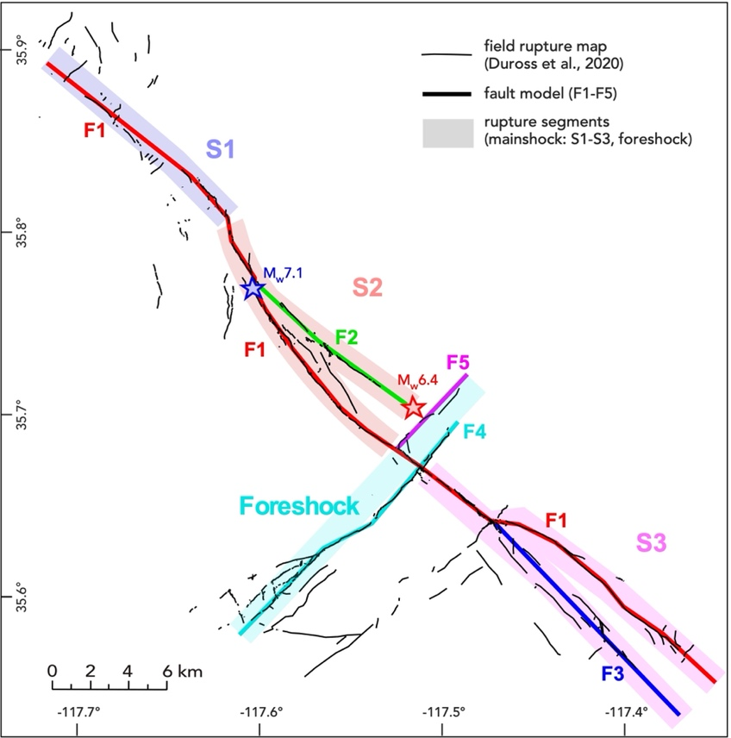
Figure S1: Fault model geometry overlapped with the field-based fault map from DuRoss et al. (2020). Colors and numbering (F1-5) refer to the 5 faults used in the model. Thick transparent swaths highlight the 3 rupture segments of the mainshock rupture (S1 in dark blue, S2 in red, S3 in pink) and the unique segment that represents the foreshock rupture (turquoise). Similar colors are used to plot the average slip versus depth profiles in Figure 4.

The final model is constituted of 23 linear sections, and is discretized using a rectangular mesh with patch sizes ranging from ~0.5x0.5 km at the surface to ~2.5x2.5 km at 20 km depth. The size of the patches is chosen such that the model can reproduce the spatial variability of displacements of the order of what is given in input of the model by the resampled optical and InSAR data (~0.2-0.5 km). The maximum depth of the model is 20 km, which is about 5 km greater than the maximum depth of the seismic events detected during the 2019 Ridgecrest sequence (Huang, 2020; Ross et al., 2019; Shelly, 2020). Even though studies using relocated earthquake catalogues report variations in shallow fault dip angles from 70 to 90 degrees, at depth, faults are sub-vertical with a dip close to 85-90° (Jin and Fialko, 2022; Plesch et al., 2020; Ross et al., 2019).

Inversion strategy, and weighting of the data
Green’s functions, that relate slip on a single fault patch at depth to displacement at a point of the ground surface, are calculated for each dataset using 3D Okada solution in a homogeneous elastic half-space (Okada, 1985). For GNSS and InSAR measurements, the Green’s functions are constructed by simply calculating the 3D displacements at each measurement point due to a unit slip for each patch. For the fault offset measurement, however, it involves the difference of displacements at two close points on different sides of the fault. Because the surface trace of the discretized fault model may not exactly follow the real fault traces where the fault offset measurements are derived, the calculation of Green’s function for the fault offset data must carefully account for the discrepancy in the location between the measurement and model. In our calculation, for each fault offset measurement, we find the closest fault patch at the surface, and calculate the surface displacements at locations 2 meters away from the top center of the patch on either side of the patch. The two displacements are then differenced and projected onto the strike of the corresponding patch to form the components of the Green’s functions of offset data. This allows to jointly invert for the fault offset data with the InSAR and GNSS data, and hence consider data density and noise in the weight matrixes.

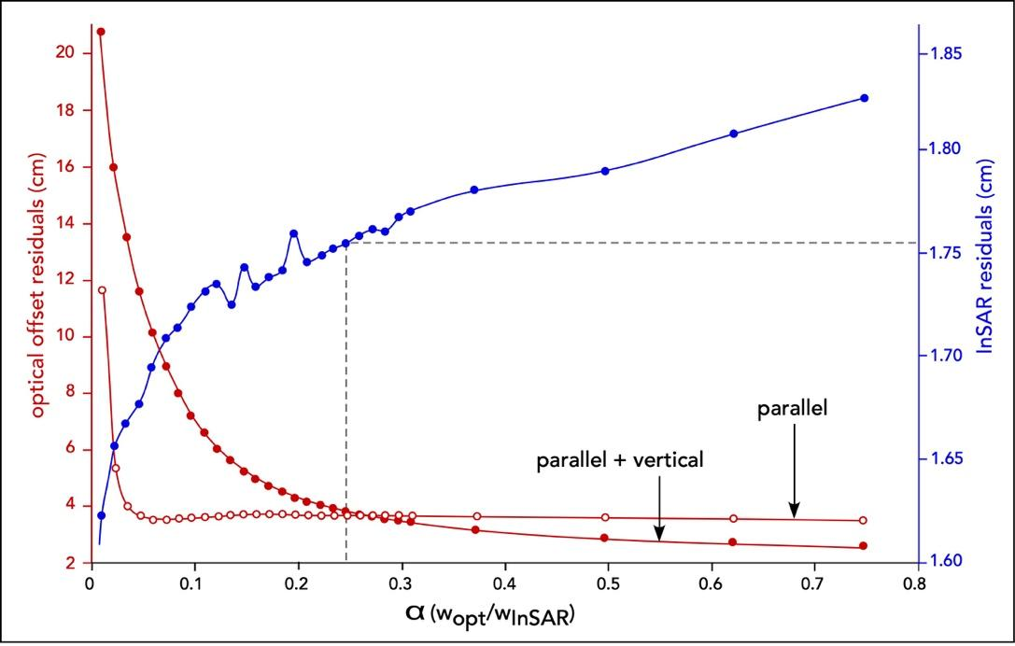
Figure S2: Residuals of optical offset (red) and InSAR data (blue) as a function of their relative weighting (α). Red open circles represent the residuals of the offset data in the fault-parallel component. Red filled circles represent the residuals of the offset data averaged over the fault-parallel and vertical components. InSAR residuals are averaged over the ascending and descending directions. Vertical dashed black line indicates the value of α that allows for the best fit of the offset data (fault-parallel and vertical, <4 cm), and a good fit of the InSAR data (~1.76 cm).

The optimal weight for data of different type is determined using trade-off curves between model residuals, and relative weight of the different data sets. InSAR residuals are averaged over the ascending and descending tracks. Figure S2 presents the average residuals (in absolute value) against the relative weighting of the InSAR and optical data. The figure shows that an increase in the weight of fault offsets allows for a much better fit both in the fault-parallel and vertical components, whereas it only slightly increases the misfit with InSAR data (1.60 to 1.76 cm). Best fit between the model and the fault offsets (parallel + vertical) is found for a relative weight of 0.26, which corresponds to a weight of 8 for the InSAR data, and a weight of 2.1 for the optical imagery-based fault offset data. The weight of the GNSS data does not significantly impact the slip model nor the fit to the data, and is thus fixed to be equal to the weight of the InSAR data.

Choice of the smoothing parameter
Because of the heterogeneous distribution and noise of the data, regularization (e.g., smoothing and positivity constraints) must be applied to reduce model instabilities. However, the degree of smoothing significantly impacts the slip distribution (Causse et al., 2010; Ortega-Culaciati et al., 2021); hence, one must find the optimal regularization parameter that allows a good trade-off between a heterogenous slip model that fits the surface displacement data, and a smooth slip model that generally has larger misfit to the data. Here we apply regularization through a slip positivity constraint (the fault cannot slip backward in the context of the regional stress field, i.e., only right-lateral slip is allowed on faults trending NW-SE and only left-lateral slip is allowed on faults trending NE-SW) and a second-order Laplacian spatial smoothing kernel. To assess the best smoothing parameter ($λ$), we use an L-curve that displays the evolution of the average InSAR residuals with increasing roughness (1/ $λ$; Fig. S3). We also test the impact of the regularization on the average amplitudes of slip obtained in the model (Fig. S4).

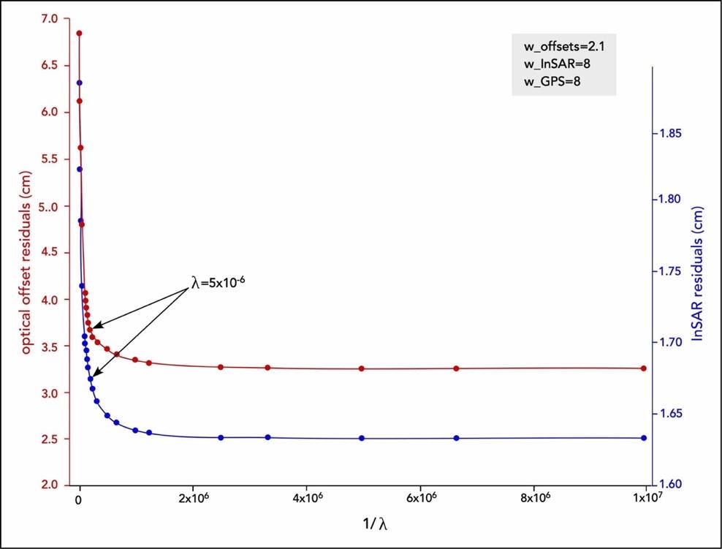
Figure S3: Trade-off curve of the residuals of fault offset and InSAR data with the model predictions versus the roughness of the model (1/ λ). For the fault offset and InSAR data, residuals are averaged over the fault-parallel and vertical, and ascending and descending components, respectively. Grey inset indicates the weights of the different data set used to perform the regularization analysis. These are the weights used in the final version of the model (Figs. S5 and S6). The arrows show the preferred smoothing parameter values based on consideration of average slip amplitude differences (Fig. S4).

The L-curve (Fig. S3) shows that better fits to the InSAR data and optical data are obtained for values of $λ$ in the inversion ranging between 5.10⁻⁶ and 1.10⁻⁵. However, direct comparison of the amplitudes of slip obtained in the model and in the optical data shows that using a stronger smoothing ( $λ$ > 5.10⁻⁶) leads to a systematic under-estimation of the surface displacements (Fig. S4). This arises from the fact that increasing the smoothing tends to distribute slip across the whole fault plane, and hence, reduces the amplitude of the slip on the shallow patches of the model. As a consequence, we chose to use a $λ$ value of 5.10⁻⁶ (roughness of 2.10⁵).

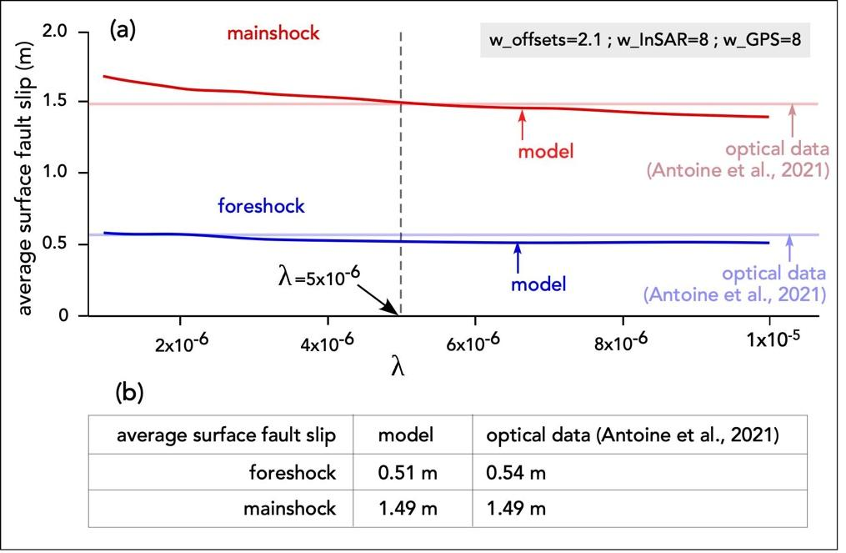
Figure S4: (a) Average surface displacement along the fault model for the foreshock (blue) and mainshock (red) events plotted against the smoothing value of λ in the inversion. Light blue and light red horizontal lines indicate the average values of fault displacement measured along the foreshock and mainshock ruptures, as derived from the optical displacement maps by Antoine et al. (2021). (B) Table with the average surface displacements measured along the faults of the preferred model (λ=5x10⁻⁶), and in the optical data of Antoine et al. (2021).

Preferred model
The preferred model after determining the best fault geometry, data weighting, and model regularization, is presented in Figure S5 in 3D view, and in Figure S6 in longitudinal view. The slip distribution is heterogeneous along the fault plane with discontinuous patches of large (> 4 m) slip. Heterogeneity of slip in the shallow crust is enabled by the high-resolution (~0.5 km) mesh. Maximum slip of ~10 m occurs in the region of the mainshock epicenter (blue star), and occurs along F1 and F2. Interestingly, slip along F2 occurs only at depths larger than 2.5 km (Figs. S5a and 6a), whereas slip on the sub-parallel portion of F1 occurs only from 0 to 4 km depth (Figs. S5b and 6a). This feature is consistent with several previous studies suggesting that the two faults may join at depth, with a dip angle of 55° for F1 at the shallow depth, and of >80 for F2 (Jin and Fialko, 2020; Plesch et al., 2020; Wang et al., 2020). Maximum slip along the foreshock fault system is about 5 m and occurs on F4, a few kilometers SW of the junction between the foreshock and mainshock ruptures.

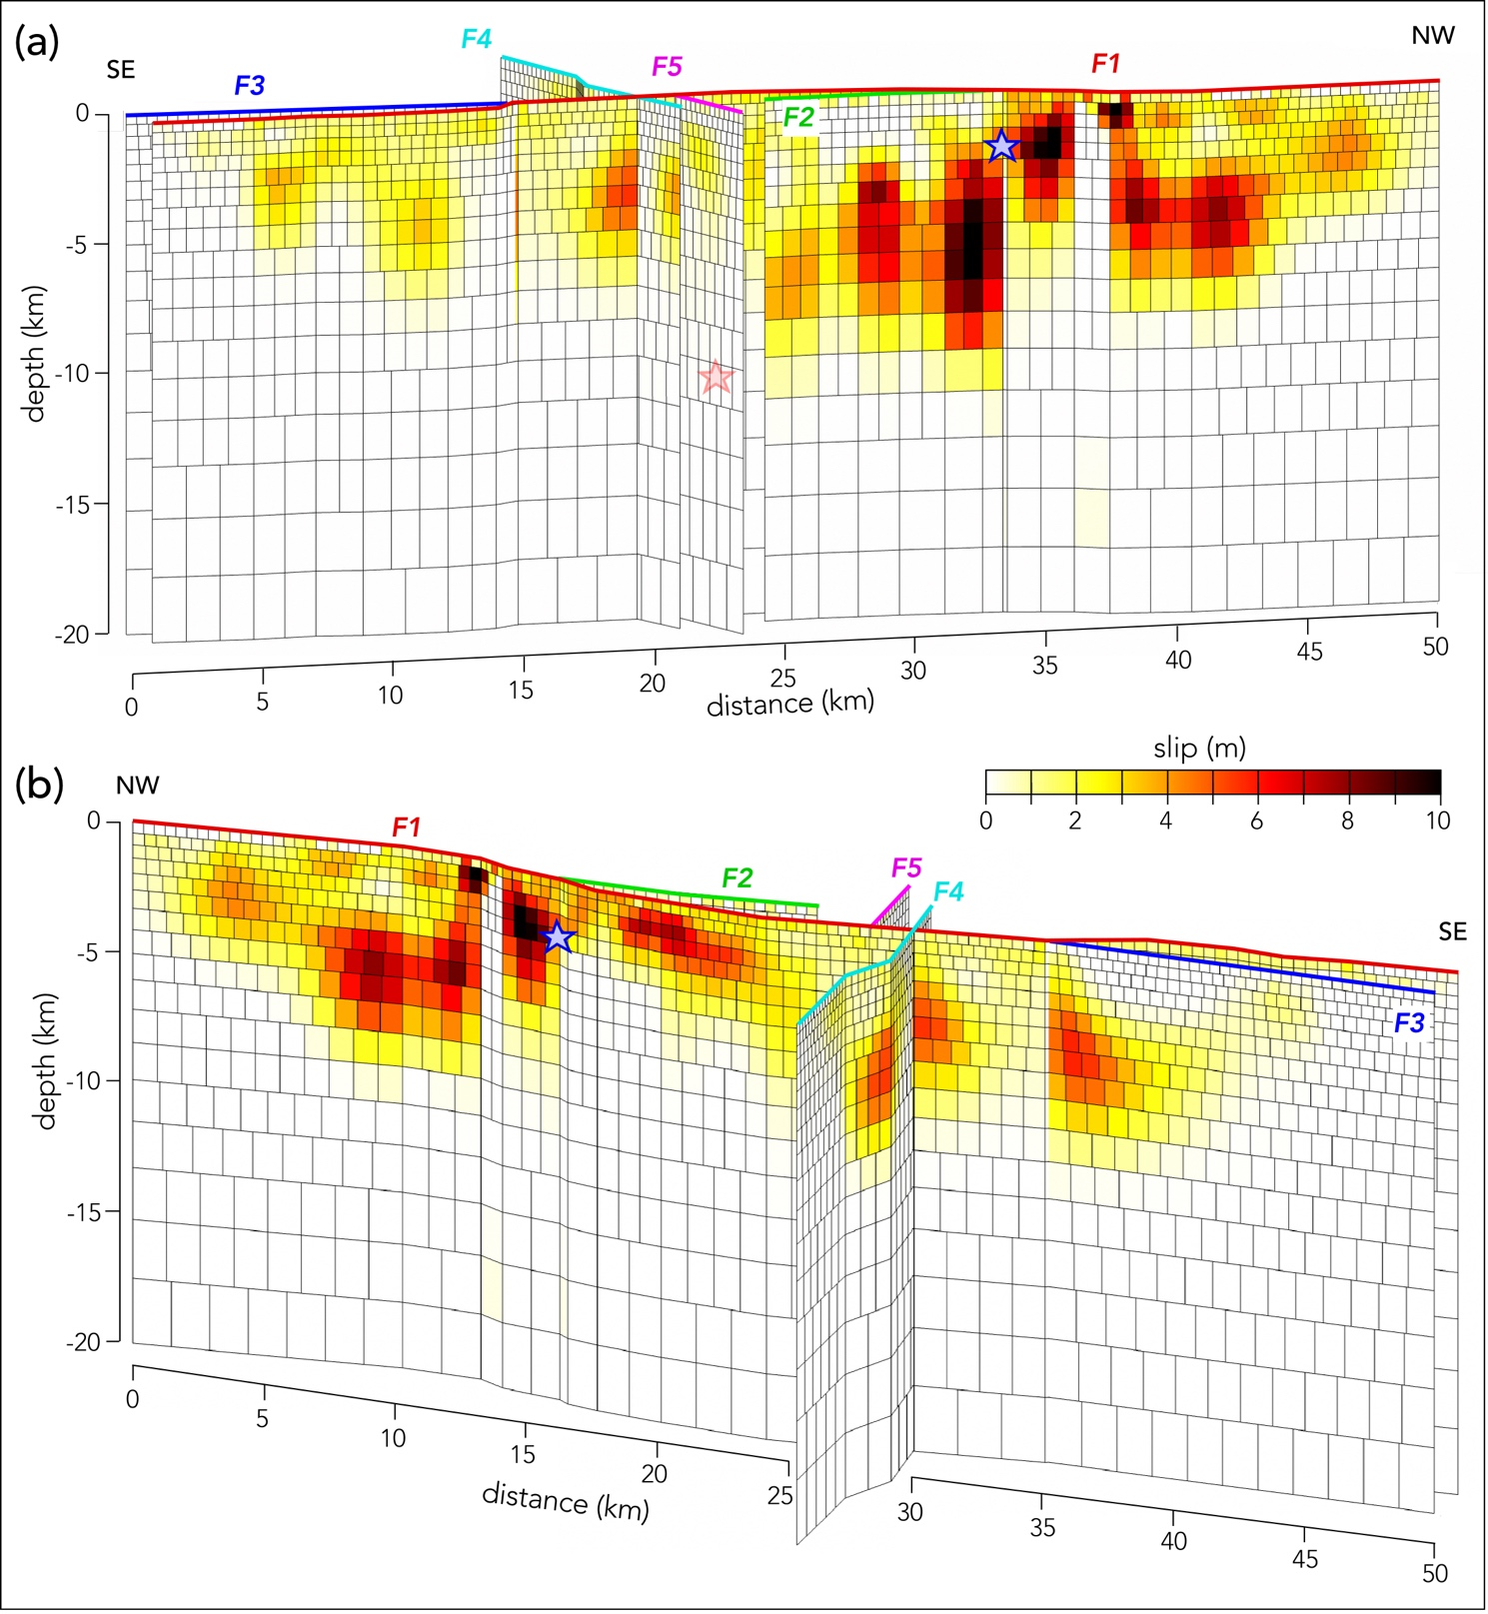
Figure S5: Coseismic slip model of the 2019 Ridgecrest earthquake sequence from the kinematic joint inversion of InSAR, GNSS and optical imagery-based fault offset data. Slip (in m) is in the fault-parallel component. Model segments are highlighted using the colors and numbering from Fig. S1. The mainshock epicenter from Huang (2020) is indicated by a blue star. The foreshock epicenter from Huang (2020) is reported by a red star in (a) because it is located behind F4 and F5, at the junction with F2 (see Fig. S1 for epicenter map locations). The slip model is presented in a north-east view in (a), and a south-west view in (b).

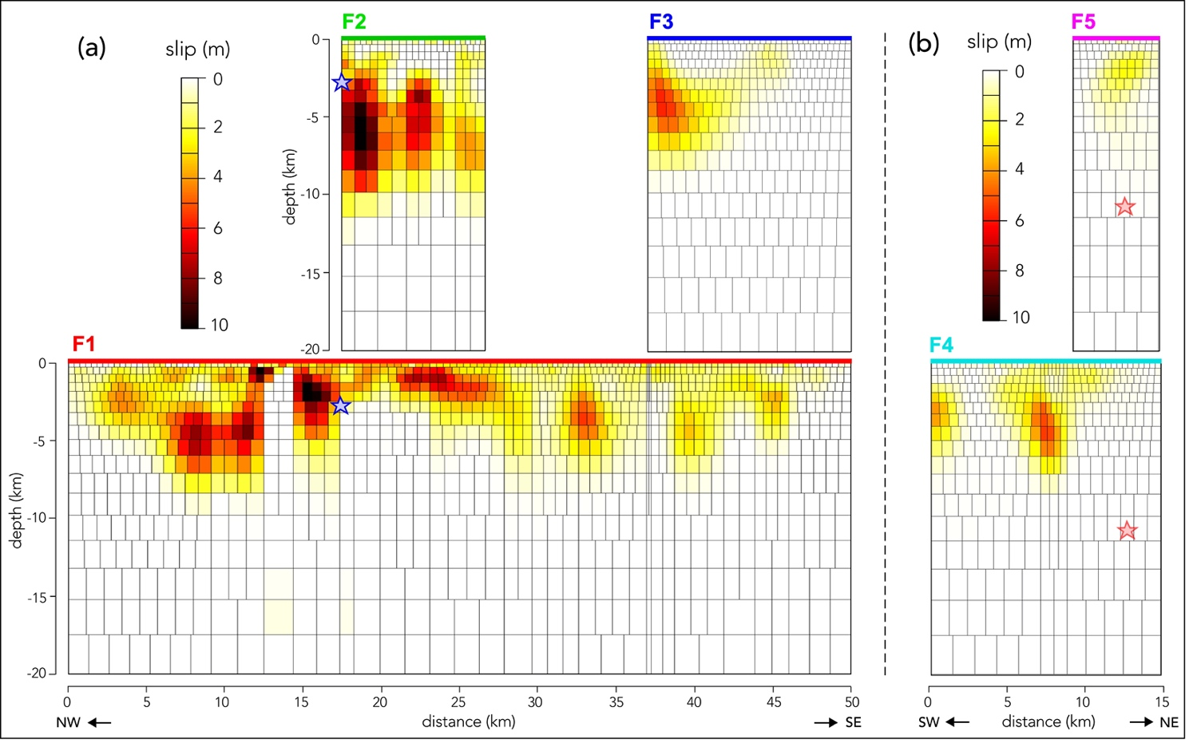
Figure S6: Coseismic slip model of the mainshock (a) and foreshock (b) of the 2019 Ridgecrest sequence from the kinematic slip joint inversion of InSAR, GNSS and optical data, presented in side view. Slip (in m) is in the fault-parallel component. Model segments are highlighted using the colors and numbering from Fig. S1. Mainshock epicenter from Huang (2020) is indicated in (a) by a blue star. Projection of the foreshock epicenter from Huang (2020) is reported in (b) with a red star (see Fig. S1 for epicenter map locations).

Model fit with the data
The prediction of the surface displacements is calculated using the slip model from Figures S5 and S6. First, the prediction of the GNSS displacements (blue) shows a near perfect fit, both in direction and amplitude, with the data (red).

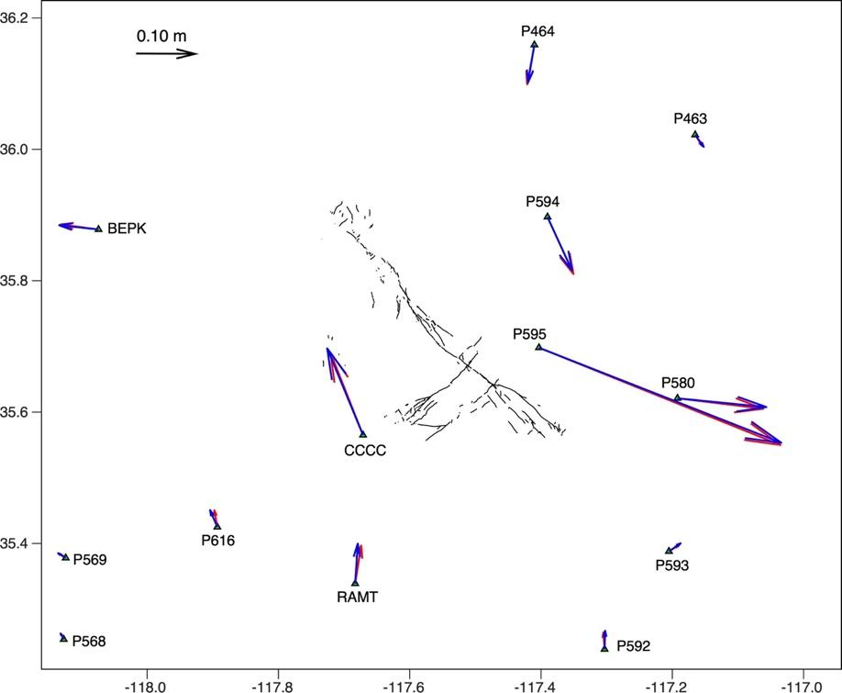
Figure S7: Comparison between GPS observations (red) and predicted surface displacements (blue) based on the inverted slip model from Figures S5 and S6. Only the stations located within 20 km around the surface ruptures (black lines, DuRoss et al., 2020) are shown, but a total of 96 stations were used to constrain the slip model.

Second, predictions of surface displacements in the ascending and descending LOS directions (Fig. S8) show, on average, a very good fit with the data (room-mean-square of misfit is 1.71 cm and 1.79 cm for the ascending and descending components, respectively). For comparison, a model of Wang et al. (2020), that uses a similar inversion strategy (inversion code is similar) but without the fault offset data, refined fault model geometry and mesh, and lowered regularization, obtained residuals of 2.24 cm and 3.32 cm with the ascending and descending InSAR data, respectively. The present model (Figs. S5 and S6) better reproduces both the large-scale and near-fault displacement patterns. However, part of the near-fault displacement field that includes complex elastic (associated with geometrical complexities not included in the model), and inelastic distributed deformations, cannot be explained by the present model.
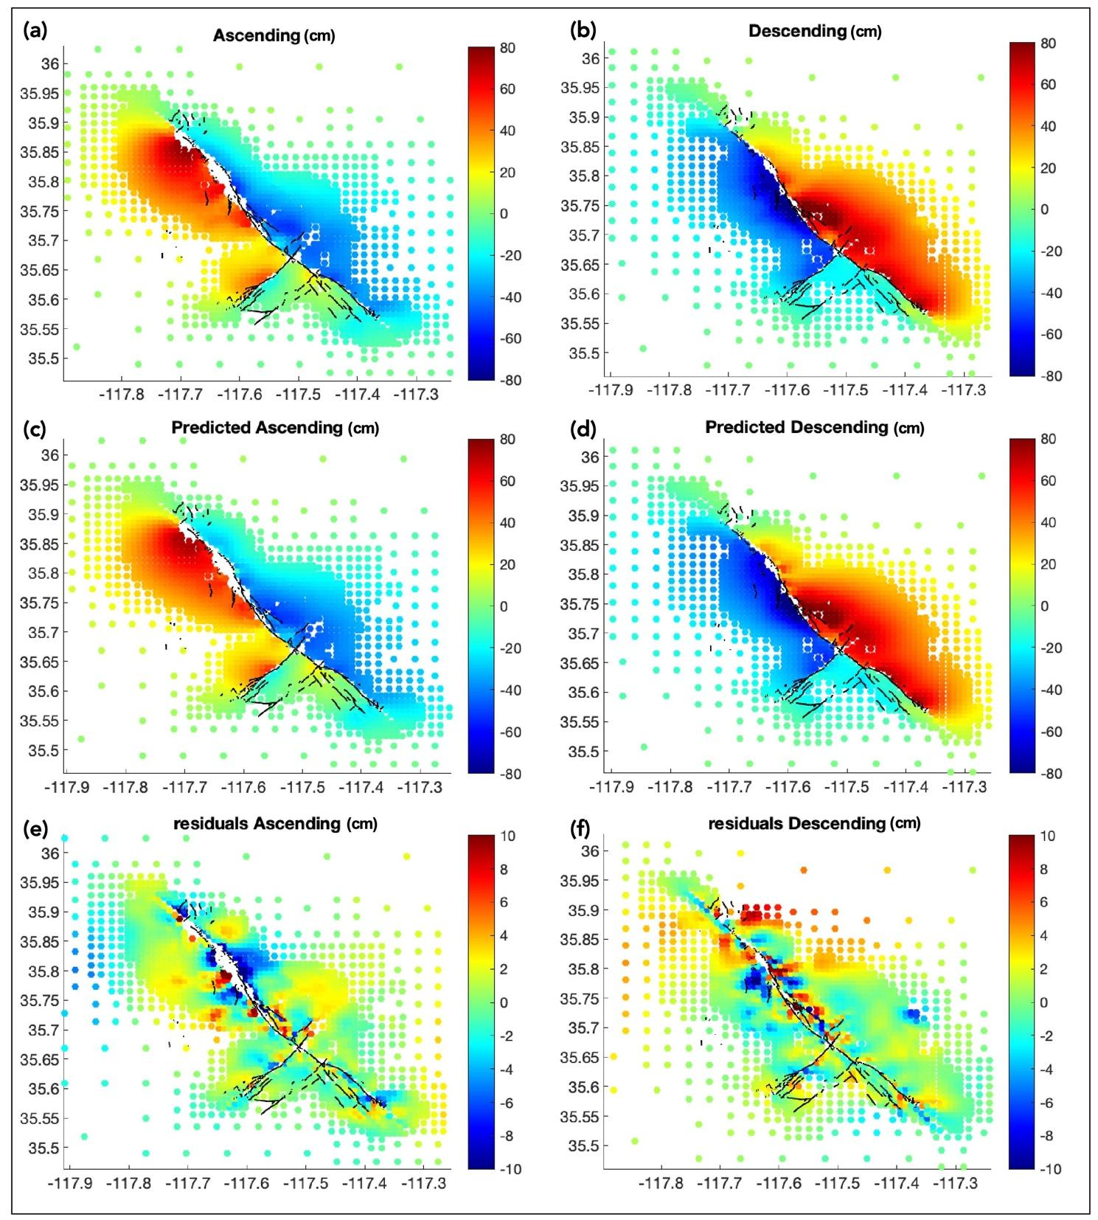
Figure S8: Comparison of the surface displacement field between InSAR observations (a, b) and slip model predictions (c, d) for the ascending and descending components. Residuals between the observations and predictions are presented in (e) and (f), respectively in the ascending and descending directions. The unit of the color bars is centimeter. Note the reduced color ranges for residuals.

We also predict the surface displacement offsets (Fig. S9), and obtain average residuals of 3.65 cm and 3.66 cm in the fault-parallel and vertical components, respectively. As a comparison, prediction of the offset data using the model from Wang et al. (2020) gives a misfit of 69.86 cm in the fault-parallel component, and of 19.30 cm in the vertical component. This is explained by the fact that model from Wang et al. (2020) lacks constraints on slip at the surface, and has a low-resolution mesh (> 2 km), and a higher degree of smoothing, which do not allow for a clear separation between slip occurring at the surface and at shallow depth.

The majority of the residuals between our model (Figs. S5 and S6) and the offset data, in the fault-parallel component, occur in the maximum slip zone (along S2, that is the central section of the mainshock rupture), but have amplitudes lower than ±15 cm. This is relatively small when compared to the amplitude of fault slip that is about 2-5 m in this region. Maximum residual in the vertical component of -20 cm is seen along F1 in the pull-apart basin area, where the maximum subsidence reaches 2.5 m, and vertical offset along F1 is of 1 m. Adding a fault in the pull-apart basin to represent its S-W border (fault 4 in Antoine et al., 2021) does not allow for a better fit with the data. This suggests that the subsidence in this area may not originate from elastic processes. Indeed, significant diffuse deformation occurred in the pull-apart basin (Antoine et al., 2021).

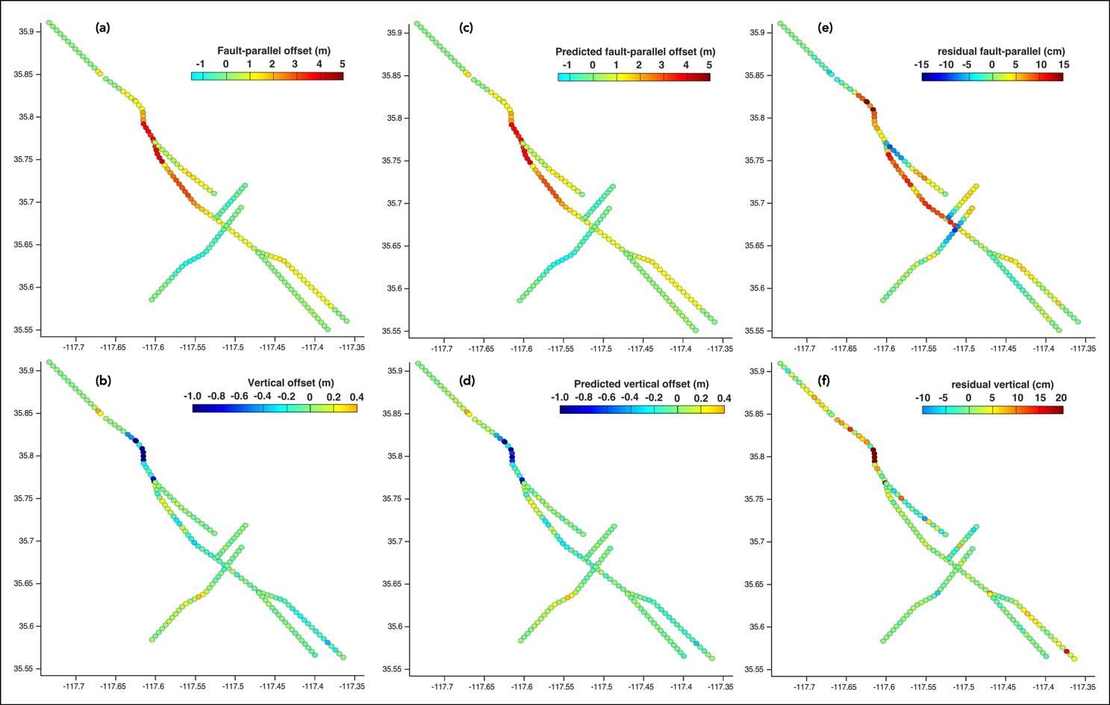
Figure S9: Comparison of the fault-parallel and vertical surface displacement offsets measured in the optical displacement maps (a, b, in m) and the predictions of surface displacement offsets (c, d, in m) using the slip model from Figures S5 and S6. (e, f) Residuals (cm) between the observations (a, b) and the predictions (c, d).

Finally, we predict the surface displacements in the E-W, N-S, and vertical components of the high-resolution optical displacement maps from Antoine et al., 2021 (Fig. S10). Residuals with the optical data from Antoine et al. (2021) are of 17.36 cm, 24.9 cm, and 17.13 cm in the EW, NS, and vertical components, respectively. These residuals are about 10 times larger than for the InSAR and offset data, which justifies our choice not to use the optical displacement maps directly in the inversion process. Similar values of residuals are obtained when using the model from Wang et al. (2020) to predict the E-W, N-S, and vertical high-resolution surface displacements (20.38 cm in the EW, 28.76 cm in the NS, and 16.66 cm in the vertical components). This again confirms that the optical-imagery displacement maps may contain complex elastic and inelastic deformations that are not reproduced in the model, as well as some long wavelengths artifacts. For example, regions of inelastic deformation are visible in the pull-apart basin, in the bookshelf faulting region just N-E of the pull-apart, and at the junction between F1 and F3 (Fig. S10h). In these regions, the amplitude of residual (1-2 m) matches the amplitude of the diffuse deformation measured in Antoine et al. (2021).

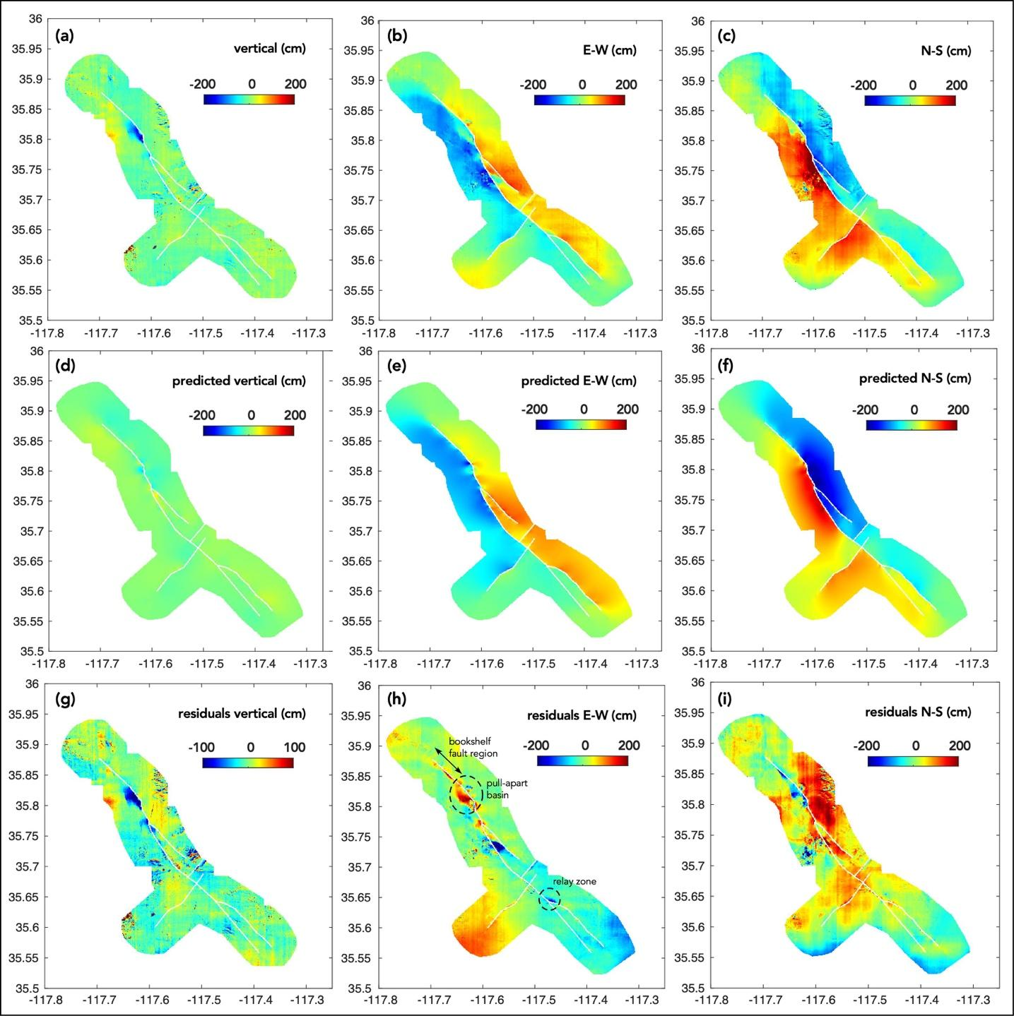
Figure S10: Comparison of the surface displacement field between optical observations (a-c) and slip model predictions (d-f) for the E-W, N-S, and vertical components. Residuals between the observations and predictions are presented in (g-i). Major complexities where diffuse deformation was observed in Antoine et al. (2021) are indicated in (h).

Calculation of the average slip versus depth profiles, and SSD
Average slip $\overline{s}$ is calculated in each depth range i (between 0 and 20 km) using the following equation: ${\overline{s}}_{i}= \frac{\sum_{i}{L_{i}W_{i}s_{i}}}{\sum_{i}{L_{i}W_{i}}}$ with s the slip on the rupture patch, W the width of the patch, and L the length of the patch (Wang et al., 2020). Slip is cumulated on sub-parallel faults (F1 to F3 for the mainshock rupture, F4 and F5 for the foreshock rupture) but, before doing so, one has to take into account their relative length. This ensures that small sections of faults (e.g., F3 along the S3 segment, Fig. S1) do not have the same weight than long ones (e.g., F1 along the S3 segment, Fig. S1) in the averaged slip distribution of the different segments. Relative weighting of the faults is made with following the equation: for a rupture segment j that includes n sub-parallel faults: ${\overline{sz}}_{j}= \frac{\sum_{n}{{\overline{sz}}_{n}L_{n}}}{\sum_{n}{L_{n}}}$, where $\overline{sz}$ is the average slip profile, and L the length of the faults.

 | ${\overline{s}}_{max}$ (m) | Depth of ${\overline{s}}_{max}$ (m) | Average surface slip (m) | SSD (m) | SSD (%)
S1 | 0.88 | 4.03 | 0.48 | 0.40 | 45.45
S2 | 3.40 | 2.42 | 2.63 | 0.77 | 22.64
S3 | 1.23 | 5.47 | 0.48 | 0.75 | 60.97
Mainshock | 2.12 | 3.19 | 1.49 | 0.63 | 29.71
Foreshock | 1.32 | 4.03 | 0.49 | 0.83 | 62.87
Total rupture | 1.86 | 3.19 | 1.15 | 0.71 | 38.17
Table S1: Maximum average subsurface slip (${\overline{s}}_{max}$), depth of maximum average slip, and average surface slip (in m) obtained in the model and estimated from the average slip versus depth profiles from Figure 1. The values are presented for the three segments of the mainshock rupture (S1, S2, and S3), the whole mainshock rupture, the foreshock rupture, and the entire rupture (see Figure S1 for the model and rupture geometries). SSD (m) corresponds to the difference between the maximum average slip (occurring between ~2 and 6 km depth), and the average surface slip. SSD (%) corresponds to the percentage of SSD relatively to the maximum average slip that occurs at depth.

Calculation of the average diffuse deformation
Diffuse deformation was estimated from the optical image data every 100 m along the mainshock and foreshock ruptures by Antoine et al. (2021). At each location, diffuse deformation was measured as the difference between total surface displacement taken over a large-aperture profile (>5 km), and the sum of fault displacements, if any occurring across this region, each taken across small-aperture profiles (<500 m). Details on the method to measure total and fault displacements are given in Antoine et al. (2021). Average diffuse deformation for the mainshock and foreshock ruptures is given in Antoine et al. (2021) but is re-estimated in this study such that the length of the segments over which diffuse deformation is estimated is equal to the length of the rupture segments in the model (S1 to S3 for the mainshock, and the foreshock). We calculated, along the length of each rupture segment, the average amount of diffuse deformation ($\overline{dd}$) and total surface displacement ($\overline{D}$) in meters. The percentage of average diffuse deformation for each segment is then: $\overline{dd} (\%) = \overline{dd} (m) x 100 / \overline{D} (m)$.

Area of the rupture | $\overline{D }$(m) | average surface slip (m) | $\overline{dd}$ (m) | $\overline{dd}$ (%)
S1 | 1,41 | 0,35 | 1,06 | 75,17
S2 | 3,51 | 3,08 | 0,54 | 15,38
S3 | 1,43 | 0,86 | 0,57 | 39,86
Mainshock | 2,15 | 1,49 | 0,71 | 33,02
Foreshock | 0,79 | 0,54 | 0,26 | 32,91
Entire rupture | 1,83 | 1,26 | 0,60 | 32,99
Table S2: Average total displacement ($\overline{D}$, in m), average slip (localized deformation, in m), and average diffuse deformation ($\overline{dd}$, in m and %) obtained for each rupture segment, re-computed from results of Antoine et al. (2021) for the same segment lengths (Figs. S5 and S6, Tab. S1). Percentage of average diffuse deformation is calculated relatively to the total surface displacement.

Relation between surface displacements, SSD, and earthquake magnitude
Figure S11 shows the evolution of maximum surface displacement, measured along fault ruptures, against the rupture magnitude. Data come from the synthesis of surface observation data, and rupture models for 24 earthquakes including the 2019 Ridgecrest sequence. References of the data used are given in the Tables S3. Along with the analysis from the main text, these figures show that the average diffuse deformation and SSD (in %) decrease with increasing earthquake magnitude.

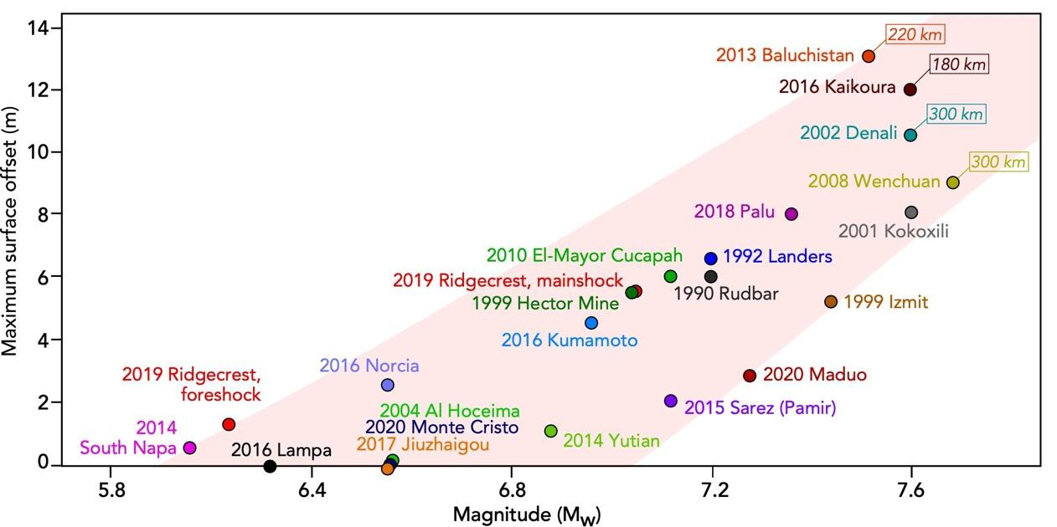
Figure S11: Maximum surface offset plotted against the magnitude for 24 continental earthquakes of various mechanisms (Tab. S3). The figure includes the two 2019 Ridgecrest earthquakes.

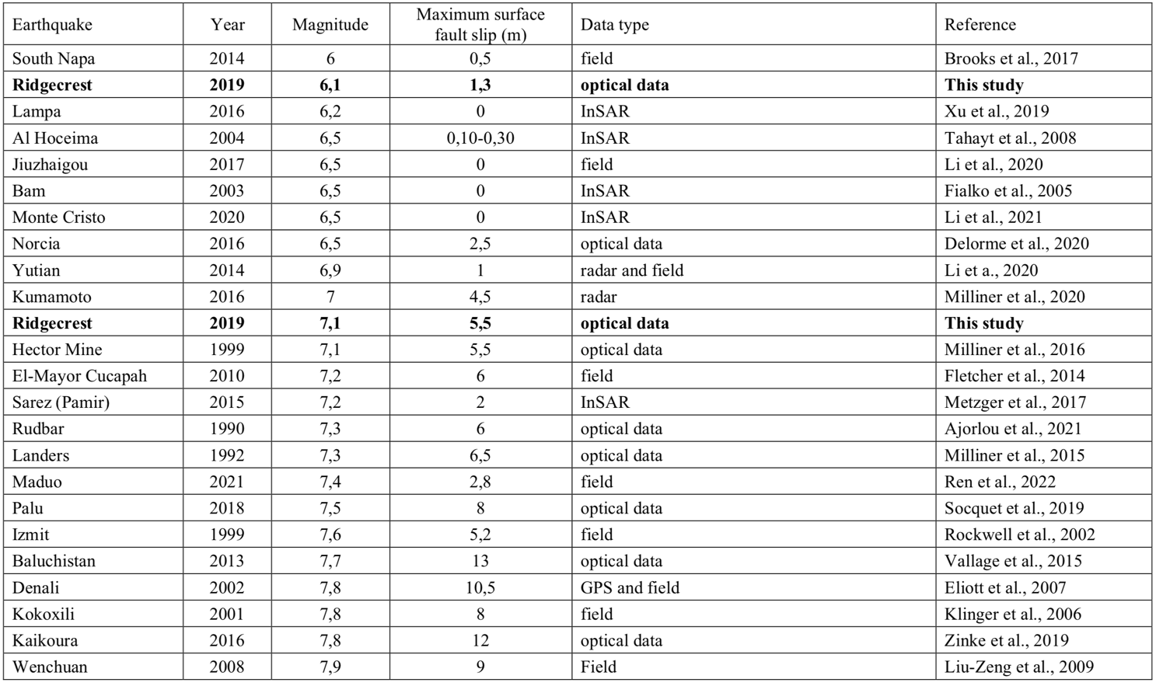
Table S3: Synthesis of measurements of maximum fault displacement for 24 continental earthquakes with, indicated from left to right, the earthquake reference, the year, the magnitude, the value of maximum surface slip, the type of data, and the reference of the study.

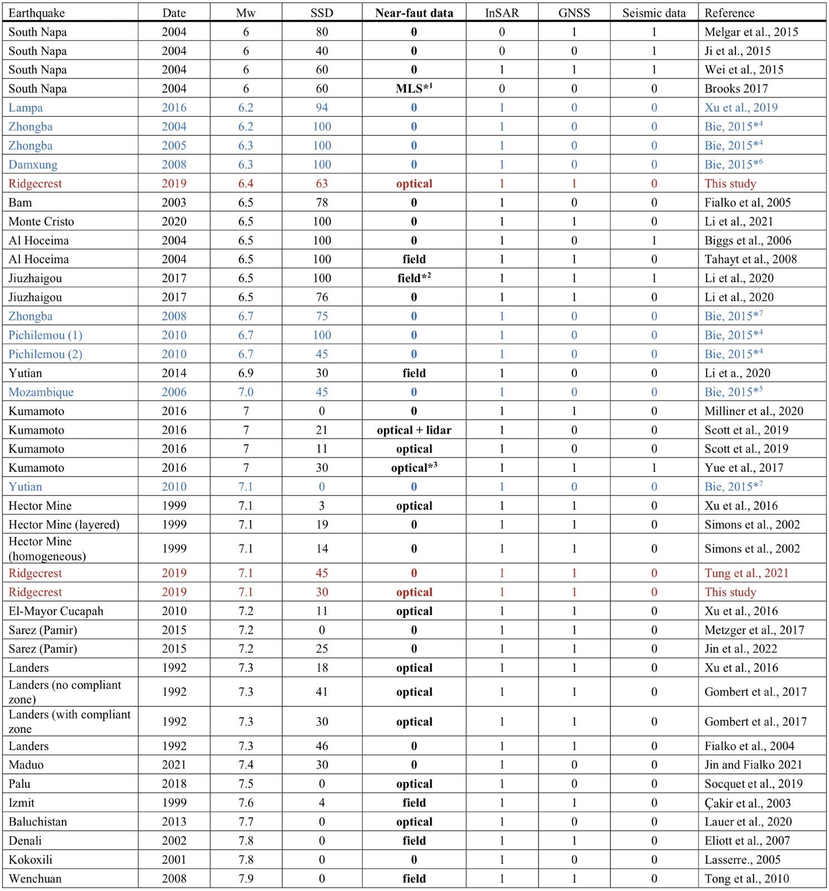
Table S4: Synthesis of estimations of SSD for 29 continental earthquakes with, indicated from left to right, the earthquake reference, the year, the magnitude, the SSD, in percentage, the datasets used in the inversion (near-fault data refer to types of data that allow measuring the surface displacement with a ground resolution of a few meters around the faults), and the reference of the study. InSAR, GNSSS, and seismic data are indicated either with 1 if used, or 0 if un-used in the different studies. The near-fault data, if used, are indicated following their type (optical, field, lidar, MLS*¹). *¹: Mobile Laser Scanning. *²: USGS teams report no surface rupture in the regions (Li et al., 2020). *³: Optical data are at 15 m resolution, which often results in an under-estimation of the slip compared to meter-resolution optical data studies (Antione et al., 2021). Slip models used to derive the slip versus depth profiles in Bie (2015) are *⁴ from Ryder et al. (2012), *⁵ from Copley et al. (2012), *⁶ from Bie et al. (2014), and *⁷ from Bie and Ryder (2014).

References of the supplemental information
Ajorlou, N., Hollingsworth, J., Mousavi, Z., Ghods, A., Masoumi, Z., 2021. Characterizing Near-Field Surface Deformation in the 1990 Rudbar Earthquake (Iran) Using Optical Image Correlation. Geochemistry, Geophysics, Geosystems 22, e2021GC009704. https://doi.org/10.1029/2021GC009704
Antoine, S.L., Klinger, Y., Delorme, A., Wang, K., Bürgmann, R., Gold, R.D., 2021. Diffuse Deformation and Surface Faulting Distribution from Submetric Image Correlation along the 2019 Ridgecrest, California, Ruptures. Bulletin of the Seismological Society of America. https://doi.org/10.1785/0120210036
Bie, L., 2015. Investigating the earthquake cycle of normal faults [WWW Document]. URL http://livrepository.liverpool.ac.uk/2036419 (accessed 4.6.22).
Bie, L., Ryder, I., 2014. Recent seismic and aseismic activity in the Ashikule stepover zone, NW Tibet. Geophysical Journal International 198, 1632–1643. https://doi.org/10.1093/gji/ggu230
Bie, L., Ryder, I., Nippress, S.E.J., Bürgmann, R., 2014. Coseismic and post-seismic activity associated with the 2008 Mw 6.3 Damxung earthquake, Tibet, constrained by InSAR. Geophysical Journal International 196, 788–803. https://doi.org/10.1093/gji/ggt444
Biggs, J., Bergman, E., Emmerson, B., Funning, G.J., Jackson, J., Parsons, B., Wright, T.J., 2006. Fault identification for buried strike-slip earthquakes using InSAR: The 1994 and 2004 Al Hoceima, Morocco earthquakes. Geophysical Journal International 166, 1347–1362. https://doi.org/10.1111/j.1365-246X.2006.03071.x
Brooks, B.A., Minson, S.E., Glennie, C.L., Nevitt, J.M., Dawson, T., Rubin, R., Ericksen, T.L., Lockner, D., Hudnut, K., Langenheim, V., Lutz, A., Mareschal, M., Murray, J., Schwartz, D., Zaccone, D., 2017. Buried shallow fault slip from the South Napa earthquake revealed by near-field geodesy. Science Advances 3, e1700525. https://doi.org/10.1126/sciadv.1700525
Brooks, B.A., Murray, J., Svarc, J., Phillips, E., Turner, R., Murray, M., Ericksen, T., Wang, K., Minson, S., Burgmann, R., Pollitz, F., Hudnut, K., Nevitt, J., Roeloffs, E., Hernandez, J., Olson, B., 2020. Rapid Geodetic Observations of Spatiotemporally Varying Postseismic Deformation Following the Ridgecrest Earthquake Sequence: The U.S. Geological Survey Response. Seismological Research Letters 91, 2108–2123. https://doi.org/10.1785/0220200007
Çakir, Z., Chabalier, J.-B. de, Armijo, R., Meyer, B., Barka, A., Peltzer, G., 2003. Coseismic and early post-seismic slip associated with the 1999 Izmit earthquake (Turkey), from SAR interferometry and tectonic field observations. Geophysical Journal International 155, 93–110. https://doi.org/10.1046/j.1365-246X.2003.02001.x
Causse, M., Cotton, F., Mai, P.M., 2010. Constraining the roughness degree of slip heterogeneity. Journal of Geophysical Research: Solid Earth 115. https://doi.org/10.1029/2009JB006747
Copley, A., Hollingsworth, J., Bergman, E., 2012. Constraints on fault and lithosphere rheology from the coseismic slip and postseismic afterslip of the 2006 Mw7.0 Mozambique earthquake. Journal of Geophysical Research 117. https://doi.org/10.1029/2011JB008580
Delorme, A., Grandin, R., Klinger, Y., Pierrot‐Deseilligny, M., Feuillet, N., Jacques, E., Rupnik, E., Morishita, Y., 2020. Complex Deformation at Shallow Depth During the 30 October 2016 Mw6.5 Norcia Earthquake: Interference Between Tectonic and Gravity Processes? Tectonics 39, e2019TC005596. https://doi.org/10.1029/2019TC005596
DuRoss, C.B., Gold, R.D., Dawson, T.E., Scharer, K.M., Kendrick, K.J., Akciz, S.O., Angster, S.J., Bachhuber, J., Bacon, S., Bennett, S.E.K., Blair, L., Brooks, B.A., Bullard, T., Burgess, W.P., Chupik, C., DeFrisco, M., Delano, J., Dolan, J.F., Frost, E., Graehl, N., Haddon, E.K., Hatem, A.E., Hernandez, J.L., Hitchcock, C., Hudnut, K., Jobe, J.T., Koehler, R., Kozaci, O., Ladinsky, T., Madugo, C., McPhillips, D.S., Milliner, C., Morelan, A., Olson, B., Patton, J., Philibosian, B., Pickering, A.J., Pierce, I., Ponti, D.J., Seitz, G., Spangler, E., Swanson, B., Thomas, K., Treiman, J., Valencia, F., Williams, A., Zinke, R., 2020. Surface Displacement Distributions for the July 2019 Ridgecrest, California, Earthquake Ruptures. Bulletin of the Seismological Society of America 110, 1400–1418. https://doi.org/10.1785/0120200058
Elliott, J.L., Freymueller, J.T., Rabus, B., 2007. Coseismic deformation of the 2002 Denali fault earthquake: Contributions from synthetic aperture radar range offsets. Journal of Geophysical Research: Solid Earth 112. https://doi.org/10.1029/2006JB004428
Fialko, Y., 2004. Probing the mechanical properties of seismically active crust with space geodesy: Study of the coseismic deformation due to the 1992 Mw7.3 Landers (southern California) earthquake. Journal of Geophysical Research: Solid Earth 109. https://doi.org/10.1029/2003JB002756
Fialko, Y., Sandwell, D., Simons, M., Rosen, P., 2005. Three-dimensional deformation caused by the Bam, Iran, earthquake and the origin of shallow slip deficit. Nature 435, 295–299. https://doi.org/10.1038/nature03425
Fletcher, J., Teran, O., Rockwell, T., Oskin, M., Hudnut, K., Mueller, K., Spelz, R., Akciz, S., Masana, E., Faneros, G., Fielding, E., Leprince, S., Morelan, A., Stock, J.M., Lynch, D., Elliott, A., Gold, P., Liu-Zeng, J., Ortega, A., Gonzalez-Garcia, J., 2014. Assembly of a large earthquake from a complex fault system: Surface rupture kinematics of the 4 April 2010 El Mayor–Cucapah (Mexico) Mw 7.2 earthquake. Geosphere. https://doi.org/10.1130/GES00933.1
Gombert, B., Duputel, Z., Jolivet, R., Doubre, C., Rivera, L., Simons, M., 2018. Revisiting the 1992 Landers earthquake: a Bayesian exploration of co-seismic slip and off-fault damage. Geophysical Journal International 212, 839–852. https://doi.org/10.1093/gji/ggx455
Huang, H., 2020. Spatio-temporal foreshock evolution of the 2019 M 6.4 and M 7.1 Ridgecrest, California earthquakes. Earth and Planetary Science Letters 11.
Ji, C., Archuleta, R.J., Twardzik, C., 2015. Rupture history of 2014 Mw 6.0 South Napa earthquake inferred from near-fault strong motion data and its impact to the practice of ground strong motion prediction. Geophysical Research Letters 42, 2149–2156. https://doi.org/10.1002/2015GL063335
Jin, Z., Fialko, Y., 2021. Coseismic and early postseismic deformation due to the 2021 M7.4 Maduo (China) earthquake. Geophysical Research Letters n/a, e2021GL095213. https://doi.org/10.1029/2021GL095213
Jin, Z., Fialko, Y., 2020. Finite Slip Models of the 2019 Ridgecrest Earthquake Sequence Constrained by Space Geodetic Data and Aftershock Locations. Bulletin of the Seismological Society of America 110, 1660–1679. https://doi.org/10.1785/0120200060
Jin, Z., Fialko, Y., Zubovich, A., Schöne, T., 2022. Lithospheric Deformation Due To the 2015 M7.2 Sarez (Pamir) Earthquake Constrained by 5 years of Space Geodetic Observations. Journal of Geophysical Research: Solid Earth 127, e2021JB022461. https://doi.org/10.1029/2021JB022461
Klinger, Y., Michel, R., King, G., 2006. Evidence for an earthquake barrier model from Mw∼7.8 Kokoxili (Tibet) earthquake slip-distribution. Earth and Planetary Science Letters 242, 354–364. https://doi.org/10.1016/j.epsl.2005.12.003
Lasserre, C., Peltzer, G., Crampé, F., Klinger, Y., Woerd, J.V. der, Tapponnier, P., 2005. Coseismic deformation of the 2001 Mw = 7.8 Kokoxili earthquake in Tibet, measured by synthetic aperture radar interferometry. Journal of Geophysical Research: Solid Earth 110. https://doi.org/10.1029/2004JB003500
Lauer, B., Grandin, R., Klinger, Y., 2020. Fault Geometry and Slip Distribution of the 2013 Mw 7.7 Balochistan Earthquake From Inversions of SAR and Optical Data. J. Geophys. Res. Solid Earth 125. https://doi.org/10.1029/2019JB018380
Li, S., Tao, T., Chen, Y., He, P., Gao, F., Qu, X., Zhu, Y., 2021. Geodetic Observation and Modeling of the Coseismic and Postseismic Deformations Associated With the 2020 Mw 6.5 Monte Cristo Earthquake. Earth and Space Science 8, e2021EA001696. https://doi.org/10.1029/2021EA001696
Li, X., Xu, W., Jónsson, S., Klinger, Y., Zhang, G., 2020. Source Model of the 2014 Mw 6.9 Yutian Earthquake at the Southwestern End of the Altyn Tagh Fault in Tibet Estimated from Satellite Images. Seismological Research Letters 91, 3161–3170. https://doi.org/10.1785/0220190361
Li, Y., Bürgmann, R., Zhao, B., 2020. Evidence of Fault Immaturity from Shallow Slip Deficit and Lack of Postseismic Deformation of the 2017 Mw 6.5 Jiuzhaigou Earthquake. Bulletin of the Seismological Society of America 110, 154–165. https://doi.org/10.1785/0120190162
Liu-Zeng, J., Zhang, Z., Wen, L., Tapponnier, P., Sun, J., Xing, X., Hu, G., Xu, Q., Zeng, L., Ding, L., Ji, C., Hudnut, K.W., van der Woerd, J., 2009. Co-seismic ruptures of the 12 May 2008, Ms 8.0 Wenchuan earthquake, Sichuan: East–west crustal shortening on oblique, parallel thrusts along the eastern edge of Tibet. Earth and Planetary Science Letters 286, 355–370. https://doi.org/10.1016/j.epsl.2009.07.017
Melgar, D., Geng, J., Crowell, B.W., Haase, J.S., Bock, Y., Hammond, W.C., Allen, R.M., 2015. Seismogeodesy of the 2014 M _{w} 6.1 Napa earthquake, California: Rapid response and modeling of fast rupture on a dipping strike-slip fault: SEISMOGEODESY OF THE NAPA EARTHQUAKE. J. Geophys. Res. Solid Earth 120, 5013–5033. https://doi.org/10.1002/2015JB011921
Metzger, S., Schurr, B., Ratschbacher, L., Sudhaus, H., Kufner, S.-K., Schöne, T., Zhang, Y., Perry, M., Bendick, R., 2017a. The 2015 Mw7.2 Sarez Strike-Slip Earthquake in the Pamir Interior: Response to the Underthrusting of India’s Western Promontory. Tectonics 36, 2407–2421. https://doi.org/10.1002/2017TC004581
Metzger, S., Schurr, B., Ratschbacher, L., Sudhaus, H., Kufner, S.-K., Schöne, T., Zhang, Y., Perry, M., Bendick, R., 2017b. The 2015 Mw7.2 Sarez Strike-Slip Earthquake in the Pamir Interior: Response to the Underthrusting of India’s Western Promontory. Tectonics 36, 2407–2421. https://doi.org/10.1002/2017TC004581
Milliner, C., Bürgmann, R., Inbal, A., Wang, T., Liang, C., 2020. Resolving the Kinematics and Moment Release of Early Afterslip Within the First Hours Following the 2016 Mw 7.1 Kumamoto Earthquake: Implications for the Shallow Slip Deficit and Frictional Behavior of Aseismic Creep. Journal of Geophysical Research: Solid Earth 125, e2019JB018928. https://doi.org/10.1029/2019JB018928
Milliner, C.W.D., Dolan, J.F., Hollingsworth, J., Leprince, S., Ayoub, F., 2016. Comparison of coseismic near-field and off-fault surface deformation patterns of the 1992 Mw 7.3 Landers and 1999 Mw 7.1 Hector Mine earthquakes: Implications for controls on the distribution of surface strain. Geophysical Research Letters 43, 10,115-10,124. https://doi.org/10.1002/2016GL069841
Milliner, C.W.D., Dolan, J.F., Hollingsworth, J., Leprince, S., Ayoub, F., Sammis, C.G., 2015. Quantifying near-field and off-fault deformation patterns of the 1992 Mw 7.3 Landers earthquake. Geochemistry, Geophysics, Geosystems 16, 1577–1598. https://doi.org/10.1002/2014GC005693
Okada, Y., 1985. Surface deformation due to shear and tensile faults in a half-space. Bulletin of the Seismological Society of America 75, 1135–1154. https://doi.org/10.1785/BSSA0750041135
Ortega-Culaciati, F., Simons, M., Ruiz, J., Rivera, L., Díaz-Salazar, N., 2021. An EPIC Tikhonov Regularization: Application to Quasi-Static Fault Slip Inversion. Journal of Geophysical Research: Solid Earth 126, e2020JB021141. https://doi.org/10.1029/2020JB021141
Plesch, A., Shaw, J.H., Ross, Z.E., Hauksson, E., 2020. Detailed 3D Fault Representations for the 2019 Ridgecrest, California, Earthquake Sequence. Bulletin of the Seismological Society of America 110, 1818–1831. https://doi.org/10.1785/0120200053
Ponti, D., Blair, J., Rosa, C., Thomas, K., Pickering, A., Akciz, S., Angster, S., Avouac, J.-P., Bachhuber, J., Bacon, S., Barth, N., Bennett, S., Blake, K., Bork, S., Brooks, B., Bullard, T., Burgess, W., Chupik, C., Dawson, T., Zinke, R., 2020. Documentation of Surface Fault Rupture and Ground-Deformation Features Produced by the 4 and 5 July 2019 Mw 6.4 and Mw 7.1 Ridgecrest Earthquake Sequence. Seismological Research Letters. https://doi.org/10.1785/0220190322
Ren, J., Xu, X., Zhang, G., Wang, Q., Zhang, Z., Gai, H., Kang, W., 2022. Coseismic surface ruptures, slip distribution, and 3D seismogenic fault for the 2021 Mw 7.3 Maduo earthquake, central Tibetan Plateau, and its tectonic implications. Tectonophysics 827, 229275. https://doi.org/10.1016/j.tecto.2022.229275
Rockwell, Thomas.K., Lindvall, S., Dawson, T., Langridge, R., Lettis, W., Klinger, Y., 2002. Lateral Offsets on Surveyed Cultural Features Resulting from the 1999 Izmit and Düzce Earthquakes, Turkey. Bulletin of the Seismological Society of America 92, 79–94. https://doi.org/10.1785/0120000809
Ross, Z.E., Idini, B., Jia, Z., Stephenson, O.L., Zhong, M., Wang, X., Zhan, Z., Simons, M., Fielding, E.J., Yun, S.-H., Hauksson, E., Moore, A.W., Liu, Z., Jung, J., 2019. Hierarchical interlocked orthogonal faulting in the 2019 Ridgecrest earthquake sequence. Science 366, 346–351. https://doi.org/10.1126/science.aaz0109
Scott, C., Champenois, J., Klinger, Y., Nissen, E., Maruyama, T., Chiba, T., Arrowsmith, R., 2019. The 2016 M7 Kumamoto, Japan, Earthquake Slip Field Derived From a Joint Inversion of Differential Lidar Topography, Optical Correlation, and InSAR Surface Displacements. Geophys. Res. Lett. 46, 6341–6351. https://doi.org/10.1029/2019GL082202
Shelly, D.R., 2020. A High‐Resolution Seismic Catalog for the Initial 2019 Ridgecrest Earthquake Sequence: Foreshocks, Aftershocks, and Faulting Complexity. Seismological Research Letters 91, 1971–1978. https://doi.org/10.1785/0220190309
Simons, M., Fialko, Y., Rivera, L., 2002. Coseismic Deformation from the 1999 M_w 7.1 Hector Mine, California, Earthquake as Inferred from InSAR and GPS Observations. Bulletin of the Seismological Society of America 92, 1390–1402.
Socquet, A., Hollingsworth, J., Pathier, E., Bouchon, M., 2019. Evidence of supershear during the 2018 magnitude 7.5 Palu earthquake from space geodesy. Nat. Geosci. 12, 192–199. https://doi.org/10.1038/s41561-018-0296-0
Tahayt, A., Feigl, K.L., Mourabit, T., Rigo, A., Reilinger, R., McClusky, S., Fadil, A., Berthier, E., Dorbath, L., Serroukh, M., Gomez, F., Ben Sari, D., 2009. The Al Hoceima (Morocco) earthquake of 24 February 2004, analysis and interpretation of data from ENVISAT ASAR and SPOT5 validated by ground-based observations. Remote Sensing of Environment 113, 306–316. https://doi.org/10.1016/j.rse.2008.09.015
Tong, X., Sandwell, D.T., Fialko, Y., 2010. Coseismic slip model of the 2008 Wenchuan earthquake derived from joint inversion of interferometric synthetic aperture radar, GPS, and field data. Journal of Geophysical Research: Solid Earth 115. https://doi.org/10.1029/2009JB006625
Vallage, A., Klinger, Y., Grandin, R., Bhat, H.S., Pierrot-Deseilligny, M., 2015. Inelastic surface deformation during the 2013 Mw 7.7 Balochistan, Pakistan, earthquake. Geology 43, 1079–1082. https://doi.org/10.1130/G37290.1
Wang, K., Bürgmann, R., 2020. Co‐ and Early Postseismic Deformation Due to the 2019 Ridgecrest Earthquake Sequence Constrained by Sentinel‐1 and COSMO‐SkyMed SAR Data. Seismological Research Letters 91, 1998–2009. https://doi.org/10.1785/0220190299
Wang, K., Dreger, D., Tinti, E., Burgmann, R., Taira, T., 2020. Rupture Process of the 2019 Ridgecrest, California Mw 6.4 Foreshock and Mw 7.1 Earthquake Constrained by Seismic and Geodetic Data. Bulletin of the Seismological Society of America. https://doi.org/10.1785/0120200108
Wang, K., Fialko, Y., 2015. Slip model of the 2015 Mw 7.8 Gorkha (Nepal) earthquake from inversions of ALOS-2 and GPS data. Geophysical Research Letters 42, 7452–7458. https://doi.org/10.1002/2015GL065201
Wei, S., Barbot, S., Graves, R., Lienkaemper, J.J., Wang, T., Hudnut, K., Fu, Y., Helmberger, D., 2015. The 2014 Mw 6.1 South Napa Earthquake: A Unilateral Rupture with Shallow Asperity and Rapid Afterslip. Seismological Research Letters 86, 344–354. https://doi.org/10.1785/0220140249
Xu, G., Xu, C., Wen, Y., Yin, Z., 2019. Coseismic and Postseismic Deformation of the 2016 MW 6.2 Lampa Earthquake, Southern Peru, Constrained by Interferometric Synthetic Aperture Radar. Journal of Geophysical Research: Solid Earth 124, 4250–4272. https://doi.org/10.1029/2018JB016572
Xu, X., Tong, X., Sandwell, D.T., Milliner, C.W.D., Dolan, J.F., Hollingsworth, J., Leprince, S., Ayoub, F., 2016. Refining the shallow slip deficit. Geophys. J. Int. 204, 1843–1862. https://doi.org/10.1093/gji/ggv563
Yue, H., Ross, Z.E., Liang, C., Michel, S., Fattahi, H., Fielding, E., Moore, A., Liu, Z., Jia, B., 2017. The 2016 Kumamoto Mw = 7.0 Earthquake: A Significant Event in a Fault–Volcano System. Journal of Geophysical Research: Solid Earth 122, 9166–9183. https://doi.org/10.1002/2017JB014525
Zinke, R., Hollingsworth, J., Dolan, J.F., Dissen, R.V., 2019. Three-Dimensional Surface Deformation in the 2016 MW 7.8 Kaikōura, New Zealand, Earthquake From Optical Image Correlation: Implications for Strain Localization and Long-Term Evolution of the Pacific-Australian Plate Boundary. Geochemistry, Geophysics, Geosystems 20, 1609–1628. https://doi.org/10.1029/2018GC007951

