Supplemental Material

Diurnal rhythmicity of wearable device-measured wrist temperature predicts future disease incidence in the UK Biobank

Thomas G. Brooks PhD¹, Nicholas F. Lahens PhD¹, Gregory R. Grant PhD^{1,2}, Yvette I. Sheline MD^{3,4,5}, Garret A. FitzGerald MD^{1,6}, & Carsten Skarke MD^{1,6}
¹ Institute for Translational Medicine and Therapeutics (ITMAT), ² Department of Genetics, ³Department of Radiology, ⁴Department of Psychiatry, ⁵Department of Neurology, ⁶Department of Medicine, University of Pennsylvania Perelman School of Medicine, Philadelphia, PA, USA

Corresponding Authors:
Thomas G. Brooks, PhD (thobr@sas.upenn.edu) & Carsten Skarke, MD (cskarke@pennmedicine.upenn.edu) Institute for Translational Medicine and Therapeutics (ITMAT), University of Pennsylvania Perelman School of Medicine, Smilow Center for Translational Research 10-101, 3400 Civic Center Blvd, Philadelphia, Pennsylvania 19104, USA

Supplemental Methods

Activity Variables
The UK Biobank project collected 1 week of actigraphy using custom accelerometer devices on 103,688 participants roughly from June 2013 to December 2015 using the Aximetry AX3 wrist-worn device on dominant wrists ²¹. The data were calibrated and processed using an existing pipeline ²² modified slightly to better accommodate daylight savings time changes and to output light and temperature readings (https://github.com/tgbrooks/biobankAccelerometerAnalysis). Participants were excluded from further analyses based on failed calibration (n=2,826), insufficient data (n=4,258) or crossing over daylight savings time (n=4,279), following prior experiments^{6,7,21}. A further n=873 subjects were excluded for missing data from the covariates.

Phenotypes
Since phenotyping through hospital billing codes is imprecise, we use the exclusion criteria defined by the PheCODE Map v 1.2b1 to remove additional subjects from consideration, for each phenotype. The exclusion criteria denote similar conditions that may indicate likelihood of undiagnosed patients of the phenotype under consideration. For example, for the renal failure analysis, subjects were excluded if they had a history of acute glomerulonephritis; renal sclerosis (unspecified); disorders resulting from impaired renal function; small kidney of unknown cause; or infections of kidney, as well as renal failure itself. Full details of exclusions are reported for each phenotype in the supplementary table S1 as well as on the online atlas. These exclusions are determined by in-patient hospital diagnosis codes (mapped to PheCODEs by the PheCODE Map v 1.2b1 and v1.2 for both ICD-10 and ICD-9 codes) and for self-reported medical conditions that were determined at initial assessment (mapped to PheCODEs by expert opinion, C.S.). All subjects meeting any of these exclusion diagnoses at the end of the one-year lag period (i.e., one year after actigraphy) were excluded from the analysis as likely or potential prior cases.

Wrist Temperature
Wrist temperatures were determined via a temperature sensor on the Aximetry AX3 device which records temperature as well as acceleration and light levels. While the temperature sensor was originally included for the purposes of calibration of the accelerometer, it provides a useful measure which has components both of ambient environmental temperature and skin temperature ¹⁶. To convert into degrees Celsius, the values reported by our actigraphy pipeline, we corrected them as T = (500 X - 2550)/256, where X is the original value reported and T is the temperature. This makes our values match those used in ¹⁶.
Since each actigraphy device was used by multiple individuals, we examined the device-effect to check for calibration problems. We identified three “clusters” of device ids with distinctly different values reported, Figure S 4 top. The clusters were separated according to device IDs below 7,500, between 7,500 and 12,500, between 12,500 and 20,000, or above 20,000. The highest device ID cluster occurred only during repeat measurements data, used in this study only to correct for seasonality. The temperature amplitude was corrected by a multiplicative scaling of each cluster such that the median of each cluster was set to be equal to the overall median.
After this correction, we assessed calibration quality, by comparing the mean values among all individuals who used the same device to the means of a random permutation of the device ids. We expect measures without calibration problems to have a comparable device-level distribution to that generated by the random permutation of device IDs. The mean temperature shows strong device-specific bias compared, Figure S 4 c, indicating a lack of temperature-sensor calibration. However, the cosinor amplitude of temperature measures are robust and show little device-specific bias, Figure S 4 c.

Participants
Other studies have found a “healthy volunteer” effect in the UKBB where participants have greater health than the overall population ⁶⁶. This bias increased among participants enrolled in actigraphy collection, who tended to have overall fewer diagnoses in their medical records (mean±SD 9.3±11.5 per person) than did those who did not enroll in actigraphy (11.7±14 per person), counting all diagnoses, not just those used for the prospective study. Compared to the UKBB overall, individuals with actigraphy tended to be slightly more likely to be Caucasian, female, younger, and with lower BMI (Table S 2).

Stability assessment
Repeat assessments of the 7-day actigraphy were performed on a subset of individuals (n=3,197; n=2,339 with five total assessments, 727 with four, 93 with three and 38 with two). To assess the stability and repeatability of the measured temperature rhythm, we computed amplitudes on each of these repeats. Among individuals with at least four measurements, the mean of the intra-individual standard deviations was 0.70°C for the temperature amplitude (after correcting for seasonality and device clusters, described above). Since the mean amplitude was 2.3°C, this indicates moderate intra-individual variability. Measurements of duration longer than one week, repeated multiple times, or with more precisely calibrated temperature monitors may result in more stable measurements.

Appropriateness of the Cox Proportional Hazard Model Assumptions
To assess the appropriateness of the model assumptions, the top 12 phenotypes were examined in detail. For these, the Schoenfeld residuals were plotted and were tested for non-zero slope by the cox.zph function. For variables displaying significant (p<0.01) non-constant violations, a second model was rerun including a linear time-interaction term (if quantitative) or a stratification term (if categorical) which was then compared to the original model to assess impact. To validate the linearity of the effect, a third model was run which included a penalized smoothing spline over the amplitude with 3 degrees of freedom. Effects were then plotted and inspected for non-linearity. Lastly, models were rerun while treating death as a competing outcome. All results were confirmed to show only small changes in hazard ratios of the wrist temperature amplitude compared to the original model (see Supplemental File 1).

Validation and Multiple Hypothesis Testing
We further validated that the results were consistent within two sub cohorts. These cohorts were chosen based off the actigraphy device ID clusters (see Wrist Temperature section) with cluster A as one cohort (n=53,912 complete cases) and the two smaller clusters, B and C, were combined as a second cohort (n=28,500 complete cases). The expectation was that actigraphy device cohort may correlate with unknown confounders such as the study center responsible for handling them and therefore represent good choices to verify robustness of the analysis.
All results presented in this paper were consistent between all three cohorts in phenotypes with large sample sizes. For example, essential hypertension has HR of 1.23 (1.17-1.3 95% CI) in the full cohort, 1.22 (1.14-1.30) in sub cohort A and 1.26 (1.15-1.38) in sub-cohort B+C. Likewise, type 2 diabetes has HRs of 1.69 (1.53-1.88), 1.65 (1.45-1.87), and 1.79 (1.49-2.14). The results tables from this manuscript were also generated for the other cohorts and are provided in Supplemental File 1 for comparison.
To control for the large number of statistical tests performed, p-values have been adjusted where appropriate as Benjamini-Hochberg q-values to control the false discovery rate.

Mortality validation
Notably, all-cause mortality had p=0.4 in the cohort B+C, though it showed consistent effect direction (HR=0.031 per degree C decrease, n=911 deaths) with the full cohort and cohort A.

Source code
The pipeline source code run for the analysis is available at GitHub https://github.com/tgbrooks/ukbb and the modified pipeline for processing raw actigraphy data is available at https://github.com/tgbrooks/biobankAccelerometerAnalysis.

Supplemental Results

Chronotype
The time-of-day preference was surveyed through the chronotype questionnaire. Here, morningness associated with a larger amplitude in the wrist temperature rhythm than eveningness (p=3x10⁻⁵⁸, effect size 0.23°C). However, we did not find an interaction of disease with chronotype. For example, in hypertension, the difference between amplitudes of cases and controls in evening chronotypes was similar to the difference in morning chronotypes (Figure S 2).

Supplemental Figures
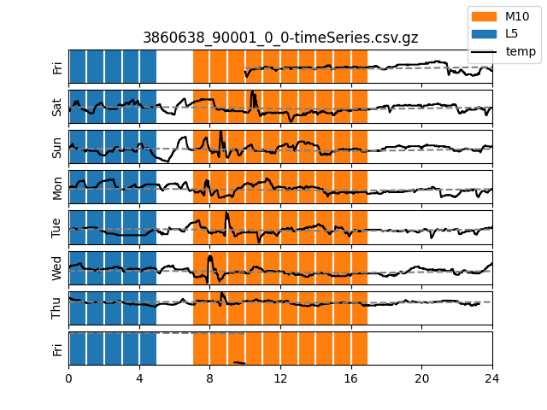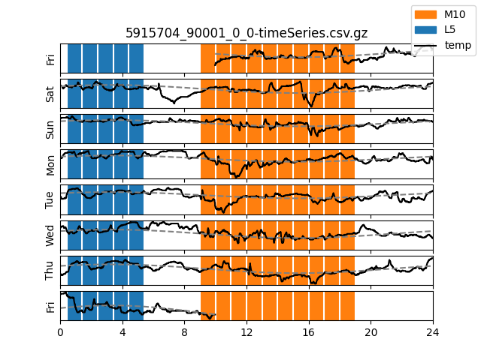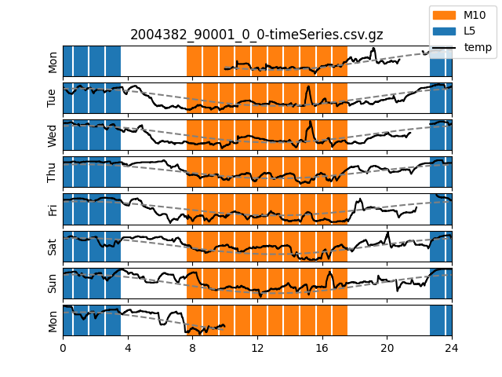

Figure S 1 – Example temperature traces
Example temperature trace from three participants with low (left), typical (middle), and high (right) temperature amplitude. The M10 period (ten hours of highest average activity) and L5 period (5 hours of lowest average activity) highlighted for reference. Cosinor fits for temperature are given in dashed gray line.

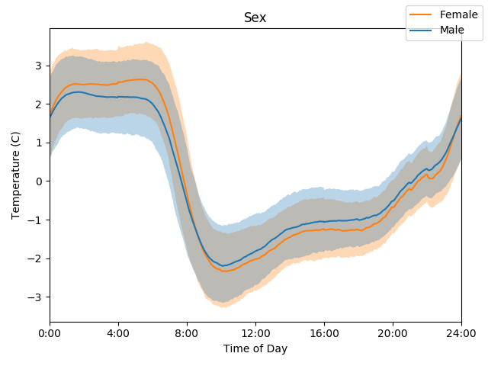 | 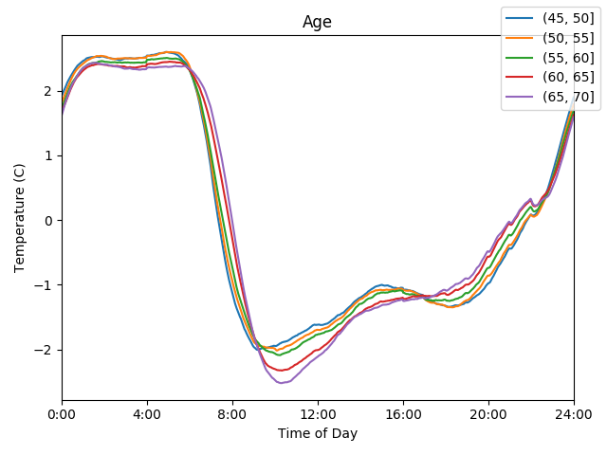 | 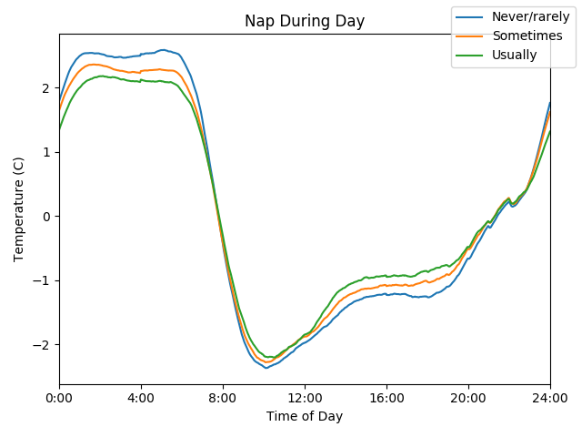
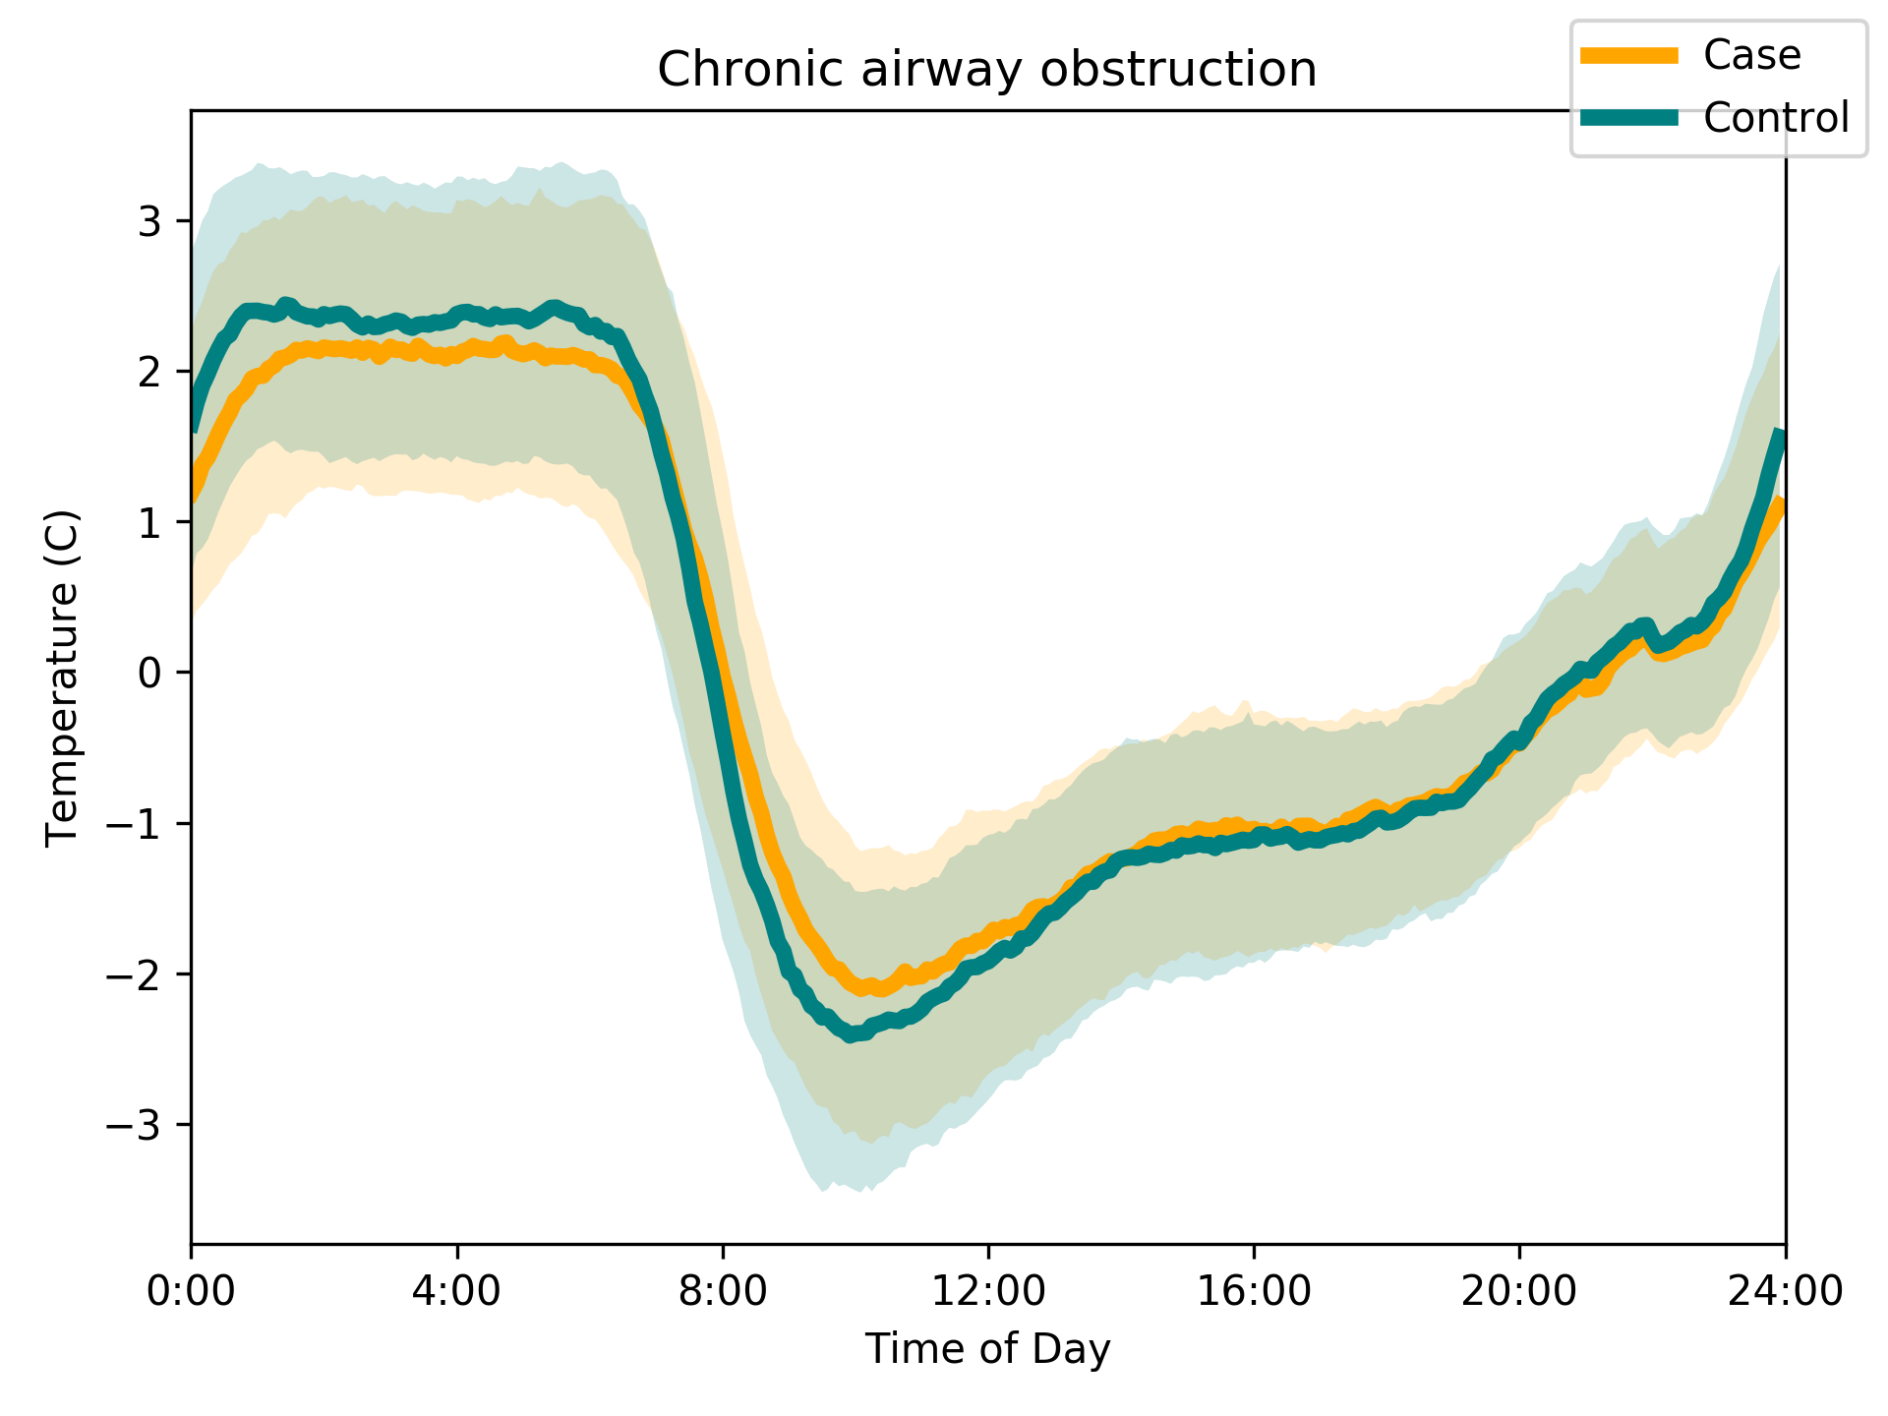 | 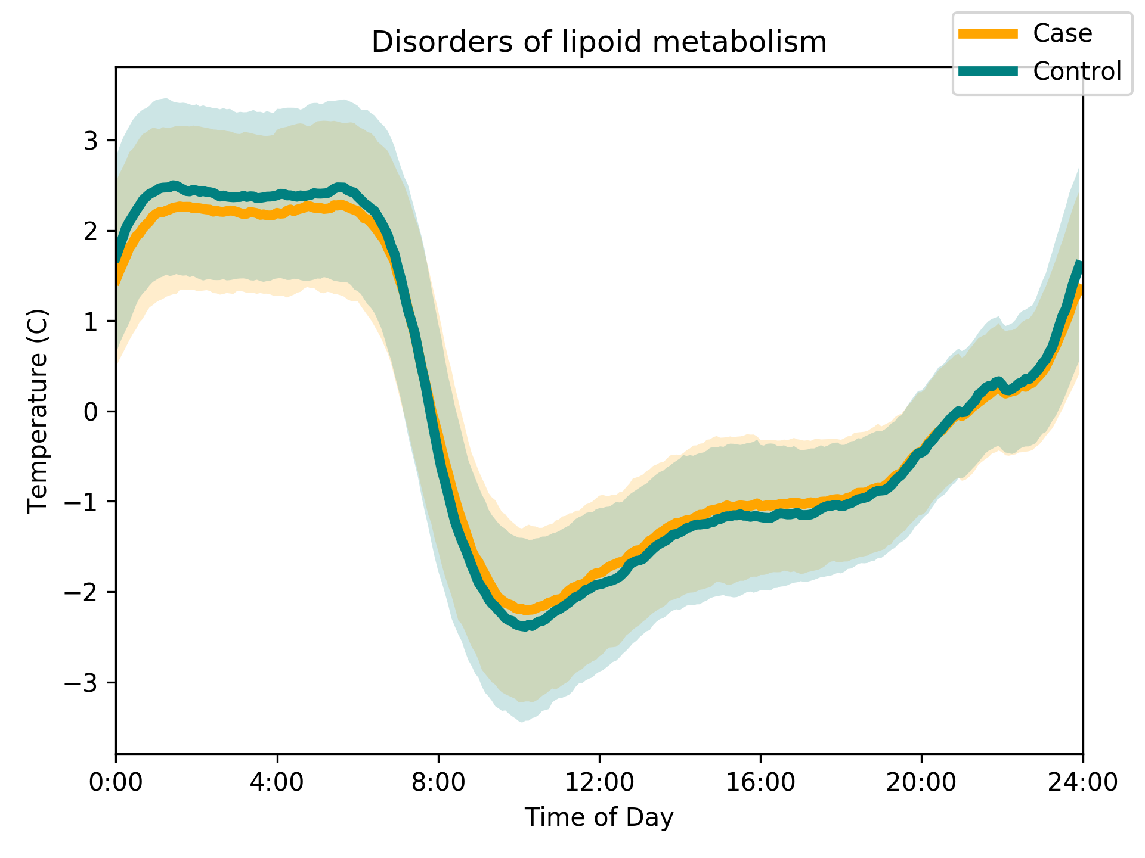 | 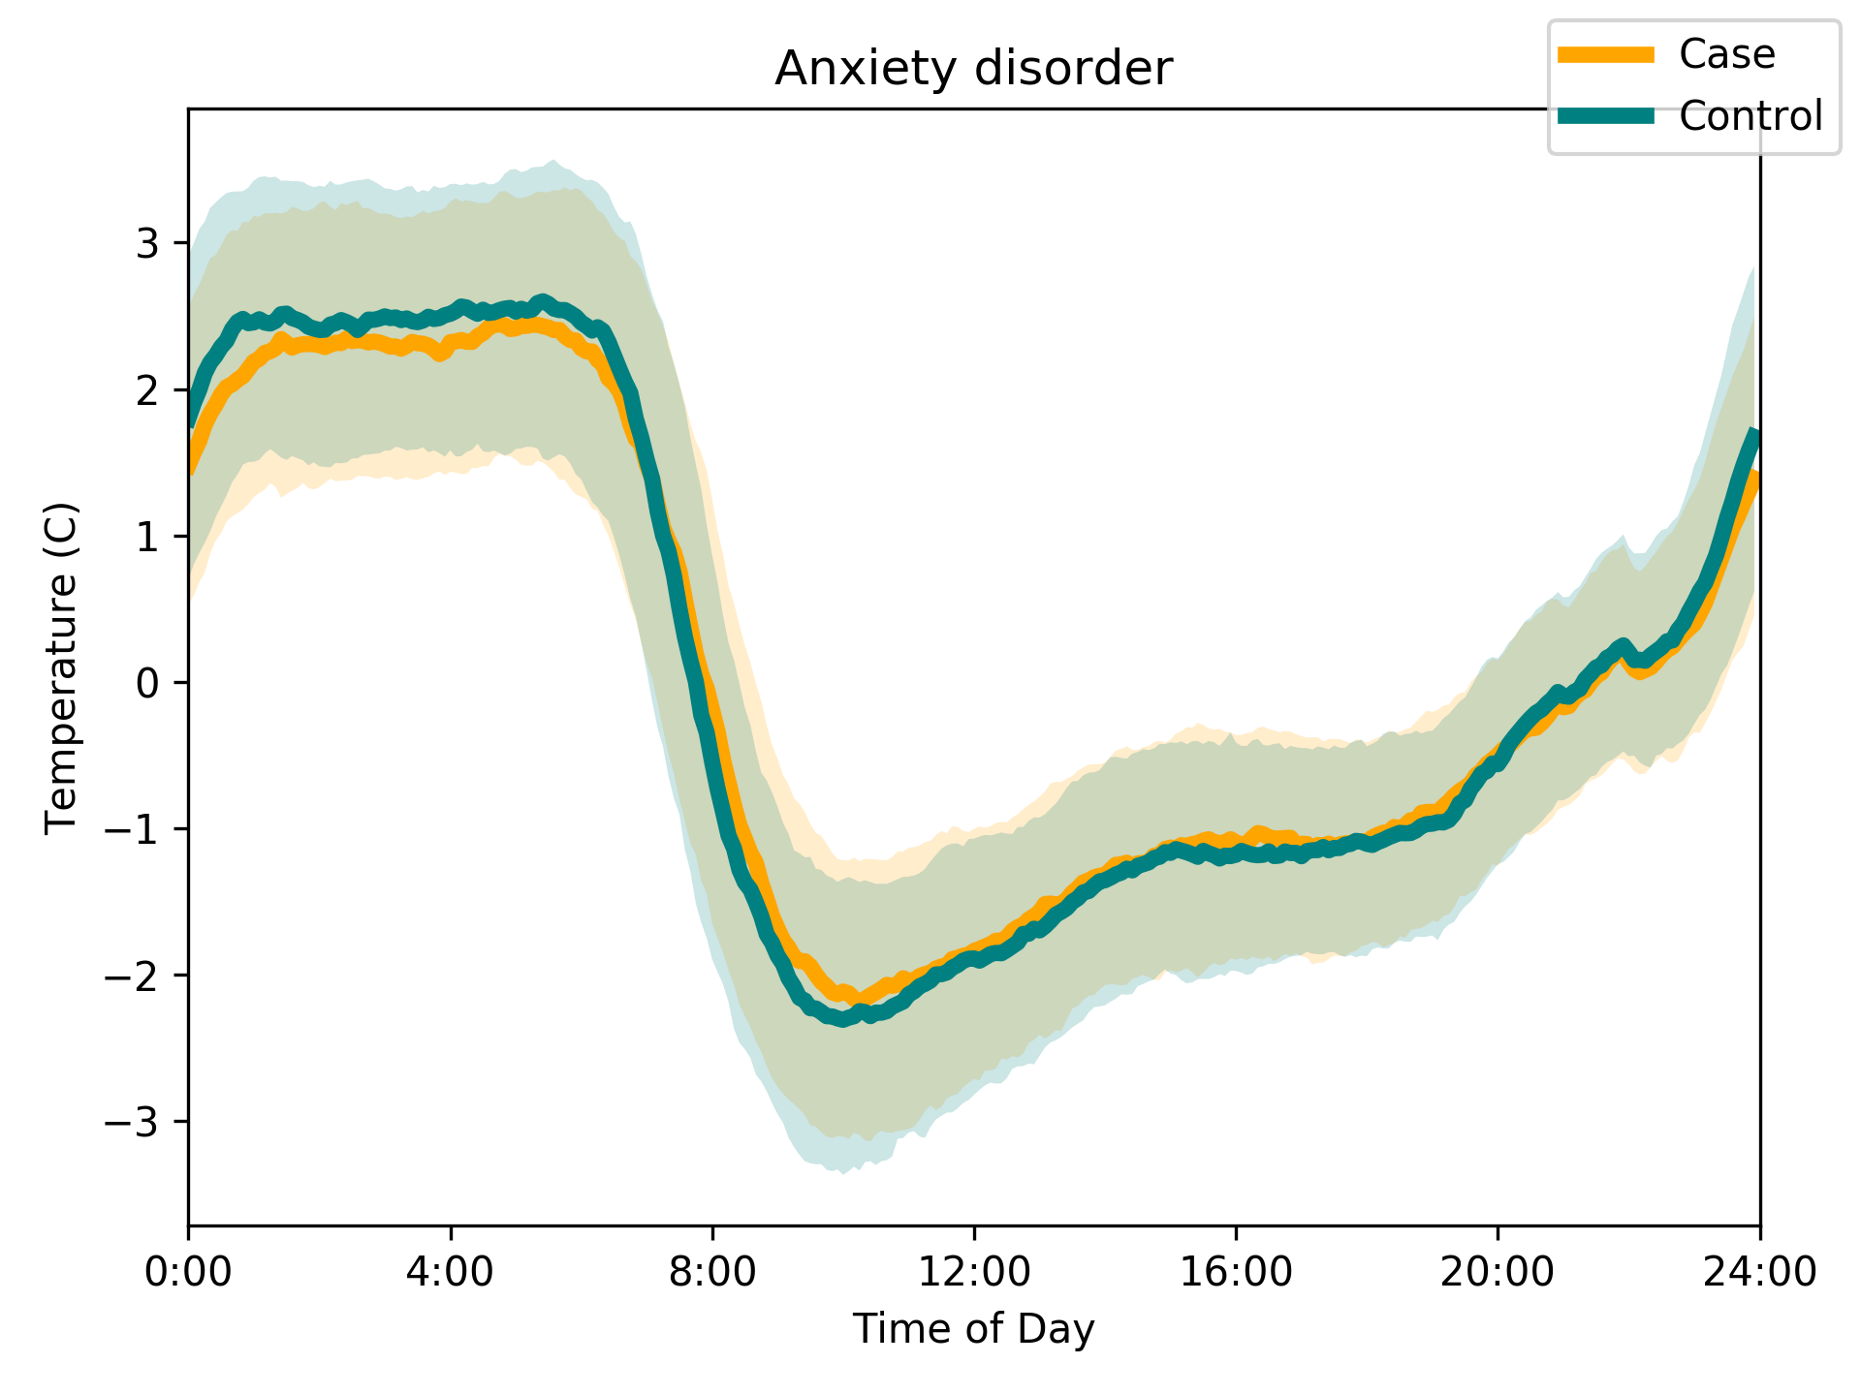
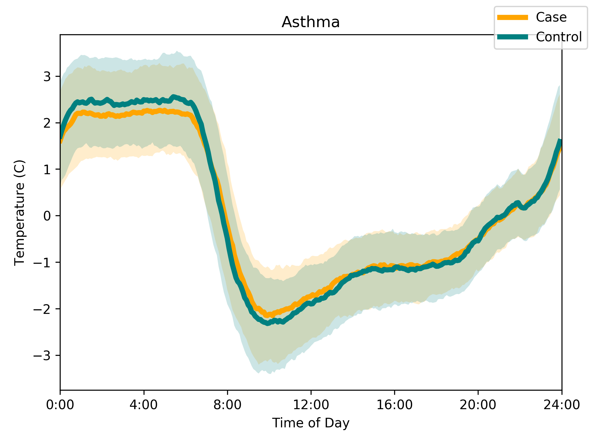 | Morning Person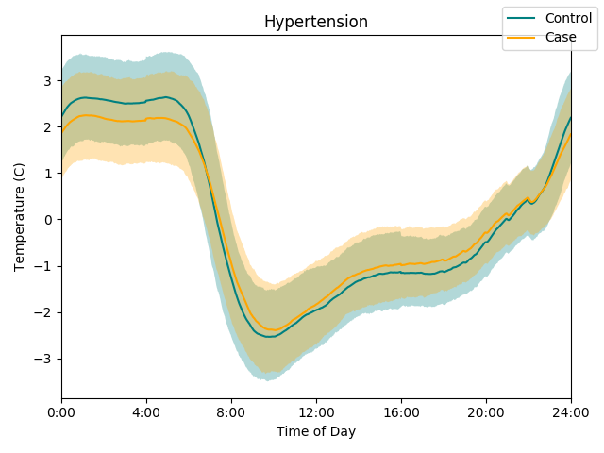 | Evening Person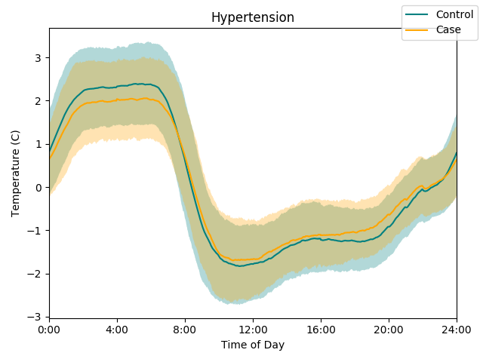
Evening Person: BMI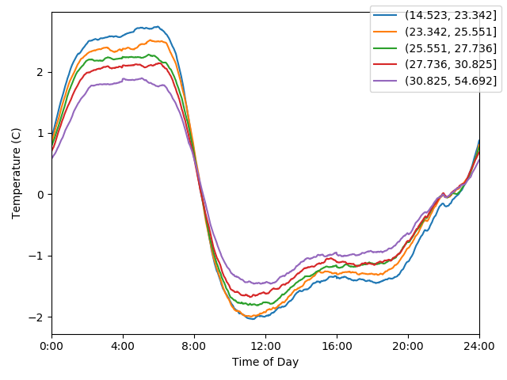 | Morning Person: BMI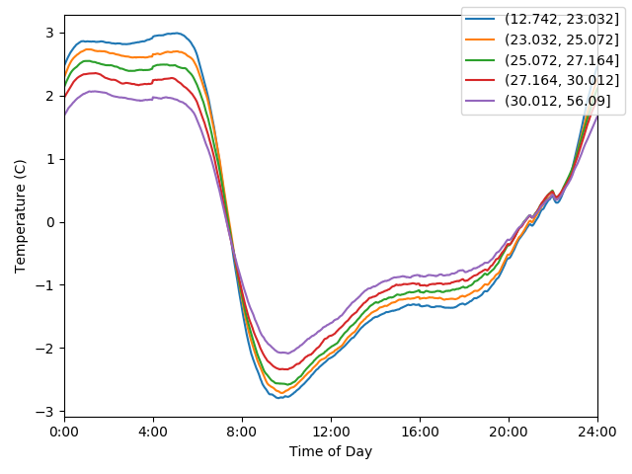

Figure S 2 – Detailed Wrist temperature traces
Wrist temperature traces comparing cases and controls for differences by sex, age, self-reported napping during the day as well as by disease condition for cases with chronic airway obstruction, disorders of lipoid metabolism, anxiety disorder, and asthma. 25th to 75th percentiles of the population are displayed in shaded regions (controls in blue, cases in yellow and overlap in grayish green). Temperature is plotted relative to an individual’s overall mean. To explore associations of ‘chronotype of person’ with ‘circadianness of disease’, we plotted the peripheral temperature trace for patients with hypertension and controls of self-reported morning chronotype. As expected, patients with hypertension compared to controls of self-reported evening chronotype display a right-shifted temperature-over-time curve but the shape of the curves are similar for cases and controls, suggesting that an interaction between chronotype and disease phenotype does not lead to aberrant temperature cycles. Increase in body weight (in quintiles of BMI) associates with a loss of amplitude in skin temperature which tracks with self-reported morning and evening chronotype but without indication of an interaction.
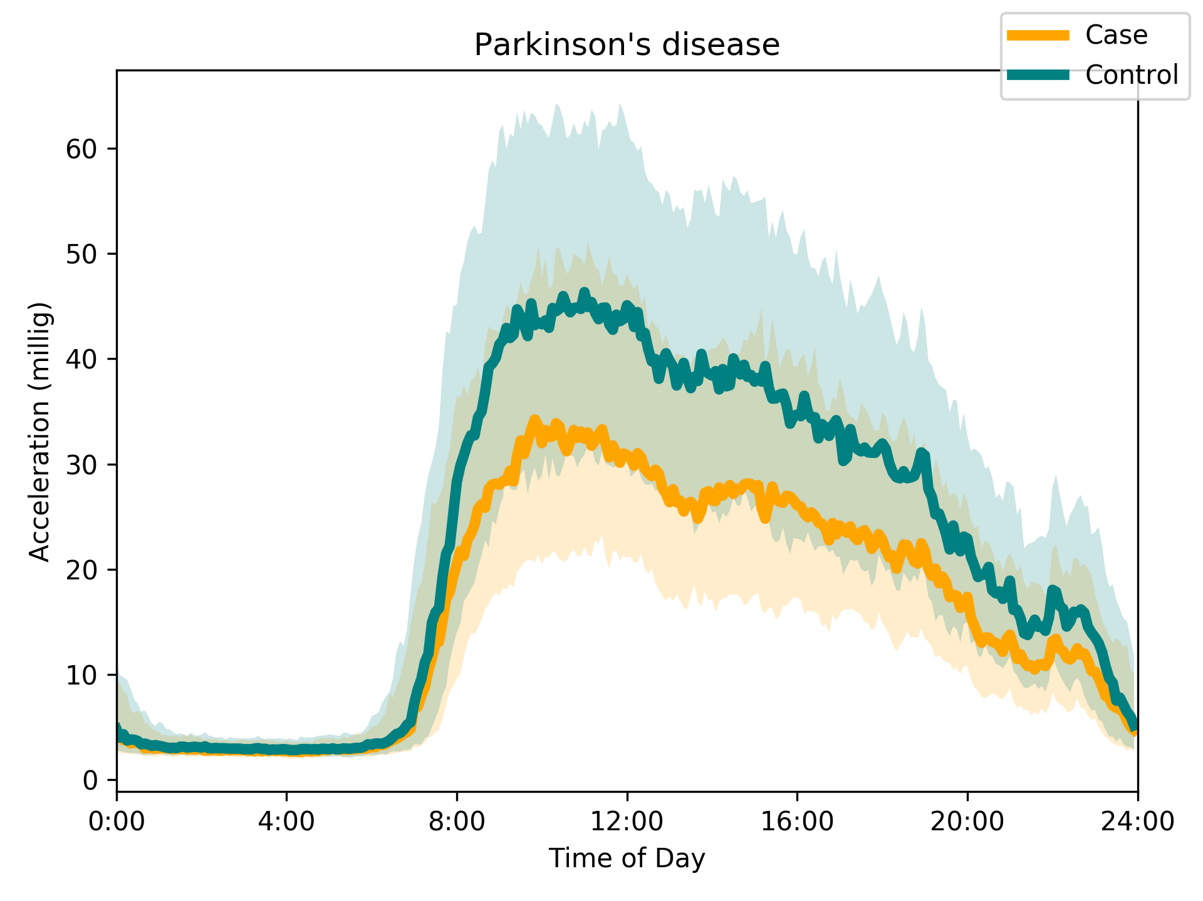 | 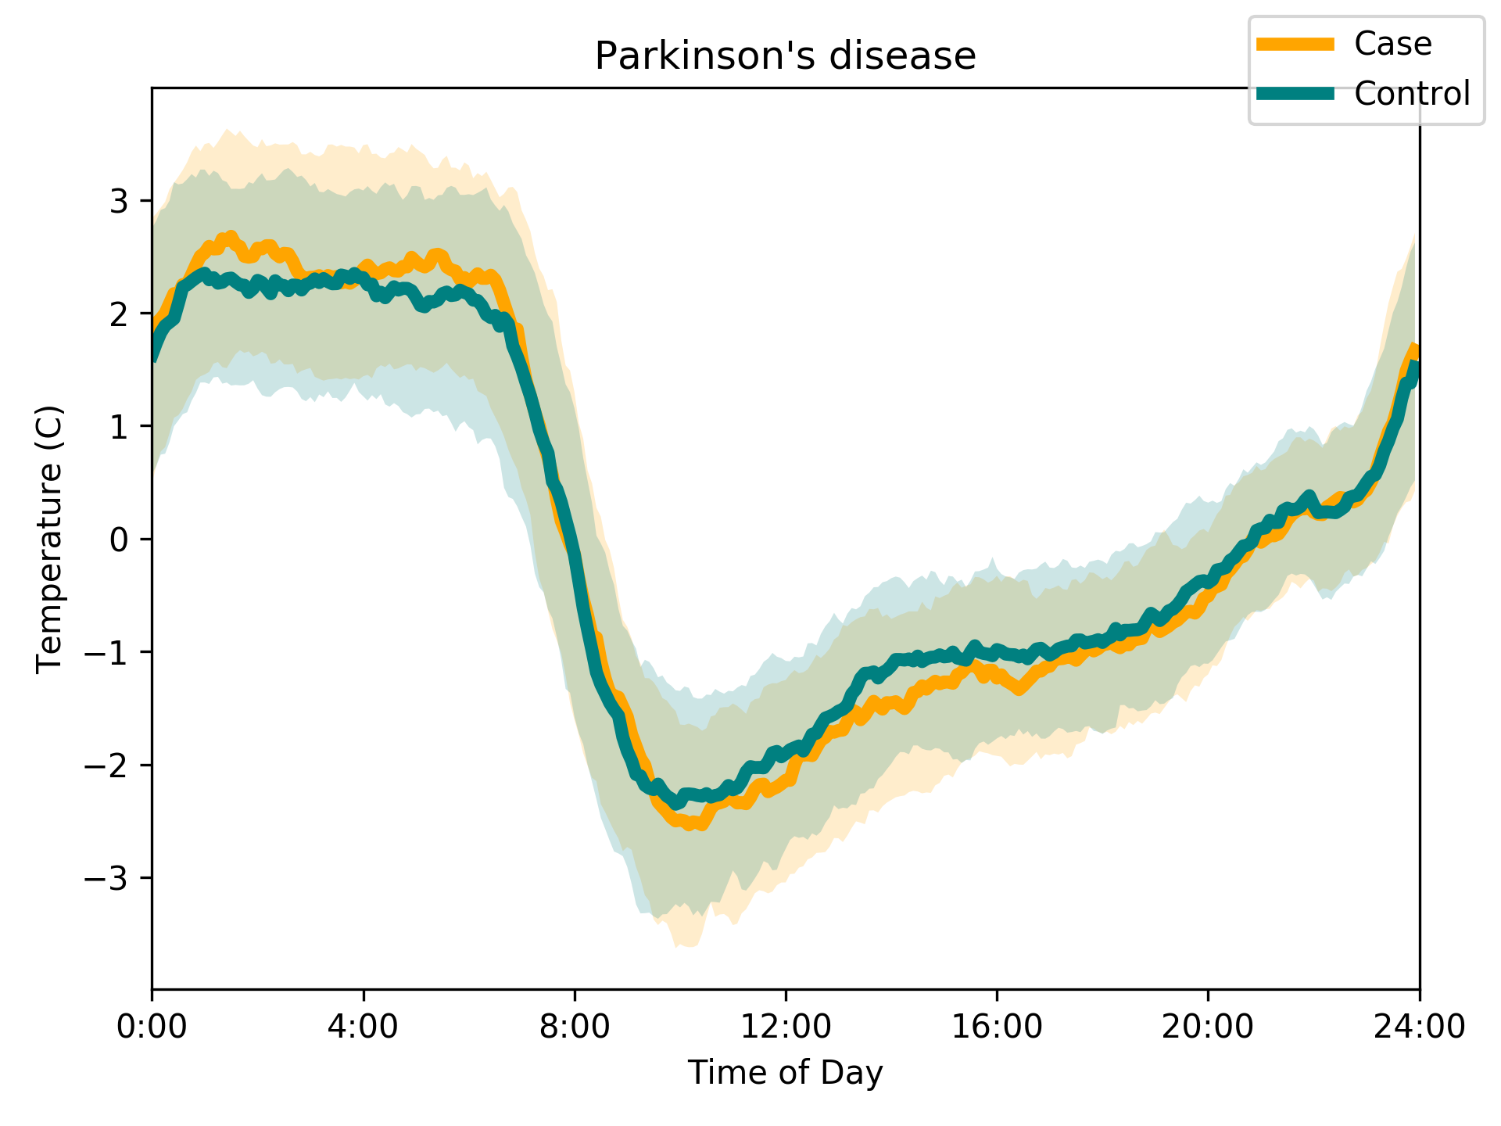

Figure S 3 - Parkinson's disease
(left) Median accelerometry trace as vector magnitude of acceleration after removal of gravitation acceleration, by time of day in 312 case-control pairs matched by age and sex. (right) Median temperature curves in the same subjects. See Figure S 2. Cases show a large drop in acceleration rhythms but a small increase in temperature rhythms.

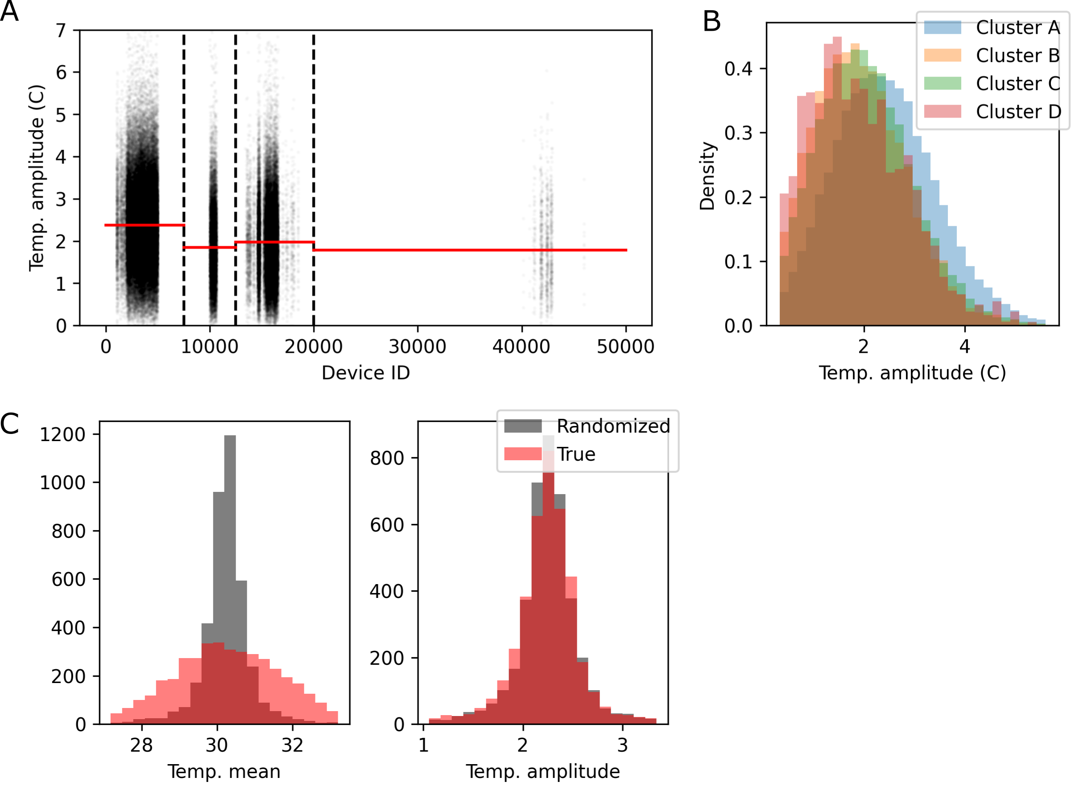

Figure S 4 – Calibration of temperature data
(A) Temperature amplitudes by device ID. Three distinct groups of device IDs are present, divided by the dashed vertical lines. Each cluster demonstrates distinct bias, with the median value of each shown in red. (Cluster A: device IDs up to 7,500, Cluster B: 7,501 through 12,500, Cluster C: 12,501 through 20,000, Cluster D: above 20,000). (B) The distributions of the temperature cosinor amplitude (temp_amplitude) in each of the clusters of actigraphy devices. Cluster D only contains readings from the repeated actigraphy measurements and so is considerably smaller in size. (C) The distribution of average (bottom left) temperature means and (right) temperature amplitude scores among all measurements from one device, in red, compared to the distribution after a random permutation of device IDs (in grey) to show expected variance. Wider true distributions than by random permutation indicate existence of device-specific biases. While mean temperature shows prominent device-specific bias, temperature rhythms are nearly device-independent.

Supplemental Tables

Table S 1 – Supplemental Results
Contains full results of proportional hazard models for predictive power of wrist temperature amplitude), also including age and sex-specific effects, for all phenotypes tested. Identification of fifty-seven novel loci for abdominal wall hernia development and their biological and clinical implications: results from the UK Biobank.

Table S 2 - Demographics of participants with and without actigraphy in the UK Biobank.
 | With Actigraphy | Without Actigraphy
N | 92,325 | 398,825
Male | 43.70% | 46.10%
Female | 56.30% | 53.90%
White | 96.60% | 93.40%
Nonwhite | 3.40% | 6.60%
Birth Year mean (SD) | 1952.0 (7.8) | 1951.4 (8.2)
BMI  mean (SD) | 26.7 (4.5) | 27.6 (4.9)

Supplementary Files

Supplemental File 1
Zip file containing the results table (Table S 1) as obtained from sub cohorts A and B+C, see Supplemental Methods. Also contains all results and figures from alternative models run on top PheCODEs, see Supplementary Methods.

