Supplementary Information

Table 1 Summary of reviewed literature

Publication | Data Type | Topic | Category | Sensor type
Tu et al., 2021 | Journal Article | OD with RGB/LWIR | RGB, LWIR, OD | RGB/LWIR
Vidas et al., 2013 | Conference Paper | LWIR mapping | RGB, LWIR | RGB, LWIR
Teju and Bhavana, 2020 | Journal Article | RGB, LWIR and OD | RGB, LWIR, OD | RGB, LWIR
St-lauren et al., 2007 | Conference Paper | OD with RGB/LWIR | RGB, LWIR, OD | RGB, LWIR
Li et al., 2021 | Journal Article | OD with LWIR on UAS | RGB, LWIR, OD, UAS | RGB, LWIR
Alldieck et al., 2016 | Journal Article | RGB-LWIR fusion | RGB, LWIR | RGB, LWIR
Lia et al., 2022 | Journal Article | OD with RGB/LWIR | RGB, LWIR, OD | RGB, LWIR
Speth et al., 2022 | Journal Article | OD with RGB/LWIR on UAS | RGB, LWIR, OD, UAS | RGB, LWIR
Chen et al., 2022 | Journal Article | OD with RGB/LWIR | RGB, LWIR, OD | RGB, LWIR
Yang et al., 2022 | Journal Article | OD with RGB/LWIR on UAS | RGB, LWIR, OD, UAS | RGB, LWIR
Zhou et al., 2021 | Journal Article | RGB/LWIR and edge detection | RGB, LWIR, OD | RGB, LWIR
Deng et al., 2021 | Conference Paper | RGB/LWIR semantic segmentation | RGB, LWIR, OD | RGB, LWIR
Sun et al., 2021 | Journal Article | RGB/LWIR semantic segmentation | RGB, LWIR, OD | RGB, LWIR
Fendri et al., 2017 | Journal Article | RGB-LWIR fusion | RGB, LWIR, OD | RGB, LWIR
Zhou et al., 2021 | Journal Article | RGB/LWIR semantic segmentation | RGB, LWIR, OD | RGB, LWIR
Zhou et al., 2022 | Journal Article | OD with RGB/LWIR | RGB, LWIR, OD | RGB, LWIR
Bañuls Arias et al., 2020 | Conference Paper | OD with RGB/LWIR | RGB, LWIR, OD | RGB, LWIR
Luo et al., 2014 | Journal Article | OD with RGB/LWIR | RGB, LWIR, OD | RGB, LWIR
Lie at al., 2019 | Conference Paper | OD with RGB/LWIR to detect oil leaks | RGB, LWIR, OD | RGB, LWIR
Guo et al., 2021 | Journal Article | OD with RGB/LWIR | RGB, LWIR, OD | RGB, LWIR
Sun et al., 2019 | Journal Article | OD with RGB/LWIR | RGB, LWIR, OD | RGB, LWIR
Krišto et al., 2020 | Journal Article | OD with RGB/LWIR | RGB, LWIR, OD | RGB, LWIR
Fei et al., 2022 | Journal Article | RGB/LWIR OD from UAS | RGB, LWIR, OD, UAS | RGB, LWIR
De Oliveira and Wehrmeister, 2018 | Journal Article | RGB/LWIR OD from UAS | RGB, LWIR, OD, UAS | RGB, LWIR
da Silva et al., 2021 | Journal Article | OD with RGB/LWIR for tree diameter | RGB, LWIR, OD | RGB, LWIR
Lahuad and Ghanem, 2017 | Conference Paper | OD with RGB/LWIR | OD | RGB
Tian et al., 2021 | Journal Article | OD with UAS | OD, UAS | RGB
Akbari et al., 2021 | Journal Article | OD with UAS | OD, UAS | RGB
Rajesh and Kavitha, 2015 | Conference Paper | UAS camera stabilization | UAS | RGB
Roy, 2022 | Journal Article | OD with RGB | RGB, OD | RGB
Kazaz et al., 2021 | Journal Article | OD with RGB on UAS | RGB, OD, UAS | RGB
Hossain and Lee | Journal Article | OD with RGB on UAS | RGB, OD, UAS | RGB
Xiaoliang Wang at al., 2019 | Journal Article | RGB OD from UAS | RGB, OD, UAS | RGB
Ezzy et al., 2021 | Journal Article | RGB OD from UAS | RGB, OD, UAS | RGB
Hyun-Ki Jung and Gi-Sang Choi, 2022 | Journal Article | RGB OD from UAS | RGB, OD, UAS | RGB
Huang et al., 2022 | Journal Article | OD with RGB | RGB, OD | RGB
Walambe et al., 2021 | Journal Article | OD on UAS with transfer learning | RGB, OD, UAS | RGB
Morales et al., 2019 | Journal Article | UAS applications | UAS | RGB
Liu et al., 2018 | Conference Paper | OD with RGB | RGB, OD | RGB
Ushma, 2022 | Journal Article | OD with RGB and edge detection | RGB, OD | RGB
Galvez et al., 2018 | Conference Paper | OD with RGB | RGB, OD | RGB
Diwan et al., 2022 | Journal Article | OD with RGB | RGB, OD | RGB
Zhou et al., 2015 | Journal Article | OD with RGB | RGB, OD | RGB
Lie et al., 2021 | Conference Paper | OD with RGB | RGB, OD | RGB
Meier at al., 2011 | Conference Paper | OD with UAS flight control | OD, UAS | RGB
Bergerson, 2010 | Conference Paper | RGB stereoscopic images | RGB | RGB
Wu et al., 2020 | Journal Article | OD with RGB and blur | RGB, OD | RGB
Koskowich et al., 2018 | Conference Paper | OD with RGB from UAS | RGB, OD, UAS | RGB
Hao and Ho, 2019 | Journal Article | OD with Scikit-learn | OD | RGB
Ozbay and Sahingil, 2017 | Conference Paper | OD in military | LWIR, OD | LWIR
Cho, 2019 | Conference Paper | LWIR obstacle regognition | LWIR | LWIR
Sachan et al., 2022 | Conference Paper | OD with LWIR | LWIR, OD | LWIR
Rai et al., 2022 | Journal Article | LWIR deblurring | LWIR | LWIR
Nguyen and Tran, 2015 | Conference Paper | OD with LWIR | LWIR, OD | LWIR
Uzun et al., 2022 | Journal Article | Athmosphrics and LWIR | LWIR | LWIR
Nirgudkar and Robinette, 2021 | Conference Paper | OD and LWIR | LWIR, OD | LWIR
Agrawal and Karar, 2018 | Conference Paper | LWIR palette selection | LWIR | LWIR
Pavlović et al., 2022 | Journal Article | OD with LWIR | LWIR, OD | LWIR
Batchuluun et al., 2021 | Journal Article | LWIR deblurring | LWIR, OD | LWIR
Khatri et al., 2022 | Conference Paper | OD and LWIR | LWIR, OD | LWIR
Driggers et al., 2021 | Journal Article | LWIR and UAS | LWIR, UAS | LWIR
Juang et al., 2020 | Conference Paper | LWIR OD from UAS | LWIR, OD, UAS | LWIR
Sergyán, 2012 | Conference Paper | LWIR and edge detection | LWIR, OD | LWIR
Agrawal and Subramanian, 2019 | Journal Article | enhancing OD with LWIR | LWIR, OD | LWIR
Choi et al., 2018 | Journal Article | OD with LWIR | LWIR, OD | LWIR
Shen et al., 2015 | Journal Article | Countermeasures to LWIR detection | LWIR | LWIR
Nan et al., 2018 | Conference Paper | OD with LWIR | LWIR, OD | LWIR
Korobchynskyi et al., 2018 | Conference Paper | OD with LWIR | LWIR, OD | LWIR
El Ahmar et al., 2022 | Conference Paper | OD with LWIR | LWIR, OD | LWIR
Bhusal, 2022 | Thesis | OD with LWIR | LWIR, OD | LWIR
Jiang et al., 2022 | Journal Article | LWIR OD from UAS | LWIR, OD, UAS | LWIR
Leira et al., 2021 | Journal Article | LWIR OD from UAS | LWIR, OD, UAS | LWIR
Altay and Velipasalar, 2020 | Conference Paper | OD with LWIR and Saliency | LWIR, OD | LWIR
Sharrab et al., 2021 | Conference Paper | OD model comparisson with LWIR | LWIR, OD | LWIR
Wei, 2021 | Conference Paper | OD with LWIR | LWIR, OD | LWIR
Shivakumar et al., 2020 | Conference Paper | LWIR semantic segmentation | LWIR, OD | LWIR
Blythman et al., 2020 | Conference Paper | Synthetic LWIR generation | LWIR, OD | LWIR
Zhao et al., 2016 | Journal Article | LWIR and thermal crossover | LWIR | LWIR
Gade and Moeslund, 2014 | Journal Article | LWIR and surveys | LWIR | LWIR
Qu et al., 2018 | Journal Article | Countermeasures to LWIR detection | LWIR | LWIR
Setjo et al., 2017 | Conference Paper | OD with LWIR | LWIR, OD | LWIR
Dai et al., 2021 | Journal Article | OD with LWIR for autonomous driving | LWIR, OD | LWIR
Lie et al., 2021 | Journal Article | LWIR image generation for OD | LWIR, OD | LWIR

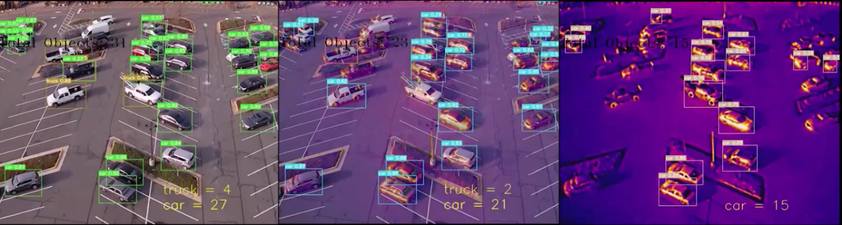
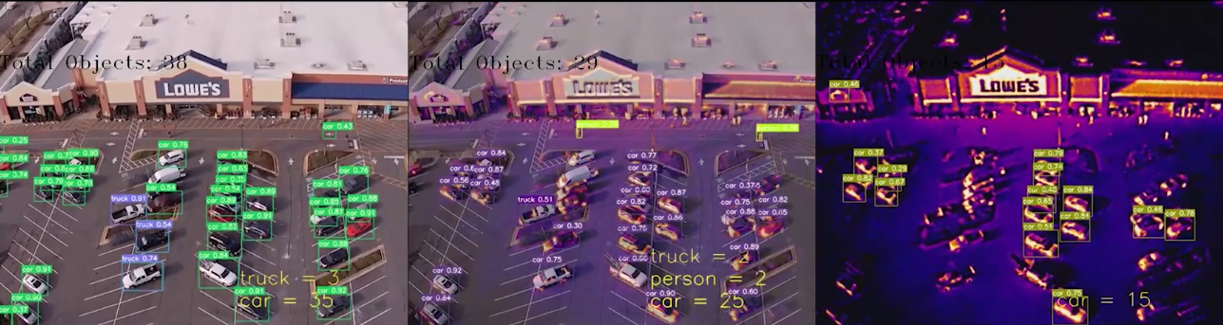
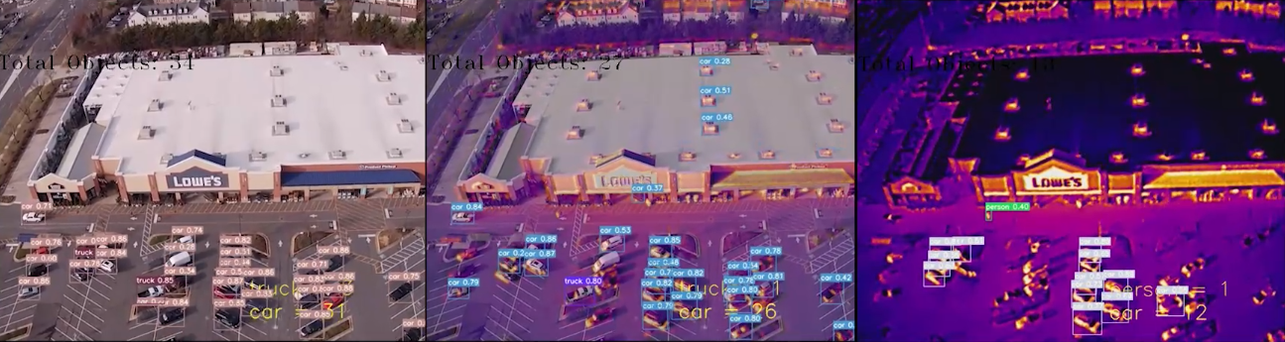
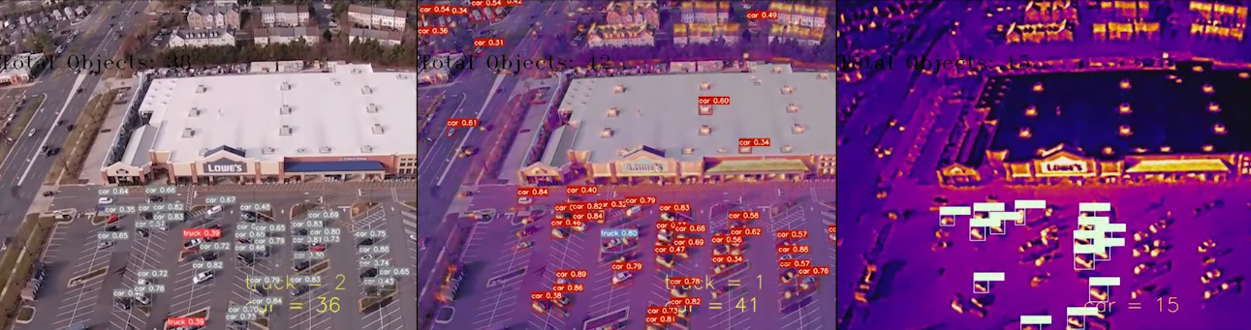


30 m (100 ft)
61 m (200 ft)
91 m (300 ft)
121 m (400 ft)
Figure 1. ML model performance at 30 m, 61 m, 91 m, and 121 m at a parking lot where all object classes were present.

REFERENCES
1. Agrawal, D. & Karar, V. Color Palette Selection In Thermal Imaging For Enhancing Situation Awareness During Detection-Recognition Tasks. in 2018 International Conference on Recent Innovations in Electrical, Electronics & Communication Engineering (ICRIEECE) 1227–1232 (2018). doi:10.1109/ICRIEECE44171.2018.9008486.
2. Nguyen, H. V. & Tran, L. H. Application of graph segmentation method in thermal camera object detection. in 2015 20th International Conference on Methods and Models in Automation and Robotics (MMAR) 829–833 (2015). doi:10.1109/MMAR.2015.7283983.
3. Rai, M. et al. An improved statistical approach for moving object detection in thermal video frames. Multimed Tools Appl 81, 9289–9311 (2022).
4. Guo, Z., Li, X., Xu, Q. & Sun, Z. Robust semantic segmentation based on RGB-thermal in variable lighting scenes. Measurement 186, 110176 (2021).
5. Tu, Z., Li, Z., Li, C., Lang, Y. & Tang, J. Multi-Interactive Dual-Decoder for RGB-Thermal Salient Object Detection. IEEE Transactions on Image Processing 30, 5678–5691 (2021).
6. Deng, F. et al. FEANet: Feature-Enhanced Attention Network for RGB-Thermal Real-time Semantic Segmentation. in 2021 IEEE/RSJ International Conference on Intelligent Robots and Systems (IROS) 4467–4473 (2021). doi:10.1109/IROS51168.2021.9636084.
7. Shivakumar, S. S. et al. PST900: RGB-Thermal Calibration, Dataset and Segmentation Network. in 2020 IEEE International Conference on Robotics and Automation (ICRA) 9441–9447 (2020). doi:10.1109/ICRA40945.2020.9196831.
8. Zhou, W., Liu, J., Lei, J., Yu, L. & Hwang, J.-N. GMNet: Graded-Feature Multilabel-Learning Network for RGB-Thermal Urban Scene Semantic Segmentation. IEEE Transactions on Image Processing 30, 7790–7802 (2021).
9. Zhou, W., Lin, X., Lei, J., Yu, L. & Hwang, J.-N. MFFENet: Multiscale Feature Fusion and Enhancement Network For RGB–Thermal Urban Road Scene Parsing. IEEE Transactions on Multimedia 24, 2526–2538 (2022).
10. Zhou, W., Dong, S., Xu, C. & Qian, Y. Edge-Aware Guidance Fusion Network for RGB–Thermal Scene Parsing. Proceedings of the AAAI Conference on Artificial Intelligence 36, 3571–3579 (2022).
11. Korobchynskyi, M., Slonov, M., Mariliv, A. & Mieshkov, S. Method for Determining the Rational Time Intervals for Detecting Objects by Thermal Imager. in 2018 IEEE Second International Conference on Data Stream Mining & Processing (DSMP) 494–497 (2018). doi:10.1109/DSMP.2018.8478596.
12. Vidas, S., Moghadam, P. & Bosse, M. 3D thermal mapping of building interiors using an RGB-D and thermal camera. in 2013 IEEE International Conference on Robotics and Automation 2311–2318 (2013). doi:10.1109/ICRA.2013.6630890.
13. Pavlović, M. S. et al. Deep Learning Based SWIR Object Detection in Long-Range Surveillance Systems: An Automated Cross-Spectral Approach. Sensors 22, 2562 (2022).
14. Yang, L., Ma, R. & Zakhor, A. Drone Object Detection Using RGB/IR Fusion. (2022).
15. Batchuluun, G. et al. Deep Learning-Based Thermal Image Reconstruction and Object Detection. IEEE Access 9, 5951–5971 (2021).
16. Blythman, R. et al. Synthetic Thermal Image Generation for Human-Machine Interaction in Vehicles. in 2020 Twelfth International Conference on Quality of Multimedia Experience (QoMEX) 1–6 (2020). doi:10.1109/QoMEX48832.2020.9123135.
17. Liu, P., Li, F., Yuan, S. & Li, W. Unsupervised Image-Generation Enhanced Adaptation for Object Detection in Thermal Images. Mobile information systems 2021, 1–6 (2021).
18. Chen, C. et al. Deep Learning-Based Thermal Image Analysis for Pavement Defect Detection and Classification Considering Complex Pavement Conditions. Remote Sensing 14, 106 (2022).
19. St-Laurent, L., Maldague, X. & Prevost, D. Combination of colour and thermal sensors for enhanced object detection. in 2007 10th International Conference on Information Fusion 1–8 (2007). doi:10.1109/ICIF.2007.4408003.
20. Uzun, E., Dursun, A. A. & Akagunduz, E. Augmentation of Atmospheric Turbulence Effects on Thermal Adapted Object Detection Models. Preprint at https://doi.org/10.48550/arXiv.2204.08745 (2022).
21. Teju, V. & Bhavana, D. An efficient object detection using OFSA for thermal imaging. The International Journal of Electrical Engineering & Education 0020720920944434 (2020) doi:10.1177/0020720920944434.
22. da Silva, D. Q., dos Santos, F. N., Sousa, A. J. & Filipe, V. Visible and Thermal Image-Based Trunk Detection with Deep Learning for Forestry Mobile Robotics. Journal of imaging 7, 176- (2021).
23. Fendri, E., Boukhriss, R. R. & Hammami, M. Fusion of thermal infrared and visible spectra for robust moving object detection. Pattern Anal Applic 20, 907–926 (2017).
24. Liao, G., Gao, W., Li, G., Wang, J. & Kwong, S. Cross-Collaborative Fusion-Encoder Network for Robust RGB-Thermal Salient Object Detection. IEEE Transactions on Circuits and Systems for Video Technology 1–1 (2022) doi:10.1109/TCSVT.2022.3184840.
25. Nan, S., Chen, J., Chau, L.-P. & Qian, K. Learning-Based Parallax Transfer on Multispectral Light Field. in 2018 IEEE 23rd International Conference on Digital Signal Processing (DSP) 1–4 (2018). doi:10.1109/ICDSP.2018.8631676.
26. FLIR. Hadron 640R - High Performance, Dual Thermal and Visible OEM Camera Module | Teledyne FLIR. https://www.flir.com/products/hadron-640r?vertical=lwir&segment=oem.
27. Li, M., Zhao, X., Li, J. & Nan, L. ComNet: Combinational Neural Network for Object Detection in UAV-Borne Thermal Images. IEEE Transactions on Geoscience and Remote Sensing 59, 6662–6673 (2021).
28. Walambe, R., Marathe, A. & Kotecha, K. Multiscale Object Detection from Drone Imagery Using Ensemble Transfer Learning. Drones (Basel) 5, 66- (2021).
29. Ezzy, H., Charter, M., Bonfante, A. & Brook, A. How the Small Object Detection via Machine Learning and UAS-Based Remote-Sensing Imagery Can Support the Achievement of SDG2: A Case Study of Vole Burrows. Remote Sensing 13, 3191 (2021).
30. El Ahmar, W. A. et al. Multiple Object Detection and Tracking in the Thermal Spectrum. in 277–285 (2022).
31. Leira, F. S., Helgesen, H. H., Johansen, T. A. & Fossen, T. I. Object detection, recognition, and tracking from UAVs using a thermal camera. Journal of Field Robotics 38, 242–267 (2021).
32. Hyun-Ki Jung & Gi-Sang Choi. Improved YOLOv5: Efficient Object Detection Using Drone Images under Various Conditions. Applied sciences 12, 7255- (2022).
33. Li, A. et al. RGB-Thermal Fusion Network for Leakage Detection of Crude Oil Transmission Pipes. in 2019 IEEE International Conference on Robotics and Biomimetics (ROBIO) 883–888 (2019). doi:10.1109/ROBIO49542.2019.8961733.
34. Aslani, B., Mohebbi, S. & Oughton, E. J. The State-of-the-Art Survey on Optimization Methods for Cyber-physical Networks. Preprint at https://doi.org/10.48550/arXiv.2210.03642 (2022).
35. Oughton, E. J., Tran, M., Jones, C. B. & Ebrahimy, R. Digital communications and information systems. in The Future of National Infrastructure: A System-of-Systems Approach (eds. Hickford, A. J., Hall, J. W., Tran, M. & Nicholls, R. J.) 181–202 (Cambridge University Press, 2016). doi:10.1017/CBO9781107588745.010.
36. Wei, C. Power Grid Facility Thermal Fault Diagnosis via Object Detection with Synthetic Infrared Imagery. in 2021 3rd International Conference on Electrical Engineering and Control Technologies (CEECT) 217–221 (2021). doi:10.1109/CEECT53198.2021.9672631.
37. Juang, J.-G., Tu, G.-T., Liao, Y.-H., Huang, T.-H. & Chang, S.-I. Drone patrol using thermal imaging for object detection. in Infrared Sensors, Devices, and Applications X vol. 11503 152–158 (SPIE, 2020).
38. Khatri, K., S, A. C. & D’Souza, J. M. Detection of Animals in Thermal Imagery for Surveillance using GAN and Object Detection Framework. in 2022 International Conference for Advancement in Technology (ICONAT) 1–6 (2022). doi:10.1109/ICONAT53423.2022.9725883.
39. Sharrab, Y. O. et al. Performance Comparison of Several Deep Learning-Based Object Detection Algorithms Utilizing Thermal Images. in 2021 Second International Conference on Intelligent Data Science Technologies and Applications (IDSTA) 16–22 (2021). doi:10.1109/IDSTA53674.2021.9660820.
40. Bhusal, S. Object detection and tracking in wide area surveillance using thermal imagery. (University of Nevada, Las Vegas).
41. Koskowich, B. J., Rahnemoonfai, M. & Starek, M. Virtualot — A Framework Enabling Real-Time Coordinate Transformation & Occlusion Sensitive Tracking Using UAS Products, Deep Learning Object Detection & Traditional Object Tracking Techniques. in IGARSS 2018 - 2018 IEEE International Geoscience and Remote Sensing Symposium 6416–6419 (2018). doi:10.1109/IGARSS.2018.8518124.
42. Akbari, Y., Almaadeed, N., Al-maadeed, S. & Elharrouss, O. Applications, databases and open computer vision research from drone videos and images: a survey. The Artificial intelligence review 54, 3887–3938 (2021).
43. Driggers, R. et al. Detection of small targets in the infrared: an infrared search and track tutorial. Applied Optics 60, 4762 (2021).
44. Why Thermal?...Why Not? https://www.flir.com/discover/security/thermal/why-thermal...why-not/.
45. Teledyne FLIR. 5 Benefits of Thermal Imaging Cameras. Teledyne FLIR https://www.flir.com/discover/security/thermal/5-benefits-of-thermal-imaging-cameras/.
46. Luo, X., Zhang, J., Cao, X., Yan, P. & Li, X. Object-aware power line detection using color and near-infrared images. IEEE Transactions on Aerospace and Electronic Systems 50, 1374–1389 (2014).
47. Ushma, A. Object Detection In Image Processing Using Edge Detection Techniques. 5.
48. Sergyán, S. Edge detection techniques of thermal images. in 2012 IEEE 10th Jubilee International Symposium on Intelligent Systems and Informatics 227–231 (2012). doi:10.1109/SISY.2012.6339520.
49. Gade, R. & Moeslund, T. B. Thermal cameras and applications: a survey. Machine Vision and Applications 25, 245–262 (2014).

