Supplementary information
Downward migrating microplastic in lake sediments is a tricky indicator for the onset of the Anthropocene

Inta Dimante-Deimantovica ^{1*}, Saija Saarni ^{2*}, Marta Barone ^{1,3}, Natalja Buhhalko ⁴, Normunds Stivrins ^{5, 6}, Natalija Suhareva ¹, Wojciech Tylmann ⁷, Alvise Vianello ⁸, Jes Vollertsen ⁸

¹ Latvian Institute of Aquatic Ecology, Riga, LV-1007, Latvia,
² University of Turku, Department of Geography and Geology, Turku, 20014, Finland
³ Daugavpils University, The Faculty of Natural Sciences and Mathematics, Daugavpils LV-5401, Latvia
⁴ Tallinn University of Technology, Department of Marine Systems, Tallinn, 12618, Estonia
⁵ University of Latvia, Department of Geography, Riga, LV-1004, Latvia
⁶ Tallinn University of Technology, Department of Geology, Tallinn, 19086, Estonia
⁷ University of Gdańsk, Faculty of Oceanography and Geography, Gdańsk, PL-80309, Poland
⁸ Aalborg University, Department of the Built Environment, Aalborg, 9220, Denmark
* Corresponding inta.dimante-deimantovica@lhei.lv, saija.saarni@utu.fi

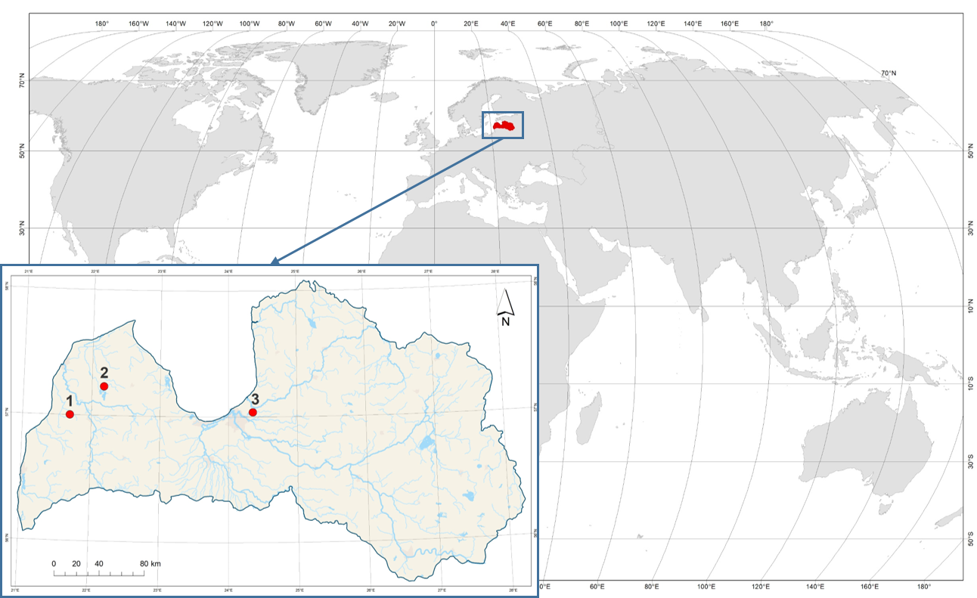
Supplementary Figure S1. Location of study sites. Sampling in three Latvian lakes, northeastern Europe: 1 - Lake Pinku, 2 - Lake Usmas, 3 - Lake Seksu. Map is generated using ArcMap 10.6.1.

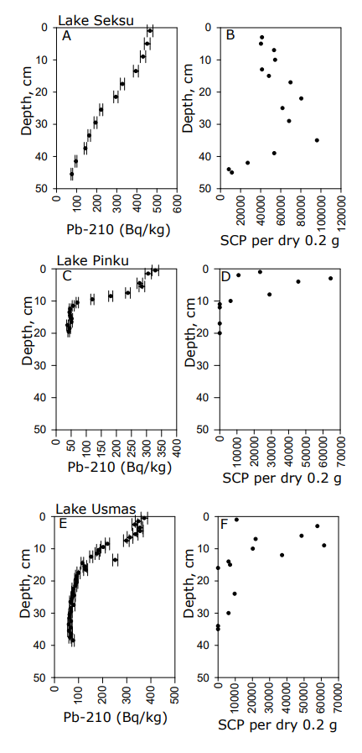
Supplementary Figure S2. Downcore distribution of lead isotope 210Pb and spheroidal carbonaceous particles (SCP) in Lake Seksu (A - B), Lake Pinku (C - D) and Lake Usmas (E - F) sediments.
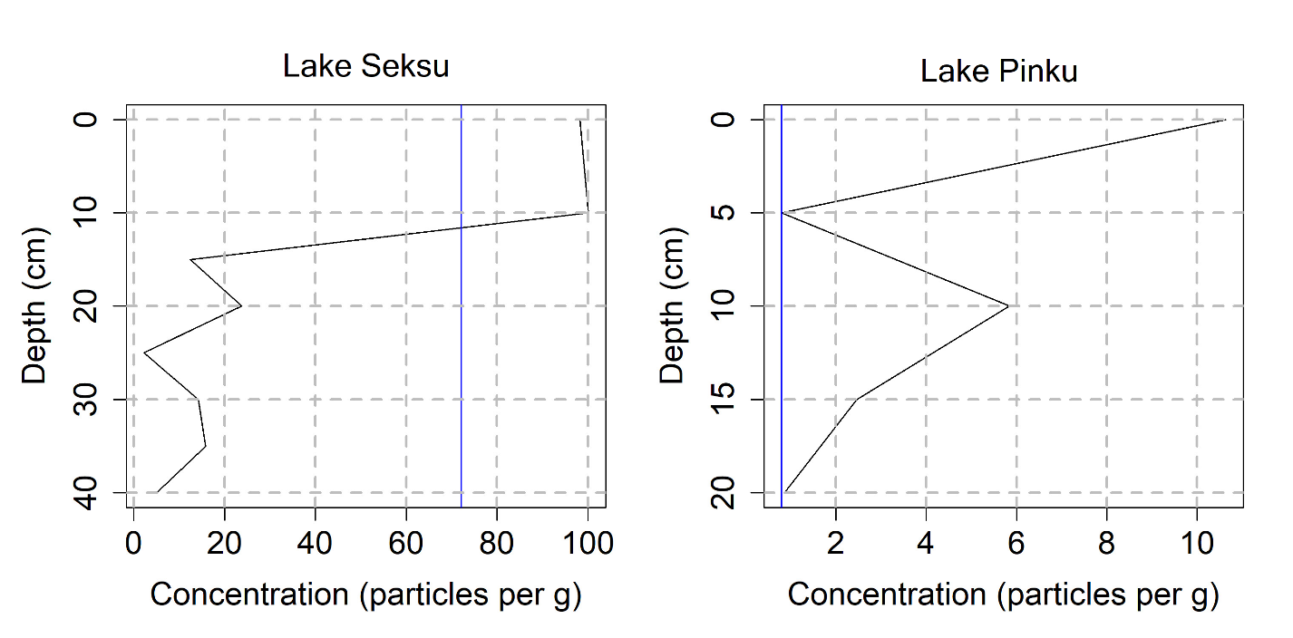

Supplementary Figure S3. Meaningful elbow points calculated for Lakes Seksu and Pinku (there was too little data of lake Usmas). The elbow point at Lake Seksu was pointed at a depth of 10-15 cm, where the concentration of microplastics (MP) was 100.1 particles∙g⁻¹. The elbow point at Lake Pinku was found at a depth of 0-5 cm referred to the MP concentration of 0.8 particles∙g⁻¹.

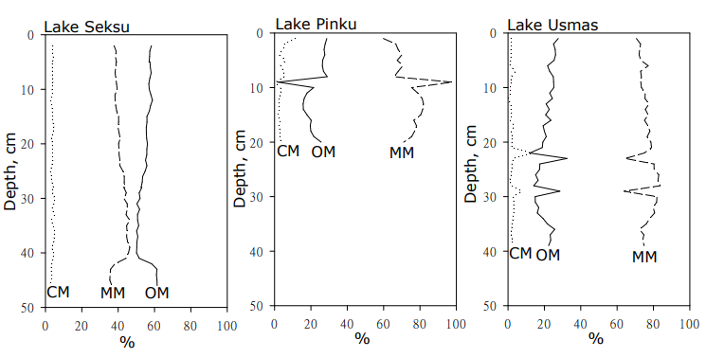
Supplementary Figure S4. Organic (OM), mineral (MM) and carbonate matter (CM, %) content in Lake Seksu, Lake Pinku and Lake Usmas sediment.

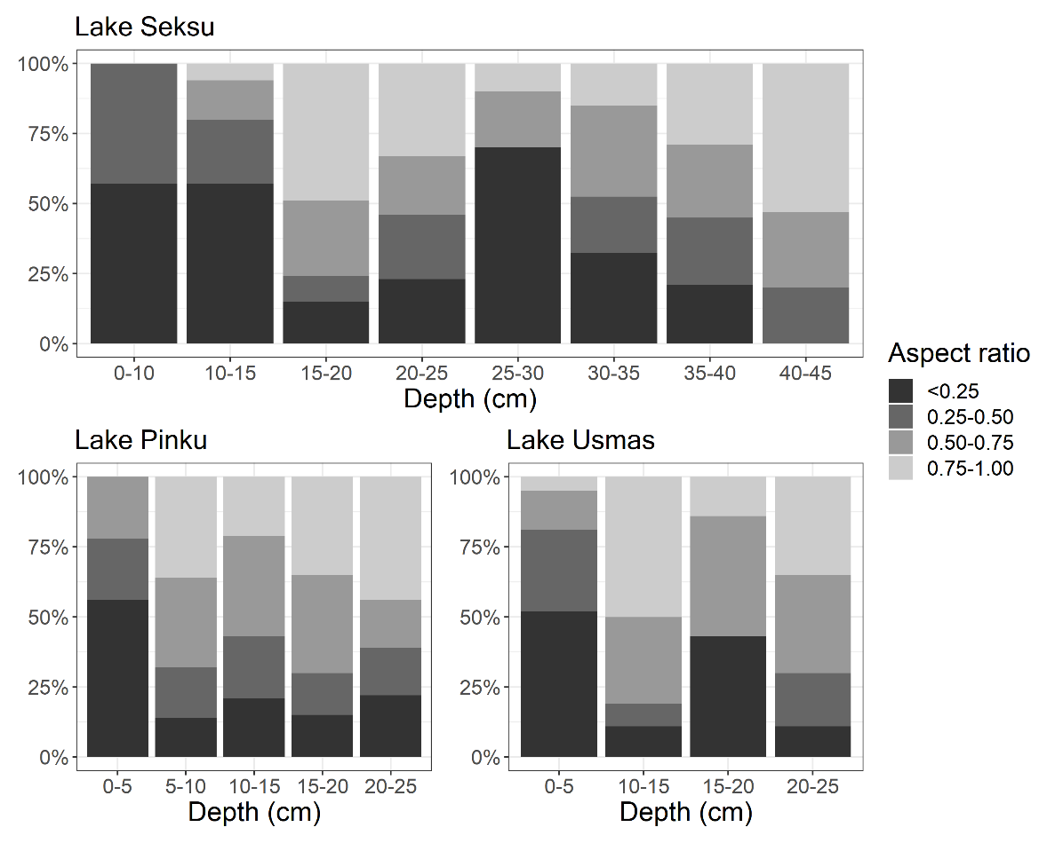

Supplementary Figure S5. Particles aspect ratio (minor vs major dimension) throughout the cores in lakes Pinku, Usmas, Seksu.

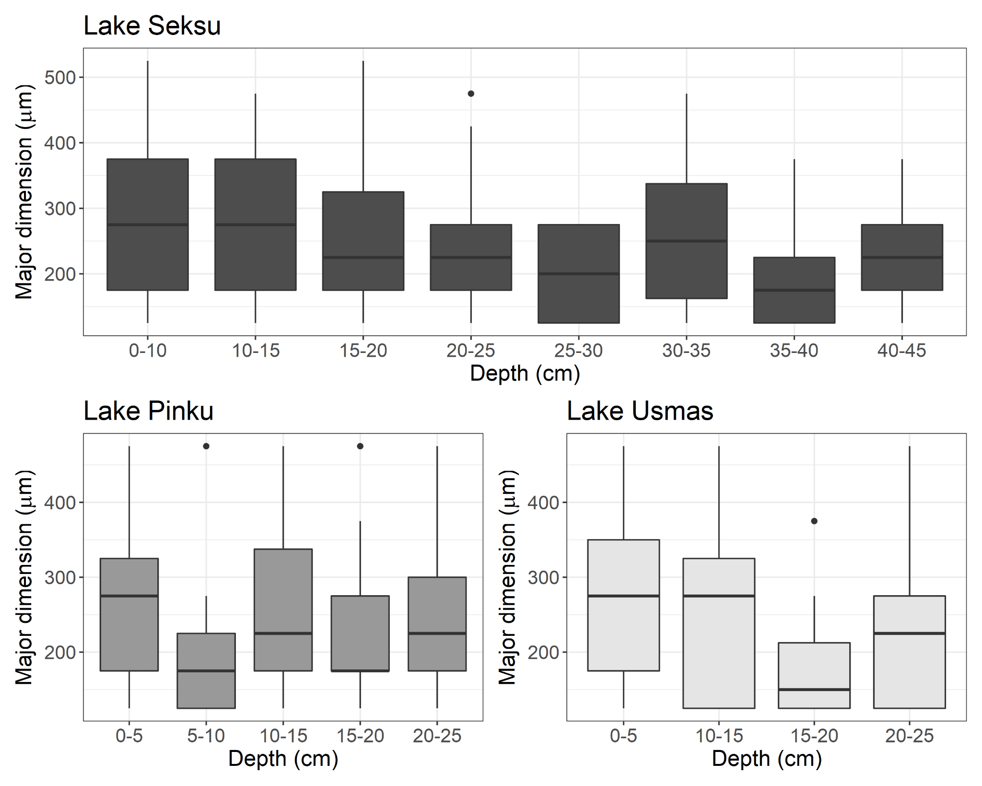

Supplementary Figure S6. The boxplot of distribution of particles described by major dimension between different depths of sediments in lakes - Seksu, Pinku and Usmas.

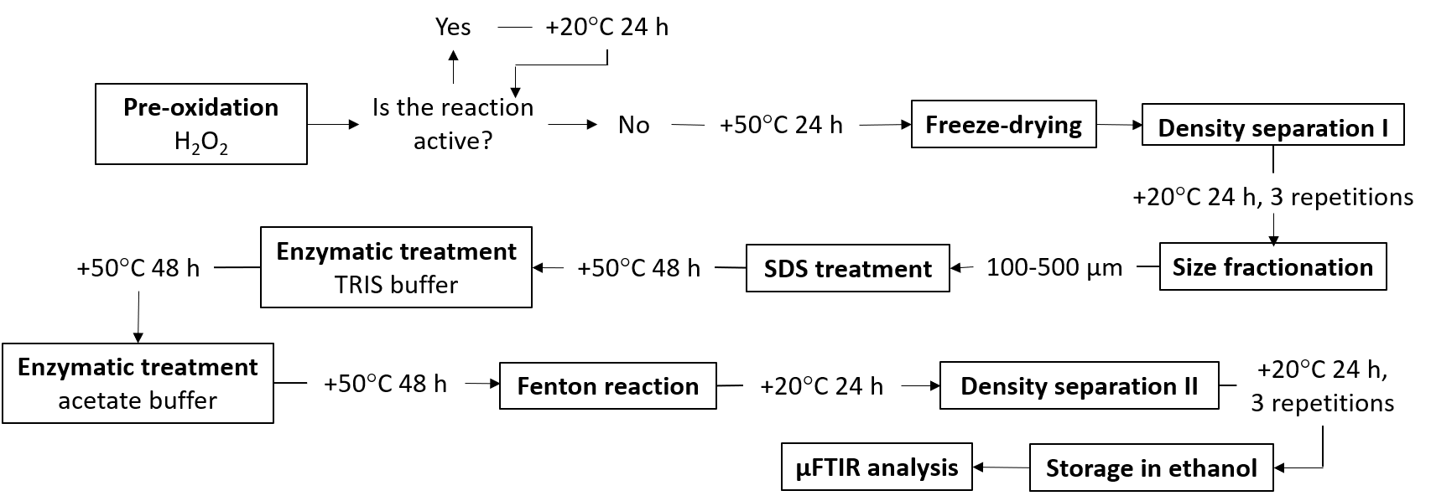
Supplementary Figure S7. Microplastic sediment samples preparation/purification scheme. First, 30 % hydrogen peroxide (H₂O₂) was added to the samples in proportion 1:2. Samples were incubated at room temperature (+20 ⁰C) or in a shaking bath (+50℃, 100 rpm) for 24 h - 48 h depending on the treatment step. Density separation was performed in a separatory funnel with heavy-density liquid (sodium polytungstate, density 1.75 kg L⁻¹), followed by size fractionation using 100 µm and 500 µm stainless steel sieves. Only the size fraction 100-500 µm was further used. The relatively high lowest size border (100 µm) was used to remove a considerable amount of pollen in the samples. Sediments were transferred from one environment to another by vacuum filtration, collecting sample material onto a 10 μm stainless steel filter. Then, the proteolytic enzyme alcalase was used with the TRIS buffer (pH 8.2), while viscozyme and cellulase (cellulose blend) with acetate buffer (pH 4.8) were added. Before the Fenton reaction, samples were transferred into 200 ml of filtered Milli-Q water and cooled to 15-20 °C. During the reaction, the samples were kept within the temperature range 20-30 °C for at least 4 hours, then left to stand overnight at an ambient temperature. Next, the final density separation was performed, after which the samples were washed with 500 ml warm (+50℃) filtered Milli-Q water and 200 ml 50 % ethanol solution and then flushed from the filter into clean crimp bottles using 50 % ethanol solution. The samples were dried at 50 ℃ until the total sample evaporated and then the volume was adjusted to 5 mL volume.

Supplementary Table S1. Found polymers in lakes Seksu, Pinku, Usmas. The microplastic concentration (particles‧g⁻¹) throughout the core and corresponding age of the dated core layer. Abbreviations and explanations: PAN - polyacrylonitrile; Acrylates – combined group of derivative polymer of acrylic acid, SAN (styrene-acrylonitrile), ABS (acrylonitrile-butadiene-styrene), NBR (acrylonitrile butadiene rubber); Rubbers – combined group of BIIR (butyl rubber), BR (butadiene rubber), SR (synthetic rubber); PA - polyamide; PE - polyethylene; PES - polyester; PET – polyethylene terephthalate; BIO – combined group of polylactic acid (PLA) and polyhydroxybutyrate (PHB); POM - polyoxymethylen; PP - polypropylene; PS - polystyrene; PUR - polyurethane; PVA - polyvinyl acetate; PVC - polyvinyl chloride.
 | SEKSU |  |  |  |  | PINKU |  |  |  |  | USMAS
 | Polymer | Depth (cm) | Year | Concentration (particle‧g⁻¹) |  | Polymer | Depth (cm) | Year | Concentration (particle‧g⁻¹) |  | Polymer | Depth (cm) | Year | Concentration (particle‧g⁻¹)
 | PAN | 0-10 | 2019-2007 | 10.68 |  | Rubbers | 0 - 5 | 2019-2002 | 4.29 |  | Acrylates | 0 - 5 | 2019-1997 | 0.08
 | Acrylates | 0-10 | 2019-2007 | 2.55 |  | PE | 0 - 5 | 2019-2002 | 1.68 |  | Rubbers | 0 - 5 | 2019-1997 | 1.90
 | Rubbers | 0-10 | 2019-2007 | 10.32 |  | PET | 0 - 5 | 2019-2002 | 0.19 |  | PA | 0 - 5 | 2019-1997 | 0.30
 | PA | 0-10 | 2019-2007 | 6.92 |  | PUR | 0 - 5 | 2019-2002 | 4.10 |  | PE | 0 - 5 | 2019-1997 | 0.38
 | PE | 0-10 | 2019-2007 | 16.27 |  | PVA | 0 - 5 | 2019-2002 | 0.37 |  | PP | 0 - 5 | 2019-1997 | 0.23
 | PES | 0-10 | 2019-2007 | 1.70 |  | PA | 5-10 | 2002-1953 | 0.05 |  | PS | 0 - 5 | 2019-1997 | 0.15
 | PET | 0-10 | 2019-2007 | 6.56 |  | PE | 5-10 | 2002-1953 | 0.15 |  | PUR | 0 - 5 | 2019-1997 | 0.38
 | BIO | 0-10 | 2019-2007 | 9.83 |  | PES | 5-10 | 2002-1953 | 0.15 |  | PVA | 0 - 5 | 2019-1997 | 0.46
 | POM | 0-10 | 2019-2007 | 0.61 |  | PP | 5-10 | 2002-1953 | 0.21 |  | PVC | 0 - 5 | 2019-1997 | 0.23
 | PP | 0-10 | 2019-2007 | 3.04 |  | PUR | 5-10 | 2002-1953 | 0.10 |  | PAN | 10-15 | 1971-1949 | 0.06
 | PS | 0-10 | 2019-2007 | 12.26 |  | PVA | 5-10 | 2002-1953 | 0.13 |  | PA | 10-15 | 1971-1949 | 0.11
 | PUR | 0-10 | 2019-2007 | 10.08 |  | Rubbers | 10-15 | 1953-1881 | 0.28 |  | PES | 10-15 | 1971-1949 | 0.22
 | PVA | 0-10 | 2019-2007 | 7.41 |  | PA | 10-15 | 1953-1881 | 0.84 |  | PET | 10-15 | 1971-1949 | 0.06
 | PAN | 10-15 | 2007-1997 | 10.68 |  | PE | 10-15 | 1953-1881 | 0.47 |  | PP | 10-15 | 1971-1949 | 0.17
 | Rubbers | 10-15 | 2007-1997 | 1.58 |  | PES | 10-15 | 1953-1881 | 1.45 |  | PUR | 10-15 | 1971-1949 | 1.06
 | PA | 10-15 | 2007-1997 | 14.24 |  | BIO | 10-15 | 1953-1881 | 1.17 |  | PVA | 10-15 | 1971-1949 | 0.39
 | PE | 10-15 | 2007-1997 | 8.70 |  | PP | 10-15 | 1953-1881 | 0.61 |  | PVC | 10-15 | 1971-1949 | 0.17
 | PES | 10-15 | 2007-1997 | 11.87 |  | PUR | 10-15 | 1953-1881 | 0.47 |  | Rubbers | 10-15 | 1971-1949 | 0.17
 | BIO | 10-15 | 2007-1997 | 13.45 |  | PVA | 10-15 | 1953-1881 | 0.47 |  | Rubbers | 15-20 | 1949-1925 | 0.15
 | PP | 10-15 | 2007-1997 | 8.70 |  | PVC | 10-15 | 1953-1881 | 0.09 |  | PA | 15-20 | 1949-1925 | 0.15
 | PS | 10-15 | 2007-1997 | 0.79 |  | PA | 15-20 | 1881-1813 | 1.36 |  | PE | 15-20 | 1949-1925 | 0.31
 | PUR | 10-15 | 2007-1997 | 17.80 |  | PUR | 15-20 | 1881-1813 | 0.47 |  | PES | 15-20 | 1949-1925 | 0.08
 | PVA | 10-15 | 2007-1997 | 11.47 |  | PVA | 15-20 | 1881-1813 | 0.63 |  | PET | 15-20 | 1949-1925 | 0.15
 | PVC | 10-15 | 2007-1997 | 0.79 |  | PA | 20-25 | 1813-1733 | 0.24 |  | PP | 15-20 | 1949-1925 | 0.08
 | PAN | 15 - 20 | 1997-1988 | 0.83 |  | PE | 20-25 | 1813-1733 | 0.18 |  | PVA | 15-20 | 1949-1925 | 0.15
 | PA | 15 - 20 | 1997-1988 | 1.00 |  | PES | 20-25 | 1813-1733 | 0.29 |  | Rubbers | 20-25 | 1925-1900 | 0.15
 | PE | 15 - 20 | 1997-1988 | 2.49 |  | PET | 20-25 | 1813-1733 | 0.03 |  | PA | 20-25 | 1925-1900 | 0.38
 | PES | 15 - 20 | 1997-1988 | 0.33 |  | BIO | 20-25 | 1813-1733 | 0.05 |  | PE | 20-25 | 1925-1900 | 0.61
 | PP | 15 - 20 | 1997-1988 | 1.82 |  | PP | 20-25 | 1813-1733 | 0.08 |  | PES | 20-25 | 1925-1900 | 0.23
 | PS | 15 - 20 | 1997-1988 | 0.33 |  |  |  |  |  |  | BIO | 20-25 | 1925-1900 | 0.15
 | PUR | 15 - 20 | 1997-1988 | 4.64 |  |  |  |  |  |  | PP | 20-25 | 1925-1900 | 0.31
 | PVA | 15 - 20 | 1997-1988 | 0.83 |  |  |  |  |  |  | PUR | 20-25 | 1925-1900 | 0.46
 | PVC | 15 - 20 | 1997-1988 | 0.17
 | PAN | 20-25 | 1988-1979 | 0.52
 | Rubbers | 20-25 | 1988-1979 | 5.35
 | PE | 20-25 | 1988-1979 | 1.38
 | PES | 20-25 | 1988-1979 | 0.86
 | PET | 20-25 | 1988-1979 | 0.35
 | BIO | 20-25 | 1988-1979 | 0.86
 | PS | 20-25 | 1988-1979 | 3.45
 | PUR | 20-25 | 1988-1979 | 4.49
 | PVA | 20-25 | 1988-1979 | 6.21
 | PVC | 20-25 | 1988-1979 | 0.35
 | PAN | 25-30 | 1979-1969 | 0.15
 | PA | 25-30 | 1979-1969 | 0.30
 | PES | 25-30 | 1979-1969 | 0.45
 | PET | 25-30 | 1979-1969 | 0.30
 | BIO | 25-30 | 1979-1969 | 0.15
 | PP | 25-30 | 1979-1969 | 0.30
 | PUR | 25-30 | 1979-1969 | 0.60
 | PA | 30-35 | 1969-1959 | 1.29
 | PE | 30-35 | 1969-1959 | 3.11
 | PES | 30-35 | 1969-1959 | 0.78
 | PP | 30-35 | 1969-1959 | 2.85
 | PS | 30-35 | 1969-1959 | 0.52
 | PUR | 30-35 | 1969-1959 | 1.04
 | PVA | 30-35 | 1969-1959 | 4.40
 | PVC | 30-35 | 1969-1959 | 0.26
 | PAN | 35-40 | 1959-1949 | 0.26
 | Rubbers | 35-40 | 1959-1949 | 0.52
 | PA | 35-40 | 1959-1949 | 2.59
 | PE | 35-40 | 1959-1949 | 3.63
 | PES | 35-40 | 1959-1949 | 0.52
 | PS | 35-40 | 1959-1949 | 2.07
 | PUR | 35-40 | 1959-1949 | 0.26
 | PVA | 35-40 | 1959-1949 | 5.96
 | PA | 40-45 | 1949-1936 | 1.51
 | PAN | 40-45 | 1949-1936 | 0.25
 | PE | 40-45 | 1949-1936 | 1.76
 | PUR | 40-45 | 1949-1936 | 0.25
 | PVA | 40-45 | 1949-1936 | 1.26

Supplementary Table S2. The total microplastic concentrations (particles‧g⁻¹) in lakes Seksu, Pinku, Usmas. Concentrations throughout the core and average concentration, standard deviation (SD) are shown.

Lake | Depth (cm) | Concentration (particle g-1) | Average concentration (particle g-1) | SD
SEKŠU | 0-10 | 98.22 | 33.99 | 40.76
SEKŠU | 10-15 | 100.09 | 33.99 | 40.76
SEKŠU | 15 - 20 | 12.44 | 33.99 | 40.76
SEKŠU | 20-25 | 23.81 | 33.99 | 40.76
SEKŠU | 25-30 | 2.25 | 33.99 | 40.76
SEKŠU | 30-35 | 14.24 | 33.99 | 40.76
SEKŠU | 35-40 | 15.80 | 33.99 | 40.76
SEKŠU | 40-45 | 5.04 | 33.99 | 40.76
PINKU | 0 - 5 | 10.63 | 4.12 | 4.18
PINKU | 5-10 | 0.80 | 4.12 | 4.18
PINKU | 10-15 | 5.84 | 4.12 | 4.18
PINKU | 15-20 | 2.46 | 4.12 | 4.18
PINKU | 20-25 | 0.86 | 4.12 | 4.18
USMAS | 0 - 5 | 4.11 | 2.47 | 1.25
USMAS | 10-15 | 2.40 | 2.47 | 1.25
USMAS | 15-20 | 1.07 | 2.47 | 1.25
USMAS | 20-25 | 2.30 | 2.47 | 1.25

Supplementary Table S3. Output from principal component analysis (PCA): A - variable coordinates in nine principal components; B - quality of representation of the variables on factor map COS² (square cosine, squared coordinates); C - variable contribution in accounting for the variability in a given principal component (%). Abbreviations: MN – minor dimension, MJ – major dimension, PD – polymer density, DE – depth, DA – date, SH – shape, OM – organic matter, BD – dry bulk density, RBD – relative bulk density.
- Variable coordinates
 | PC1 | PC2 | PC3 | PC4 | PC5 | PC6 | PC7 | PC8 | PC9
MN | 0.44895 | 0.73161 | -0.48240 | 0.01853 | -0.03553 | 0.02156 | -0.00670 | 0.00667 | -0.16832
MJ | -0.04847 | 0.75683 | -0.05090 | -0.02072 | 0.64055 | 0.01602 | 0.00966 | -0.00187 | 0.10575
PD | -0.02124 | 0.16892 | 0.20776 | -0.85480 | -0.13455 | 0.42292 | -0.01125 | 0.00742 | 0.00443
Depth | 0.34337 | -0.51940 | -0.59538 | -0.33720 | 0.28398 | -0.18819 | 0.10833 | 0.12777 | -0.00256
Date | -0.83503 | 0.19974 | -0.06122 | 0.30450 | -0.13769 | 0.34068 | 0.06282 | 0.16548 | -0.00154
Shape | 0.55885 | 0.28414 | -0.56853 | 0.06435 | -0.50910 | 0.01184 | -0.00802 | 0.00928 | 0.14179
OM | -0.80586 | -0.00085 | -0.52890 | -0.10649 | -0.06075 | -0.00795 | 0.19288 | -0.13619 | -0.00300
BD | 0.77167 | 0.04656 | 0.51238 | 0.18476 | -0.01373 | 0.19401 | 0.26039 | -0.00772 | -0.00071
RBD | 0.30497 | -0.45398 | -0.43300 | 0.25647 | 0.25512 | 0.61135 | -0.07386 | -0.05770 | -0.00239

- Quality on the factor map COS2
 | PC1 | PC2 | PC3 | PC4 | PC5 | PC6 | PC7 | PC8 | PC9
MN | 0.202 | 0.535 | 0.233 | <0.001 | 0.001 | <0.001 | <0.001 | <0.001 | 0.028
MJ | 0.002 | 0.573 | 0.003 | <0.001 | 0.410 | <0.001 | <0.001 | <0.001 | 0.011
PD | <0.001 | 0.029 | 0.043 | 0.731 | 0.018 | 0.179 | <0.001 | <0.001 | <0.001
Depth | 0.118 | 0.270 | 0.354 | 0.114 | 0.081 | 0.035 | 0.012 | 0.016 | <0.001
Date | 0.697 | 0.040 | 0.004 | 0.093 | 0.019 | 0.116 | 0.004 | 0.027 | <0.001
Shape | 0.312 | 0.081 | 0.323 | 0.004 | 0.259 | <0.001 | <0.001 | <0.001 | <0.001
OM | 0.649 | <0.001 | 0.280 | 0.011 | 0.004 | <0.001 | 0.037 | 0.019 | <0.001
BD | 0.595 | 0.002 | 0.263 | 0.034 | <0.001 | 0.038 | 0.068 | <0.001 | <0.001
RBD | 0.093 | 0.206 | 0.187 | 0.066 | 0.065 | 0.374 | 0.005 | 0.003 | <0.001

- Variable contribution
 | PC1 | PC2 | PC3 | PC4 | PC5 | PC6 | PC7 | PC8 | PC9
MN | 7.550 | 30.846 | 13.772 | 0.033 | 0.147 | 0.063 | 0.035 | 0.068 | 47.487
MJ | 0.088 | 33.009 | 0.153 | 0.041 | 47.853 | 0.035 | 0.074 | 0.005 | 18.742
PD | 0.017 | 1.644 | 2.555 | 69.372 | 2.111 | 24.084 | 0.100 | 0.084 | 0.033
Depth | 4.416 | 15.547 | 20.979 | 10.796 | 9.406 | 4.769 | 9.280 | 24.797 | 0.011
Date | 26.118 | 2.299 | 0.222 | 8.803 | 2.211 | 15.628 | 3.120 | 41.594 | 0.004
Shape | 11.698 | 4.653 | 19.130 | 0.393 | 30.228 | 0.019 | 0.051 | 0.131 | 33.698
OM | 24.325 | 0.000 | 16.556 | 1.077 | 0.430 | 0.009 | 29.416 | 28.173 | 0.015
BD | 22.305 | 0.125 | 15.537 | 3.241 | 0.022 | 5.068 | 53.611 | 0.091 | 0.001
RBD | 3.484 | 11.877 | 11.096 | 6.245 | 7.591 | 50.326 | 4.314 | 5.058 | 0.010

