Supplementary data

Supplementary Table 1: F-values and p-values of repeated measures ANOVAS for all presented parameters.
RM ANOVA outcome | treatment | time point | interaction
Stomatal Conductance
stomatal Conductance  pre re-watering | F_{(1,6)} = 10.87  p = 0.017 * | F_{(1,21)} = 0.42  p = 0.53 | F_{(1,21)} = 44.66  p < 0.0001 ***
Only 1 time point post-watering
stomatal Conductance  overall | F_{(1,6)} = 13.47  p = 0.011 * | F_{(1,37)} = 0.65  p = 0.43 | F_{(1,37)} = 2.35  p = 0.13
Photosynthesis rate
photosynthesis rate  pre re-watering | F_{(1,6)} = 10.79  p = 0.017 * | F_{(1,21)} = 14.33  p = 0.0011 ** | F_{(1,21)} = 65.68  p < 0.0001 ***
Only 1 time point post-watering
photosynthesis rate  overall | F_{(1,6)} = 16.16  p = 0.007 ** | F_{(1,37)} = 4.04  p = 0.052 | F_{(1,37)} = 5.27  p = 0.028 *
Leaf water potential
leaf water potential  Pre-rewatering | F_{(1,6)} = 13.28  p = 0.011 * | F_{(1,6)} = 28.92  p = 0.0017 ** | F_{(1,6)} = 45.18  p = 0.0005 ***
leaf water potential  Post-rewatering | F_{(1,6)} = 5.28  p = 0.061 | F_{(1, 5)} = 14.25  p = 0.013 * | F_{(1, 5)} = 2.04  p = 0. 21
leaf water potential  overall | F_{(1,6)} = 1.70  p = 0.24 | F_{(1, 14)} = 0.28  p = 0. 60 | F_{(1, 14)} = 0.28  p = 0. 60
Leaf tissue ABA
leaf tissue ABA  pre re-watering | F_{(1,6)} = 2.19  p = 0.19 | F_{(1,6)} = 6.22  p = 0.047 * | F_{(1,6)} = 13.15  p = 0.010 *
leaf tissue ABA  post re-watering | F_{(1,6)} = 5.28  p = 0.061 | F_{(1,5)} = 14.25  p = 0.013 * | F_{(1,5)} = 2.04  p = 0.21
leaf tissue ABA  overall | F_{(1,6)} = 3.62  p = 0.11 | F_{(1, 21)} = 0.67  p = 0. 42 | F_{(1, 21)} = 0.07  p = 0. 80
mean soil moisture
mean soil moisture  pre rewatering | F_{(1,6)} = 18.90  p = 0.005 ** | F_{(1,30)} = 75.28  p < 0.0001 *** | F_{(1,30)} = 48.15  p < 0.0001 ***
mean soil moisture  post re-watering | F_{(1,6)} = 34.27  p = 0.0011 ** | F_{(1,6)} = 22.11  p = 0.0033 ** | F_{(1,6)} = 4.02  p = 0.09
mean soil moisture  overall | F_{(1,6)} = 2.32  p = 0.18 | F_{(1,46)} = 0.64  p = 0.43 | F_{(1,46)} = 5.52  p = 0.023 *
Normalised average tuber water content (TWC)
normalised average TWC  pre rewatering | F_{(1, 6)} = 13.65  p = 0.010 * | F_{(1,78)} = 3.13  p = 0.081 | F_{(1,78)} = 4.42  p = 0.039 *
normalised average TWC  post re-watering | F_{(1,6)} = 3.64  p = 0.11 | F_{(1, 38)} = 23.00  p < 0.0001 *** | F_{(1,38)} = 6.49  p = 0.02 **
normalised average TWC  overall | F_{(1,6)} = 13.47  p = 0.010 * | F_{(1,126)} = 5.15  p = 0.025* | F_{(1,126)}= 0.03  p = 0.86
Normalised tuber volume
normalised tuber volume  pre re-watering | F_{(1,6)} = 27.38  p = 0.002 ** | F_{(1,78)} = 19.18  p < 0.0001 *** | F_{(1,78)} = 31.98  p < 0.0001 ***
normalised tuber volume  post re-watering | F_{(1,6)} = 12.49  p = 0.012 * | F_{(1,38)} = 36.56  p < 0.0001 *** | F_{(1,38)} = 6.78  p = 0.013 *
normalised tuber volume  overall | F_{(1,6)} = 9.48  p = 0.02 * | F_{(1,126)} = 39.66  p < 0.0001 *** | F_{(1,126)} = 2.17  p = 0.14
Normalised total tuber water content (TWC)
normalised total TWC  pre re-watering | F_{(1,6)} = 9.45  p = 0.021 * | F_{(1,78)} = 9.02  p = 0.0036 ** | F_{(1,78)} = 12.12  p = 0.0008 ***
normalised total TWC  post re-watering | F_{(1,6)} = 3.63  p = 0.11 | F_{(1,38)} = 23.0  p < 0.0001 *** | F_{(1,38)} = 6.49  p = 0.015 *
normalised total TWC  overall | F_{(1,6)} = 3.69  p = 0.10 | F_{(1,126)} = 16.43  p = 0.0001 *** | F_{(1,126)} = 0.03  p = 0.86

Supplementary Figure 1: Calibration curve of the soil water profiler for different soil water contents of the soil used in this experiment. Each symbol indicates the same soil with different amounts of water added.

Supplementary Figure 2: Soil water retention curve for the soil (“Kaldenkirchen soil with 10 % sand) used in the experiment. Data from three independent measurement courses.

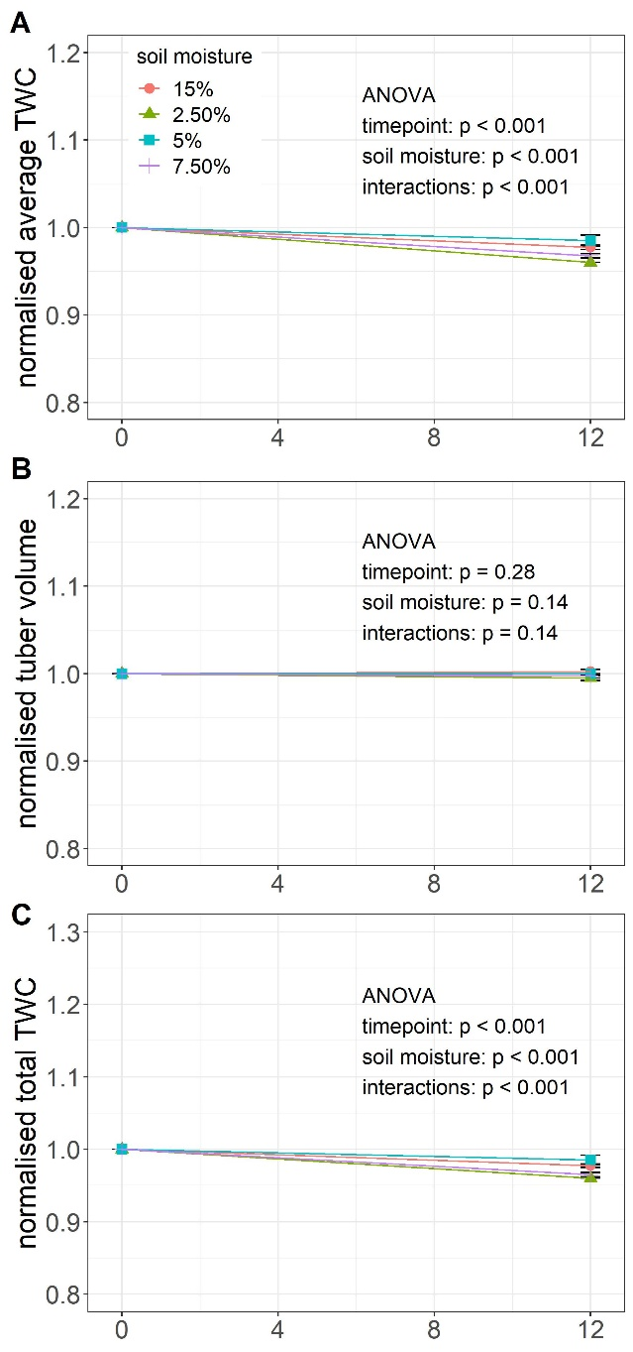

Supplementary Figure 3: Normalised average TWC (tuber water content) (A), normalised tuber volume (B) and normalised total TWC (C) of individual unsprouted tubers measured in the morning (0 HAS) and evening (12 HAS) of the same day. The starting point of the experiment is set to 1 for each tuber (normalised). Symbols are means ± SE of 16 tubers. Asterisks indicate significant differences between the two measured timepoints according to t-test with * p < 0.05, ** p < 0.01, *** p < 0.001.

