A green and selective process for the preparation of N-monosubstituted ureas in a mixture of choline chloride and Aluminium nitrate as solvent

Mohammadreza Jafari, Atefeh darvishi and Akbar Heydari

Table of Contents:
IR, Mass, 1H and 13C NMR spectra of 1b
IR, Mass, 1H and 13C NMR spectra of 2b
IR, Mass, 1H and 13C NMR spectra of 3b
IR, Mass, 1H and 13C NMR spectra of 4b
IR, Mass, 1H and 13C NMR spectra of 5b
IR, Mass and 1H NMR spectra of 6b
IR, Mass, 1H and 13C NMR spectra of 7b
IR, Mass, 1H and 13C NMR spectra of 8b
IR, Mass, 1H and 13C NMR spectra of 2d
IR, Mass, 1H and 13C NMR spectra of 3d
IR, Mass, 1H and 13C NMR spectra of 4d
IR, Mass, 1H and 13C NMR spectra of 6d

IR, Mass, ¹H and ¹³C NMR analysis for Benzyl urea

Molecular weight: 150.18

IR:
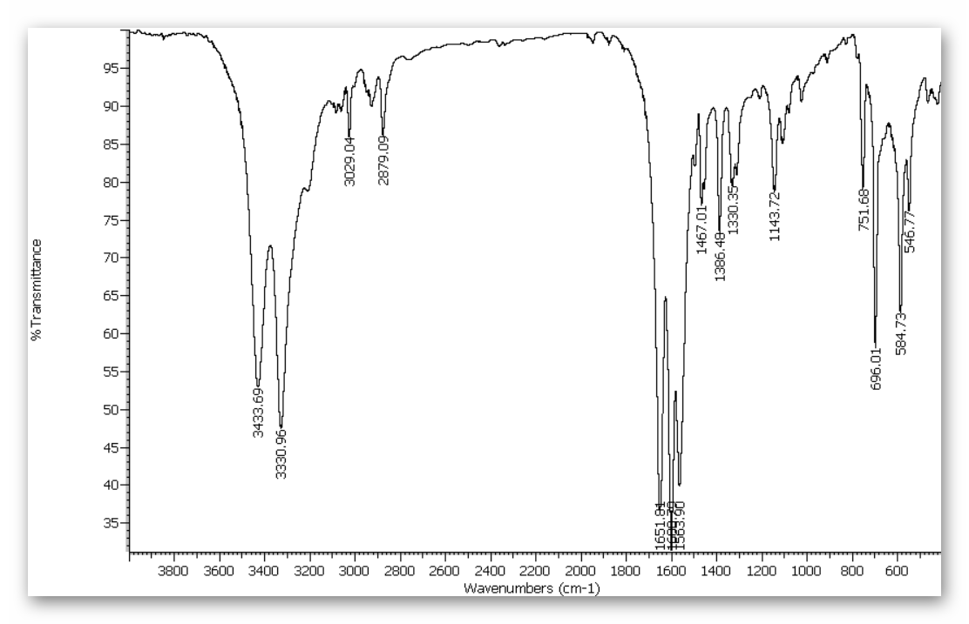
The two peaks located at 3433 and 3330 cm⁻¹, were attributed to the asymmetric and symmetric stretching vibrations of the NH-bond. Additionally, the FT-IR peaks, at 1600 and 1467 cm⁻¹ were due to the deformation and stretching vibrations of the N-H and CN-bonds.The adsorption in the region of 1651 cm⁻¹ is due to the tensile vibration of the C = O bond.

Mass:
m/z: 150.2
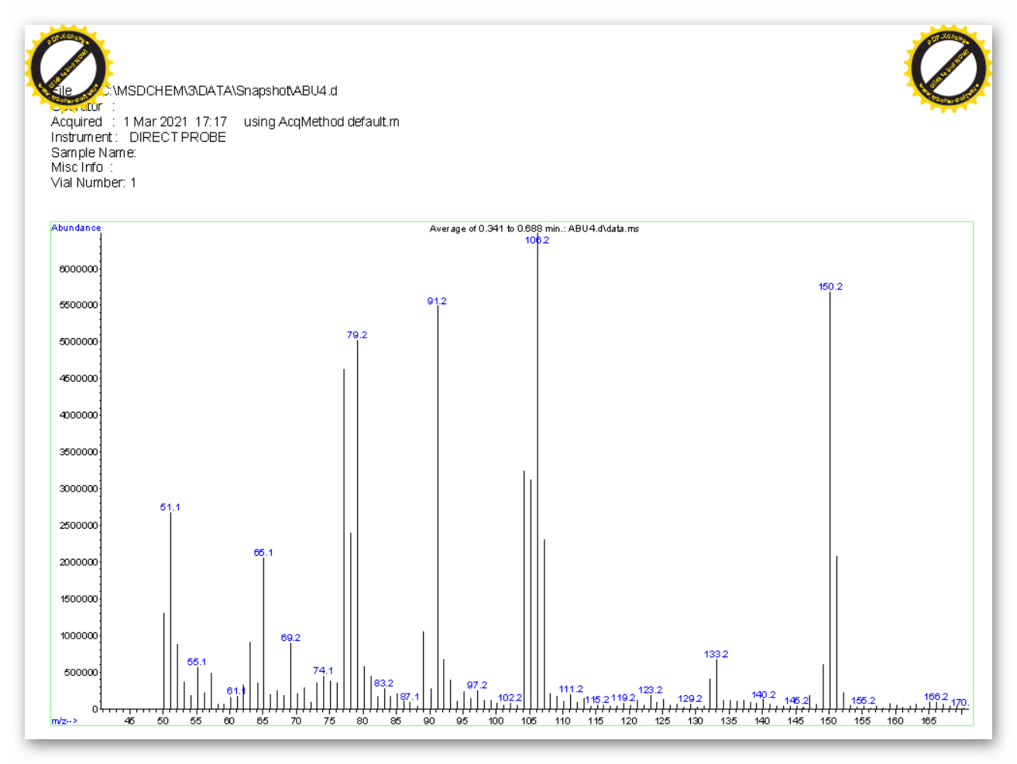

¹H NMR:
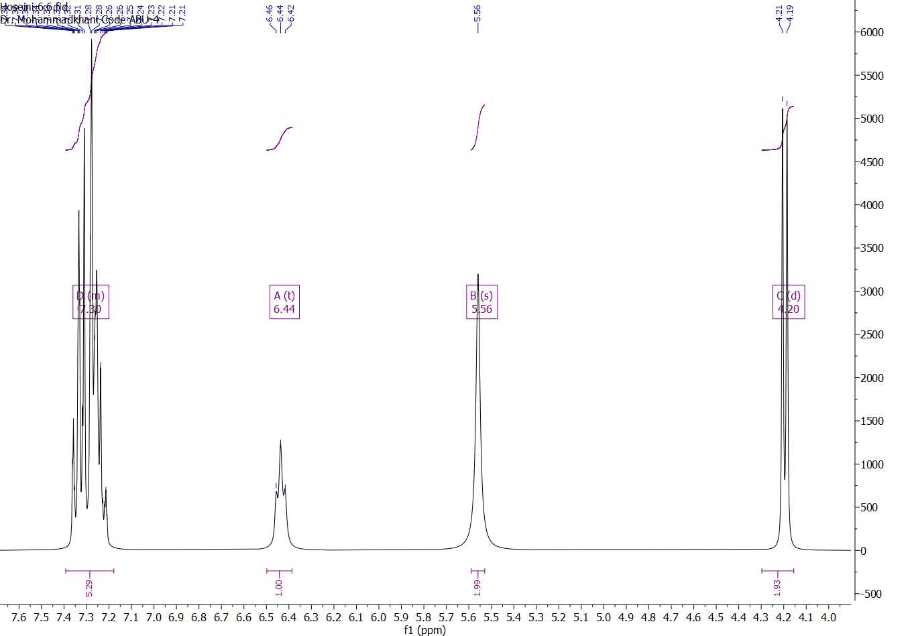
¹³C NMR:
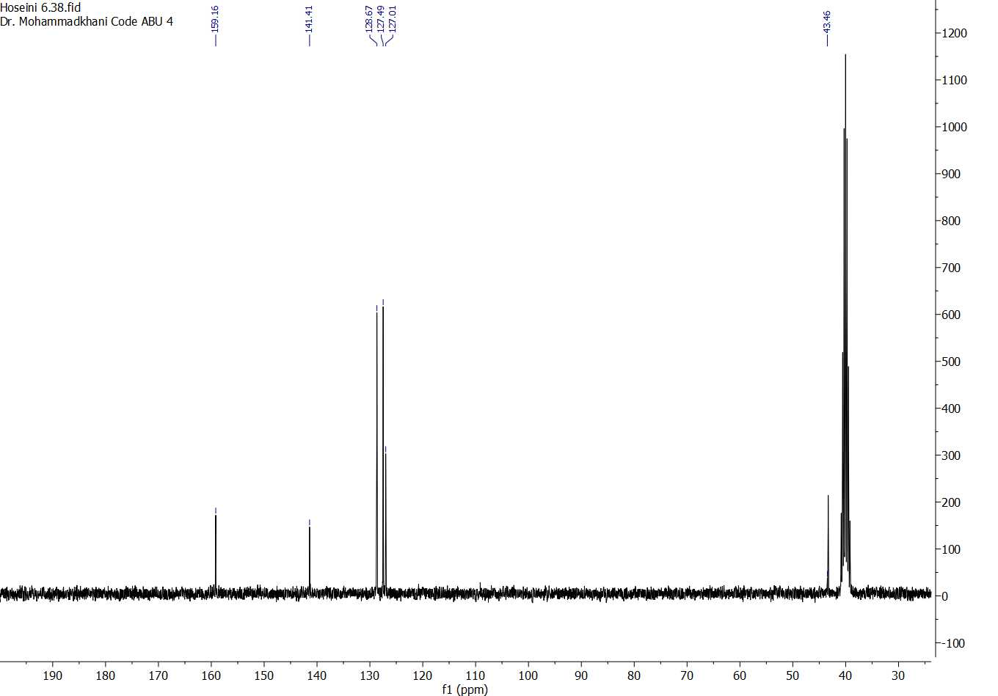

Isolated yield 91%; white solid; Melting point: 150-152 ºC. ¹H-NMR (300 MHz, DMSO-d₆) δ 7.30 (m, 5H), 6.44 (t, j=6 Hz, 1H), 5.56 (s, 2H), 4.2 (d, j=6Hz, 2H). ¹³C-NMR (75 MHz, DMSO-d₆) δ 159.16, 141.41, 128.67, 127.49, 127.01, 43.46. IR (neat, cm⁻¹): 3433.69, 3330.96, 3029.04, 2879.09, 1651.81, 1600.79, 1563.90, 1467.01, 1386.48, 1330.35, 1143.72, 751.68, 696.01, 584.73, 546.77.

IR, Mass, ¹H and ¹³C NMR analysis for 4-methoxyBenzyl urea
Molecular weight: 180.21

IR:
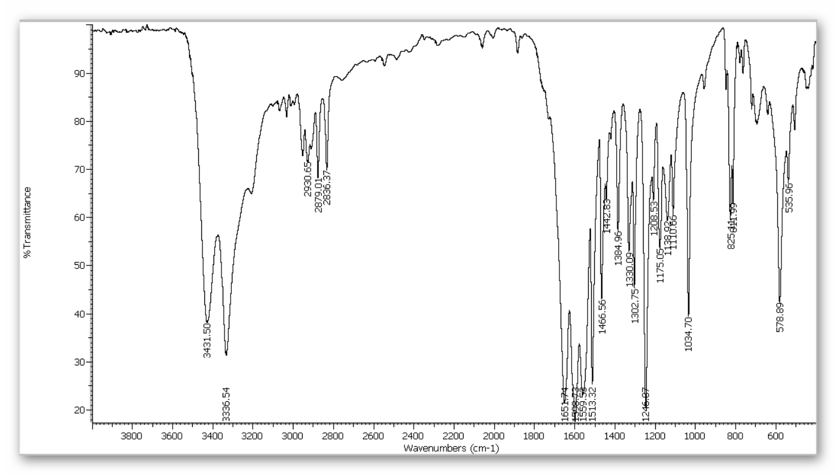

Mass:
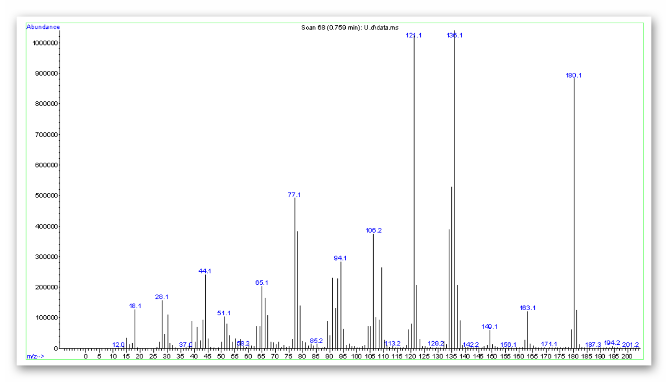

m/z: 180.1

¹H-NMR:
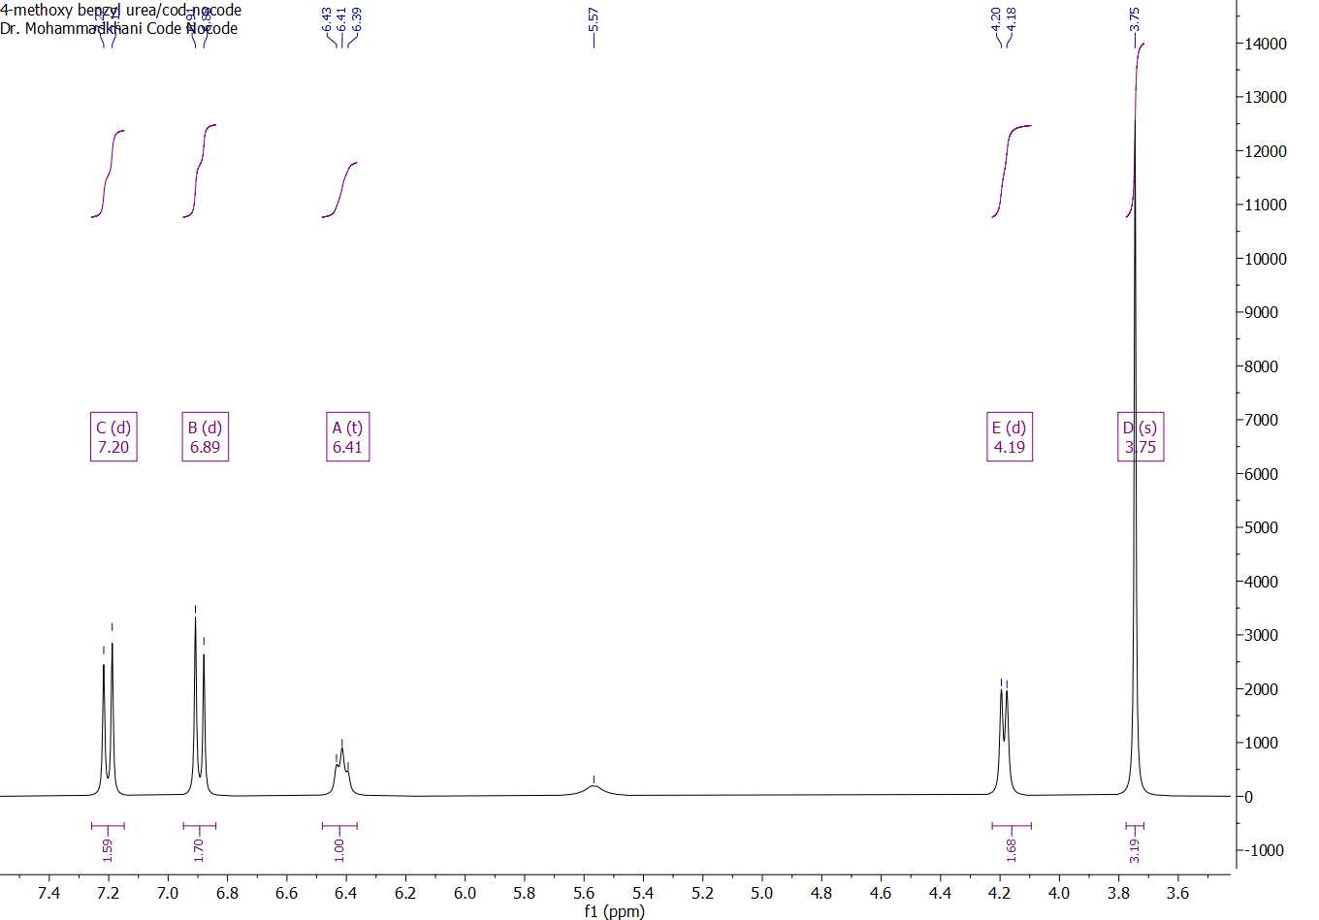

¹³C NMR:
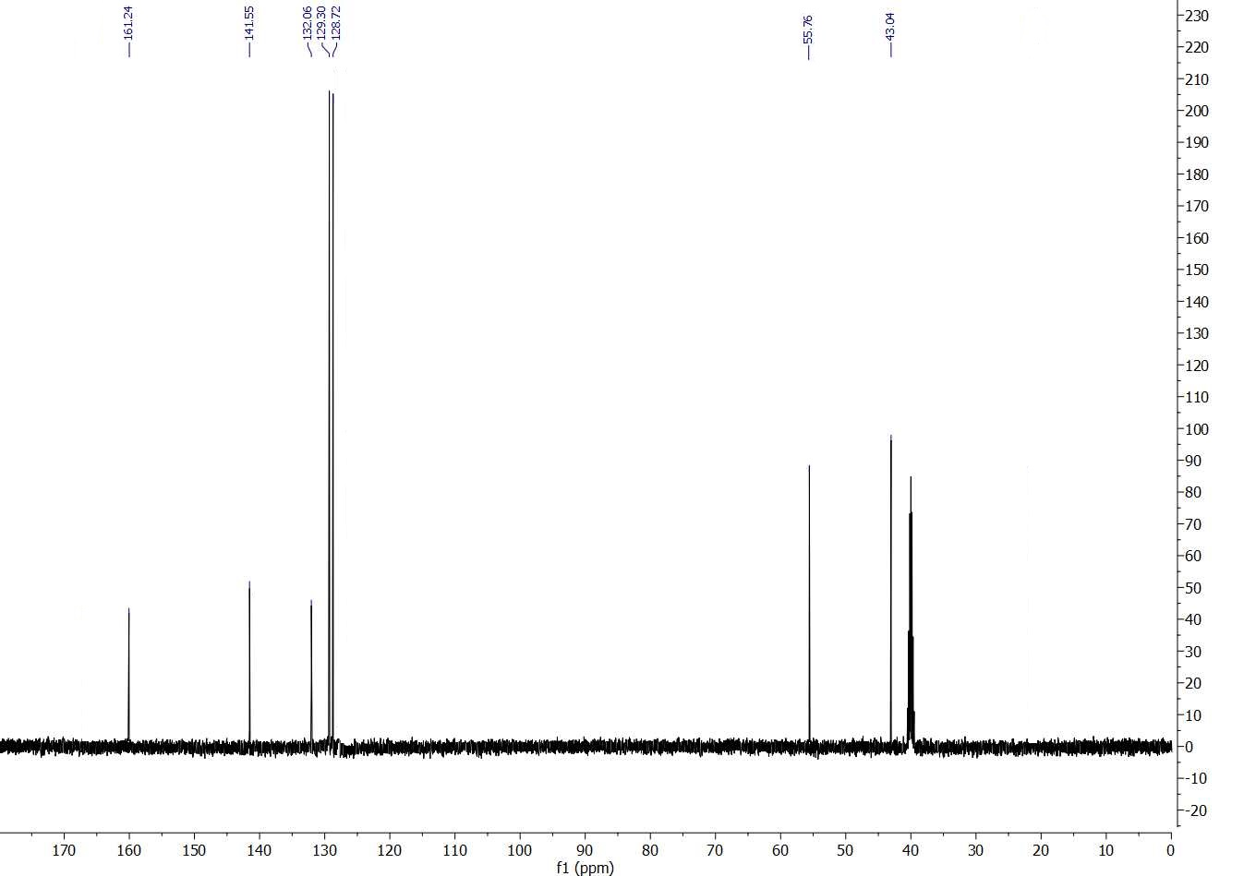
Isolated yield >>91%; white solid; Melting point: 153-154 ºC. ¹H-NMR (300 MHz, DMSO-d₆) δ 7.20 (d, j=9 Hz, 2H), 6.89 (d, j=9 Hz, 2H), 6.41 (t, j=6Hz, 1H), 5.57 (s, 2H), 4.19 (d, j=6 Hz, 2H), 3.75 (s, 3H). ¹³C-NMR (75 MHz, DMSO-d₆) δ 161.24, 141.55, 132.06, 129.30, 128.72, 55.76, 43.04. IR (neat, cm⁻¹): 3431.50, 3336.54, 2930.65, 2836.37, 1651.74, 1600.73, 1559.53, 1513.32, 1456.56, 1442.83, 1384.96, 1330.09, 1302.75, 1246.07, 1208.53, 1175.05, 1138.92, 1110.66, 1034.70, 825, 811.99, 578.89, 535.96.

IR, Mass, ¹H and ¹³C NMR analysis for 4-methylBenzyl urea
Molecular weight: 164.21

IR:
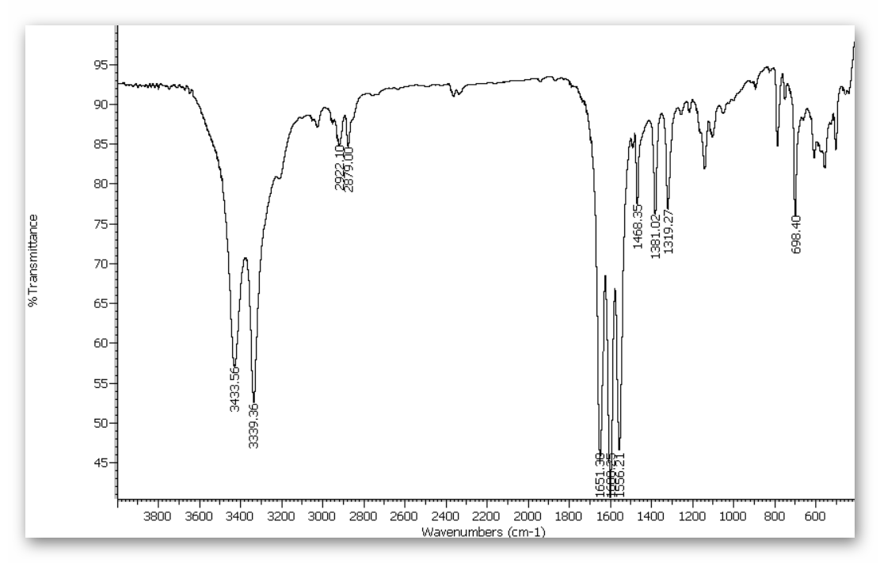
Mass:
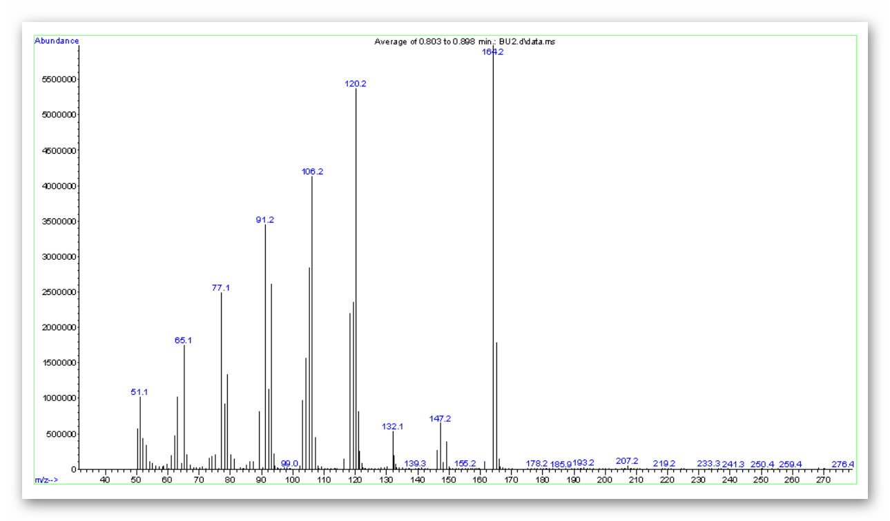

m/z: 164.2

¹H NMR:
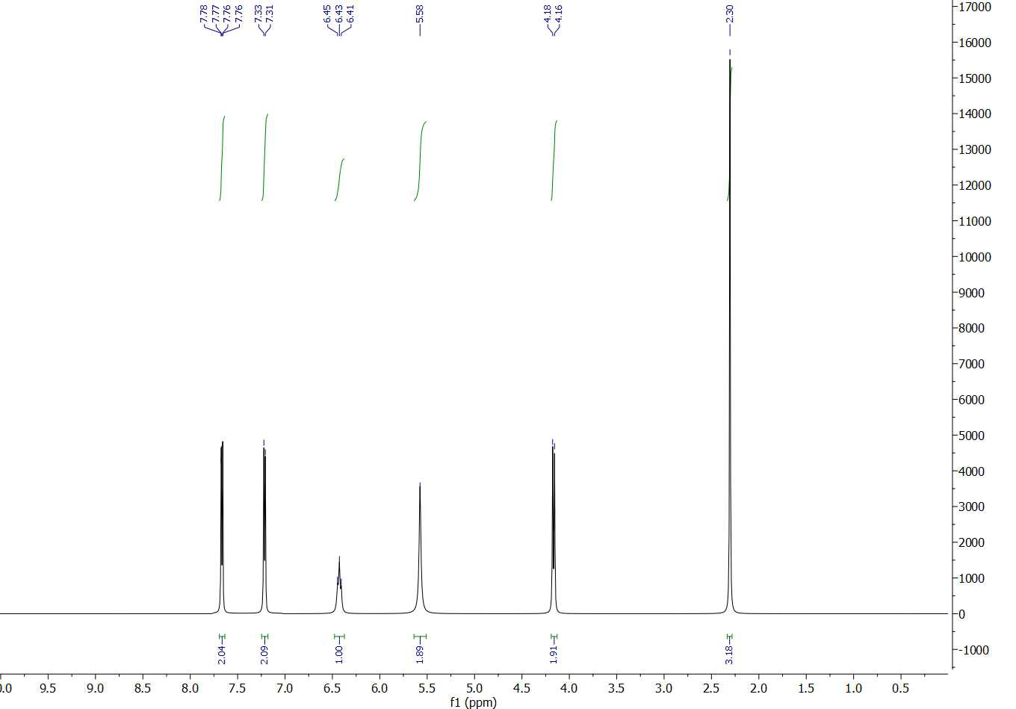
¹³C NMR:
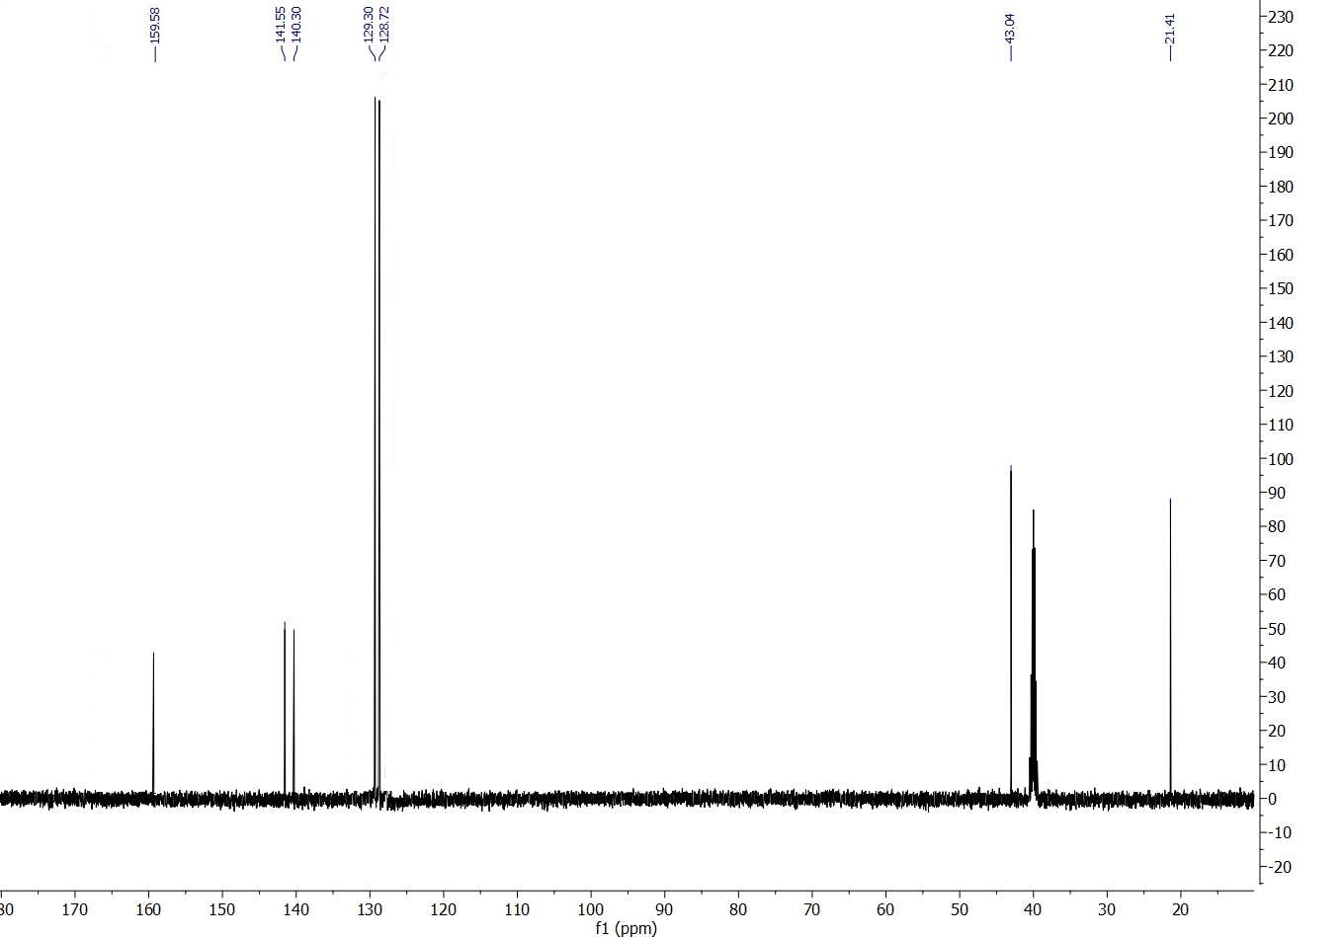

Isolated yield 94%; white solid; Melting point: 198-201 ºC. ¹H-NMR (300 MHz, DMSO-d₆) δ 7.70 (d, j=9 Hz, 2H), 7.32 (d, j=9 Hz, 2H), 6.43 (t, j=6Hz, 1H), 5.58 (s, 2H), 4.17 (d, j=6 Hz, 2H), 2.30 (s, 3H). ¹³C-NMR (75 MHz, DMSO-d₆) δ 159.58, 141.55, 140.30, 129.30, 128.72, 43.06, 21.41. IR (neat, cm⁻¹): 3433.56, 3339.36, 2922.10, 2879.00, 1651.39, 1600.25, 1556.21, 1468.35, 1381.02, 1319.27, 698.40.

IR, Mass, ¹H and ¹³C NMR analysis for 4-ChloroBenzyl urea

Molecular weight: 184.62

IR:
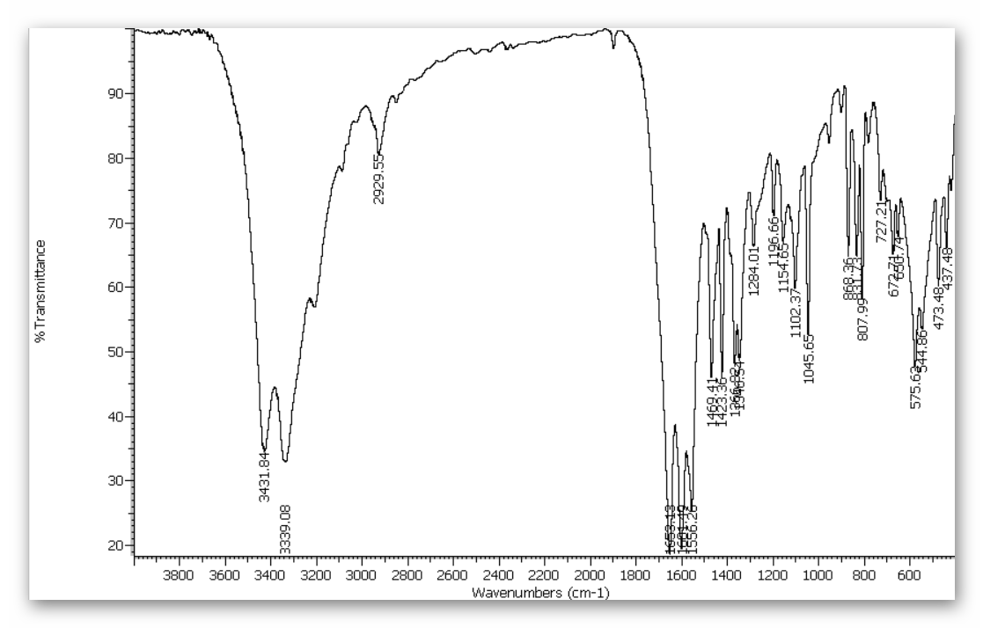
Mass:
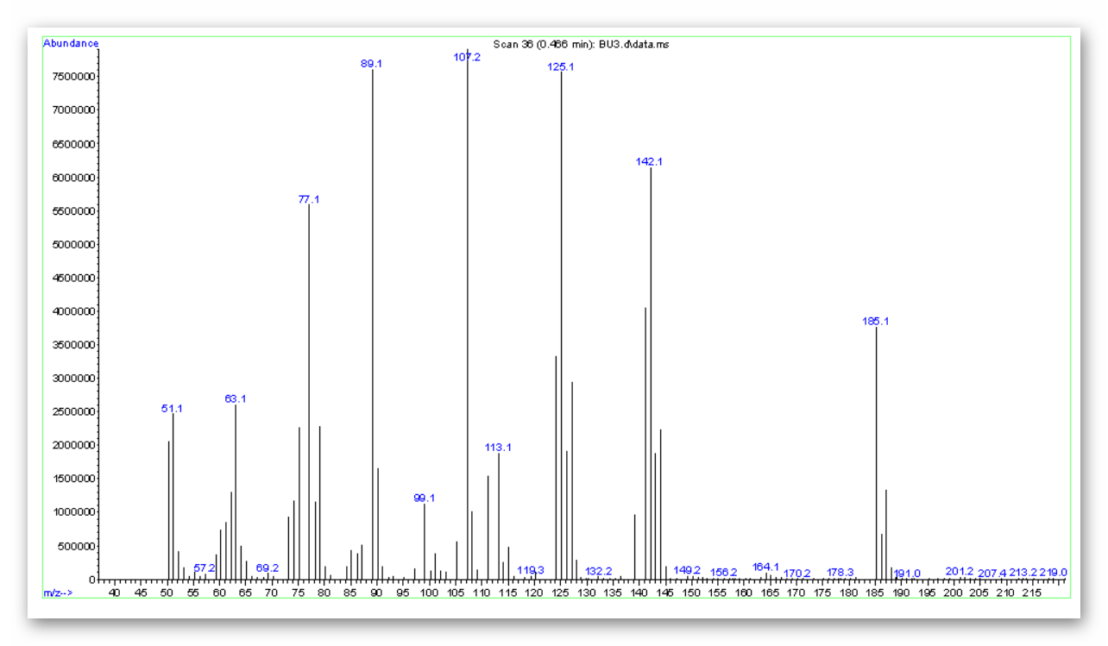

m/z: 185.1
¹H NMR:
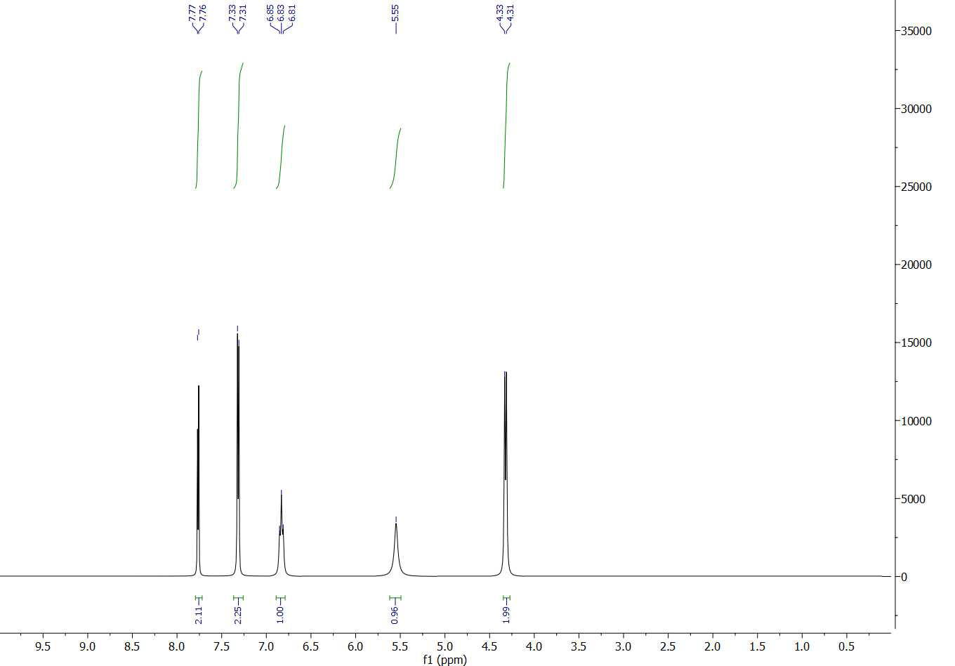
¹³C NMR:
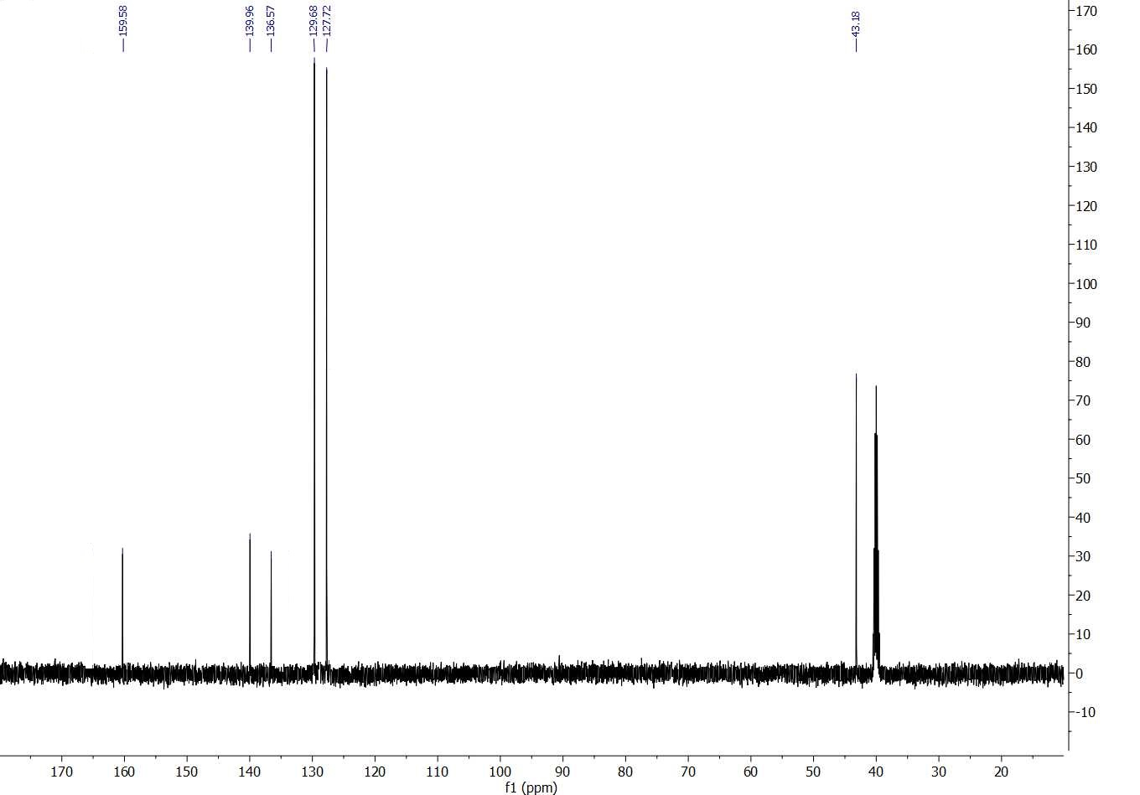
Isolated yield 89%; white solid; Melting point: 197-199 ºC. ¹H-NMR (300 MHz, DMSO-d₆) δ 7.77 (d, j=9 Hz, 2H), 7.32 (d, j=9 Hz, 2H), 6.83 (t, j=6Hz, 1H), 5.55 (s, 2H), 4.32 (d, j=6 Hz, 2H. ¹³C-NMR (75 MHz, DMSO-d₆) δ 159.58, 139.96, 136.57, 129.68, 127.72, 43.18. IR (neat, cm⁻¹): 3431.84, 3339.08, 2929.55, 1653.13, 1601.19, 1556.26, 1469.41, 1423.36, 1366.82, 1284.01, 1196.66, 1154.65, 1102.37, 1045.65, 868.36, 831.73, 807.99, 727.21, 627.71, 650.74, 575.62, 544.86, 473.48, 437.48.
IR, Mass and ¹H and ¹³C NMR analysis for 2, 4-Dichlorobenzyl urea

Molecular weight: 219.07

IR:

Mass:
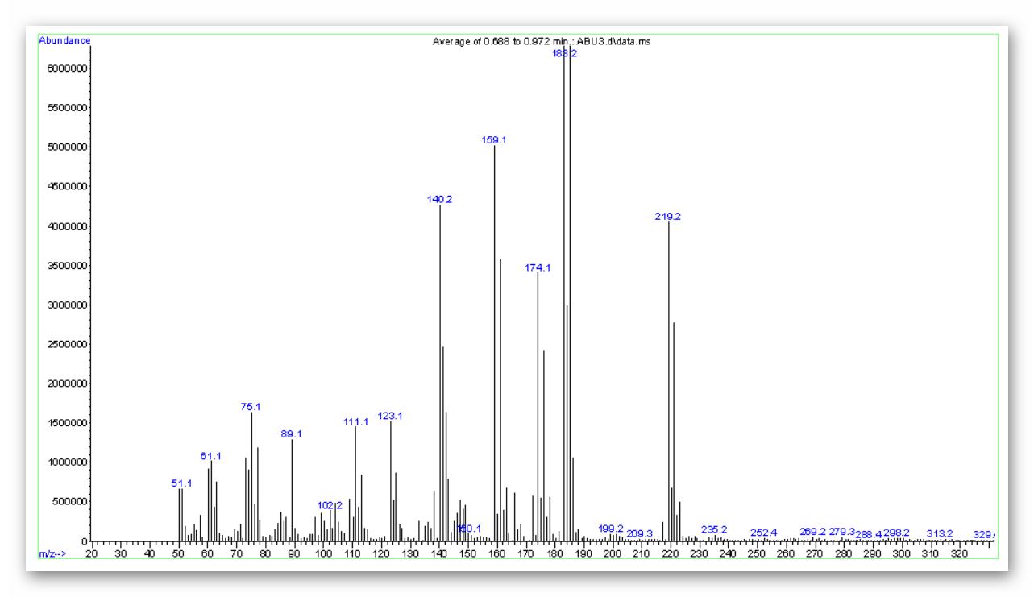
M/Z: 219.2

¹H-NMR:
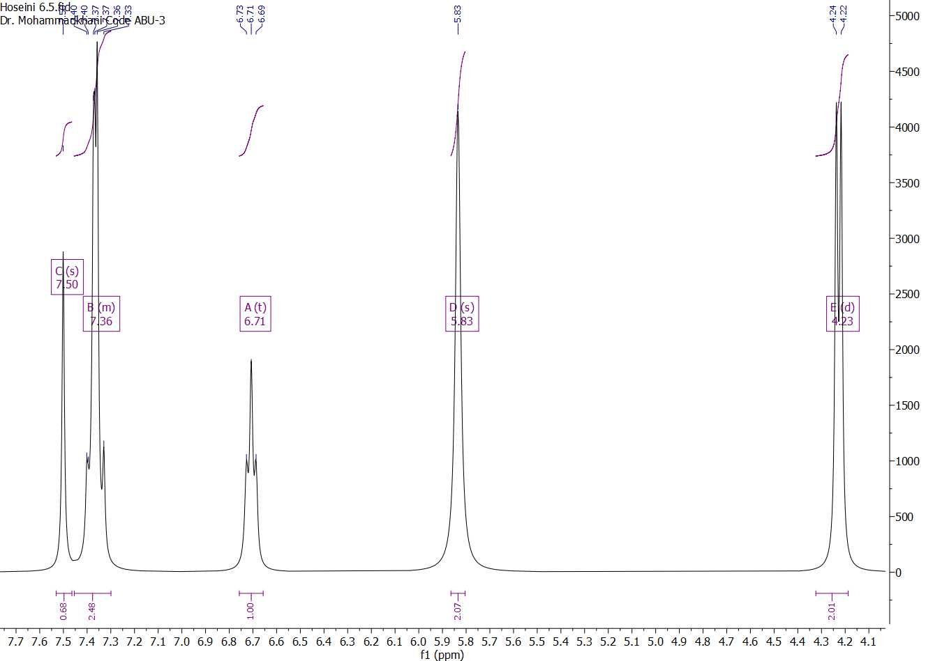
¹³C NMR:
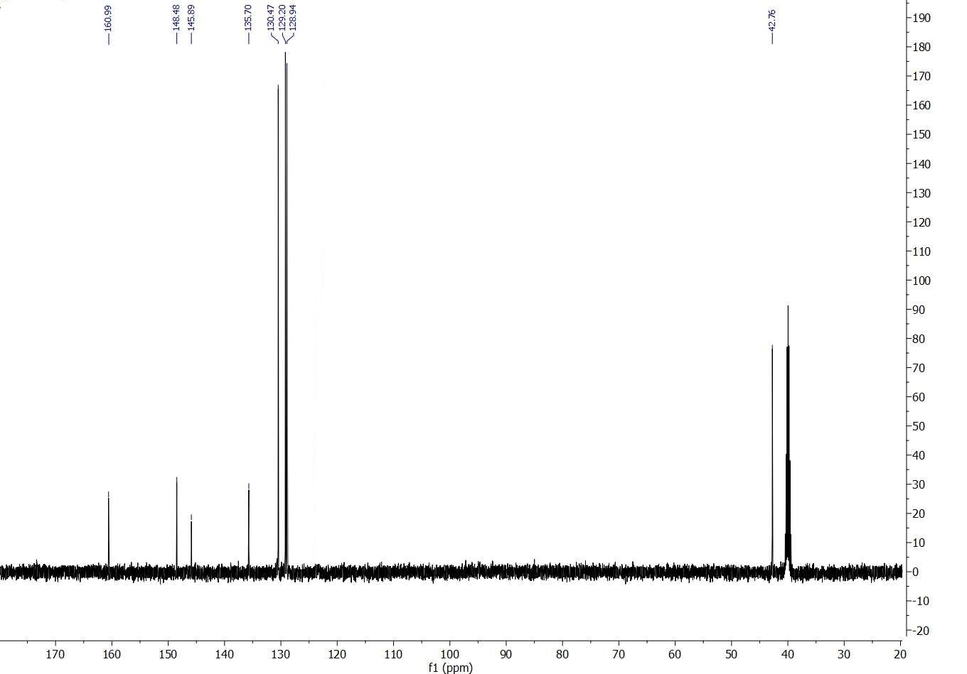

Isolated yield 85%; white solid; Melting point: 131-134 ºC. ¹H-NMR (300 MHz, DMSO-d₆) δ 7.5 (s, 1H), 7.36 (m, 2H), 6.71 (t, j= 6 Hz, 1H), 5.83 (s, 2H), 4.23 (d, j= 6 Hz, 2H). ¹³C-NMR (75 MHz, DMSO-d₆) δ 160.99, 148.48, 145.89, 135.70, 130.47, 129.20, 128.94, 42.76. IR (neat, cm⁻¹): 3431.84, 3339.08, 2929.55, 1653.13, 1601.19, 1556.26, 1469.41, 1423.36, 1366.82, 1284.01, 1196.66, 1154.65, 1102.37, 1045.65, 868.36, 831.73, 807.99, 727.21, 627.71, 650.74, 575.62, 544.86, 473.48, 437.48.

IR, Mass and ¹H-NMR analysis for 4-Bromobenzyl urea:

Molecular weight: 229.08
IR:
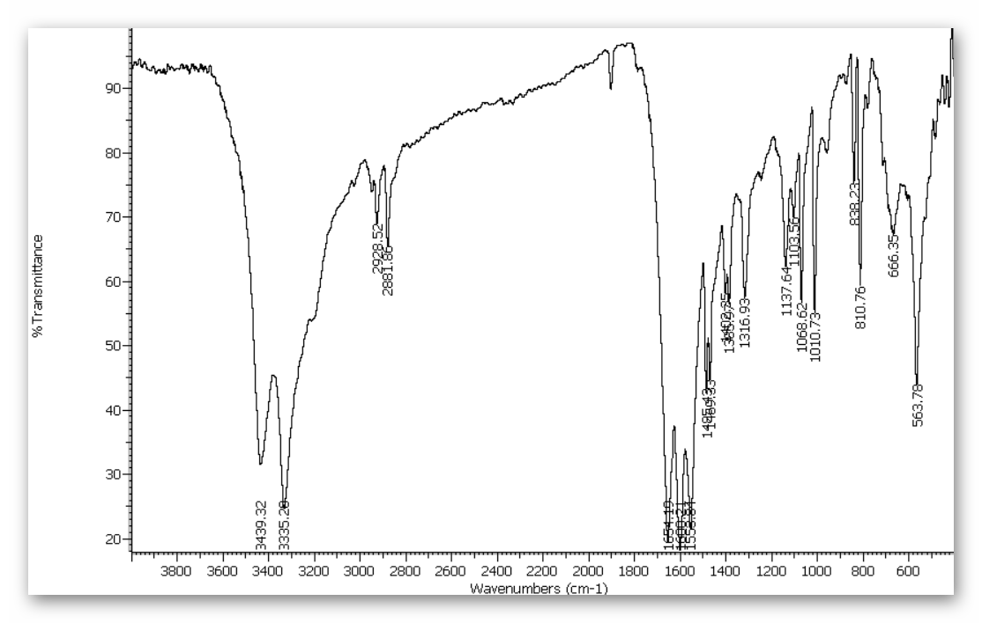

Mass:
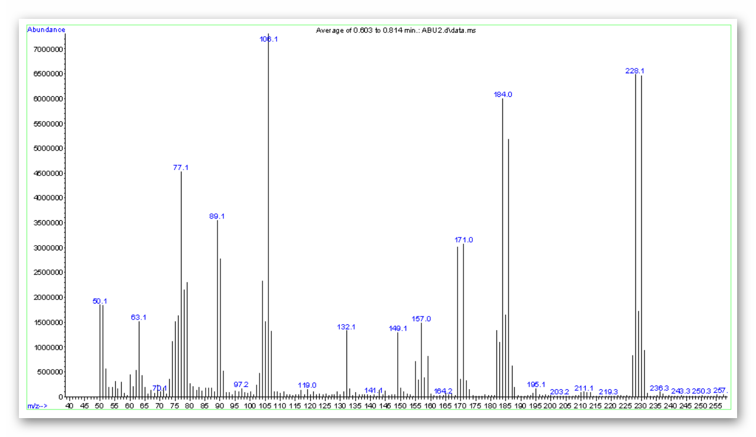
m/z: 229.1, 227.99

¹H-NMR:
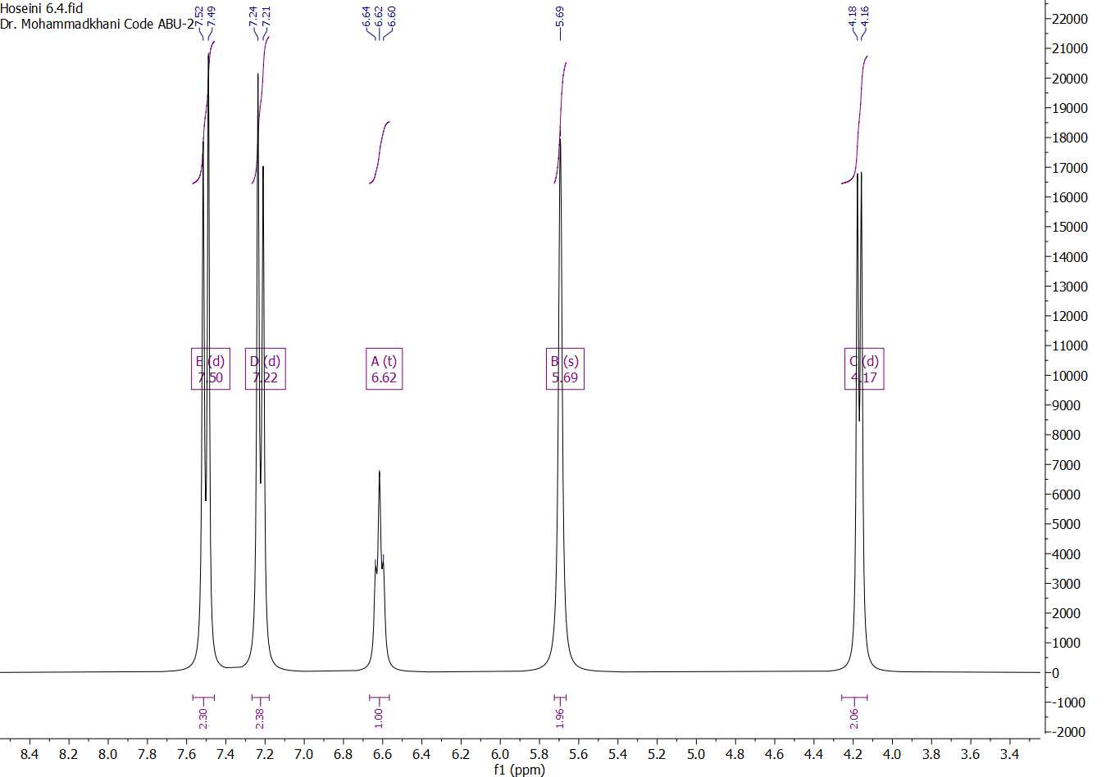

Isolated yield 92%; white solid; Melting point: 180-182 ºC. ¹H-NMR (300 MHz, DMSO-d₆) δ 7.5 (d, j= 9 Hz, 2H), 7.22 (d, j= 9 Hz, 2H), 6.62 (t, j= 6 Hz, 1H), 5.69 (s, 2H), 4.17 (d, j= 6 Hz, 2H). IR (neat, cm⁻¹): 3439.32, 3335.20, 2928.52, 2881.86, 1654.19, 1600.21, 1553.81, 1495.43, 1469.33, 1316.93, 1137.64, 1103.56, 1068.62, 1010.73, 838.20, 810.76, 666.35, 563.78.

IR, Mass and ¹H and ¹³C NMR analysis for 4-Nitrobenzyl urea

Molecular weight: 229.08

IR:
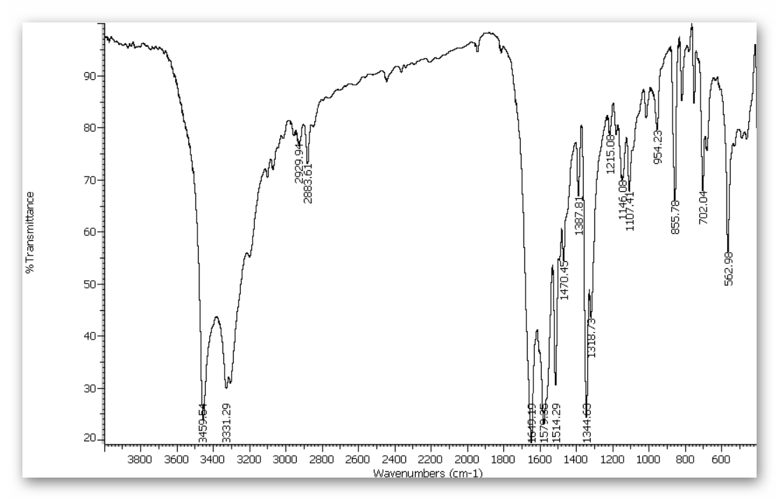
Mass:
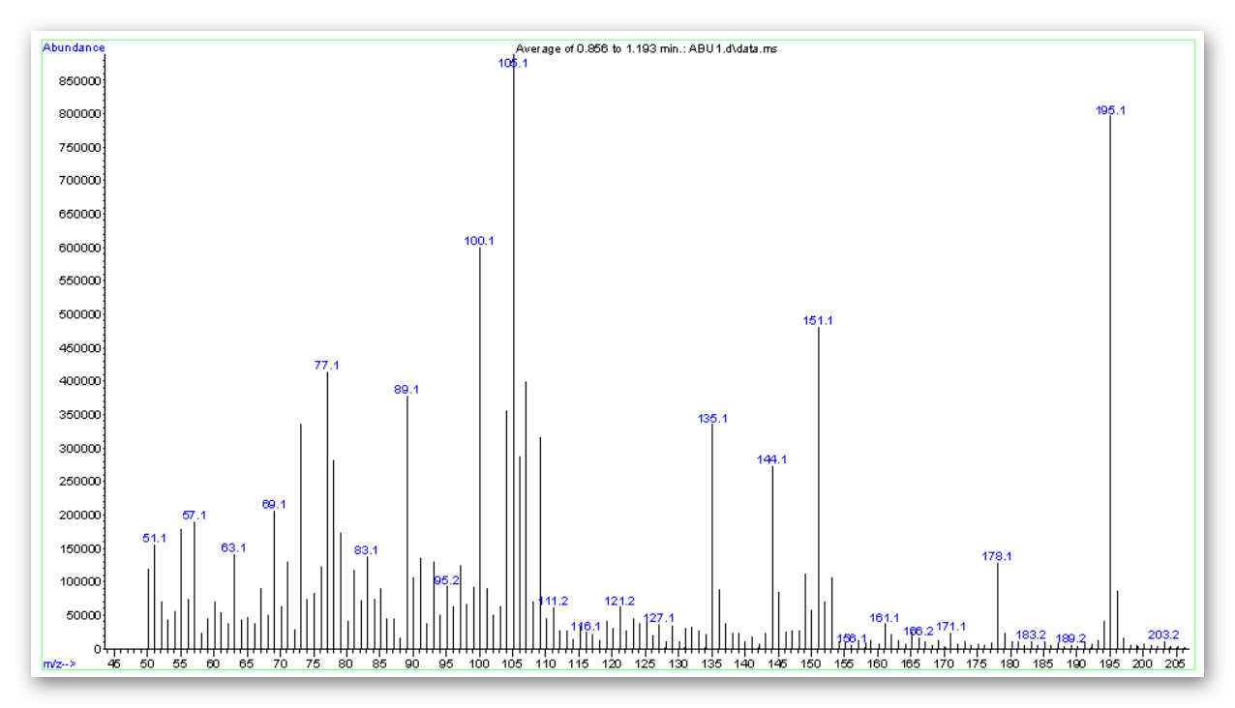

m/z: 195.1

¹H-NMR:
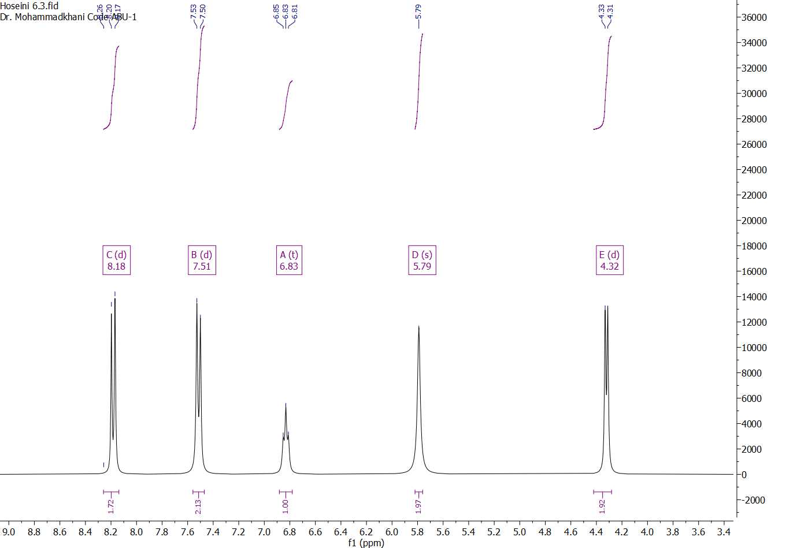
¹³C NMR:
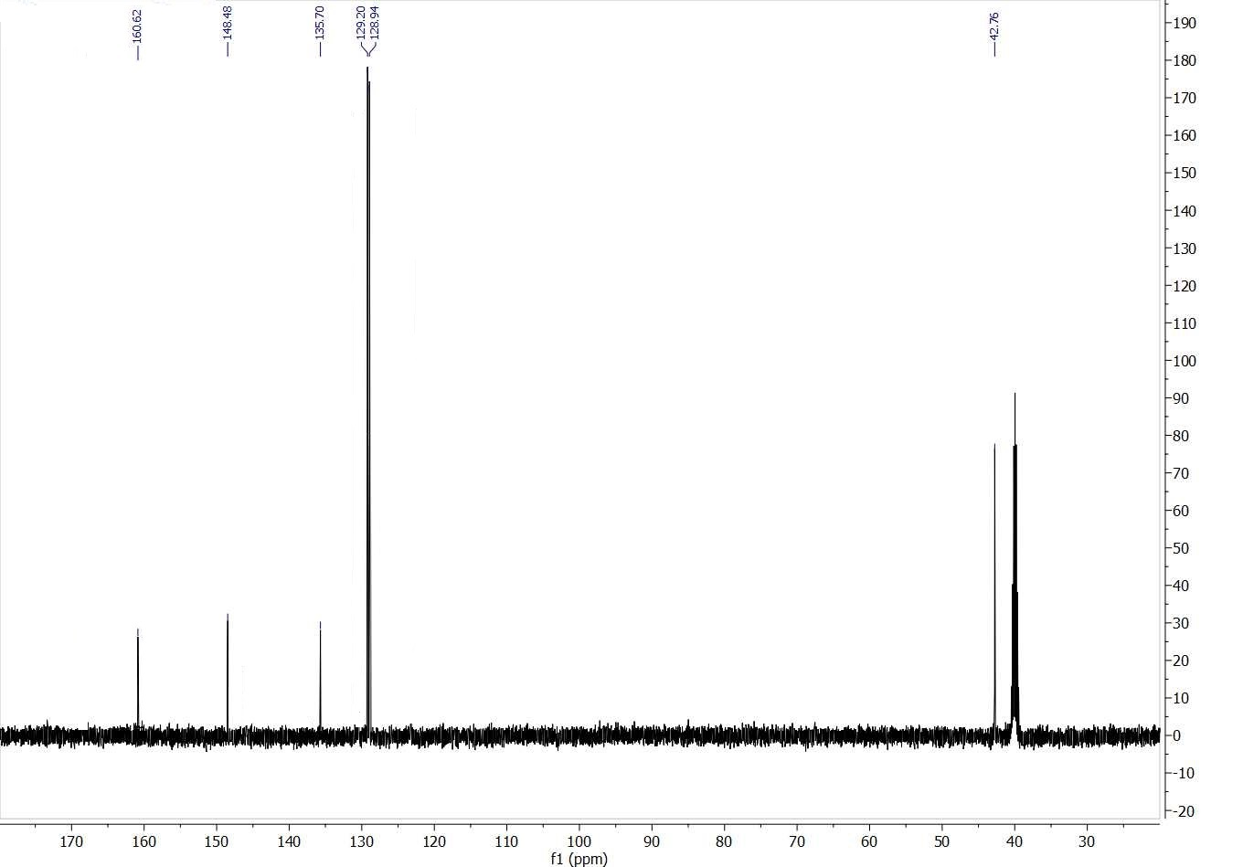

Isolated yield 88%; white solid; Melting point: 163-165 ºC. ¹H-NMR (300 MHz, DMSO-d₆) δ 8.8 (d, j= 9 Hz, 2H), 7.51 (d, j= 9 Hz, 2H), 6.83 (t, j= 6 Hz, 1H), 5.79 (s, 2H), 4.32 (d, j= 6 Hz, 2H). ¹³C-NMR (75 MHz, DMSO-d₆) δ 160.62, 148.48, 135.70, 129.20, 128.94, 42.76. IR (neat, cm⁻¹): 3459.54, 3331.29, 2929.94, 2883.61, 1649.19, 1579.35, 1514.29, 1470.45, 1387.81, 1344.63, 1318.73, 1215.08, 1146.08, 1107.41, 954.23, 855.79, 702.04, 562.99.

IR, Mass and ¹H and ¹³C NMR analysis for 3-Nitrobenzyl urea

Molecular weight: 229.08

IR:
Mass:
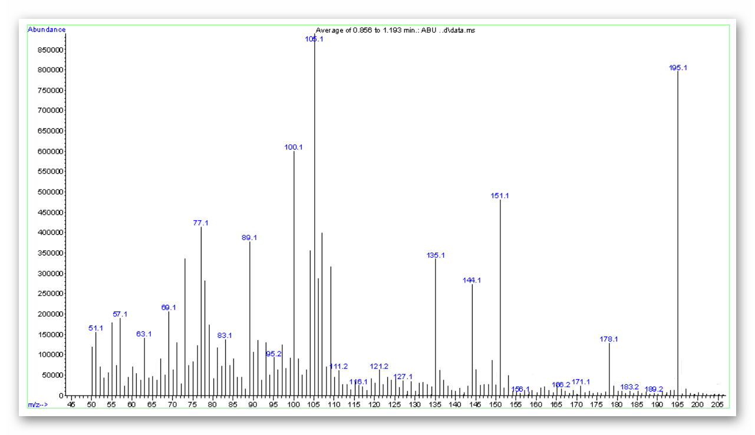

m/z: 195.1
¹H NMR:
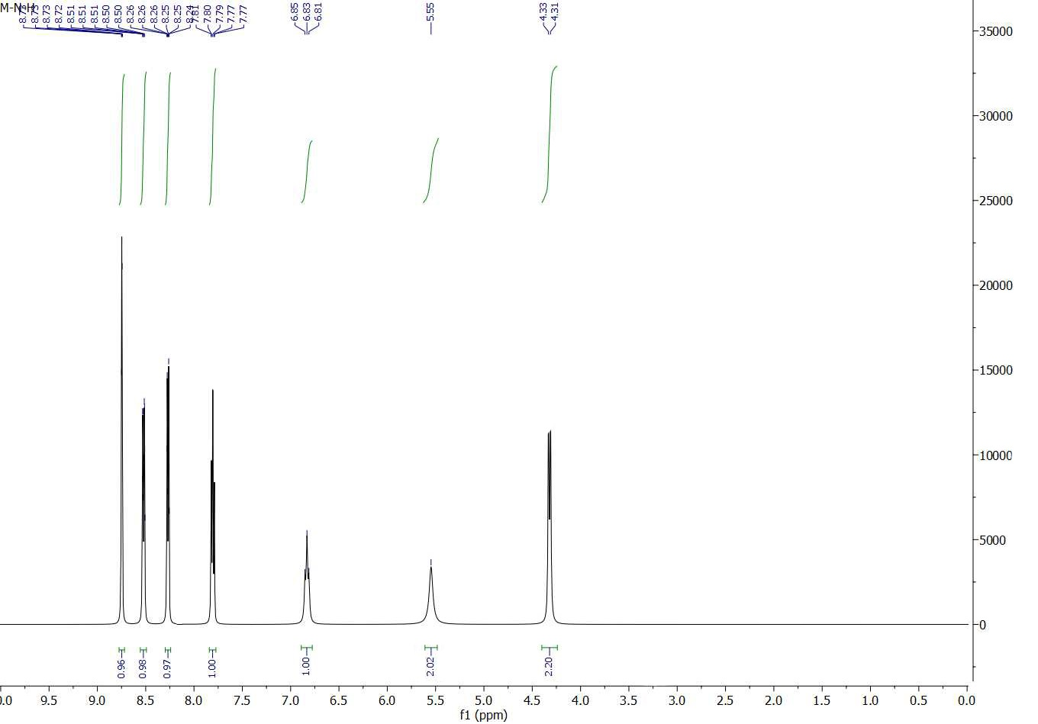

¹³C NMR:
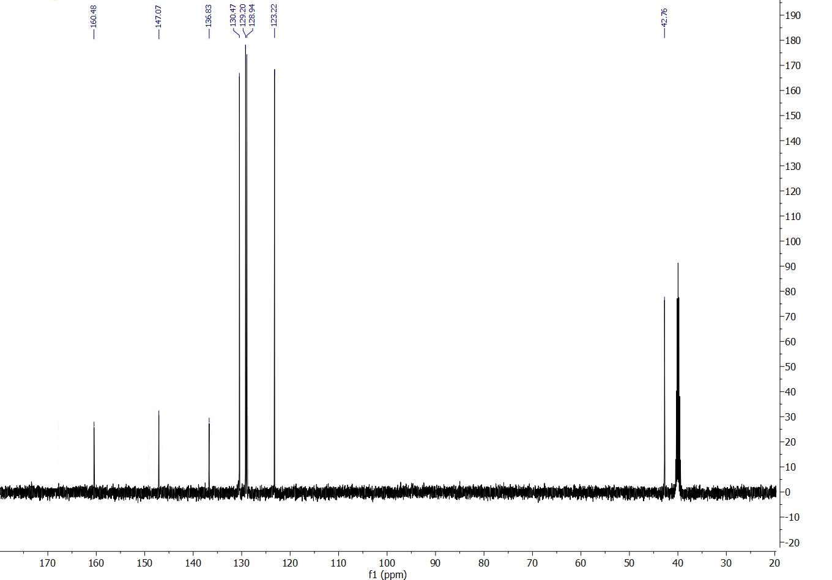

Isolated yield 90%; white solid; Melting point: 159-163 ºC. ¹H-NMR (300 MHz, DMSO-d₆) δ 8.76 (s, 1H), 8.5 (dd, 1H), 8.25 (m, 1H), 7.79 (m, 1H), 6.83 (t, j= 6 Hz, 1H), 5.55 (s, 2H), 4.32 (d, j= 6 Hz, 2H). ¹³C-NMR (75 MHz, DMSO-d₆) δ 160.48, 147.07, 136.83, 130.47, 129.20, 128.94, 123.22, 42.76. IR (neat, cm⁻¹): 3459.54, 3331.29, 2929.94, 2883.61, 1649.19, 1579.35, 1514.29, 1470.45, 1387.81, 1344.63, 1318.73, 1215.08, 1146.08, 1107.41, 954.23, 855.79, 702.04, 562.99.

IR, Mass and ¹H and ¹³C NMR analysis for 3-methoxybenzyl urea

Molecular weight: 180.21
IR:
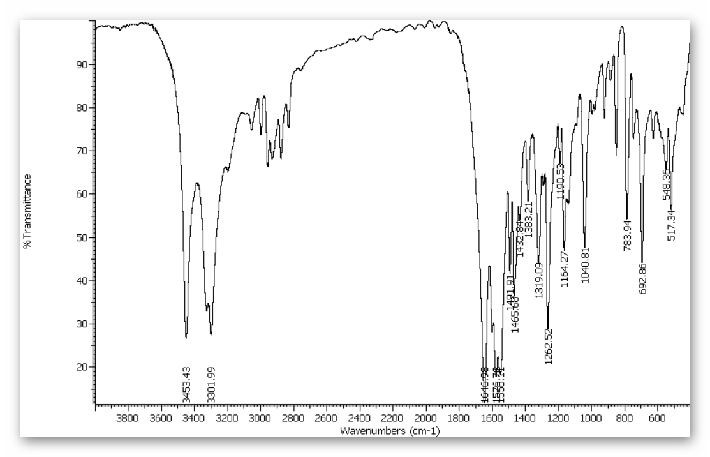

Mass:
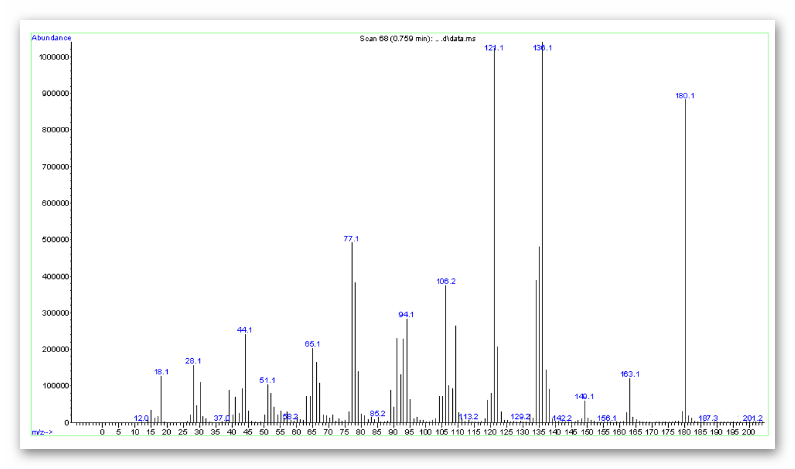
m/z: 180.1

¹H NMR:
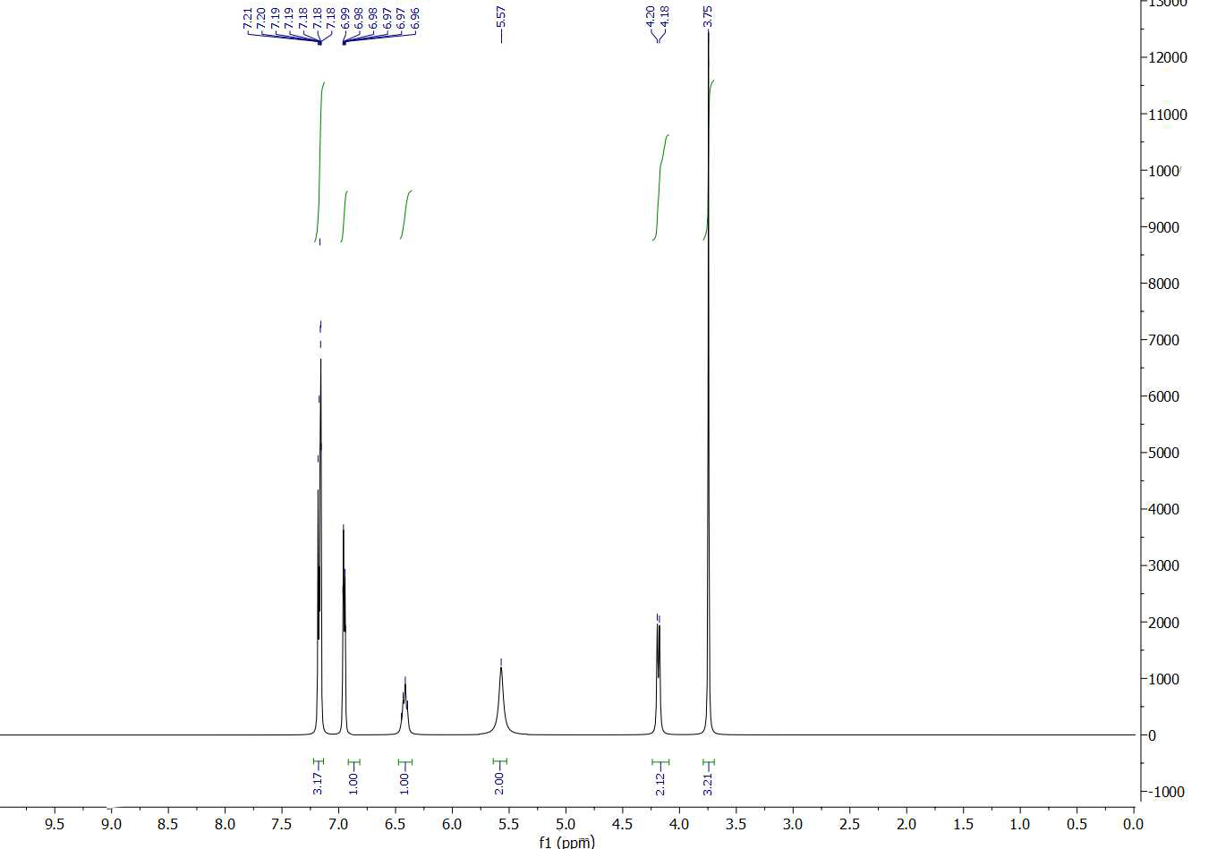
¹³C NMR:
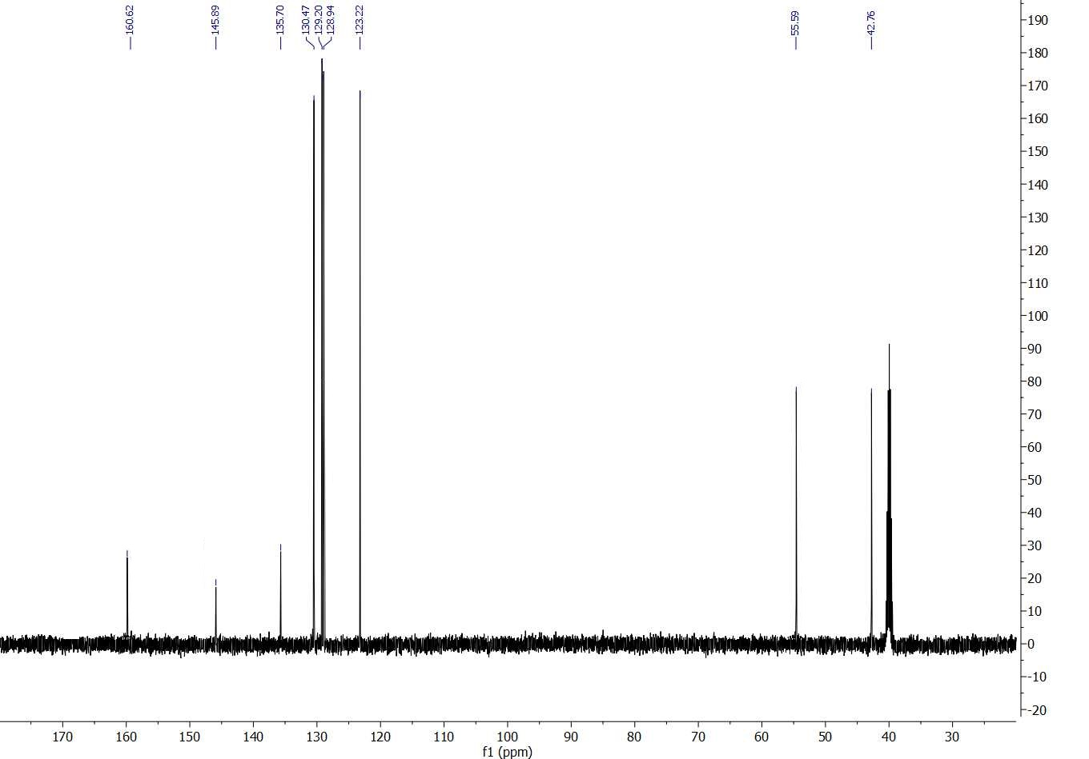

Isolated yield 80%; white solid; Melting point: 110-112 ºC. ¹H-NMR (300 MHz, DMSO-d₆) δ 7.19 (m, 3H), 6.97 (m, 1H), 6.43 (t, j= 6 Hz 1H), 5.57 (s, 2H), 4.19 (d, j= 6 Hz, 2H), 3.75 (s, 3H). ¹³C-NMR (75 MHz, DMSO-d₆) δ 160.62, 145.89, 135.70, 130.47, 129.20, 128.94, 123.22, 55.59, 42.76. IR (neat, cm⁻¹): 3453.43, 3301.99, 2929.94, 2883.61, 1646.98, 1576.78, 1558.11, 1491.91, 1465.68, 1432.84, 1383.21, 1319.09, 1262.52, 1190.53, 1164.27, 1040.81, 783.94, 692.86, 548.36, 517.34.

IR, Mass, ¹H and ¹³C NMR analysis for 3-MethylBenzyl urea
Molecular weight: 164.21
IR:
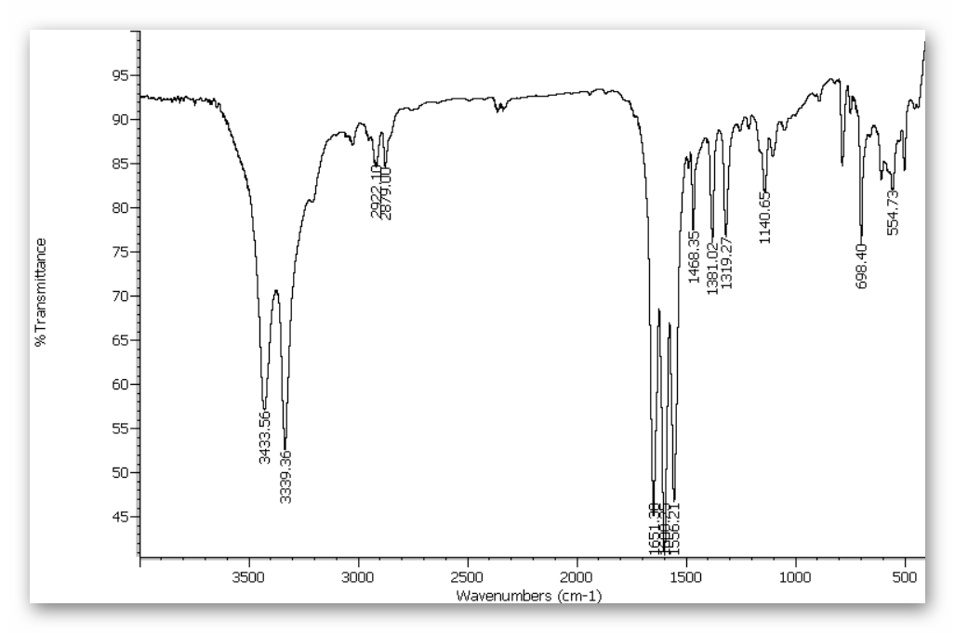

Mass:
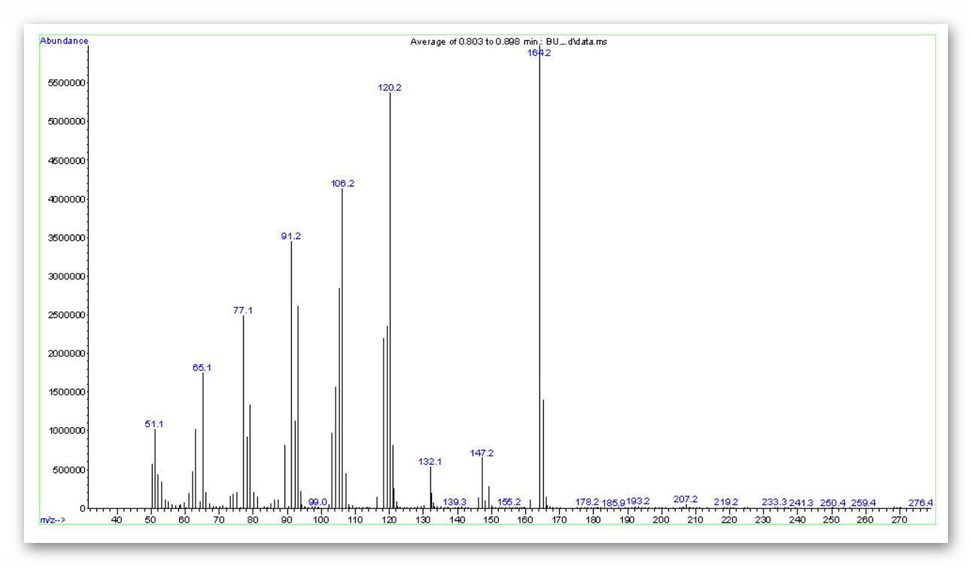

m/z: 164.2
¹H-NMR:
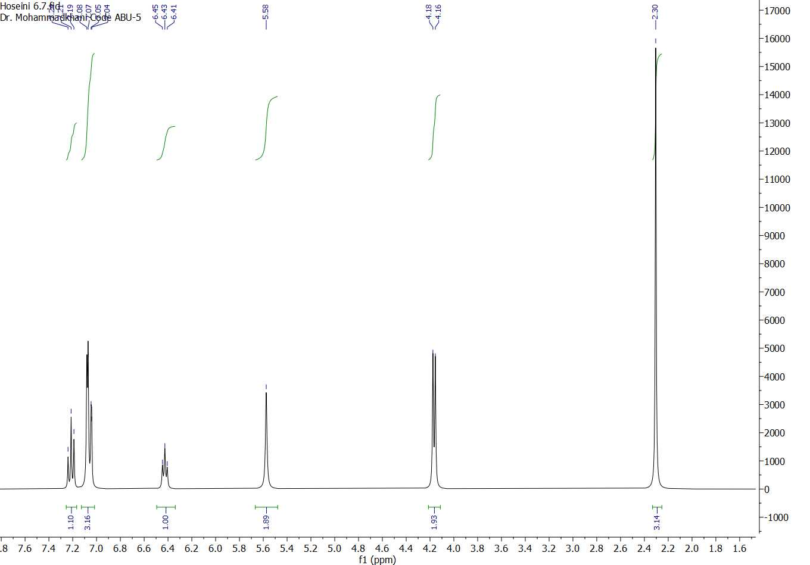

¹³C-NMR:
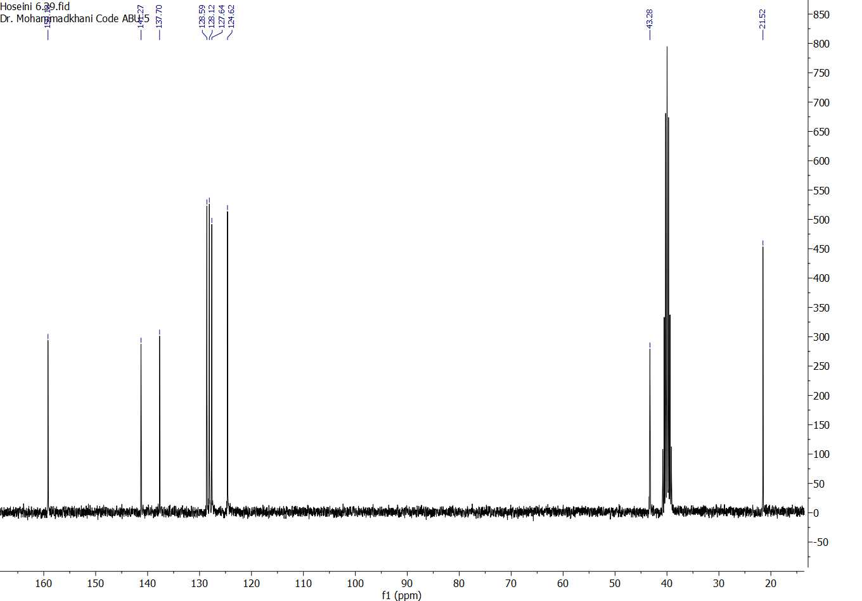

Isolated yield 83%; white solid; Melting point: 147-150 ºC. ¹H-NMR (300 MHz, DMSO-d₆) δ 7.21 (t, j= 9 Hz, 1H), 7.06 (m, 3H), 6.43 (t, j= 6 Hz, 1H), 5.58 (s, 2H), 4.17 (d, j= 6 Hz, 2H), 2.30 (s, 3H). ¹³C-NMR (75 MHz, DMSO-d₆) δ 159.18, 141.27, 137.70, 128.59, 128.12, 127.64, 124.62, 43.28, 21.52. IR (neat, cm⁻¹): 3433.56, 3339.36, 2922.10, 2879.00, 1651.30, 1600.25, 1556.21, 1468.35, 1381.02, 1319.27, 1140.65, 698.40, 554.73.

IR, Mass, ¹H and ¹³C NMR analysis for 2-chlorobenzyl urea

Molecular weight: 184.62

IR:
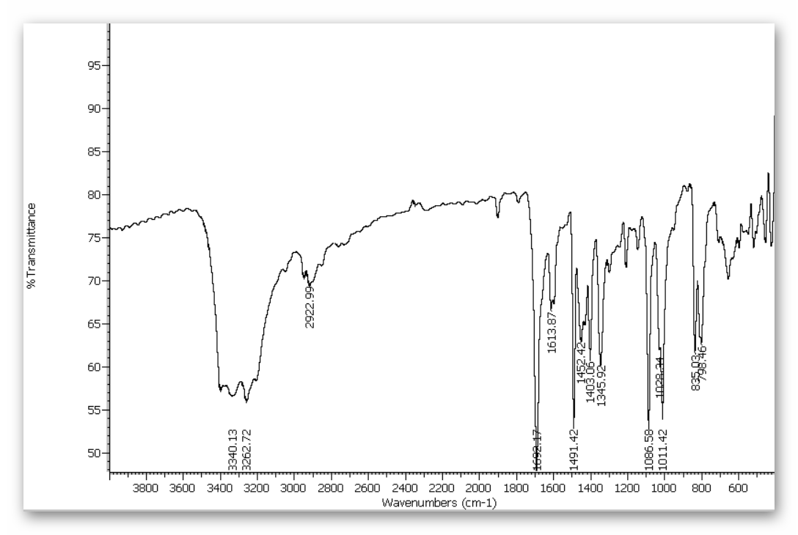
Mass:
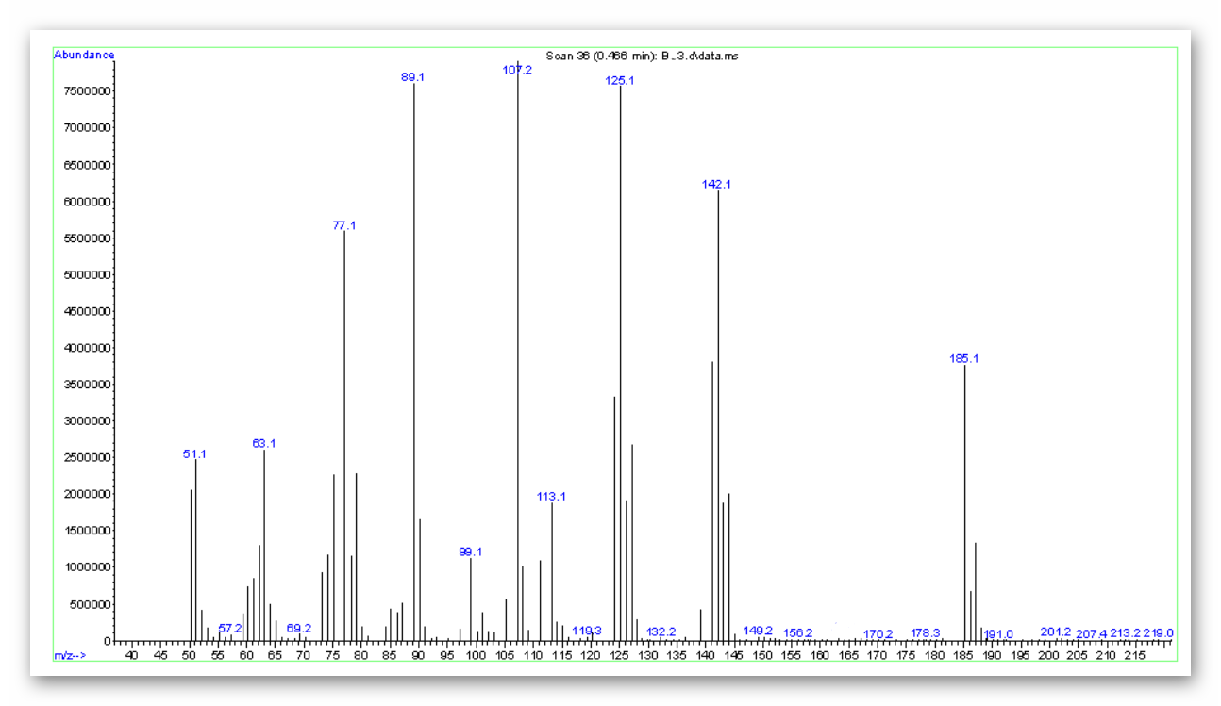
m/z: 185.1
¹H NMR:
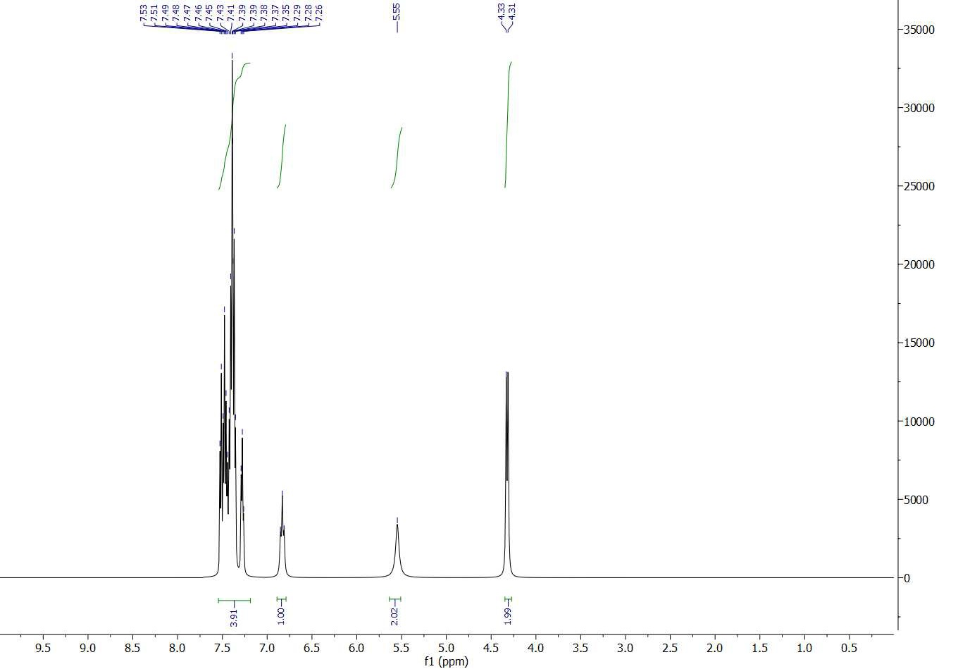
¹³C NMR:
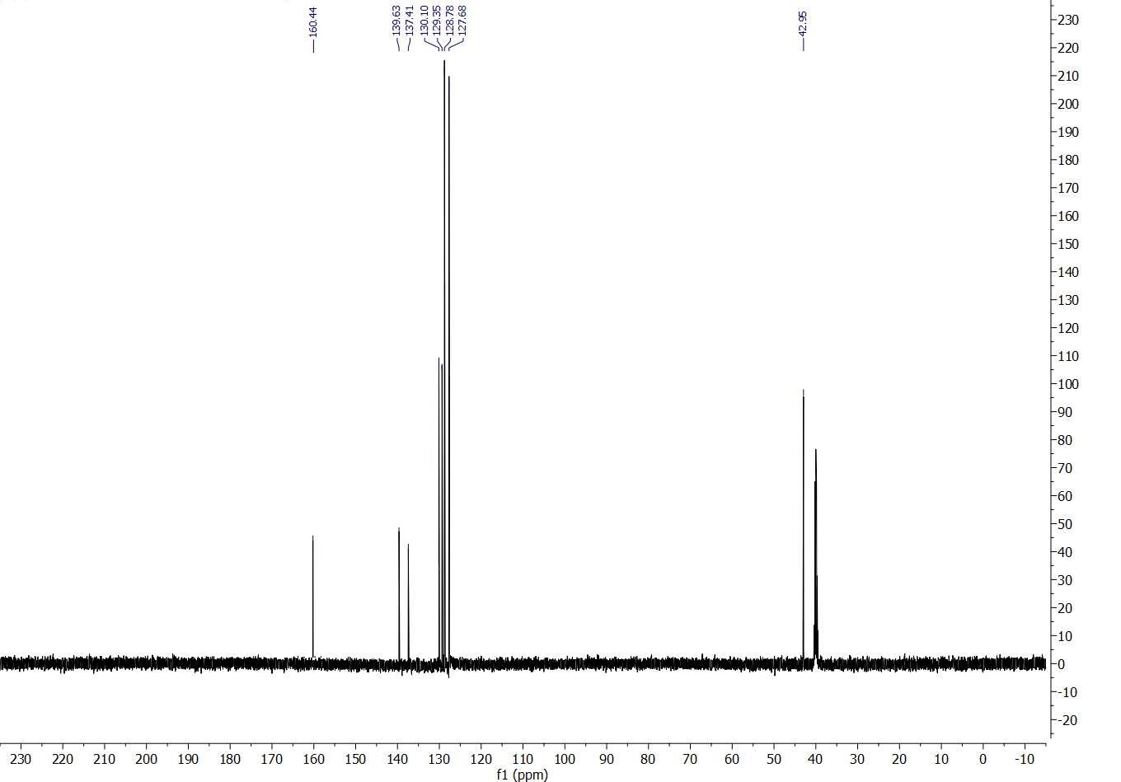

Isolated yield 74%; white solid; Melting point: 110-113 ºC. ¹H-NMR (300 MHz, DMSO-d₆) δ 7.41 (m, 4H), 6.71 (t, j= 6 Hz, 1H), 5.55 (s, 2H), 4.32 (d, j= 6 Hz, 2H). ¹³C-NMR (75 MHz, DMSO-d₆) δ 160.44, 139.63, 137.41, 130.10, 129.35, 128.78, 127.68, 42.95. IR (neat, cm⁻¹): 3453.43, 3340.13, 3262.72, 2922.99, 2883.61, 1692.17, 1613.87, 1491.42, 1452.42, 1403.06, 1345.92, 1086.59, 1011.42, 835.03, 796.46.

IR, Mass, ¹H and ¹³C NMR analysis for 2-bromobenzyl urea

Molecular weight: 229.08

IR:
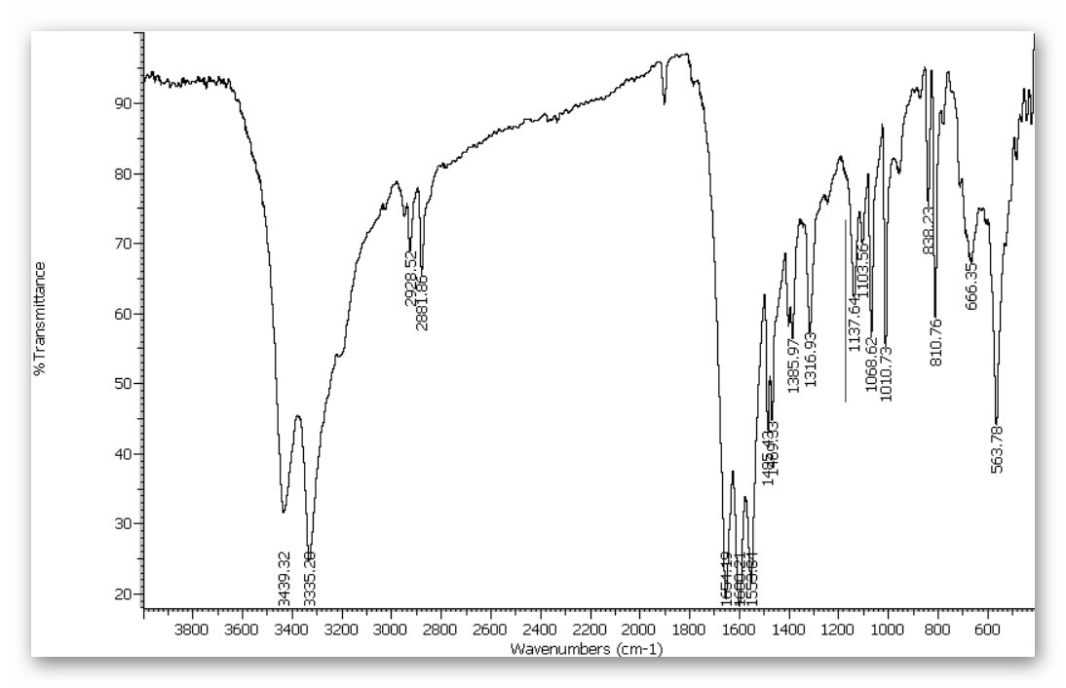

Mass:
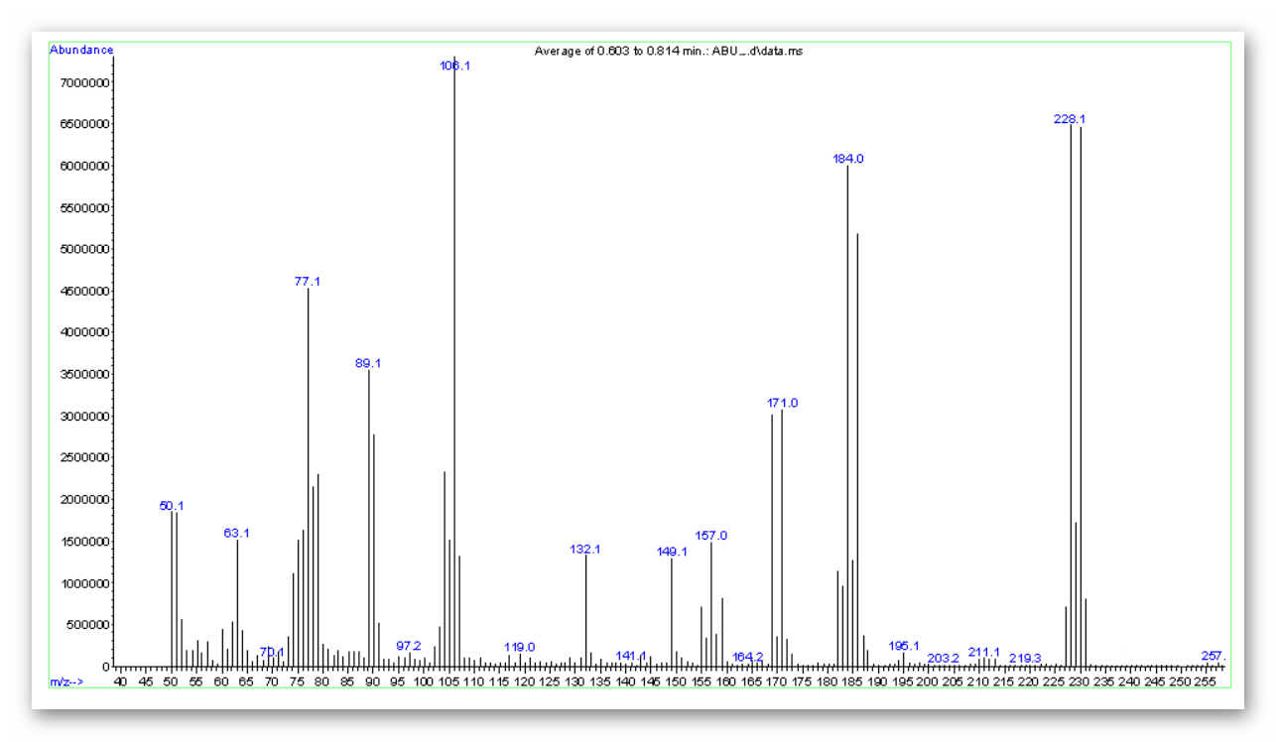
m/z: 228.1
¹H NMR:
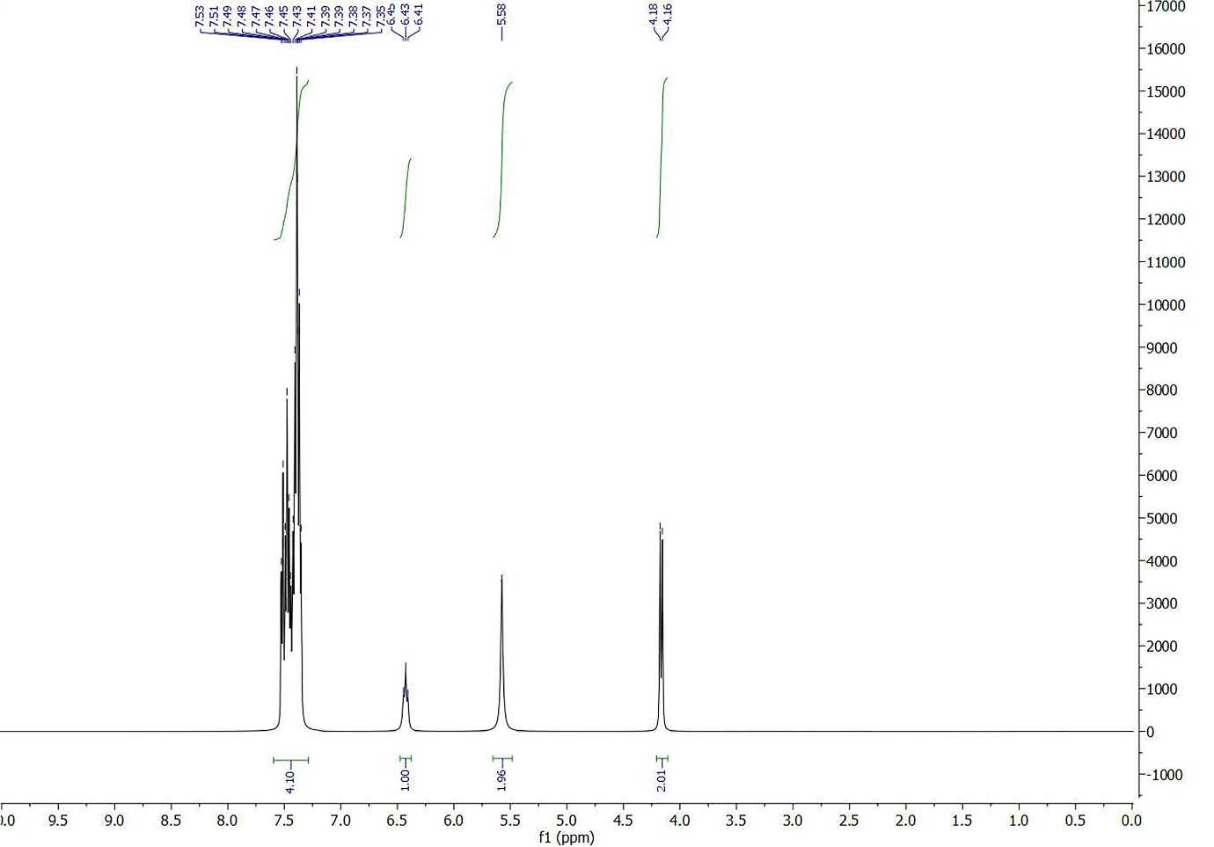

¹³C NMR:
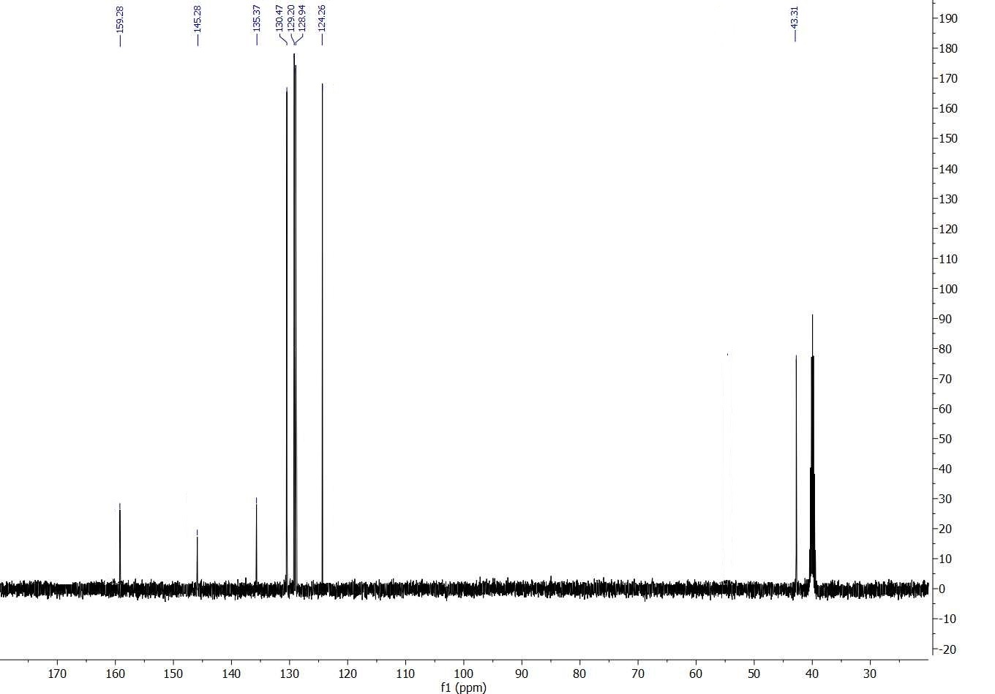

Isolated yield 79%; white solid; Melting point: 161-163 ºC. ¹H-NMR (300 MHz, DMSO-d₆) δ 7.43 (m, 4H), 6.43 (t, j= 6 Hz, 1H), 5.58 (s, 2H), 4.17 (d, j= 6 Hz, 2H). ¹³C-NMR (75 MHz, DMSO-d₆) δ 159.28, 145.28, 135.37, 130.47, 129.20, 128.94, 124.26, 43.31. IR (neat, cm⁻¹): 3439.32, 3335.29, 2928.52, 2881.86, 1651.19, 1600.21, 1553.61, 1485.43, 1489.33, 1385.97, 1316.93, 1137.64, 1103.56, 1068.62, 1010.73, 838.23, 810.76m 666.35, 563.78.

