Supplementary materials

Insights into regulating mechanism of mutagenesis strains of Elizabethkingia meningoseptica sp. F2 by omics analysis.

Qiang Yang^{1,2}, Zhiming Zheng^{1,*}, Peng Wang ¹, Li Wang¹, Han Wang^{1,2}, Mengxue Zhang^{1,2}, Genhai Zhao ^{1,*}
¹ Institute of Intelligent Machines, Hefei Institutes of Physical Science, Chinese Academy of Sciences, Hefei 230031, China/P. R. China;
²University of Science and Technology of China, Hefei 230026, China/P. R. China;
*Corresponding Author: Zhiming Zheng and Genhai Zhao, Tel/Fax:+86-0551-55913148,e-mail: zhengzhiming2014@163.com;
zhgh327@ipp.ac.cn

Fig S1 (a) Gram staining of Elizabethkingia meningoseptica sp. F2, the cell strain is Gram-negative. (b) Flagellar assembly of Elizabethkingia meningoseptica based on KEGG pathway assignment. Only the MotB gene was identified. (c)Scanning electron micrographs of the cell membrane. (d) Transmission electron microscopy to observe the internal structure of cells.

Eme sp. F2
b
a

D
C

Figure S2. COG annotation. y: Annotation result, x: Gene number.

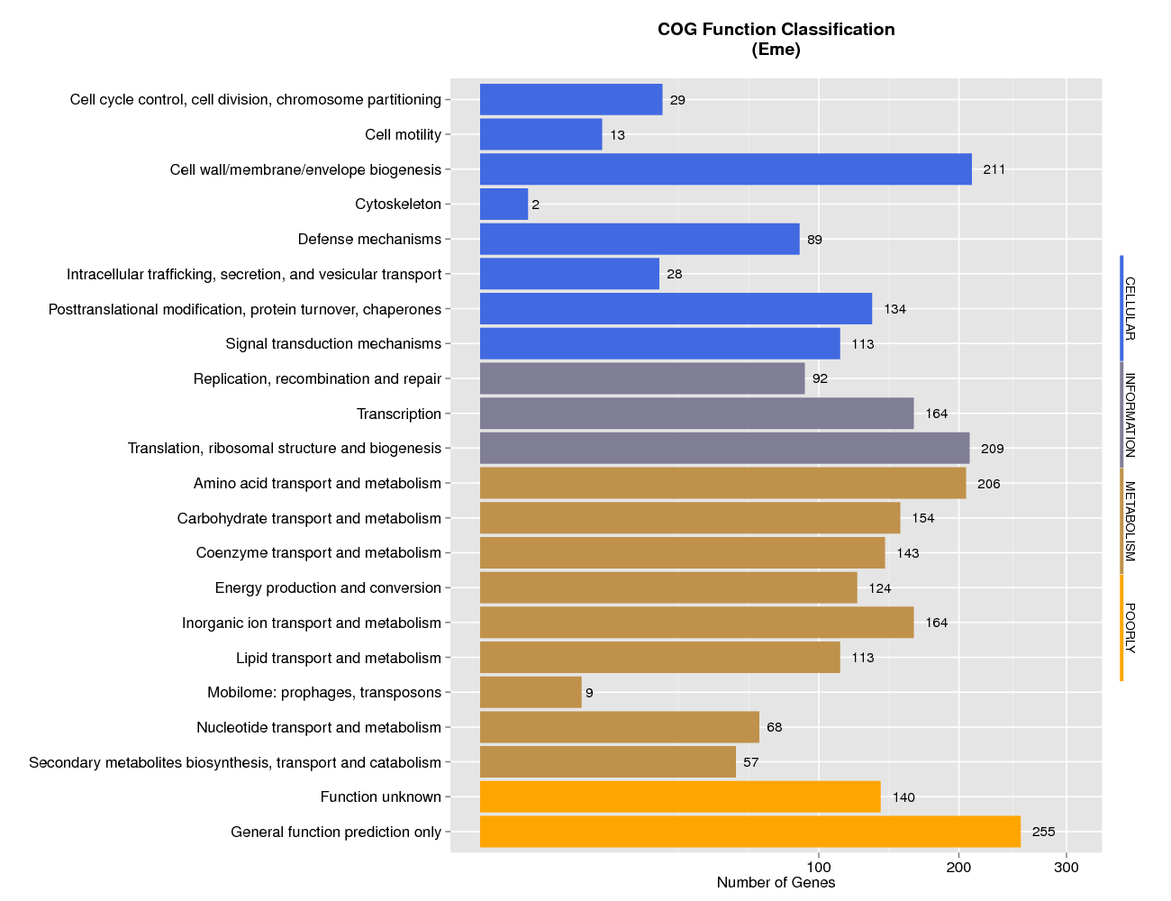
Elizabethkingia meningoseptica sp. F2

Figure S3. A circular representation of the Elizabethkingia meningoseptica sp. F2 chromosome illustrating each predicted protein-coding region's location and selected features of the genome, colored according to the cluster of orthologous groups (COG)classification. From outer to inner: 1. Genome Size 2. Forward Strand Gene, colored according to cluster of orthologous groups (COG) classification 3. Reverse Strand Gene, colored according to cluster of orthologous groups (COG) classification 4. Forward Strand ncRNA 5. Reverse Strand ncRNA 6. Repeat 7. GC 8. GC-SKEW
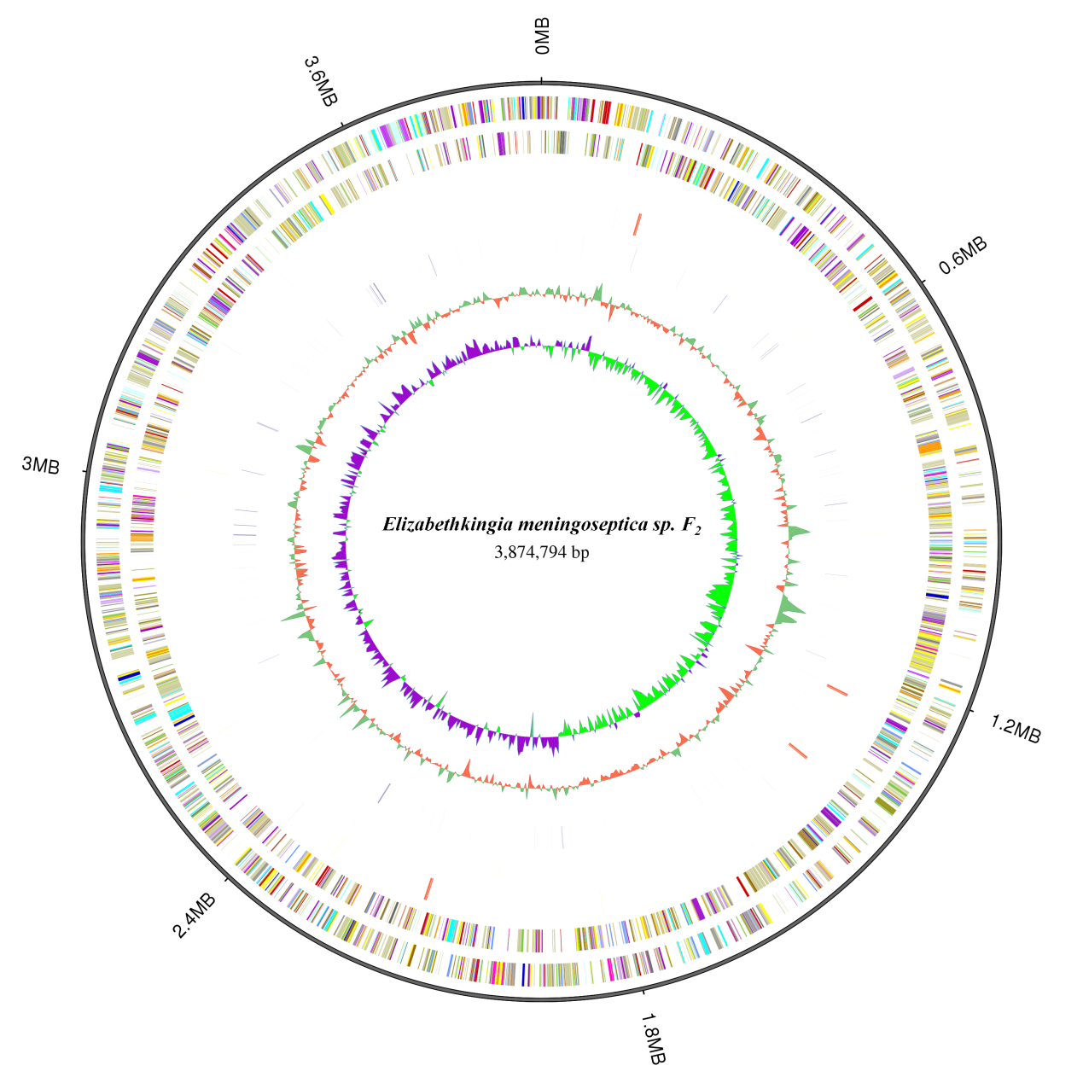

Figure S4. The beta-lactam resistance of Elizabethkingia meningoseptica sp. F2 based on KEGG pathway assignment.
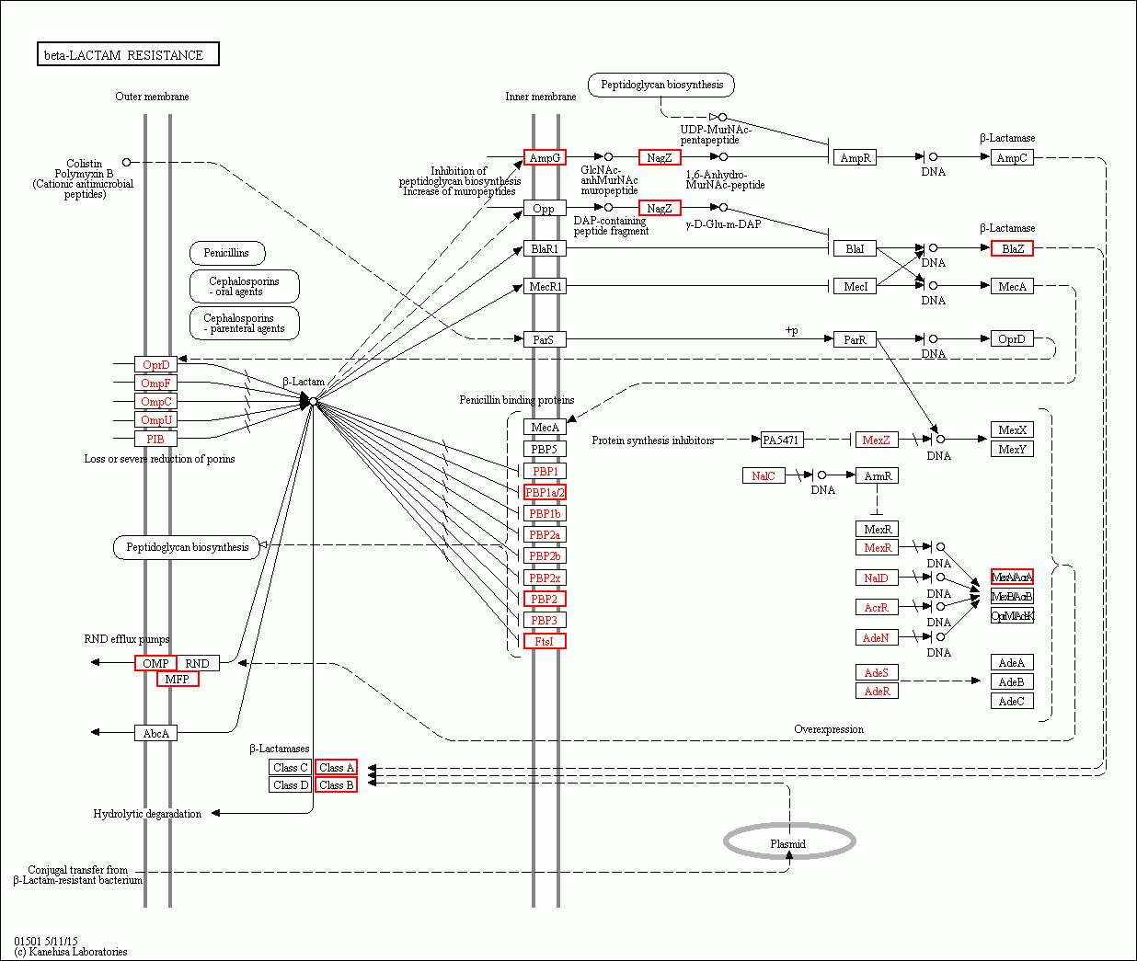

Fig. S5. Comparative Genomics. (A,B,C)Elizabethkingia meningoseptica sp. G4076, Elizabethkingia meningoseptica sp.G4120, Elizabethkingia meningoseptica sp.KC1913, Elizabethkingia meningoseptica sp. F2 nucleic acid level synteny. Yellow box stands for forward chain and blue box stands for reverse chain within the upper and following sequence region. In the box of sequence, the yellow region stands for the nucleic acid sequence in the forward chain of this genome sequence and the blue region stands for the nucleic acid sequence in the reverse chain of this genome sequence. In the middle region of two sequences, the yellow line stands for forward alignment and the blue line stands for reverse complementary alignment. (D) Dispensable gene heat map. below are each strain name, left are Dispensable gene cluster, top are strain cluster, the similarities of gene are shown in the middle with different color represent different coverage by heat map. color/depth in top left pic. (E)Venn graph of Pan gene.Each ellipse represent one strain, the number in the ellipse means the only cluster number. One cluster have the genes that more than 50 percent identity and less than 0.3 length diversity.
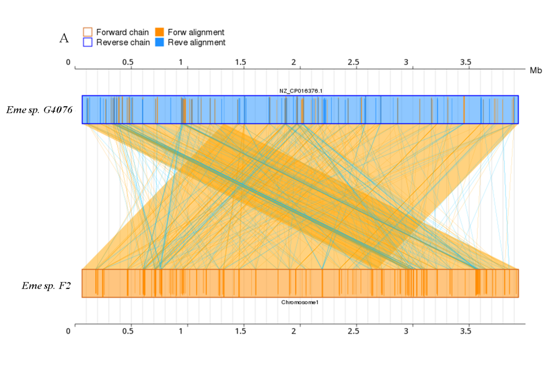
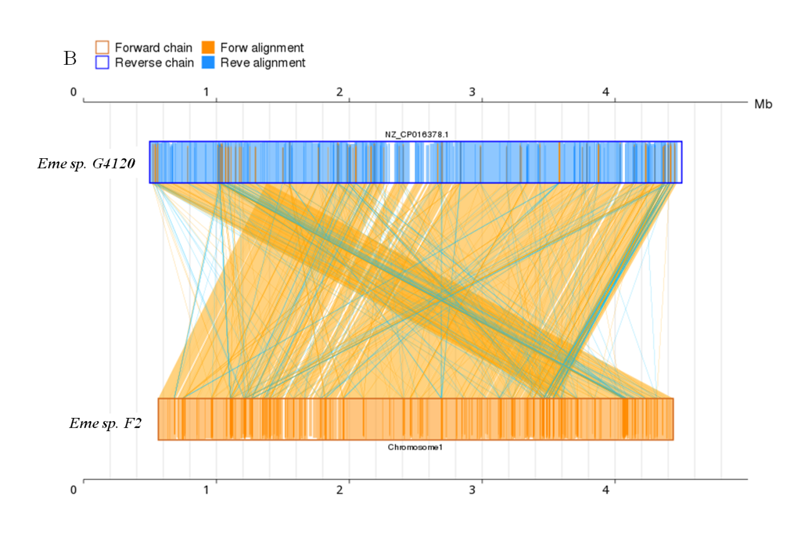
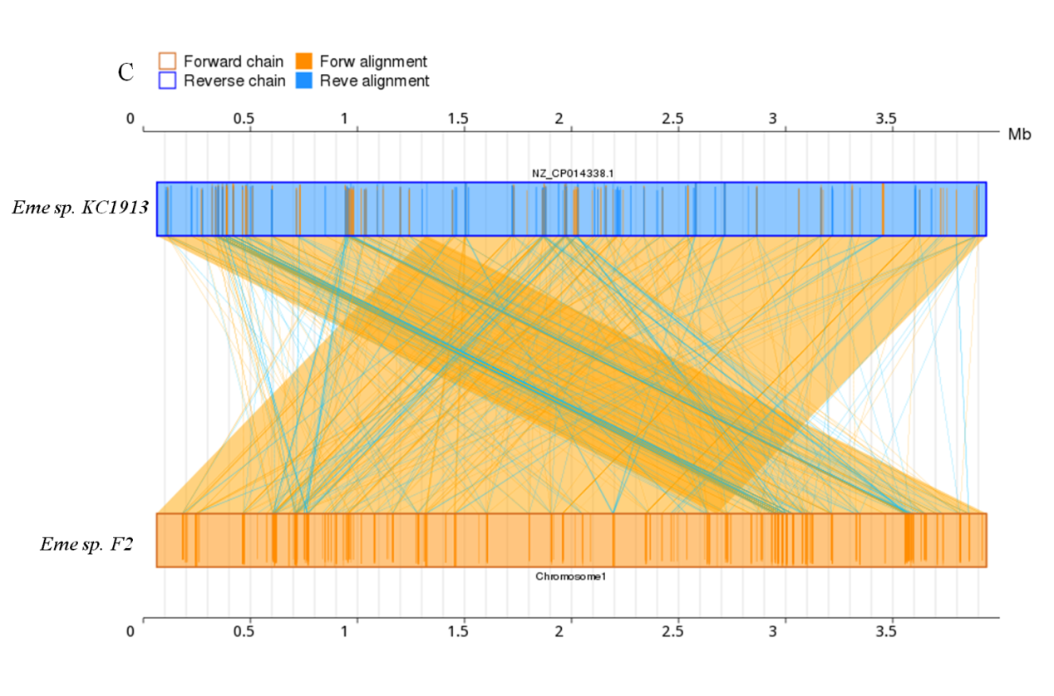
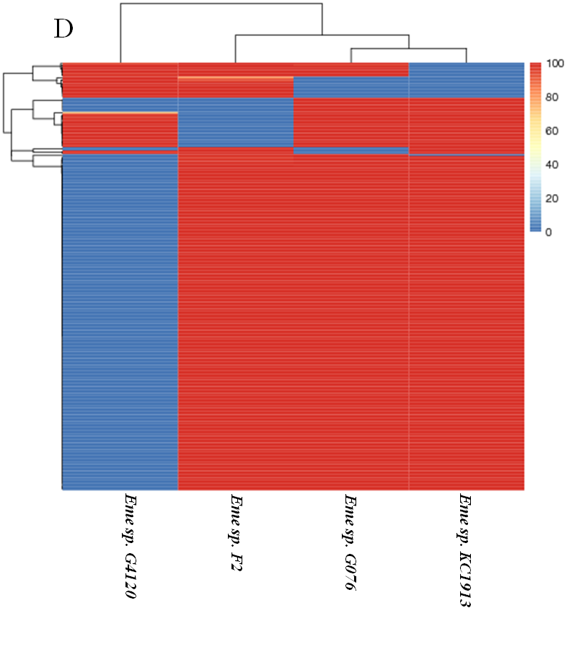
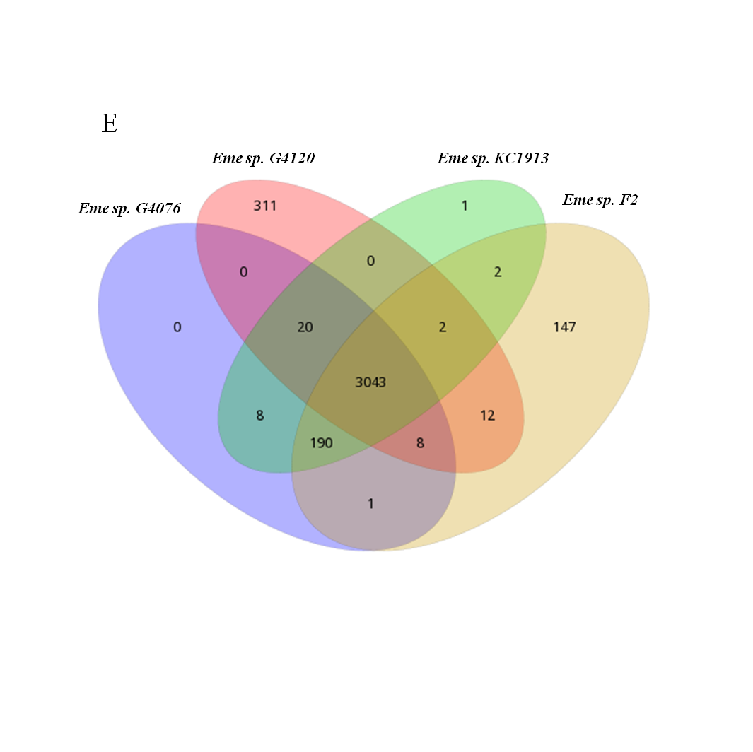

Figure S6 COG annotation Classification (Dispensable). y: Annotation result, x: Gene number.
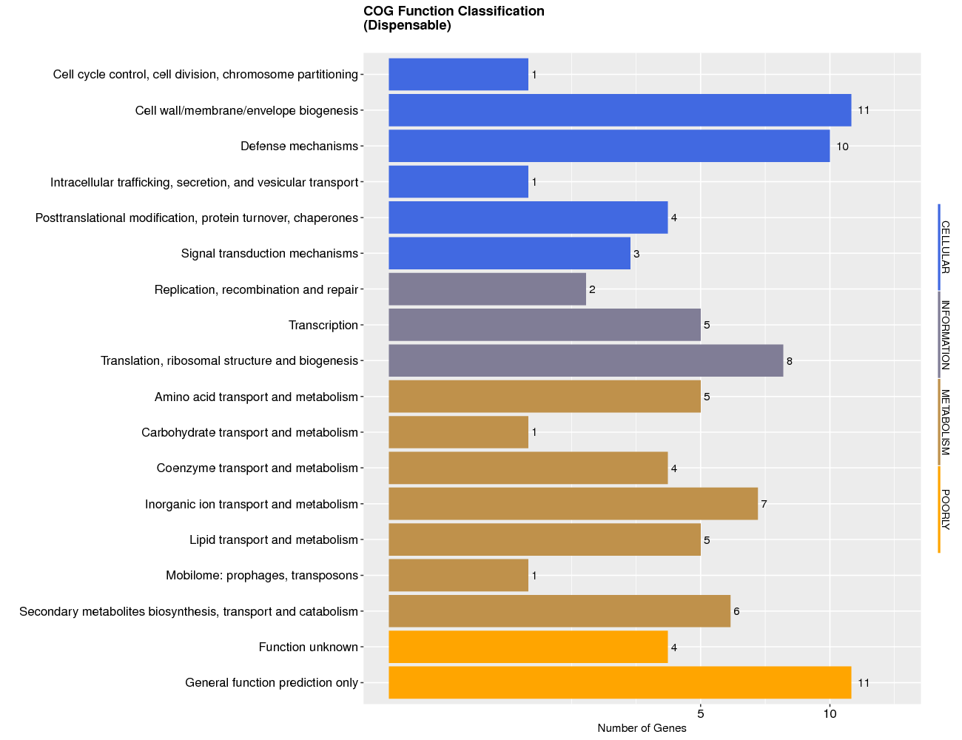

Figure S7. Terpenoid backbone biosynthesis(a) and Uniquinone and other terpenoid-quinone biosynthesis(b) of Elizabethkingia meningoseptica sp. F2 based on KEGG pathway assignment.
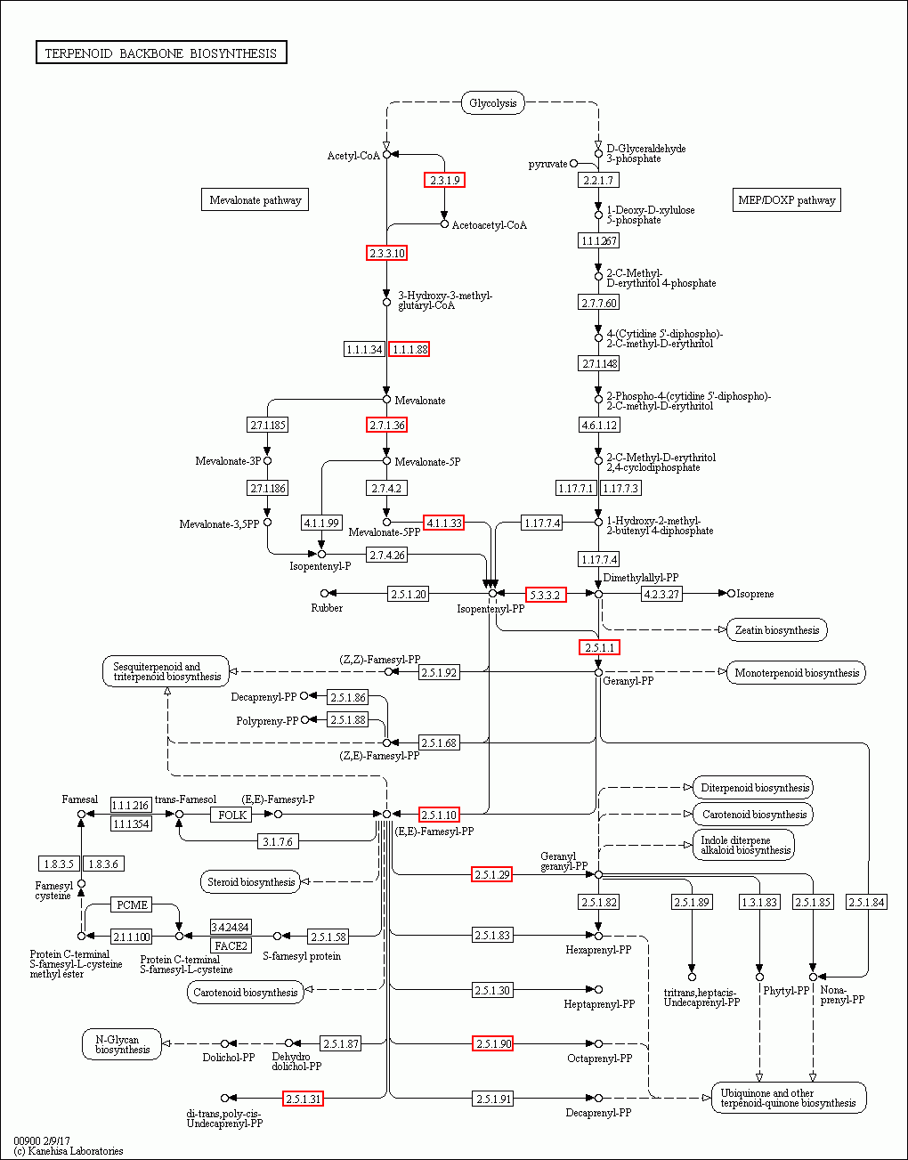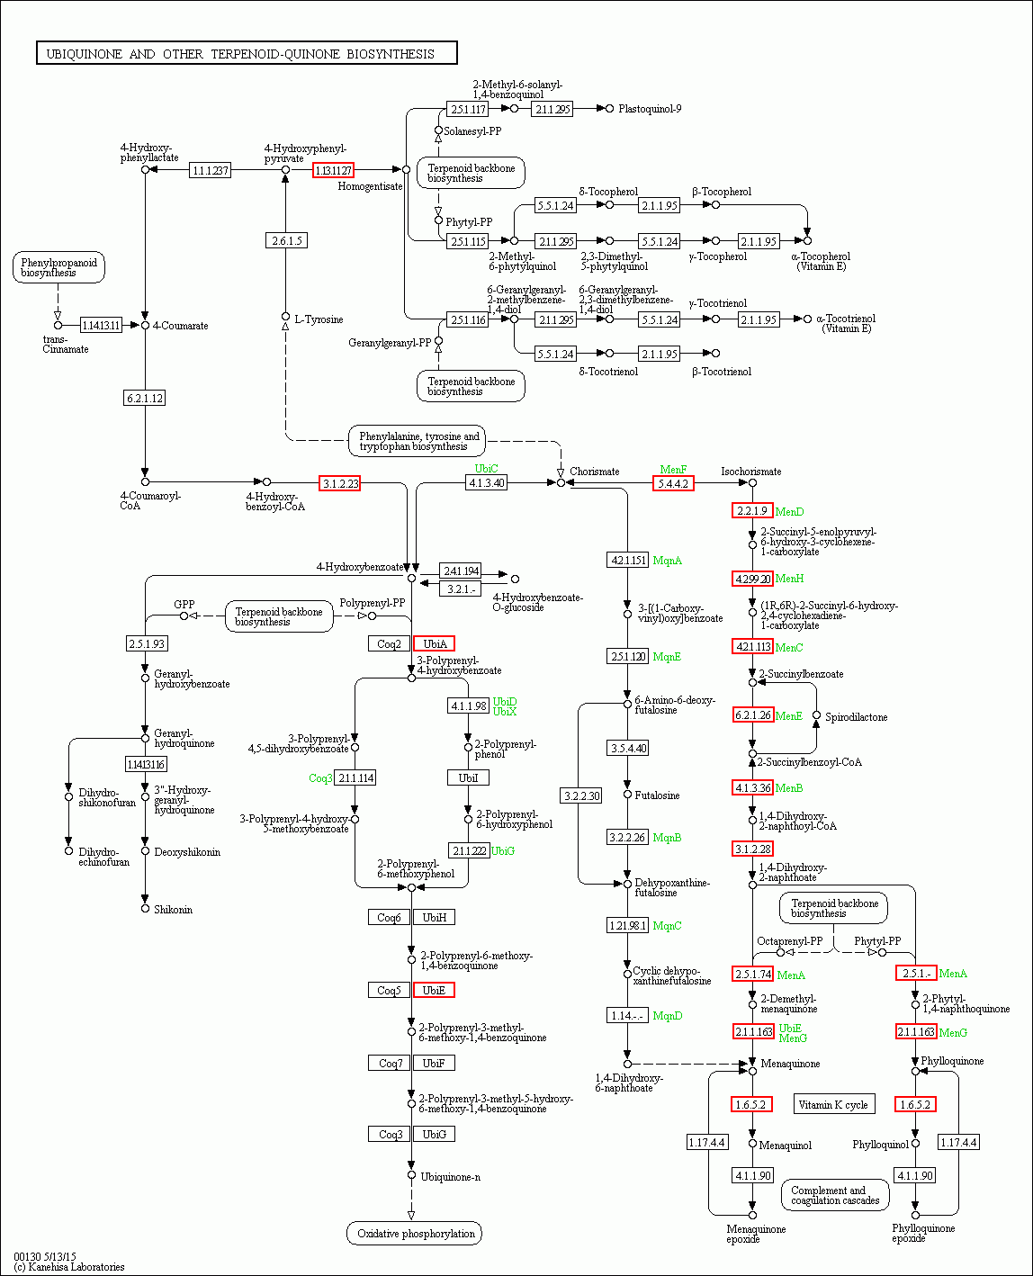
a
b

Fig S8. Changes in gene expression by q-RT-PCR analysis at different stags in mevalonate pathway: (A) atoB, acetyl-CoA acetyltransferase. HMGS, hydroxymethylglutaryl-CoA synthase. HMGR, hydroxymethylglutaryl-CoA reductase. (B) MK, mevalonate kinase. MVD, diphosphomevalonate decarboxylase. (C) IDI, isopentenyl-diphosphate delta-isomerase. GGPPS, geranylgeranyl diphosphate synthase.
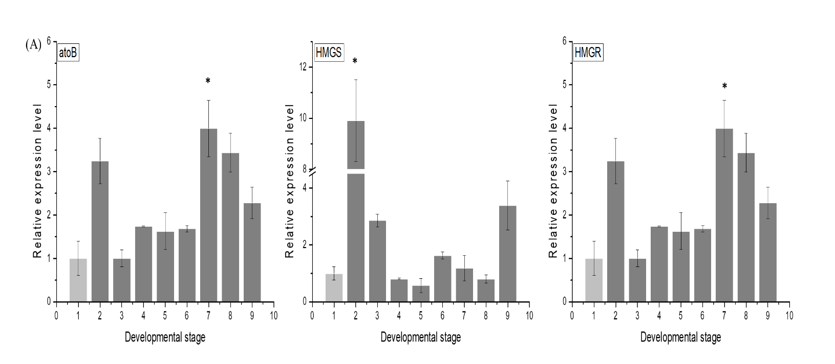
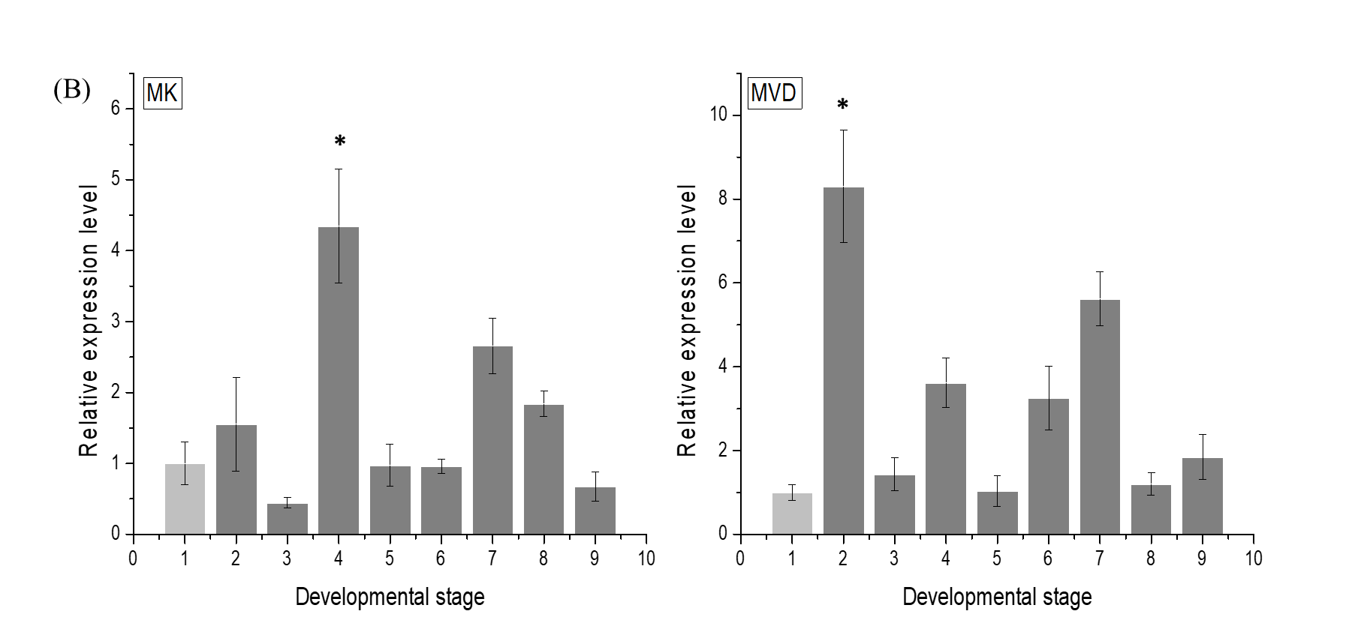
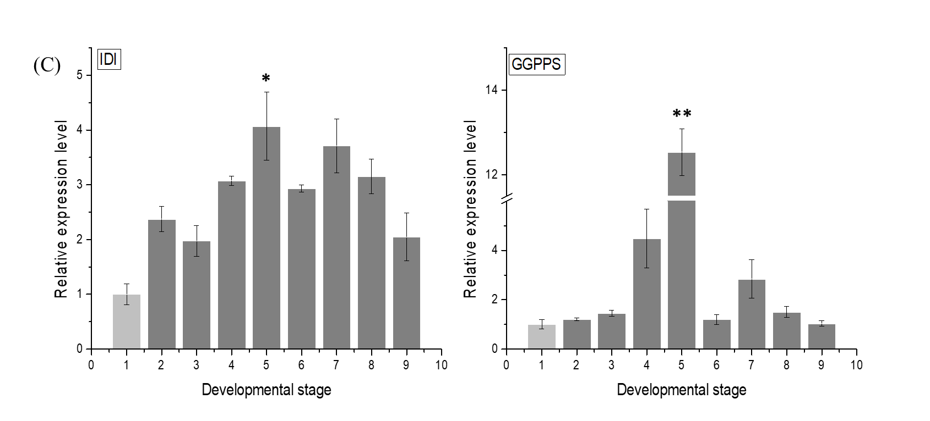

Fig.S9. Identification and analysis of the proteome of samples.（A）Protein mass distribution. X-axis: Molecular weight(kDa); Y-axis: Percentage of protein number. (B) Peptide length distribution. This picture depicts the percentage of different peptide length. X-axis: the peptide length; Y-axis: the corresponding peptide. (C) Unique peptide number distribution. The X-axis shows the unique peptide number of each protein, and the y-axis shows the corresponding protein number. This picture's trend describes that most of the identified proteins contain less than 10 peptides, and protein quantity becomes less with the increase of peptide. (D) Protein Coverage distribution. The X-axis shows the protein coverage range, and the Y-axis shows the corresponding protein number.
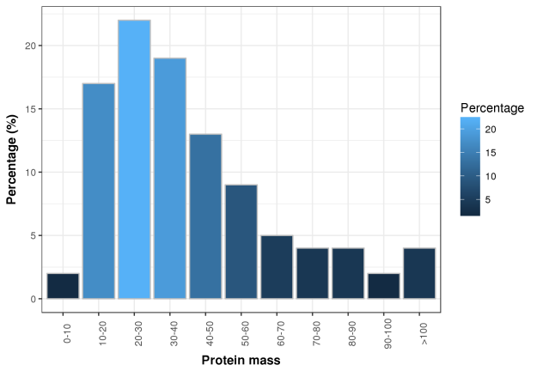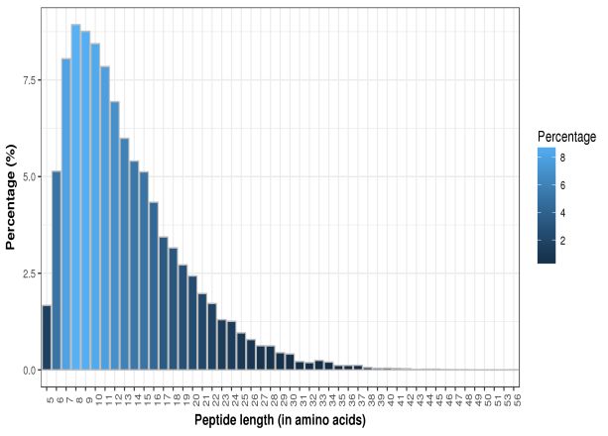
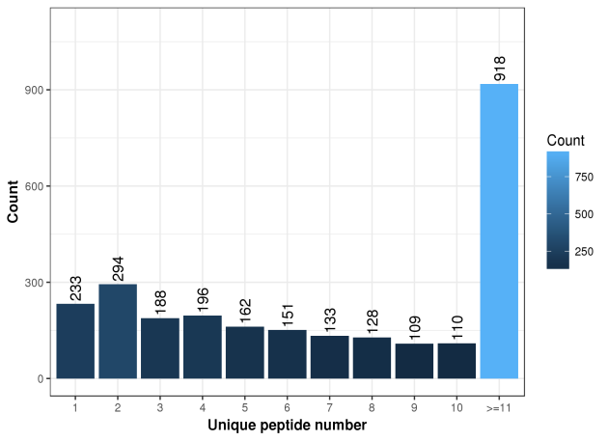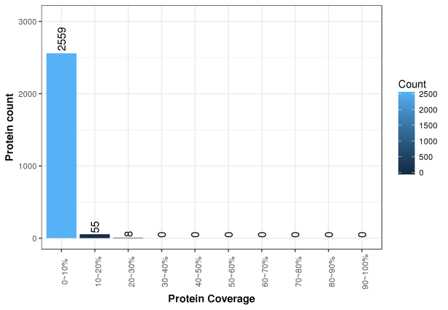

Table S1 Primers sets used in the experiments for qRT-PCR.
Primer | Forward 5’- 3’ Reverse 5’- 3
MenA CGGTATAACCGATAGCGGCA ATAGGTGAAGCAGAAGCCCG
MenB AGTTTCGACGGTGGATACGG TTGCTTCACCCGCAAAAACC
MenC GACGAACTGGCTTCGCTAGA CCGCCTACCAAAGATGGCTT
MenD GGCCAGACCATTCGTCAGAA TTTCCGGCATGGGCAGTAAT
MenI CCTGTTGTGCATCAGCCATTG CTTGCAGTCCCCGTAACCATA
MenE GCTCGGCTGAGATGACTTGT CAGCAGCACCGCCAATAATC
MenF AAACGATGAGTCTCGCAGGG GCACTGCTCTTTCGGAACAC
MenG AACCGGTACAGGAGATCTTGC GCTCCGCATCTCCCTTTATC
atoB AGGTCTTCCGGATACAACGC GCACAAAGTTCGGCACAGTT
HMGS TGTGCCGCACTTGTATTTGG AAGTGCGCTTTCGGTTCCTA
MVD CTCGACGAAGCTTTTGCAGG ACCCTTCCAGATCTCCGGTT
HMGR TTCCGTGCTACAGAAGCCTG GAACGAAGTGCGGCAAAGTT
ERG1 TACGGCGTAGGAAGTTCAGG GGCCCCGTCTCTCCTATCTG
IDI TCAGGCTCATAAAAACGGGC CCCCTGTCCAACATCTGCTTT
GGPPS CGTGCAGTGTGTGAATCGTT GGCACTTGCGGTTGAGTTTT
gyrA TTGCACCGGATTTCCCTACA TTCCGCAGTTCTGGCAATCA

