Electronic Suplementary material

Sedimentation-diffusion behaviour of nanoparticles

Francesco Giorgi¹, Peter Macko², Judith M. Curran¹, Maurice Whelan², Andrew Worth², and Eann A. Patterson¹.
¹ Faculty of Science and Engineering, University of Liverpool, Liverpool L69 3GH, United Kingdom
² European Commission, Joint Research Centre (JRC), Ispra 21027, Italy

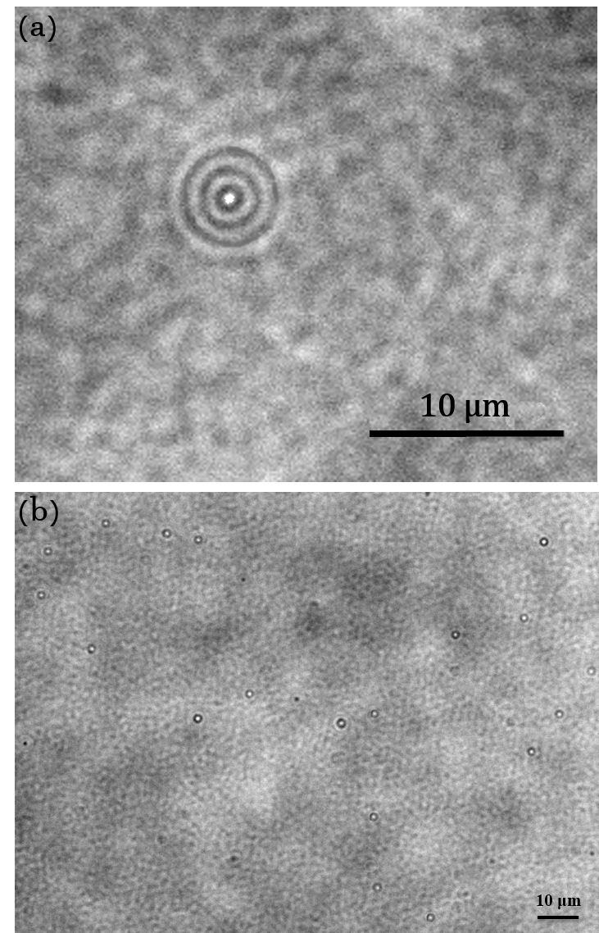
Figure S1: (a) Photograph of a caustic generated by a 100 nm diameter gold nanoparticle in solution. Caustic signatures consist of a central bright spot surrounded by concentric and much fainter diffraction rings. See Patterson & Whelan [25] for more details. (b) Typical image acquired during the experiment showing 100 nm gold nanoparticles in solution. Particles has been counted using the algorithm “find maxima” implemented in the software ImageJ.
Figure S2: The diffusion coefficient D(n) as a function of the normalised local concentration of the nanoparticles n.

Nanoparticles  diameter (nm) | Sedimentation  velocity (m/s)
60 | 1.45*10⁻⁸
80 | 3.15*10⁻⁸
100 | 4.25*10⁻⁸
150 | 12*10⁻⁸

Figure S3: Sedimentation velocity values used in the Giorgi–Macko model.

