Peroxidase-catalyzed proximity labeling to survey the proteome of nanomaterial-cell interface during macropinocytosis-mediated internalization

Supplementary information

Supplementary Materials
Supplementary Methods
Supplementary Figure 1 ~ 13
Supplementary Table 1 ~ 3
Supplementary Table 4-16 for proteome data, H1975 cell membrane proteome, statistic data and so on.

Materials
Supplementary Table 1. Some materials used in the study.
Antibodies
Materials |  |  | Vendor |  |  | Cat#
Rab5 (C8B1) Rabbit mAb |  |  | Cell Signaling Technology |  |  | 3547T
EEA1 (C45B10) Rabbit mAb |  |  | Cell Signaling Technology |  |  | 3288T
LAMP1 (D2D11) XP® Rabbit mAb |  |  | Cell Signaling Technology |  |  | 9091T
Clathrin Heavy Chain (D3C6) XP® Rabbit mAb |  |  | Cell Signaling Technology |  |  | 4796T
Flotillin-1 (D2V7J) XP® Rabbit mAb |  |  | Cell Signaling Technology |  |  | 18634T
Tf (CD71 (D7G9X)) XP® Rabbit mAb |  |  | Cell Signaling Technology |  |  | 13113T
GAPDH (D16H11) XP® Rabbit mAb |  |  | Cell Signaling Technology |  |  | 5174T
4F2hc/CD98 (D3F9D) XP® Rabbit mAb |  |  | Cell Signaling Technology |  |  | 47213S
Neuropilin-1 (D62C6) Rabbit mAb |  |  | Cell Signaling Technology |  |  | 3725S
CDH1, E-Cadherin (24E10) Rabbit mAb |  |  | Cell Signaling Technology |  |  | 3195
CDH1, E-Cadherin (24E10) Mouse mAb |  |  | Cell Signaling Technology |  |  | 14472S
β-Actin (BA3R) Mouse mAb |  |  | Thermo Fisher |  |  | MA5-15739
IRDye® 680RD Donkey anti-Rabbit IgG |  |  | Li-Cor |  |  | 926-68073
IRDye® 800CW Donkey anti-Mouse IgG |  |  | Li-Cor |  |  | 926-32212
IRDye® 800CW Streptavidin |  |  | Li-Cor |  |  | 926-32230
Neutravidin, Oregon Green 488 |  |  | Invitrogen |  |  | A6374
Neutravidin, DyLight 550 |  |  | Invitrogen |  |  | 84606
Donkey anti-mouse IgG, AF488 |  |  | Invitrogen |  |  | A32766
Donkey anti rabbit IgG, AF488 |  |  | Invitrogen |  |  | A21206
Donkey anti rabbit IgG, AF647 |  |  | Invitrogen |  |  | A31573
siRNAs
Materials |  |  | Vendor |  |  | Cat#
Negative control siRNA |  |  | Invitrogen |  |  | 4390843
Silencer™ FAM-labeled Negative Control siRNA |  |  | Invitrogen |  |  | AM4620
Silencer™ Select GAPDH Positive Control siRNA |  |  | Invitrogen |  |  | VH40322
CDH1 siRNA |  |  | Invitrogen |  |  | S2768
DAG1 siRNA |  |  | Invitrogen |  |  | S3908
SHISA4 siRNA |  |  | Invitrogen |  |  | S45277
CEACAM1 siRNA |  |  | Invitrogen |  |  | S1976
Primers
Genes | Forward primer |  |  | Reverse primer
CDH1 | CGAGAGCTACACGTTCACGG |  |  | GGGTGTCGAGGGAAAAATAGG
DAG1 | TCGAGTGACCATTCCAACAGA |  |  | GCACACCCTTATCAGTGTCAA
SHISA4 | TGACCTTGCTTATCACCGAGA |  |  | CTGAGGCGATGCCTGCTATG
CEACAM1 | TGCTCTGATAGCAGTAGCCCT |  |  | TGCCGGTCTTCCCGAAATG
GAPDH | ACAACTTTGGTATCGTGGAAGG |  |  | GCCATCACGCCACAGTTTC
CDH1 CRISPR sgRNAs and primers
sgRNA target sequence |  | Forward primer |  |  | Reverse primer
AAGTCACGCTGAATACAGTG |  | TCTGTGATTTCTGCCCTGCA |  |  | CGATCCCCACACCCCAAAA
CTGGAGATTAATCCGGACAC |  | TGAAGAAGCGCTTAAGCCGT |  |  | AAAAGAAGGGAGGGGCAAGG
GCAATGCGTTCTCTATCCAG |  | GCCTCCGTTTCTGGAATCCA |  |  | AAACTGTCCCACGTTCTCCC
TGAACCACCAGGGTATACGT |  | GTCAGGAGGATCCAGAGGGT |  |  | AAAGACTTCGCCCATGAGCA
HRP
Reagents/Kits |  |  | Vendor |  |  | Cat#
Biotin-HRP |  |  | Fisher |  |  | 432040
Thiol-HRP |  |  | NanoCS |  |  | HRP-TH-1
HRP substrate |  |  | Sigma |  |  | P6782-5mg
Maleimide-HRP |  |  | Fisher |  |  | 31485
EZ-Link™ Plus Activated Peroxidase Kit |  |  | Fisher |  |  | 31489

Nanoparticle synthesis
NPs used in study are summarized in the Table S2.
Supplementary Table 2. NPs used in the study
NPs¹ | Coating² | Application
AuNP | PEG5000 | Cell uptake
T-Au | PEG5000, NA, TAT | Cell uptake
T-Au-HRP | PEG5000, NA, TAT, HRP | T-Au biotinylation
R-Au-HRP | PEG5000, NA, RPAR, HRP | R-Au biotinylation
AgNP | PEG5000 | Bystander AgNP, cell uptake
T-Ag | PEG5000, NA, TAT | Cell uptake
R-Ag | PEG5000, NA, RPAR | Cell uptake
MAP-Ag | PEG5000, NA, MAP | Cell uptake
IONP | Dextran | Cell uptake
T-IONP | Dextran, PEG2000, TAT | Cell uptake
IONW | Dextran | Cell uptake
LNP | PEG2000 | Cell uptake
T-LNP | PEG2000, TAT | Cell uptake
LNP-HRP | PEG2000, HRP | Biotinylation validation
Abx | FITC | Cell uptake
T-Abx | PEG2000, TAT | Cell uptake
Abx-HRP | HRP | Biotinylation validation
T-PLGA | PEG2000, TAT | Cell uptake
QD | PEG2000 | Cell uptake
¹ T-Au is TAT peptide functionalized gold NPs. Similarly, R-Au is RPAR peptide linked AuNPs. T-Ag is TAT coupled silver NPs. MAP-Ag is MAP peptide linked AgNPs. IONP is iron oxide NPs, while IONW is iron oxide nanoworms. LNP is lipid NPs. Abx is Abraxane.
2. NA is NeutrAvidin. See materials for more details about each peptide.

Gold nanoparticles (AuNP)
AuNP at 25 and 50 nm were synthesized based on a previous report ¹. Basically, 500 mL of 0.1 mg/mL chloroauric acid trihydrate (HAuCl₄·3H₂O) is heated to boiling and then Sodium citrate tribasic dihydrate (Na₃C₆H₅O₇·2H₂O) at 10 mg/mL is added with the volume of 7.5 mL for 25 nm and 4.1 mL for 50 nm of AuNP. The purified AuNP is suspended in DI H₂O with optical density (OD) 50 and coated with HS-PEG5000-NH₂ and OPSS-NA (NA is neutravidin, which is pre-coated with OPSS-PEG5000-NHS through NHS-amine reaction) to get NA-Au-NH₂ complexes ². Alternatively, AuNP are also mixed with HS-PEG5000-NH₂ to give Au-PEG5000-NH₂. These AuNP complexes are easily labeled with NHS-CF555 to obtain NA-Au-CF555 and Au-CF555 for further use. To make T-Au, 1 mL of OD 40 NA-Au-CF555 is incubated with the mixture of 20 µL 2 mM biotin-TAT-NH₂ and 80 µL 2 mM biotin for 30 min. Similarly, R-Au are made by mix NA-Au-555 with 20 µL 2 mM biotin-RPARPAR. After centrifuge to remove free peptide, T-Au and R-Au are suspended in PBST buffer at OD 40 and stored at 4 °C.
The mole concentration of AuNP were determined based on the absorbance at 450 nm ³ for a standard path length of 1 cm according to:
c = A450/ε450
Where A450 is the AuNP absorbance at 450nm, ε450 is the molar decadic extinction coefficient (ε) at 450 nm. ε450 is 1.10 × 10⁻⁹ and 9.92 × 10⁻⁹ M⁻¹ cm⁻¹ for 25 and 50 nm AuNP, respectively. The concentration is used to calculate ligand and HRP density and so on.

Silver nanoparticles (AgNP)
AgNP at 30 nm are made by the reaction of AgNO₃ and sodium citrate^{2, 4}. The purified AgNP are suspended in H₂O with OD 300 and then similarly coated with HS-PEG5000-NH₂ and OPSS-NA or HS-PEG5000-NH₂ alone to obtain NA-Ag-NH₂ and Ag-NH₂. The bystander AgNP are then made by mix Ag-NH₂ with NHS-CF488A. T-Ag and R-Ag are made similarly as T-Au and R-Au. MAP-Ag is got by mix NA-Ag-CF555 with the mixture of 20 µL 2 mM biotin-MAP and 80 µL 2 mM biotin for 30 min. All AgNPs were adjusted to OD 200 in PBST for further use.

Iron oxide nanoparticles (IONP)
IONP are synthesized via co-precipitation method with 10 kDa Dextran, FeCl₃∙6H₂O and FeCl₂∙4H₂O ⁵. The purified IONP are aminated and can be easily labeled with NHS-CF555 to get IONP-CF555 for cell uptake study. To make T-IONP, the IONP-CF555 are incubated with NHS-PEG2000-Mal to obtain CF555-IONP-PEG2000-Mal. After purified via centrifugal filter (nominal molecular weight limit, NMWL, 50 kDa), Cys-TAT is added and reacted for 1h at room temperature. T-IONP are then obtained and suspended in PBS buffer at 2 mg Fe/mL for later use.

Iron oxide nanoworms (IONW)
The synthesis of IONW was similar as IONP. Generally, 9000 mg of 4 kDa Dextran and and 1260 mg of FeCl₃∙6H₂O were dissolved in 20 mL degassed deionized water. The solution was stirred in RT for 30 min while N₂ was bubbled through it. A solution of 500 mg FeCl₂∙4H₂O in 2 mL degassed deionized water was prepared and chilled in an ice–water bath for 10 min, and then the solution was added to the flask using a syringe. 5 minutes after the FeCl₂ solution had been added, 2 mL of ice chilled NH₄·OH was added to the flask dropwise within 5 min under rapid stirring. The solution was heated to 70 °C for 1 h. After it had cooled to room temperature, the solution was purified by centrifuge filtering column (100, 000 MWCO, Millipore). The IONW were aminated similarly as IONP and then labeled with NHS-CF555 to get IONW-CF555 as non-targeted NPs for cell uptake study.

QD (ZnS)
The synthesis of ZnS QD was done with our previous protocol ⁵. The synthesized QD was coated with HS-PEG2000-NH₂ and then labeled with NHS-CF555 to get QD-CF555 for cell uptake study.

Lipid nanoparticles (LNP)⁶
Stock solutions of all lipids in chloroform are prepared. Typically, 10 µg of DOTAP, 5 µg of DOPE and 5 µg of DSPE-PEG2000-Mal were mixed and evaporated with constant N₂ flow. The lipid film was then hydrolyzed with SR101 water solution (1 mg/mL) for 30 min under vigorous agitation. The production was then extruded 7 time with 1 µm membrane and followed by 11 times with 100 nm membrane, and dialyzed against ultrapure water to obtain SR101 capsulated LNP-Mal. The LNP-Mal were reacted with Cysteine to block Mal groups as non-targeted LNP for cell uptake study. To make T-LNP, Cys-TAT was mixed with LNP-Mal and reacted for 1 h at room temperature, followed by dialysis to remove free Cys-TAT to get T-LNP for further use.

Abraxane
The conjugation of TAT on Abraxane was done based on a previous report ^{7, 8}. Abx was dissolved in PBS buffer at 5 mg/mL. Then 40 µL of 40 mM NHS-PEG2000-Mal was mixed with 1 mL of Abx solution and reacted at 4 °C overnight. After dialysis, the purified Abx-Mal was then incubated with FAM-Cys-TAT in PBS for 1h at room temperature (~25 °C) to get T-LNP. The synthesis of FITC-Abx was similar that Abx solution was mixed with 20 µL of 10 mM NHS-FITC for 1 h at temperature. After dialysis to remove free FITC, FITC-Abx was obtained as non-targeted NPs for cell uptake study.

Poly(lactide-co-glycolide) (PLGA) nanoparticles
PLGA NPs are made as previous report ^{9, 10}. Normally, PLGA (50-70 kDa, 75 :25) and PLGA-PEG2000-Mal (Nanosoftpolymer) were dissolved in methylene chloride at 10 mg/mL. The PLGA solution was added dropwise to a stirring aqueous solution of 100 mM phosphate buffer and 10 mM NaCl (pH 7.4). The mixture was kept at 37 °C for 2 h, 45 °C for another 1 h, and then cooled down slowly to room temperature. The PLGA NPs were purified with centrifugation (22,000 g) and resuspended in PBS buffer. T-PLGA were then made by adding 20 µL 2 mM of FAM-Cys-TAT peptide to 1 mL of PLGA NPs and stirred for 1 h at room temperature. After centrifugation, T-PLGA were collected and stored at 4 °C for further cell uptake study.

HRP conjugations (X-HRP)
The conjugation methods are mainly showed in Supplementary Figure1. See details below for each X-HRP conjugations.

T-Au-HRP
The T-Au-HRP were synthesized with CF555-Au-NA. Usually, 1 mL of OD 40 CF555-Au-NA was mixed with 200 µL 2 mg/mL biotin-HRP (Fisher, 432040) and incubated at room temperature for 1 h. Then 20 µL of 2 mM biotin-TAT was directly added to the mixture and incubated for another 30 min. After centrifugation to remove free HRP and TAT, T-Au-HRP were resuspended in 1 mL PBST and stored at 4 °C for further use. Both 25 nm and 50 nm AuNP can be used in this protocol.

R-Au-HRP
Starting from NA-Au-NH₂, 1 mL of the particles were spun down and resuspended in 1 mL pH 7.2 phosphate buffer. Aldehyde-HRP was then coupled on NA-Au-NH₂ following the manual of EZ-Link™ Plus Activated Peroxidase Kit (Thermo Scientific). After then, the HRP-Au-NA were suspended in PBST and 20 µL of 2 mM biotin-RPAR was added to bind for 30 min RT. The R-Au-HRP were purified via centrifuge and sonicated to suspend in PBST for further use.

Dextran-HRP, Tf-HRP, Trastuzumab-HRP, Abx-HRP
These HRP conjugations were done with the EZ-Link™ Plus Activated Peroxidase Kit. Amino dextran (70 kDa, Fisher, D1862) was dissolved in pH 7.2 phosphate buffer. Tf was prepared in PBS at 20 mg/mL. Abx was dissolved in 7.2 phosphate buffer at 10 mg/mL. Trastuzumab was prepared in PBS buffer at 10 mg/mL and then dialyzed against PBS to remove the adjunction histidine. The Trastuzumab solution was then spun with 10 kDa centrifuge column to replace the solution to pH 7.2 phosphate buffer. 1 mL of the as-prepared solutions were mixed with 1 mg of aldehyde-HRP, respectively. After the reaction was done, the product was purified via centrifuge filter (100 kDa cutoff) to remove unreacted substrates. The final product of Dextran-HRP, Tf-HRP, Trastuzumab-HRP and Abx-HRP were suspended/dissolved in PBS for further use.

LNP-HRP
Thiol-HRP (NanoCS, HRP-TH-1) at 1mg was dissolved in PBS and mixed with LNP-Mal. LNP-HRP were obtained by dialysis (100 kDa cutoff) against PBS.

TAT-HRP
10 µL of 20 mM FAM-Cys-TAT was added to 1 mL of 1 mg/mL Maleimide-HRP (Fisher, 31845) and reacted for 1 h at RT. The TAT-HRP was got by spinning with 10 kDa centrifuge filter.

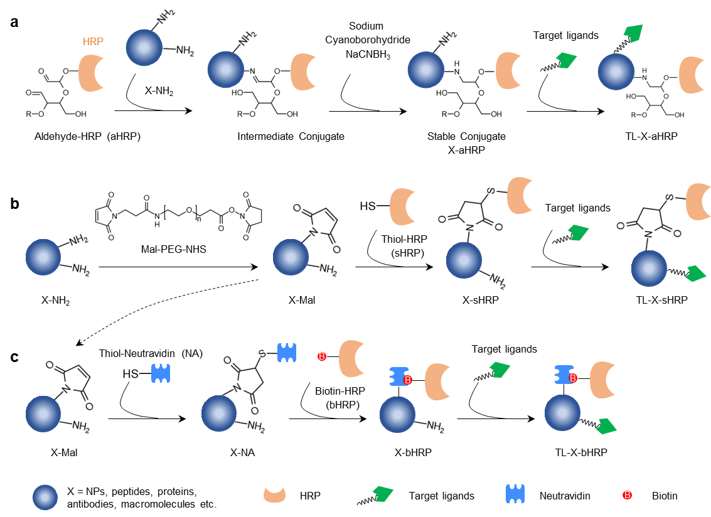
Supplementary Figure 1. Conjugation chemistry of X-HRP. X refers to NPs, peptides, proteins, antibodies, macromolecules (e.g., dextran or BSA) and so on. With the function groups on X, such as the amine group, aldehyde-HRP can be directly conjugated (a). Alternatively, the amine group can be replaced by maleimide and then linked with thiol-HRP (b) or coupled with thiol-NeutrAvidin to bind with biotin-HRP (c). X-HRP can be further conjugated with targeted ligands if needed.

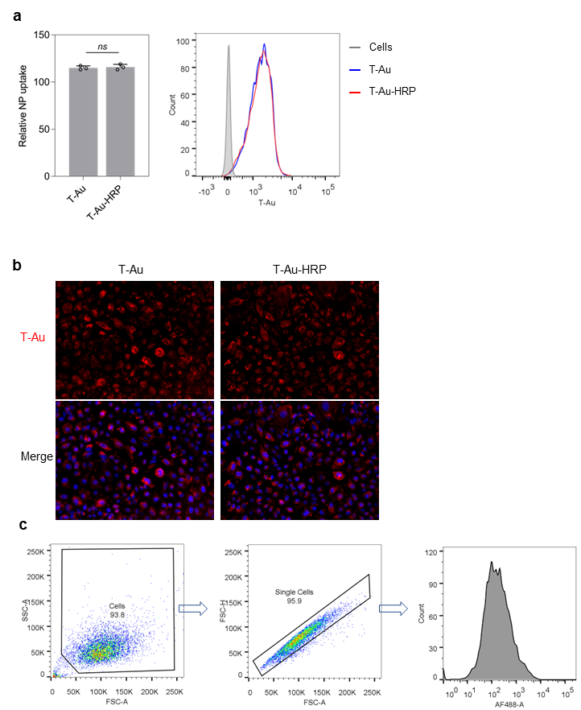
Supplementary Figure 2. HRP conjugation did not affect T-Au cell uptake.
- Flow cytometry quantification of T-Au and T-Au-HRP uptake (n = 3, unpaired t-test).
- Fluorescence images of T-Au and T-Au-HRP cellular uptake. CF555 labeled NPs were incubated with H1975 cells for 1h, followed by fixation and DAPI staining before imaged by EVOS. Three independent experiments were done, and representative images are shown here.
- The gating strategy of flow cytometry analysis in the study.

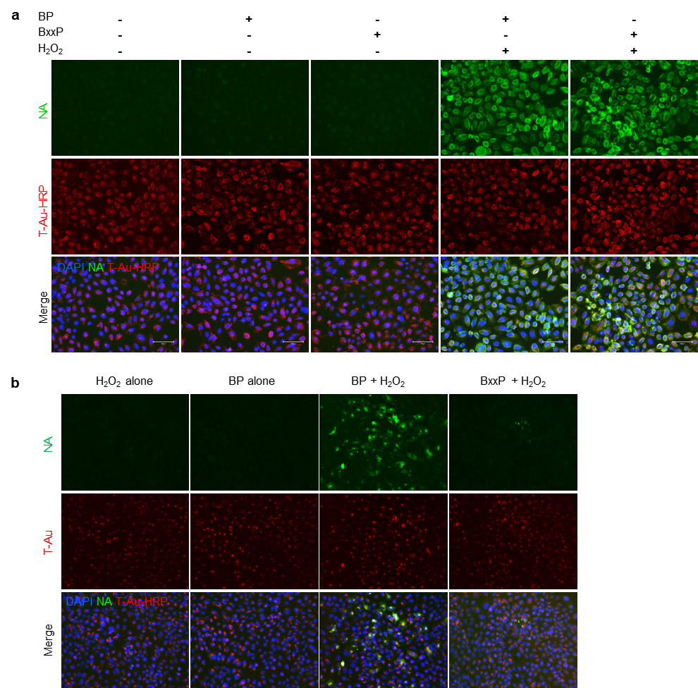

Supplementary Figure 3. T-Au-HRP induced protein biotinylation with BP or BxxP.
- T-Au-HRP showed biotinylation activities in the presence of both H₂O₂ and BP or BxxP.
- BP biotinylated intracellular proteins. H1975 cells were treated with T-Au-HRP for 1h, followed by PBS wash and fresh complete medium replacement to incubate for another 24h. In such case, all T-Au-HRP should reside inside cells. BP or BxxP was then added with H₂O₂ for biotinylation. While BP was able to effect biotinylation, BxxP failed to do so, suggesting that it cannot access the HRP on T-Au inside cells due to its membrane impermeable property. Representative images are shown here from three independent experiments.

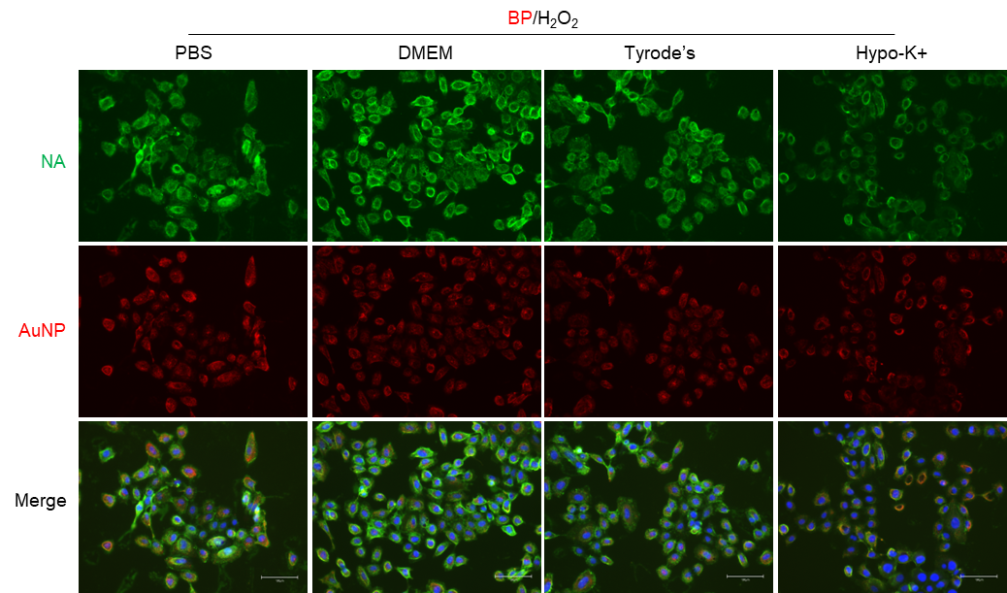

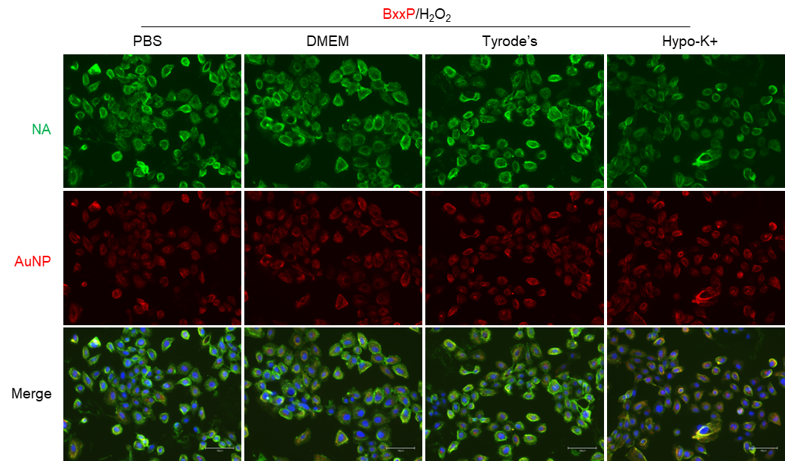
Supplementary Figure 4. Impact of reaction solution on biotinylation. After incubation with T-Au-HRP, biotinylation was performed in corresponding solutions for 1 min. FBS free DMEM showed the most stable and efficient biotinylation effect. Representative images are shown here from at least three independent experiments.

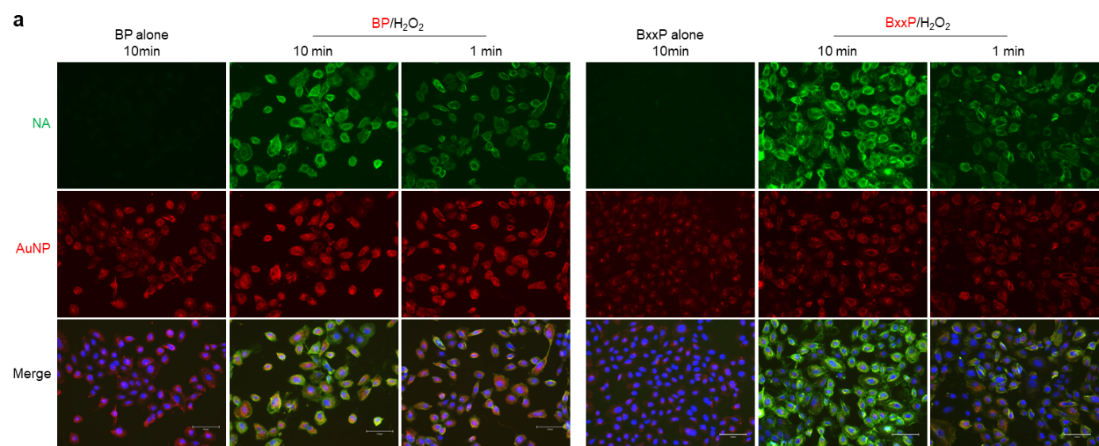
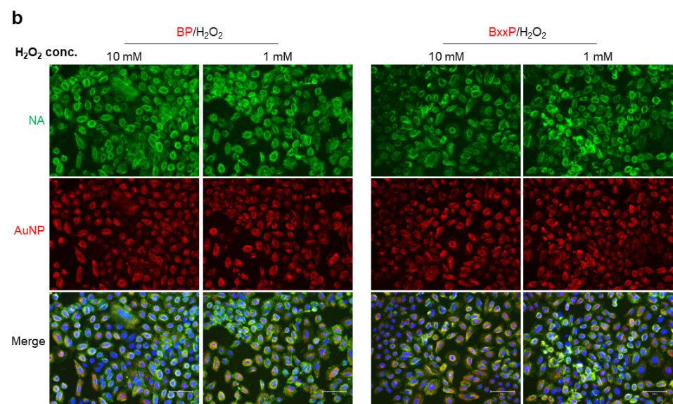

Supplementary Figure 5. Impact of labeling time and H₂O₂ concentration on biotinylation.
- Biotinylation time. T-Au-HRP incubated cells were treated with BP or BxxP plus H₂O₂ for 1 or 10 min. Although the 10-min-biotinylation induced much more labeling, the 1-min also gave enough signals. To reduce the non-specific labeling, 1-min biotinylation was chose for the following experiments.
- The concentration of H₂O₂. There was not significant difference between 1 and 10 mM of H₂O₂ for labeling and 1 mM was used in the rest studies.
Representative images are shown here from at least three independent experiments.

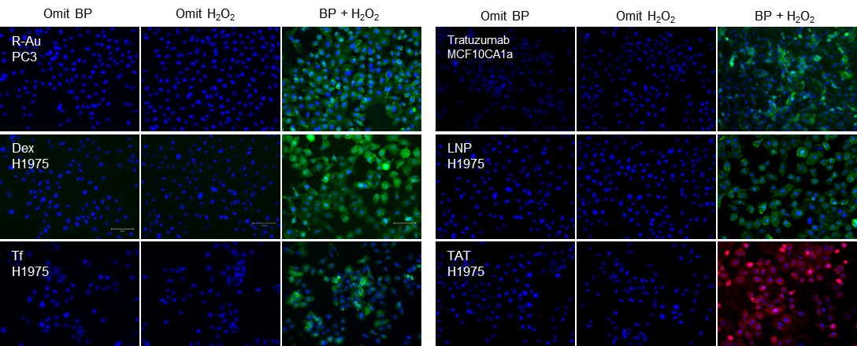
Supplementary Figure 6. Representative fluorescence images of HRP conjugation activities. R-Au, Dex, Tf, Traruzumab, LNP and TAT peptide were conjugated with HRP and performed protein biotinylation after incubation with corresponding cells. The biotinylated proteins were stained with NA-568 for TAT-HRP and NA-488 for all the rest conjugations (n = 3).

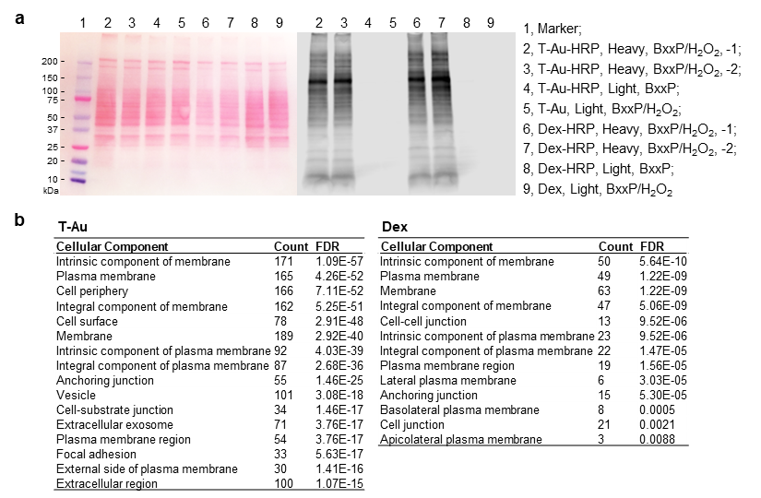
Supplementary Figure 7. Cell surface proteome of T-Au and dextran MP corresponding to Figure 4.
- Validation of biotinylation quality for T-Au-HRP and Dex-HRP. 30 µg of protein was loaded in each lane. Left: Ponceaus S staining for all proteins; Right: NA blotting for biotinylated proteins.
- Cellular component analysis of T-Au and dextran proteome. A part of the result was listed here, showing most of the hits are cell surface proteins

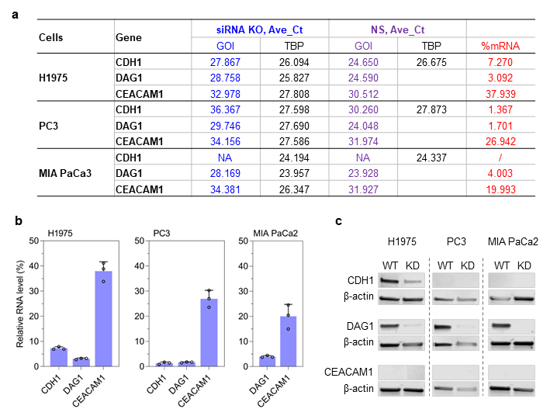
Supplementary Figure 8. CDH1, DAG1 and CEACAM1 expression level after siRNA KD.
- The mRNA level of each gene pre/post-KD analyzed by qPCR.
- The remained mRNA level of corresponding gene according to a (n =3).
- The protein expression of each gene analyzed by WB.
CDH1 expression: H1975 cells have a WB-detectable CDH1 expression, while the expression in PC3 is relatively low. CDH1 is not determined via qPCR for MIA PaCa2 cells.
DAG1 expression in all three cells are high.
CEACAM1 expression too low to be detected by WB for all three cell lines.

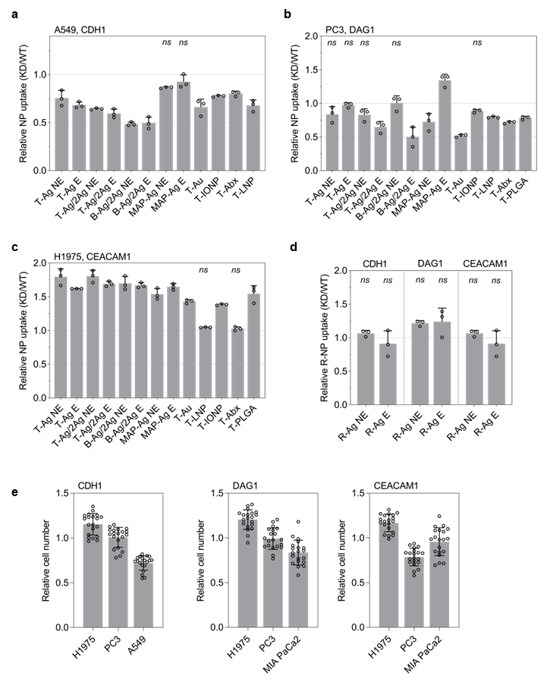
Supplementary Figure 9. Hits validation corresponding to Figure 5.
- CDH1 KD in A549 reduced targeted NP uptake.
- DAG1 KD in PC3 reduced targeted NP uptake.
- CEACAM1 KD in H1975 reduced targeted NP uptake.
- R-Ag uptake was not affected by corresponding gene KD.
- The relative cell number after siRNA KD between corresponding genes and NS siRNA (n = 20). Note that the KD of genes impact on cell survival is more cell specific, suggesting all these three genes did not harm cells largely after KD.
All quantified data were analyzed using 2-way analysis of variance (ANOVA) with Tukey’s multiple comparisons test (WT vs KD) and are expressed as mean ± s.d. (n = 3). Except for those who marked “ns” as non-significant, the rest relative uptake inhibitions are statistically significant with P < 0.05 or less.

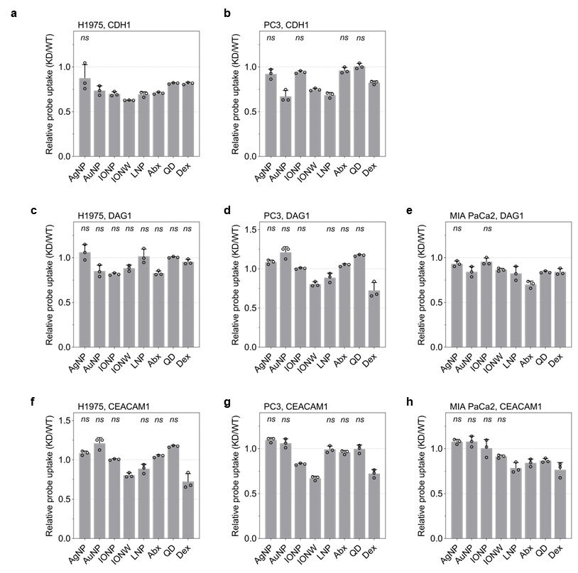
Supplementary Figure 10. Hits validation to non-targeted probes.
a, b. Impact of CDH1 KD on non-targeted probe uptake. a, H1975 cells; b, PC3 cells.
c-e. Impact of DAG1 KD on non-targeted probe uptake. c, H1975 cells; d, PC3 cells; e, MIA PaCa2 cells.
f-h. Impact of CEACAM1 KD on non-targeted probe uptake. f, H1975 cells; g, PC3 cells; h, MIA PaCa2 cells.
All quantified data were analyzed using 2-way analysis of variance (ANOVA) with Tukey’s multiple comparisons test (WT vs KD) and are expressed as mean ± s.d. (n = 3). Except for those who marked “ns” as non-significant, the rest relative uptake inhibitions are statistically significant with P < 0.05 or less.

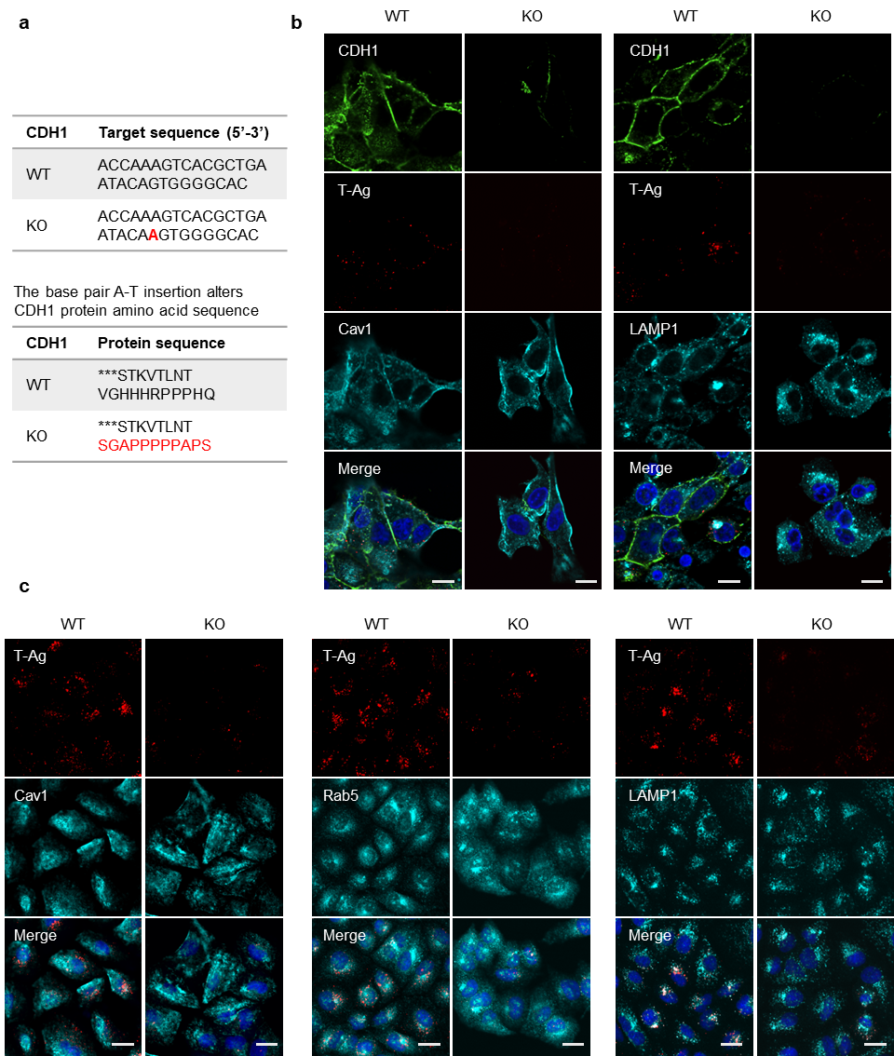
Supplementary Figure 11. Representative confocal images of T-Ag uptake with CDH1 CRISPR KO cells.
- DNA sequence of CDH1 target site after CRISPR KO. An insertion of “A” was detected.
b-c. CDH1 WT and KO A549 and H1975 cells were incubated with T-Ag for 1h before etching and fixation. The cells are stained with CDH1 and corresponding markers for imaging. At least three independent experiments were performed for each experiment.

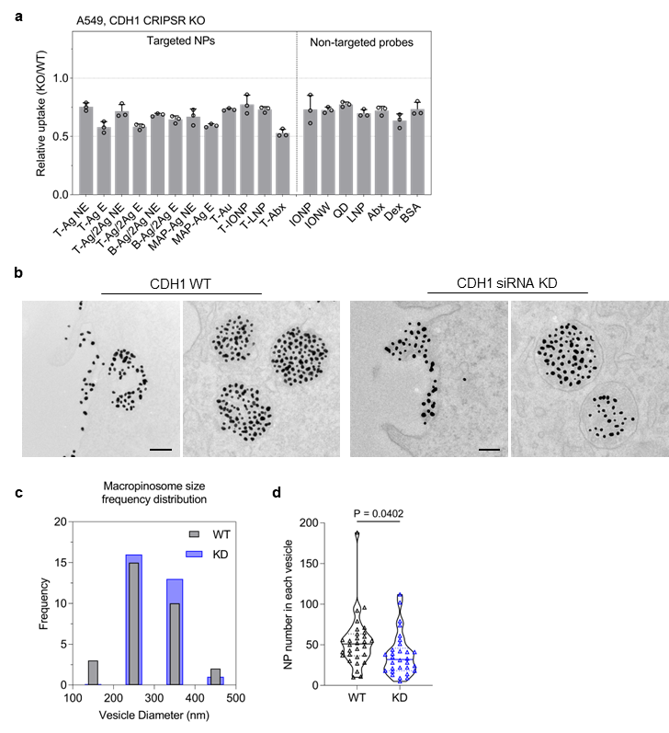
Supplementary Figure 12. TEM analysis of T-NP uptake impaired by CDH1 KD.
- CDH1 KO impairs cell uptake, related to Figure 6d.
- TEM images of T-Au uptake with CDH1 WT and KD H1975 cells. Scale bars, 100 nm.
- Frequency distribution of macropinosome size. The diameter (in nm) of each endocytic vesicle was measured and most of these vesicles are in the diameter of 200 ~ 400 nm, for both WT and KD cells without significant difference.
- The decreasing of NP number in each vesicle of KD cells is significant comparing to that of WT cells, corresponding to Figure 6e (n = 30, unpaired t test).

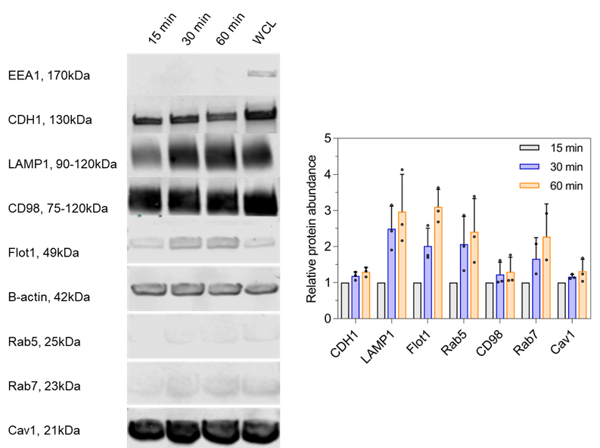
Supplementary Figure 13. CDH1 in the endocytic vesicles.
H1975 cells were incubated with T-IONP for 1h at 4 °C, then recovered to 37 °C by replace newly pre-warmed medium and incubated for another 15, 30 and 60min. Then the endocytic vesicles were isolated, and the containing proteins were identified via WB. The protein abundance is quantified with ImageJ, and then first normalized to the related β-actin abundance to obtain the relative protein amount (Protein/β-actin) at each time point. To plot the right figure, the relative protein abundance was obtained by normalizing the value of Protein/β-actin at 30 and 60 min to the 15 min one. Data shown hare are mean ± s.d. (n = 3).

Supplementary Table 3. Hits validation via siRNA KD
 |  | H1975 cells |  |  |  |  |  |  | MIA PaCa2 cells
No | Gene¹ | Cells² | T-Ag E³ | T-Ag NE |  | Dex |  | Cells |  | T-Ag E | T-Ag NE | Dex
1 | CDH1 | 0.244 | 0.503 | 0.451 |  | 1.294 |  | 0.643 |  | 0.884 | 0.579 | 1.400
2 | COL17A1 | 0.663 | 1.035 | 1.026 |  | 1.351 |  | 0.812 |  | 0.305 | 0.280 | 0.916
3 | FKBP8 | 0.457 | 0.964 | 1.024 |  | 1.332 |  | 0.683 |  | 0.525 | 0.935 | 1.325
4 | CAPN5 | 0.640 | 0.760 | 0.846 |  | 1.120 |  | 0.669 |  | 0.390 | 0.390 | 1.100
5 | ADAM17 | 0.796 | 0.870 | 1.119 |  | 1.307 |  | 0.974 |  | 1.590 | 1.627 | 1.100
6 | ATP1B1 | 0.844 | 0.774 | 1.070 |  | 1.149 |  | 1.101 |  | 0.838 | 1.000 | 1.088
7 | GPC1 | 0.739 | 0.752 | 0.901 |  | 1.316 |  | 1.104 |  | 0.798 | 0.980 | 1.016
8 | PODXL | 0.142 | 0.757 | 1.195 |  | 1.427 |  | 1.232 |  | 1.227 | 1.627 | 1.066
9 | PROM2 | 0.783 | 0.807 | 0.973 |  | 1.180 |  | 0.701 |  | 1.128 | 1.237 | 0.944
10 | ATP11C | 0.750 | 1.016 | 0.783 |  | 1.025 |  | 0.935 |  | 0.706 | 0.766 | 0.994
11 | DAG1 | 0.173 | 0.377 | 0.371 |  | 1.089 |  | 0.491 |  | 0.585 | 0.517 | 1.525
12 | DOCK7 | 1.005 | 0.823 | 0.708 |  | 1.161 |  | 1.091 |  | 0.910 | 1.031 | 0.941
13 | SH3BP4 | 0.660 | 0.846 | 0.751 |  | 1.788 |  | 0.727 |  | 0.950 | 1.667 | 1.063
14 | PGK1 | 0.387 | 0.712 | 0.580 |  | 1.544 |  | 0.658 |  | 0.577 | 0.644 | 1.244
15 | ZC3HAV1 | 0.403 | 0.850 | 0.687 |  | 1.241 |  | 0.688 |  | 0.619 | 0.669 | 1.028
16 | DOCK6 | 0.234 | 0.803 | 0.481 |  | 1.364 |  | 0.782 |  | 0.602 | 0.475 | 0.716
17 | LAMB2 | 0.512 | 0.561 | 0.515 |  | 1.073 |  | 0.888 |  | 0.313 | 0.243 | 1.019
18 | IQGAP3 | 0.179 | 0.235 | 0.247 |  | 1.231 |  | 0.803 |  | 0.458 | 0.404 | 0.822
19 | FMNL3 | 0.463 | 0.257 | 0.229 |  | 1.500 |  | 0.391 |  | 0.542 | 0.345 | 1.156
20 | SNX1 | 0.591 | 0.902 | 0.821 |  | 1.465 |  | 0.626 |  | 0.593 | 0.658 | 0.944
21 | HLA-C | 0.573 | 0.785 | 0.686 |  | 1.741 |  | 0.817 |  | 0.577 | 0.347 | 1.034
22 | ATP7A | 0.542 | 0.641 | 0.597 |  | 1.184 |  | 0.696 |  | 0.449 | 0.272 | 1.203
23 | STEAP2 | 0.252 | 0.474 | 0.664 |  | 1.747 |  | 0.896 |  | 0.811 | 0.777 | 0.803
24 | PVRL3 | 0.505 | 0.480 | 0.514 |  | 1.146 |  | 0.764 |  | 0.356 | 0.229 | 1.019
25 | CLDN1 | 0.631 | 0.698 | 0.703 |  | 1.491 |  | 0.947 |  | 0.466 | 0.322 | 0.819
26 | PTPRK | 0.668 | 0.740 | 0.760 |  | 1.759 |  | 0.769 |  | 0.423 | 0.308 | 1.169
27 | SLC2A5 | 0.657 | 0.759 | 0.737 |  | 1.601 |  | 0.926 |  | 0.897 | 0.873 | 0.966
28 | SLC7A6 | 0.369 | 0.500 | 0.482 |  | 1.206 |  | 0.964 |  | 0.509 | 0.364 | 1.034
29 | SLC7A1 | 0.611 | 0.856 | 0.806 |  | 1.623 |  | 0.943 |  | 0.864 | 0.873 | 1.191
30 | PANX1 | 0.533 | 0.821 | 0.718 |  | 1.532 |  | 0.965 |  | 0.719 | 0.503 | 1.088
31 | SHISA4 | 0.756 | 0.330 | 0.477 |  | 0.992 |  | 0.628 |  | 0.231 | 0.281 | 1.020
32 | SLC35F2 | 0.904 | 0.366 | 0.508 |  | 0.838 |  | 0.582 |  | 0.704 | 0.538 | 0.625
33 | FAM171A1 | 0.842 | 0.946 | 0.873 |  | 0.891 |  | 0.522 |  | 0.525 | 0.267 | 0.575
34 | TMPRSS11E | 1.048 | 0.627 | 0.516 |  | 0.862 |  | 0.706 |  | 0.350 | 0.287 | 0.835
35 | P2RY2 | 0.567 | 0.630 | 0.487 |  | 1.158 |  | 0.843 |  | 0.409 | 0.341 | 0.620
36 | LPHN1 | 0.812 | 0.639 | 0.764 |  | 0.931 |  | 0.850 |  | 0.757 | 0.496 | 0.865
37 | CLDN4 | 1.059 | 0.792 | 0.741 |  | 0.980 |  | 0.871 |  | 0.530 | 0.481 | 1.085
38 | CEACAM1 | 0.971 | 0.628 | 0.542 |  | 0.830 |  | 0.496 |  | 0.246 | 0.201 | 0.880
39 | CLDN7 | 1.034 | 0.757 | 0.938 |  | 0.964 |  | 0.705 |  | 0.658 | 0.574 | 0.940
40 | TMBIM1 | 1.106 | 0.620 | 0.858 |  | 1.020 |  | 0.841 |  | 0.988 | 0.912 | 1.150
41 | TAB1 | 1.114 | 0.485 | 0.748 |  | 0.927 |  | 0.905 |  | 1.058 | 0.709 | 0.880
42 | UBA3 | 1.154 | 1.061 | 0.979 |  | 0.980 |  | 0.827 |  | 0.693 | 0.564 | 0.980
43 | LANCL2 | 1.071 | 0.811 | 0.816 |  | 0.964 |  | 0.994 |  | 1.162 | 0.590 | 0.850
44 | TMEM231 | 1.013 | 0.797 | 0.902 |  | 0.992 |  | 0.988 |  | 1.504 | 0.932 | 0.965
^{1.} Gene 1-11 are T-Au specific genes (orange), 12-22 are Dex specific genes (blue), 23-44 are shared genes.
^{2.} Cell number are counted after siRNA KD. All data are normalized to corresponding NS siRNA control.
^{3.} E means etched to remove extracellular T-Ag, leaving only the internalized T-Ag for detection; NE is non-etch for overall T-Ag uptake.

Reference

1. Frens, G. Controlled Nucleation for the Regulation of the Particle Size in Monodisperse Gold Suspensions. Nature Physical Science 241, 20-22 (1973).
2. Braun, G.B. et al. Etchable plasmonic nanoparticle probes to image and quantify cellular internalization. Nat Mater 13, 904-911 (2014).
3. Haiss, W., Thanh, N.T., Aveyard, J. & Fernig, D.G. Determination of size and concentration of gold nanoparticles from UV-vis spectra. Anal Chem 79, 4215-4221 (2007).
4. Wei, Y. et al. Synergistic Entry of Individual Nanoparticles into Mammalian Cells Driven by Free Energy Decline and Regulated by Their Sizes. ACS Nano 16, 5885-5897 (2022).
5. Wei, Y., Tang, T. & Pang, H.B. Cellular internalization of bystander nanomaterial induced by TAT-nanoparticles and regulated by extracellular cysteine. Nat Commun 10, 3646 (2019).
6. Pascucci, L. et al. Paclitaxel is incorporated by mesenchymal stromal cells and released in exosomes that inhibit in vitro tumor growth: a new approach for drug delivery. Journal of controlled release : official journal of the Controlled Release Society 192, 262-270 (2014).
7. Sugahara, K.N. et al. Coadministration of a tumor-penetrating peptide enhances the efficacy of cancer drugs. Science 328, 1031-1035 (2010).
8. Karmali, P.P. et al. Targeting of albumin-embedded paclitaxel nanoparticles to tumors. Nanomedicine 5, 73-82 (2009).
9. Astete, C.E. & Sabliov, C.M. Synthesis and characterization of PLGA nanoparticles. J Biomater Sci Polym Ed 17, 247-289 (2006).
10. Harguindey, A. et al. Synthesis and Assembly of Click-Nucleic-Acid-Containing PEG-PLGA Nanoparticles for DNA Delivery. Advanced materials 29 (2017).

