Supplementary Material.
Oro-dental phenotyping and report of three families with RELT-associated amelogenesis imperfecta
Kemelly Karolliny Moreira Resende^{1,5}, Margot Charlotte Riou^{2,3,4}, Paulo Marcio Yamaguti^{1,5}, Benjamin Fournier^{2,3,4}, Sophie Rondeau^{7,10}, Laurence Pacot^{8,9}, Ariane Berdal^{2,3,4}, Juliana Forte Mazzeu⁶, Valérie Cormier-Daire^{7,10}, Céline Gaucher^{8,11,12}, Ana Carolina Acevedo^{1,3,4,5}*, Muriel de La Dure-Molla^{2,3,10}*#
1-Laboratory of Oral Histopathology, Faculty of Health Sciences, University of Brasilia, Brazil
2-Reference Center of Oral and Dental Rare Diseases (O-Rares), Rothschild Hospital, Public Assistance- Paris Hospitals, Paris, France
3-Paris Cité University, Dental Faculty, Paris, France.
4-Centre de Recherche des Cordeliers, Université Paris Cité, Sorbonne University, UMRS 1138 Inserm, Molecular Oral Physiopathology, Paris, France.
5-Oral Care Center for Inherited Diseases, University Hospital of Brasilia, Brasilia, Brazil.
6-Laboratory of Clinical Genetics, Faculty of Medicine, University of Brasília, Brasília, Brazil.
7-Reference Center for Skeletal Dysplasia, Service de Médecine Génomique des Maladies Rares, Necker Enfants Malades Hospital, Assistance Publique-Hôpitaux de Paris, Paris, France
8-Service de Médecine Génomique des Maladies de Système et d'Organe, Fédération de Génétique et de Médecine Génomique, APHP.Centre - Université Paris Cité, Hôpital Cochin, Paris, France.
9- Institut Cochin, Inserm U1016, CNRS UMR8104, Université Paris Cité, CARPEM, Paris, France
10-Paris Cité University, INSERM UMR 1163 IMAGINE Institute, Paris France
11-Université Paris Cité, URP2496, F-92120 Montrouge, France.
12-Department of Odontology, AP-HP, Hôpitaux Universitaire Henri Mondor, Paris F-94000, France.

Appendix S1. Material and Methods. Molecular Analysis.
In family 1 (proband IV:2) exome sequencing was performed using the Illumina platform at Macrogen (Seoul, Korea) and the variants were analyzed on the VarStation and Franklin Genoox platforms. Further Sanger sequencing was done in the affected siblings and parents using primers according to Appendix S2. In family 2 proband (V:3), exome sequencing was performed using Human Exome Refseq Kit (Twist Bioscience) and a Novaseq (Illumina). Annotation and visualization of the variants was made on Polyweb Interface (Imagine Institute, Paris). Finally, in family 3, (proband II;2) high-throughput targeted sequencing was performed using a hybridization capture DNA library (NimbleDesign®-Roche sequencing solutionTM) and a MiSeq® platform (IlluminaTM)(Appendix S3A).
All variants were classified according to the latest American College of Medical Genetics guidelines (Richards et al, 2015). Variants were identified as a novel by their absence from the Osteogenesis Imperfecta Variant Database (http://www.le.ac.uk/ge/collagen). The nomenclature of all variants was checked on the Mutalyzer Website (https://mutalyzer.nl). All variants were registered in the Leiden Open Variation Database (LOVD)
Appendix S2. Sequences of the primers used for RELT gene amplification of Family 1:

RELT | Primers (5’->3’) | Amplicon size (bp)
Exon 3-F | GTCCCTACCACTGGGGTTTC | 269
Exon 3-R | AAGCCTGAGGACCCTTGG | 269
bp: base pairs.

Appendix S3 A: Targeted genes panel used for molecular analysis for family 3.
Protein | Gene (HGNC) | Localization | ENST
Amelogenin | AMELX | Xp22.31-22.1 | ENST0000380712.7
Enamelin | ENAM | 4q13.3 | ENST00000396073.3
Ameloblastin | AMBN | 4q21 | ENST00000922937.10
Distal less homeobox 3 | DLX3 | 17q21 | ENST00000434704.2
Integrin, beta 6 | ITGB6 | 2q24.2 | ENST00000283249.6
Laminin, beta 3 | LAMB3 | 1q32 | ENST00000356082.8
Amelotin | AMTN | 4q13.3 | ENST00000339336.8
WD repeat domain 72 | WDR72 | 15q21.3 | ENST00000360509.9
Matrix metallopeptidase 20 | MMP20 | 11q22.3 | ENST00000260228.2
Solute carrier Family 24A4 | SLC24A4 | 14q32.12 | ENST00000532405.5
Kallikrein-related peptidase 4 | KLK4 | 19q13.41 | ENST00000324041.5
Bone morphogenetic phosphoprotein 2 | BMP2 | 20p13 | ENST00000378827.4
Odontogenesis-associated phosphoprotein | ODAPH | 4q21.1 | ENST00000311623.8
Collagen 17 alpha 1 | COL17A1 | 10q24.3 | ENST00000353479.9
Cyclin and CBS domain divalente metal cátion transport mediator 4 | CNNM4 | 2q11.2 | ENST00000377075.2
Family with sequence similarity 83, member H | FAM83H | 8q24.3 | ENST00000388913.3
Laminin subunit alpha 3 | LAMA3 | 18q11 | ENST00000313654.13
Acid phosphatase 4 | ACP4 | 19q13.33 | ENST00000270593.1
G-protein-coupled receptor 68 | GPR68 | 14q32 | ENST00000531499.2
Receptor Expressed in Lymphoid Tissues | RELT | 11q13.4 | ENST00000064780.7
FAM20a golgi associated secretory pathway pseudokinase | FAM20A | 17q24.2 | ENST00000592554.2 ENST00000619787.4
Latent Transforming Growth Factor beta Binding Protein 3 | LTBP3 | 11q13.1 | ENST00000301873.1
HGNC=HUGO gene nomenclature Committee
Appendix S3 B: Sequences of the primers used for RELT gene amplification of Family 2:
RELT | Primers (5’->3’) | Amplicon size (bp)
Exon 3-4F | CTACCACTGGGGTTTCAGGA | 560
Exon 3-4R | GGCCTGCTCAGGGTACAATA | 560
Exon 10-11F | TCTGGTCCATGAACTTGCTG | 640
Exon 10-11R | GCCTTGGTCTTTGCTGTCTC | 640
Appendix S4. Description of the RELT disease-causing variants according to coverage depth, zygosity, and protein computational prediction.
Variant  c.DNA | Coverage Depth | Zygosity | Population Frequency  gnomAD
c.120+1G>A | 130X | HOM | 0.016%
c.120+1G>T | 154X | HOM | 0.020%
c.193T>C | 932X | HET | 0%
c.1260_1263dup | 548X | HET | 0.006%
HOM: Homozygous; HET:Heterozygous

Appendix S5.
- Family 1

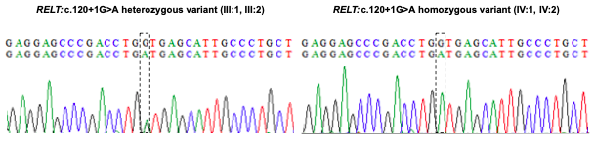

- Family 3:

RELT: c.193T>C heterozygous variant (I:2, II:1, II:2) RELT:c.1260_1263dup heterozygous variant (I:1, II:2)
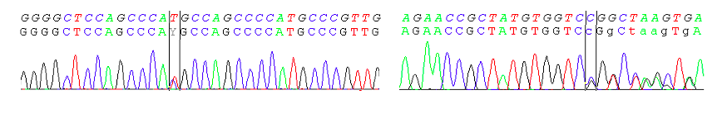

Appendix S6.
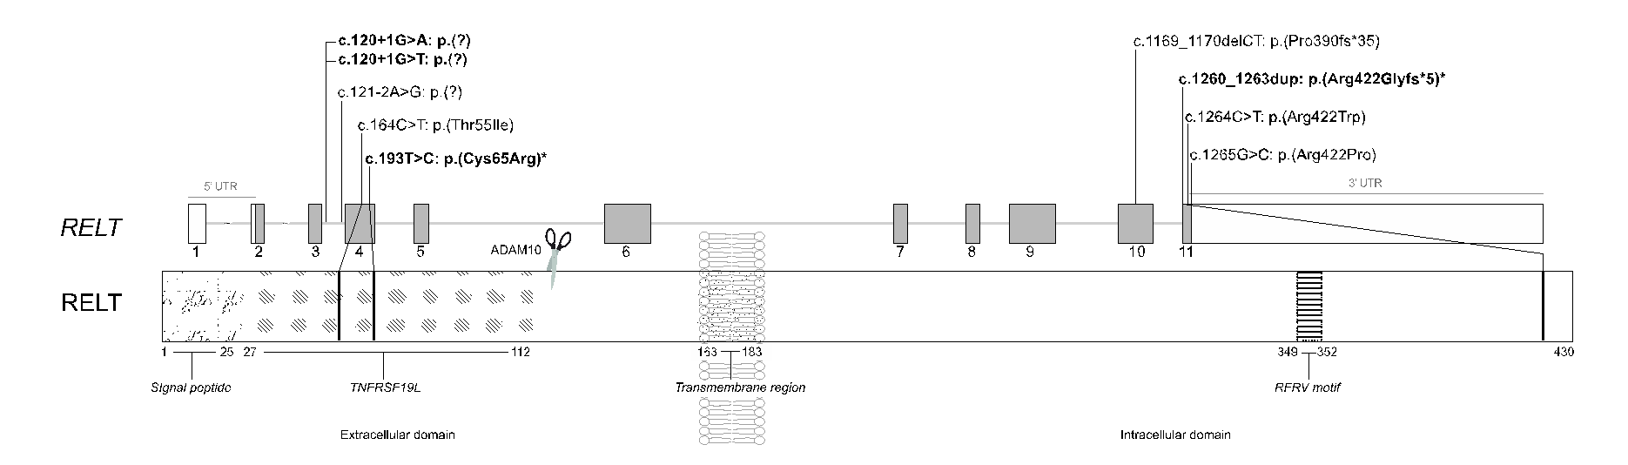
Schematic representation of RELT gene (NM_152222.2) and encoded protein (NP_689408.1) illustrating the position of the 5 previously reported disease-causing RELT variants, and the 4 novel variants reported in this study (in bold). The new compound heterozygous variants of family III (proband II:2) were marked with *. Two possible hotspot localizations appeared to be restricted to two different regions: (1) between intron 3 and exon 4 at the extracellular domain, and (2) between exons 10 and 11 in the cytoplasmic region of the carboxy-terminal end. Ikeda et al (2019) demonstrated that ADAM10 can cleave the RELT at the extracellular domain (represented by the scissors). Between positions 349-352, a SPAK binding motif (RFRV) is proposed to play a role in mediating p38 activation. TNFRSF19L= tumor necrosis factor receptor superfamily member 19-like.

