Additional Figure 1. Abu Haraz village - East Gezira locality overlap among the three lists of deceased people used for this analysis
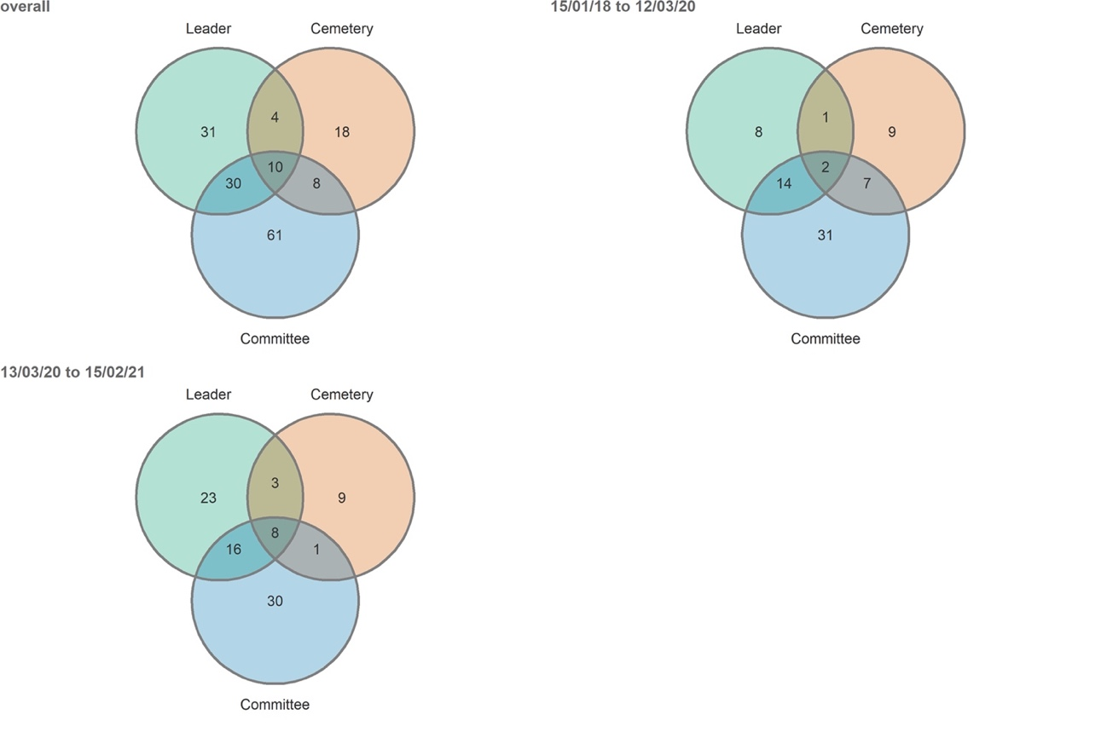
Additional Figure 2. Hai al Quba neighbourhood- El Obeid City overlap among the three lists of deceased people used for this analysis

