Supplement Materials
Supplementary Table S1: Sequences of oligonucleotide primers used for amplification and detection of LSDV genes and cytokines.
Target genes | Primer Sequence | Probe sequence | Annealing temp. | References
p32 | AAA ACG GTA TAT GGA ATA GAG TTG GAA | FAM-TGG CTC ATA GAT TTC CT-MGBNFQ | 60 | ²²
p32 | AAA TGA AAC CAA TGG ATG GGA TA | FAM-TGG CTC ATA GAT TTC CT-MGBNFQ | 60 | ²²
RPO30 | CAG CTG TTT GTT TAC ATT TGA TTT TT | - | 60 | ²⁴
RPO30 | TCG TAT AGA AAC AAG CCT TTA ATA GA | - | 60 | ²⁴
RPO30 | TTT GAA CAC ATT TTA TTC CAA AAA G | - | 60 | ²⁴
RPO30 | AAC CTA CAT GCA TAA ACA GAA GC | - | 60 | ²⁴
GPCR | TGAAAAATTAATCCATTCTTCTAAACA | - | 60 | ²⁴
GPCR | TCATGTATTTTATAACGATAATGCAAA | - | 60 | ²⁴
GPCR | TTAGCGGTATAATCATTCCAAATA | - | 60 | ²⁴
GPCR | GCGATGATTATGATGATTATGAAGTG | - | 60 | ²⁴
GPCR | CACAATTATATTTCCAAATAATCCAA | - | 60 | ²⁴
GPCR | TGTACATGTGTAATTTTAATGTTCGTA | - | 60 | ²⁴
IFNG | TGGATATCATCAAGCAAGACATGTT | CAGATCATCCACC GGAATTTGAATCAGC | 60 | ³⁰
IFNG | ACGTCATTCATCACTTTCATGAGTTC | CAGATCATCCACC GGAATTTGAATCAGC | 60 | ³⁰
TNFa | TCTTCTCAAGCCTCAAGTAACAAGT | AGCCCACGTTGTA GCCGACATCAACTCC | 60 | ³⁰
TNFa | CCATGAGGGCATTGGCATAC | AGCCCACGTTGTA GCCGACATCAACTCC | 60 | ³⁰
IL-2 | GGATTTACAGTTGCTTTTGGAGAAA | CGTGCCCAAGGTTAA CGCTACAGAATTGAA | 60 | ³⁰
IL-2 | GCACTTCCTCTAGAAGTTTGAGTTCTT | CGTGCCCAAGGTTAA CGCTACAGAATTGAA | 60 | ³⁰
IL-10 | CTTGTC GGAAAT GATCCA GTTTT | - | 62 | ³¹
IL-10 | TCAGGC CCGTGG TTCTCA | - | 62 | ³¹
B-actin | CGATGAAGATCAAGATCATTGC | TCC ACC TTC CAG CAG ATG TGG ATC A | 60 | ³²
B-actin | AAGCATTTGCGGTGGAC | TCC ACC TTC CAG CAG ATG TGG ATC A | 60 | ³²

Supplementary Table S2 GenBank accession numbers of studied LSDV sequences.
Provinces | Genes | Accession numbers
Nakhon Pathom (NKPT) | RPO30 | OK323149
Nakhon Pathom (NKPT) | GPCR | OK323151
Kanchanaburi (KNBR) | RPO30 | OL685739
Kanchanaburi (KNBR) | GPCR | OL685740
Ratchaburi (RBR) | RPO30 | OK323150
Ratchaburi (RBR) | GPCR | OK323152

Supplementary Table S3 Results of ELISA test grouped as control, subclinical, and clinical LSD cattle at 1-, 2-, 7-, 10-, 12-, and 15-month(s) post symptoms.
 | 1 mps |  |  |  | 2 mps |  |  |  | 7 mps |  |  |  | 10 mps |  |  |  | 12 mps |  |  |  | 15 mps
 | Control | Subclinical | Clinical | Total | Control | Subclinical | Clinical | Total | Control | Subclinical | Clinical | Total | Control | Subclinical | Clinical | Total | Control | Subclinical | Clinical | Total | Control | Subclinical | Clinical | Total
Total number | 20 | 9 | 36 | 65 | 20 | 9 | 35 | 64 | 16 | 8 | 31 | 55 | 15 | 6 | 19 | 40 | 11 | 6 | 26 | 43 | 12 | 5 | 19 | 36
No. ELISA positive | 0 | 4 | 32 | 36 | 4 | 4 | 31 | 39 | 4 | 2 | 26 | 32 | 3 | 3 | 24 | 30 | 1 | 2 | 20 | 23 | 1 | 2 | 10 | 13
Percent positive | 0.00 | 44.44 | 88.89 | 55.38 | 20.00 | 44.44 | 88.57 | 60.94 | 25.00 | 25.00 | 83.87 | 58.18 | 20.00 | 50.00 | 126.32 | 75.00 | 9.09 | 33.33 | 76.92 | 53.49 | 8.33 | 40.00 | 52.63 | 36.11
Mean S/P ratio | 0.84 | 42.12 | 122.44 | 55.13 | 32.37 | 51.15 | 149.95 | 77.82 | 26.32 | 56.1 | 136.02 | 72.81 | 14.73 | 75.1 | 136.94 | 75.59 | 4.77 | 46.68 | 95.81 | 49.09 | 9.72 | 56.78 | 77.64 | 48.05
SEM | 0.29 | 20.12 | 11.06 | 10.49 | 17.28 | 22.26 | 12.69 | 17.41 | 12.6 | 38.06 | 15.36 | 22.01 | 11.7 | 36.8 | 19.23 | 22.58 | 4.11 | 30.46 | 16.08 | 16.88 | 7.56 | 36.56 | 21.34 | 21.82
mps: month(s) post-symptoms
Supplementary Table S4 Results of serum neutralization test grouped as control, subclinical, and clinical LSD cattle at 1-, 2-, 7-, 10-, 12-, and 15-month(s) post symptoms.
 | 1 mps |  |  |  | 2 mps |  |  |  | 7 mps |  |  |  | 10 mps |  |  |  | 12 mps |  |  |  | 15 mps
 | Control | Subclinical | Clinical | Total | Control | Subclinical | Clinical | Total | Control | Subclinical | Clinical | Total | Control | Subclinical | Clinical | Total | Control | Subclinical | Clinical | Total | Control | Subclinical | Clinical | Total
Total number | 19 | 9 | 36 | 64 | 20 | 9 | 33 | 62 | 16 | 8 | 30 | 54 | 16 | 6 | 31 | 53 | 16 | 6 | 26 | 48 | 12 | 5 | 19 | 36
SNT positive (≥1:2) | 0 | 7 | 36 | 43 | 5 | 5 | 31 | 41 | 3 | 2 | 29 | 34 | 2 | 3 | 29 | 34 | 1 | 3 | 24 | 28 | 1 | 2 | 14 | 17
Percent positive | 0.00 | 77.78 | 100.00 | 67.19 | 25.00 | 55.56 | 93.94 | 66.13 | 18.75 | 25.00 | 96.67 | 62.96 | 12.50 | 50.00 | 93.55 | 64.15 | 6.25 | 50.00 | 92.31 | 58.33 | 8.33 | 40.00 | 73.68 | 47.22
Mean titer log₂ | 0 | 3 | 5.53 | 2.84 | 1.25 | 2.33 | 5.14 | 2.91 | 0.63 | 0.88 | 3.03 | 1.51 | 0.38 | 2.5 | 3.87 | 2.25 | 0.25 | 1.83 | 3.87 | 1.98 | 0.29 | 1.8 | 1.79 | 1.29
SEM | 0 | 0.94 | 0.33 | 0.42 | 0.53 | 0.96 | 0.34 | 0.61 | 0.36 | 0.64 | 0.25 | 0.42 | 0.31 | 1.23 | 0.36 | 0.63 | 0.25 | 1.14 | 0.36 | 0.58 | 0.29 | 1.2 | 0.34 | 0.61
mps: month(s) post-symptoms

Supplementary Figure S1 Standard curve of threshold cycle (Ct) value correlated with the log number copies/µl of LSDV p32 gene. R² was calculated by simple linear regression.

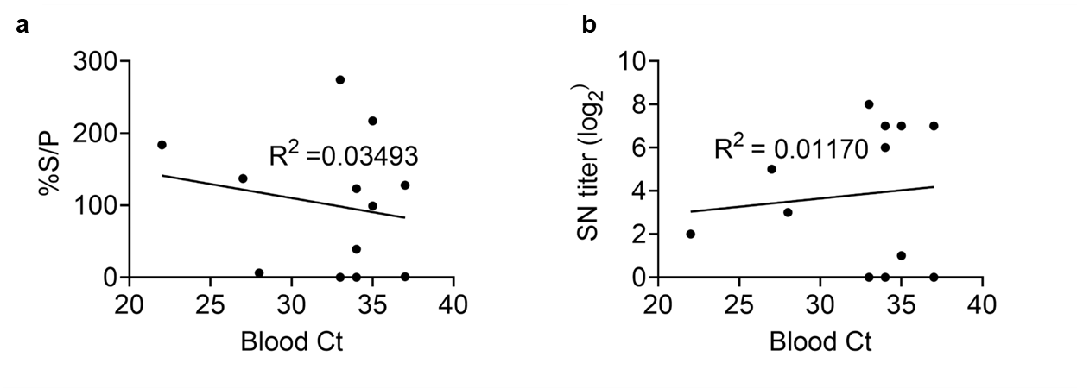
Supplementary Figure S2 Correlation between the antibody level and viral load of LSDV p32 in blood. a) Blood Ct vs %S/P by ELISA test b) Blood Ct vs SN titer (log₂) by SNT. R² was calculated by simple linear regression, n=12.

