Transition Metal-N₂P₂ Embedded Graphene (TM-NPC) as Single Atoms Catalyst for Oxygen Reduction Reaction: A Computational Study
Srinivasu Kancharlapalli
Chemistry Division, Bhabha Atomic Research Centre, Mumbai, India
Homi Bhabha National Institute, Anushaktinagar, Mumbai, India
Email: ksvasu@barc.gov.in

(a)
(b)
(c)
(d)

Figure S1. Total and partial density of stated for (a) Fe, (b) Co, (c) Ni and (d) Cu decorated N₂P₂ embedded graphene.

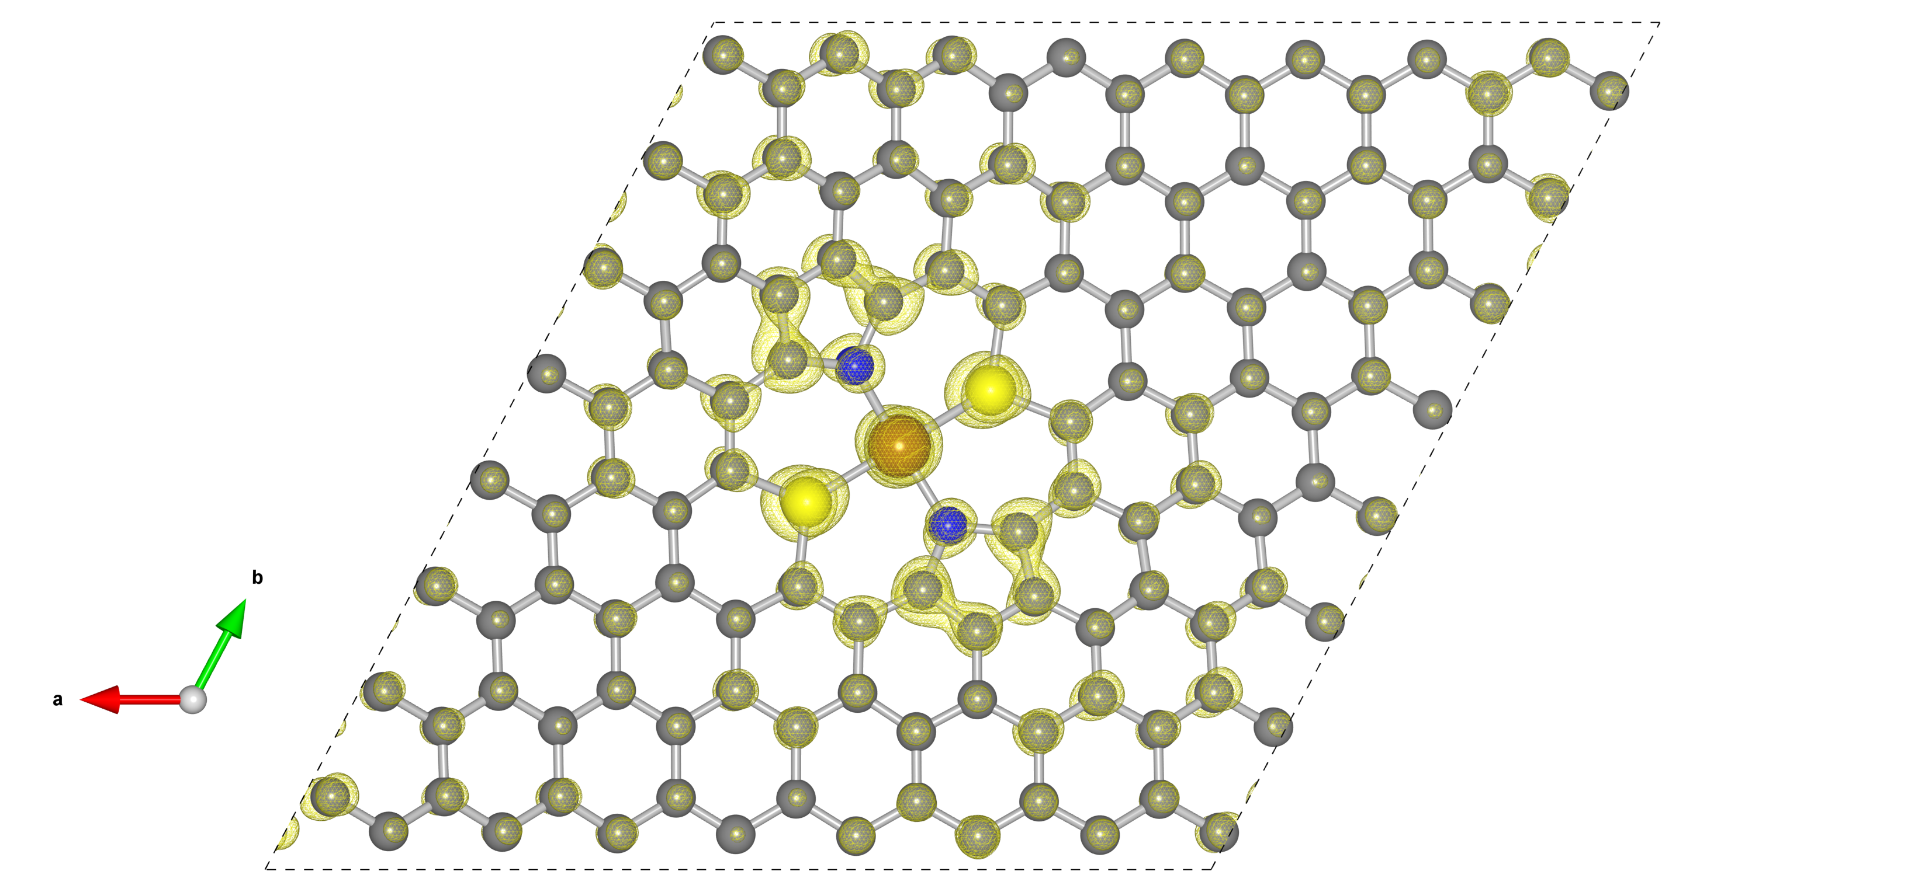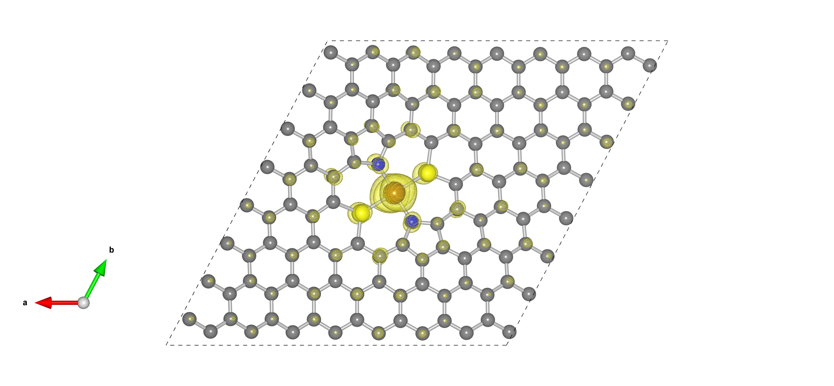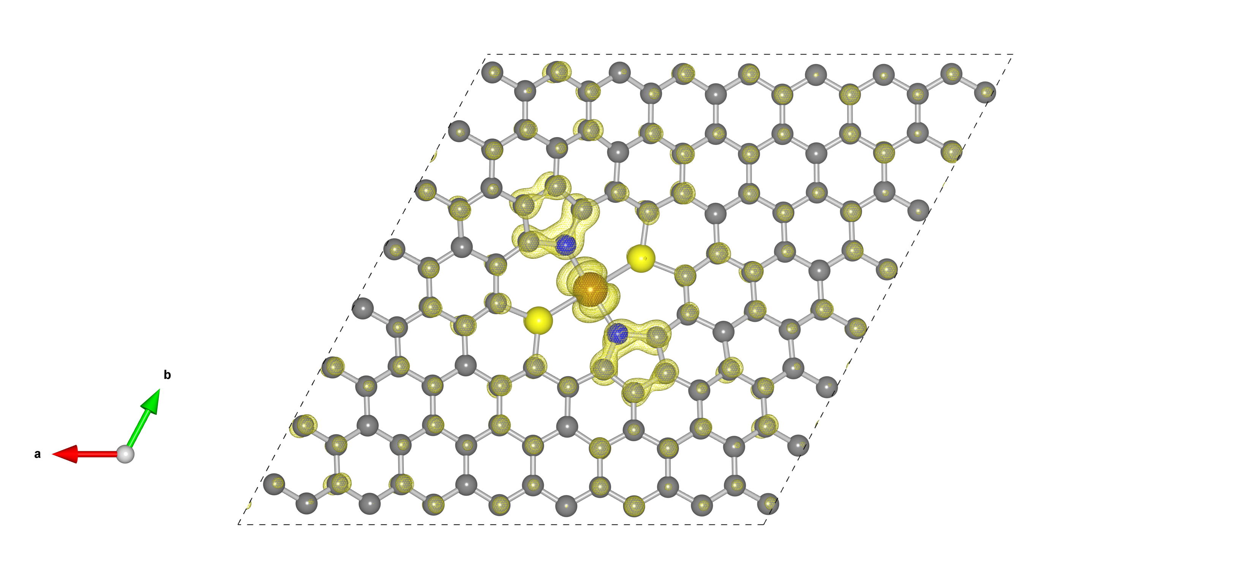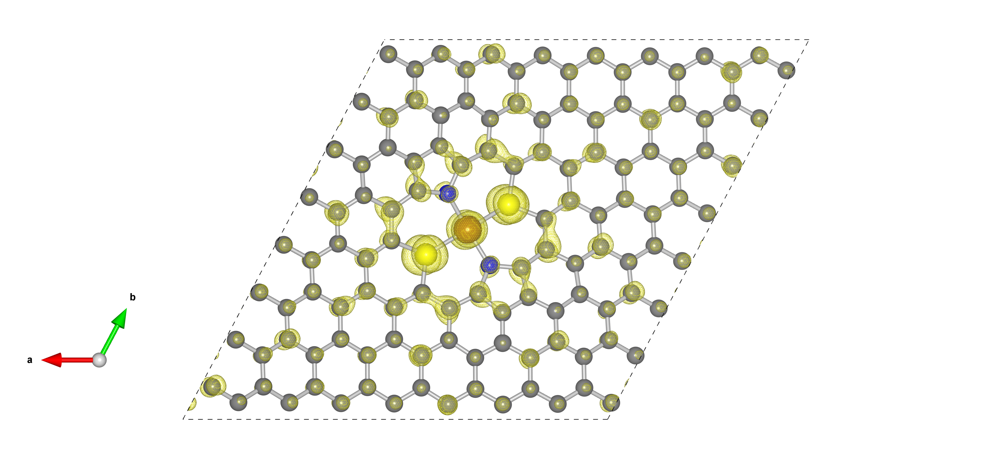
(a)
(b)
(c)
(d)

Figure S2. Band decomposed charge density iso-surfaces of (a) highest doubly occupied state, (b) second lowest singly occupied state, (c) highest singly occupied state and (d) lowest unoccupied state of Fe-NPC.

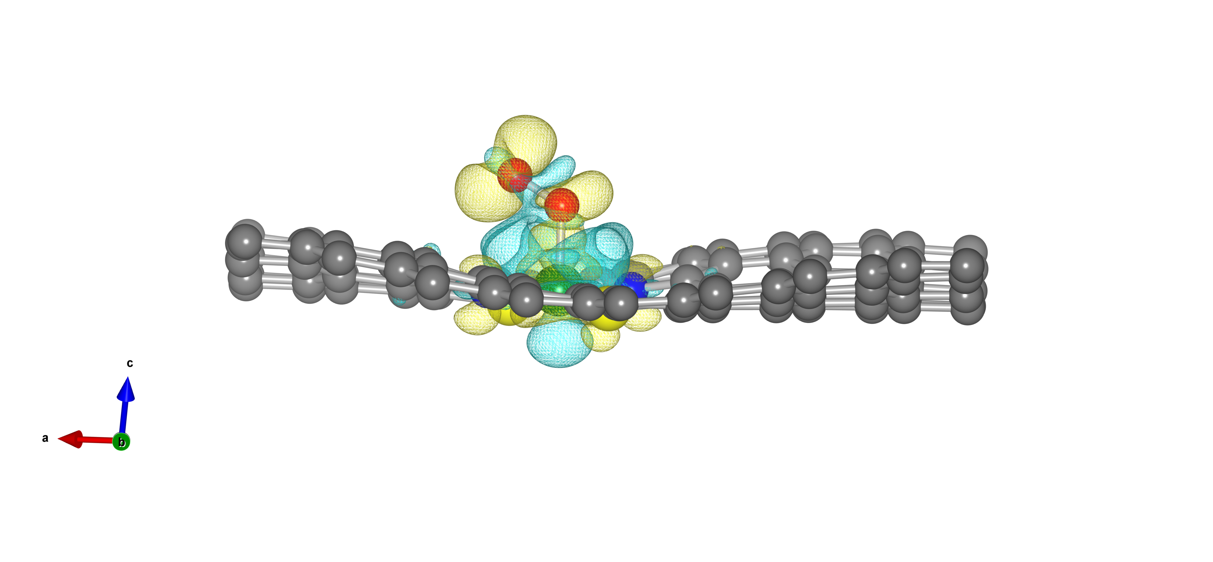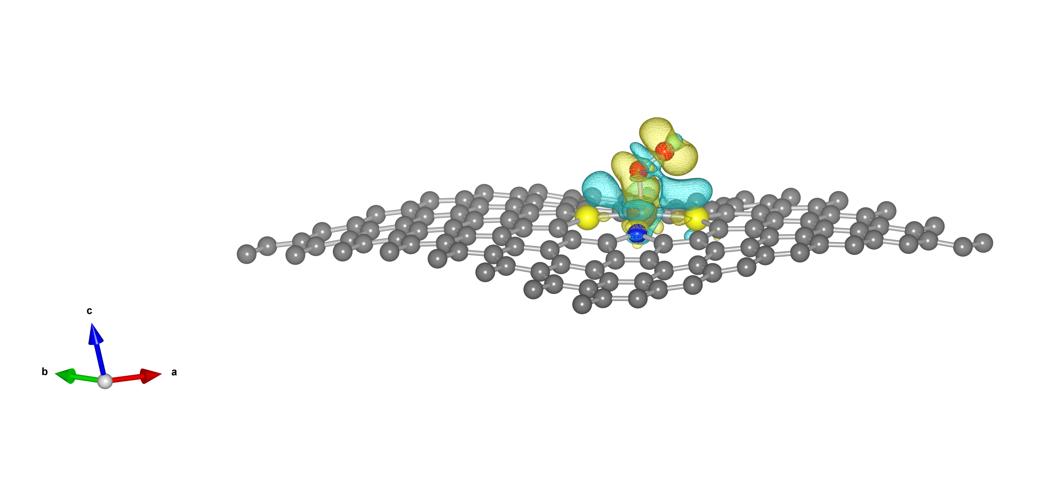
(a)
(b)

Figure S3. Charge density difference iso-surface plots (blue and yellow represent positive and negative charge density) for O₂ adsorbed (a) Fe-NPC and (b) Co-NPC.

