Table 1. Study Characteristics
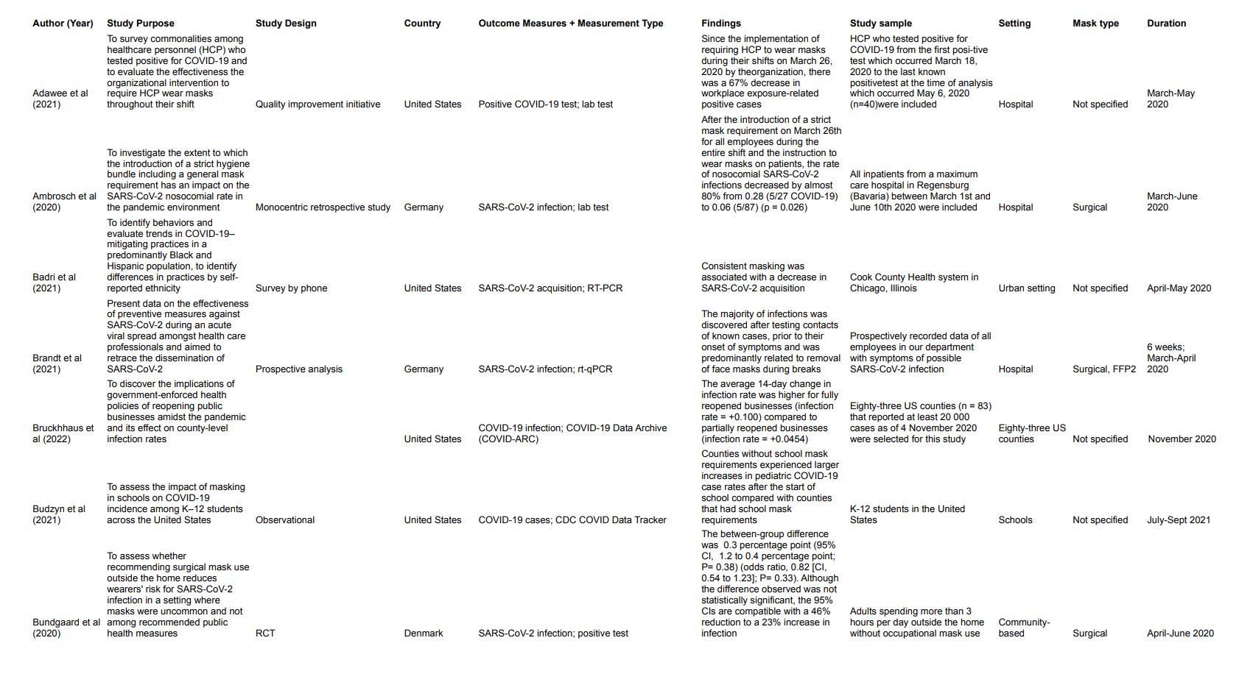
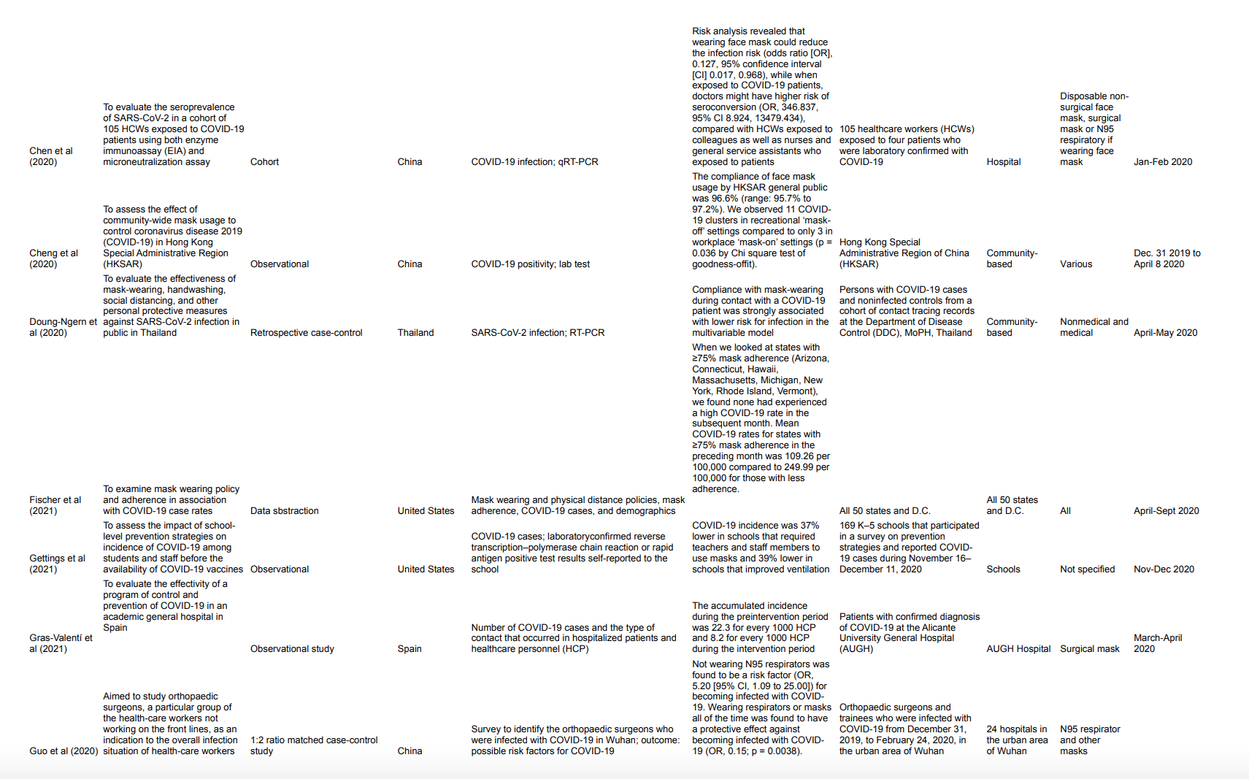
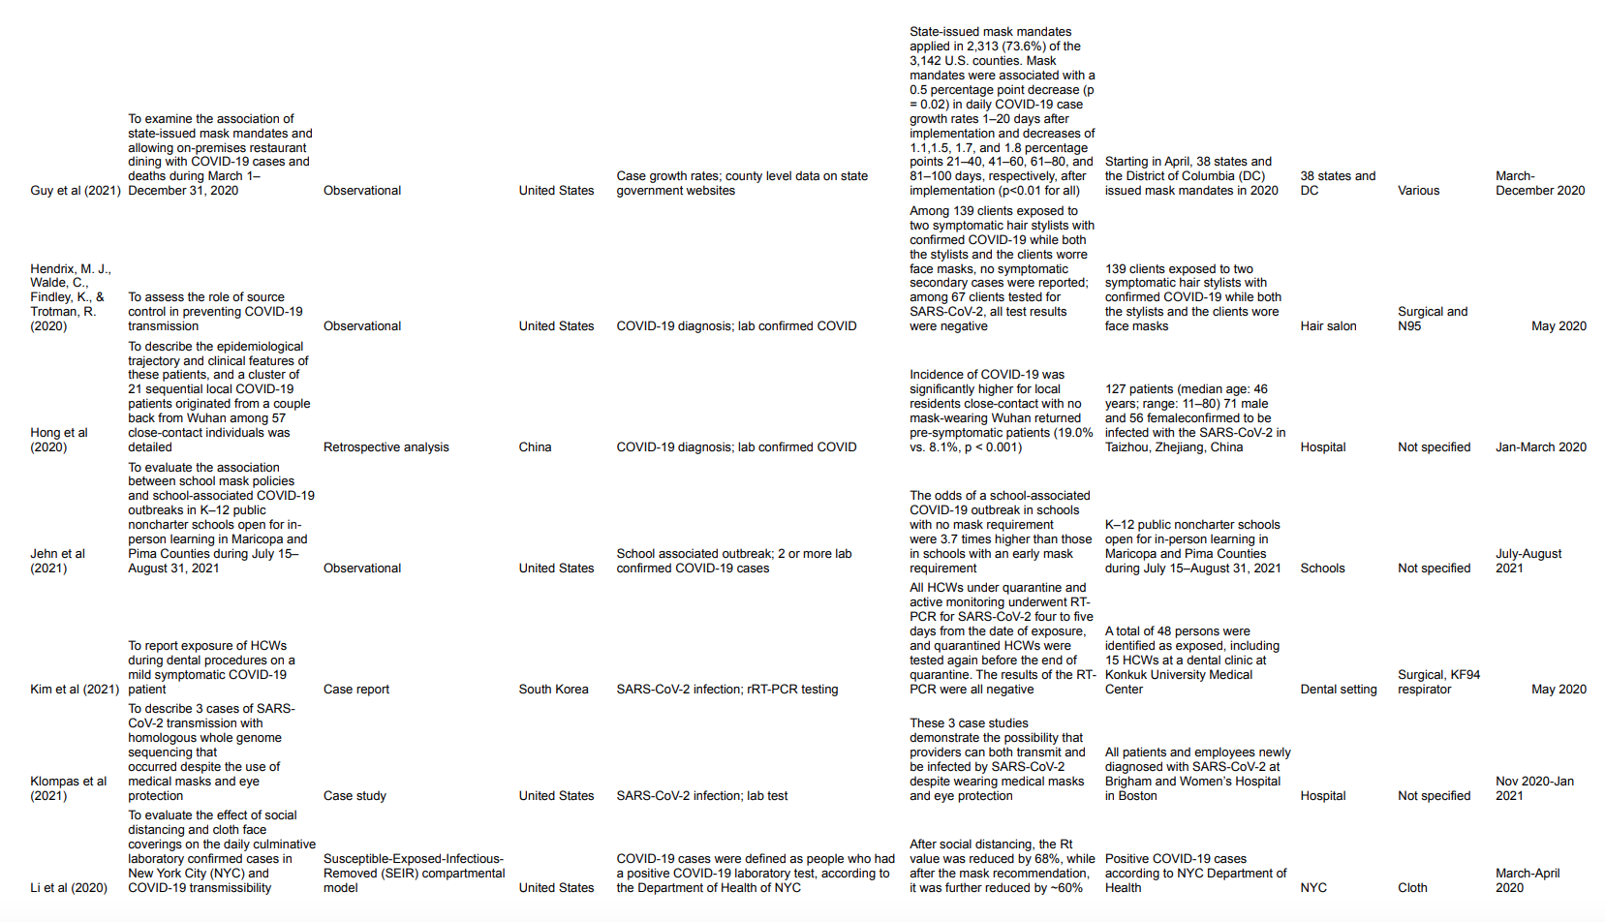
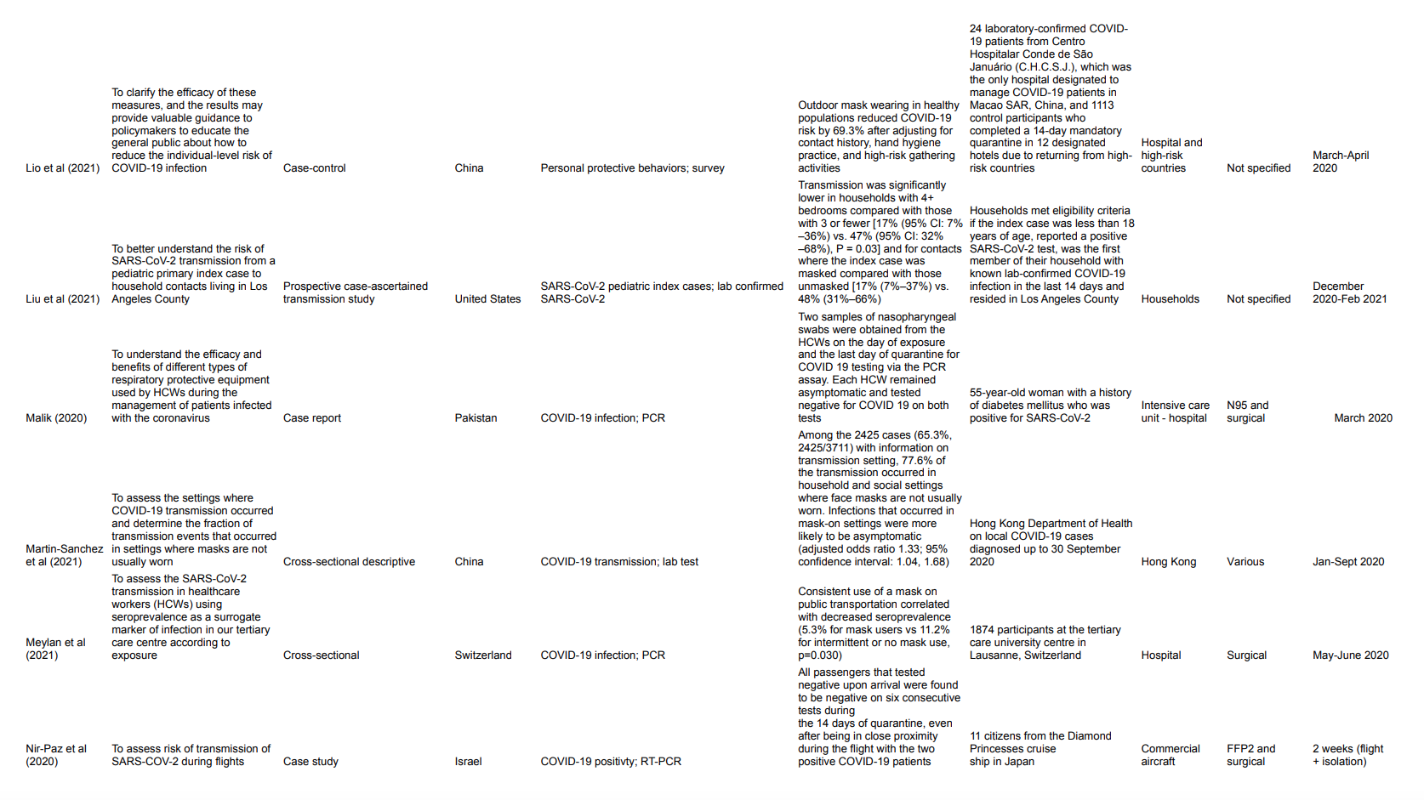

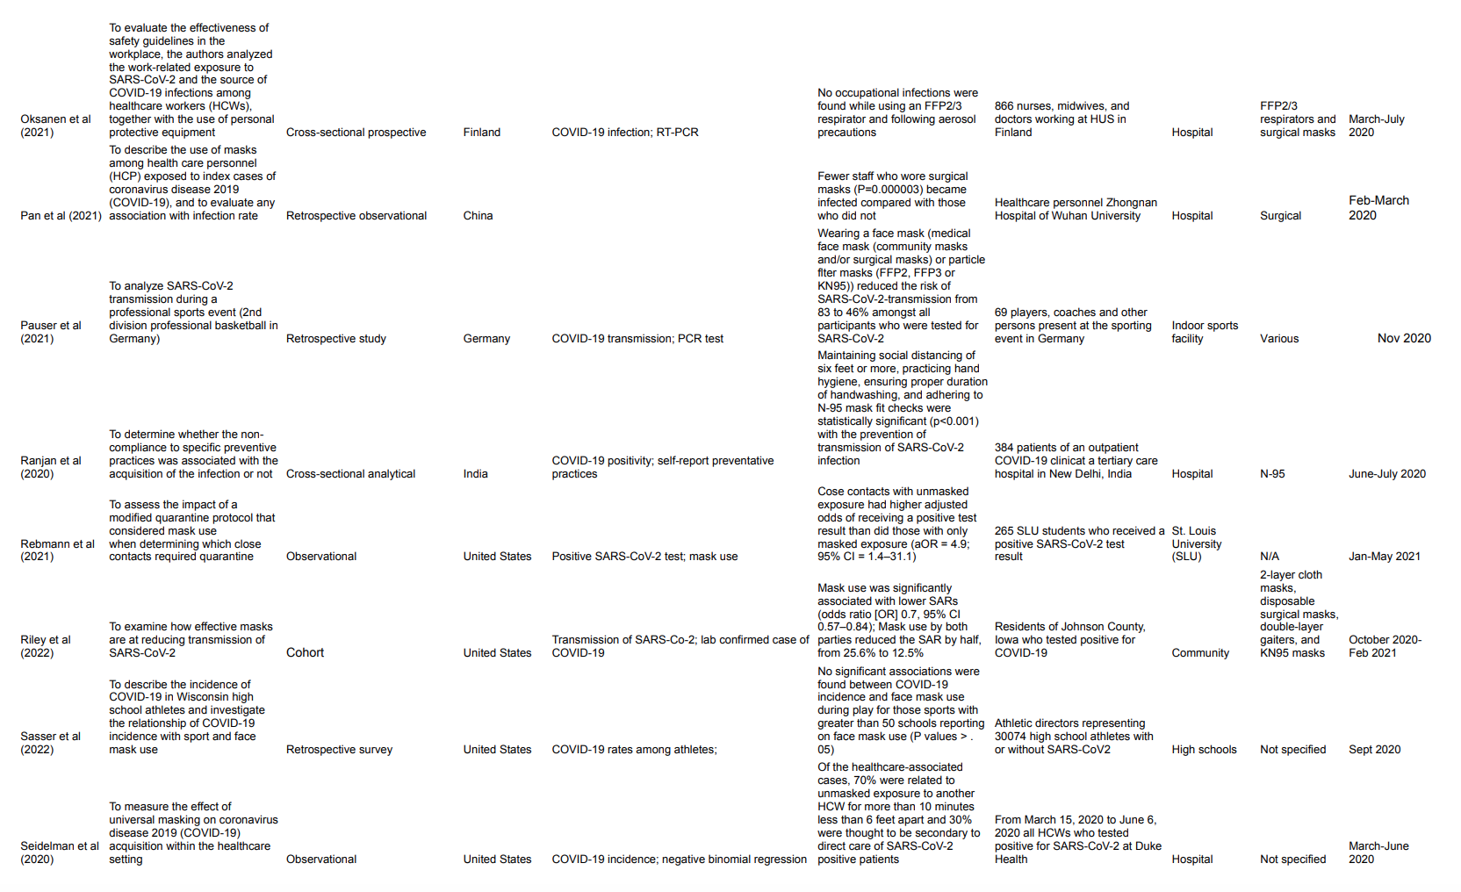
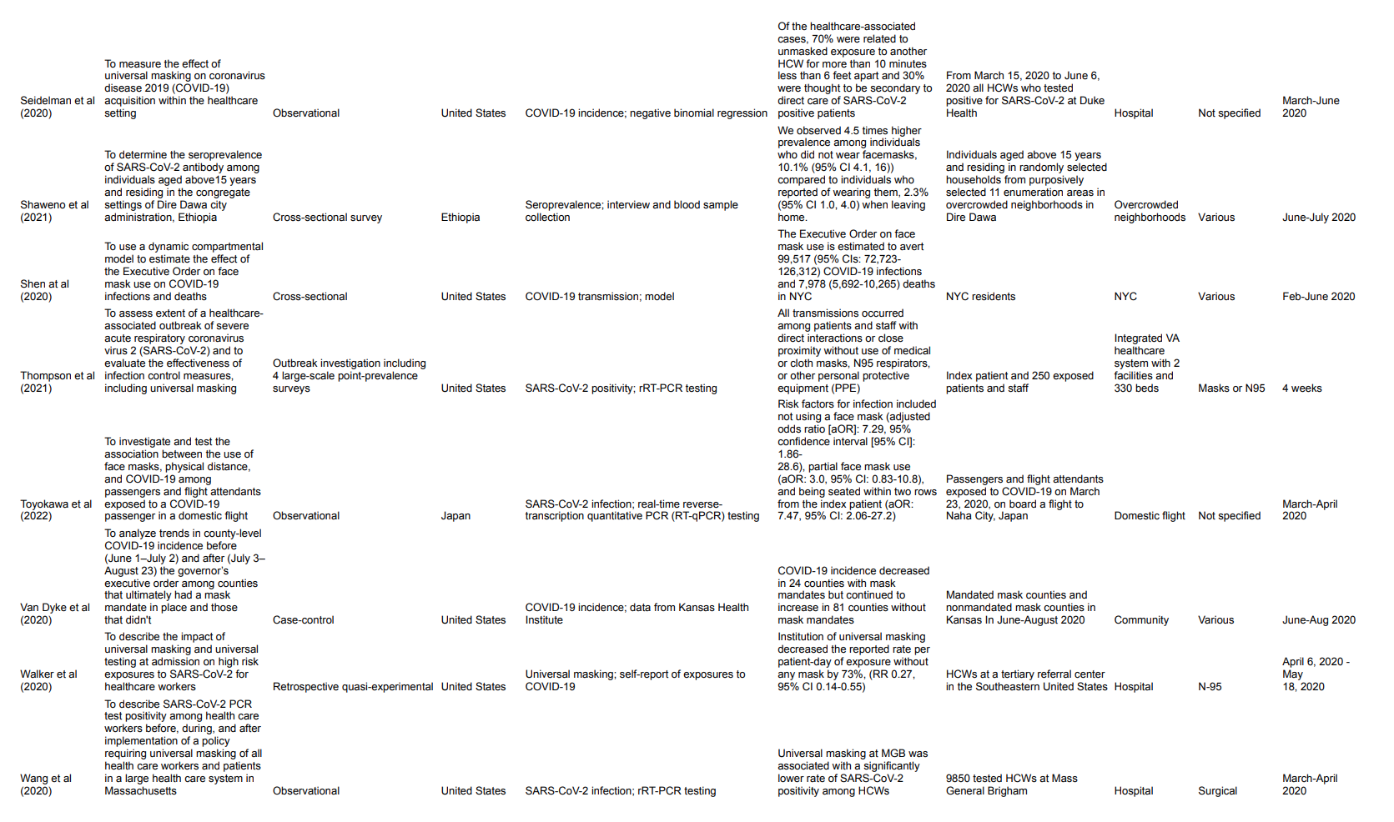
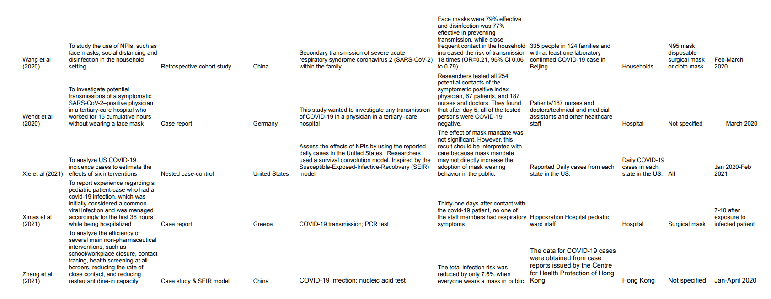

Table 2. JBI Risk of Bias Quality Assessment – Case Reports
Study | A1 | A2 | A3 | A4 | A5 | A6 | A7 | A8 | Yes (%) | Risk
Wendt et al (2020) |  |  |  |  |  |  |  |  | 100 | Low
Nir-Paz et al (2020) |  |  |  |  |  |  |  |  | 75 | Moderate
Malik (2020) |  |  |  |  |  |  |  |  | 75 | Moderate
Kim et al (2021) |  |  |  |  |  |  |  |  | 100 | Low
Zhang et al (2021) |  |  |  |  |  |  |  |  | 50 | Moderate
Xinias et al (2021) |  |  |  |  |  |  |  |  | 62.5 | Moderate
Chen et al (2020) |  |  |  |  |  |  |  |  | 87 | Low
^{A1}Were patient’s demographic characteristics clearly described?
^{A2}Was the patient’s history clearly described and presented as a timeline?
^{A3}Was the current clinical condition of the patient on presentation clearly described?
^{A4}Were diagnostic tests or assessment methods and the results clearly described?
^{A5}Was the intervention(s) or treatment procedure(s) clearly described?
^{A6}Was the post-intervention clinical condition clearly described?
^{A7}Were adverse events (harms) or unanticipated events identified and described?
^{A8}Does the case report provides takeaway lessons?
Yes
Unclear
No

Table 3. JBI Risk of Bias Quality Assessment – Prevalence Study
Study | B1 | B2 | B3 | B4 | B5 | B6 | B7 | B8 | B9 | Yes (%) | Risk
Thompson et al (2021) |  |  |  |  |  |  |  |  |  | 88.9 | Low
^{B1}Was the sample frame appropriate to address the target population?
^{B2}Were study participants sampled in an appropriate way?
^{B3}Was the sample size adequate?
^{B4}Were the study subjects and the setting described in detail?
^{B5}Was the data analysis conducted with sufficient coverage of the identified sample?
^{B6}Were valid methods used for the identification of the condition?
^{B7}Was the condition measured in a standard, reliable way for all participants?
^{B8}Was there appropriate statistical analysis?
^{B9}Was the response rate adequate, and if not, was the low response rate managed appropriately?

Table 4. JBI Risk of Bias Quality Assessment – Quasi-Experimental
Study | C1 | C2 | C3 | C4 | C5 | C6 | C7 | C8 | C9 | Yes (%) | Risk
Walker et al (2020) |  |  |  |  |  |  |  |  |  | 66.7 | Moderate
^{C1}Is it clear in the study what is the ‘cause’ and what is the ‘effect’ (i.e., there is no confusion about which variable comes first)?
^{C2}Were the participants included in any comparisons similar?
^{C3}Were the participants included in any comparisons receiving similar treatment/care, other than the exposure or intervention of interest?
^{C4}Was there a control group?
^{C5}Were there multiple measurements of the outcome both pre and post the intervention/exposure?
^{C6}Was follow up complete and if not, were differences between groups in terms of their follow up adequately described and analyzed?
^{C7}Were the outcomes of participants included in any comparisons measured in the same way?
^{C8}Were outcomes measured in a reliable way?
^{C9}Was appropriate statistical analysis used?
Table 5. JBI Risk of Bias Quality Assessment – Cohort Studies

Study | D1 | D2 | D3 | D4 | D5 | D6 | D7 | D8 | D9 | D10 | D11 | Yes (%) | Risk
Wang et al (2020) |  |  |  |  |  |  |  |  |  |  |  | 82 | Low
Wang et al (2020) |  |  |  |  |  |  |  |  |  |  |  | 64 | Moderate
Liu et al (2021) |  |  |  |  |  |  |  |  |  |  |  | 64 | Moderate
Hong et al (2020) |  |  |  |  |  |  |  |  |  |  |  | 82 | Low
Brandt et al (2021) |  |  |  |  |  |  |  |  |  |  |  | 45 | High
Riley et al (2022) |  |  |  |  |  |  |  |  |  |  |  | 100 | Low
^{D1}Were the two groups similar and recruited from the same population?
^{D2}Were the exposures measured similarly to assign people to both exposed and unexposed groups?
^{D3}Was the exposure measured in a valid and reliable way?
^{D4}Were confounding factors identified?
^{D5}Were strategies to deal with confounding factors stated?
^{D6}Were the groups/participants free of the outcome at the start of the study (or at the moment of exposure)?
^{D7}Were the outcomes measured in a valid and reliable way?
^{D8}Was the follow up time reported and sufficient to be long enough for outcomes to occur?
^{D9}Was follow up complete, and if not, were the reasons to loss to follow up described and explored?
^{D10}Were strategies to address incomplete follow up utilized?
^{D11}Was appropriate statistical analysis used?

Table 6. JBI Risk of Bias Quality Assessment – Case-Control Studies
Study | E1 | E2 | E3 | E4 | E5 | E6 | E7 | E8 | E9 | E10 | Yes (%) | Risk
Xie et al (2021) |  |  |  |  |  |  |  |  |  |  | 80 | Low
Lio et al (2021) |  |  |  |  |  |  |  |  |  |  | 90 | Low
Jehn et al (2021) |  |  |  |  |  |  |  |  |  |  | 80 | Low
Guo et al (2020) |  |  |  |  |  |  |  |  |  |  | 100 | Low
Gettings et al (2021) |  |  |  |  |  |  |  |  |  |  | 70 | Moderate
Doung-Ngern et al (2020) |  |  |  |  |  |  |  |  |  |  | 100 | Low
Budzyn et al (2021) |  |  |  |  |  |  |  |  |  |  | 50 | Moderate
Van Dyke et al (2020) |  |  |  |  |  |  |  |  |  |  | 90 | Low
Rebmann et al (2021) |  |  |  |  |  |  |  |  |  |  | 100 | Low
^{E1}Were the groups comparable other than the presence of disease in cases or the absence of disease in controls?
^{E2}Were cases and controls matched appropriately?
^{E3}Were the same criteria used for identification of cases and controls?
^{E4}Was exposure measured in a standard, valid and reliable way?
^{E5}Was exposure measured in the same way for cases and controls?
^{E6}Were confounding factors identified?
^{E7}Were strategies to deal with confounding factors stated?
^{E8}Were outcomes assessed in a standard, valid and reliable way for cases and controls?
^{E9}Was the exposure period of interest long enough to be meaningful?
^{E10}Was appropriate statistical analysis used?

Table 7. JBI Risk of Bias Quality Assessment – Cross sectional Studies
Study | F1 | F2 | F3 | F4 | F5 | F6 | F7 | F8 | Yes (%) | Risk
Sugimura et al (2021) |  |  |  |  |  |  |  |  | 100 | Low
Seidelman et al (2020) |  |  |  |  |  |  |  |  | 75 | Moderate
Ranjan et al (2020) |  |  |  |  |  |  |  |  | 75 | Moderate
Pauser et al (2021) |  |  |  |  |  |  |  |  | 75 | Moderate
Oksanen et al (2021) |  |  |  |  |  |  |  |  | 87.5 | Low
Meylan et al (2021) |  |  |  |  |  |  |  |  | 100 | Low
Hendrix et al (2020) |  |  |  |  |  |  |  |  | 62.5 | Moderate
Guy et al (2021) |  |  |  |  |  |  |  |  | 87.5 | Low
Gras-Valentí et al (2021) |  |  |  |  |  |  |  |  | 87.5 | Low
Fischer et al (2021) |  |  |  |  |  |  |  |  | 87.5 | Low
Cheng et al (2020) |  |  |  |  |  |  |  |  | 62.5 | Moderate
Bruckhhaus et al (2022) |  |  |  |  |  |  |  |  | 87.5 | Low
Badri et al (2021) |  |  |  |  |  |  |  |  | 87.5 | Low
Ambrosch et al (2020) |  |  |  |  |  |  |  |  | 100 | Low
Adawee et al (2021) |  |  |  |  |  |  |  |  | 100 | Low
Klompas et al (2021) |  |  |  |  |  |  |  |  | 50 | Moderate
Sasser et al (2022) |  |  |  |  |  |  |  |  | 75 | Moderate
Pan et al (2021) |  |  |  |  |  |  |  |  | 87.5 | Low
Li et al (2020) |  |  |  |  |  |  |  |  | 87.5 | Low
Toyokawa et al (2022) |  |  |  |  |  |  |  |  | 87.5 | Low
Shaweno et al (2021) |  |  |  |  |  |  |  |  | 87.5 | Low
Martin-Sanchez et al (2021) |  |  |  |  |  |  |  |  | 87.5 | Low
^{F1}Were the criteria for inclusion in the sample clearly defined?
^{F2}Were the study subjects and the setting described in detail?
^{F3}Was the exposure measured in a valid and reliable way?
^{F4}Were objective, standard criteria used for measurement of the condition?
^{F5}Were confounding factors identified?
^{F6}Were strategies to deal with confounding factors stated?
^{F7}Were the outcomes measured in a valid and reliable way?
^{F8}Was appropriate statistical analysis used?

Study | G1 | G2 | G3 | G4 | G5 | G6 | G7 | G8 | G9 | G10 | G11 | G12 | G13 | Yes (%) | Risk
Bundgaard et al (2020) |  |  |  |  |  |  |  |  |  |  |  |  |  | 61.5 | Moderate
^{G1}Was true randomization used for assignment of participants to treatment groups?
^{G2}Was allocation to treatment groups concealed?
^{G3}Were treatment groups similar at the baseline?
^{G4}Were participants blind to treatment assignment?
^{G5}Were those delivering treatment blind to treatment assignment?
^{G6}Were outcomes assessors blind to treatment assignment?
^{G7}Were treatment groups treated identically other than the intervention of interest?
^{G8}Was follow up complete and if not, were differences between groups in terms of their follow up adequately described and analyzed?
^{G9}Were participants analyzed in the groups to which they were randomized?
^{G10}Were outcomes measured in the same way for treatment groups?
^{G11}Were outcomes measured in a reliable way?
^{G12}Was appropriate statistical analysis used?
^{G13}Was the trial design appropriate, and any deviations from the standard RCT design (individual randomization, parallel groups) accounted for in the conduct and analysis of the trial?
Table 8. JBI Risk of Bias Quality Assessment – Randomized Controlled Trial

