Predicting Rejection of Emerging Contaminants through RO Membrane Filtration based on ANN- QSAR Modelling Approach: Trends in Molecular Descriptors and Structures towards Rejections

For submission to: Environmental Science and Pollution Research

Setare Loh Mousavi, Faculty of Chemistry, Semnan University, Semnan, Iran
Seyedeh Maryam Sajjadi*, Faculty of Chemistry, Semnan University, Semnan, Iran, E-mail: sajjadi@semnan.ac.ir, Tel. (+98) 23 – 31533192, Fax: (+98) 23 33384110

Table S-1: The relationship between molecular descriptors and structural compounds that used in modelling
ID | compound | abbrev. | structure | ESpm14u | R2e | SIC1 | EEig03d | Rejection (exp)
1 | 1,1,1,2-tetrachloroethane | 1,1,1,2-TCA | 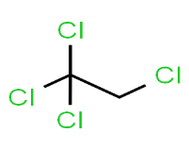 | 15.777 | 1.981 | 0.583 | -0.17 | 99
2 | 1,1,1-trichkoroethan | 1,1,1-TCA | 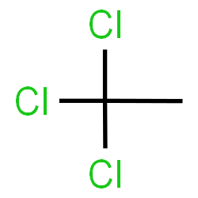 | 15.381 | 2 | 0.604 | -0.17 | 98
3 | 1,1,2,2-tetrachloroethane | 1,1,2,2-TCA | 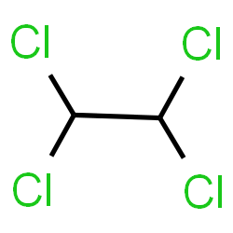 | 13.17 | 1.954 | 0.5 | 0.2 | 97
4 | 1,1,2-trichloroethane | 1,1,2-TCA | 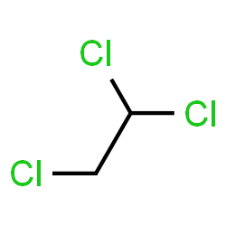 | 10.852 | 1.913 | 0.604 | 0.2 | 86
5 | 1,1-dichloroethane | 1,1-DCA | 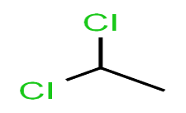 | 9.704 | 1.924 | 0.583 | -0.69 | 80
6 | 1,1-dichloroethene | 1,1-DCE | 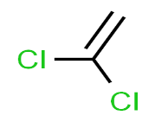 | 9.704 | 0.792 | 0.742 | -0.69 | 17
7 | 1,1-dichloropropene | 1,1-DCP | 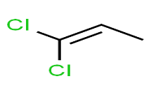 | 10.852 | 1.452 | 0.763 | 0.2 | 45
8 | 1,2,3-trichlorobenzene | 1,2,3-TCB | 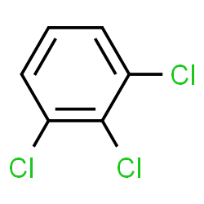 | 14.972 | 0.884 | 0.558 | 1.92 | 91
9 | 1,2,3-trichloropropane | 1,2,3-TCP | 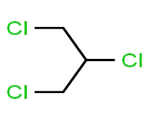 | 11.685 | 1.8 | 0.517 | 1.26 | 95
10 | 1,2,4-trichlorobenzene | 1,2,4-TCB | 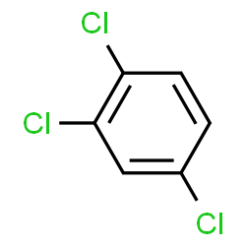 | 14.473 | 0.888 | 0.558 | 2.13 | 79
11 | 1,2,4-trimethylbenzene | 1,2,4-TMB | 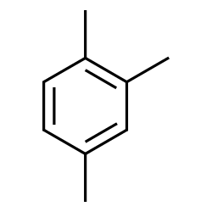 | 14.473 | 1.642 | 0.485 | 1.63 | 97
ID | compound | abbrev. | structure | ESpm14u | R2e | SIC1 | EEig03d | Rejection (exp)
12 | 1,2-dibromo-3-chloropropane | 1,2-DB-3-CP | 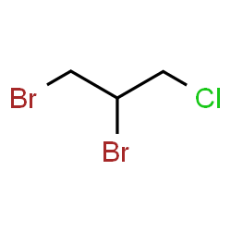 | 11.685 | 1.675 | 0.642 | 1.50 | 97
13 | 1,2-dibromoethane | EDB | 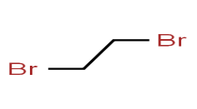 | 5.549 | 1.743 | 0.5 | -0.85 | 40
14 | 1,2-dichlorobenzene | 1,2-DCB | 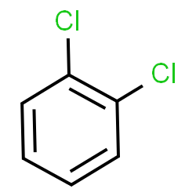 | 14.084 | 0.902 | 0.535 | 1.53 | 83
15 | 1,2-dichloroethane | 1,2-DCA | 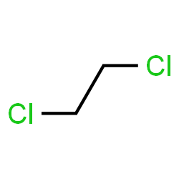 | 5.549 | 1.89 | 0.5 | -0.83 | 34
16 | 1,2-dichloropropane | 1,2-DCP | 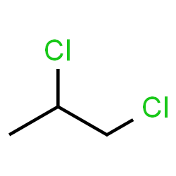 | 10.852 | 1.861 | 0.54 | -0.28 | 91
17 | 1,3,5-trimethylbenzene | 1,3,5-TMB | 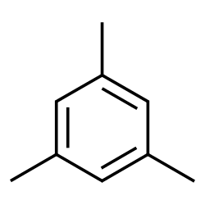 | 14.094 | 1.722 | 0.485 | 2.14 | 99
18 | 1,3-dichlorobenzene | 1,3-DCB | 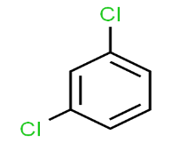 | 13.393 | 0.902 | 0.535 | 1.31 | 71
19 | 1,3-dichloropropane | 1,3-DCP | 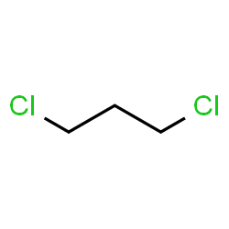 | 7.431 | 1.843 | 0.487 | 0.24 | 71
20 | 1,4-dichlorobenzene | 1,4-DCB | 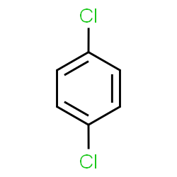 | 13.23 | 0.908 | 0.535 | 1 | 59
21 | 1,4-dioxane | 1,4-D | 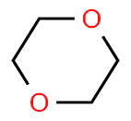 | 10.397 | 2.388 | 0.362 | 1.34 | 98
22 | 2-butanone | 2-But | 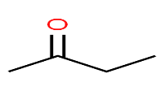 | 10.852 | 1.881 | 0.501 | 0.17 | 73
23 | 2-chlorotoluene | 2-CT | 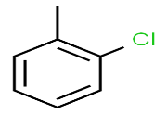 | 14.084 | 1.418 | 0.646 | 1.48 | 88
ID | compound | abbrev. | structure | ESpm14u | R2e | SIC1 | EEig03d | Rejection (exp)
24 | 2-hexanone | 2-Hex | 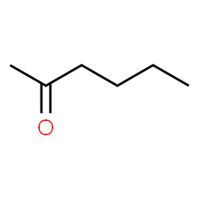 | 11.259 | 1.805 | 0.442 | 0.73 | 83
25 | 4-chlorotoluene | 4-CT | 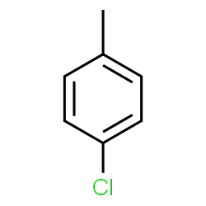 | 13.23 | 1.454 | 0.646 | 1 | 67
26 | 4-isopropyltoluene | 4-IPT | 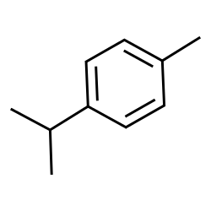 | 14.328 | 1.704 | 0.516 | 1.29 | 98
27 | 4-methyl-2-pentanone | MIBK | 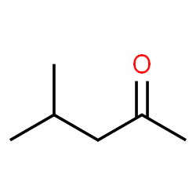 | 12.358 | 1.863 | 0.442 | 0.63 | 98
28 | acetone | acetone | 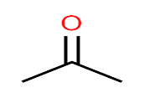 | 9.704 | 1.775 | 0.473 | -0.32 | 55
29 | acetonitrile | Ace-N | 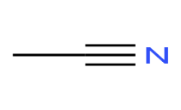 | 1.099 | 1.597 | 0.693 | 0 | 23
30 | acrylonitrile | Acr-N | 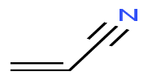 | 5.549 | 0.616 | 0.758 | -0.64 | 18
31 | benzene | benzene | 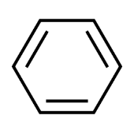 | 10.397 | 0.944 | 0.279 | 1 | 79
32 | bromobenzene | BB | 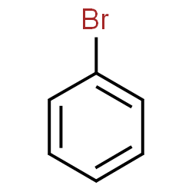 | 12.41 | 0.893 | 0.46 | 1 | 59
33 | bromochloromethane | BCM | 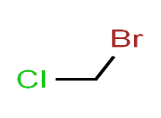 | 1.099 | 2.13 | 0.828 | 0 | 25
34 | bromodichloromethane | BDCM | 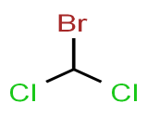 | 9.704 | 2.221 | 0.828 | 0.2 | 82
35 | bromoform | BF | 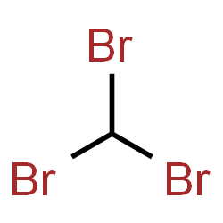 | 9.704 | 1.95 | 0.59 | 0.48 | 85
36 | bromomethane | BM | 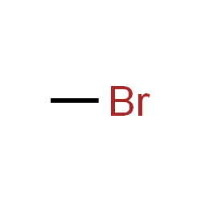 | 0 | 2.091 | 0.59 | 0 | 0
37 | carbon tetrachloride | C-Tet | 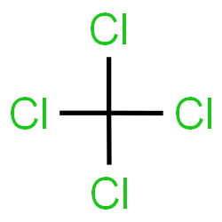 | 15.381 | 2.527 | 0.311 | -0.17 | 97
ID | compound | abbrev. | structure | ESpm14u | R2e | SIC1 | EEig03d | Rejection (exp)
38 | chlorobenzene | CB | 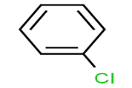 | 12.41 | 0.922 | 0.46 | 1 | 63
39 | chloroethane | CA | 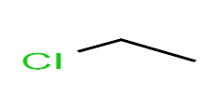 | 1.099 | 1.884 | 0.516 | 0 | 15
40 | chloroform | CF | 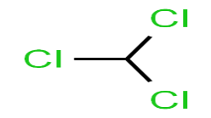 | 9.704 | 2.381 | 0.59 | -0.17 | 73
41 | chloromethane | CM | 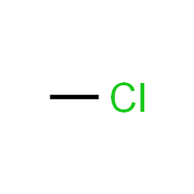 | 0 | 2.237 | 0.59 | 0 | 4
42 | cis-1,2-dichloroethene | cis-1,2-DCE | 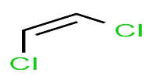 | 5.549 | 0.759 | 0.613 | -0.83 | 11
43 | cis-1,3-dichloropropene | cis-1,3-DCP | 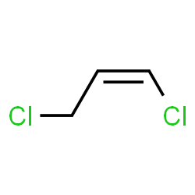 | 7.431 | 1.514 | 0.86 | 0.47 | 48
44 | dibromochloromethane | DBCM | 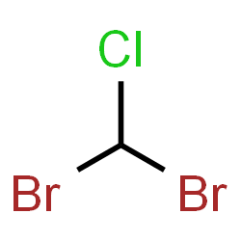 | 9.704 | 2.078 | 0.828 | 0.48 | 78
45 | dibromomethane | DBM | 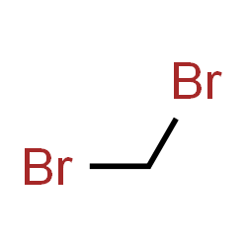 | 1.099 | 1.993 | 0.655 | 0 | 25
46 | ethylbenzene | EB | 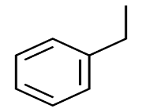 | 12.869 | 1.687 | 0.536 | 1 | 87
47 | hexachloro-1,3-butadiene | HCBD | 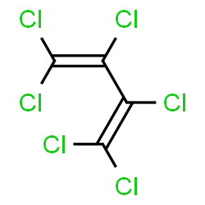 | 15.148 | 1.118 | 0.413 | 2.28 | >96
48 | isopropyl alcohol | IPA | 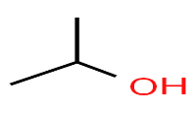 | 9.704 | 1.737 | 0.497 | -1 | 91
49 | isopropyl benzene | cumene | 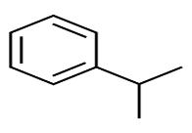 | 14.087 | 1.637 | 0.514 | 1 | 97
50 | isopropyl ether | IPE | 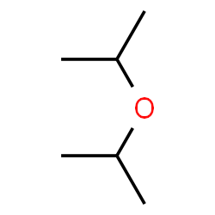 | 12.358 | 1.899 | 0.314 | -0.048 | 99
ID | compound | abbrev. | structure | ESpm14u | R2e | SIC1 | EEig03d | Rejection (exp)
51 | methyl tert-butyl ether | MTBE | 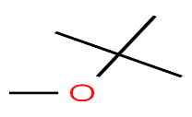 | 15.777 | 1.824 | 0.364 | -0.80 | 99
52 | methylene chloride | MC | 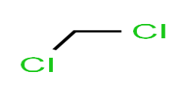 | 1.099 | 2.282 | 0.655 | 0 | 10
53 | m-xylenes | m-xylenes | 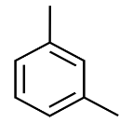 | 13.393 | 1.578 | 0.527 | 1.22 | 88
54 | p-xylenes | p-xylenes | 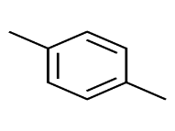 | 13.23 | 1.573 | 0.527 | 1 | 88
55 | naphthalene | Naph | 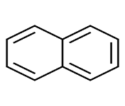 | 14.73 | 0.961 | 0.334 | 1.61 | 91
56 | n-butylbenzene | n-BB | 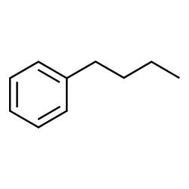 | 12.996 | 1.716 | 0.512 | 1.30 | 90
57 | n-propylbenzene | n-PB | 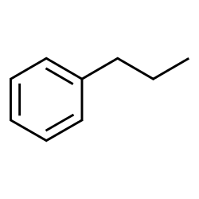 | 12.969 | 1.727 | 0.535 | 1 | 88
58 | o-xylene | o-xylene | 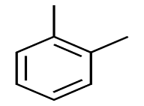 | 14.084 | 1.514 | 0.527 | 1.46 | 96
59 | sec-butylbenzene | s-BB | 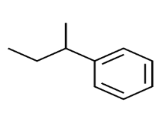 | 14.301 | 1.71 | 0.512 | 1.15 | 98
60 | tert-amyl methyl ether | TAME | 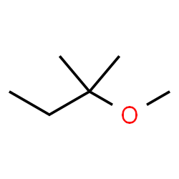 | 16.127 | 1.919 | 0.371 | 0.38 | 99
61 | tert-butyl alcohol | TBA | 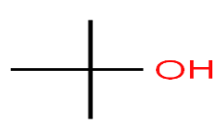 | 15.381 | 1.592 | 0.432 | -1 | 99
62 | tert-butyl ethyl ether | TBEE | 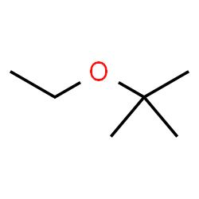 | 15.824 | 1.851 | 0.335 | -0.21 | 99
ID | compound | abbrev. | structure | ESpm14u | R2e | SIC1 | EEig03d | Rejection (exp)
63 | tert-butylbenzene | TBB | 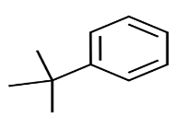 | 16.758 | 1.623 | 0.487 | 1.20 | >96
64 | tetrachloroethene | PCE | 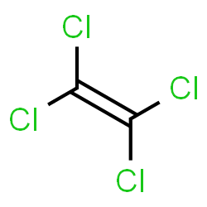 | 13.17 | 0.754 | 0.355 | 0.2 | 83
65 | toluene | toluene | 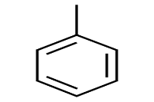 | 12.41 | 1.441 | 0.523 | 1 | 82
66 | trans-1,2-dichloroethene | t-1,2-DCE | 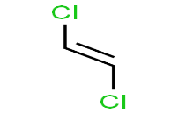 | 5.549 | 0.766 | 0.613 | -0.83 | 15
67 | trans-1,3-dichloropropene | t-1,3-DCP | 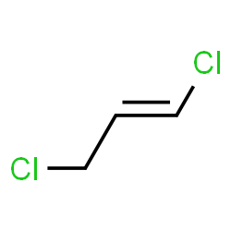 | 7.431 | 1.453 | 0.86 | 0.47 | 27
68 | trans-1,4-dichloro-2-butene | t-1,4-DCB | 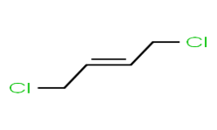 | 8.384 | 1.599 | 0.628 | 0.98 | 51
69 | trichloroethene | TCE | 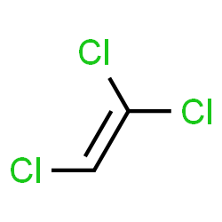 | 10.852 | 0.786 | 0.693 | 0.2 | 46
70 | vinyl acetate | VA | 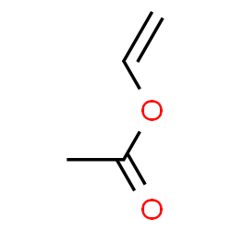 | 11.149 | 1.663 | 0.779 | 0.51 | 46
71 | vinyl chloride | VC | 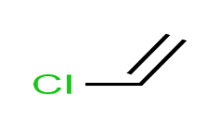 | 1.099 | 0.764 | 0.693 | 0 | 17
72 | vinylbenzene | styrene | 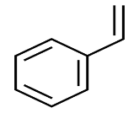 | 12.869 | 1.259 | 0.444 | 1 | 75

