Table 1. The structure of molecules and rejection of each ECs in QSAR-ANN studies [42]
ID | abbrev. | structure | Rejection (ANN) | Rejection (exp) | Set of data
1 | 1,1,1,2-TCA | 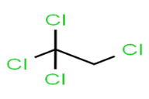 | 94.07 | 99 | Training
2 | 1,1,1-TCA | 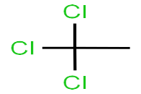 | 93.12 | 98 | Training
3 | 1,1,2,2-TCA | 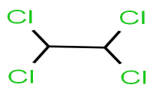 | 97.01 | 97 | Validation
4 | 1,1,2-TCA | 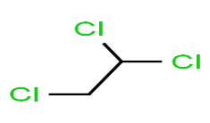 | 81.72 | 86 | Training
5 | 1,1-DCA | 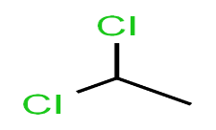 | 76.02 | 80 | Training
6 | 1,1-DCE | 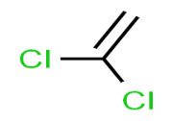 | 16.17 | 17 | Training
7 | 1,1-DCP | 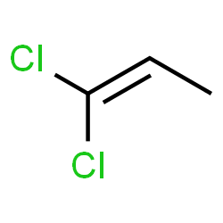 | 42.77 | 45 | Training
8 | 1,2,3-TCB | 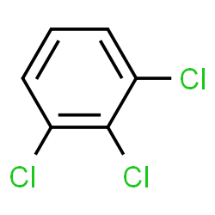 | 91.01 | 91 | Validation
9 | 1,2,3-TCP | 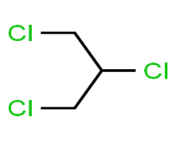 | 95.09 | 95 | Test
10 | 1,2,4-TCB | 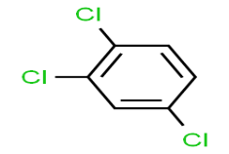 | 75.07 | 79 | Training
11 | 1,2,4-TMB | 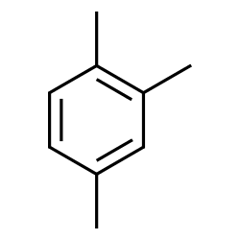 | 92.17 | 97 | Training
12 | 1,2-DB-3-CP | 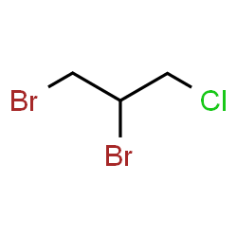 | 92.17 | 97 | Training
13 | EDB | 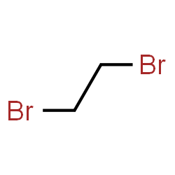 | 40.09 | 40 | Test
14 | 1,2-DCB | 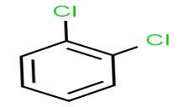 | 83.01 | 83 | Validation
15 | 1,2-DCA | 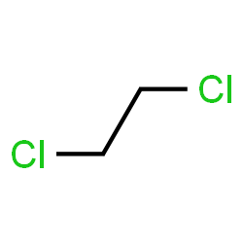 | 32.32 | 34 | Training
16 | 1,2-DCP | 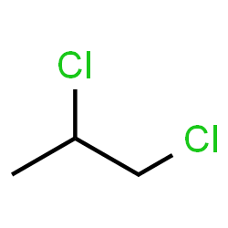 | 86.47 | 91 | Training
17 | 1,3,5-TMB | 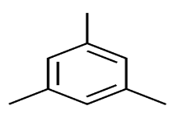 | 94.07 | 99 | Training
18 | 1,3-DCB | 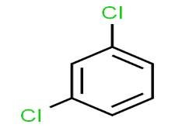 | 67.47 | 71 | Training
19 | 1,3-DCP | 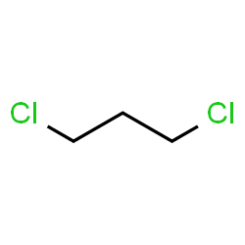 | 67.47 | 71 | Training
20 | 1,4-DCB | 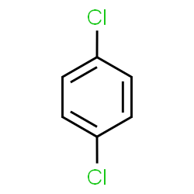 | 56.07 | 59 | Training
21 | 1,4-D | 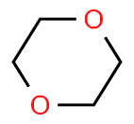 | 93.12 | 98 | Training
22 | 2-But | 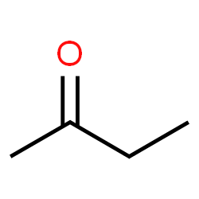 | 69.37 | 73 | Training
23 | 2-CT | 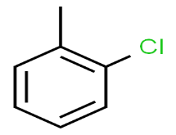 | 88.09 | 88 | Test
24 | 2-Hex | 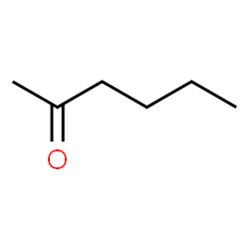 | 78.87 | 83 | Training
25 | 4-CT | 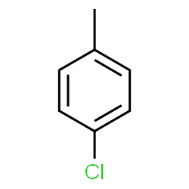 | 63.67 | 67 | Training
26 | 4-IPT | 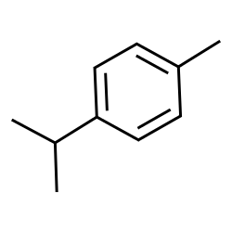 | 98.01 | 98 | Validation
27 | MIBK | 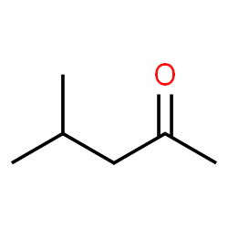 | 93.12 | 98 | Training
28 | acetone | 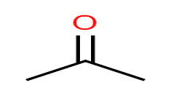 | 55.09 | 55 | Test
29 | Ace-N | 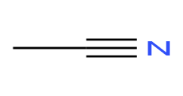 | 23.01 | 23 | Validation
30 | Acr-N | 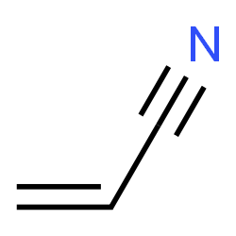 | 18.09 | 18 | Test
31 | benzene | 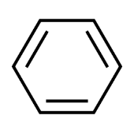 | 75.07 | 79 | Training
32 | BB | 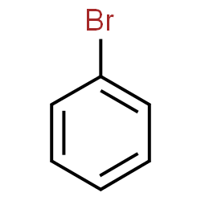 | 56.07 | 59 | Training
33 | BCM | 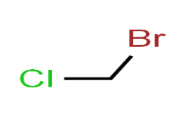 | 23.77 | 25 | Training
34 | BDCM | 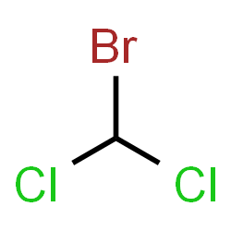 | 77.92 | 82 | Training
35 | BF | 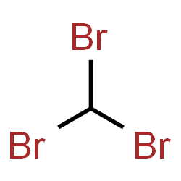 | 85.09 | 85 | Test
36 | BM | 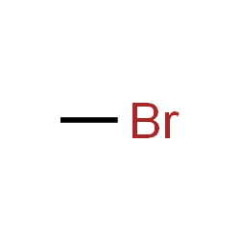 | 0.02 | 0 | Training
37 | C-Tet | 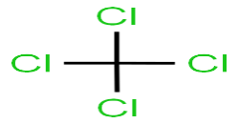 | 92.17 | 97 | Training
38 | CB | 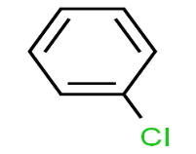 | 59.87 | 63 | Training
39 | CA | 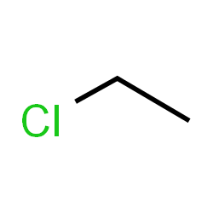 | 14.27 | 15 | Training
40 | CF | 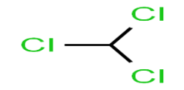 | 73.01 | 73 | Validation
41 | CM | 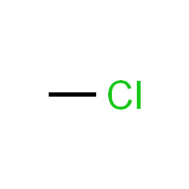 | 4.01 | 4 | Validation
42 | cis-1,2-DCE | 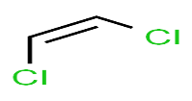 | 11.09 | 11 | Test
43 | cis-1,3-DCP | 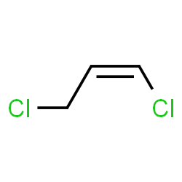 | 45.62 | 48 | Training
44 | DBCM | 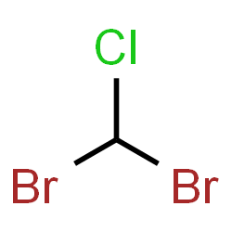 | 74.12 | 78 | Training
45 | DCM | 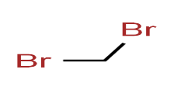 | 23.77 | 25 | Training
46 | EB | 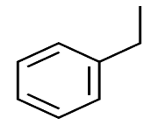 | 82.67 | 87 | Training
47 | HCBD | 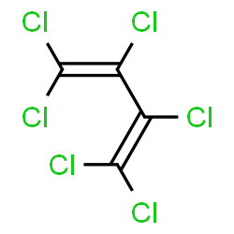 | 96.01 | >96 | Validation
48 | IPA | 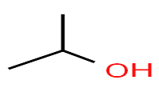 | 86.47 | 91 | Training
49 | cumene | 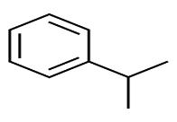 | 92.17 | 97 | Training
50 | IPE | 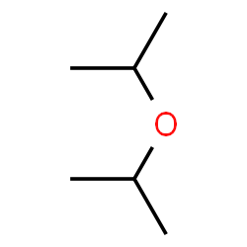 | 99.09 | 99 | Test
51 | MTBE | 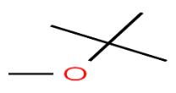 | 94.07 | 99 | Training
52 | MC | 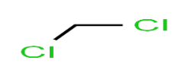 | 9.5 | 10 | Training
53 | m-xylenes | 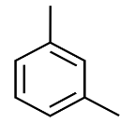 | 88.01 | 88 | Validation
54 | p-xylenes | 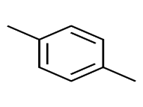 | 88.01 | 88 | Validation
55 | Naph | 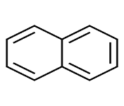 | 86.47 | 91 | Training
56 | n-BB | 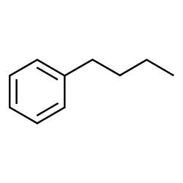 | 85.52 | 90 | Training
57 | n-PB | 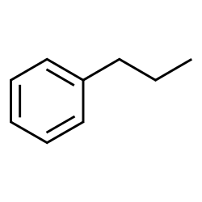 | 83.62 | 88 | Training
58 | o-xylene | 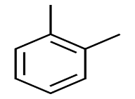 | 91.22 | 96 | Training
59 | s-BB | 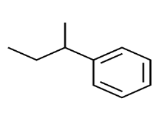 | 98.01 | 98 | Test
60 | TAME | 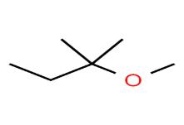 | 94.07 | 99 | Training
61 | TBA | 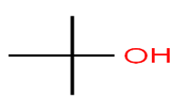 | 99.01 | 99 | Validation
62 | TBEE | 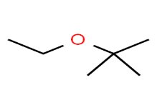 | 99.09 | 99 | Test
63 | TBB | 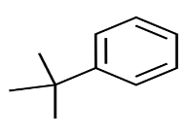 | 91.22 | >96 | Training
64 | PCE | 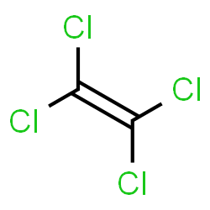 | 78.87 | 83 | Training
65 | toluene | 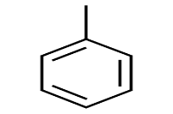 | 77.92 | 82 | Training
66 | t-1,2-DCE | 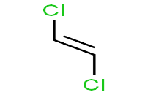 | 14.27 | 15 | Training
67 | t-1,3-DCP | 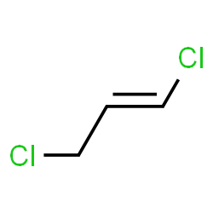 | 25.67 | 27 | Training
68 | t-1,4-DCB | 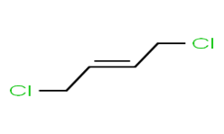 | 48.47 | 51 | Training
69 | TCE | 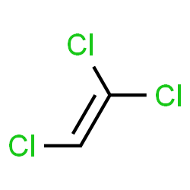 | 43.72 | 46 | Training
70 | VA | 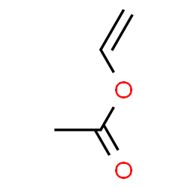 | 43.72 | 46 | Training
71 | VC | 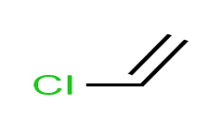 | 16.17 | 17 | Training
72 | styrene | 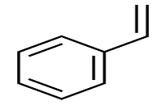 | 75.09 | 75 | test

