Supplementary table S1. Differences in gut microbiota among three groups at phylum level
 | Mean(Patient) | Mean(Control) | Mean(Follow) | p-value
Firmicutes | 0.33±0.12 | 0.36±0.13 | 0.28±0.12 | 0.02*
Bacteroidetes | 0.55±0.14 | 0.54±0.14 | 0.64±0.14 | 0.01*
*The difference was significant. p<0.05

Supplementary table S2. Differences in gut microbiota among three groups at genus level
 | Mean(Patient) | Mean(Control) | Mean(Follow) | p-value
Family_XIII_UCG-001 | 0.00±0.00 | 0.00±0.00 | 0.00±0.00 | ＜0.01*
Ruminococcaceae_UCG-003 | 0.00±0.00 | 0.00±0.00 | 0.00±0.00 | ＜0.01*
Ruminococcaceae_UCG-014 | 0.02±0.02 | 0.00±0.01 | 0.00±0.01 | ＜0.01*
Bacillus | 0.00±0.00 | 0 | 0.00±0.00 | ＜0.01*
Lachnospira | 0.01±0.01 | 0.02±0.02 | 0.01±0.01 | ＜0.01*
Dorea | 0.00±0.00 | 0.01±0.00 | 0.00±0.00 | ＜0.01*
Parasutterella | 0.03±0.04 | 0.01±0.01 | 0.01±0.01 | ＜0.01*
Collinsella | 0.00±0.00 | 0.00±0.00 | 0.00±0.00 | 0.01*
[Eubacterium]_eligens_group | 0.01±0.01 | 0.00±0.00 | 0.00±0.01 | 0.01*
Odoribacter | 0.00±0.00 | 0.00±0.00 | 0.00±0.01 | 0.01*
Erysipelatoclostridium | 0.00±0.00 | 0.00±0.00 | 0.00±0.00 | 0.01*
Ruminococcaceae_NK4A214_group | 0.00±0.00 | 0.00±0.00 | 0.00±0.00 | 0.01*
Bacteroides | 0.40±0.11 | 0.37±0.19 | 0.49±0.17 | 0.02*
Lachnospiraceae_NK4A136_group | 0.01±0.01 | 0.00±0.01 | 0.01±0.01 | 0.02*
Intestinimonas | 0.00±0.00 | 0.00±0.00 | 0.00±0.00 | 0.02*
Unassigned | 0.00±0.00 | 0 | 0.00±0.00 | 0.02*
Oscillibacter | 0.00±0.00 | 0.00±0.00 | 0.00±0.00 | 0.02*
uncultured_bacterium_f_Lachnospiraceae | 0.01±0.00 | 0.01±0.01 | 0.01±0.00 | 0.02*
Granulicatella | 0.00±0.00 | 0.00±0.00 | 0.00±0.00 | 0.04*
Hungatella | 0.00±0.00 | 0.00±0.00 | 0.00±0.00 | 0.04*
UBA1819 | 0.00±0.00 | 0.00±0.00 | 0.00±0.00 | ＜0.05*
[Eubacterium]_hallii_group | 0.00±0.00 | 0.01±0.01 | 0.00±0.00 | ＜0.05*
Ruminococcaceae_UCG-004 | 0.00±0.00 | 0.00±0.00 | 0.00±0.00 | ＜0.05*
*The difference was significant. p<0.05
Supplementary Figure S3. Sample clustering tree. It has shown that two samples of species was more similar to the branches was shorter and closer. In this Figure, the first episode depressive patients were named SF; patients for treatment with ecitalopram were named YY；health controls were named ZC. The gut microbiota of depressed patients was significantly different from that of the normal population and was highly similar. After treatment, the microbiota of depressed patients were more similar to that of normal people.

A
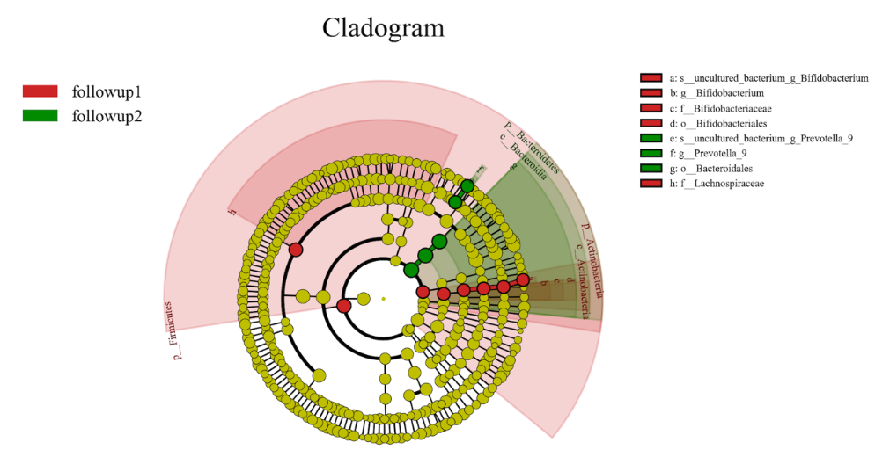

B
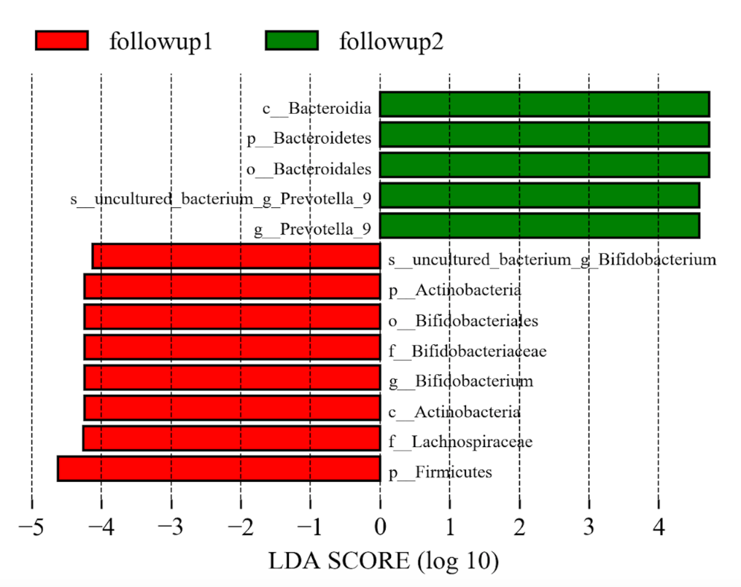
Supplementary Figure S4. Differently abundant taxa identified using LEfSe analysis. A. LEfSe cladogram showed the most differentially abundant taxa between the two cohorts. Taxa enriched for follow-up group1 in red; follow-up group 2 enriched taxa in green. The brightness of each dot is proportional to its effect size. B. Visualization of only taxa meeting an LDA threshold >4.
Supplementary table S5. Differences in metabolic pathways between Patients and Follows
 | Follow: mean rel.freq.(%) |  | Depression: mean rel.freq.(%) | P value
Carbohydrate metabolism |  | 10.6738905 | 10.49951841 |  | 0.18434568
Lipid metabolism |  | 2.094345256 | 2.096879094 |  | 0.98035723
Metabolism of cofactors and vitamins |  | 4.117770494 | 4.100932949 |  | 0.86214698
Energy metabolism |  | 4.252448169 | 4.284765926 |  | 0.6305466
Amino acid metabolism |  | 6.57498274 | 6.593295201 |  | 0.86890374
Nucleotide metabolism |  | 3.370264659 | 3.363175392 |  | 0.95886952
Biosynthesis of other secondary metabolites |  | 1.172319469 | 1.127939377 |  | 0.02431743*
Metabolism of terpenoids and polyketides |  | 1.108466863 | 1.114807623 |  | 0.77812332
Xenobiotics biodegradation and metabolism |  | 0.713131555 | 0.756875601 |  | 0.188076
Metabolism of other amino acids |  | 1.298149915 | 1.27577994 |  | 0.23062456
Glycan biosynthesis and metabolism |  | 1.822531511 | 1.689974023 |  | 0.19603031
Translation |  | 3.05919388 | 3.092963531 |  | 0.76469891
Global and overview maps |  | 43.67362455 | 43.7362727 |  | 0.78545385
Drug resistance: Antimicrobial |  | 0.834662529 | 0.834047036 |  | 1.03911155
Drug resistance: Antineoplastic |  | 0.002864843 | 0.001795163 |  | 0.62044905
Membrane transport |  | 3.250833368 | 3.46678242 |  | 0.25824223
Signal transduction |  | 2.371914562 | 2.389478316 |  | 0.90909068
Cellular community - prokaryotes |  | 1.27800921 | 1.32675229 |  | 0.25692951
Cell motility |  | 0.440302312 | 0.479364219 |  | 0.58926607
Folding, sorting and degradation |  | 1.362356941 | 1.363338193 |  | 0.98033951
Transcription |  | 0.124171131 | 0.127094776 |  | 0.61852967
Replication and repair |  | 2.706112751 | 2.693836402 |  | 0.91738725
Endocrine system |  | 0.641448157 | 0.63020365 |  | 0.55820158
Signaling molecules and interaction |  | 0.037081205 | 0.037235319 |  | 0.96929789
Cell growth and death |  | 0.45297974 | 0.450882831 |  | 0.96334806
Transport and catabolism |  | 0.451064101 | 0.396629147 |  | 0.08668273
Aging |  | 0.240167168 | 0.234356744 |  | 0.63147457
Circulatory system |  | 0.002704098 | 0.000635751 |  | 0.47524487
Development |  | 0 | 0 |  | 1.04545455
Cellular community - eukaryotes |  | 0 | 0 |  | 1.02222222
Immune system |  | 0.077918314 | 0.076644507 |  | 0.70036488
Environmental adaptation |  | 0.150329736 | 0.149761762 |  | 0.96525719
Nervous system |  | 0.220419971 | 0.211153168 |  | 0.23301309
Sensory system |  | 0 | 0 |  | 1
Endocrine and metabolic diseases |  | 0.188222037 | 0.183732482 |  | 0.38690567
Excretory system |  | 0.022643029 | 0.020477634 |  | 0.63596815
Digestive system |  | 0.059083698 | 0.053484267 |  | 0.71570141
*The difference was significant. p<0.05

