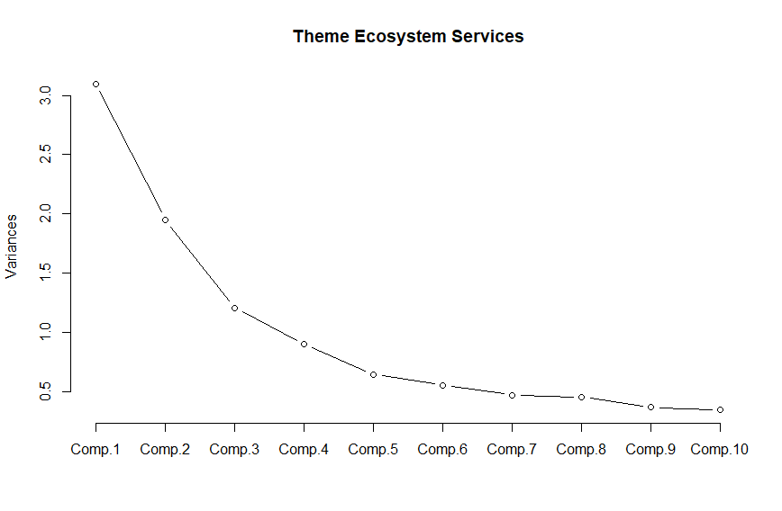
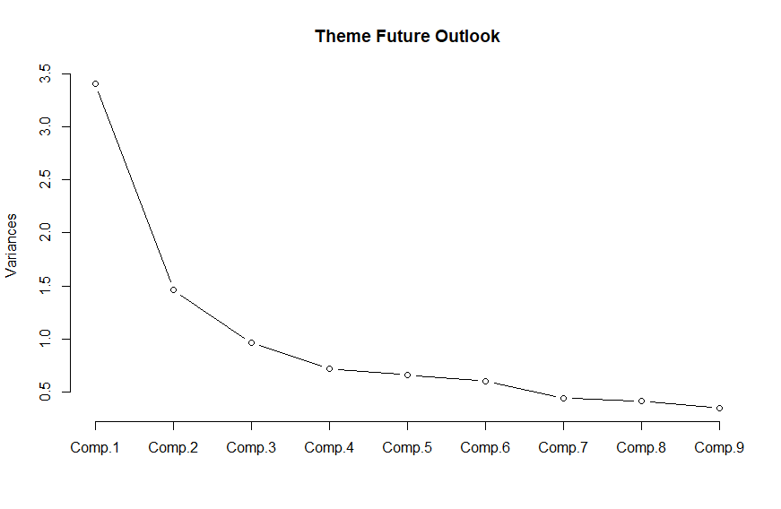
Appendix A: Supplementary material
Fig 7 Scree plot for the principal component analysis of the theme Ecosystem Services

Fig 8 Scree plot for the principal component analysis of the theme Future Outlook

Fig 9 Respondent answers regarding adaptation, sociodemographic characteristics, and knowledge exchange. No = dark blue, yes = yellow. Total = overall sample responses, NCNM = non-certified non-members, NCM = non-certified members, CNM = certified non-members, CM = certified members. Significant differences between the group and the overall sample frequency (Total) are indicated with (* = p < 0.05, ** = p < 0.01, *** = p < 0.001)

