Supporting informations for:
Selection of electronically deficient products as very good antifungal condidates
Wafa Mihoubi¹, Haitham Elleuch^{2,*}, Manel Boudabbous¹, Emna Ketata¹, Ines Borgi¹, Farhat Rezgui² and Ali Gargouri¹.

1-Laboratoire de Biotechnologie Moléculaire des Eucaryotes, Centre de Biotechnologie de Sfax B.P ‘1177’’ 3018; Université de Sfax, Tunisia
2-Laboratoire de Chimie Organique Structurale LR99ES14, Faculté des Sciences de Tunis. Université El Manar, Tunisia

Corresponding author: elleuchhaitham@gmail.com

Monitoring of anti fungal activity ofMorita-Baylis-Hillman products

Contents | page
General informations | S2
Synthesis of MBH adducts | S2
Synthesis of MBH alcohols | S2
Synthesis of MBH acetates | S3
Synthesis of MBH phosphonates | S4
Synthesis of MBH hydrazonophosphonates | S5
Values of the diameter of the zone of inhibition of anti fungal MHB products against fungi | S6
Antifungal activity of MBH adducts | S7
RMN profil of MBH adducts | S11

General information
Chemistry
- Melting points were determined on a Kofler melting apparatus and are uncorrected. 1H and 13C-NMR spectra were obtained on a Varian 500MHz spectrometer. The chemical shifts (δ) and coupling constants (J) are expressed in ppm and hertz respectively. Microanalyses and mass spectrometry analyses were carried out on a Carlo Erba EA 1102 and on a 3200 QTRAP (Applied Biosystem SCIEX) respectively. All solvents and reagents were obtained from commercial sources and purified before use if necessary. Merck Kieselgel 60F254 plates were used for TLC, and Merck Silica gel 60 (0.063–0.100 mm) for column chromatography.

Synthesis of MBH adducts

Our series of Morita-Baylis-Hillman (MBH) adducts have been synthesized as described in our previous work

Table 1:Synthesis of MBH alcohols 1a-l: F. Rezgui, H. Amri, M. M. El Gaied, Tetrahedron 59 (2003) 1369.
Ref | Chemical structure | Ref | Chemical structure | Ref | Chemical structure
1a | 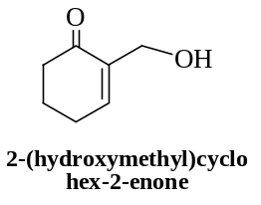 | 1e | 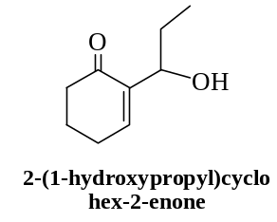 | 1i | 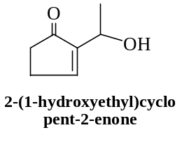
1b | 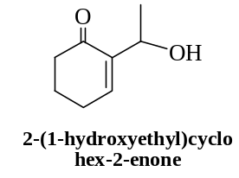 | 1f | 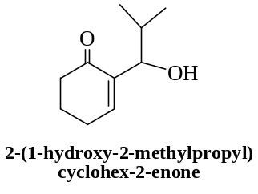 | 1j | 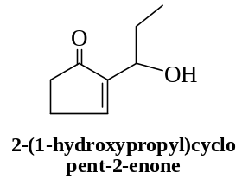
1c | 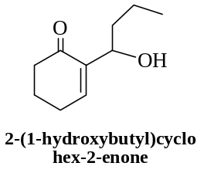 | 1g | 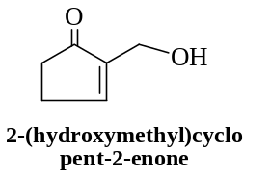 | 1k | 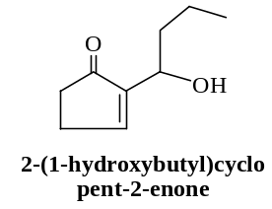
1d | 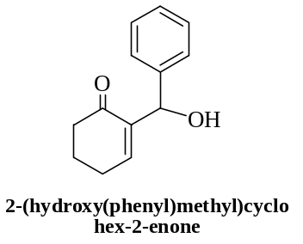 | 1h | 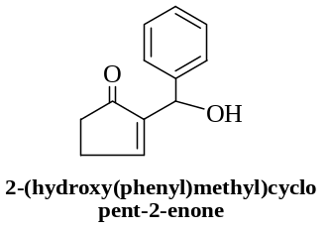 | 1l | 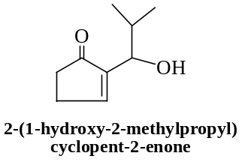

Table 2:Synthesis of MBH acetates 2a-l: F. Rezgui, H. Amri, M. M. El Gaied, Tetrahedron 59 (2003) 1369.

Ref | Chemical structure | Ref | Chemical structure | Ref | Chemical structure
2a | 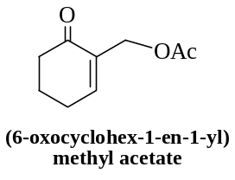 | 2e | 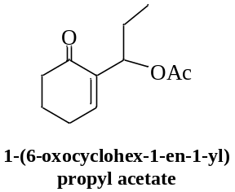 | 2i | 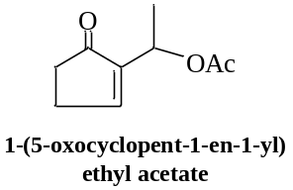
2b | 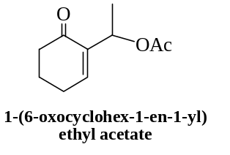 | 2f | 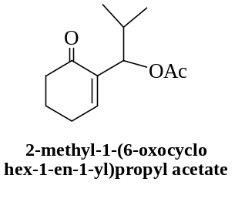 | 2j | 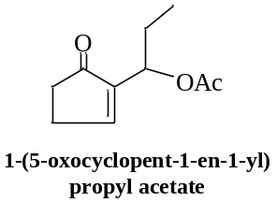
2c | 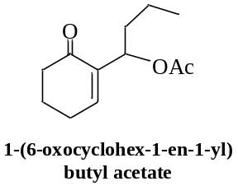 | 2g | 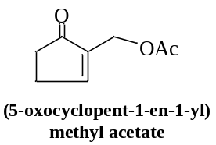 | 2k | 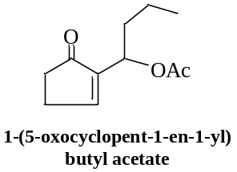
2d | 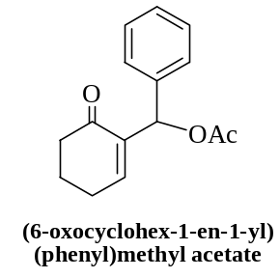 | 2h | 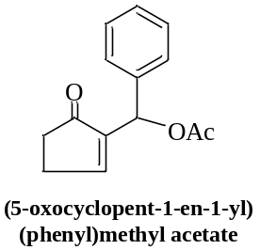 | 2l | 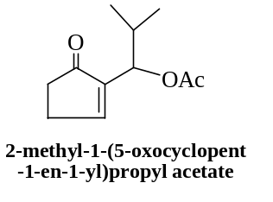

Table 3:Synthesis of MBH phosphonates 3a-l:
https://pubs.acs.org/doi/suppl/10.1021/acs.joc.5b02106/suppl_file/jo5b02106_si_001.pdf

Ref | Chemical structure | Ref | Chemical structure | Ref | Chemical structure
3a | 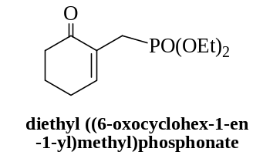 | 3e | 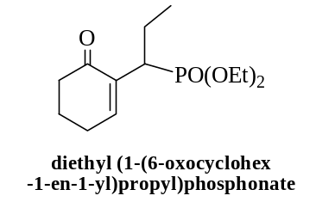 | 3i | 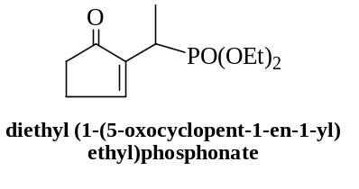
3b | 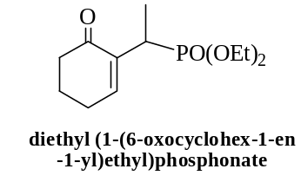 | 3f | 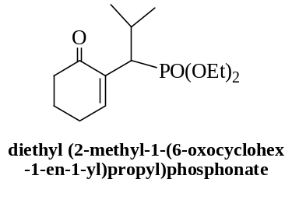 | 3j | 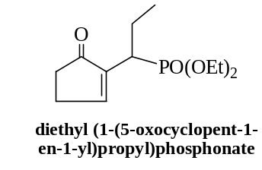
3c | 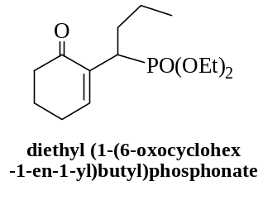 | 3g | 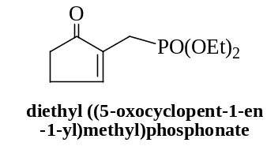 | 3k | 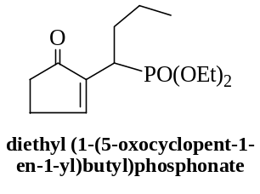
3d | 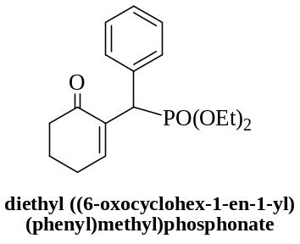 | 3h | 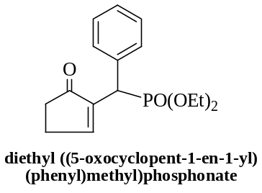 | 3l | 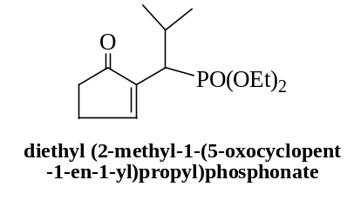

Table 4:Synthesis of MBH hydrazonophosphonates 4a-c:
https://www.arkat-usa.org/get-file/60166/

Ref | Chemical structure
4a | 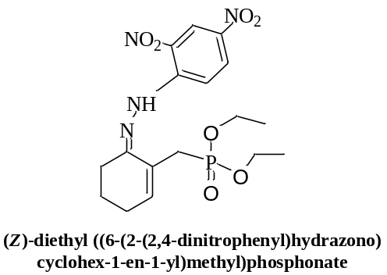
4b | 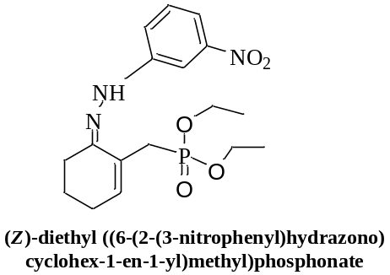
4c | 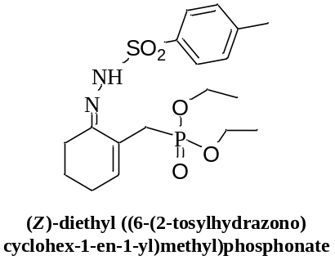

Table 5:Values of the diameter of the zone of inhibition of anti fungal MHB products against Fusarium oxysporum, Trichoderma parceramosum, stachybotris microspore and Tricoderma resei

Fusarium oxysporum | 1f  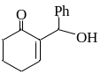 | 2f  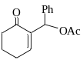 | 2g  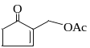 | 2i  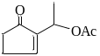 | 2k  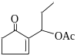 | 2m  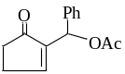 | 2l  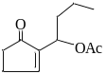 | 2b  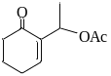
Diameter (cm) | 1.5±0.14 | 1.7÷0.14 | 4.75÷0.21 | 2.6±0 | 2.3±0 | 2.15±0.21 | 2±0 | 1.4±0
Trichoderma parceramosum | 1f | 2f | 2g | 2i | 2k | 2m | 2l | 2b
Diameter (cm) | 4.05±0.07 | 3.35±0.07 | 4.35±0.21 | 3.55±0.07 | 4.1±0.14 | 3.7±0.14 | 3.85±0.07 | 3.95±0.07
Stachybotris microspore | 1f | 2f | 2g | 2i | 2k | 2m | 2l | 2b
Diameter (cm) | 2.6±0.14 | 3.6±0.28 | 6.1±0.14 | 4.1±0.14 | 3.95±0.07 | 3.35±0.21 | 3.55±0.21 | 2,5±0
Trichoderma reesei | 1f | 2g | 2i | 2k | 2m | 2l | 2b | 2a  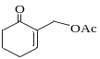
Diameter (cm) | 2.95±0.07 | 4.85±0.07 | 3.9±0.14 | 3.05±0.07 | 3,6±0 | 3.05±0.07 | 3.55±0.07 | 2.5±0

Table 6: Values of the diameter of the zone of inhibition anti fungal MHB products against Fusarium solani, Penicillium occitanis and Aspergillus niger.

Fusarium solani | 2g | 2i | 2k | 2m | 2l
Diameter (cm) | 3.9÷0.14 | 2.05±0.07 | 2.05±0.07 | 2.15±0.21 | 1.85±0.07
penicillium occitanis | 2g | 2i | 2k | 2m | 2l
Diameter (cm) | 3.55±0.07 | 2 .3±0.14 | 2.1±0.14 | 2.2±0.28 | 1.9±0.14
Aspergillus niger | 2g | 2i | 2k | 2m | 2l
Diameter (cm) | 3±0 | 0 | 0 | 0 | 0
Figure 1 : Anti fngal activity of MHB products measured in Well diffusion method against (a) Fusarium oxysporum, (b) Trichoderma parceramosum, (c) stachybotris microspore, (d) Tricoderma resei,(e) Fusarium solani, (f) Penicillium occitanis and (g) Aspergillus niger

Figure(a)Fusarium oxysporum
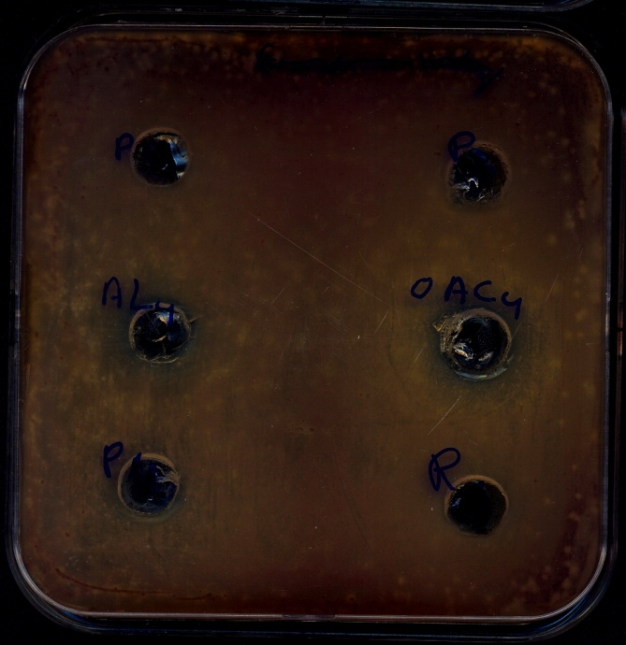
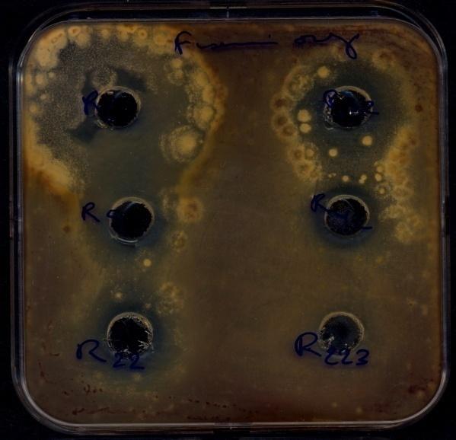

2i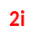
2g

1f
2k
2l
2f

2mm

Figure(b) Trichoderma parceramosum (N2-20)

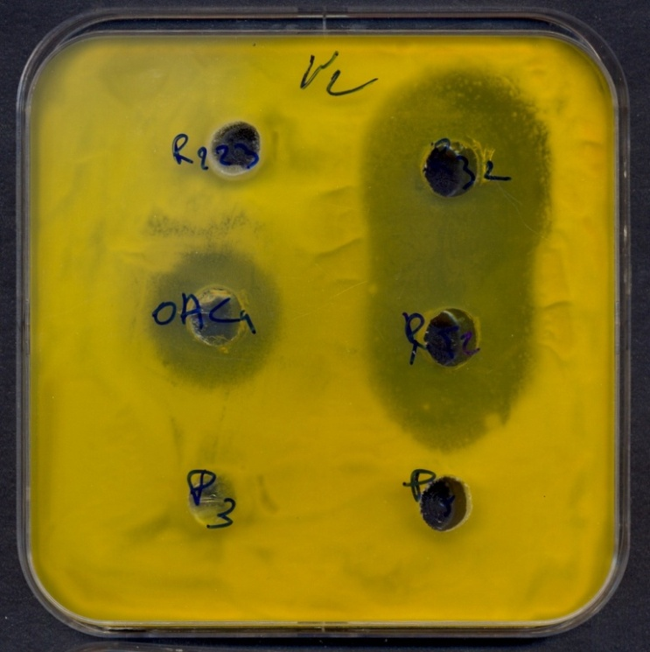
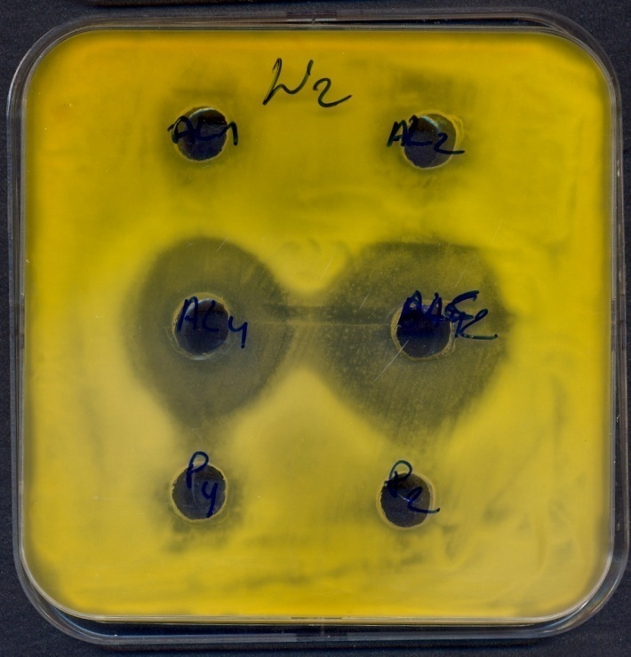

2i

2f
2b
2f
2k

Figure(c)Trichoderma reisei (RutC30)
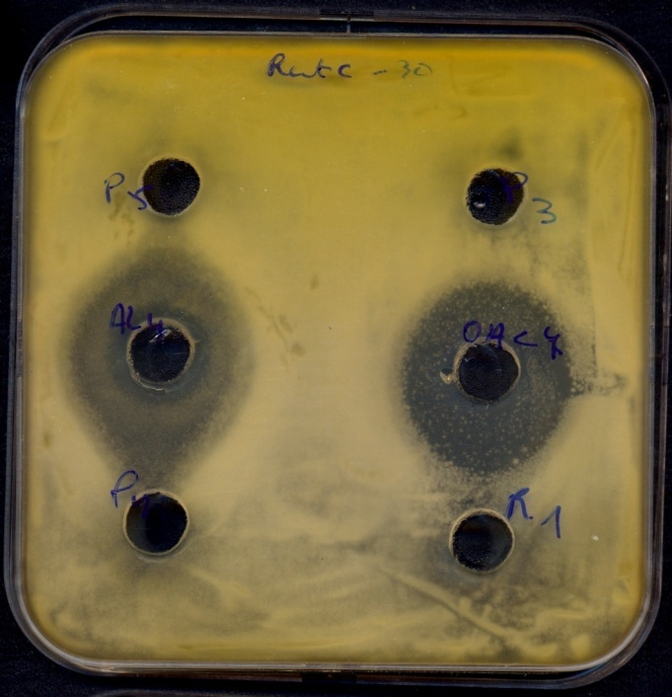
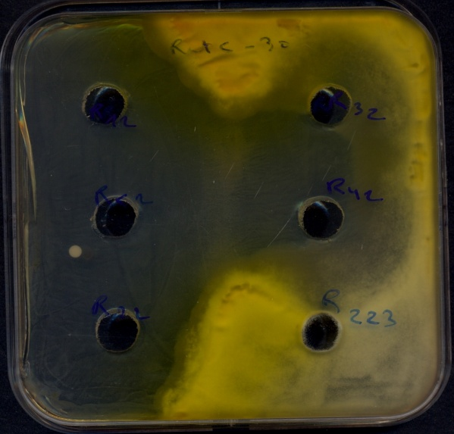

2i
2g

2l
2k
1f
2f

2mm

Figure(b)Trichoderma reisei (RutC30)

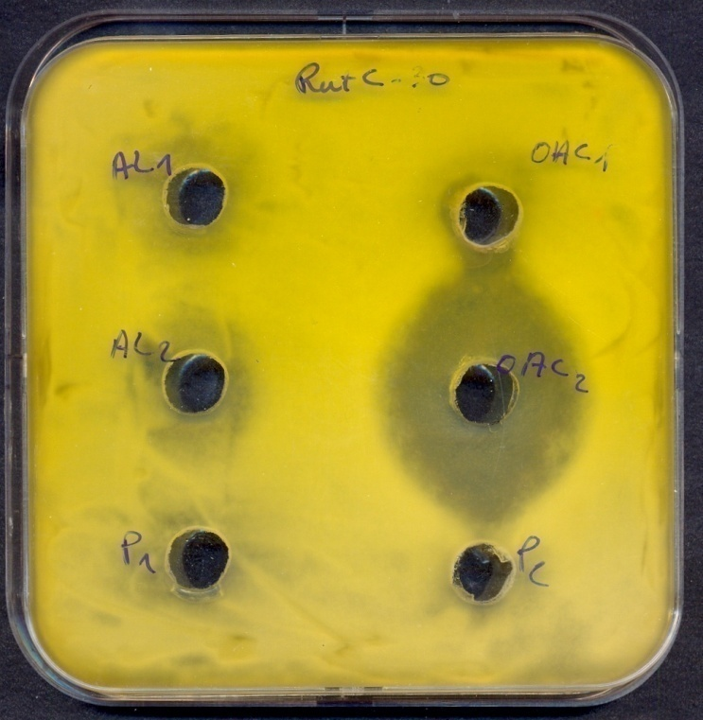

2b

Figure(d)Stacchybotris microspora (N1)

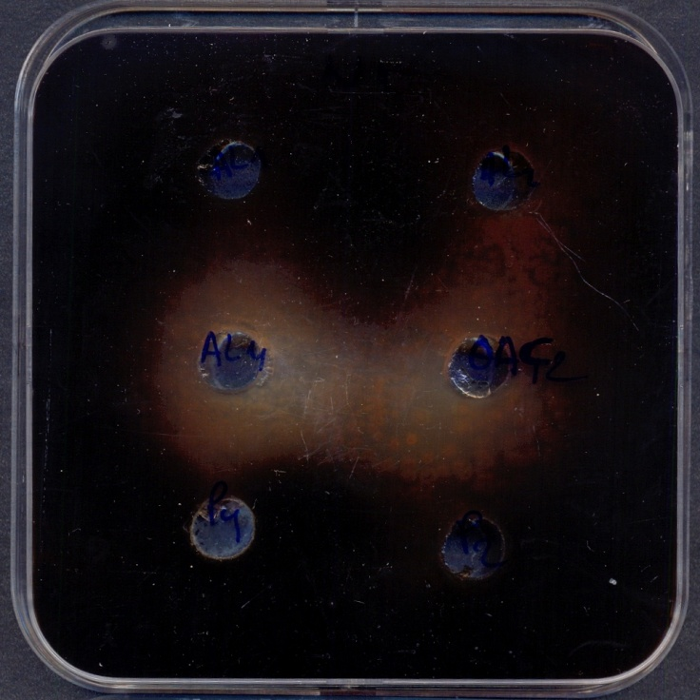
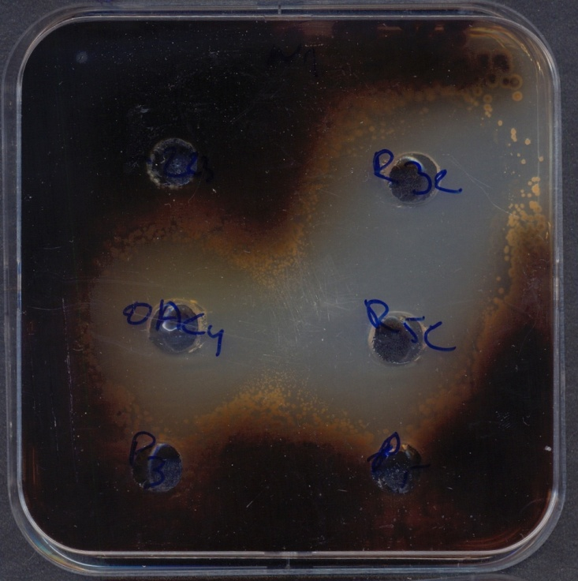

2i

2b
1f
2f
2k

Figure(e)Fusarium solani

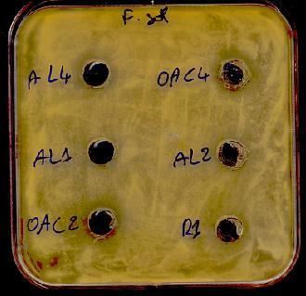
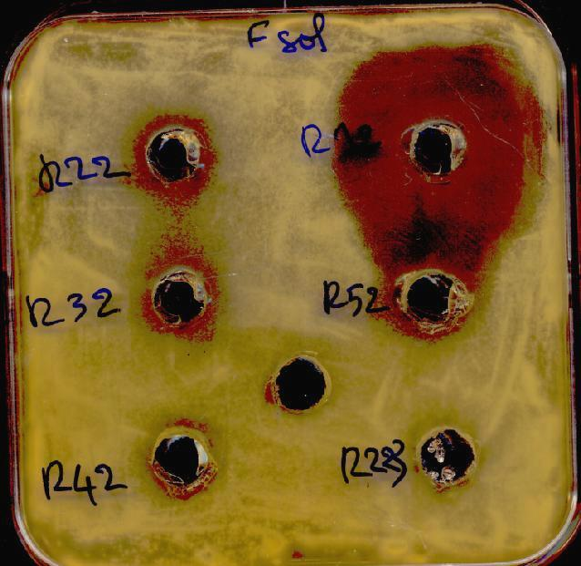

2g
2m

2k
2i

2k

Figure(f)Penicillium occitanis (CT1)Figure(g)Aspergillus niger (A1)
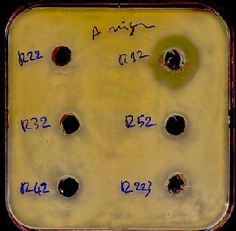
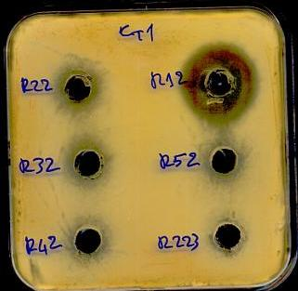

2g
2g
2i

2k
2j

2j

