Table 1: Chemical structure of cyclic MBH adducts.
Alcool | Acetate | Phosphonate | Hydrazonophosphonates
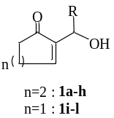 | 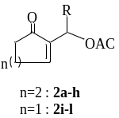 | 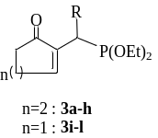 | 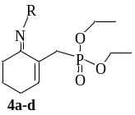
n=2  R = a: H, b: CH₃, C: (CH₂)₂CH₃, d: Ph, e: CH₂CH₃, f: CH(CH₃)₂ |  |  | a: R=NH-Ph(NO₂)₂, b: R=NH-Ph(NO₂), c: R= NH-SO₂Ph-Me
n=1  R = g: H, h: Ph, i: CH3, j: CH₂CH₃ , k: (CH₂)₂CH₃, l : CH(CH₃)₂ |  |  | a: R=NH-Ph(NO₂)₂, b: R=NH-Ph(NO₂), c: R= NH-SO₂Ph-Me

Table 2: Zone of inhibition diameter values of MHB antifungal products against Fusarium oxysporum, Trichoderma parceramosum, Stachybotrys microspora and Trichoderma reesei.
Fusarium oxysporum | 1d  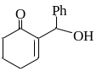 | 2d  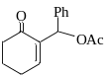 | 2g  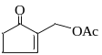 | 2i  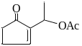 | 2j  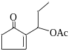 | 2h  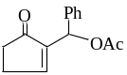 | 2k  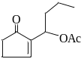 | 2b  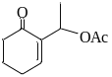
Diameter (cm) | 1.5±0.14 | 1.7÷0.14 | 4.75÷0.21 | 2.6±0 | 2.3±0 | 2.15±0.21 | 2±0 | 1.4±0
Trichoderma parceramosum | 1d | 2d | 2g | 2i | 2j | 2h | 2k | 2b
Diameter (cm) | 4.05±0.07 | 3.35±0.07 | 4.35±0.21 | 3.55±0.07 | 4.1±0.14 | 3.7±0.14 | 3.85±0.07 | 3.95±0.07
Stachybotrys microspora | 1d | 2d | 2g | 2i | 2j | 2h | 2k | 2b
Diameter (cm) | 2.6±0.14 | 3.6±0.28 | 6.1±0.14 | 4.1±0.14 | 3.95±0.07 | 3.35±0.21 | 3.55±0.21 | 2,5±0
Trichoderma reesei | 1d | 2g | 2i | 2j | 2h | 2k | 2b | 2a  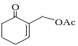
Diameter (cm) | 2.95±0.07 | 4.85±0.07 | 3.9±0.14 | 3.05±0.07 | 3,6±0 | 3.05±0.07 | 3.55±0.07 | 2.5±0

Table 3: Values of the diameter of the zone of inhibition of MHB antifungal products against Fusarium solani, Penicillium occitanis and Aspergillus niger.
Fusarium solani | 2g | 2i | 2j | 2h | 2k | 2a | Nystatin
Diameter (cm) | 4.54± 0.11 | 2.05±0.07 | 2.05±0.07 | 2.15±0.21 | 1.85±0.07 | 3.8± 0.14 | 1.06 ± 0.11
Penicillium occitanis | 2g | 2i | 2k | 2h | 2k
Diameter (cm) | 3.55±0.07 | 2 .3±0.14 | 2.1±0.14 | 2.2±0.28 | 1.9±0.14
Aspergillus niger | 2g | 2i | 2j | 2h | 2k | 2a | Nystatin
Diameter (cm) | 3±0 | 0 | 0 | 0 | 0.66± 0.16 | 1.7± 0.16 | 1.4 ± 0.14

Table 4: Values of the diameter of the zone of inhibition of MHB antifungal products against Fusarium aethiopicum, Alternaria alternata and Aspergillus flavus strains.
Fusarium aethiopicum | 2g | 2k | 2a | Nystatin
Diameter (cm) | 3.2± 0.2 | 2.8± 0.28 | 4.4± 0.34 | 3.66 ± 0.15
Alternaria alternata | 2g | 2k | 2a | Nystatin
Diameter (cm) | 5.36 ± 0.26 | 0 | 4.1± 0.66 | 3.3 ± 0.14
Aspergillus flavus | 2g | 2k | 2a | Nystatin
Diameter (cm) | 5.06± 0.5 | 3.06± 0.11 | 4± 0.11 | 3.66 ± 0.15

