Table 2
The phases of the musical complex span task and how they were mapped on TBRS*C processes.
Duration | Phase | Exemplary stimulus image | TBRS*C
2,000 ms | Fixation cross | 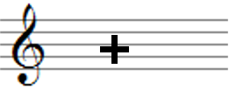 | Refreshing
2,500 ms | Memorandum | 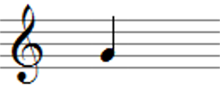 | Encoding;  (Chunking); Refreshing
6,856 ms | Count-in & preview |  | Processing distractors;  Refreshing
13,714 ms | Musical Performance |  | Processing distractors;  Refreshing
6,124 ms | Saving eye tracking data |  | Refreshing
Note: For music students, the count-in phase was split-up in a getting ready (3,428 ms) and a preview phase (3,428 ms) and the eye tracking data saving took 4,425 ms.

Table 3
Each staff shows the twelve to-be-remembered notes that were presented successively in one trial of the complex span task.
Major triads | Arbitrary trichords
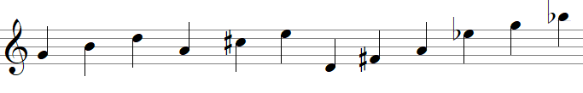 | 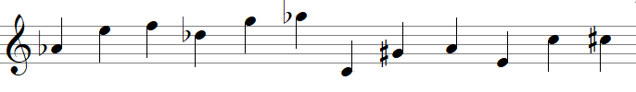
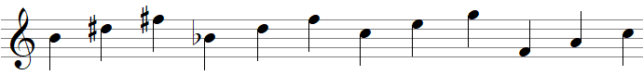 | 