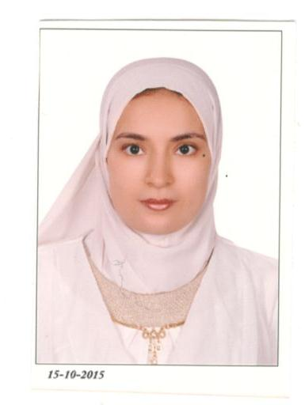
Amaal S. A. El-Hameed received
her B.Sc. and M.Sc. in Electronics
and Communications Engineering
from Cairo University in 2008
and 2013 respectively. Her M.Sc.
work focused on network cod
ing. She received her Ph.D. in
Electronics and Communications
Engineering from Cairo University
in 2021. Her Ph.D. work focused in
the area of machine learning
techniques for radio resource
management in 4G/5G wireless
systems.

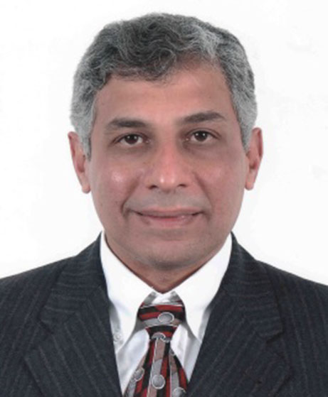
Khaled M. F. Elsayed received
the Ph.D. in Computer Science
and Computer Engineering from
North Carolina State University
in 1995 and the M.Sc. in Engi
neering Mathematics and the
B.Sc. (honors) in Electrical Engi
neering from Cairo University
in 1990 and 1987 respectively.
He is currently a professor of
Communication Networks and
the head of the Computing Group
in the Department of Electronics
and Communications Engineer
ing in Cairo University, Egypt. His recent work focused on radio
resource management and architectures for 4G/5G wireless systems
and devising scalable standards-based Internet of Things systems.
He has about 110+ publications in international journals and confer
ences. Previously, he was the chief technical offificer of the Embedded
Wireless Division in SySDSoft which was acquired by Intel in March
2011. He also held positions in Nortel and Alphatronix in the USA.
Dr. Elsayed was an editor for the IEEE Communications Magazine
Internet Technology Series from Nov. 1998 till Dec. 2002. He has
also been a member of the technical program committees and session
chair for several IEEE, IFIP, and ITC conferences. He is a senior
member of IEEE.

