Supporting materials for:

IGF2BP3 promotes adult myocardial regeneration by stabilizing MMP3 mRNA through interaction with N6-methyladenosine modification
Simeng Li, Siman Shen, Hao Xu, Shuyun Cai, Xiaodong Yuan, Changsen Wang, Xiaojun Zhang, Suyun Chen, Jianning Chen, De-Li Shi, Liangqing Zhang

Authors for correspondence: Liangqing Zhang and De-Li Shi

This PDF file includes:

Figures S1 to S8
Tables S1 to S3
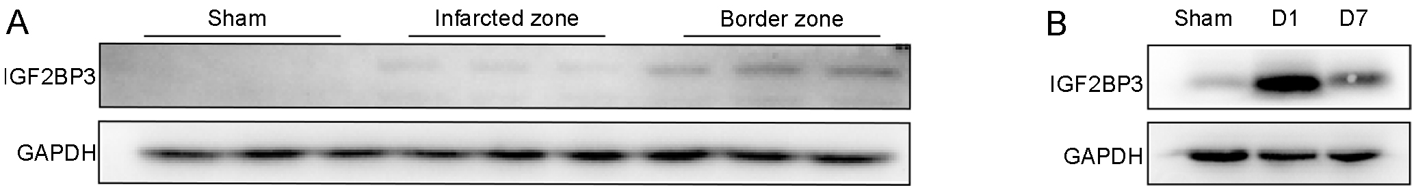
Figure S1. IGF2BP3 expression in MI heart. (A) Increased expression of IGF2BP3 in the border zone of adult heart at day 7 post-MI. (B) Expression of IGF2BP3 at day 1 and 7 post-MI in adult mice.

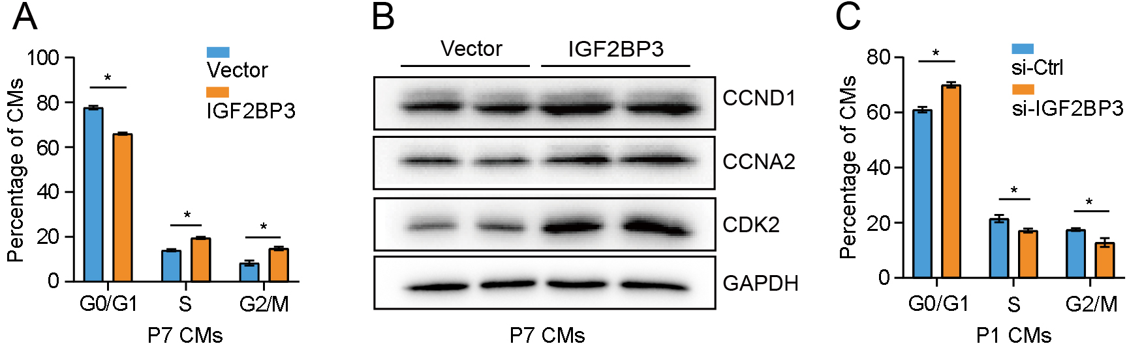

Figure S2. Regulation of cell cycle progression in CMs by IGF2BP3. (A) Flow cytometry analysis of IGF2BP3-overexpressing P7 CMs at different phases of the cell cycle (*, P < 0.05). (B) IGF2BP3 increases the expression of proteins associated with cell cycle progression in P7 CMs. (C) Flow cytometry analysis shows the inhibitory effects of IGF2BP3 knockdown on cell cycle progression in P1 CMs (*, P < 0.05).

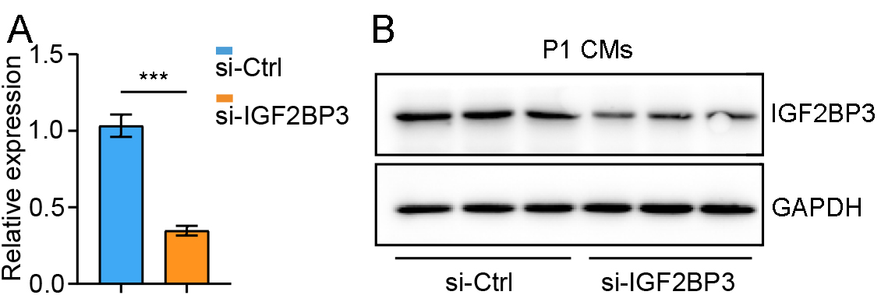
Figure S3. Efficiency of IGF2BP3 knockdown. (A) RT-qPCR analysis of IGF2BP3 mRNA levels in P1 CMs. Values in the si-Ctrl condition are set to 1 as a reference, after normalization to GAPDH. Data are the mean±s.e.m. from three independent samples (***, P < 0.001). (B) Western blot analysis of IGF2BP3 expression following its knockdown in P1 CMs.
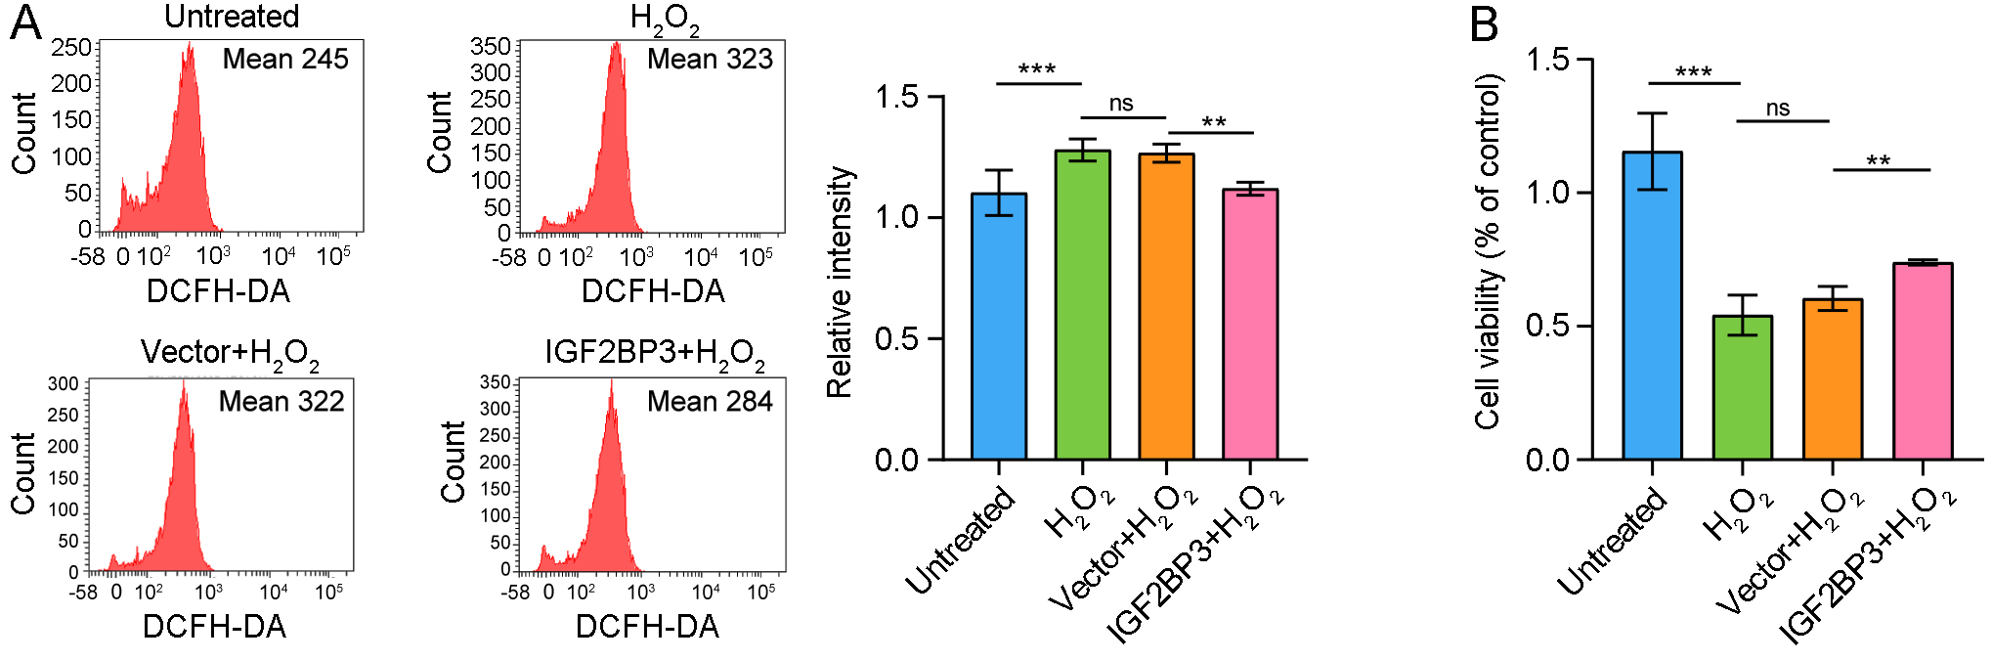
Figure S4. Protection of CM damage by IGF2BP3. (A) Measurement and statistical analysis of ROS levels in indicated conditions following treatment with H₂O₂ (**, P < 0.01; ***, P < 0.001; ns, not significant). (B) CCK-8 cell proliferation and cytotoxicity assay shows the protective effect of IGF2BP3 on cell viability (**, P < 0.01; ***, P < 0.001; ns, not significant).

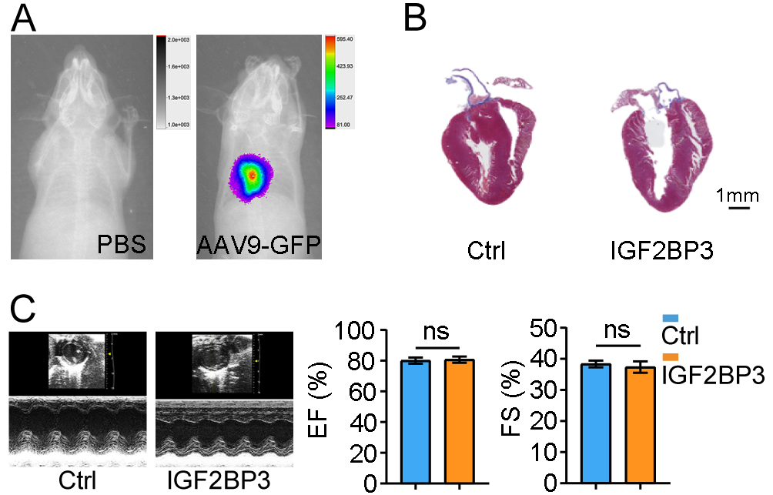
Figure S5. Overexpression of IGF2BP3 does not affect heart morphology and function. (A) Verification of successful targeting of apical myocardial region using AAV9-packaged GFP as a control. (B) HE staining of adult mouse hearts shows comparable morphology between control and IGF2BP3-overexpressing conditions. (C) Adult mouse cardiac ultrasound in control and IGF2BP3-overexpressing conditions shows similar function (ns, not significant).

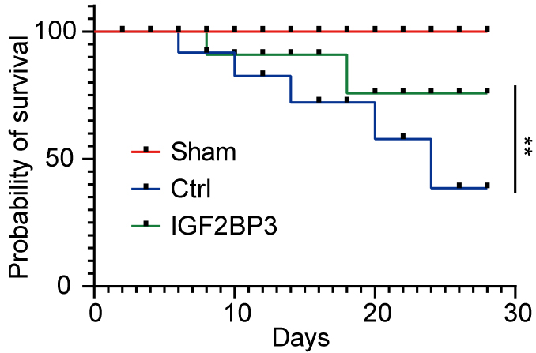
Figure S6. IGF2BP3 protects survival of adult MI mice. Kaplan-Meier survival curve shows increased survival rate of adult MI mice following injection of IGF2BP3 in the heart (n = 30 mice for each group; **, P < 0.01).

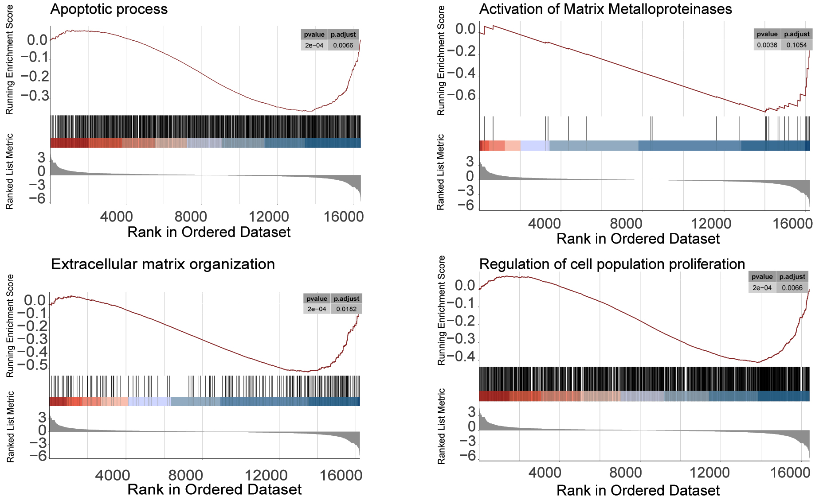
Figure S7. IGF2BP3-regulated biological processes in P1 CMs. Gene set enrichment analysis (GSEA) analysis of the DEGs identified by RNA-seq.

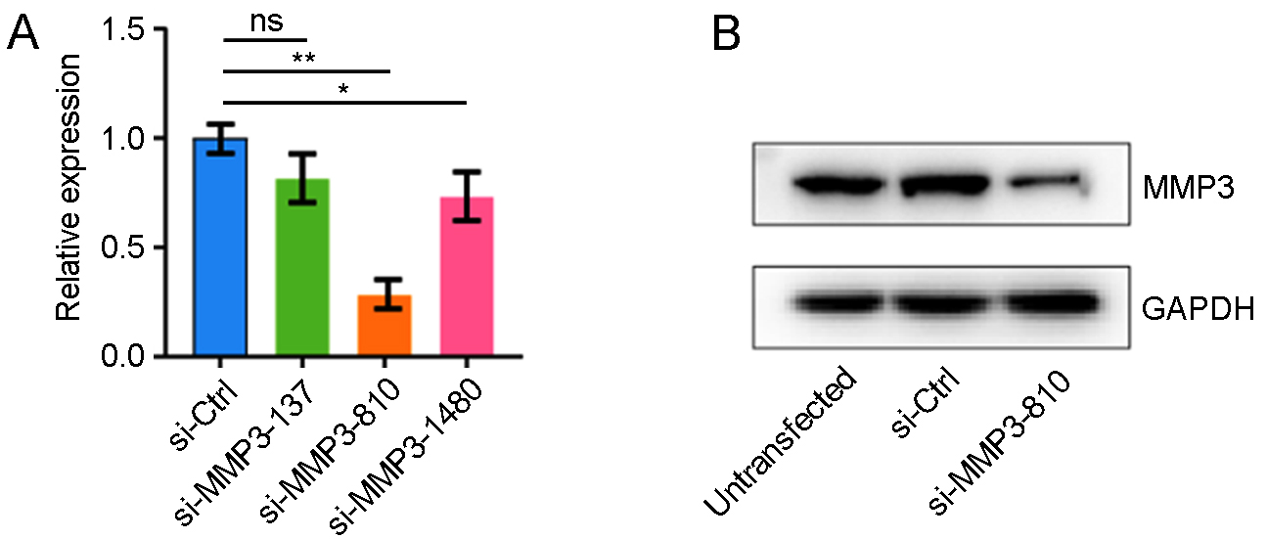
Figure S8. Efficiency of MMP3 knockdown. (A) RT-qPCR analysis of MMP3 expression shows the efficiency of the 3 siRNAs against MMP3 (*, P < 0.05; **, P < 0.01; ns, not significant). (B) Western blot analysis of MMP3 protein expression after knockdown of P1 CMs using si-MMP3-810.

Table S1. Primer sequences used for PCR.
Gene names | Orientations |  | Sequences (5'-3')
IGF2BP3 | F |  | CATCTGTTTATTCCCGCCCTGTCC
IGF2BP3 | R |  | TCACCATCCGCACTTTAGCATCTG
YTHDF1 | F |  | ACAGTTACCCCTCGATGAGTG
YTHDF1 | R |  | GGTAGTGAGATACGGGATGGGA
YTHDF2 | F |  | GAGCAGAGACCAAAAGGTCAAG
YTHDF2 | R |  | CTGTGGGCTCAAGTAAGGTTC
METTL3 | F |  | CTGGGCACTTGGATTTAAGGAA
METTL3 | R |  | TGAGAGGTGGTGTAGCAACTT
METTL14 | F |  | CTGAGAGTGCGGATAGCATTG
METTL14 | R |  | GAGCAGATGTATCATAGGAAGCC
WTAP | F |  | TAGACCCAGCGATCAACTTGT
WTAP | R |  | CCTGTTTGGCTATCAGGCGTA
Alkbh5 | F |  | CGCGGTCATCAACGACTACC
Alkbh5 | R |  | ATGGGCTTGAACTGGAACTTG
FTO | F |  | TTCATGCTGGATGACCTCAATG
FTO | R |  | GCCAACTGACAGCGTTCTAAG
MMP3 | F |  | GACGATGATGAACGATGGACAGAGG
MMP3 | R |  | TGTGGAGGACTTGTAGACTGGGTAC
Ctss (1) | F |  | GCCAGCCATTCCTCCTTCTTCTTC
Ctss (1) | R |  | CAAGAGTCCCATAGCCAACCACAAG
Ctss (2) | F |  | GCCAGCCATTCCTCCTTCTTCTTC
Ctss (2) | R |  | CAAGAGTCCCATAGCCAACCACAAG
Il1rn (1) | F |  | CGCTTTACCTTCATCCGCTCTGAG
Il1rn (1) | R |  | AGGACGGTCAGCCTCTAGTGTTG
Il1rn (2) | F |  | CGCTTTACCTTCATCCGCTCTGAG
Il1rn (2) | R |  | AGGACGGTCAGCCTCTAGTGTTG
Il1rn (3) | F |  | CGCTTTACCTTCATCCGCTCTGAG
Il1rn (3) | R |  | AGGACGGTCAGCCTCTAGTGTTG
Ccl6 | F |  | ACTGCTGCTTCTCTTATGCCACAC
Ccl6 | R |  | CCCTCCTGCTGATAAAGATGATGCC
Ccl9 | F |  | GCAGTCTGAAGGCACAGCAAGG
Ccl9 | R |  | GGACAGGCAGCAATCTGAAGAGTC
Mmp12 (1) | F |  | AGCAACTGGGCAACTGGACAAC
Mmp12 (1) | R |  | CCGCTTCATCCATCTTGACCTCTG
MMP12 (2) | F |  | AGCAACTGGGCAACTGGACAAC
MMP12 (2) | R |  | CCGCTTCATCCATCTTGACCTCTG
Mmp12 (3) | F |  | AGCAACTGGGCAACTGGACAAC
Mmp12 (3) | R |  | CCGCTTCATCCATCTTGACCTCTG
Lyz2 | F |  | CTCCTGCTTTCTGTCACTGCTCAG
Lyz2 | R |  | CCATAGTAGCCAGCCATTCCATTCC
Cxcl3 | F |  | GCCACTCTCAAGGATGGTCAAGAAG
Cxcl3 | R |  | GGACTTGCCGCTCTTCAGTATCTTC
SerpinB2 (1) | F |  | CAAACTGGCACAAAGCTACGAACTC
SerpinB2 (1) | R |  | CGCTGGCTTGATGGAACACCTC
Serpinb2 (2) | F |  | CAAACTGGCACAAAGCTACGAACTC
Serpinb2 (2) | R |  | CGCTGGCTTGATGGAACACCTC
Cemip | F |  | TCTGTCGCAGTGAATGATGAAGGC
Cemip | R |  | GCTCCAAGGGTGTCTAAATCCAAGG
Sprr1a | F |  | CCAGAGCCCTGCCAACCTAAGG
Sprr1a | R |  | CTTCTGCTGGTATGGTGATGGAGTG
HP (1) | F |  | CGGCTATGTGGAGCACTTGGTTC
HP (1) | R |  | AGCGACTGTGTTCACCCATTGC
HP (2) | F |  | CTGGTGGAGATTGAGAAGGTCGTTC
HP (2) | R |  | GAAGGCAGGCAGATAGGCATGAC
Ccl3 | F |  | CTCCCAGCCAGGTGTCATTTTCC
Ccl3 | R |  | CAGGCATTCAGTTCCAGGTCAGTG
Slco4a1 (1) | F |  | GCTCATCGCAGGGCTCACTTTC
Slco4a1 (1) | R |  | AGACCATCTGAGGACACGGAAGG
Slco4a1 (2) | F |  | TGAGAAGCGGAGTAGCCAGACAG
Slco4a1 (2) | R |  | GCACACAGGAAGAAGAGGAAGCC
Cxcl5 | F |  | TGCGTTGTGTTTGCTTAACCGTAAC
Cxcl5 | R |  | TGACTTCCACCGTAGGGCACTG
GAPDH | F |  | GCCTTCCGTGTTCCTACCC
GAPDH | R |  | CCCTCAGATGCCTGCTTCAC

Table S2. Reagents used in this study.
Reagents |  | Sources |  | Cat. numbers
Primary antibodies | Anti-METTL3 |  | Abcam | ab195352
Primary antibodies | Anti-FTO |  | CST | 45980
Primary antibodies | Anti-YTHDF1 |  | Proteintech | 17479-1-AP
Primary antibodies | Anti-YTHDF2 |  | Proteintech | 24744-1-AP
Primary antibodies | Anti-GAPDH |  | Proteintech | 10494-1-AP
Primary antibodies | Anti-IGF2BP3 |  | Proteintech | 14642-1-AP
Primary antibodies | Anti-YTHDC1 |  | Abcam | ab259990
Primary antibodies | Anti-YTHDC2 |  | Abcam | ab220160
Primary antibodies | Anti-WTAP |  | CST | 56501
Primary antibodies | Anti-β-Actin |  | CST | 4970
Primary antibodies | Anti-Ki-67 |  | CST | 11882
Primary antibodies | Anti-Hochest |  | CST | 4082
Primary antibodies | Anti-cTnT |  | Proteintech | 15513-1-AP
Primary antibodies | Anti-pH3 |  | Abcam | ab80612
Secondary  antibodies | HRP-conjugated affinipure goat anti-mouse IgG (H+L) |  | Proteintech | SA00001-1
Secondary  antibodies | HRP-conjugated affinipure goat anti-Rabbit IgG (H+L) |  | Proteintech | SA00001-2
Secondary  antibodies | Alexa Fluor-488 goat anti-mouse IgG |  | Abcam | Ab150113
Secondary  antibodies | Alexa Fluor-594 goat anti-rabbit IgG |  | Abcam | Ab150080
Culture medium, Kits, and other reagents | Cell-Light EdU Apollo-567 In Vitro Kit |  | RIBOBIO | C10310-1
Culture medium, Kits, and other reagents | BCA Protein Assay Kit |  | Beyotime | P0010S
Culture medium, Kits, and other reagents | Cell Cycle and Apoptosis Analysis Kit |  | Beyotime | C1052
Culture medium, Kits, and other reagents | ROS Assay Kit |  | Beyotime | S0033S
Culture medium, Kits, and other reagents | Annexin V-FITC Apoptosis Detection Kit |  | Beyotime | C1062S
Culture medium, Kits, and other reagents | Actinomycin D |  | MCE | HY-17559
Culture medium, Kits, and other reagents | Magna RIP™ Quad RNA-Binding Protein Immunoprecipitation Kit |  | Millipore | 17-704
Culture medium, Kits, and other reagents | Lipofectamine® RNAiMAX |  | Invitrogen | 13778-150
Culture medium, Kits, and other reagents | Fetal bovine serum |  | Gibco | 10099-141
Culture medium, Kits, and other reagents | DMEM |  | Gibco | 12440079
Culture medium, Kits, and other reagents | TTC |  | Sigma | T8877

Table S3. Target sequences of siRNAs and shRNAs used for gene knockdown experiments.
Names | Orientations | Oligonucleotides
Negative control | Sense | UUCUCCGAACGUGUCACGUTT
Negative control | Antisense | ACGUGACACGUUCGGAGAATT
IGF2BP3 siRNA-1 | Sense | AAAUGAUAUUGCUUCCAUGAAUCUU
IGF2BP3 siRNA-1 | Antisense | AAGAUUCAUGGAAGCAAUAUCAUUU
MMP3 siRNA-137 | Sense | CCAUUGCAUGACAGUGCAATT
MMP3 siRNA-137 | Antisense | UUGCACUGUCAUGCAAUGGTT
MMP3 siRNA-810 | Sense | CCACAGACUUGUCCCGUUUTT
MMP3 siRNA-810 | Antisense | AAACGGGACAAGUCUGUGGTT
MMP3 siRNA-1480 | Sense | CCACAUAUUGAAGAGCAAUTT
MMP3 siRNA-1480 | Antisense | AUUGCUCUUCAAUAUGUGGTT
sh-METTL3 (8746-1) | 5’-3’ | GCTGACCCACCTTGGGATATT
sh-METTL3 (8747-2) | 5’-3’ | GAAGGAACACTGCTTGGTTGG
sh-METTL3 (8748-1) | 5’-3’ | GCCAAGGAACAGTCCATTGTT
sh-Ctrl | 5’-3’ | TTCTCCGAACGTGTCACGT

