Supplementary Table 1. Comparison of C-index in different inflammatory indexes.
 | PLR | NLR | ALI | PNI | SII
C-incex | 0.718 | 0.714 | 0.718 | 0.709 | 0.716
95%CI | 0.703-0.733 | 0.699-0.729 | 0.703-0.733 | 0.694-0.724 | 0.701-0.731

Abbreviations: PLR, platelet–lymphocyte ratio; NLR, neutrophil-to-lymphocyte ratio; ALI, advanced lung cancer inflammatory index; PNI, prognostic nutritional index; SII, systemic immune-inflammatory index.

Supplementary Table 2. Trend test of the relationship between PLR and ICU.
ICU  (no:0; yes:1) | Odds ratio(95%CI)
ICU  (no:0; yes:1) | Model a | p value | Model b | p value | Model c | p value
As continuous(per SD) | 0.99 (0.95,1.02) | 0.377 | 0.99 (0.96,1.02) | 0.462 | 0.99 (0.95,1.02) | 0.394
By cut-off
PLR<155.65 | ref |  | ref |  | ref
PLR≥155.65 | 1.04 (0.99,1.09) | 0.132 | 1.05 (1.00,1.11) | 0.044 | 1.06 (1.00,1.11) | 0.036
By quartile
Q1 (~107.32) | ref |  | ref |  | ref
Q2(107.32~152.94) | 0.96 (0.90,1.03) | 0.276 | 0.97 (0.90,1.04) | 0.326 | 0.96 (0.89,1.03) | 0.265
Q3(152.94~225.00) | 1.06 (0.99,1.14) | 0.084 | 1.08 (1.01,1.16) | 0.034 | 1.08 (1.01,1.16) | 0.031
Q4(225.00~) | 0.98 (0.91,1.05) | 0.508 | 0.99 (0.92,1.07) | 0.832 | 0.99 (0.92,1.06) | 0.805
p for trend |  | 0.794 |  | 0.462 |  | 0.449

Model a: No adjusted.
Model b: Adjusted for age, sex, BMI and TNM stage.
Model c: Adjusted for age, sex, BMI, TNM stage, tumor type, smoking, alcohol, hypertension, diabetes, family history.
Abbreviations: PLR, platelet–lymphocyte ratio; ICU, intensive care unit..

Supplementary Figure 1. Flow chart.
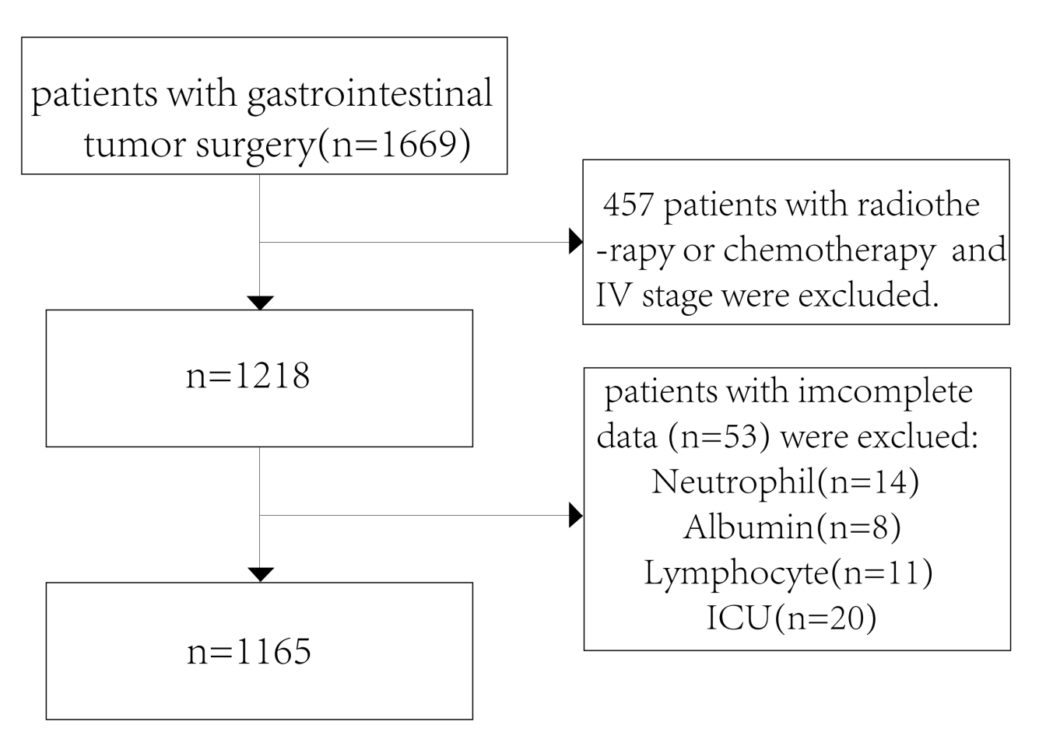

Supplementary Figure 2. The association of PLR with overall survival in patients with gastrointestinal tumor surgery (excluded participants died within three months).

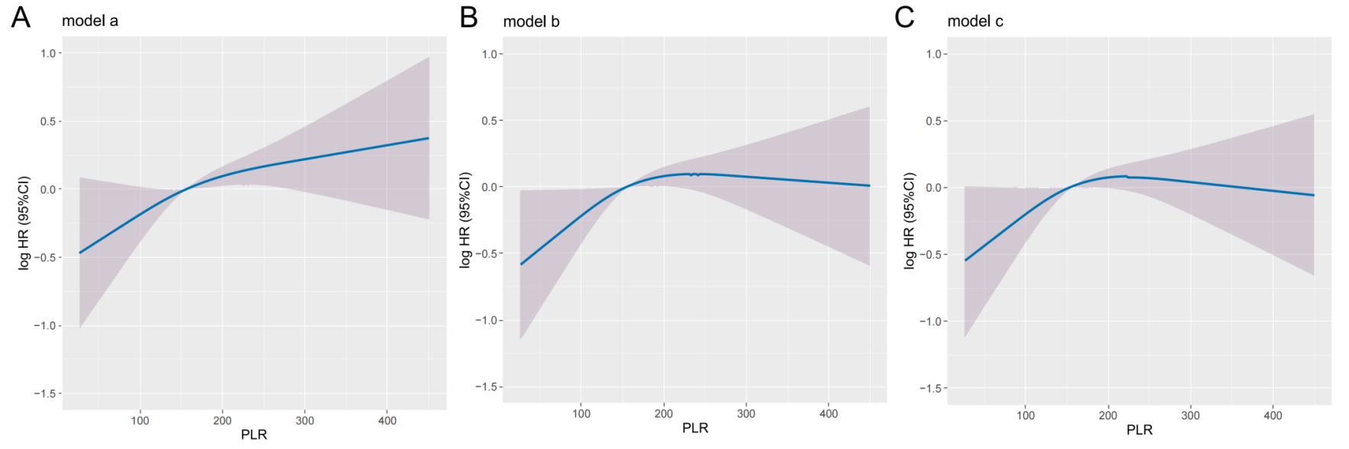

Notes: (A) model a: no adjusted; (B) model b: adjusted for age, sex, BMI and TNM stage ; (C) model c: adjusted for age, sex, BMI, TNM stage, tumor type, smoking, alcohol, hypertension, diabetes, family history.
Abbreviations: PLR, platelet–lymphocyte ratio.

