CD38 targeted and red blood cell membrane camouflaged nanoparticle based on smart drug delivery system improves efficacy in multiple myeloma
Fangrong Zhang¹, QinYang¹, Sishi Tang¹, SiYi Jiang¹, Cong Xu³, Jing Liu¹, Yunfeng Fu²
Correspondence: jingliu0318@aliyun.com; fuyunfeng@csu.edu.cn;
- Department of Hematology, The Third Xiangya Hospital, Central South University, Changsha 410013, People’s Republic of China;
- Department of Blood Transfusion, The Third Xiangya Hospital, Central South University, Changsha 410013, People’s Republic of China;
Full list of author information is available at the end of the article
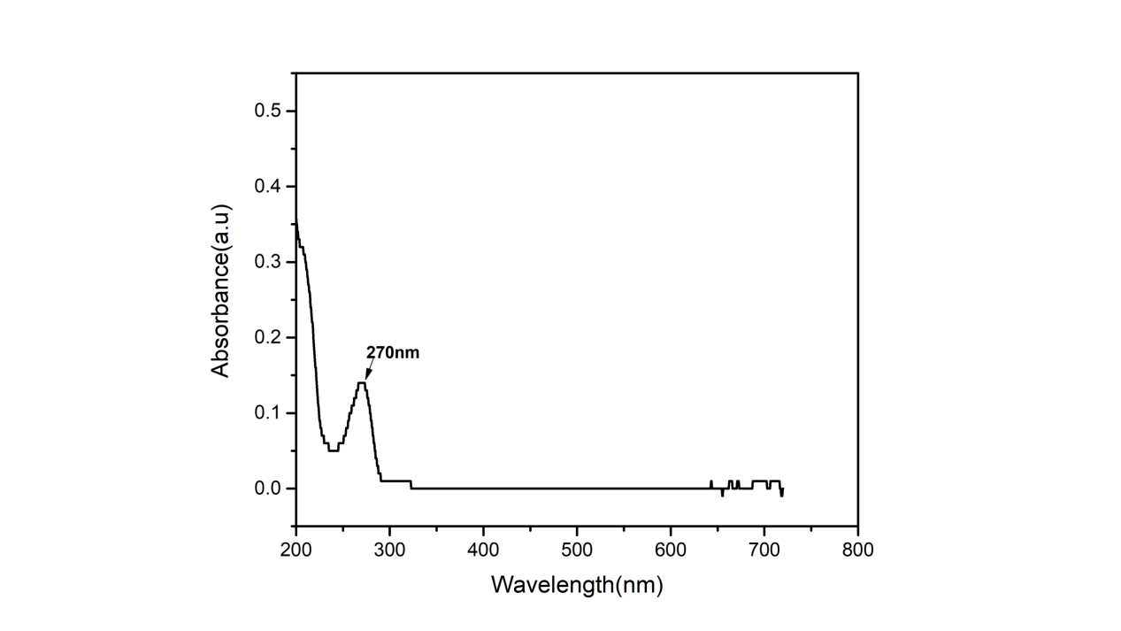
Supplementary Figure 1 UV-Vis absorbance curve for the BTZ at 270 nm.

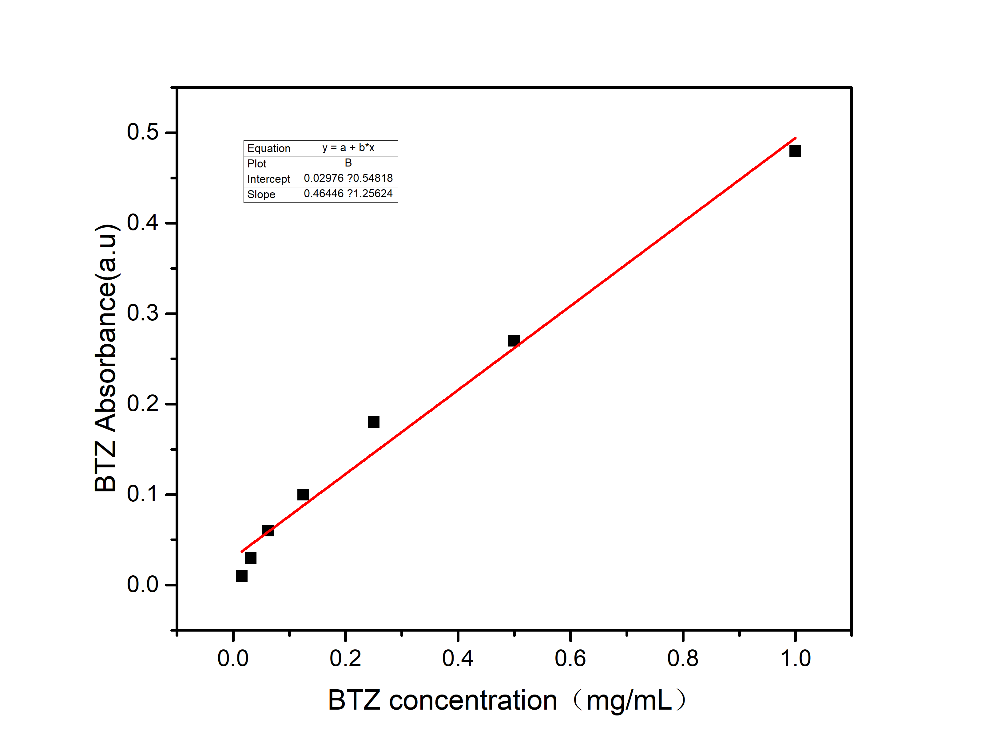
Supplementary Figure 2 The standard curve of BTZ concentration versus absorbance. Standard curve was created by plotting the mean absorbance for each standard on the y-axis against the concentration of BTZ on the x-axis.

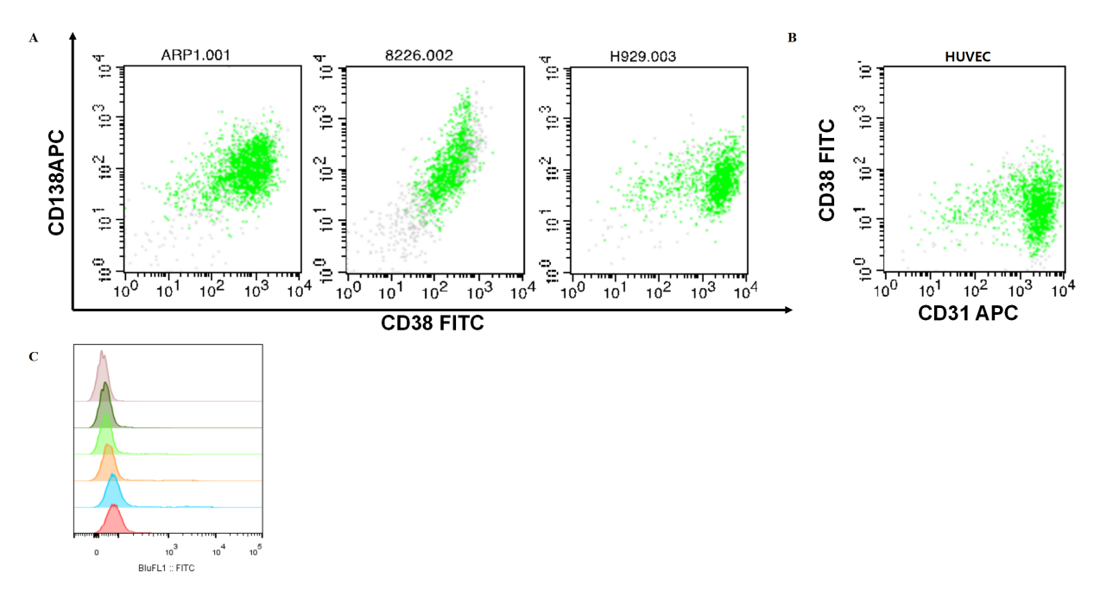
Supplementary Figure 3 (A) CD38 expression detection in ARP1, RPMI8226, H929 cell lines. (B) CD38 expression detection of human umbilical vein endothelial cells (HUVECs, CD31+). (C)Binding affinity of peptides P to CD38- HUVECs.

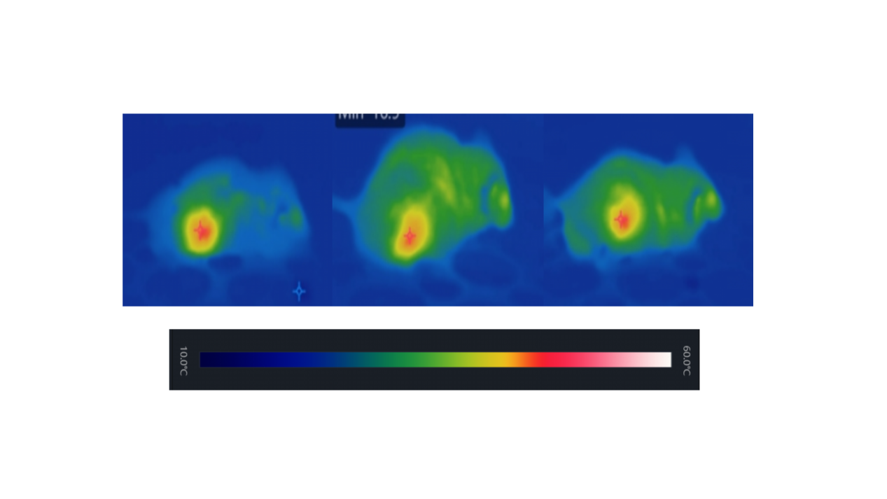
Supplementary Figure 4 Near-infrared (NIR)-camera recorded a rapid elevation of local temperature up to around 50˚C in the tumor site under NIR laser exposure (NIR 808nm, 5min, 1W/cm²).

