Online resource 1 Primer design list
 | Primer name | Nucleic acid sequence
1 | G35-69WU | TTTTACCAACGATtgcAAGCTGCGT
2 | G35-69WD | GAGTTGTGGTAgcaTAACGGTTCCCA
3 | G35-69U | CCGTTAtgcTACCACAACTCCTCCACCT
4 | G35-69D | AGCTTgcaATCGTTGGTAAAAGTTGCATT
5 | G102-231WU | GTACTATtgcTGGGTTAAGTACACCTCAAAC
6 | G102-231WD | GGTTTCATgcaCACTTCGCACTTGCCGTAA
7 | G102-231U | TGCGAAGTGtgcATGAAACCGGC
8 | G102-231D | CTTAACCCAgcaATAGTACGCATACAG
9 | G18-34U | TTACAGCAACGGCGGTATGTTCAACTGCACCTGGCGTtgcAATAATGC
10 | G18-34D | GTTGCTGTAACCGTCCGCgcaTTGCCAGGTGGAGGAGT
Online resource 2
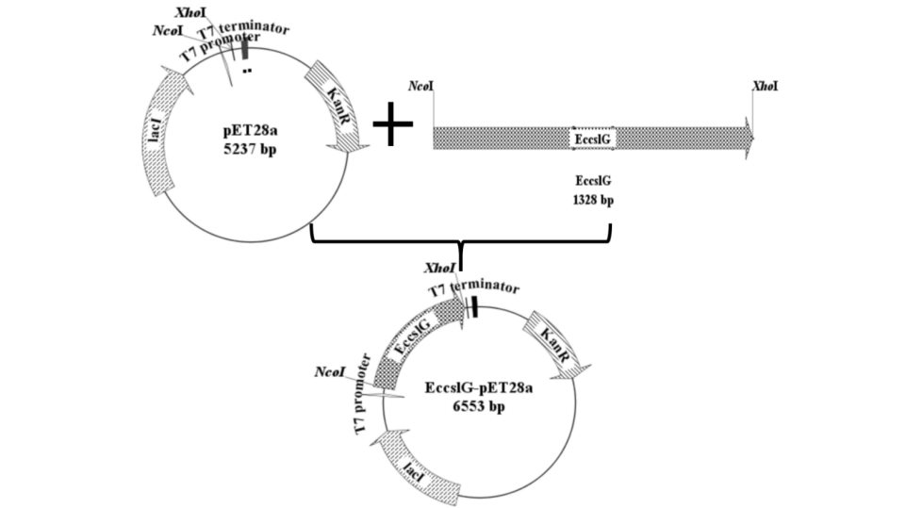
Recombinant construction of EccslG-pET28a

Online resource 3
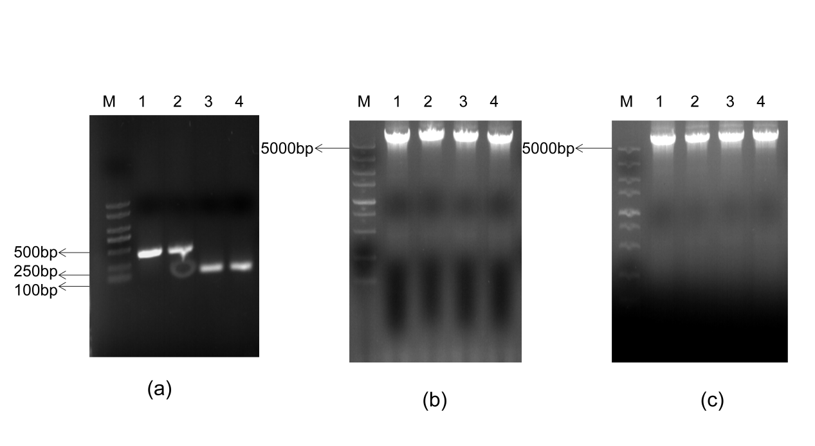
(a)2000marker lane 1, 2Eccsl69 the alternative gene, lane 3, 4 Eccsl18 the alternative gene
(b)5000markerlane 1, 2Eccsl18 the alternative gene vector, lane 3, 4 Eccsl102
(c)5000markerlane 1, 2, 3, 4 Eccsl69 the alternative gene vector

