Crystal structure of AgSCN coordination polymers for sensing of iron (III) ions, Nitrobenzene and photocatalytic activity under ultrasonic irradiation
Safaa El-din H. Etaiw¹, Mohamed M. Dawood², Hassan Marie¹
¹Chemistry Department, Faculty of Science, Tanta University, Tanta, Egypt.
²Tanta Higher Institute of Engineering and Technology (THIET), Tanta, Egypt.
Supplementary materials

Table S1 Bond lengths (Å) and bond angles (deg.) of the SCP1
Ag1-Ag1 | 3.3429(16) | C3- N4 | 1.166(6)
Ag1-S2 | 2.8415(16) | Ag1-Ag1-S2 | 67.81(4)
Ag1-Ag1 | 3.2593(17) | Ag1-Ag1-Ag1 | 91.73(5)
Ag1-Ag1 | 3.4636(17) | S2-Ag1-Ag1 | 158.46(3)
Ag1-S2 | 2.9973(17) | Ag1-Ag1-S2 | 165.29(3)
Ag1-N4 | 2.156(4) | S2-Ag1-S2 | 107.28(4)
Ag1-S2 | 2.4749(13) | Ag1- Ag1- S2 | 94.20(4)
S2- C3 | 1.660(4) | Ag1- Ag1- N4 | 79.24(12)
S2- Ag1- N4 | 92.13(12) | S2- Ag1- N4 | 87.25(11)
Ag1- Ag1- N4 | 90.45(11) | S2- Ag1- S2 | 101.91(4)
S2- Ag1- S2 | 97.07(3) | N4- Ag1- S2 | 163.27(11)
Ag1- S2 - Ag1 | 125.94(6) | Ag1- S2 - C3 | 100.04(15)
Ag1- S2- C3 | 99.55(15) | S2- C3- N4 | 179.9(4)
Ag1- N4- C3 | 172.3(4)
Symmetry codes SCP1: +X,+Y,+Z', -X,+Y+ 1/2,-Z'

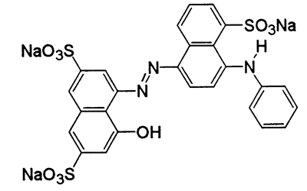
Scheme S1 Structure of Acid blue-92 (AB-92) dye used for investigation
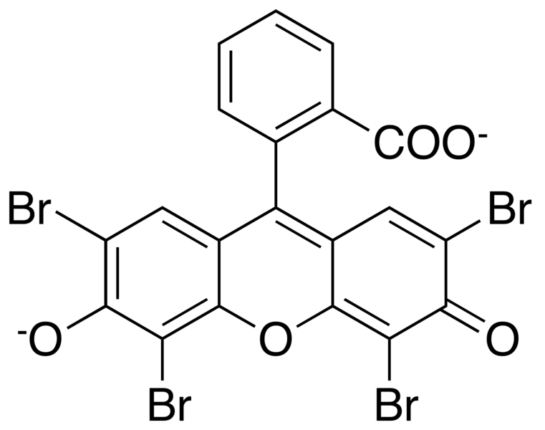
Scheme S2 Structure of Eosin-Y (EO) dye used for investigation
Fig. 1. FT-IR Spectra of SCP1 and its nanosized 2

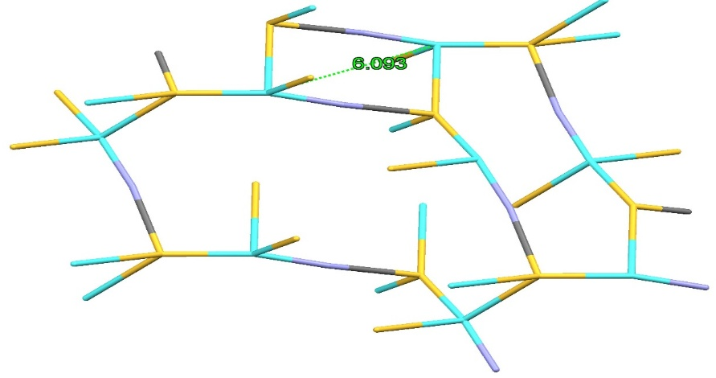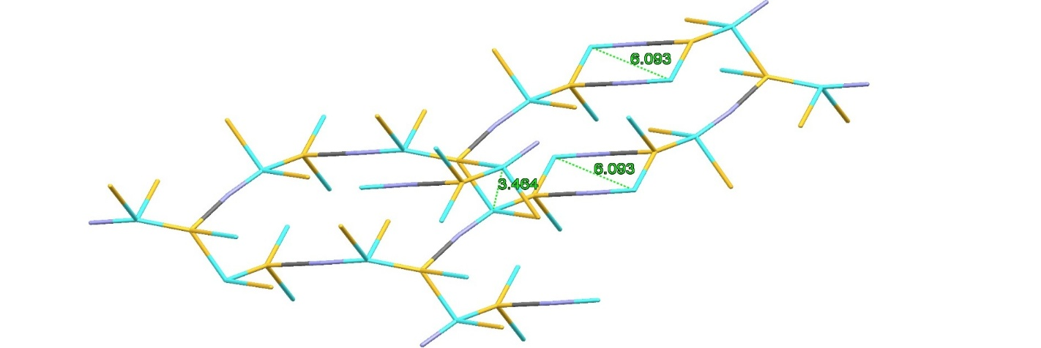
Figure S2 view of the distorted polygonal rings containing 4 atoms (Ag₂S₂), 8 atoms [Ag₂(SCN)₂], 12 atoms [Ag₄S₂(SCN)₂], 18 atoms [Ag₅S(SCN)₄] and 20 atoms [Ag₆S₂(SCN)₄] along the b-axis showing the orientation of the 4- and 8-membered rings

Figure S3 UV-Vis spectra of SCP1 as nujl moll in solid state

Figure S4 (1) Solid state emission spectra of SCP1 and nanosized 2

Figure S5 Quenching efficiency at different NB concentrations
Figure S6 LOD of SCP1 at different NB concentrations

Figure S7 Quenching efficiency at different Fe³⁺ concentrations

Figure S8 LOD of SCP1 at different Fe³⁺ concentrations

Figure S9 The UV-vis absorption spectra of AB-92 dye solution during photocatalytic degradation of the AB-92 solution without using nanosized 1 catalyst in the presence of H₂O₂ at room temperature

Figure S10 The UV-vis absorption spectra of EO-Y dye solution during photocatalytic degradation of the EO-Y solution without using nanosized 1 catalyst in the presence of H₂O₂ at room temperature

Fig. S11. Kinetic data for degradation of AB-92 dye under different irradiation sources.
Fig. S12. Kinetic data for degradation of EO-Y dye under different irradiation sources.

Figure S13 The UV-vis absorption spectra of EO-Y dye solution during photocatalytic degradation using nanosized 1 in the presence of H₂O₂ and 20 mg of AO as scavengers for holes (h⁺) radical under uV-light irradiation
Figure S14 The UV-vis absorption spectra of EO dye solution during photocatalytic degradation using nanosized 1 in the presence of H₂O₂ and 20 mg of BQ as scavengers for (.O₂–) radical under UV-light irradiation

Figure S15 The UV-vis absorption spectra of EO-Y dye solution during photocatalytic degradation using nanosized 1 in the presence of H₂O₂ and 2 gm of IPA as scavengers for (.OH) radical under UV-light irradiation

Figure S16 kinetic data for the photodegradation of EO-Y dye under scavenger experiments

