Supporting Information
Cholesterol removal significantly improves performance of a model anti-tumor biomimetic nano delivery system integrating immunotherapy and STING activation
Lin Liª, Jing Liª, LeYao Fuª, Mengxing Zhang^{b}, Tiantian Liu^{b}, Qixue Baoª, Shiqi Huang^{b}, Zhirong Zhang^{c}, Zhenmi Liuª*, Ling Zhang^{b}*
ª Institute of Systems Epidemiology, West China School of Public Health and West China Fourth Hospital, Sichuan University, Chengdu 610041, China.
^{b} Med-X center for Materials, College of Polymer Science and Engineering, Sichuan University, Chengdu 610065, China.
^{c} Key Laboratory of Drug Targeting and Drug Delivery Systems of Ministry of Education, West China School of Pharmacy, Sichuan University, Chengdu 610065, China.
*Corresponding author. Tel.: 028-85501566; fax: 028-85501615
E-mail: zhangling83@scu.edu.cn
liuzhenmi1983@hotmail.com

Figure S1. Sizes of QFN₇₁₇, nCSP, nCISP and CISP.

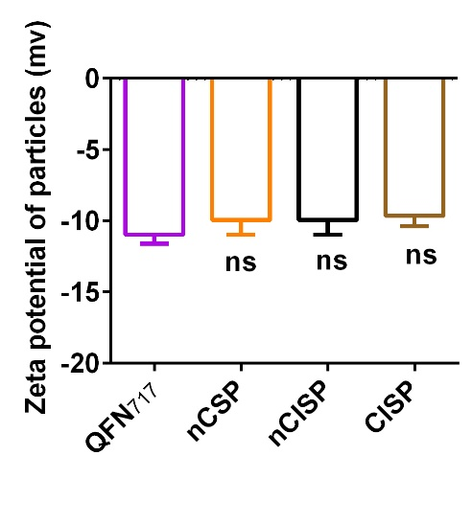
Figure S2. Zeta potential of QFN₇₁₇, nCSP, nCISP and CISP. n=3.

Figure S3. Protein expression difference in nCISP and CISP.

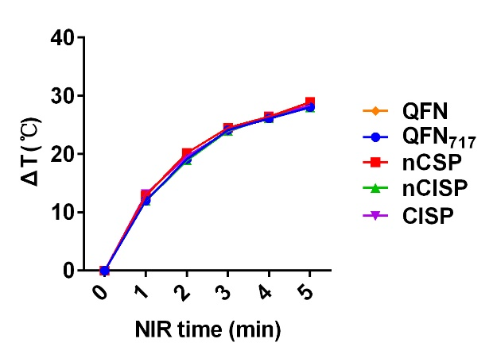
Figure S4. Temperature curves of QFN, QFN₇₁₇, nCSP, nCISP and CISP with laser irradiation (1.0 W/cm²). The concentration of QFN is 200 μg/mL in all groups. n=3.

Figure S5. The uptake of CISP by B16F10^{PDL1 KO} cells. (A) WB analysis of PD-L1 in B16F10 cells and B16F10^{PDL1 KO} cells. (B) The uptake of CISP by B16F10^{PDL1 KO} cells was detected by flow-cytometry. n=5.

Figure S6. The expression of PD-L1 in B16F10 cells. B16F10 cells were treated with SR-717 (20 μM), nCSP, nCISP, CISP or CIP (low-Cholesterol membrane coated ICB agent and Photothermal agent) for 18 h, and the expression of PD-L1 in tumor cells was detected by flow-cytometry. n=5.

Figure S7. Fluorescence images of major organs after treated with free DiD, QFN₇₁₇, nCSP, nCISP and CISP at 24 h post injection (iv.). The semi-quantitative analysis is shown on the right. n=3.

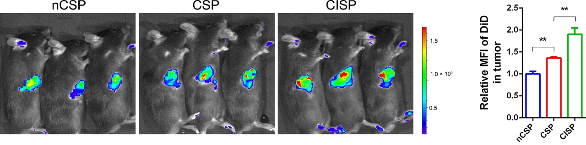
Figure S8. Fluorescence images of tumor in mice treated with nCSP, CSP and CISP at 12 h post injection (iv.). The semi-quantitative analysis is shown on the right. n=3.

Figure S9. The tumor targeting ability of PEG-nCISP in vivo. (A)(B) The uptake of PEG-nCISP by RAW264.7 cells and B16F10 cells detected by flow-cytometry. The semi-quantitative analysis is shown on the right. n=5. (C) The fluorescence images of B16F10 tumor in mice treated with QFN₇₁₇, nCISP and PEG-nCISP at 12 h post injection (iv.), and the semi-quantitative analysis is shown on the right. n=3.

Figure S10. Fluorescence images of tumor in mice treated with nCBM and CBM at 12 h post injection (iv.). Cell membrane from B16F10 cells were used to coat PLGA nanoparticles (marked with DiD, 6 μg/mice). The semi-quantitative analysis is shown on the right. n=3.

Figure S11. Representative fluorescence images of major organs after treated with free nCISP and CISP at 0.5 h post injection (iv.). n=3.

Figure S12. The uptake of nCISP and CISP by lymphocytes and neutrophils in the blood. (A) The uptake of nCISP and CISP by lymphocytes in the blood at 0.5 h post injection (iv.). and the semi-quantitative analysis is shown on the right. n=5. (B) The uptake of nCISP and CISP by neutrophils in the blood at 0.5 h post injection (iv.), and the semi-quantitative analysis is shown on the right. n=5.

Figure S13. The uptake of nCISP and CISP by monocytes in human blood. (A) Schematic illustration of the experiment process. (B) The uptake of nCISP and CISP by monocytes in the blood at 30 min post incubation, and the semi-quantitative analysis is shown on the right. n=6. (C) Representative fluorescence images of plasma at 30 min post incubation, and the semi-quantitative analysis is shown on the right. n=6.

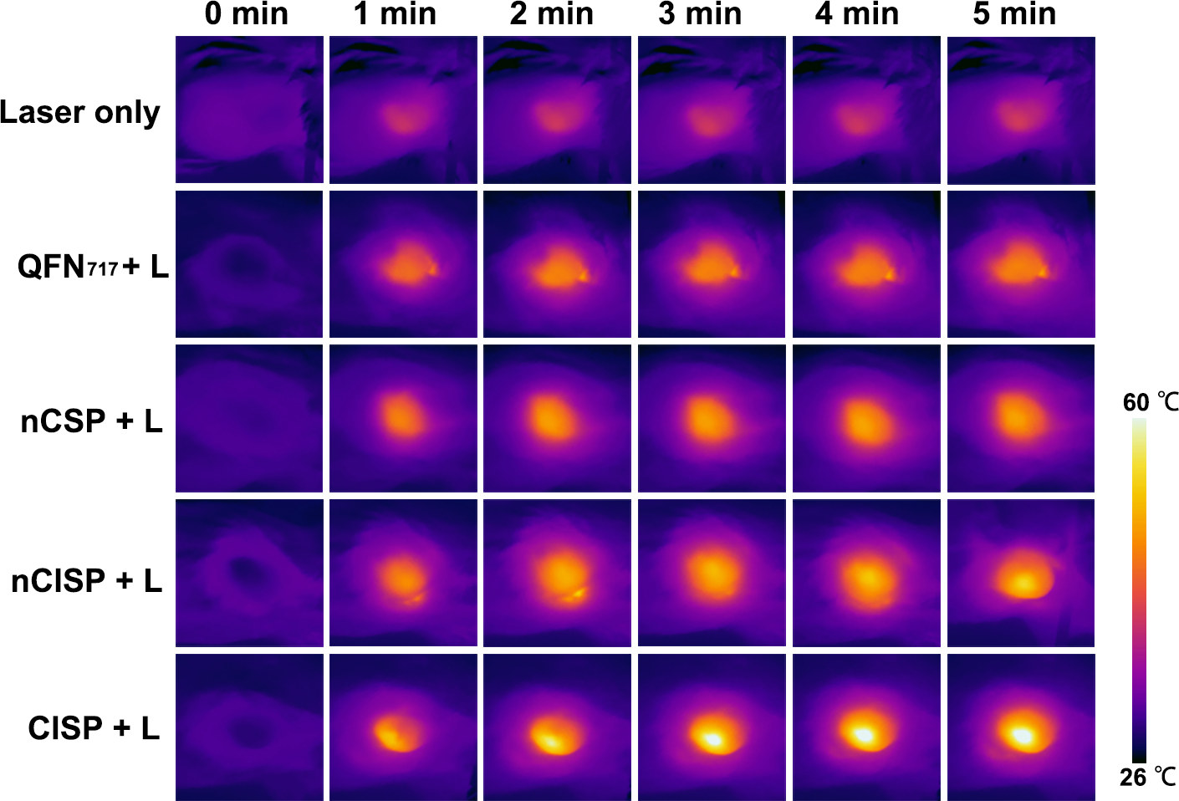
Figure S14. The infrared thermal images of mice. Mice bearing tumors were injected with QFN₇₁₇, nCSP, nCISP or CISP, and mice were irradiated for 5 min with a near-infrared laser (808 nm, 1.0 W/cm²) at 12 h post injection (iv.). n=3.

Figure S15. The expression of PD-L1 in B16F10 tumors at 7 days post laser irradiation. n=5.

Figure S16. In vivo antitumor immunity activation after different treatments. (A)(B) Flow-cytometric analysis of CD4⁺T cells and CD8⁺ T cells in tumors at 7 days post laser irradiation. n=5. (C) Flow-cytometric analysis of M1 macrophages in tumors at 7 days post laser irradiation. n=5. (D) Flow-cytometric analysis of the maturation of DCs in lymph node at 7 days post laser irradiation. n=5.

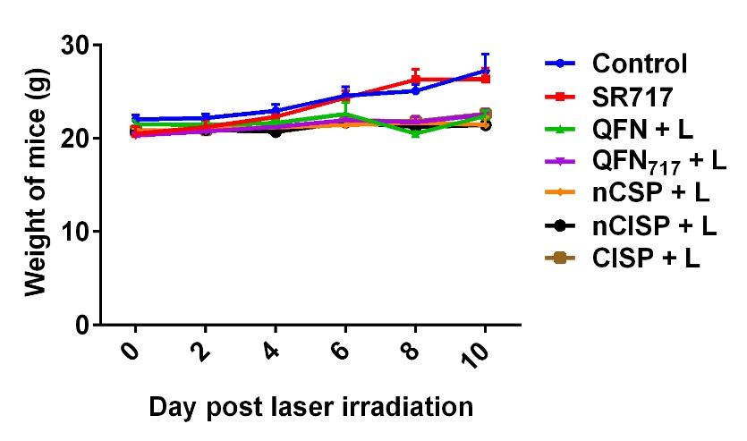
Figure S17. Body weight of mice after different treatments. n=5.

Figure S18. Biosafety of CISP in mice. (A) H&E staining of major organs after different treatments at 7 days post laser irradiation. n=3. Scale bar, 100 μm. (B) Blood routine examination of mice at 7 days post laser irradiation. n=5.

