A diagnostic model of technical acoustic measurements combined with clinical parameters for differential diagnosis of nonalcoholic steatohepatitis

Sup table 1 Correlation of liver pathological parameters with technical acoustic measurements and clinical parameters
Pathological parameters | SWS | SWD | AC | NLV | NLV-SD | Ratio
Steatosis | 0.295 | 0.130 | 0.519 | -0.391 | -0.356 | 0.285
p value | 0.010* | 0.267 | <0.001* | 0.001* | 0.002* | 0.016*
Intralobular Inflammation | 0.217 | 0.149 | 0.353 | -0.379 | -0.326 | 0.174
p value | 0.062 | 0.202 | 0.003* | 0.001* | 0.006* | 0.146
Ballooning Degeneration | 0.315 | 0.102 | 0.290 | -0.250 | -0.216 | 0.161
p value | 0.006* | 0.386 | 0.014* | 0.035* | 0.070 | 0.599
Fibrosis | 0.306 | 0.117 | 0.191 | -0.199 | -0.192 | -0.124
p value | 0.008* | 0.317 | 0.111 | 0.097 | 0.108 | 0.304
NASH | 0.312 | 0.108 | 0.286 | -0.254 | -0.221 | 0.164
p value | 0.007* | 0.358 | 0.015* | 0.032* | 0.064 | 0.173
Sup table 1（continued）
Pathological parameters | Age | AST | ALT | GGT | TBIL | ALB | BUN
Steatosis | 0.175 | 0.450 | 0.520 | 0.301 | 0.255 | 0.280 | -0.233
p value | 0.132 | <0.001* | <0.001* | 0.009* | 0.027* | 0.015* | 0.044*
Intralobular Inflammation | 0.312 | 0.458 | 0.330 | 0.246 | 0.231 | 0.142 | 0.000
p value | 0.007* | 0.000* | 0.004* | 0.035* | 0.046* | 0.224 | 1.000
Ballooning Degeneration | 0.299 | 0.213 | 0.107 | 0.191 | 0.238 | 0.039 | -0.035
p value | 0.009* | 0.067 | 0.363 | 0.104 | 0.040* | 0.738 | 0.764
Fibrosis | 0.347 | 0.244 | 0.287 | 0.197 | 0.067 | 0.011 | -0.148
p value | 0.002* | 0.035* | 0.012* | 0.093 | 0.569 | 0.924 | 0.205
NASH | 0.287 | 0.206 | 0.091 | 0.192 | 0.226 | 0.034 | -0.050
p value | 0.012* | 0.076 | 0.437 | 0.101 | 0.051 | 0.773 | 0.672

Sup table 2 Differences of various technical acoustic measurements and clinical parameters between non-NASH and NASH groups
Parameters | non-NASH (n=59) | NASH  (n=16) | Z/t value | p value
SWS | 1.24 | 1.34 | -3.275† | 0.002*
SWD | 11.35 | 11.85 | -1.019† | 0.311
AC | 0.72 | 0.81 | -2.433† | 0.018*
NLV | 1.12 | 1.07 | -2.127& | 0.033*
NLV-SD | 0.43 | 0.29 | -1.900& | 0.057
Ratio | 2.00 | 2.38 | -1.362& | 0.173
age | 53.0 | 57.5 | -2.472& | 0.013*
WC | 94.4 | 95.2 | -0.245† | 0.807
BMI | 25.3 | 26.2 | -0.168& | 0.866
PLT | 226.5 | 217.4 | 0.487† | 0.628
AST | 23.0 | 24.0 | -1.775& | 0.076
ALT | 24.0 | 25.5 | -0.783& | 0.434
Glu | 5.29 | 5.61 | -1.966& | 0.049*
TG | 1.94 | 1.82 | 0.553† | 0.582
TC | 5.28 | 5.50 | -0.701† | 0.485
GGT | 27.0 | 42.0 | -1.641& | 0.101
TBIL | 11.7 | 24.9 | -1.947& | 0.052
ALP | 84.3 | 84.4 | -0.009† | 0.993
ALB | 43.4 | 43.7 | -0.358† | 0.721
LDL-C | 3.0 | 2.8 | 1.041† | 0.301
HDL-C | 1.15 | 1.14 | -0.420& | 0.674
BUN | 4.9 | 4.8 | 0.091† | 0.928
UA | 342.0 | 356.0 | -0.800& | 0.424
Distance | 1.76 | 1.97 | -1.552& | 0.121
CK-18 | 7.8 | 6.2 | -0.738& | 0.461
sFAS | 623.9 | 634.2 | -0.344† | 0.731
FGF-21 | 30.5 | 21.6 | -1.476† | 0.140
&Mann-Whitney U test; †independent sample t test; *p<0.05
WC, waist circumference; Distance, distance from skin to liver capsule

Sup table 3 Factors associated with SWS value
Characteristic | Univariate Analysis |  |  | Multivariate Analysis
 | Coefficient | 95% CI | p value | Coefficient | 95% CI | p value
Degree of steatosis | 0.046 | 0.013-0.079 | 0.007*
Intralobular Inflammation | 0.058 | 0.021-0.094 | 0.002*
Ballooning Degeneration | 0.090 | 0.039-0.140 | 0.001*
Grade of fibrosis | 0.080 | 0.044-0.116 | <0.001* | 0.054 | 0.017-0.090 | 0.005*
Gender (male) | 0.013 | -0.043-0.070 | 0.638
age | 0.003 | 0.000-0.005 | 0.021*
WC | 0.002 | -0.001--0.006 | 0.158
BMI | 0.031 | -0.005-0.011 | 0.423
DM | -0.017 | -0.097-0.063 | 0.670
Hypertension | 0.047 | -0.009-0.103 | 0.097
AST | 0.003 | 0.002-0.005 | <0.001* | 0.003 | 0.001-0.004 | 0.001*
ALT | 0.001 | 0.000-0.002 | 0.003*
DM, Diabetes mellitus; WC, waist circumference; *p<0.05

Sup table 4 Factors associated with AC value
Characteristic | Univariate Analysis |  |  | Multivariate Analysis
 | Coefficient | 95% CI | p value | Coefficient | 95% CI | p value
Degree of steatosis | 0.076 | 0.045-0.108 | < 0.001* | 0.077 | 0.038-0.116 | < 0.001*
Intralobular Inflammation | 0.050 | 0.010-0.090 | 0.015* | 0.008 | -0.037-0.053 | 0.730
Ballooning Degeneration | 0.068 | 0.012-0.124 | 0.019* | 0.020 | -0.046-0.087 | 0.546
Grade of fibrosis | 0.013 | 0.005-0.021 | 0.001* | -0.032 | -0.080-0.016 | 0.186
Gender (male) | -0.036 | -0.097-0.025 | 0.245
age | 0.002 | 0.000-0.005 | 0.077
WC | 0.002 | -0.001-0.006 | 0.160
BMI | 0.003 | -0.005-0.011 | 0.492
DM | 0.090 | 0.008-0.172 | 0.031* | 0.080 | 0.007-0.154 | 0.032*
Hypertension | 0.037 | -0.024-0.097 | 0.233
AST | -0.00001468 | -0.002-0.002 | 0.986
ALT | 0.000007976 | -0.001-0.001 | 0.982
DM, Diabetes mellitus; WC, waist circumference; *p<0.05

Sup table 5 Factors associated with NLV value
Characteristic | Univariate Analysis |  |  | Multivariate Analysis
 | Coefficient | 95% CI | p value | Coefficient | 95% CI | p value
Degree of steatosis | -0.085 | -0.128--0.042 | < 0.001*
Intralobular Inflammation | -0.073 | -0.122--0.024 | 0.004* | -0.026 | -0.051--0.001 | 0.041*
Ballooning Degeneration | -0.063 | -0.135--0.008 | 0.080
Grade of fibrosis | -0.050 | -0.103-0.003 | 0.064
Gender (male) | -0.027 | -0.140-0.050 | 0.485
age | -0.004 | -0.007--0.002 | 0.003*
WC | -0.003 | -0.005--0.001 | 0.007* | -0.002 | -0.004--0.001 | 0.012*
BMI | -0.011 | -0.021--0.001 | 0.030*
DM | -0.076 | -0.181-0.029 | 0.151
Hypertension | -0.104 | -0.177--0.031 | 0.006*
AST | -0.104 | -0.003-0.001 | 0.323
ALT | -0.001 | -0.001-0.000 | 0.236
DM, Diabetes mellitus; WC, waist circumference; *p<0.05

Sup table 6 Factors associated with NLV-SD value
Characteristic | Univariate Analysis |  |  | Multivariate Analysis
 | Coefficient | 95% CI | p value | Coefficient | 95% CI | p value
Degree of steatosis | -0.166 | -0.257--0.075 | 0.001* | -0.060 | -0.114--0.007 | 0.026*
Intralobular Inflammation | -0.150 | -0.253--0.047 | 0.005*
Ballooning Degeneration | -0.147 | -0.295--0.001 | 0.052
Grade of fibrosis | -0.121 | -0.231--0.011 | 0.031*
Gender (male) | -0.041 | -0.202-0.121 | 0.618
age | -0.009 | -0.015--0.003 | 0.006*
WC | -0.007 | -0.001--0.002 | 0.005* | -0.006 | -0.011--0.002 | 0.006*
BMI | -0.023 | -0.044--0.002 | 0.032*
DM | -0.164 | -0.383-0.056 | 0.142
Hypertension | -0.238 | -0.389--0.087 | 0.002*
AST | -0.002 | -0.007-0.002 | 0.262
ALT | -0.001 | -0.003-0.001 | 0.247
DM, Diabetes mellitus; WC, waist circumference; *p<0.05

Sup table 7 Factors associated with Ratio value
Characteristic | Univariate Analysis
 | Coefficient | 95% CI | p value
Degree of steatosis | 0.311 | 0.003-0.619 | 0.048*
Intralobular Inflammation | 0.213 | -0.129-0.556 | 0.218
Ballooning Degeneration | 0.448 | -0.025-0.920 | 0.063
Grade of fibrosis | 0.194 | -0.164-0.553 | 0.283
Gender (male) | 0.145 | -0.368-0.657 | 0.575
age | 0.011 | -0.009-0.031 | 0.285
WC | -0.004 | -0.035-0.026 | 0.775
BMI | -0.007 | -0.075-0.062 | 0.849
DM | 0.238 | -0.469-0.944 | 0.505
Hypertension | 0.244 | -0.266-0.754 | 0.343
AST | 0.011 | -0.003-0.025 | 0.119
ALT | 0.002 | -0.003-0.008 | 0.408
DM, Diabetes mellitus; WC, waist circumference; *p<0.05

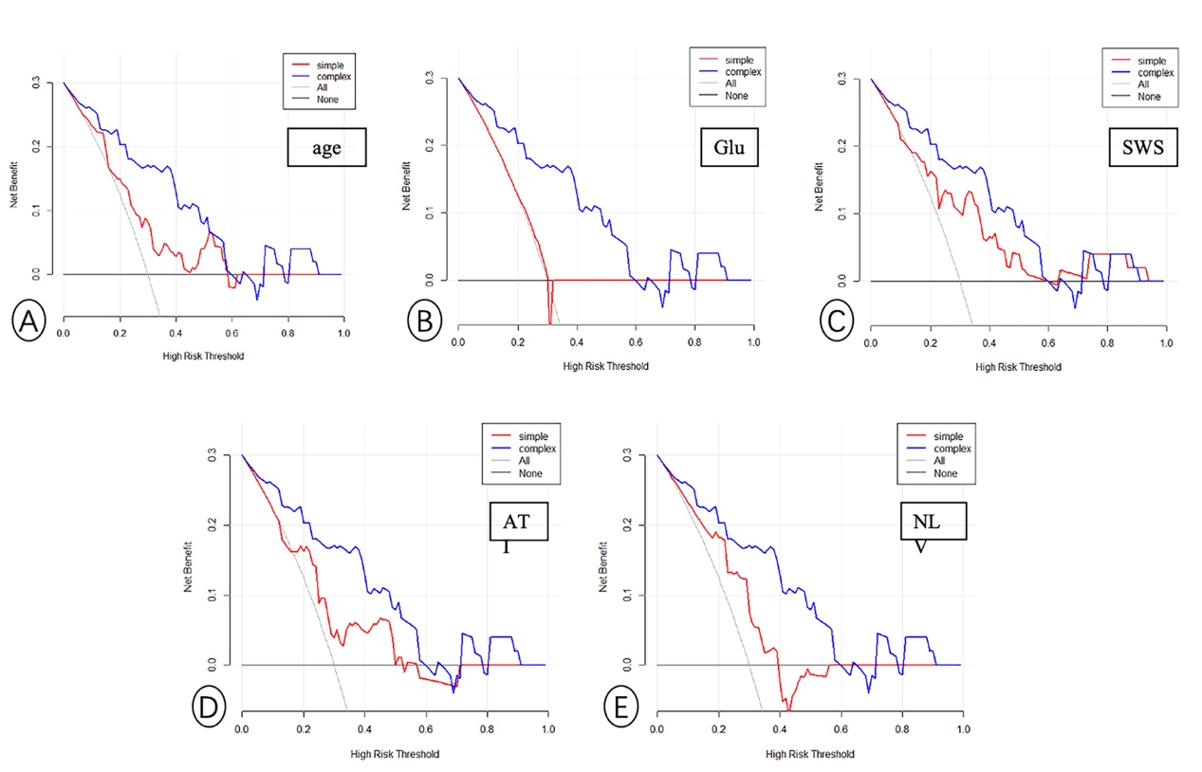
Sup fig 1. Decision curve analysis for the combined nomogram model. The y-axis indicates the net benefit; the x-axis indicates threshold probability. The red lines represent the net benefit of single parameters age (A), Glu (B), SWS (C), ATI (D), NLV (E), respectively. The blue lines represent net benefit of the combined nomogram model. The combined nomogram model has a higher overall net benefit than the single factor model within most reasonable threshold probabilities for the identification of NASH.

