Supplementary Information

Null allele analysis
Deviations from Hardy-Weinberg expectations may be mistakenly attributed to null alleles when other factors are responsible for a heterozygosity deficit, for example, true inbreeding or a Wahlund Effect. However, it is understood these factors should be identifiable in multi-locus analysis as they would be expected to occur consistently across the loci, whereas null alleles tend to be locus-specific (Dakin & Avise 2004). Dewoody et al. (2006) recommend evolutionary or demographic factors be considered for heterozygote deficits affecting most or all loci.

In the case of Argyrodendron trifoliolatum, heterozygote deficits were identified at five of the seven loci (L1, L5, L9, L10, L11). However, the potential presence of null alleles was consistently identified across all populations at only three of these loci (L1, L5, L11). For another locus, L10, null alleles were predicted in only two populations (wild and restored) within the same region of the Tweed. Loci identified as potentially containing null alleles consistently across all populations were treated as containing null alleles. Loci for which null alleles were identified across two populations in the same region were also treated as containing null alleles as it is considered plausible that the null allele may be unique to that particular region or uncommon and, as a result, unsampled in the other region. In summary, four of the seven loci analysed for A. trifoliolatum were treated as containing null alleles (L1, L5, L10 and L11). The other locus identified as potentially containing null alleles in only one population (L9) was assumed to have other factors responsible for the heterozygosity deficit.

For D. australis, heterozygote deficits were identified in all loci. However, potential null alleles were only consistently identified in two loci (L2 and L4) across the four populations. Heterozygote deficits were identified in L1 and L3 for one population only (restored D. australis in the Tweed). For this reason, L2 and L4 were treated as containing null alleles, and the other loci (L1 and L3) were assumed to have other factors responsible for their heterozygote deficit. For those loci assumed to be affected by null alleles, the allele frequencies were adjusted using the Brookfield 2 estimator (Brookfield 1996) in Micro-checker v2.2.3 (Van Oosterhout et al. 2004). Adjustments to error-prone loci are often necessary for downstream analyses in hypothesis testing to prevent biases in biological conclusions (Dewoody et al. 2006).

Determining the cause of the heterozygosity deficit present in two of the three species investigated in this study – A. trifoliolatum and D. australis, is difficult. It could be argued that the deficit was spread across most loci suggesting that the cause was true inbreeding or a Wahlund Effect and not due to the presence of null alleles at all. If this were the case, corrections for null alleles would not be warranted and would in fact mask other contributing factors. The justification for carrying out analyses with null allele estimates is detailed above. However, it is important to note that the data was also analysed unaltered, without the inclusion of null alleles (the ‘no null allele scenario’). The results under this scenario were slightly different with regards to the comparative analysis of genetic diversity between wild and restored cohorts. Namely, the lower genetic diversity for the Big Scrub A. trifoliolatum restored population compared to the wild population was statistically significant (Rs, p = 0.017; He, p = 0.034). Expected heterozygosity was also significantly higher in the wild population of D. australis in the Tweed when compared to the restored population there (He, p = 0.044). However, no other comparison was significantly different. The results under the ‘no null allele scenario’ are more suggestive of a reduction in genetic diversity in restored populations compared to wild populations, however, the results still did not consistently provide the statistical power to support the test hypothesis. Of note, however, is the high inbreeding levels detected under the ‘no null allele scenario’ across all A. trifoliolatum and D. australis populations, including the wild populations (A trifoliolatum: $\overline{x}$ F = 0.155 – 0.255, SD < 0.1 under no null allele scenario versus $\overline{x}$ F = 0.012 – 0.090, SD < 0.05 under null allele adjusted data; D. australis: $\overline{x}$ F = 0.220 – 0.553, SD < 0.15 under the no null allele scenario versus $\overline{x}$ F = -0.114 – 0.035, SD < 0.22 under null allele adjusted data). Whilst the case for applying null allele corrections could be argued for or against, the analysis of the data under both scenarios indicates this treatment of the data represents a minor influence on the conclusions being drawn on the key hypothesis questions tested under this research: namely whether genetic diversity is lower and inbreeding is higher in restored versus wild populations. The absolute values of inbreeding are substantially different under the ‘no null allele scenario’ indicating inbreeding in wild populations of A. trifoliolatum and D. australis. However, the results from the comparison of inbreeding levels between cohorts told a similar story whether null alleles were applied or not (e.g. aside from the Tweed F. watkinsiana populations, there was no significant difference). For this reason, the value in this data lies more in the comparisons between treatment and control cohorts and less so in the absolute values of the inbreeding coefficient.

Table S1. SSR markers, primers and labels
Species | Locus no. | Locus id. | Forward primer label | Forward primer sequence | Reverse primer label* | Reverse primer sequence | Motif | Locus range (bps)
A. trifoliolatum | L1 | 151398 | 6 FAM | TGATCAGAAGTAACAATGGACACA | - | GTGATATCATTTCAGCTAAGTTACAGG | AT | 90-160
A. trifoliolatum | L2 | 188660 | 6 FAM | TATGCAGATGGGTGATTGGT | - | AGACAGGCTGCAATGGAGAG | AAT | 140-195
A. trifoliolatum | L4 | 166478 | 6 FAM | AGCACAATATGGCTCACTGCT | - | TGTGTTTCAATTCCCTAGCCTT | AACCCG | 250-320
A. trifoliolatum | L5 | 93244 | 6 FAM | GCATTTGAGAGAGATGATGACAA | - | GCAACACCGCACTAGTCAAA | AAT | 215-290
A. trifoliolatum | L9 | 175229 | 6 FAM | CTTATCTTTACTTGCTGAGAGGAGA | - | AAAGGAAAGGGTGGGAAATG | AAT | 90 - 150
A. trifoliolatum | L10 | 126625 | 6 FAM | CCCACATCTTACCTTTGATGA | - | TATGCTAGGCATGAATAAATAAAGTG | AAT | 151-220
A. trifoliolatum | L11 | 230186 | 6 FAM | TGCCTTCCTCCTTAGTAGAAACA | - | TCTTAAGCAGGAAAGTGCAGC | AAT | 240-320
F. watkinsiana | L2 | 17077 | VIC | CCCAAACTAGGACGAAACAA | GTTT | TCTGTAATGCGTCCTTATTGAA | AAT | 170-295
F. watkinsiana | L4 | 186696 | 6 FAM | TCTTCCGGATTAATAAATGGATG | - | TCTTCCGGATTAATAAATGGATG | AAT | 250-320
F. watkinsiana | L5 | 152294 | 6 FAM | TCATCAAATGATCATATCTAACGAGAA | - | TCATCAAATGATCATATCTAACGAGAA | AAAAGG | 160-230
F. watkinsiana | L6 | 226612 | PET | GCTGTTCATGTAAATCTAGTCTGTCA | GTTT | CAGCCGTTGGCCTTTACTT | AAT | 180-260
F. watkinsiana | L7 | 214915 | 6 FAM | AGCACAAATTAGTCACGAAGAAGA | - | GATGTTCTGATTGCCGTGTG | AT | 120-180
F. watkinsiana | L10 | 208971 | 6 FAM | AGCTAATTAATGGTAATGCGGT | - | GAATATTCCTGGATATGGAGGTC | AT | 190-250
D. australis | L1 | 157557 | 6 FAM | CCATATCACTTTCTGTCCATGA | - | TTCCTTATAGCATGGCGAGG | AT | 175-280
D. australis | L2 | 110843 | VIC | TTCCATCATGTTTGGAGAGTC | - | TCCTTACTAATTCTAACACAGCACTAA | AT | 140-240
D. australis | L3 | 1812 | 6 FAM | GGCTTGTTTCATTGATTCCAA | - | TCCTTACTAATTCTAACACAGCACTAA | AT | 180-260
D. australis | L4 | 11764 | VIC | AGCCACACCCATTTGTCTTC | - | AAAGTGCAGCAACACTATATAATTCA | AT | 160-198
*PIG tails as described by Brownstein et al. (1996) were added to some primers to reduce stuttering. Primers were designed by Bottaro (2017).

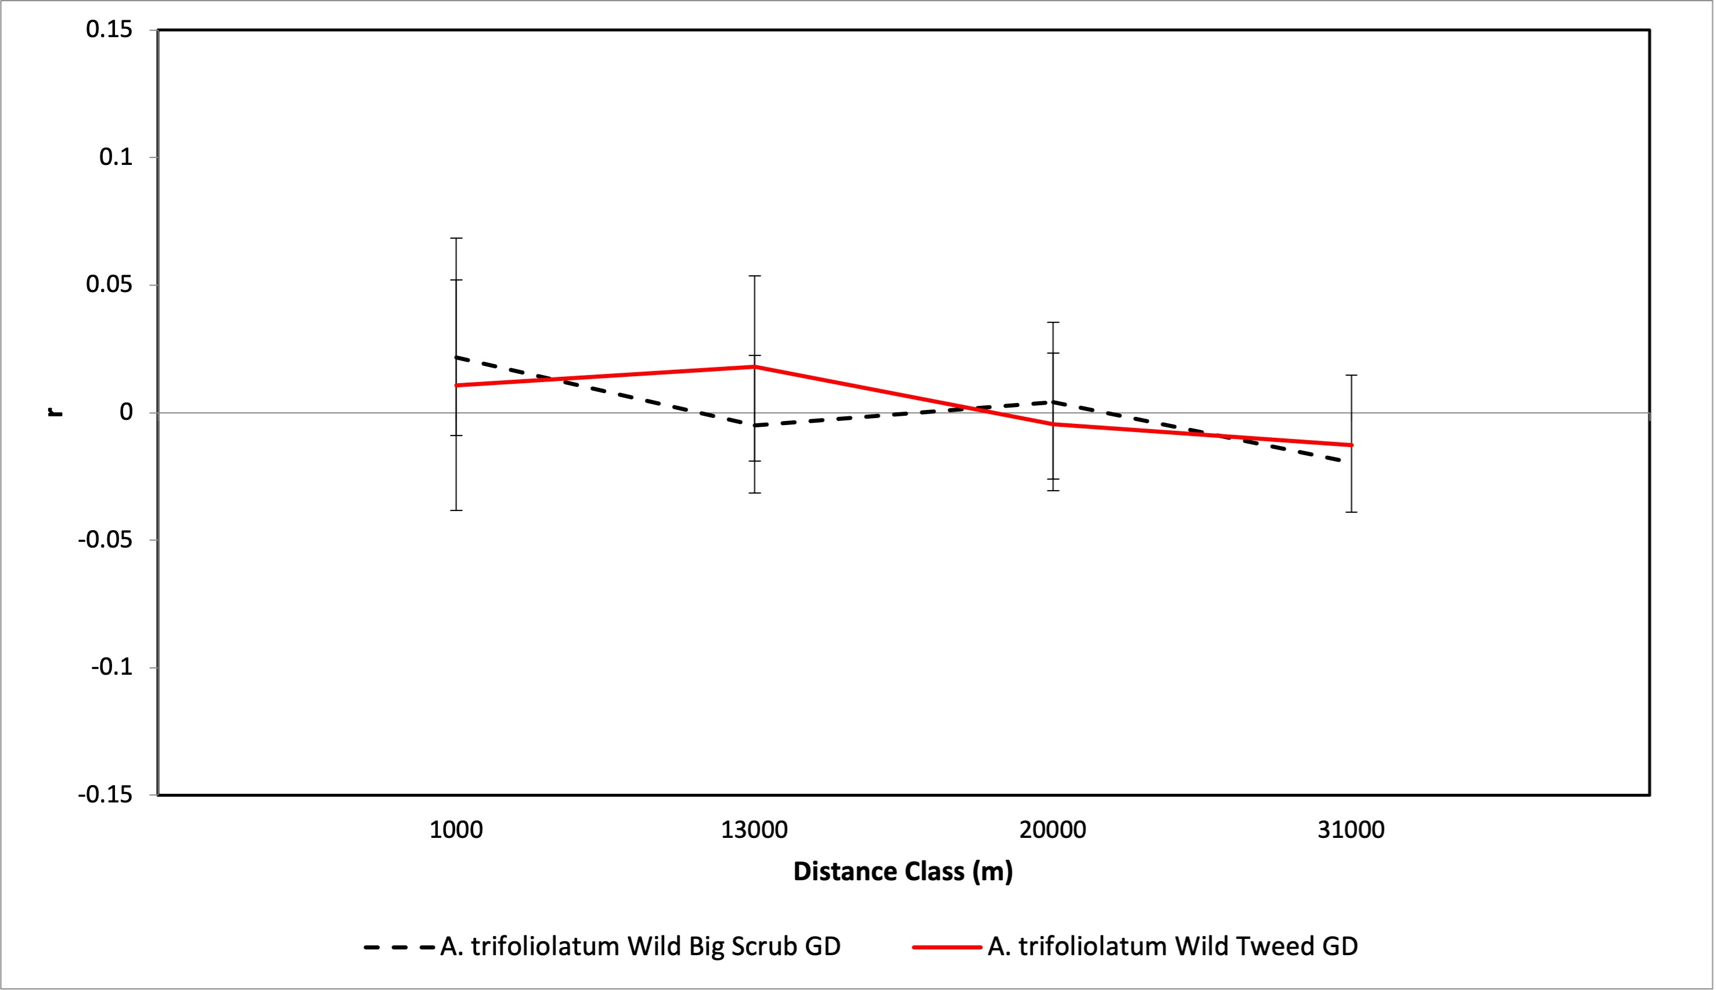
Figure S1. Spatial auto-correlation heterogeneity test for A. trifoliolatum Big Scrub and Tweed populations

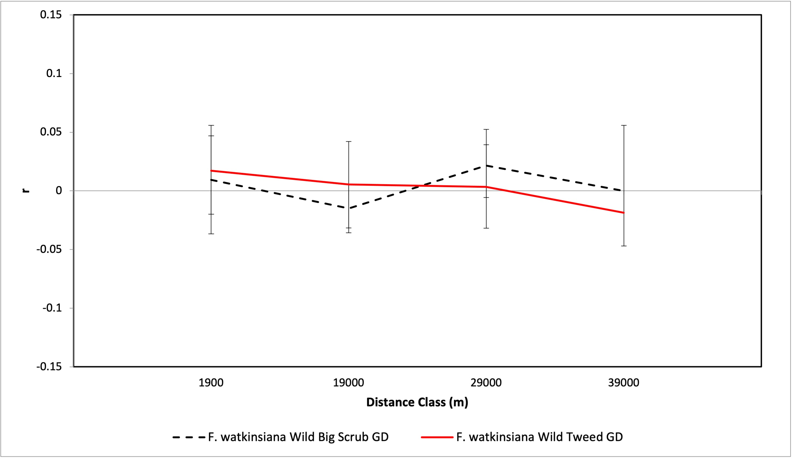
Figure S2. Spatial auto-correlation heterogeneity test for F. watkinsiana Big Scrub and Tweed populations

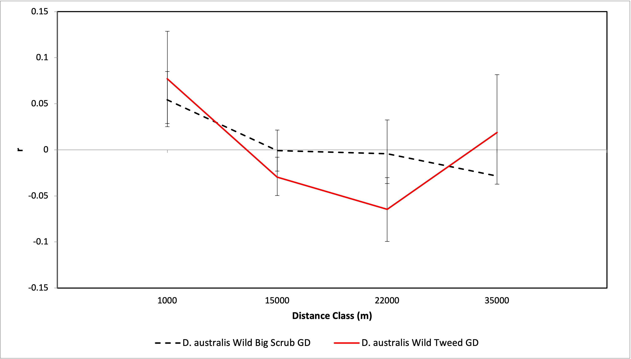
Figure S3. Spatial auto-correlation heterogeneity test for D. australis Big Scrub and Tweed populations

References
Brookfield, J. F. (1996). A simple new method for estimating null allele frequency from heterozygote deficiency. Mol Ecol, 5(3), 453-455. doi:10.1111/j.1365-294x.1996.tb00336.x
Dakin, E. E., & Avise, J. C. (2004). Microsatellite null alleles in parentage analysis. Heredity, 93(5), 504-509. doi:10.1038/sj.hdy.6800545
Dewoody, J., Nason, J. D., & Hipkins, V. D. (2006). Mitigating scoring errors in microsatellite data from wild populations. Molecular Ecology Notes, 6(4), 951-957. doi:https://doi.org/10.1111/j.1471-8286.2006.01449.x
Van Oosterhout, C., Hutchinson, W. F., Wills, D. P. M., & Shipley, P. (2004). micro-checker: software for identifying and correcting genotyping errors in microsatellite data. Molecular Ecology Notes, 4(3), 535-538. doi:https://doi.org/10.1111/j.1471-8286.2004.00684.x

