Extended Data
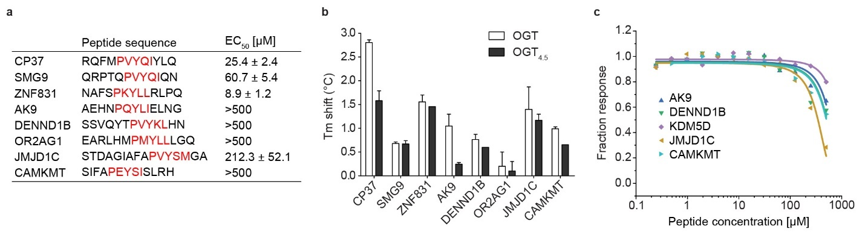
Extended Data Figure 1. OGT binding evaluation of motif-containing peptides. (a) Sequences of one consensus (CP37) and seven natural motif-containing peptides along with their apparent binding affinities (EC₅₀) from competitive fluorescence polarization assay using 5-FAM-SMG9 peptide and OGT_{4.5}. Standard deviations from three biological replicates are shown. PxYx[I/L] motif in each peptide is highlighted in red. (b) Thermal shift assay showing the shift in denaturation temperature (T_{m}) of OGT and OGT_{4.5} with peptide incubation, n=3. (c) Competitive fluorescence polarization assay between 5-FAM-SMG9 and motif-containing peptides AK9 (blue), DENND1B (green), KDM5D (purple), JMJD1C (brown), and CAMKMT (cyan) for OGT_{4.5} binding. Error bars represent standard deviation of n=3 biological replicates.

Extended Data Table 1. Data collection and refinement statistics (molecular replacement)
 | OGT_{4.5}:UDP-GlcNAc:SMG9  PDB 8FE7 | OGT_{4.5}:UDP-GlcNAc:ZNF831  PDB 8FUF | OGT_{4.5}:UDP-GlcNAc:CP37  PDB 8FE6
Data collection
Wavelength (Å) | 0.97872 | 1.12717 | 1.12713
Space group | P 3 2 1 | P 3 2 1 | H 3
Cell dimensions
a, b, c (Å) | 273.67, 273.67, 143.14 | 274.01, 274.01, 143.08 | 281.53, 281.53, 143.21
α, β, γ (°) | 90.00, 90.00, 120.00 | 90.00, 90.00, 120.00 | 90.00, 90.00, 120.00
Resolution (Å) | 237.00 - 2.98 (3.03 - 2.98)* | 137.01 - 3.69 (3.69 - 3.75) | 123.48 - 3.06 (3.06 - 3.11)
R_{sym} or R_{merge} | 0.110 (1.017) | 0.282 (2.398) | 0.183 (1.473)
I / σI | 13.7 (2.2) | 12.1 (2.2) | 12.9 (2.2)
Completeness (%) | 99.5 (99.6) | 99.9 (100.0) | 99.7 (100.0)
Redundancy | 7.7 (7.8) | 20.7 (21.3) | 10.5 (11.0)
Refinement
Resolution (Å) | 63.42 - 2.98 | 53.06 - 3.69 | 40.64 - 3.06
No. reflections | 124,762 | 66,440 | 79,576
R_{work} / R_{free} | 0.1880/0.2203 | 0.1977/0.2415 | 0.1791/0.2187
No. atoms
Protein | 22632 | 22336 | 22396
Ligand/ion | 156 | 156 | 156
Water | 0 | 0 | 0
B-factors | 72.46 | 135.69 | 70.10
Protein | 72.44 | 135.61 | 70.13
Ligand | 75.74 | 147.17 | 64.91
R.m.s. deviations
Bond lengths (Å) | 0.003 | 0.002 | 0.003
Bond angles (°) | 0.63 | 0.45 | 0.55
*Each structure was solved from one crystal.
*Values in parentheses are for highest-resolution shell.

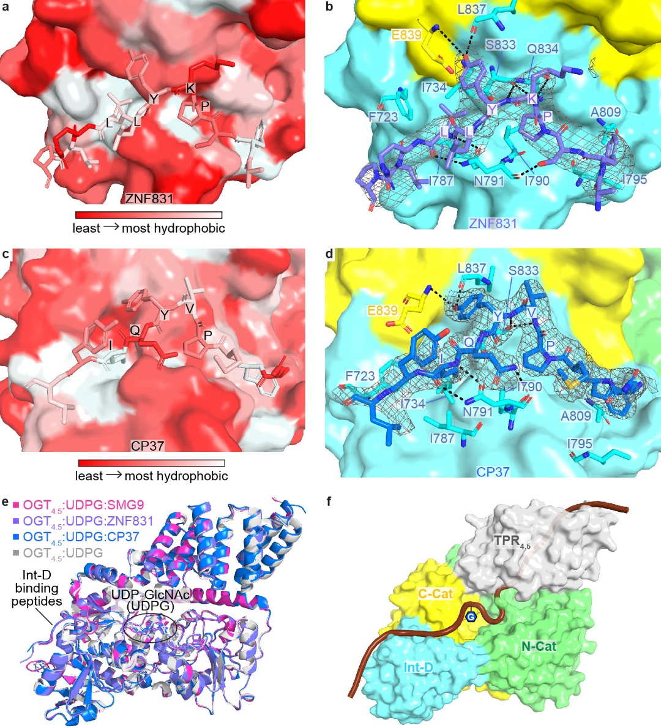
Extended Data Figure 2. (a) Zoom-in view at the Int-D binding site demonstrating hydrophobic interactions between ZNF831 peptide (shown as sticks) and Int-D in OGT_{4.5} (shown as surface). Red and white colors represent the least and most hydrophobic areas, respectively. (b) Zoom-in view at the Int-D binding site demonstrating polar interactions between ZNF831 peptide (shown as purple sticks) and Int-D in OGT_{4.5} (shown as surface) with interacting OGT residues shown in sticks. 2F_{o}–F_{c} electron density map of ZNF831 peptide is shown as grey mesh and contoured at 1.0 σ. (c) Zoom-in view at the Int-D binding site demonstrating hydrophobic interactions between CP37 peptide (shown as sticks) and Int-D in OGT_{4.5} (shown as surface). Red and white colors represent the least and most hydrophobic areas, respectively. (d) Zoom-in view at the Int-D binding site demonstrating polar interactions between CP37 peptide (shown as blue sticks) and Int-D in OGT_{4.5} (shown as surface) with interacting OGT residues shown in sticks. 2F_{o}–F_{c} electron density map of CP37 peptide is shown as grey mesh and contoured at 1.0 σ. (e) Superimposition of OGT_{4.5}:UDP-GlcNAc (4GZ5, grey), OGT_{4.5}:UDP-GlcNAc:SMG9 (magenta), OGT_{4.5}:UDP-GlcNAc:ZNF831 (purple), and OGT_{4.5}:UDP-GlcNAc:CP37 (blue) crystal structures showing peptide binding to Int-D does not change the overall structure of OGT_{4.5}. (f) A proposed model of a substrate peptide (shown as brown cartoon) binding to OGT_{4.5} (shown as surface, domains colored as in Figure 1a). Int-D and TPR domain interactions facilitate substate glycosylation in the active site of OGT. G symbol represents GlcNAc moiety.

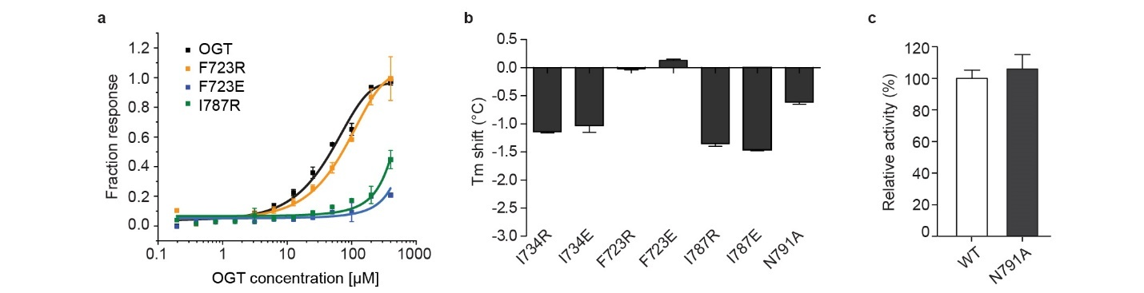
Extended Data Figure 3. OGT Int-D mutants reduce peptide binding but retain intrinsic activity. (a) Saturation fluorescence polarization (FP) binding assay of fluorescently labeled 5-FAM-SMG9 peptide with WT OGT (black) and mutants F723R (orange), F723E (blue), and I787R (green), n = 3. (b) Thermal shift assay showing the mutation induced change in OGT denaturation temperature (T_{m}), n = 3. (c) Radiolabeled activity assay measuring integration of UDP-³H-GlcNAc onto CKII peptide by recombinantly purified WT OGT (WT) or OGT-N791A (N791A), n = 3. Error bars represent standard deviation of three biological replicates.

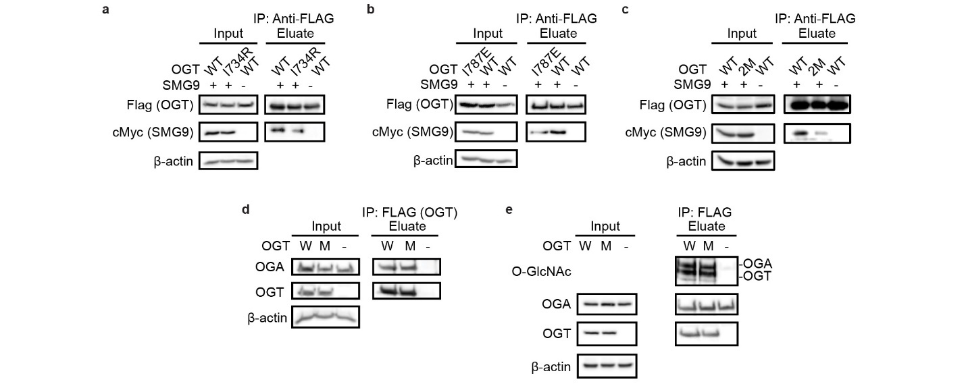
Extended Data Figure 4. The Int-D binding site is a motif-dependent regulator of protein association and O-GlcNAcylation. Co-immunoprecipitation of cMyc-SMG9 with Flag-OGT (WT) or (a) Flag-OGT-I734R (I734R), (b) Flag-OGT-I787E (I787E), (c) Flag-OGT-I787E-N791A (2M), from TRex-293 cells, followed by western blot. (d) Co- immunoprecipitation of endogenous OGA with Flag-OGT (W) or Flag-OGT-N791A (M) from TRex-293 cells, followed by western blot. (e) O-GlcNAcylation detection on Flag-OGT (W), Flag-OGT-N791A (M), and Flag-HA-OGA-D175N. Flag-tagged OGT and OGA were immunoprecipitated from TRex-293 cell lysate by Flag-agarose, followed by western blot (representative of at least three biological replicates).

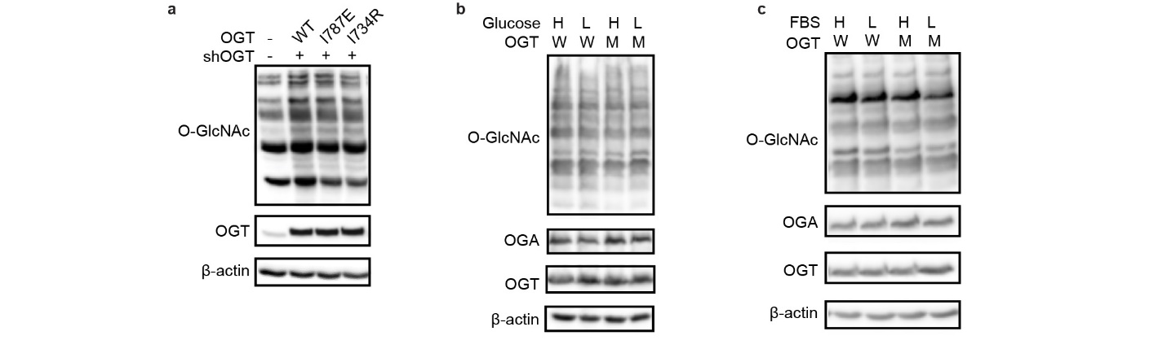
Extended Data Figure 5. Global O-GlcNAcylation is unperturbed by Int-D site mutation and single nutrient deprivation. (a) Western blot detection of global O-GlcNAcylation in TRex-293 cells overexpressing OGT (WT), OGT-I787E (I787E), or OGT-I734R (I734R) with endogenous OGT knockdown (shOGT). Western blots of O-GlcNAcylation under high (H) and low (L) glucose (b) or serum (c) treatment with OGT (W) or OGT-N791A (M) overexpression. High nutrient conditions include DMEM with 4.5 g/L glucose and 10% FBS, low nutrient conditions include DMEM with 0.45 g/L glucose and 1% FBS. Blots are representative of at least three biological replicates.

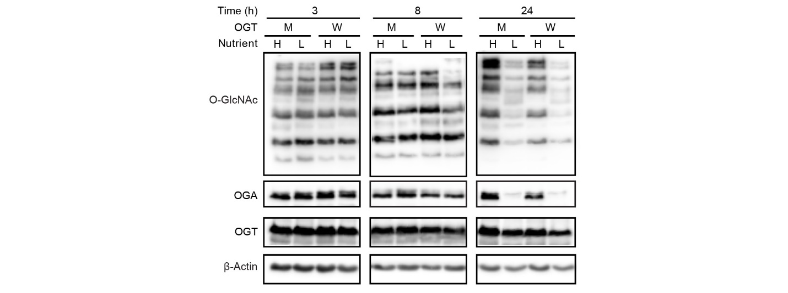
Extended Data Figure 6. Delayed response to nutrient stress in HeLa cells. Western blot showing time course study of O-GlcNAcylation response to low nutrient stress in HeLa cells stably expressing OGT (W) and OGT-N791A (M). Cells were induced for 48 hours prior to high or low nutrient treatment, then samples were collected at 3, 8, and 24 hours of treatment.

