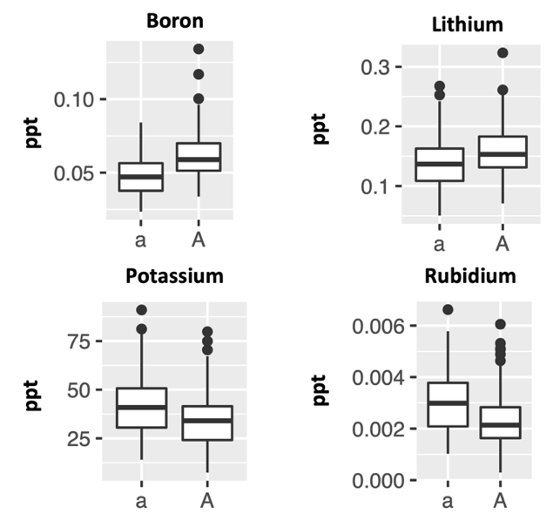
Figure S1. Effects of P.int13 genotype on leaf concentrations (parts per thousand) of Boron, Lithium, Potassium, and Rubidium. All effects are significant at p<0.01.

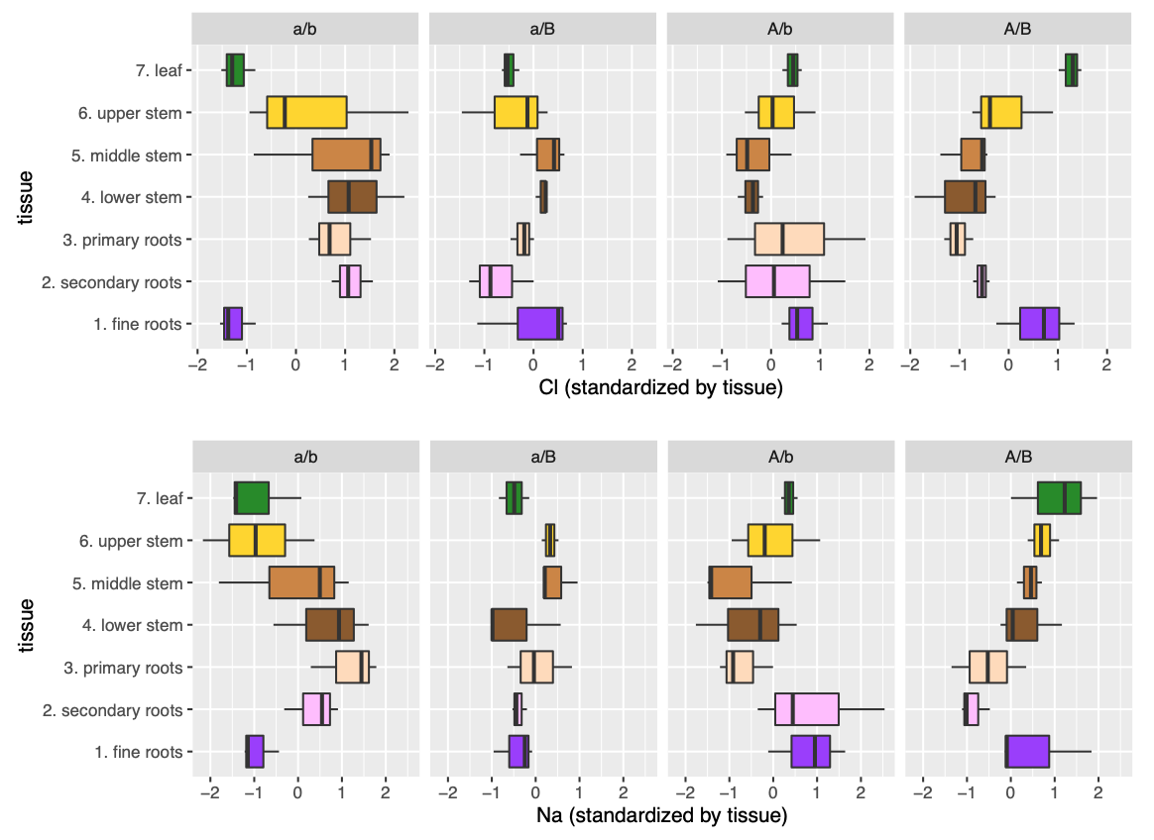

Figure S2. Effects of all four P.int13/P.atl13 haplotypes on standardized Na+ and Cl- concentrations in seven tissue types.
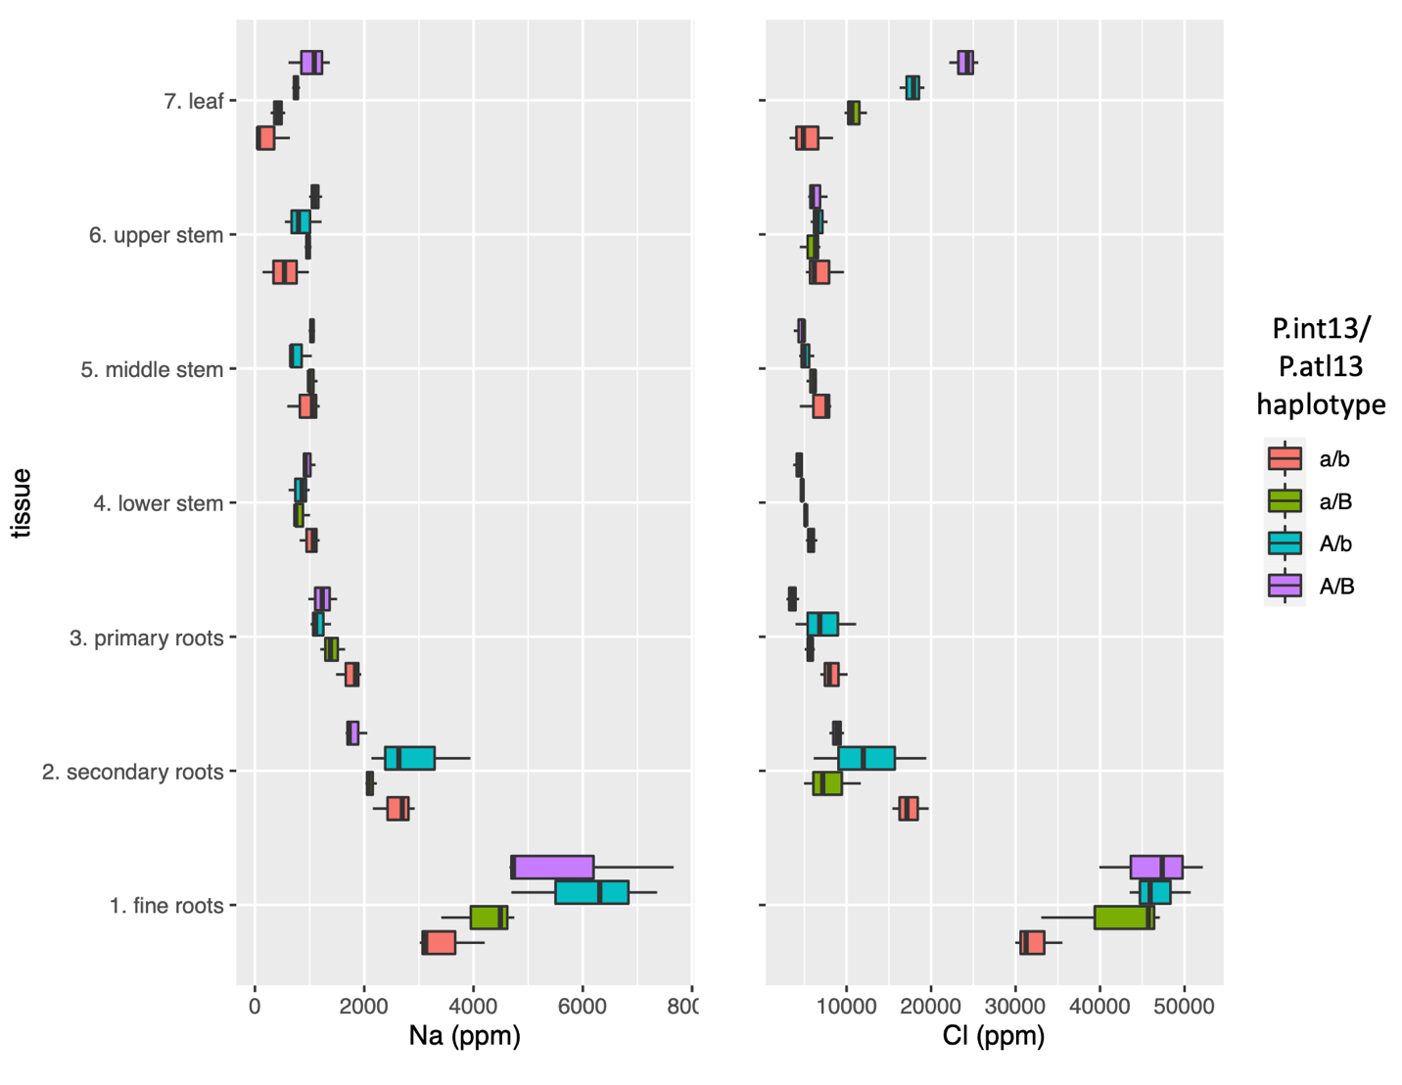
Figure S3. Effects of P.int13/P.atl13 haplotype on raw Na+ and Cl- concentrations in seven tissue types.

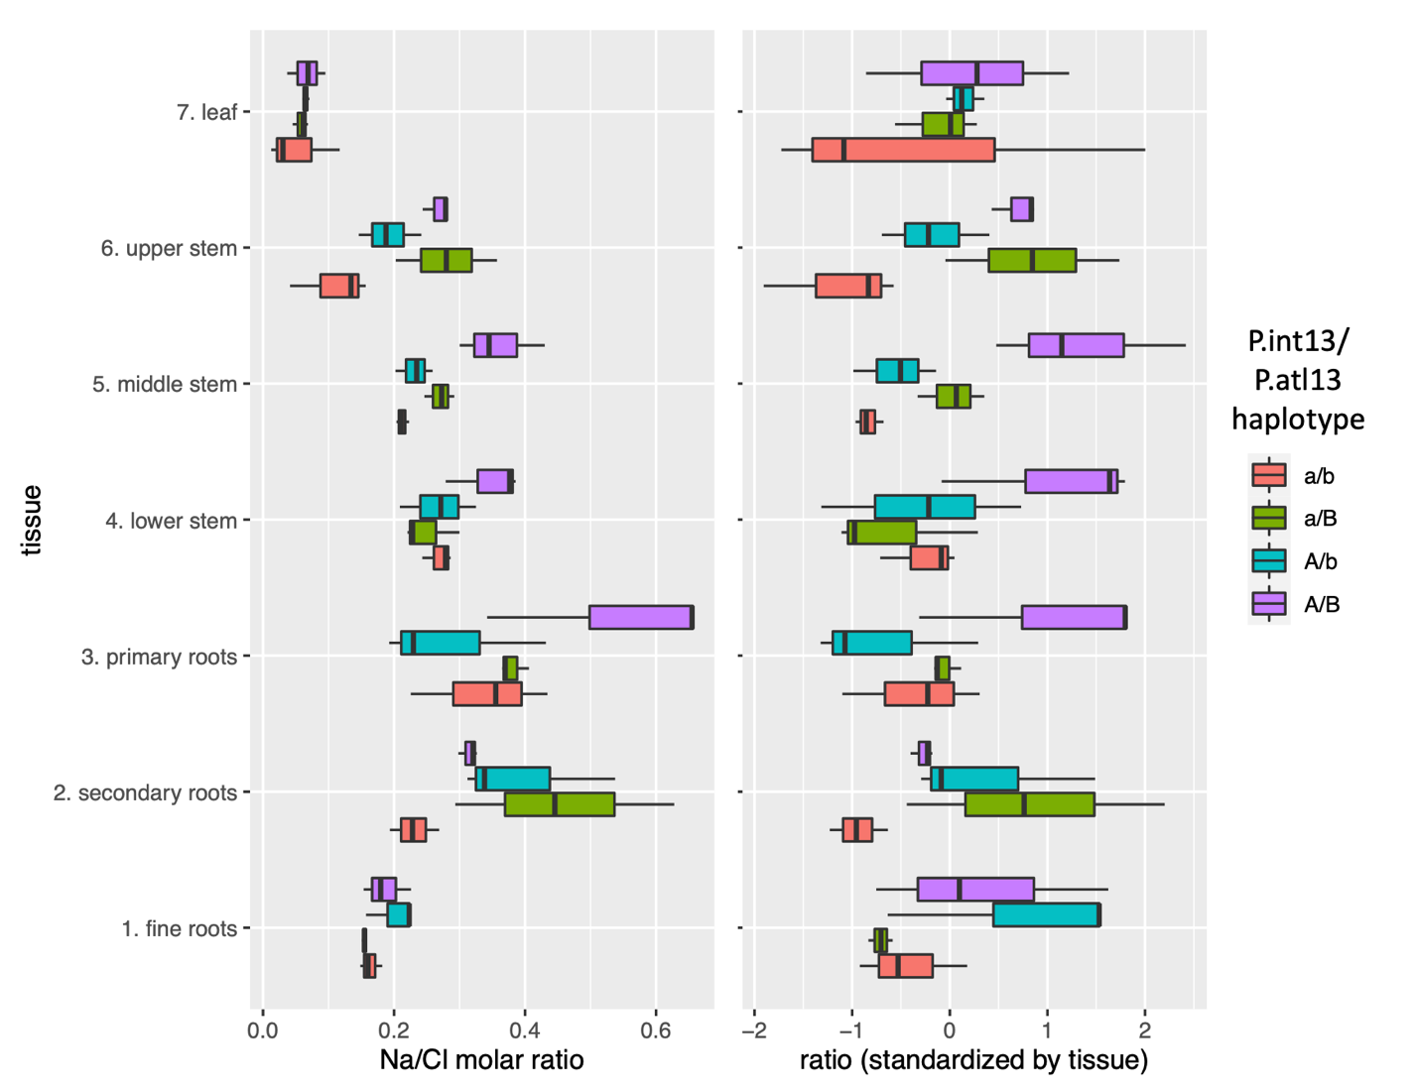

Figure S4. Effects of P.int13/P.atl13 haplotype on raw and standardized Na/Cl molar ratio in seven tissue types.

