This file includes:
Supplementary Figs. 1 to 4
Supplementary Tables 2 to 3
Supplementary Table 1 submitted as a separate excel file
Supplementary Fig. 1
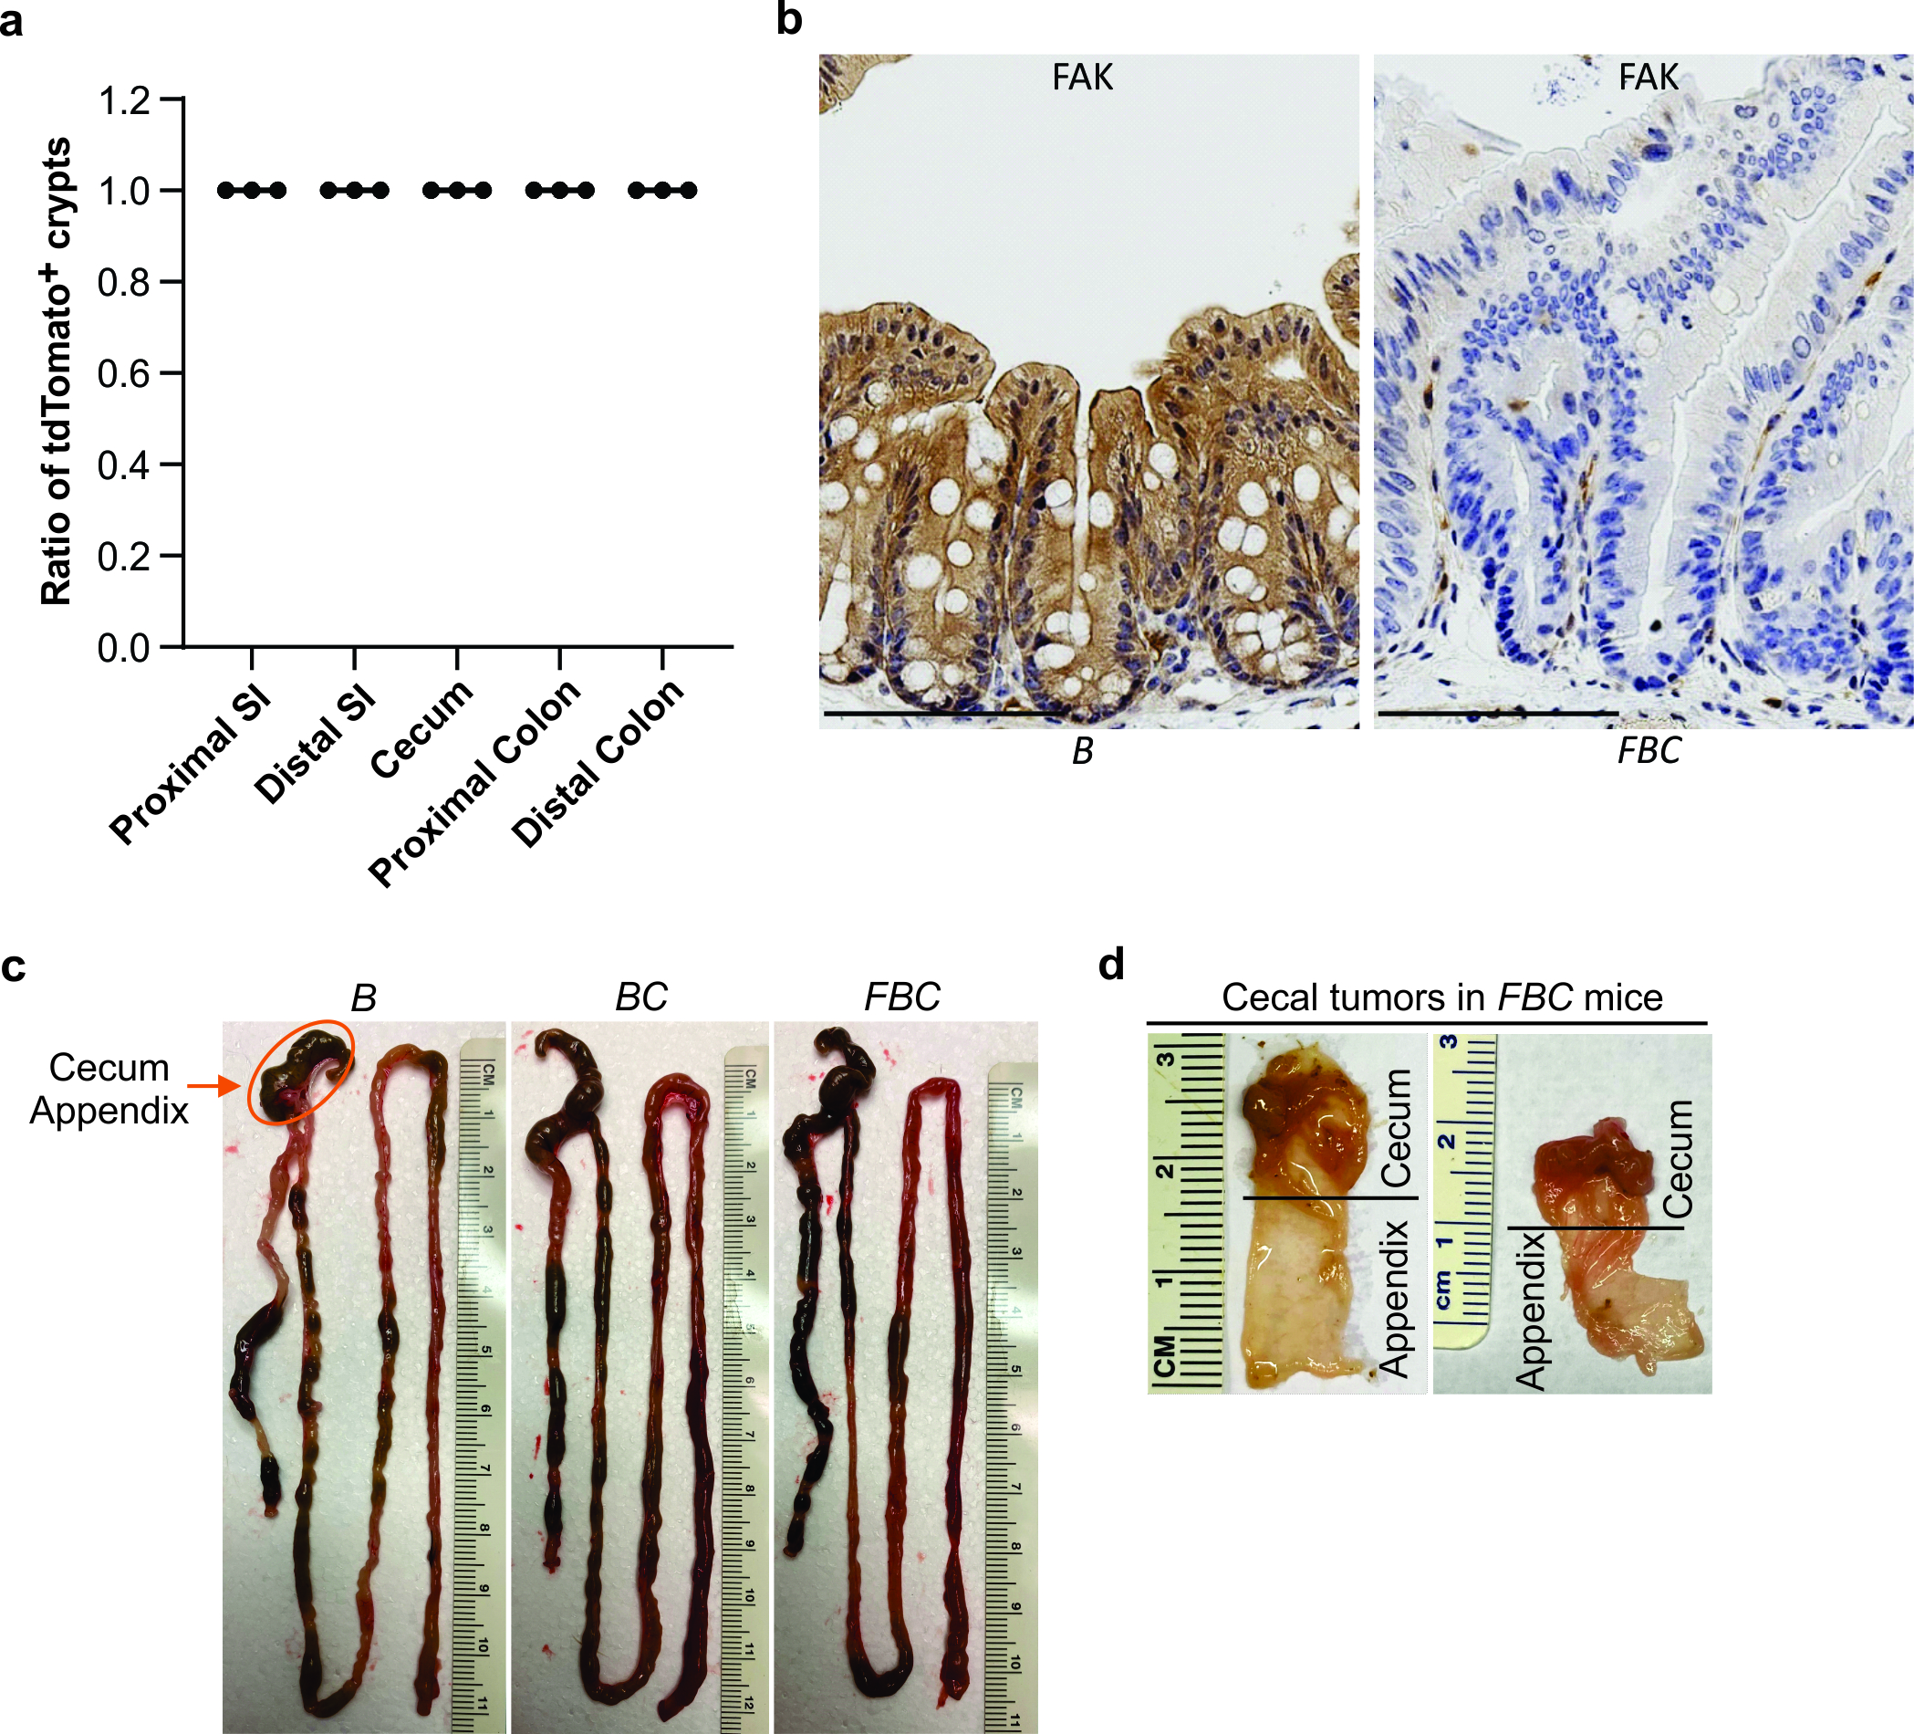

Supplementary Fig. 2
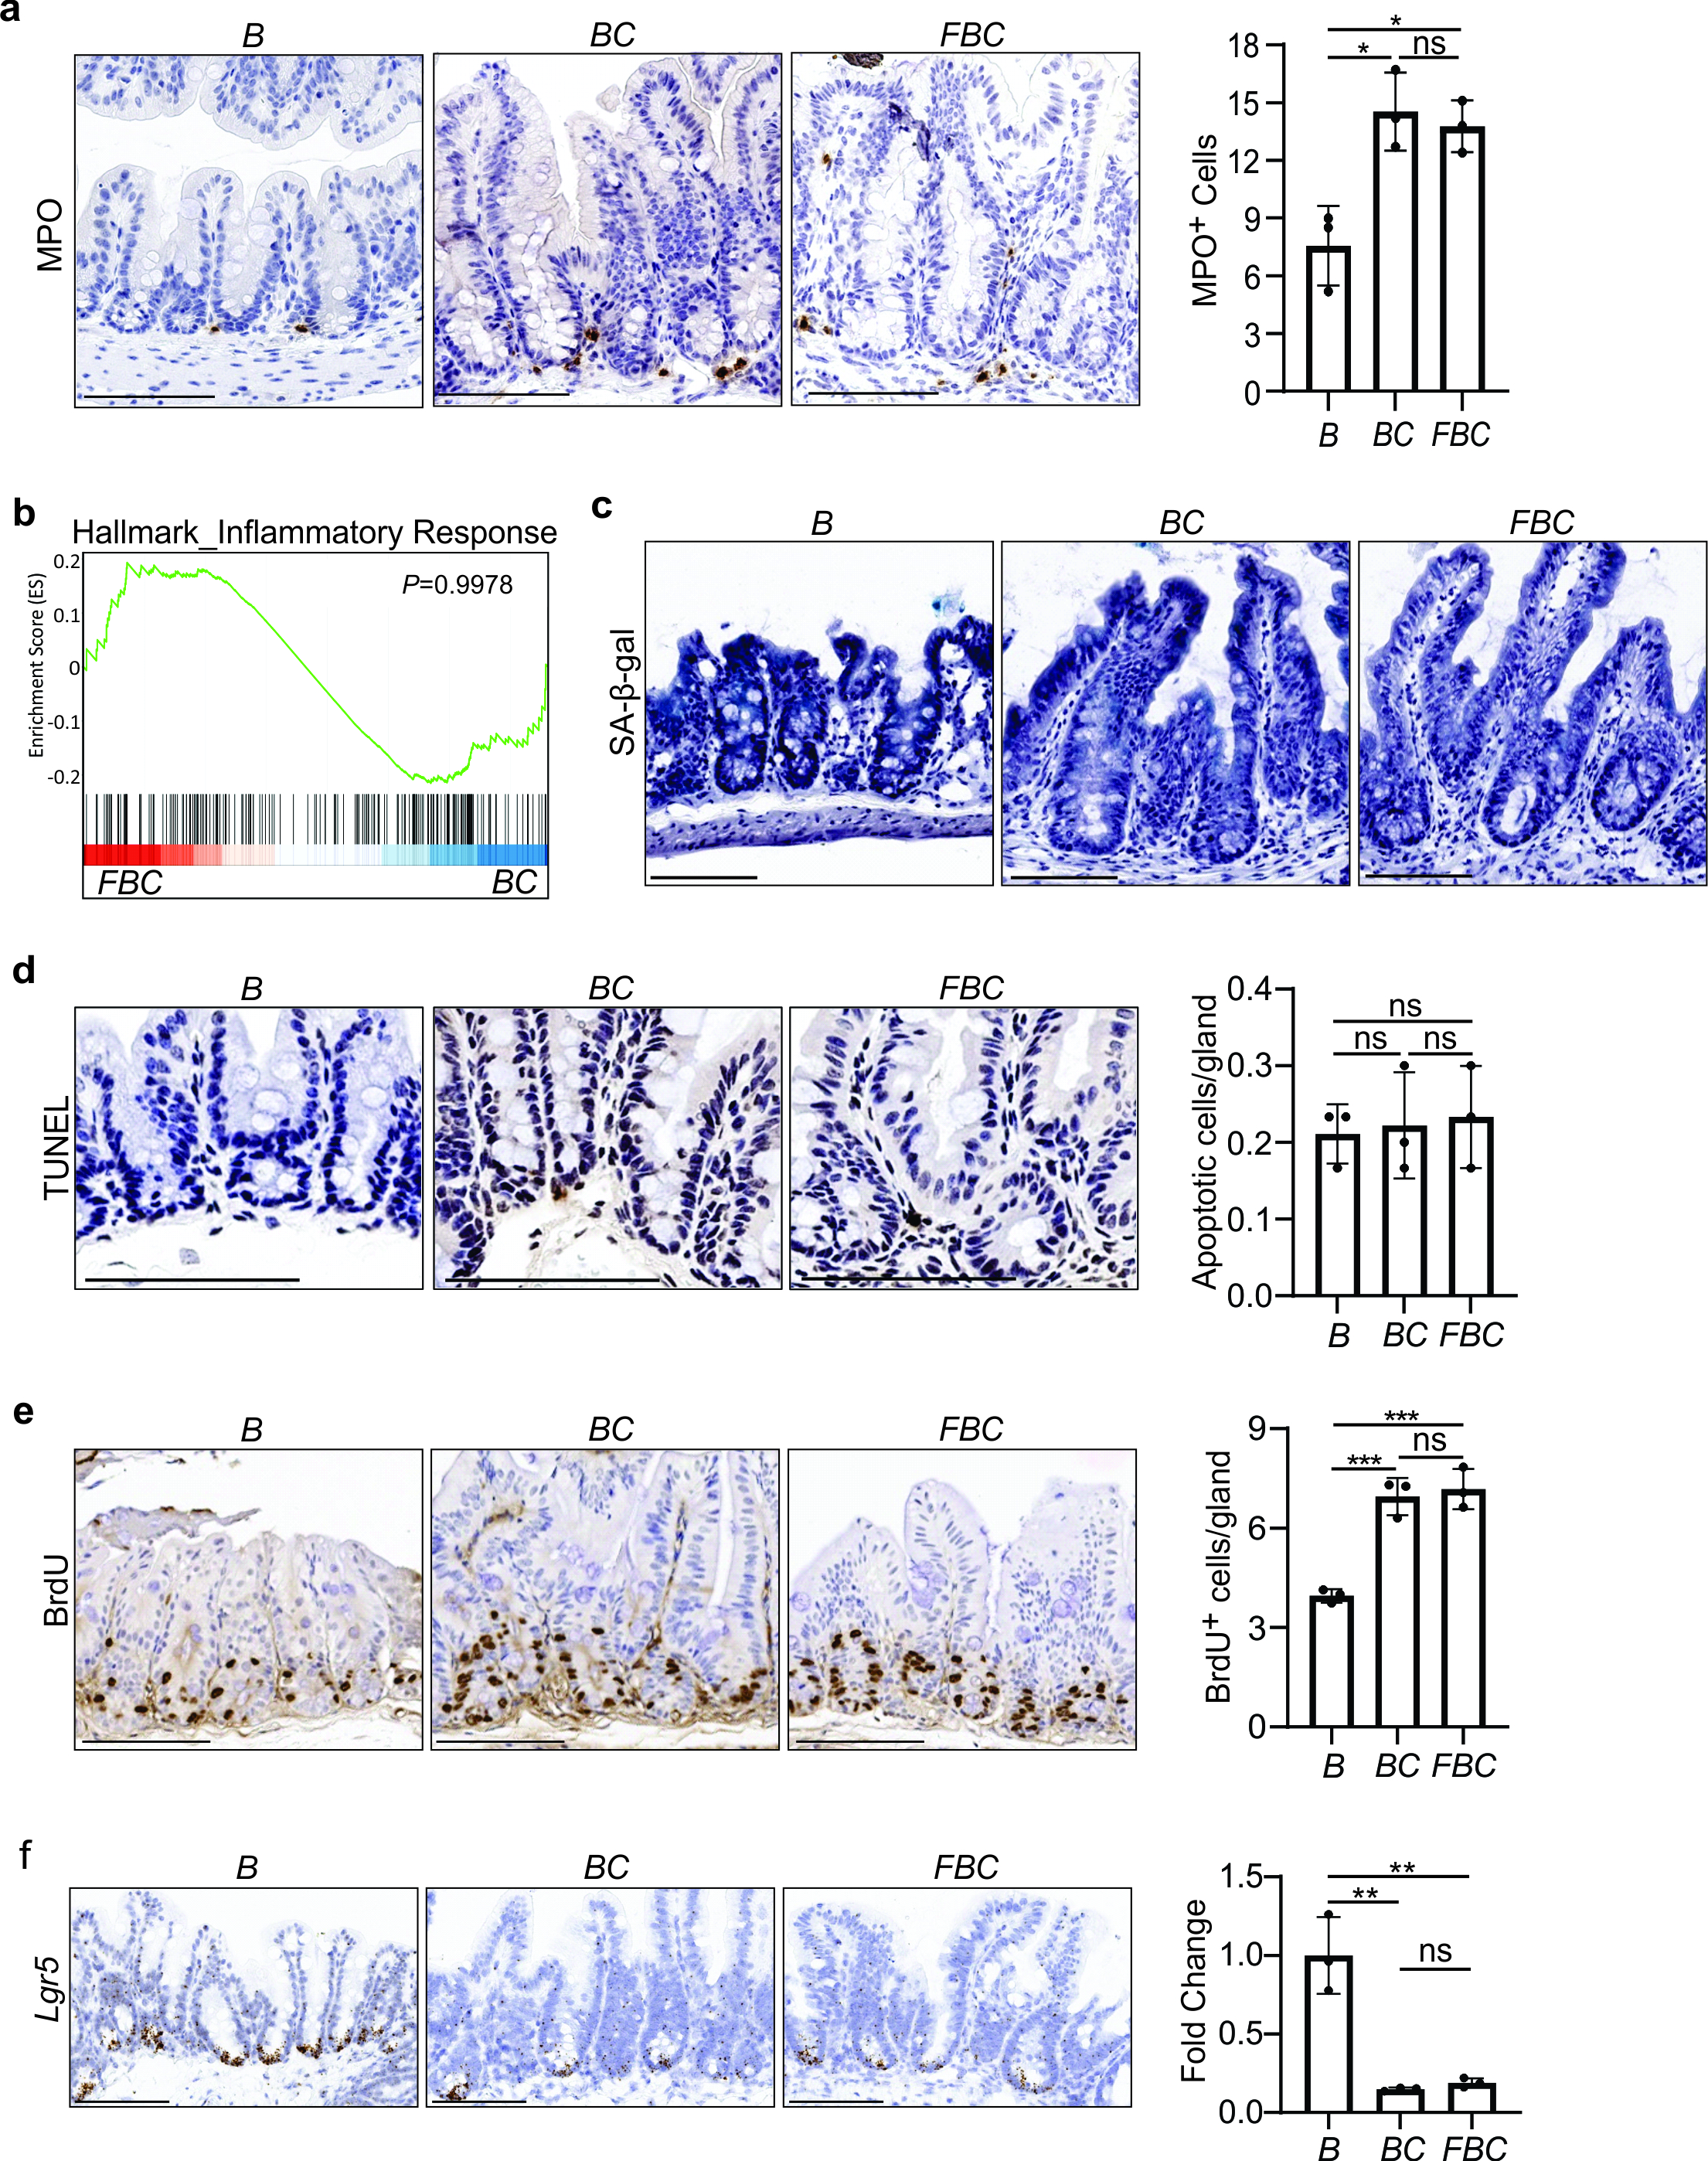

Supplementary Fig. 3
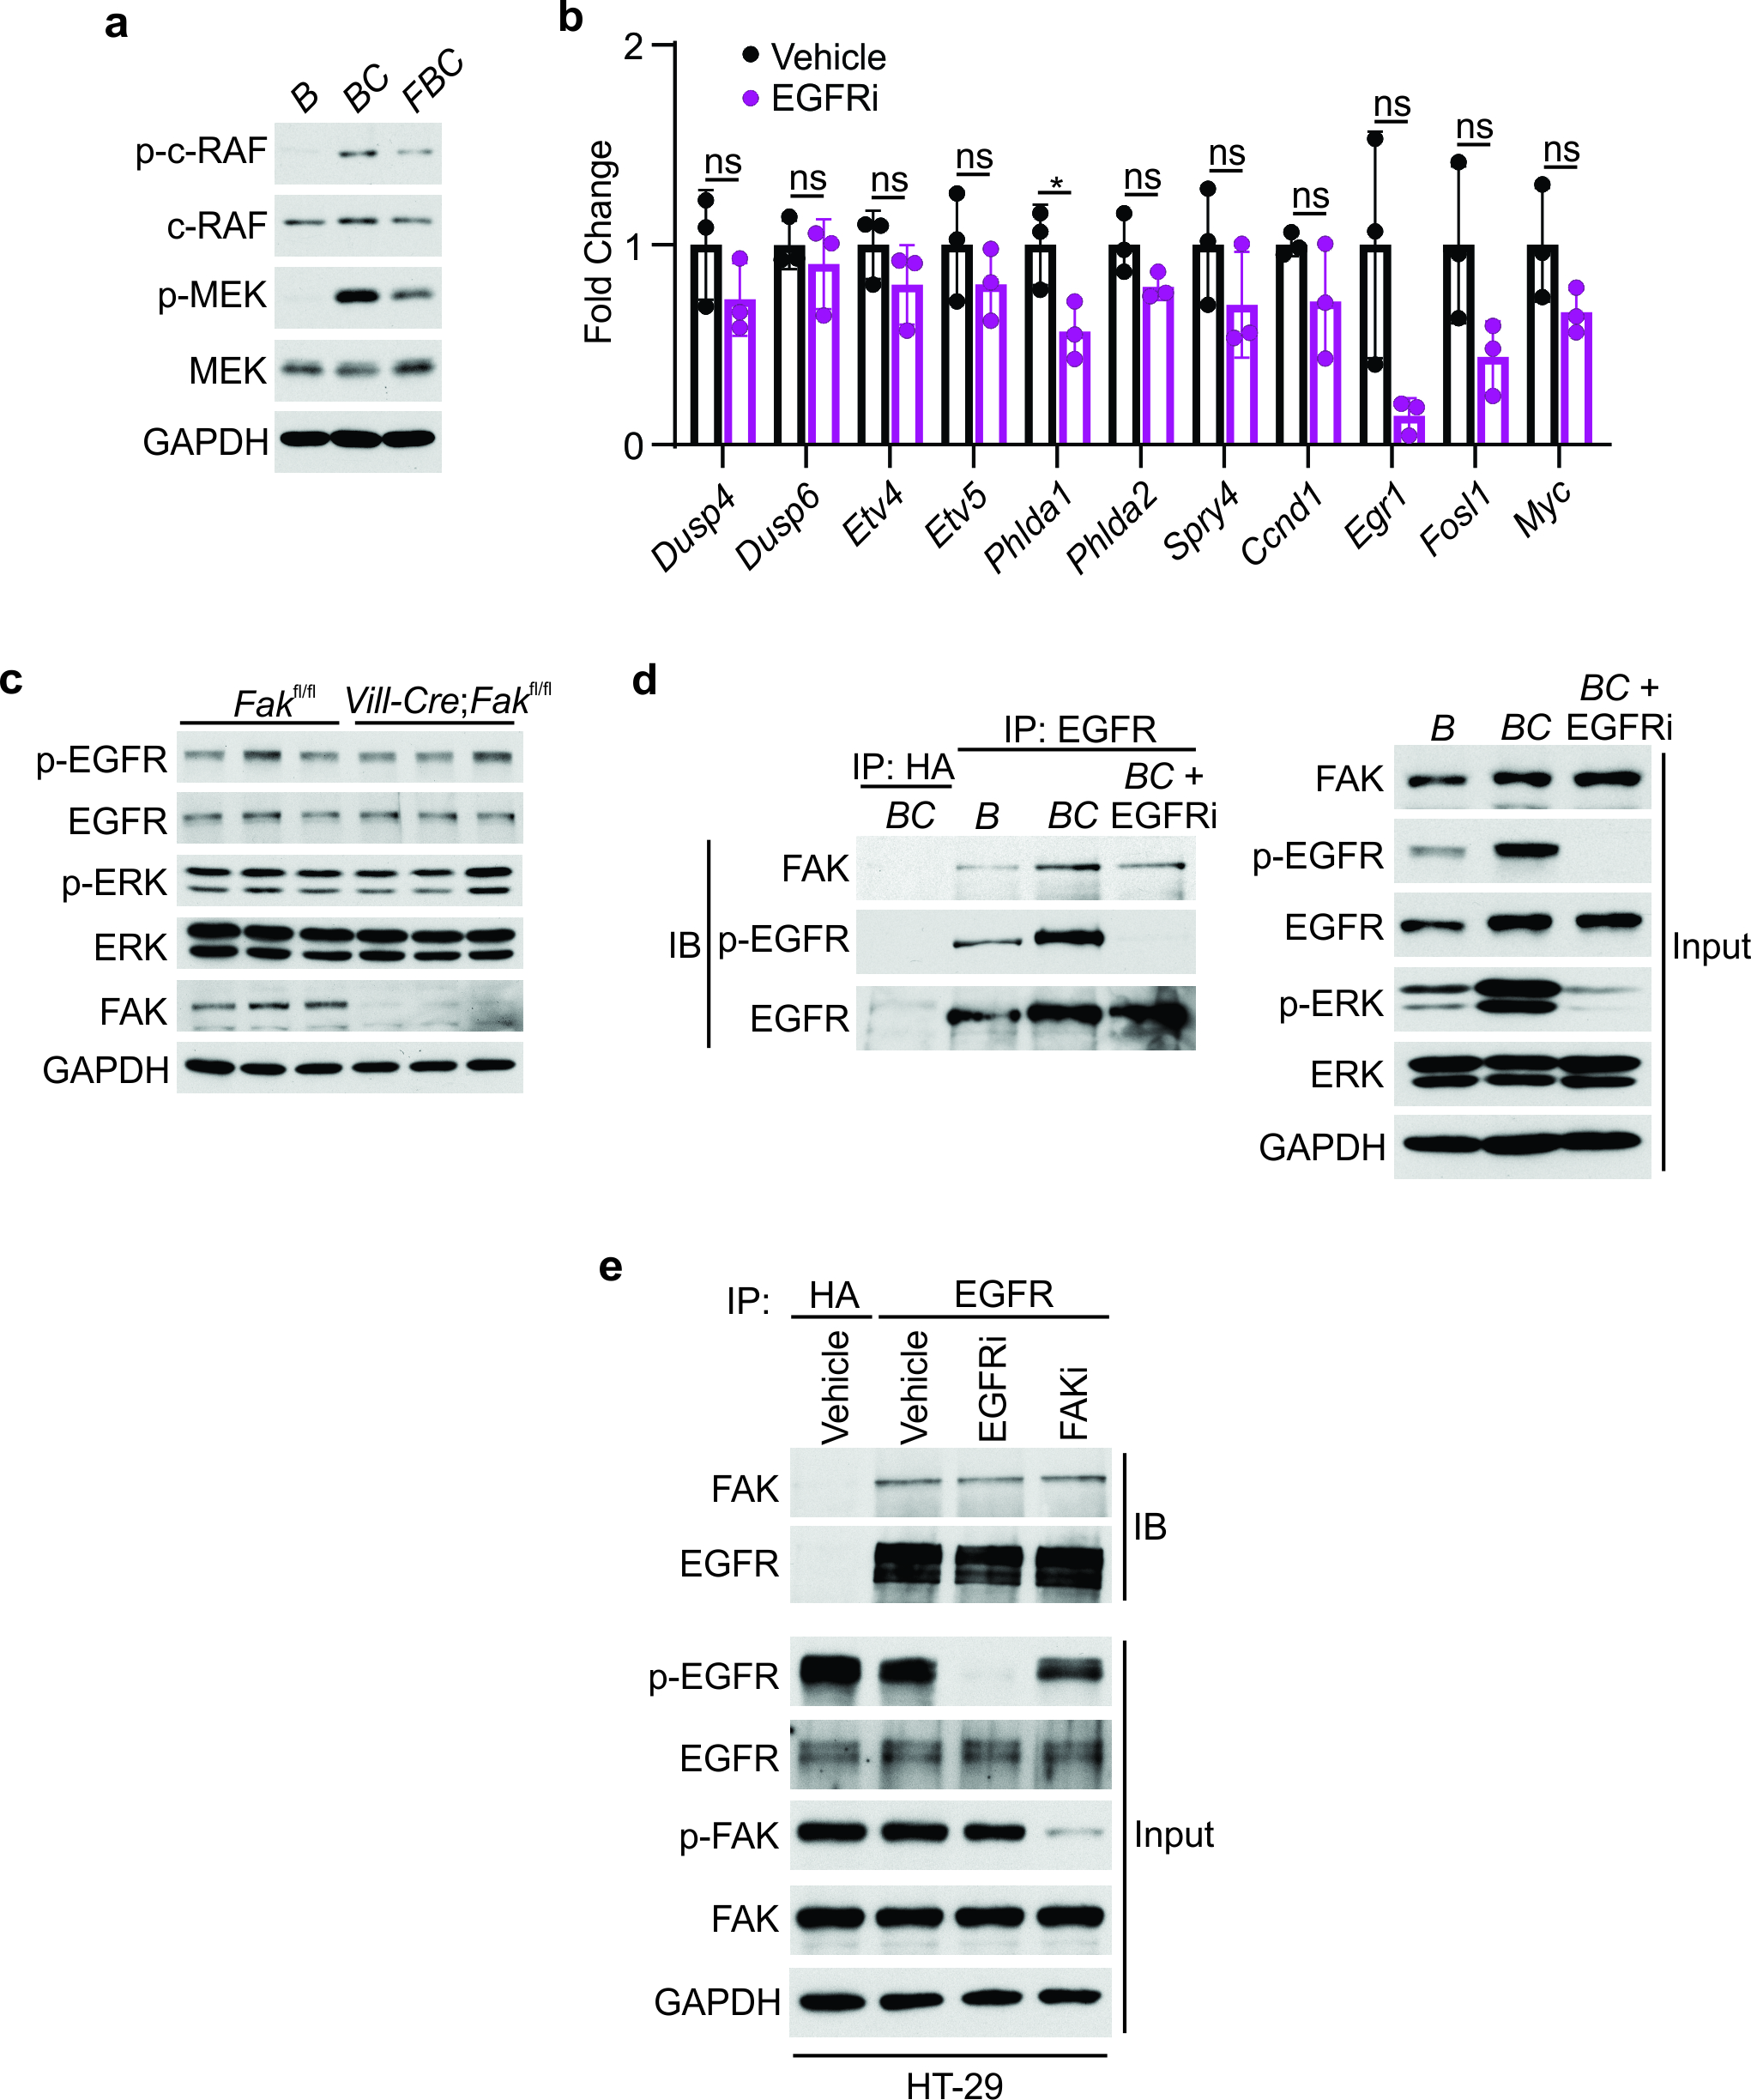

Supplementary Fig. 4
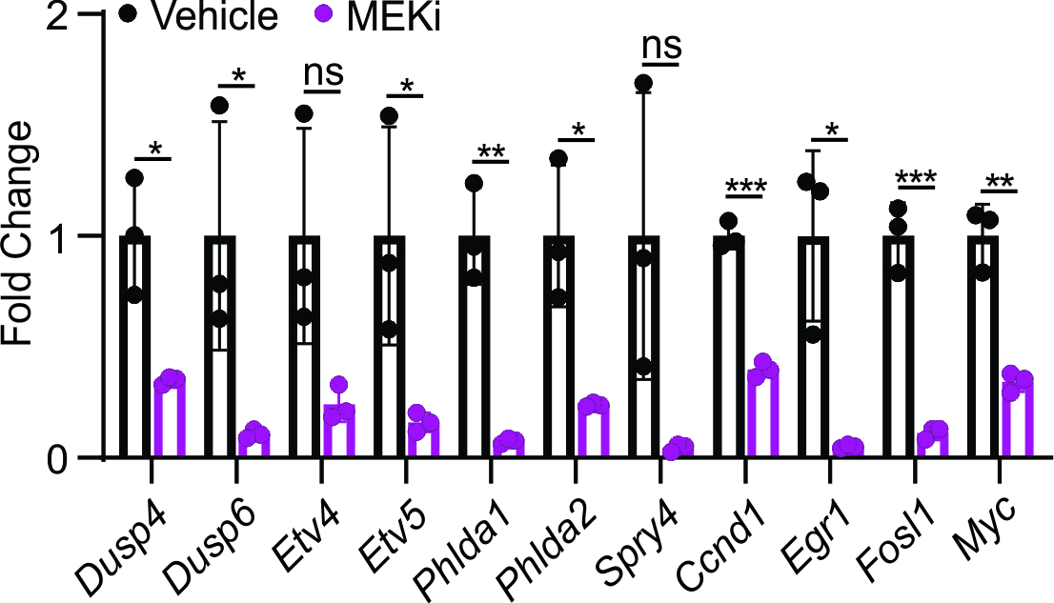

Supplementary Table 2
Supplementary Table 2. Antibody used in this study
Name | Company | Catalog nubmer | Usage
Anti-FAK | Cell Signaling Technology | 3285 | IHC, IB
Anti-p-FAK^{Y397} | Cell Signaling Technology | 3283 | IB
Anti-p-ERK1/2^{T202/Y204} | Cell Signaling Technology | 4370 | IB
Anti-ERK1/2 | Cell Signaling Technology | 4695 | IB
Anti-p-EGFR^{Y1068} | Cell Signaling Technology | 2234 | IB
Anti-p-c-RAF^{S338} | Cell Signaling Technology | 9427 | IB
Anti-c-RAF | Cell Signaling Technology | 9422 | IB
Anti-p-MEK1/2^{S217/221} | Cell Signaling Technology | 9154 | IB
Anti-MEK1/2 | Cell Signaling Technology | 9122 | IB
Anti-GAPDH | Cell Signaling Technology | 2118 | IB
Anti-NEDD4 | Cell Signaling Technology | 2740 | IB
Anti-NEDD4L | Cell Signaling Technology | 4013 | IB
Anti-Ubiquitin | Cell Signaling Technology | 20326 | IB
Anti-EGFR | Santa Cruz Biotechnology | sc-373746 | IB
Anti-EGFR agarose | Santa Cruz Biotechnology | sc-373746 AC | IP
Anti-LGR4 | Santa Cruz Biotechnology | sc-390630 | IB
Anti-LGR4 agarose | Santa Cruz Biotechnology | sc-390630 AC | IP
Anti-BrdU | MilloporeSigma | B8434 | IHC
Anti-MPO | Abcam | ab208670 | IHC
Anti-RFP | Rockland Immunochemicals | 600-401-379 | IHC
IHC, immunohistochemistry; IB, immunoblotting; IP, immunoprecipitation

Supplementary Table 3
Supplementary Table 3. PCR primers used in this study
Gene name | Forward (5’-3’) | Reverse (5’-3’)
Mouse β-actin | CATTGCTGACAGGATGCAGAAGG | TGCTGGAAGGTGGACAGTGAGG
Dusp4 | CGAGTACATCGACGCAGTAAA | ACCCGCTTCTTCATCATCAG
Dusp6 | GAATGAGAACACTGGTGGAGAG | GGAACTTACTGAAGCCACCTT
Etv4 | GGTGATGGAGTGATGGGTTATG | CTTCCTGCTTGATGTCTCCTTC
Etv5 | CTACATGAGAGGCGGGTATTTC | GGTACCACGCAAGTATCATCAA
Phlda1 | CTTCACTGTGGTGATGACGGAG | TTCTGCCTGGTAGACTTGACCG
Phlda2 | TTCACCATCGTCACCAACTATTA | CGGTTCTGGAAGTCGATCAG
Spry4 | CCGCTGTGACCAGGATATTAC | TGGAGCCATGTGATCTAGGA
Ccnd1 | CAGAGGCGGATGAGAACAAG | GAGGGTGGGTTGGAAATGAA
Egr1 | AACAACCCTATGAGCACCTG | GAGTCGTTTGGCTGGGATAA
Fosl1 | ACACCCTCTCTGACTCCTTT | CACTGCTGCTGCTACTCTTT
Myc | TCGCTGCTGTCCTCCGAGTCC | GGTTTGCCTCTTCTCCACAGAC
Lgr5 | GAGTCAACCCAAGCCTTAGTATCC | CATGGGACAAATGCAACTGAAG
Lgr4 | GTCCTAACCCTCCAGAACAATC | CCTCCGGGACTGAGGTAATA
Human β-ACTIN | CACTCTTCCAGCCTTCCTTC | GGATGTCCACGTCACACTTC
Human LGR4 | GCATCCCTGACTTTGCATTTAC | AGGTCTCCAGGTTATCTAGTCC

