Supplementary Information

Figure S1: The location of the template on both hemisphere, red numbers indicate the source, blue number are detectors and yellow lines are the channels. The orientation of the template starts from the frontal on the left, moves to the left hemisphere in middle and the final image shows the template location on the right hemisphere.

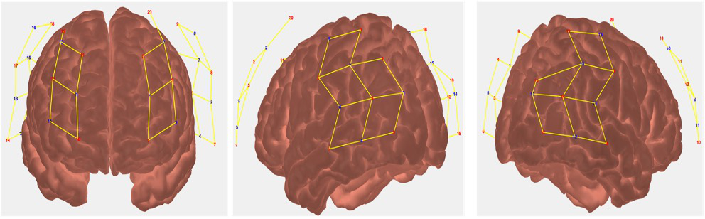

Figure S2: Example of the HRF timecourse from 1-4 seconds during the phoneme deletion task for one subject
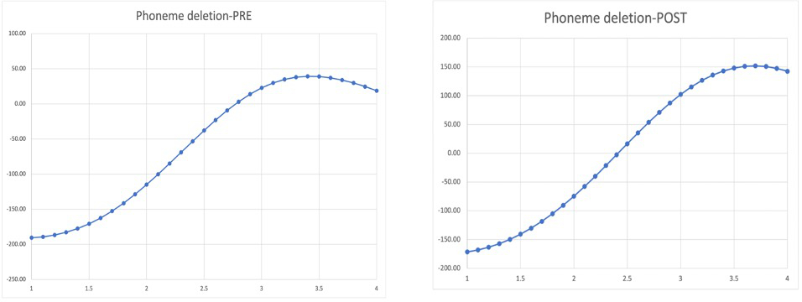

Figure S3: Example of the HRF timecourse from 2 to 6 seconds during the sentence comprehension task for one subject
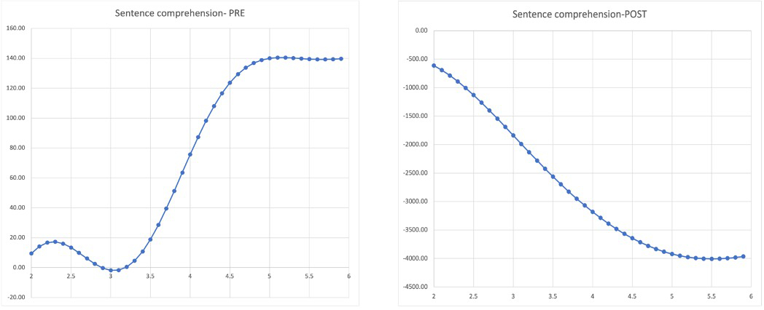

Figure S4: Accuracy scores for the sentence comprehension task for both training groups at pre and post timepoints; error bars at 95% CI

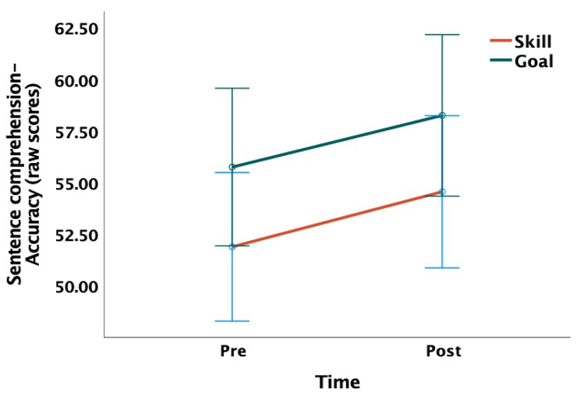
Figure S5: Oxygenated hemoglobin concentration of right superior temporal gyrus during phoneme deletion task for both training groups at pre and post timepoints; error bars at 95% CI
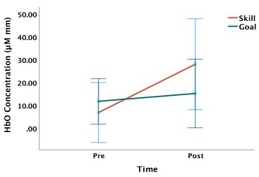

Figure S6: Mean HbO HRF of right superior temporal during the sentence comprehension task for both training groups at pre and post timepoints; error bars at 95% CI
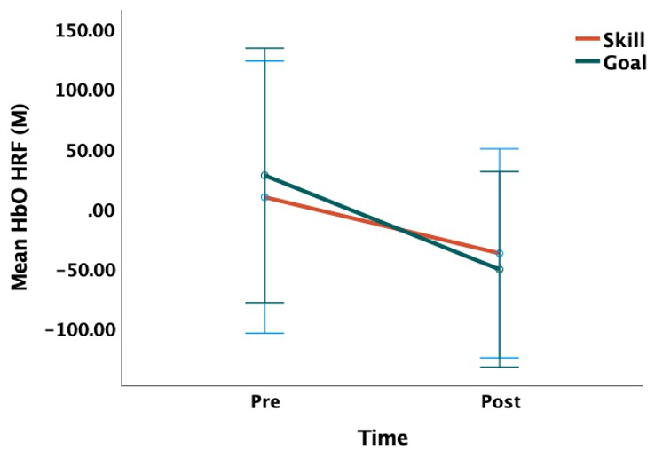

Figure S7: Mean HbO HRF of left fusiform gyrus during sentence comprehension task for both training groups at pre and post timepoints; error bars at 95% CI
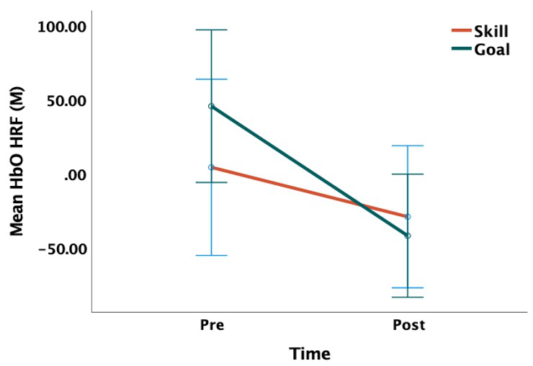

Table S1: Stimuli for the phonemic deletion task at both pre- and post-intervention timepoints
Pre-intervention task stimuli |  | Post-intervention task stimuli
Nonword | Nonword without sound | Nonword | Nonword without sound
Adash | Adash without /sh/ | Abail | Abail without l
Adrid | Adrid without /r/ | Abert | Abert without a
Alept | Alept without /p/ | Bloot | Bloot without o
Avide | Avide without /a/ | Cebel | Cebel without c
Forn | Forn without /f/ | Cugby | Cugby without i
Bont | Bont without /t/ | Elsom | Elsom without l
Duts | Duts without /d/ | Felly | Felly without f
Foze | Foze without /z/ | Flave | Flave without l
Meap | Meap without /p/ | Maiza | Maiza without z
Leop | Leop without /l/ | Moona | Moona without a
Vone | Vone without /n/ | Olens | Olens without n
Tronce | Tronce without /s/ | Plour | Plour without r
Pasil | Pasil without /s/ | Prail | Prail without p
Peads | Peads without /d/ | Jold | Jold without l
Masic | Masic without /s | Nawl | Nawl without l
Seans | Seans without /s/ | Smot | Smot without m
Scranch | Scranch without /ch/ | Tibs | Tibs without t
Beppy | Beppy without /i/ | Voar | Voar without r
Sheed | Sheed without /sh/ | Dort | Dort without r
Prain | Prain without /p/ | Fike | Fike without f
Frick | Frick without /k/ | Seft | Seft without t
Gacked | Gacked without /t/ | Yans | Yans without n
Vanon | Vanon without /v/ | Aprect | Aprect without k
Fapes | Fapes without /s/ | Snotter | Snotter without s
Claft | Claft without /k/ | Bresis | Bresis without b
Fren | Fren without /n/ | Caveet | Caveet without v
Husket | Husket without /k/ | Cierce | Cierce without r
Namery | Namery without /m/ | Datter | Datter without t
Cailed | Cailed without /k/ | Doncur | Doncur without r
Guffle | Guffle without /f/ | Drenzy | Drenzy without y
Gutiny | Gutiny without /t/ | Endibe | Endibe without d
Oglong | Oglong without /l/ | Forves | Forves without v
Ostaine | Ostaine without /s/ | Frimes | Frimes without f
Fackton | Fackton without /f/ | Grousa | Grousa without a
Geincher | Geincher without /ch/ | Gumice | Gumice without s
Heelon | Heelon without /h/ | Seading | Seading without d
Hestome | Hestome without /t/ | Lecome | Lecome without l
Inkista | Inkista without /a/ | Marnal | Marnal without m
Jellantif | Jellantif without /n/ | Prumple | Prumple without r
Annitizer | Annitizer without /t/ | Raisley | Raisley without r
Benalopy | Benalopy without /b/ | Randate | Randate without t
Jedabulos | Jedabulos without /b/ | Rommune | Rommune without m
Gistorpulin | Gistorpulin without /p/ | Scrones | Scrones without k
Zooben | Zooben without /z/ | Scrurge | Scrurge without g
Planot | Planot without /l/ | Sarasita | Sarasita without t
Glaque | Glaque without /k/ | Sayogara | Sayogara without s
Hastel | Hastel without /t/ | Arominate | Arominate without t
Sparty | Sparty without /i/ | Hundinoty | Hundinoty without y
Dompom | Dompom without /d/ | Digantulin | Digantulin without d
Prefty | Prefty without /r/ | Vamonticay | Vamonticay without k
Welf | welf without /f/ | Abail | Abail without l
Threet | threet without /r/ | Abert | Abert without a
Pench | pench without /ch/ | Bloot | Bloot without o
Greal | greal without /r/ | Cebel | Cebel without c
spowl | spowl without /p/ | Cugby | Cugby without i

