Supplementary Tables and Figures

- Diet

1.1) Body Size

1.1.2)
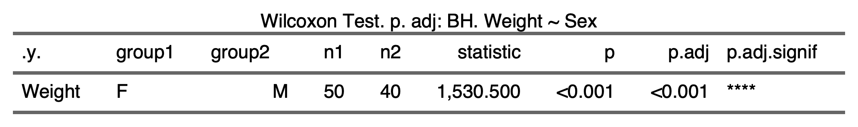
1.1.3)
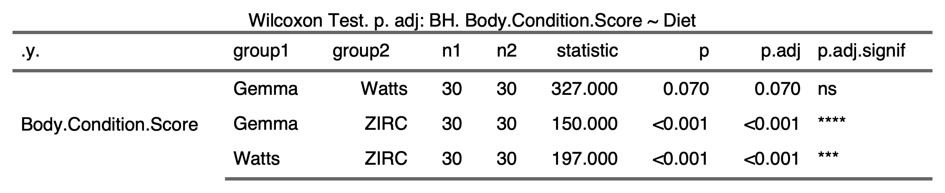
1.1.4)


1.2) Alpha Diversity

1.2.1)
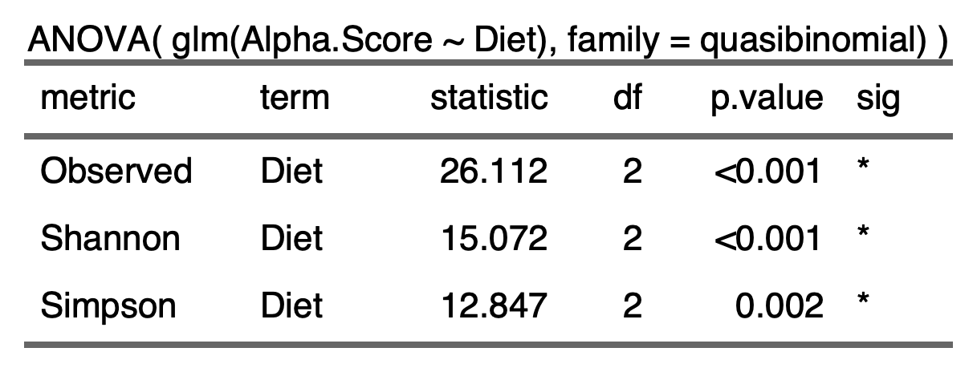
1.2.2)
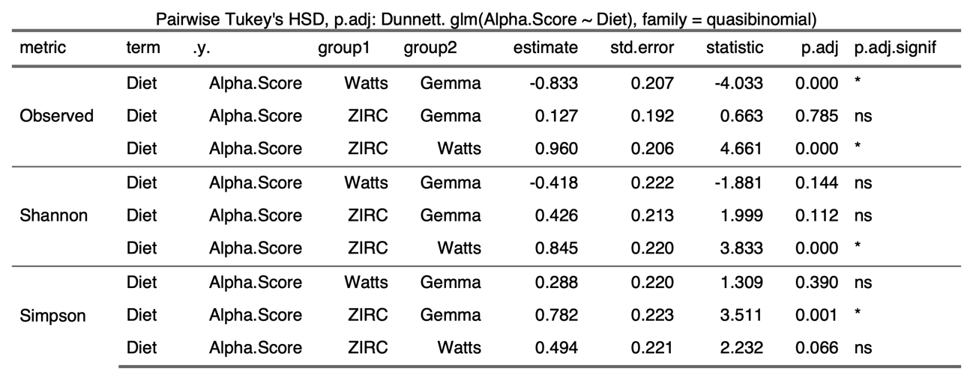

1.3) Beta-diversity

1.3.1)
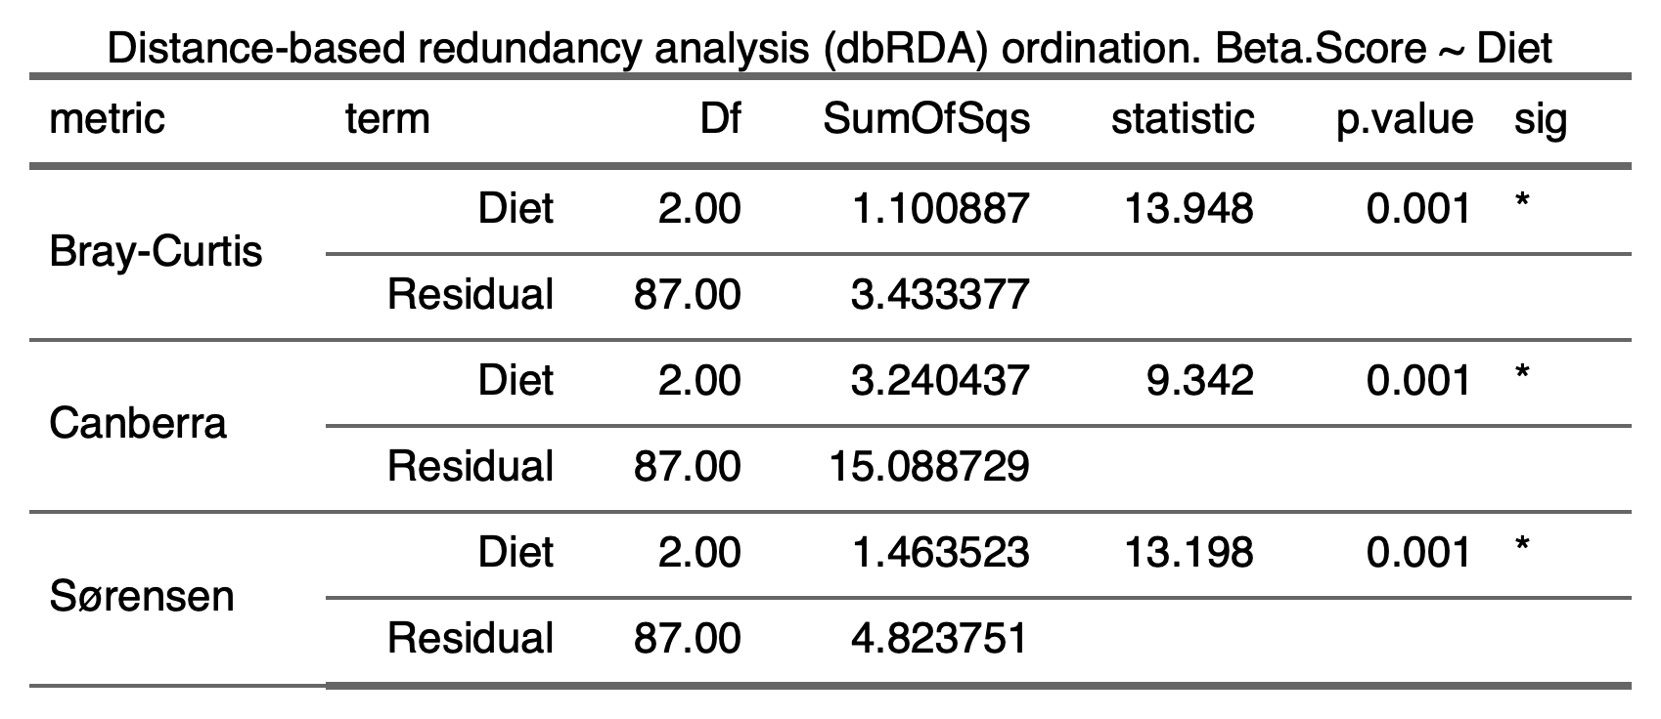
1.4) Beta-Dispersion

1.4.1)
Bray-Curtis | Canberra | Sørensen
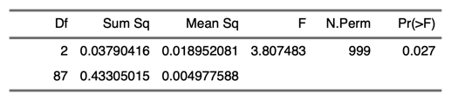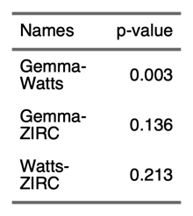 | 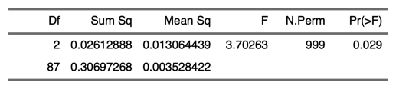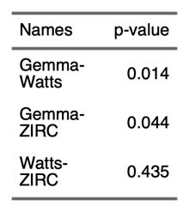 | 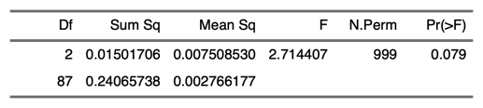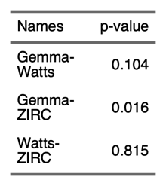

1.5) Differential Abundance

1.5.1)
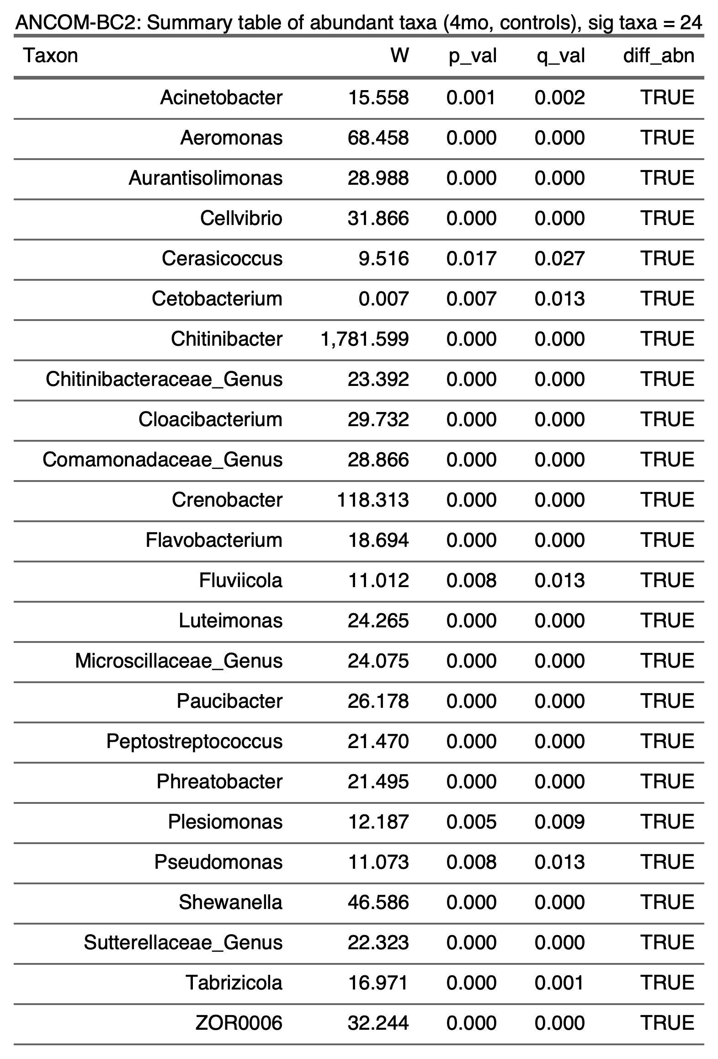
- Diet and development

2.1) Body Size

2.1.1)

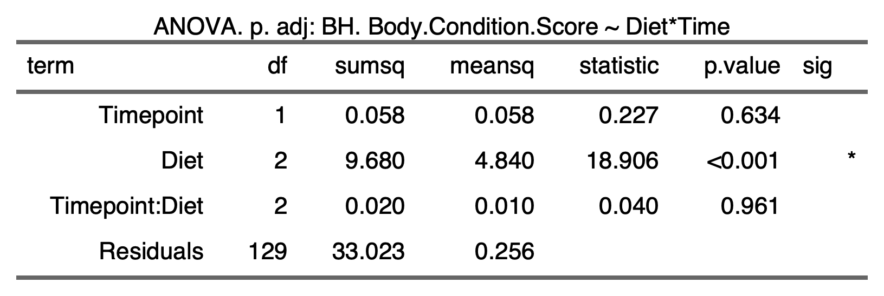

2.1.2) Microbiome

2.1.2.1) Alpha Diversity 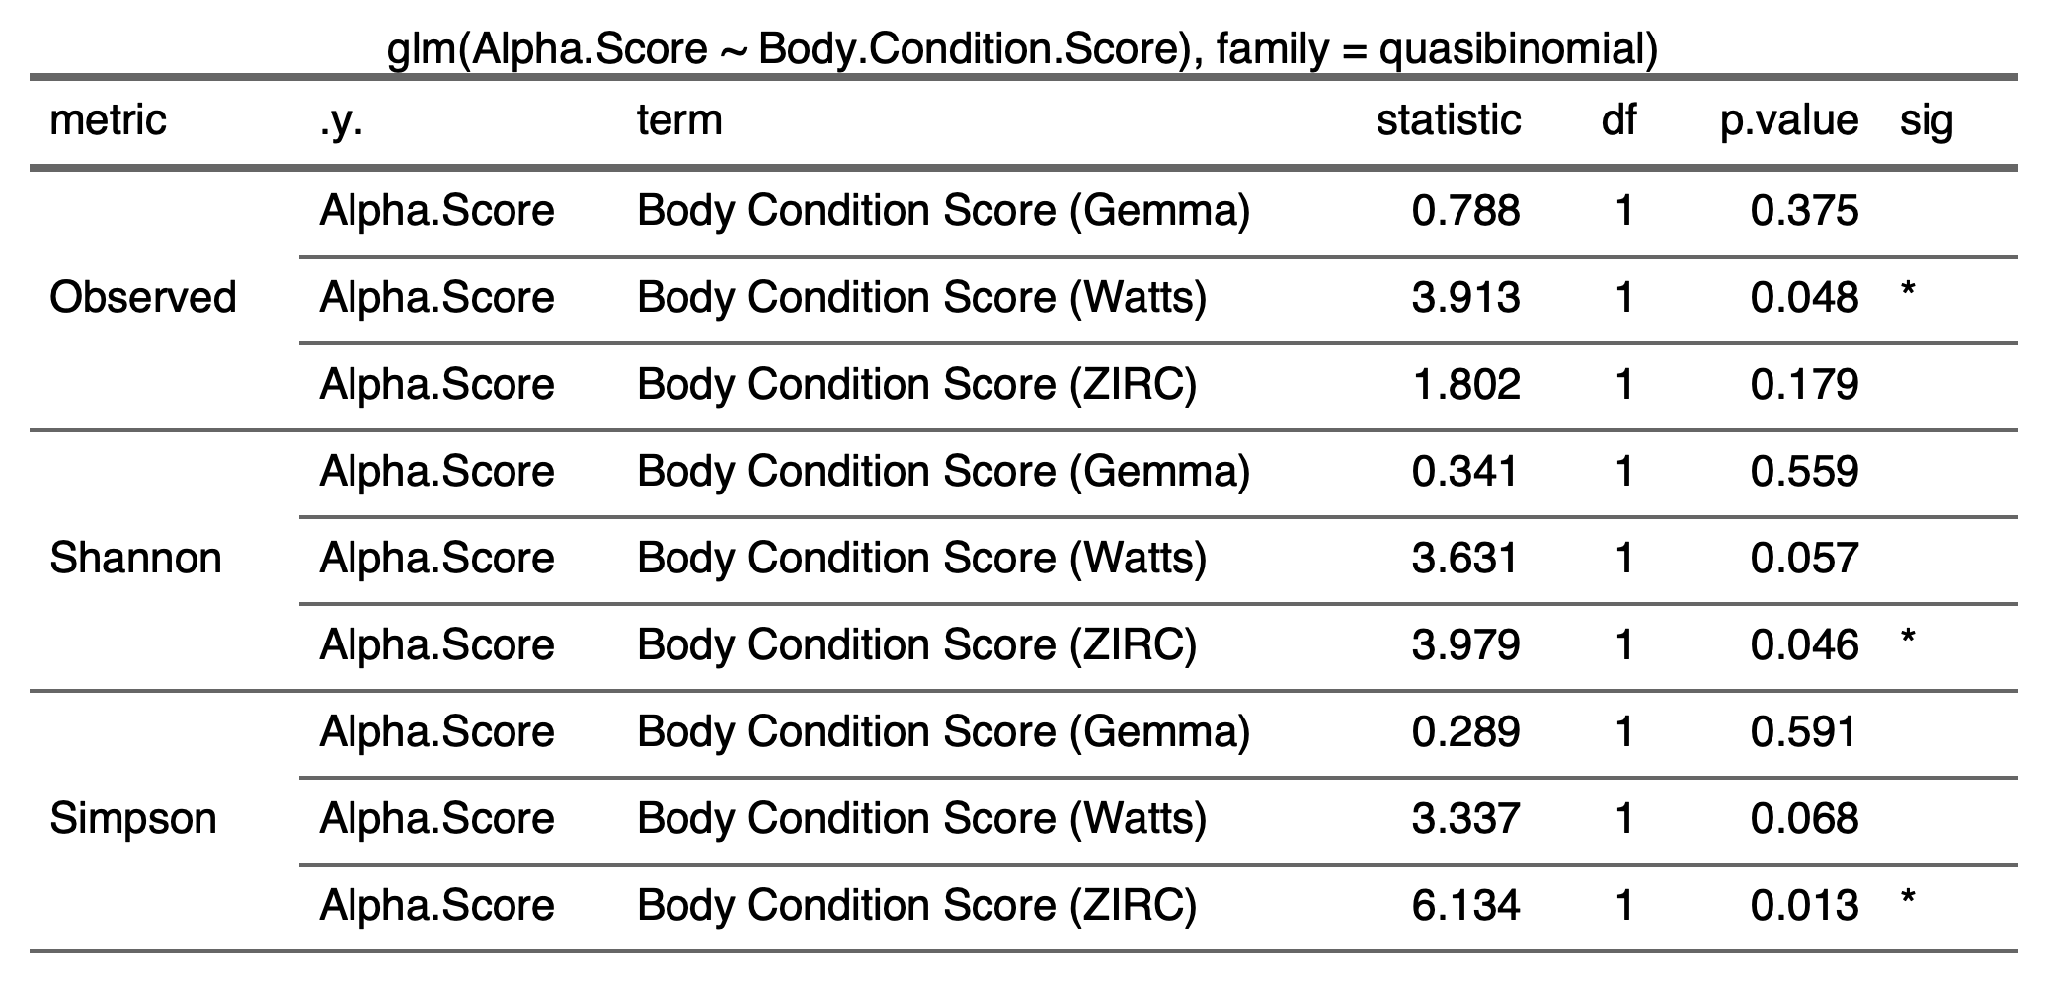

2.1.2.2) Beta Diversity
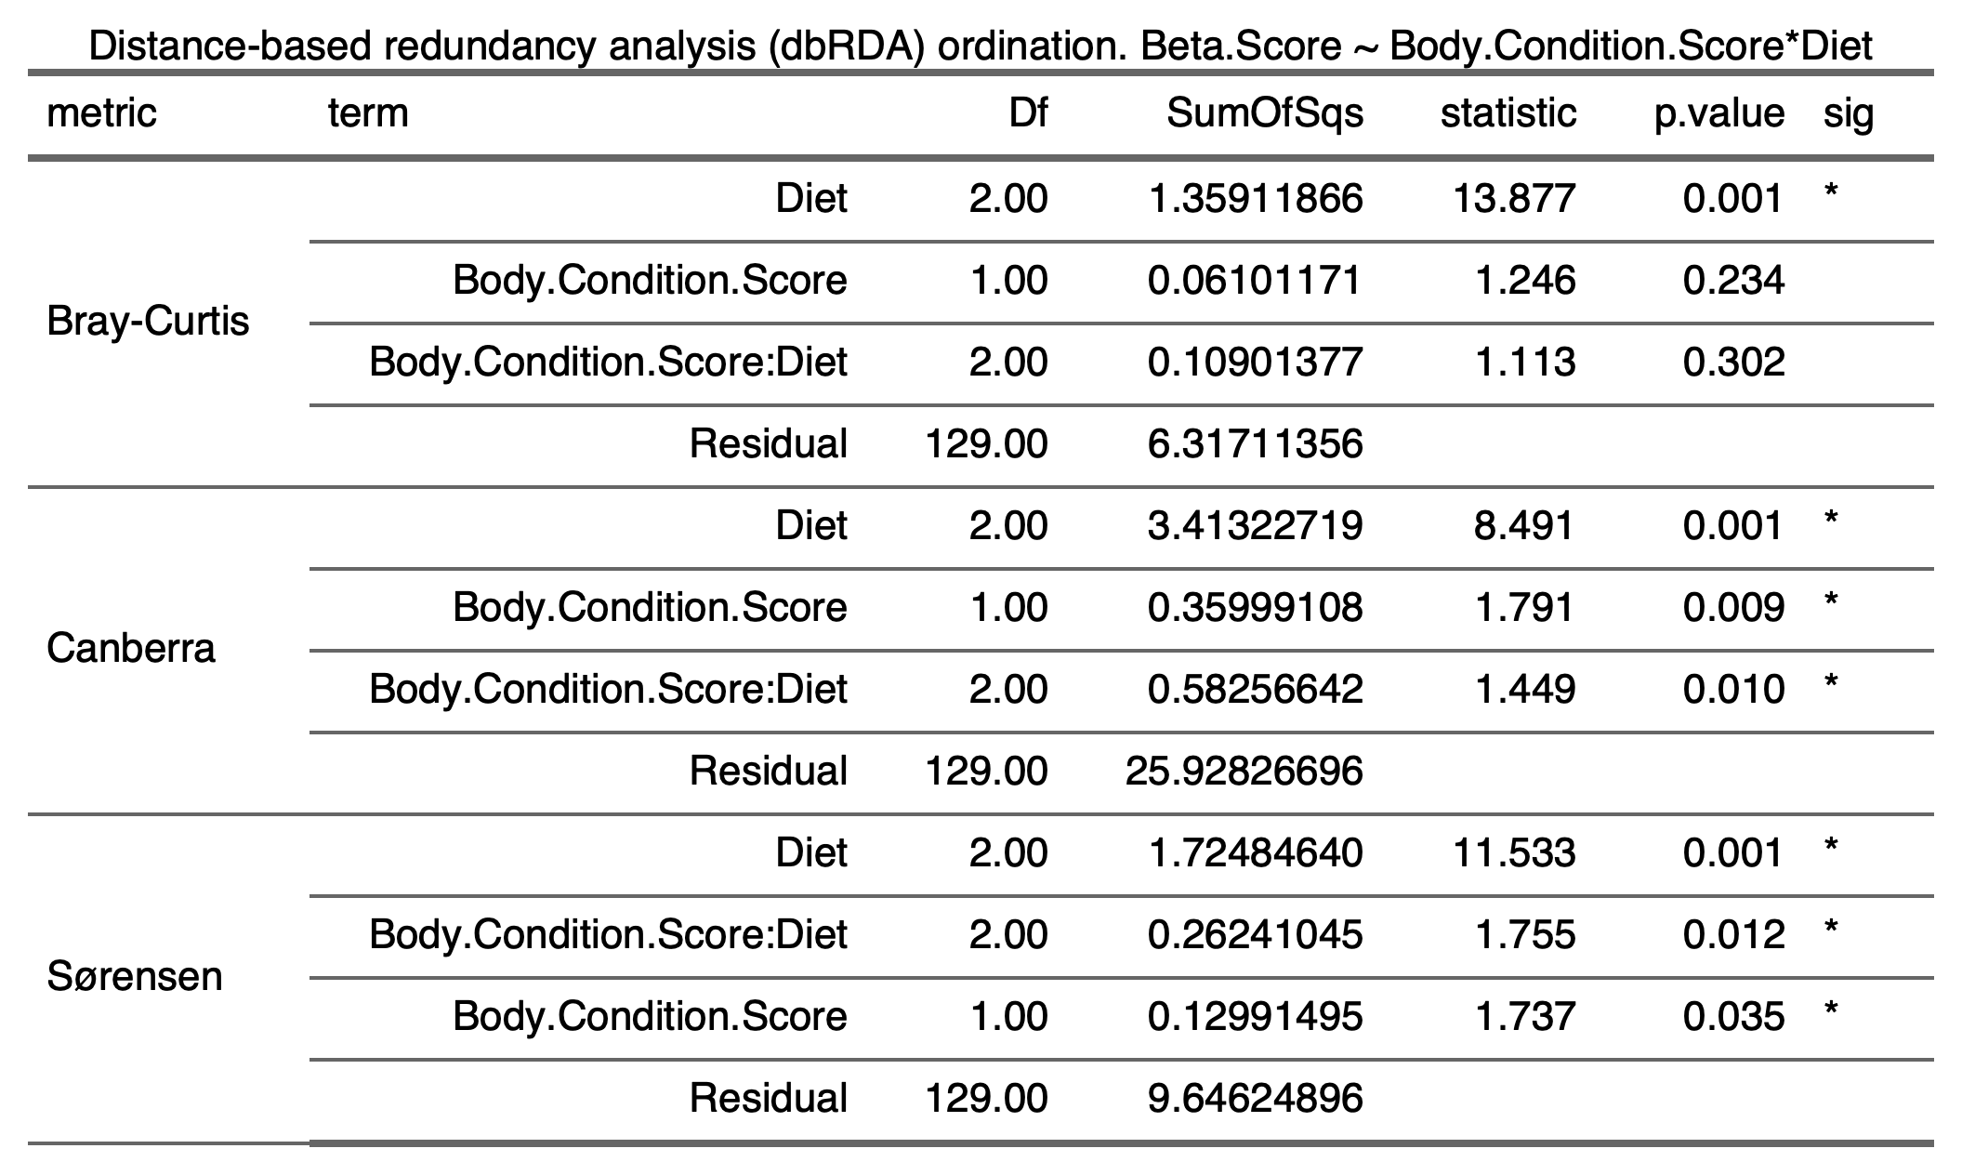

2.1.3) 7 mpf

2.1.3.1) Body Size

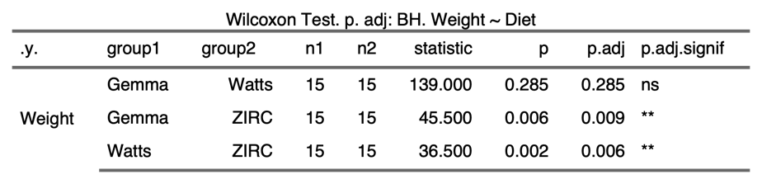

2.1.3.2) Alpha Diversity

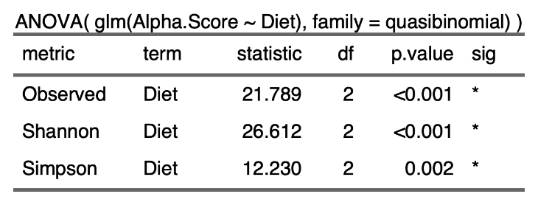

2.1.3.3) Beta Diversity

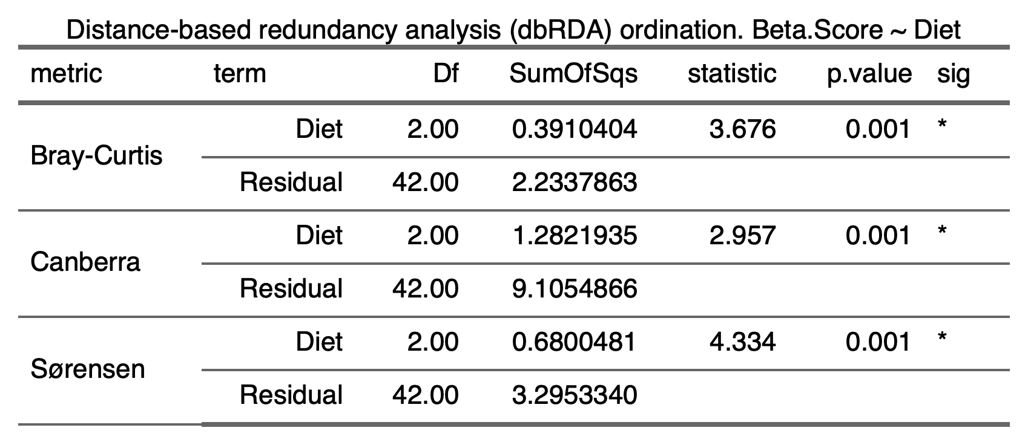

2.1.3.4) Beta diversity

Bray-Curtis | Canberra | Sørensen
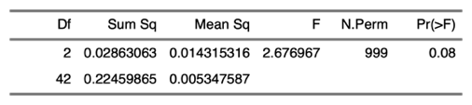  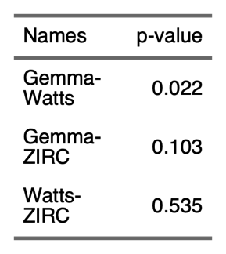 | 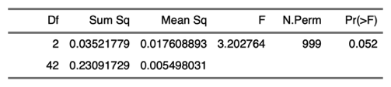  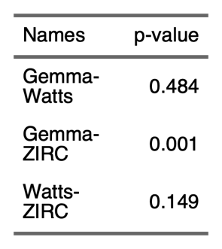 | 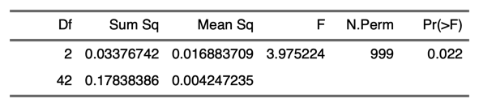  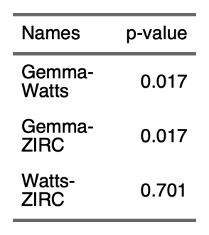

2.2) Alpha Diversity

2.2.1)
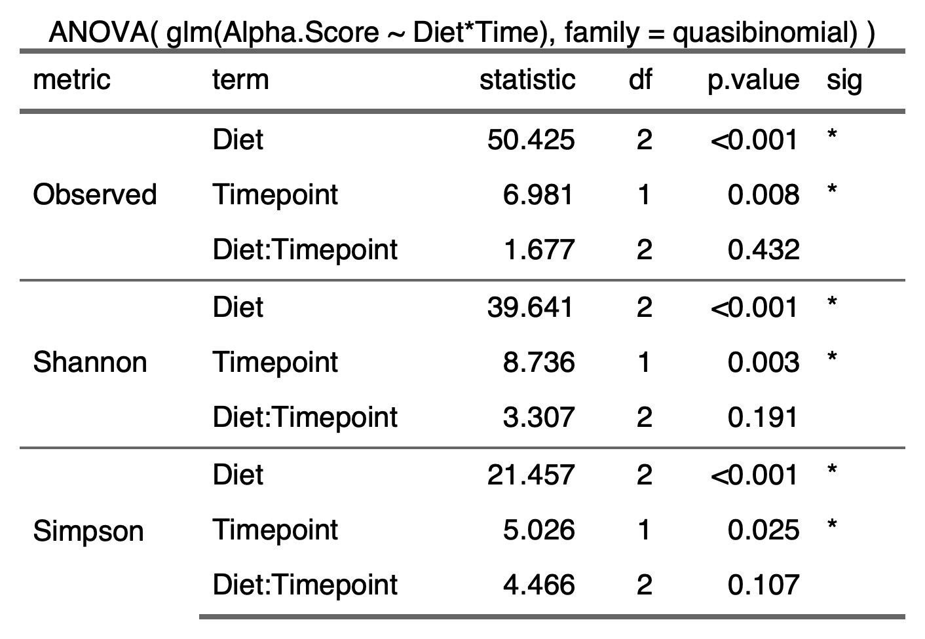
2.2.2)
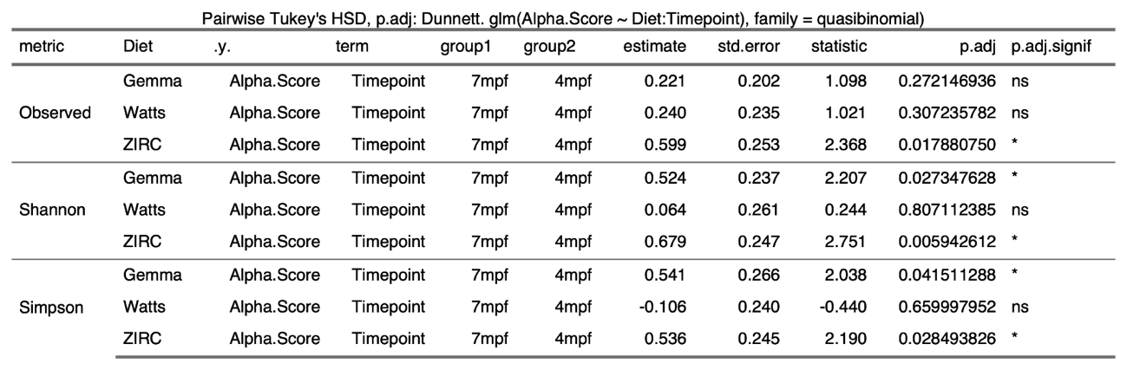

2.3) Beta Diversity

2.3.1)
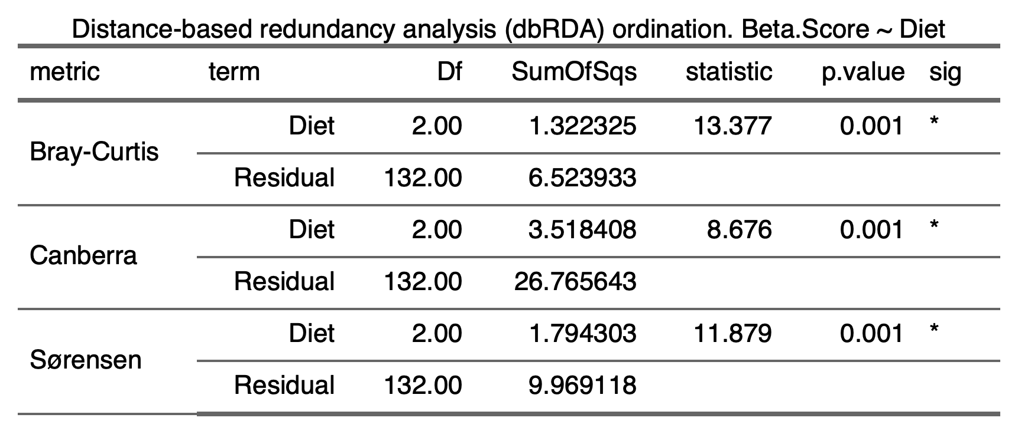

2.3.2)
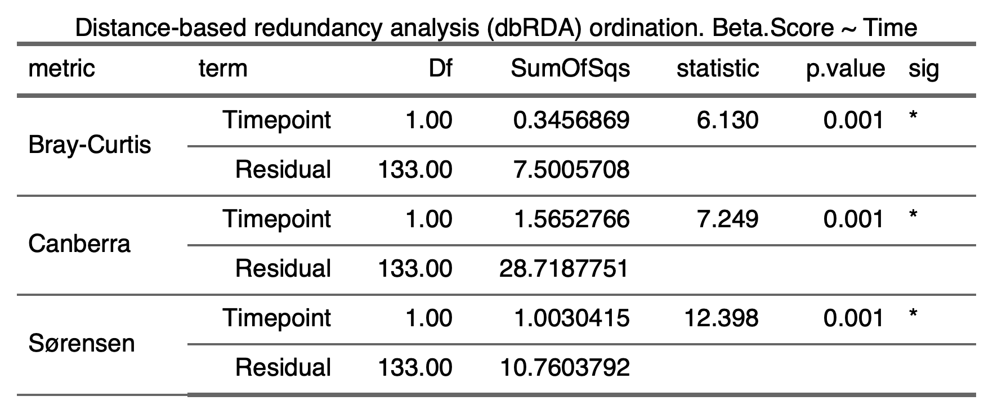

2.4) Beta Dispersion

2.4.1) Diet

2.4.1.1) Gemma Diet

Bray-Curtis | Canberra | Sørensen
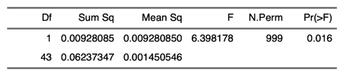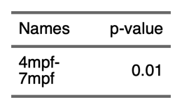 | 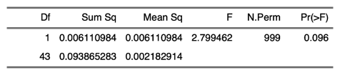  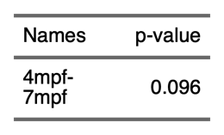 | 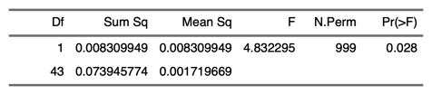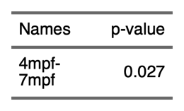

2.4.1.2) Watts Diet

Bray-Curtis | Canberra | Sørensen
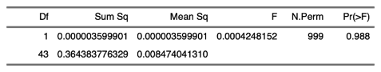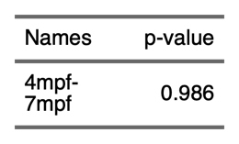 | 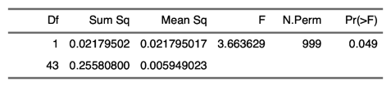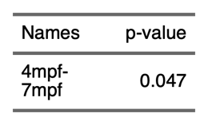 | 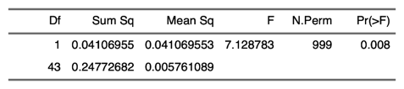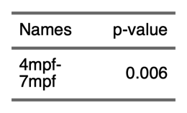

2.4.1.3) ZIRC Diet

Bray-Curtis | Canberra | Sørensen
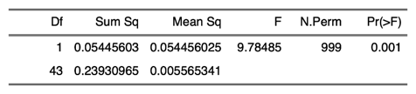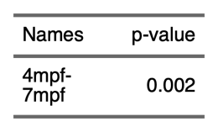 | 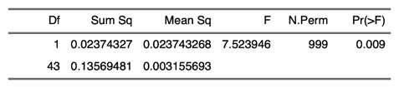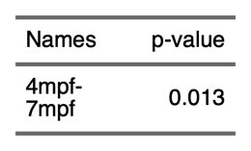 | 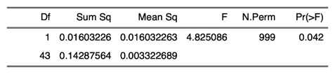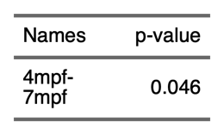

2.5) Differential Abundance

2.5.1) All diets (4 mpf vs 7 mpf)

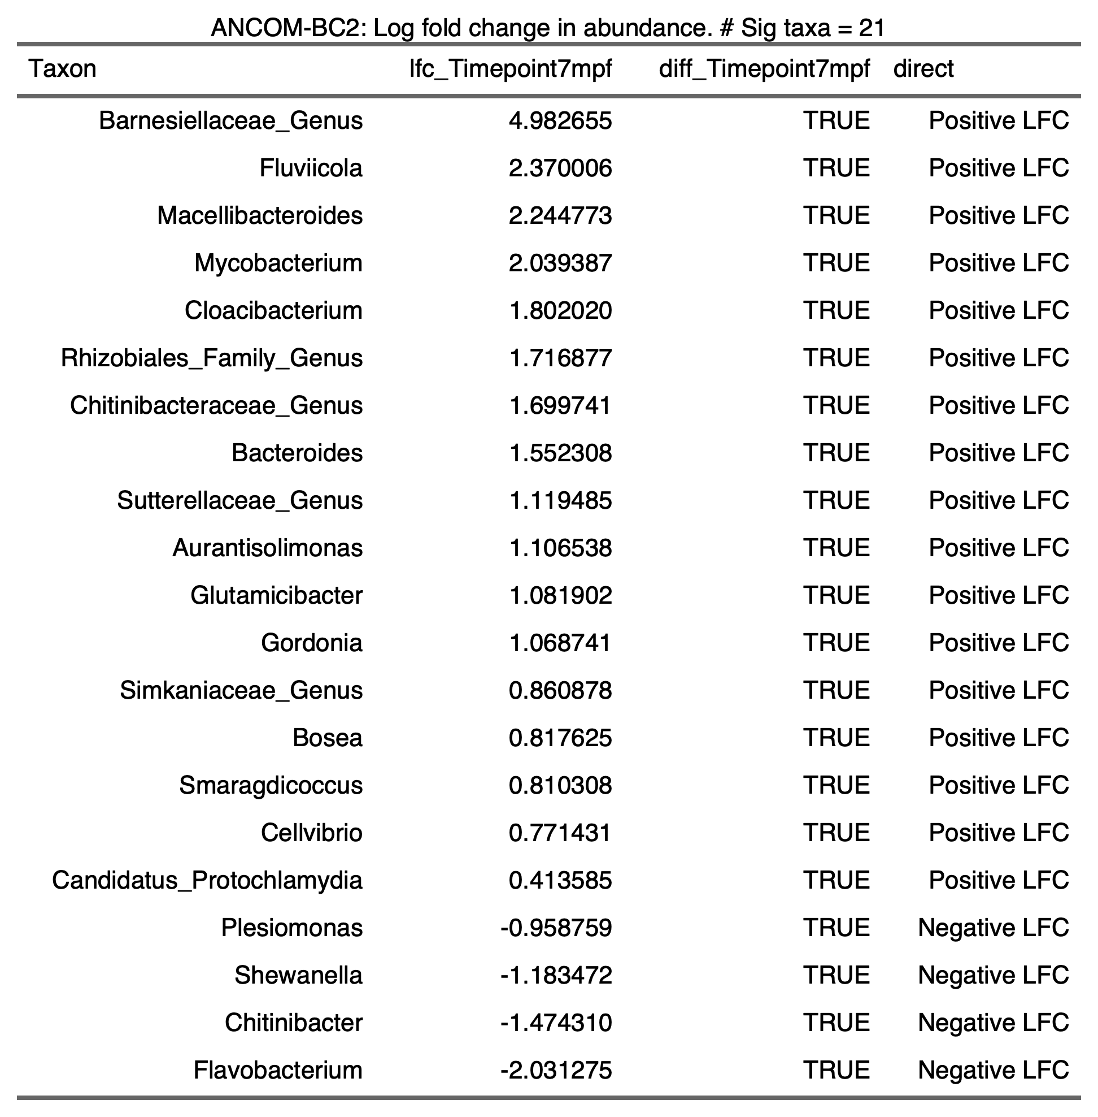

2.5.2) Gemma Diet

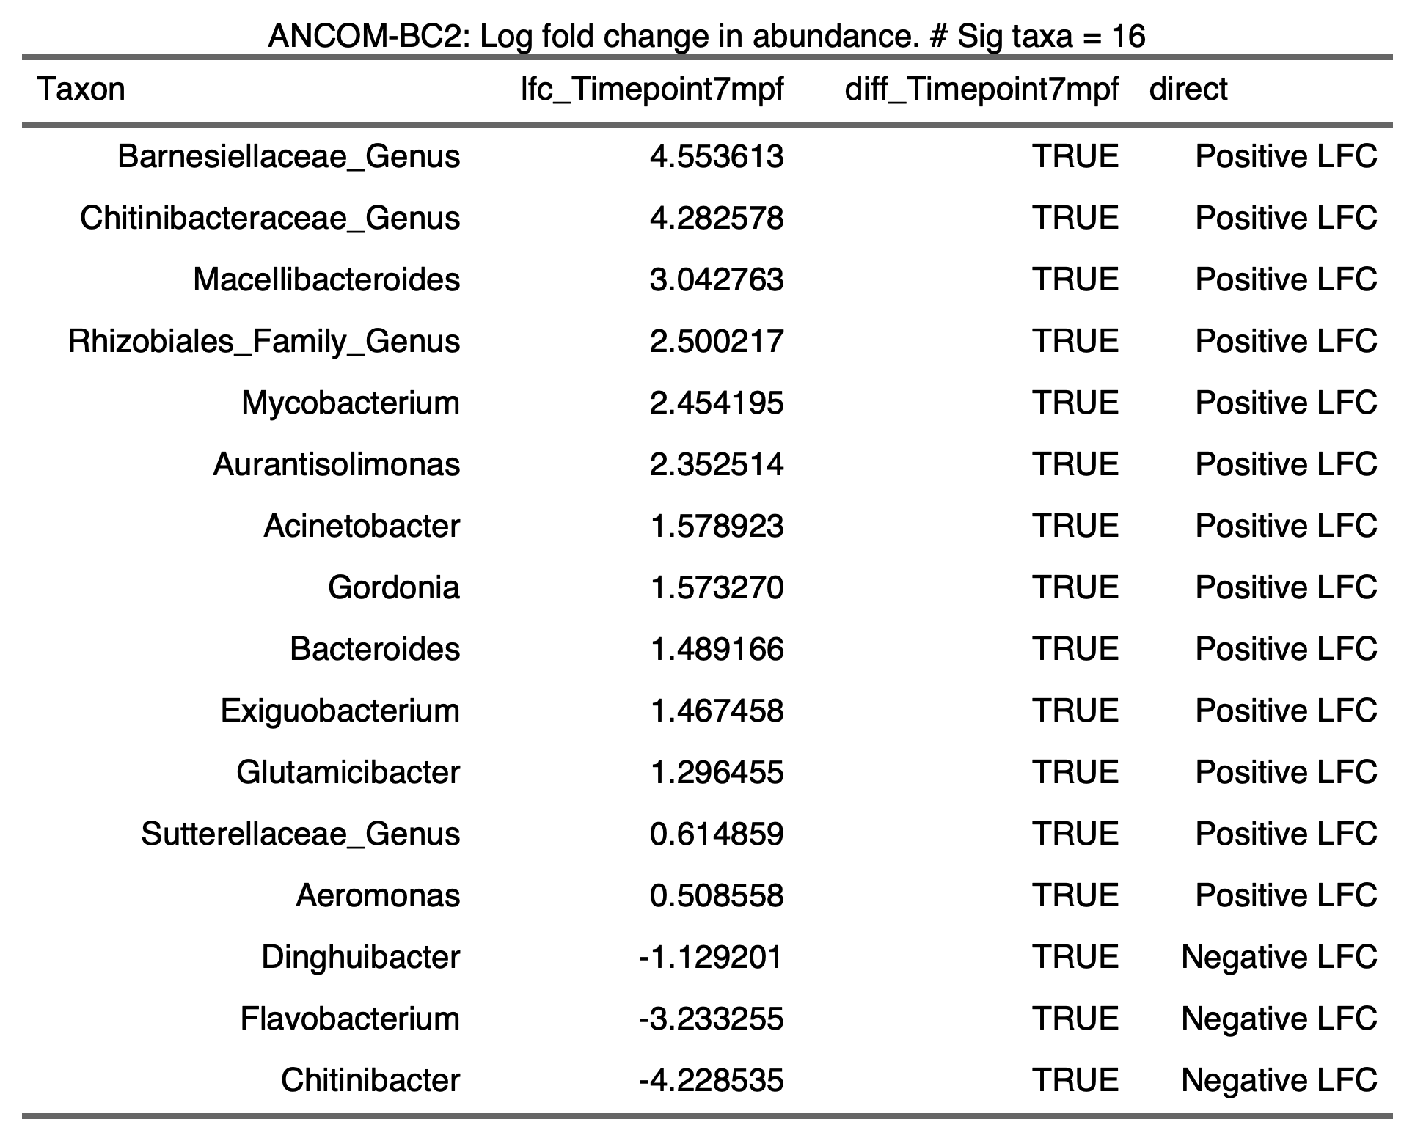

2.5.3) Watts Diet

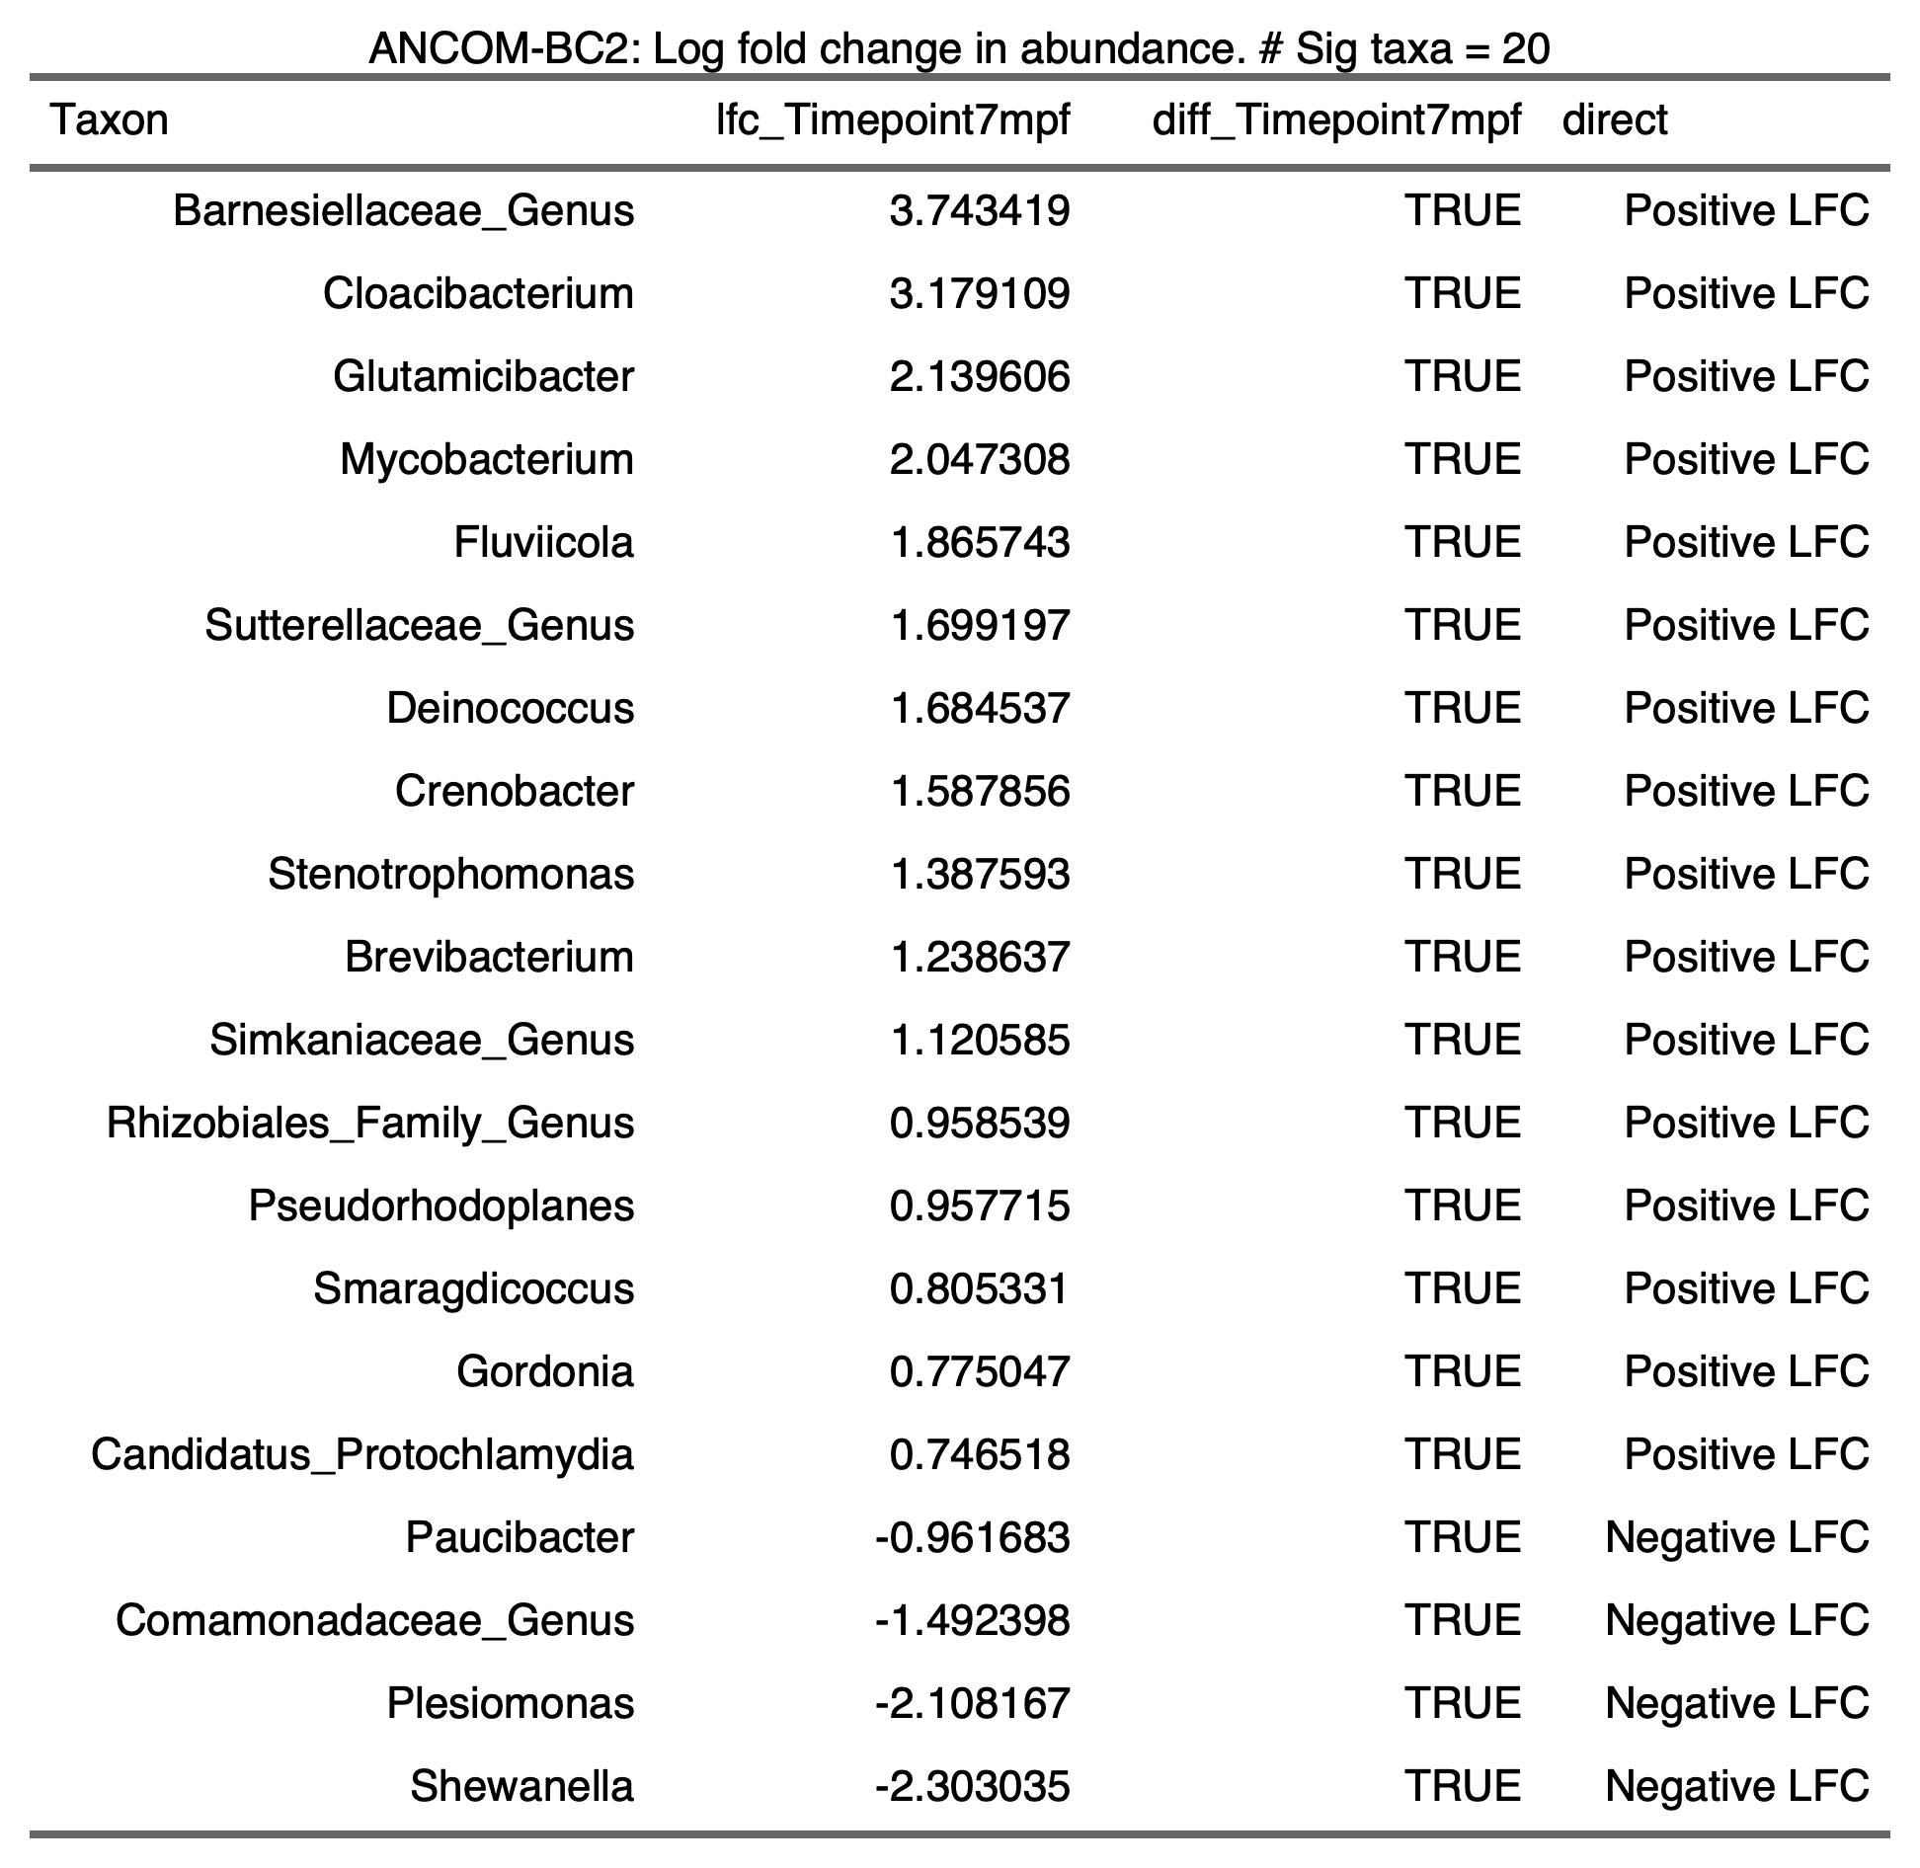

2.5.4) ZIRC Diet

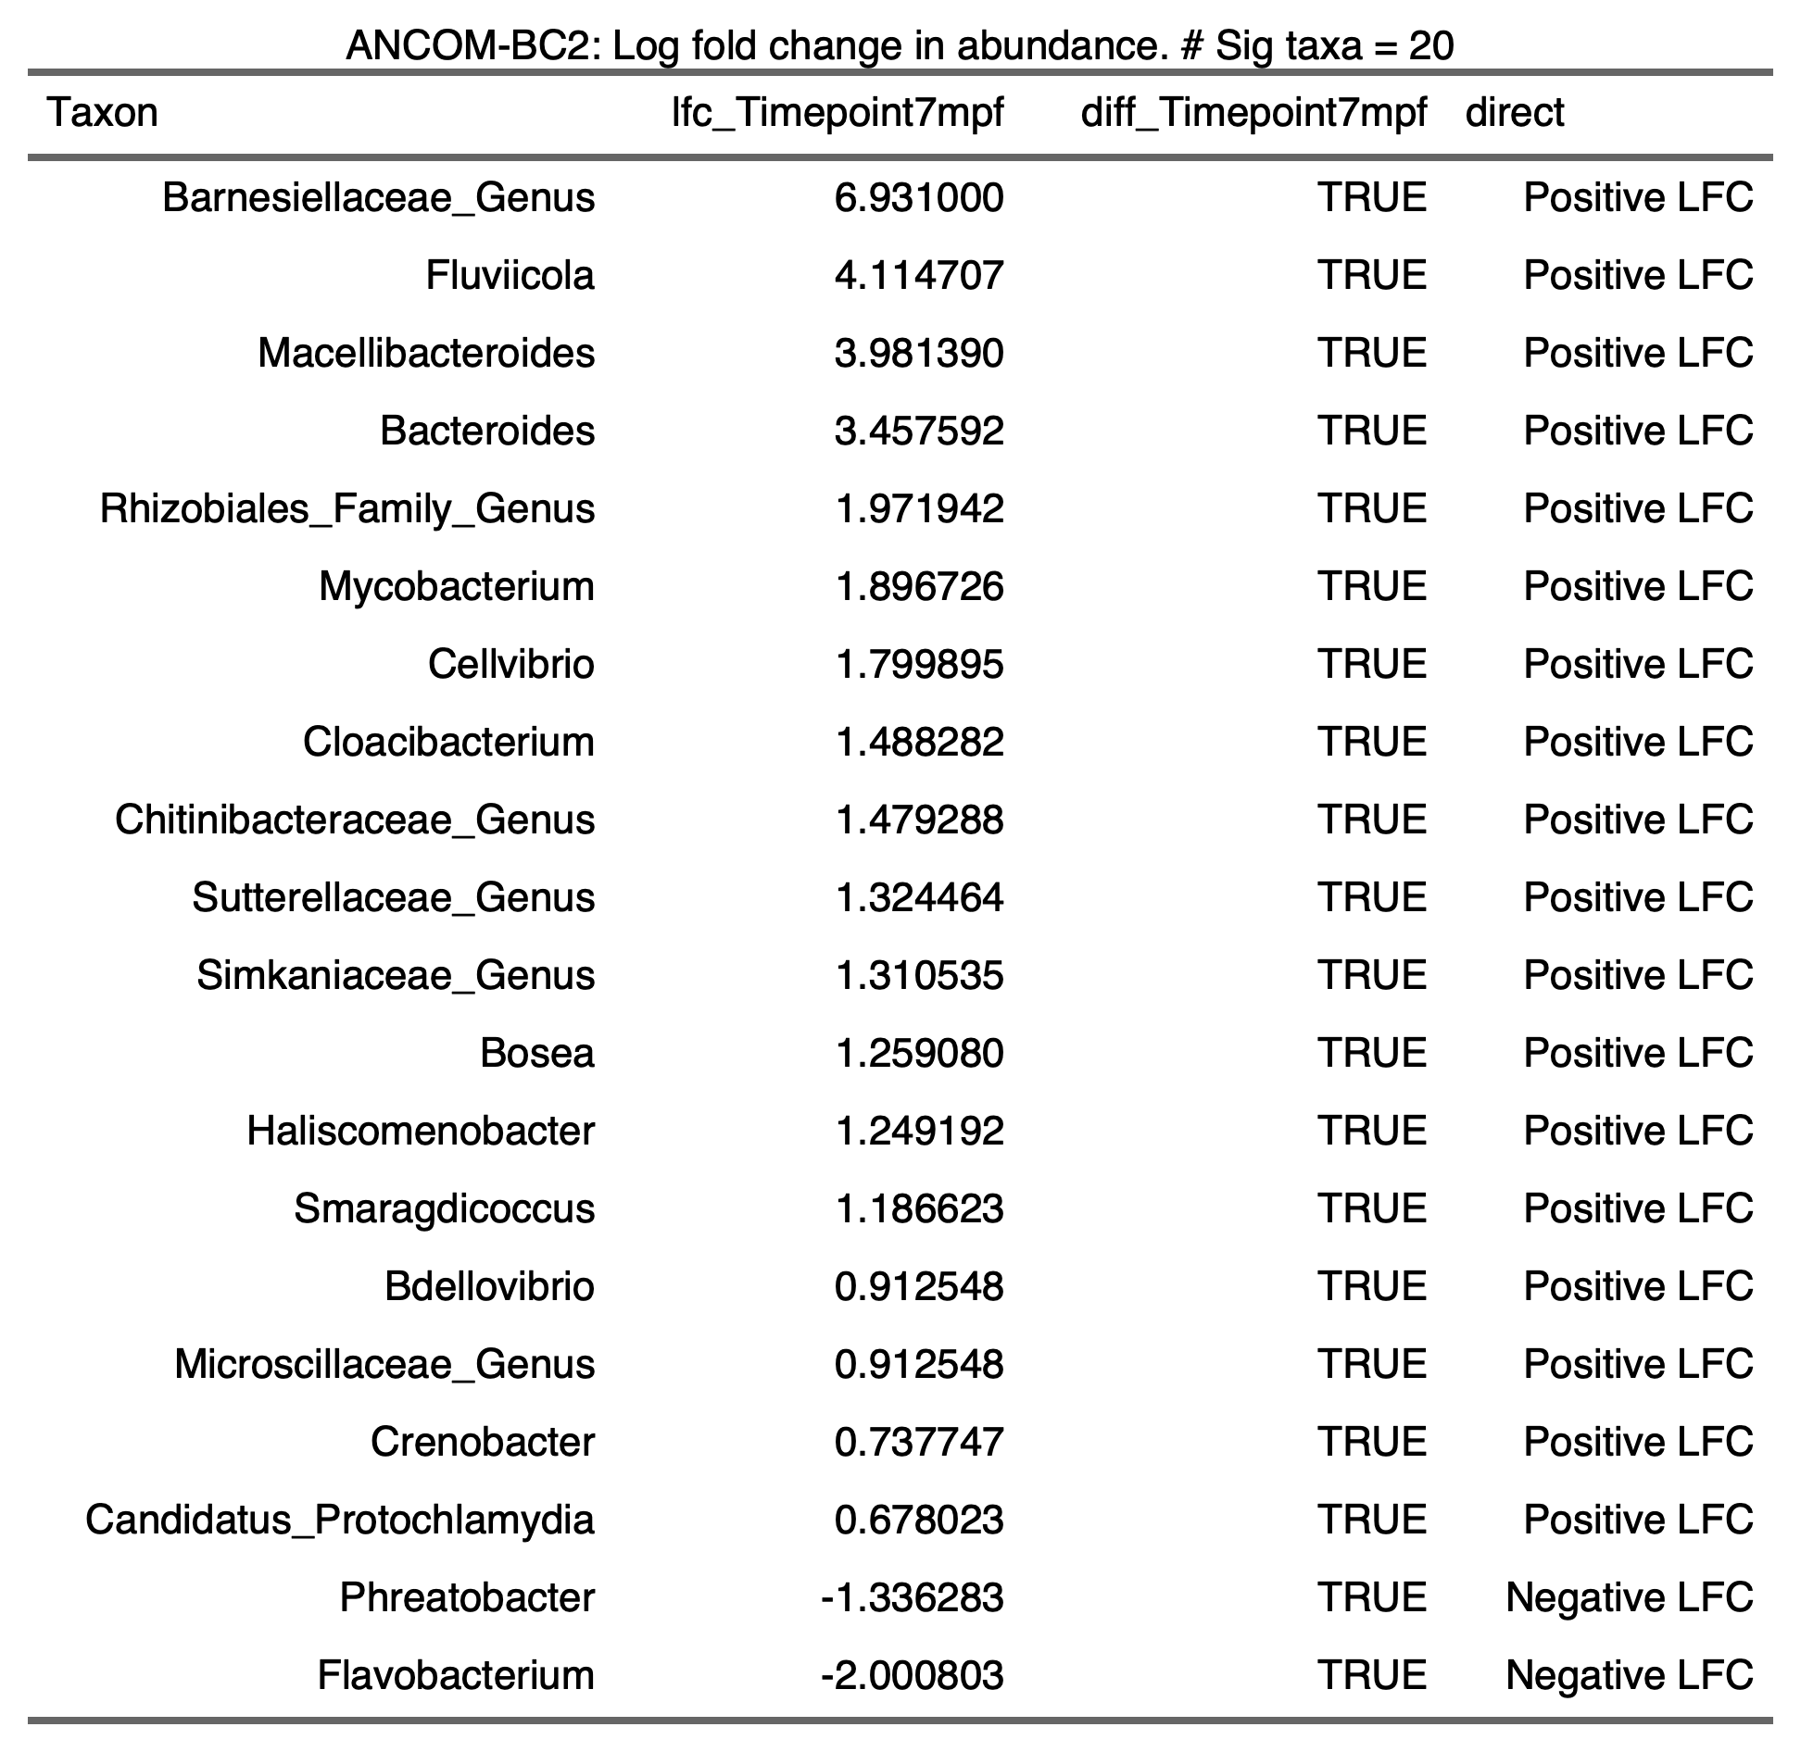

- Pathogen Exposure

3.1) Histopathology

3.1.1) Infection Counts ~ Diet + Sex

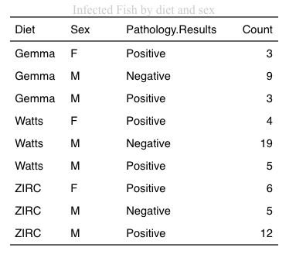
Asymptotic Pearson Chi-Squared Test
data: Var2 by Var1 (p, n)
chi-squared = 11.519, df = 2, p-value = 0.003152

3.1.2) Infection Counts ~ Diet (Males only)

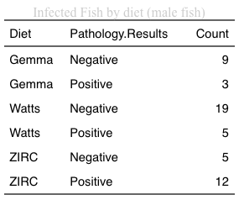
Asymptotic Pearson Chi-Squared Test
data: Var2 by Var1 (p, n)
chi-squared = 11.519, df = 2, p-value = 0.003152

3.1.3) Infection Counts ~ Diet (Males Only), microbiome sample subset

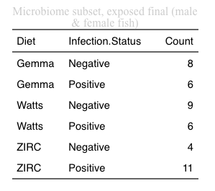
Asymptotic Pearson Chi-Squared Test
data: Var2 by Var1 (p, n)
chi-squared = 4.0699, df = 2, p-value = 0.1307

3.1.4) Body Condition Score ~ Diet*Infection Counts

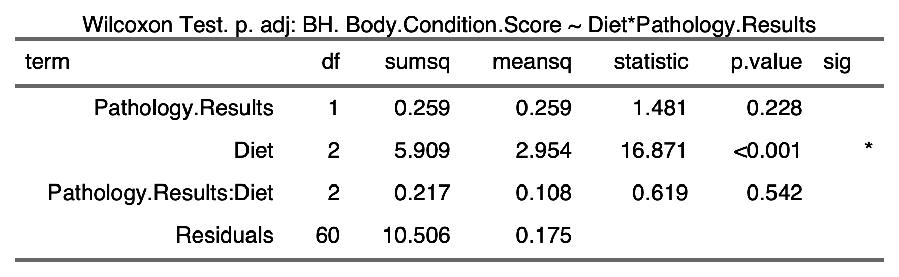

3.1.5) Alpha Diversity

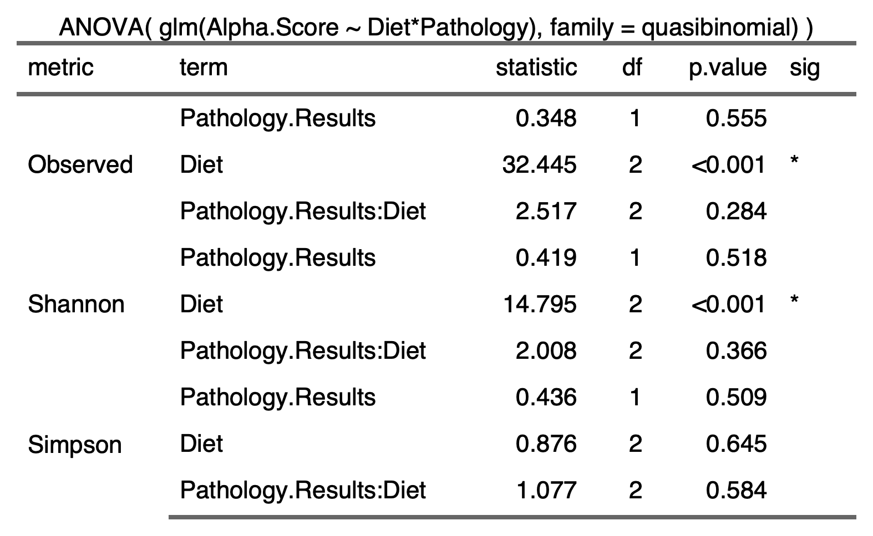

3.1.6) Beta Diversity

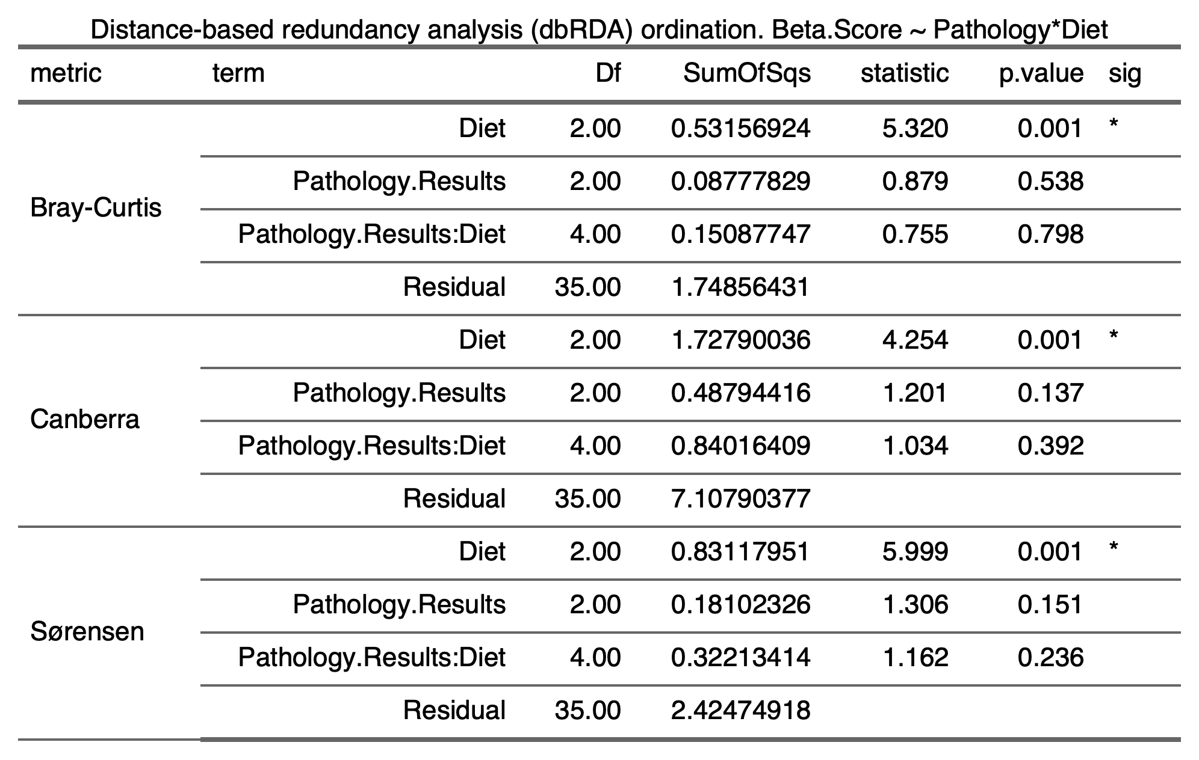

3.1.2)

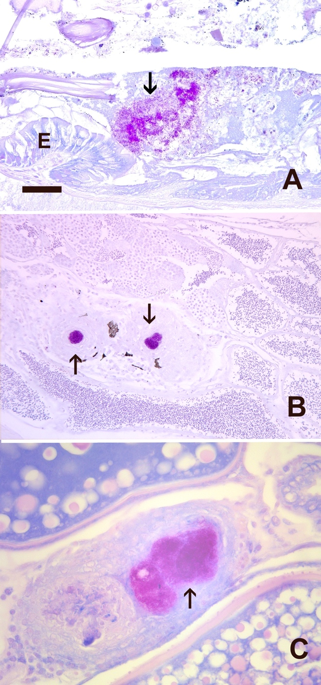

Figure 3.1Histologic sections stained with Kinyon’s acid fast statin in zebrafish exposed to Mycobacterium
chelonae. Bar = 25 um. Arrow = acid fast bacteria. A. Bacteria in intestinal lumen. E = intestinal
epithelium. B. Testis with two granulomas with acid fast bacteria. C. Ovary with two granulomas, one
containing abundant acid fast bacteria.

3.2) Alpha Diversity

3.2.1)

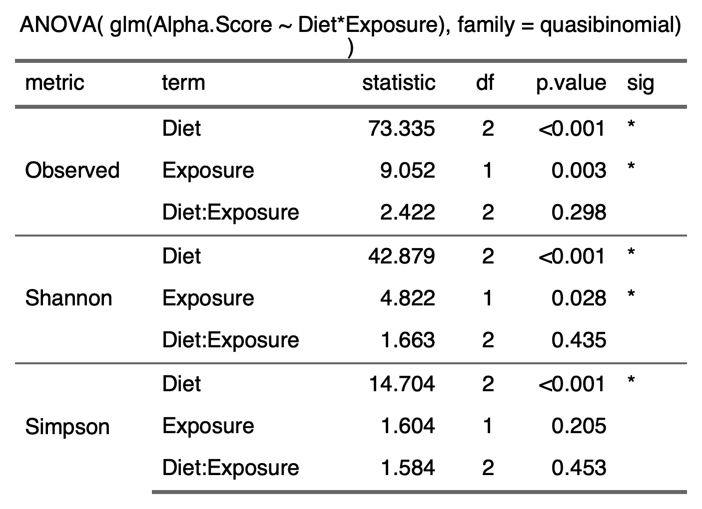

3.2.2)
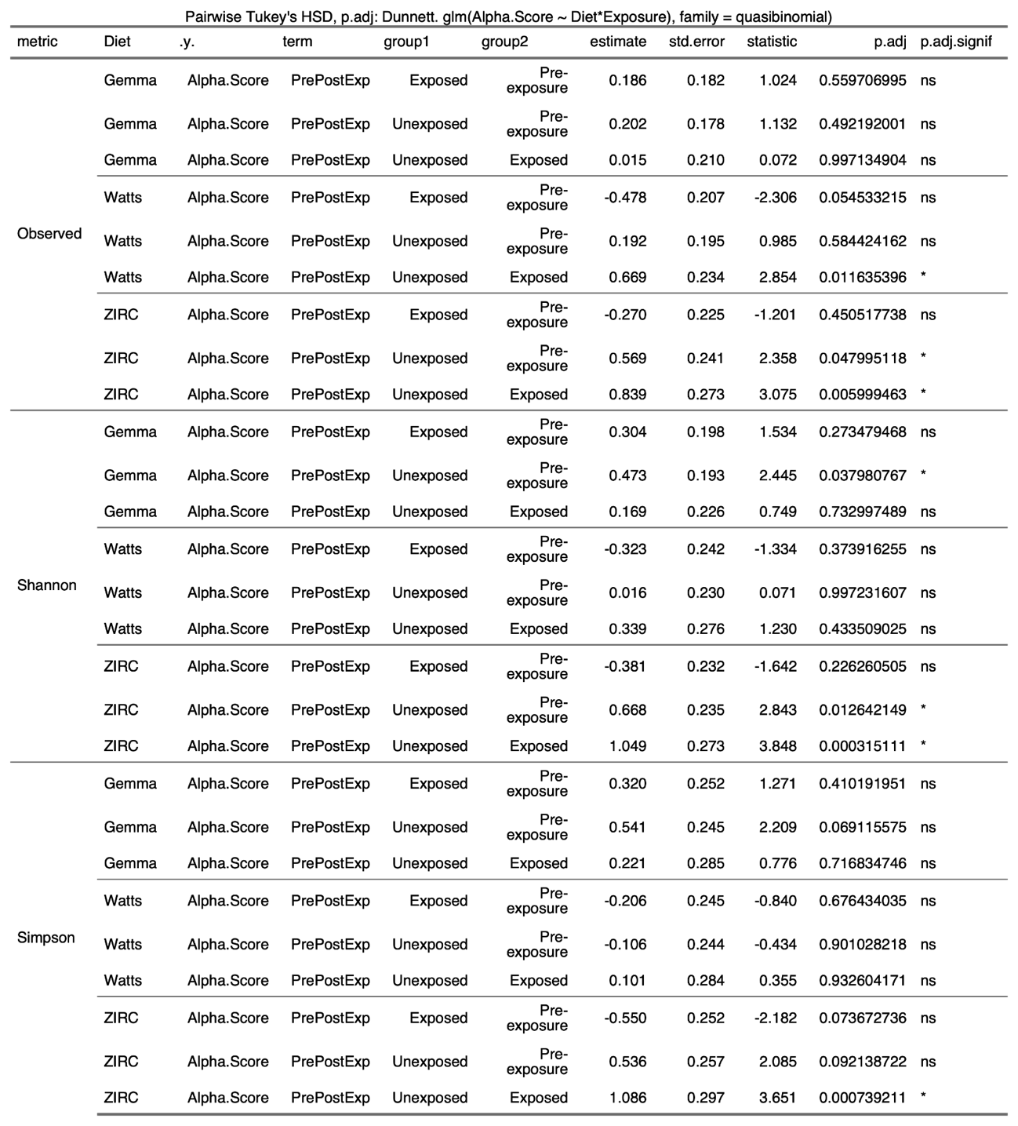

3.3) Beta Diversity

3.3.1)
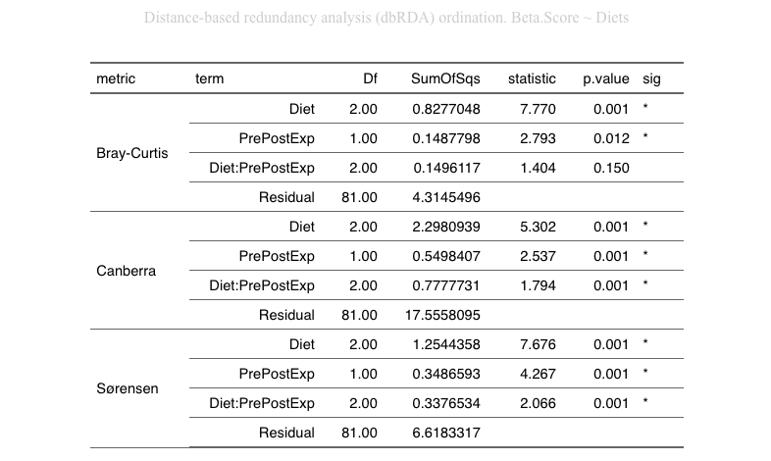

3.4) Beta Dispersion

3.4.1) Gemma Diet

Bray-Curtis | Canberra | Sørensen
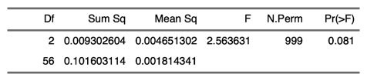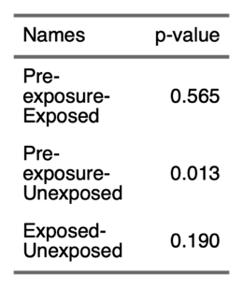 | 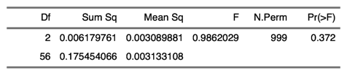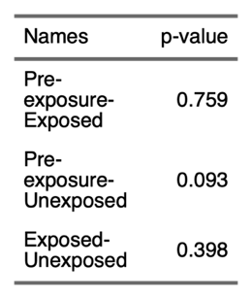 | 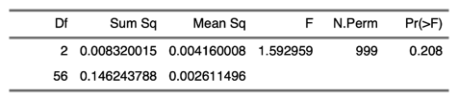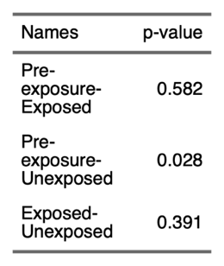

3.4.2) Watts Diet

Bray-Curtis | Canberra | Sørensen
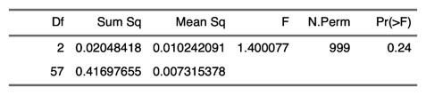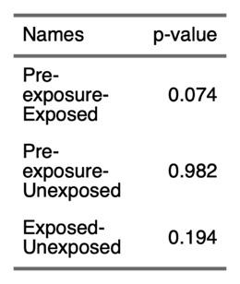 | 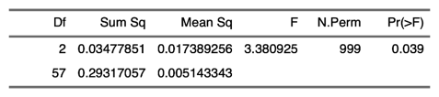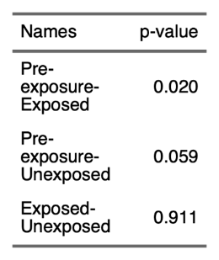 | 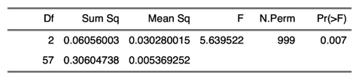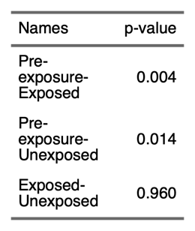

3.4.3) ZIRC Diet

Bray-Curtis | Canberra | Sørensen
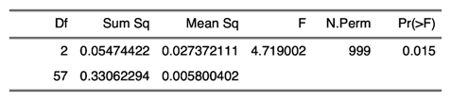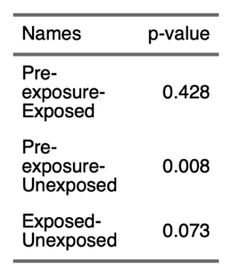 | 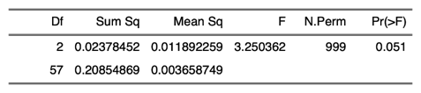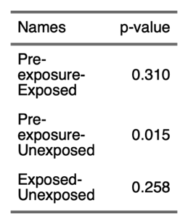 | 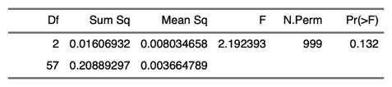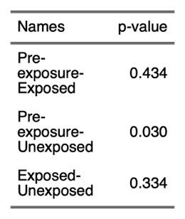

3.5) Differential Abundance

3.5.1) All Diets

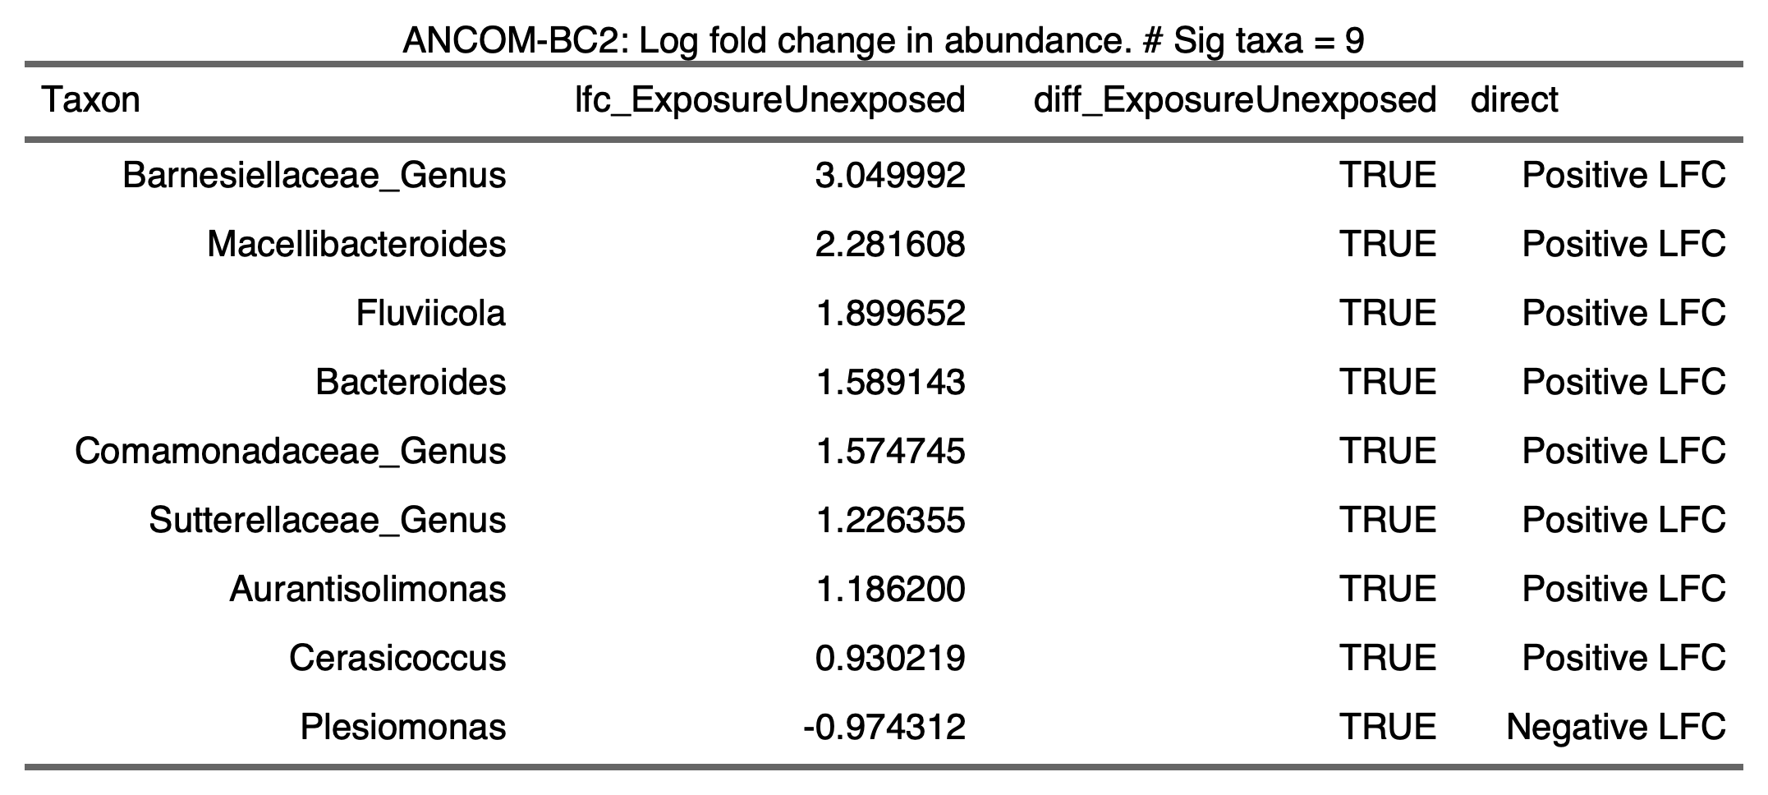

3.5.2) Gemma Diet

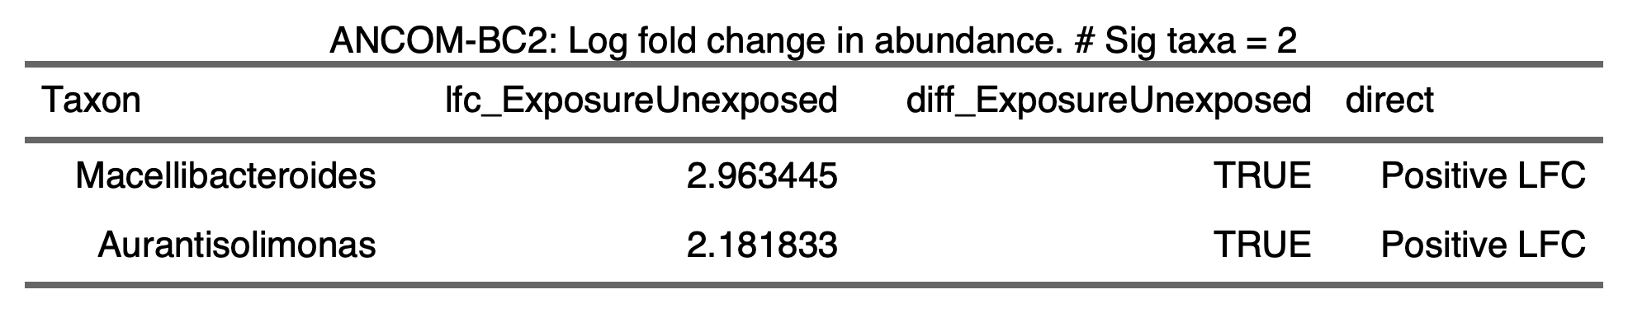

3.5.3) Watts Diet

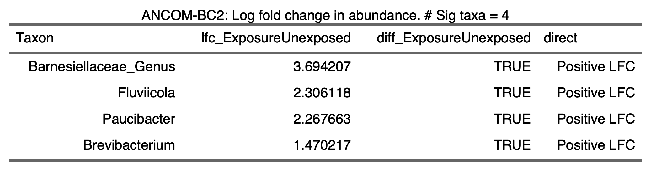

3.5.4) ZIRC Diet

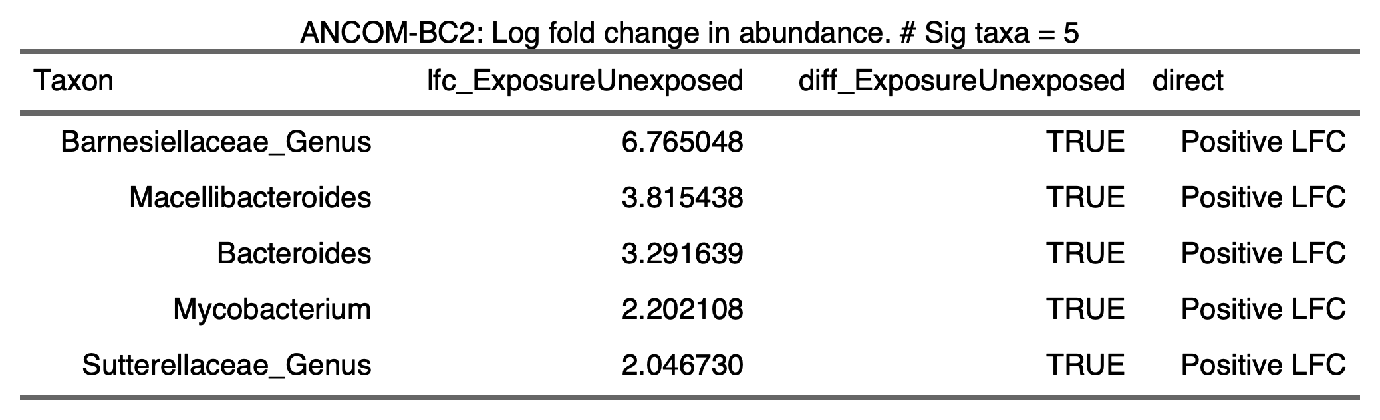

3.5.5)

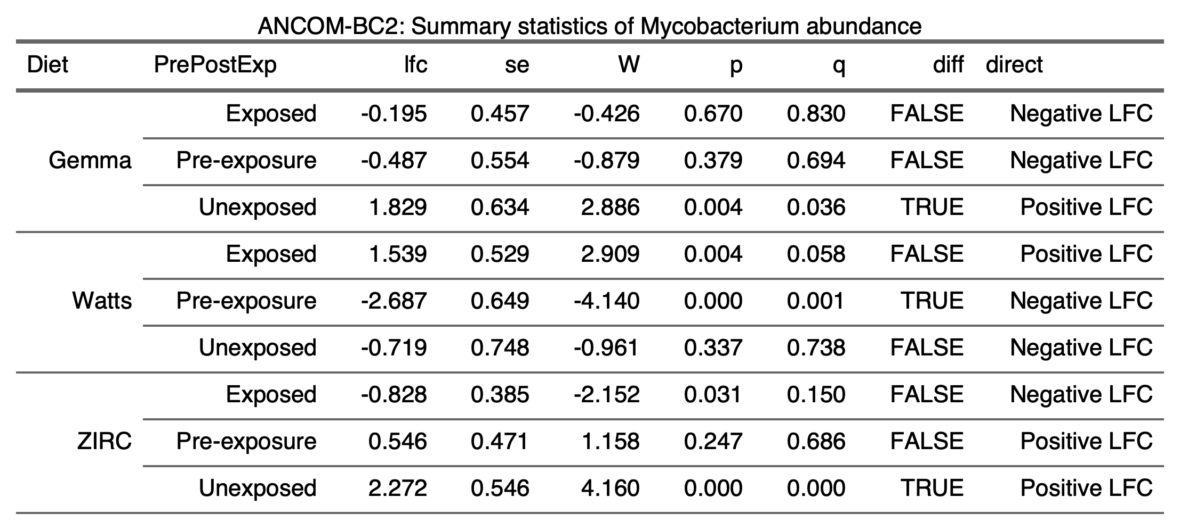

- Diet Nutrition and Formulations

4.1.1) Proximate and elemental analysis
