The distribution of Western flower thrips trapped on yellow cylinder

SUPPORTING INFORMATION
Additional supporting information can be found online in the Supporting Information section at the end of this article.

Fig S1. The spectrum of light in the assay chamber at the wind tunnel, as reflected from a spectralon plate, expressed in quantum flux. The overhead illumination for the assay chamber was designed to simulate the wavelength spectra of natural sunlight using commercially available LEDs (LED-strip – Full-color RGB + Warm White – 24V High Power Protected 5050, LuxaLight, NL). The spectrum of light in the assay chamber at the wind tunnel, as reflected from a spectralon plate, is presented in Fig. S1. The light was measured using a broadband spectroradiometer Specbos 1211 UV (JETI Technische Instrumente GmbH, Germany). The spectrum used did not include light in the ultraviolet (UV) and infrared (IR) ranges because preliminary trials indicated they had no effect on WFT attraction to yellow traps. The sum quantum flux of light in WFT visual range (400-635 nm) was 3.44 µmol/(sr*m²*s*). We had to cover the roof of the chamber with a light diffusing polyethylene film (C980 Suncover Nectarine Diffused, Ginegar Plastic Products, Israel) to overcome the strong attraction of WFT toward the light sources. Inside the chamber, all light reflecting surfaces were covered with black cloth.

Fig. S2. The yellow cup used as an attractive trap for WFT in the wind tunnel studies.

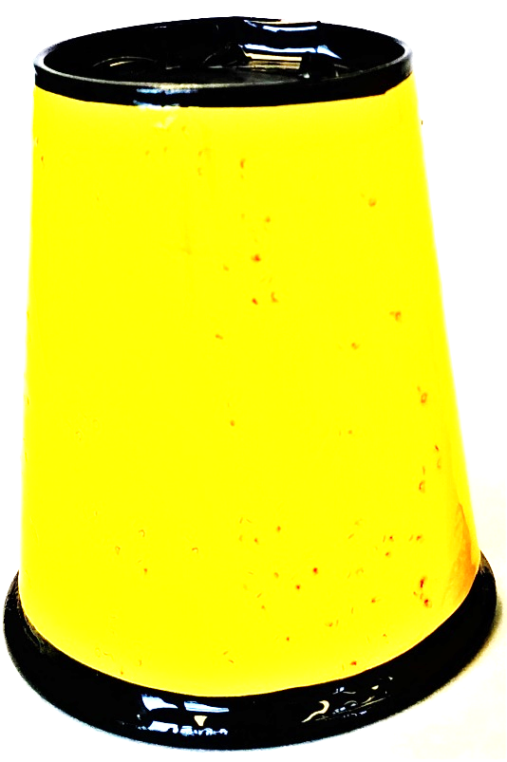

Fig. S3. A scanning electron microscope photo of adult WFT head. For insects with compound eyes, the size of an interommatidial (IO) angle is calculated by dividing the field of view by the number of ommatidia. An adult WFT has an estimated field of view of 100°-135° and 10 ommatidia in the equator of their compound eye. Thus, the size of WFT IO angle is estimated to range between 10° to 14°.

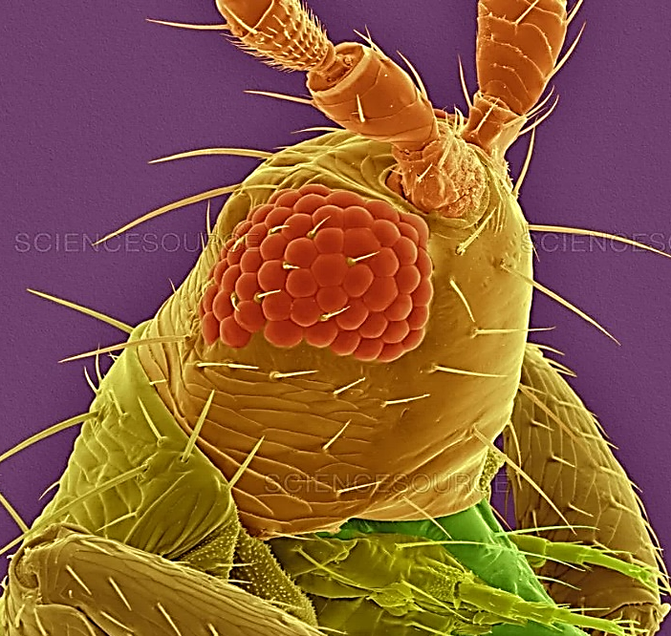
https://fineartamerica.com/featured/3-western-flower-thrips-adult-dennis-kunkel-microscopyscience-photo-library.html

