Supplemental Figures

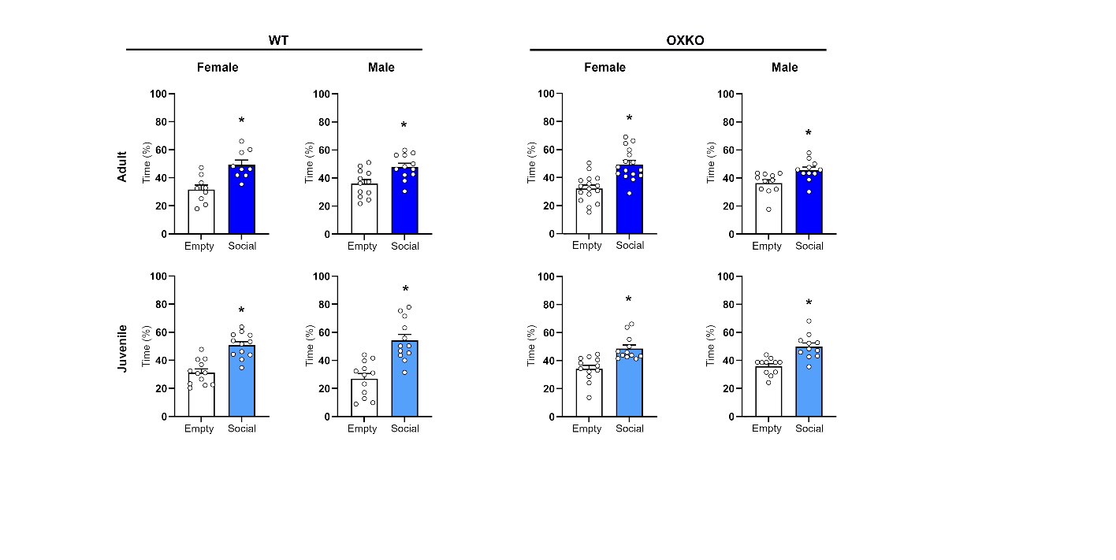
Supplemental Figure 1. OX^{-/-} mice have normal sociability. Adult female, adult male, juvenile female, and juvenile male WT and OX^{-/-} mice spend more time in the chamber of an age- and sex-matched mouse (Social) than in an empty chamber. WT mice: adult female (n=9, p=0.026); juvenile female (n=12, p=0.0026); adult male (n=12, p=0.046); juvenile male (n=12, p=0.0047). OX^{-/-} mice: adult females (n=16, p=0.0036); juvenile females (n=12, p=0.011); adult males (n=11, p=0.0094); juvenile males (n=11, p=0.0096). *, p <0.05 vs. empty chamber.

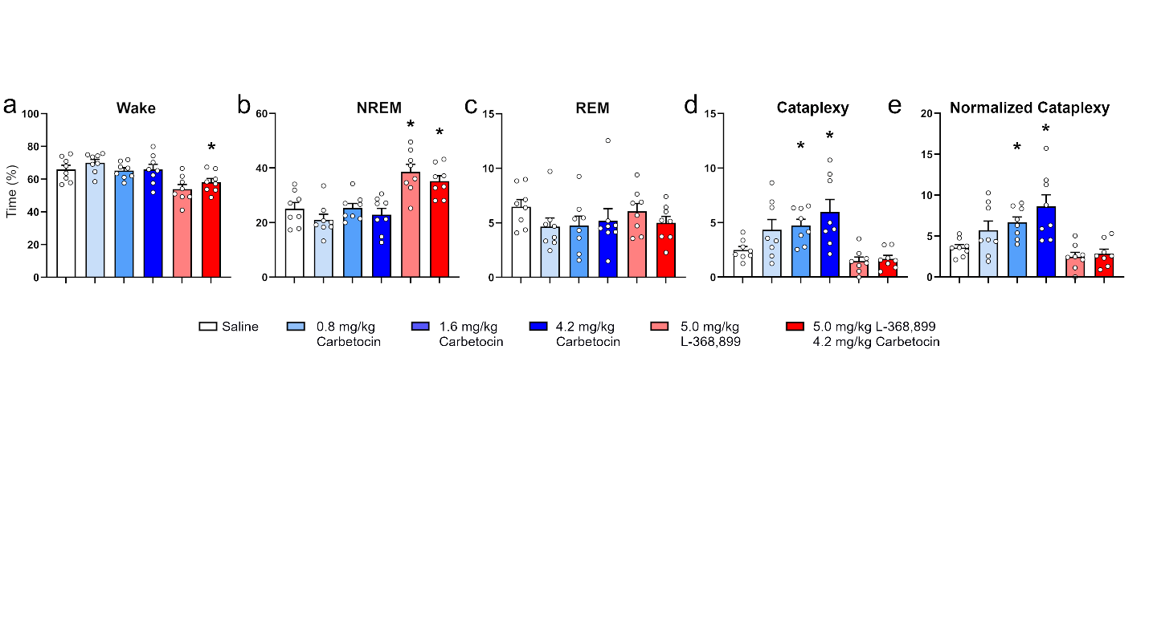

Supplemental Figure 2. An oxytocin agonist increases cataplexy but does not alter sleep/wake states. (a-c) The oxytocin agonist carbetocin does not alter the amounts of time in (a) Wake (F(1.6,11.1)=1.5, p=0.26), (b) NREM sleep (F(2.4,16.5)=1.5, p=0.26), or (c) REM sleep (F(1.5,10.4)=1.7, p=0.22). The oxytocin antagonist L368,899 (5mg/kg) increases NREM sleep (F=2.15,15)=15.1, p=0.0002) and reduces wake (F=(2.13,14.9)=9.2, p=0.002). (d, e) Carbetocin dose-dependently increases time in cataplexy (F_{(2,14)}=3.9, p=0.044), and this effect is blocked by L-368,899, including when cataplexy is corrected for the amount of Wake. *, p< 0.05 vs. saline.

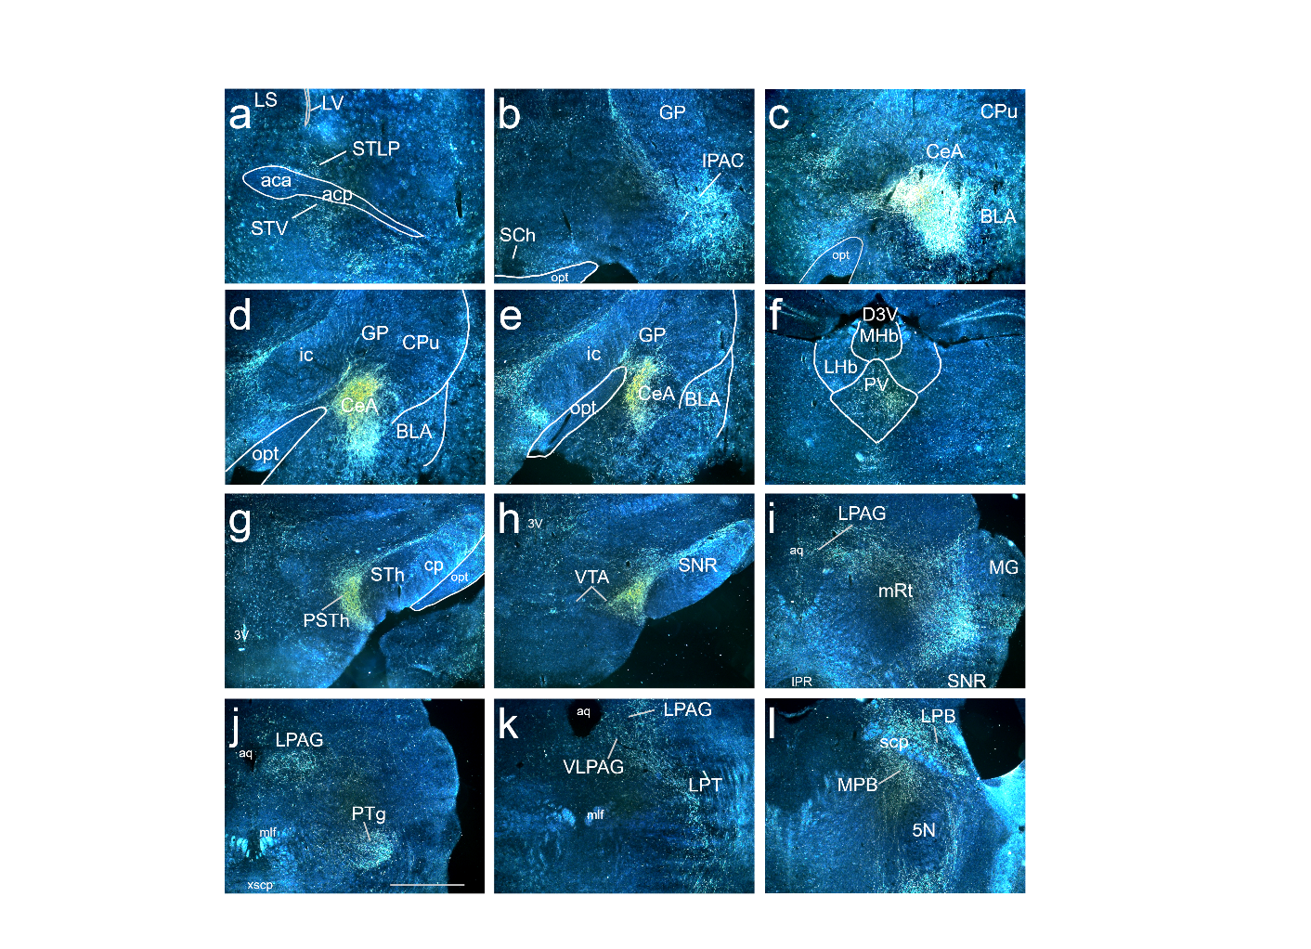
Supplemental Figure 3. CeA^{OTR} neurons project to REM atonia-suppressing regions. Anterograde tracing from the CeA of OTR-Cre mice injected with AAV-DIO-ChR2-mCherry. a) terminals in STLP, b) pre amygdala region, c-e) injection site. f) paraventricular thalamic region, g) parasubthalamic nucleus, h) VTA, i) lateral PAG and mRT. j) lateral PAG and PTG, k) ventrolateral PAG, and l) medial and lateral parabrachial nucleus.

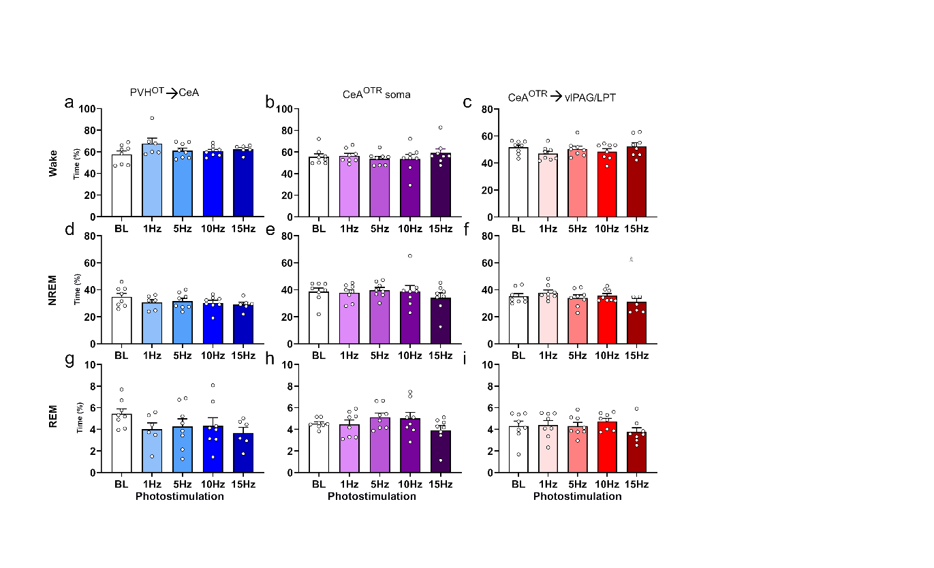
Supplemental Figure 4. Photoactivation of the PVH^{OT}→ CeA^{OTR}→ vlPAG pathway does not alter Wake or sleep. (a, d, g) Photostimulation of PVH^{OT} terminals in the CeA across the 12-hour dark period does not alter the amounts of Wake (F_{(1.7,10.1)}=1.4, p=0.28), NREM sleep (F_{(1.7,10.2)}=1.2, p=0.33), and REM sleep (F_{(2.3,13.6)}=1.4, p=0.28). (b, e, h) Photostimulation of the CeA^{OTR} soma does not alter time spent in Wake (F_{(1.6,11.4)}=1.18, p=0.33), NREM sleep (F_{(1.7,12)}=0.99, p=0.39), and REM sleep (F_{(2.6,18.14)}=2.6, p=0.09). (c, f, i) Photostimulation of the CeA^{OTR} terminals in the vlPAG/LPT does not alter the amount of Wake (F_{(2,13.7)}=2.16, p=0.15), NREM sleep (F_{(2.4,16.6)}=2.5, p=0.11), or REM sleep (F_{(3,21.24)}=1.9, p=0.17).

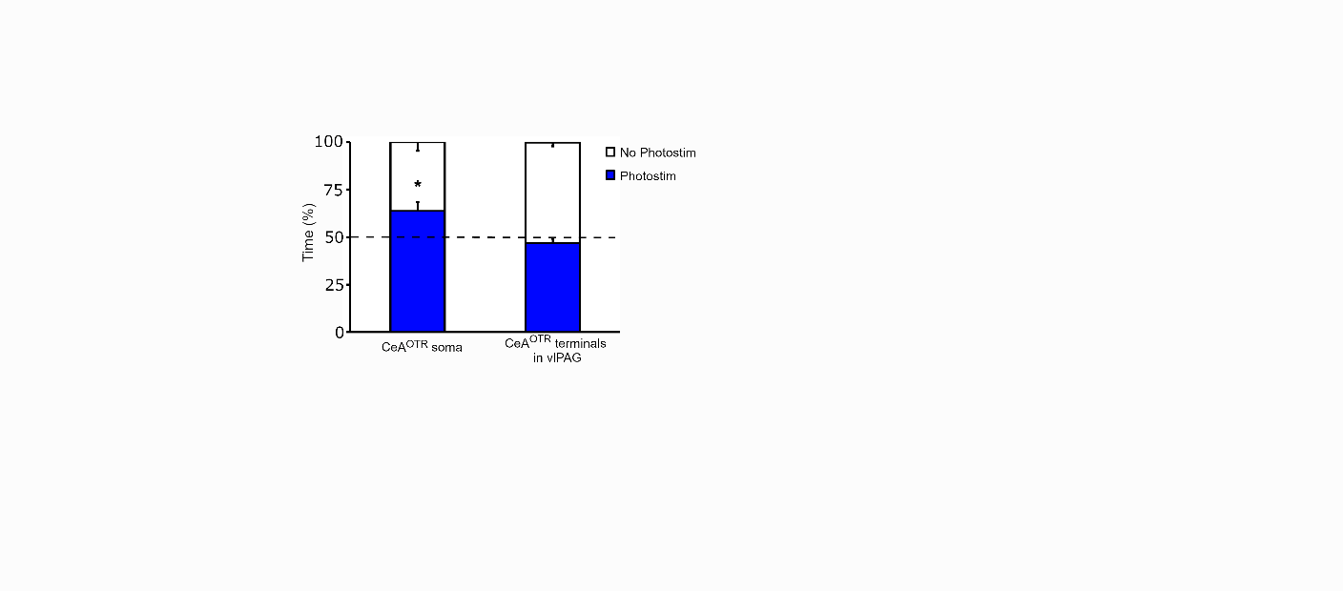
Supplemental Figure 5. Photostimulation of CeA^{OTR} neurons is positively reinforcing. Real time place preference test indicates OTR-cre::OX^{-/-} mice (n=5) prefer the chamber in which the CeA^{OTR} neurons are photostimulated at 15 Hz (Photostimulation; blue) than the non-stimulation chamber (No Stim; white). Mice (n=5) show no preference with photostimulation of CeA^{OTR} axon terminals in the vlPAG. *, p<0.05, vs. percent time in Sham chamber.

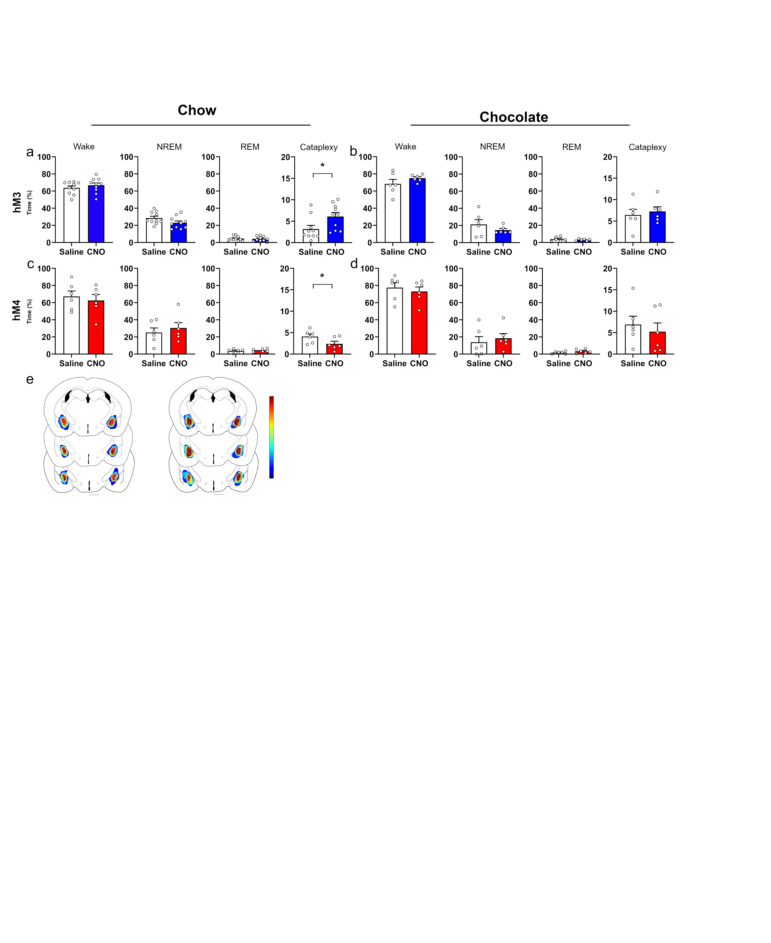
Supplemental Figure 6. Chemoactivation or chemoinhibition of the CeA^{OTR} neurons does not affect Wake or sleep. (a, b) Chemoactivation of CeA^{OTR} neurons under chow and chocolate conditions does not alter the amounts of Wake, NREM or REM sleep. Chemoactivation under chow increases the amount of cataplexy. (c, d) Chemoinhibition of CeA^{OTR} neurons under chow and chocolate conditions does not alter the amounts of Wake, NREM or REM sleep. Chemoinhibition under chow condition reduces the amount of cataplexy. (e) Summary heat maps of (left) hM3 and (right) hM4 injection sites.

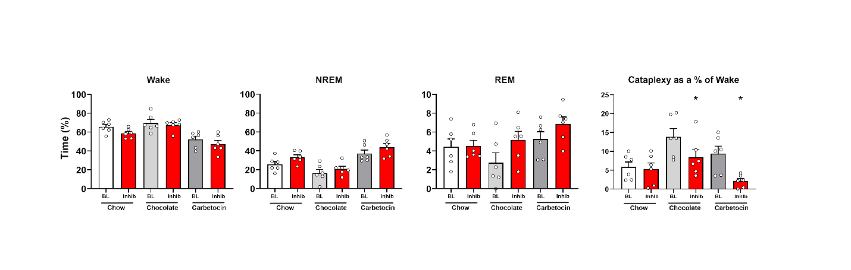
Supplemental Figure 7. Photoinhibition of the CeA^{OTR} → vlPAG pathway has little effect on Wake or sleep. Photoinhibition of CeA^{OTR} → vlPAG pathway had no effect on sleep/wake states across the chow, chocolate or carbetocin conditions. Photoinhibition of CeA^{OTR} → vlPAG pathway reduced the amount of normalized cataplexy to the amount of wake under chocolate and carbetocin conditions (F _{(2.209, 11.04)} = 10.61, p=0.002).

Supplemental Video 1. Typical behavioral arrests after reunification of four female littermates during the social isolation and reunification test (SIRT). Three of the four mice experience an abrupt behavioral arrest, lasting 30-60 sec. To identify mice, patterns were bleached into their fur.

Supplemental Table 1. The Social control and Isolation control SIRT experiments demonstrate repeated handling and general arousal are not sufficient to increase the number of behavioral arrests.

Supplemental Table 2. Summary of CeA^{OTR} neuron projections.

