Appendix I
Bayesian estimation of guessing
Each stimulus is rated as exhibiting one facial and one vocal expression. We do not expect, but do postulate — as a test — that both the facial expression smile (for example) and the vocal expression will be rated positive, while any other rating is considered incorrect. We use a Bayesian approach to determine the maximum likelihood of a correct probability(!). For each stimulus of each facial expression rated by the females (say), let $n_{1}$ be the number of ratings that agree with the postulated rating, while $n_{2}$ is the number of ratings that disagree with the postulated rating (then $n_{1}+n_{2}=n$; $n=526$ for female raters; $n=376$ for male raters). In Bayesian statistics, in which the probability s is a random variable, the likelihood function, for this situation, thelikelihood function $(s)=pdf(s)$ is the $pdf$ of a Beta Distribution
$$\left(\left(α,β\right),s\right)=\frac{\left(α+β\right)}{\left(α\right)\left(β\right)}s^{α-1}{\left(1-s\right)}^{β-1}=\frac{\left(n_{1}+n_{2}+2\right)}{\left(n_{1}+1\right)\left(n_{2}+1\right)}s^{n_{1}}{\left(1-s\right)}^{n_{2}}$$

The probability (in Bayesian statistics) of observing a result disagreeing with the postulate of guessing is then, either
$$\int_{0}^{\frac{1}{2}}{\left(\left(α,β\right),s\right) ds}$$
or
$$\int_{\frac{1}{2}}^{0}{\left(\left(α,β\right),s\right) ds}$$

depending on which side of $\frac{1}{2}$ the mode occurs.
The most likely probability $s_{ML}$ is the mode, and for a Beta distribution, $s_{ML}=\frac{α-1}{α+β-2}=\frac{n_{1}}{n_{1}+n_{2}}$ . We note that (a) the postulate is always $s$, even if the postulated rating is negative (as in the case of pain), and (b) these results are independent of $n$, even though $n$ may be small (for small $n$, the uncertainty interval HDI_{95%} becomes large).

Appendix II
The Dirichlet distributions of (a) male raters rating male and female pain stimuli, (b) female raters rating male and female pain stimuli, (c) male raters rating male and female pleasure stimuli, (d) female raters rating male and female pleasure stimuli, (e) male raters rating male and female laugh/smile stimuli, (f) female raters rating male and female laugh/smile stimuli, (g) male raters rating male and female neutral stimuli, (h) female raters rating male and female neutral stimuli. The A axis shows the probability of positive rating; the C axis shows the probability of negative rating. The domain of each of these Dirichlet functions is shown by the (purple) triangle, because $s_{1}+s_{2}+s_{3}=1$. In all figures, contour lines are color-coded according to sex of stimulus. Contour lines are in steps of $\frac{1}{14}{}_{max}$ of the distribution. For neutral, for example, the mode is expected to be very close to $s_{2}=1$; therefore the other two modes should be very close to $s_{1}=0$ and $s_{3}=0$. Fig. 3g and 3h show that this is indeed the case. For laugh, the mode is expected to be very close to $s_{1}=1$; therefore the other two modes should be very close to $s_{2}=0$ and $s_{3}=0$. Fig. 3e and 3f show that this is indeed the case. The corresponding expectations for the modes of pain and pleasure are not met — for neither sex of the raters.

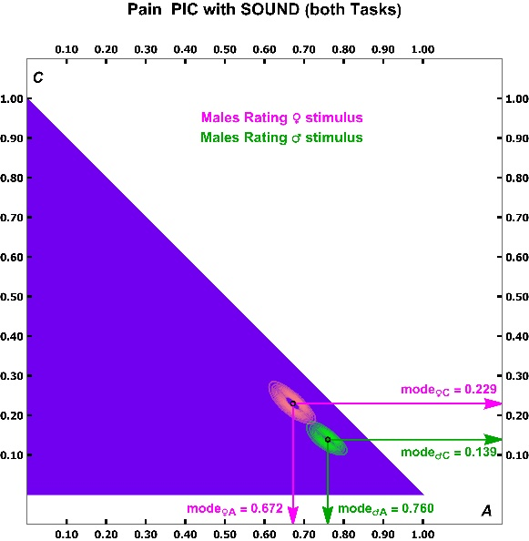
(a)

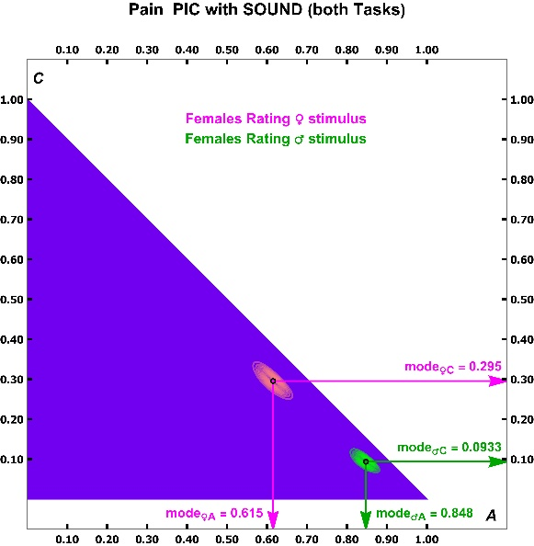
(b)

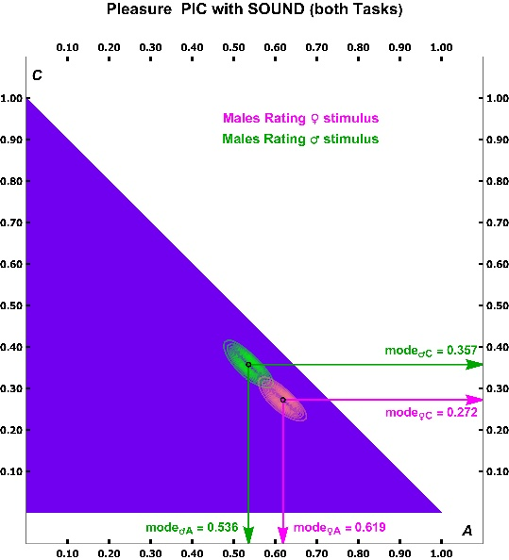
(c)

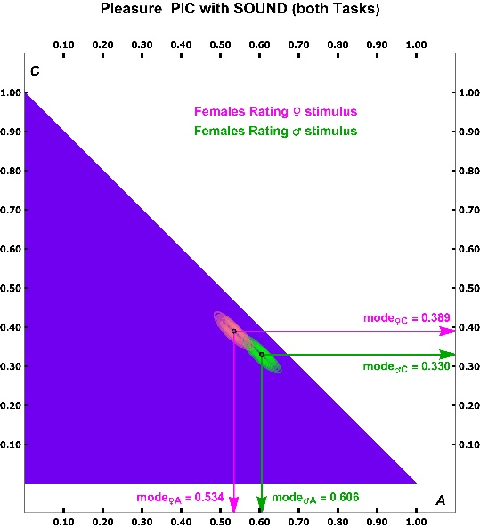
(d)

(e)
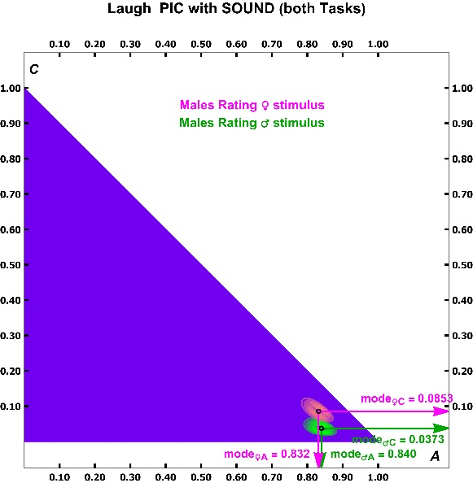
(f)
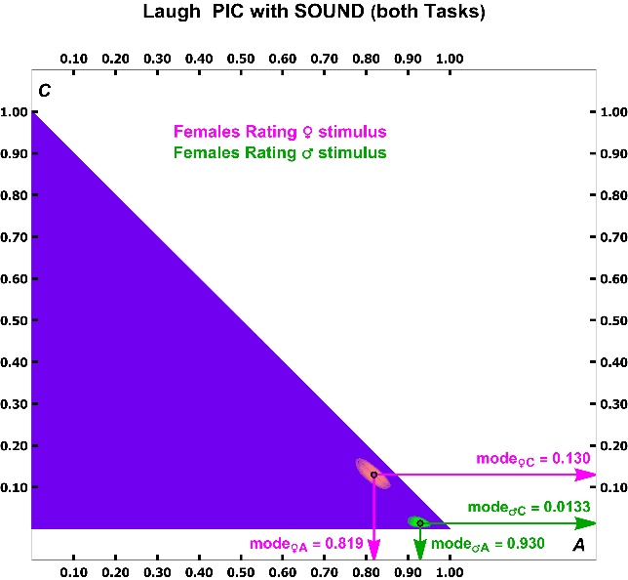

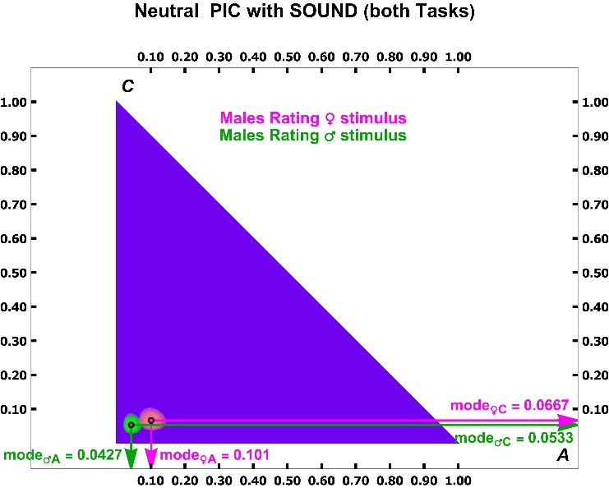
(g)

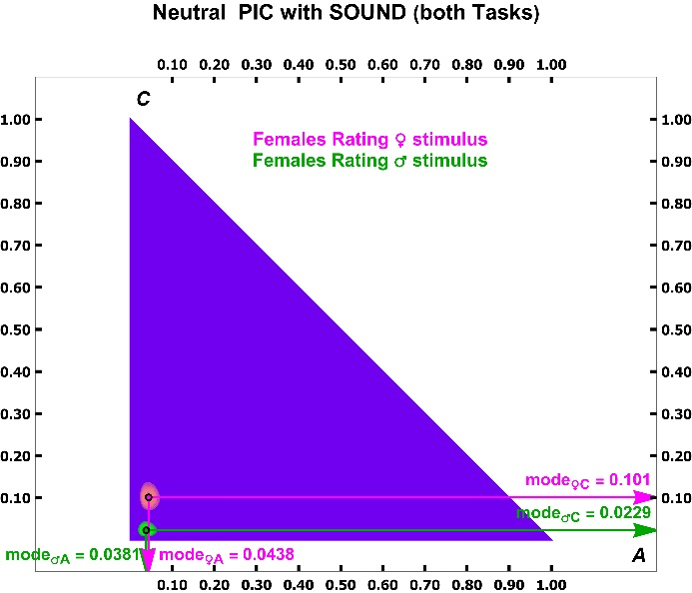
(h)

