Scientific Reports
Supporting Information for
Evaluating a low-cost method for identifying areas with failing septic systems in low-order watersheds
Emma Butzler¹ and P. Zion Klos¹
¹Marist College Department of Environmental Science and Policy

Contents of this file
Figures S1 to S5
Introduction
The supporting information provides a high- resolution snap-shot of nitrate variation over the remaining portion of the mainstem of the Fall Kill. Normalized In-situ nitrate values were collected at a 50m increment and used as a shapefile along with septic data, and enterococci counts. The nitrate data was collected once longitudinally and does not represent the average nitrate load in a given location.

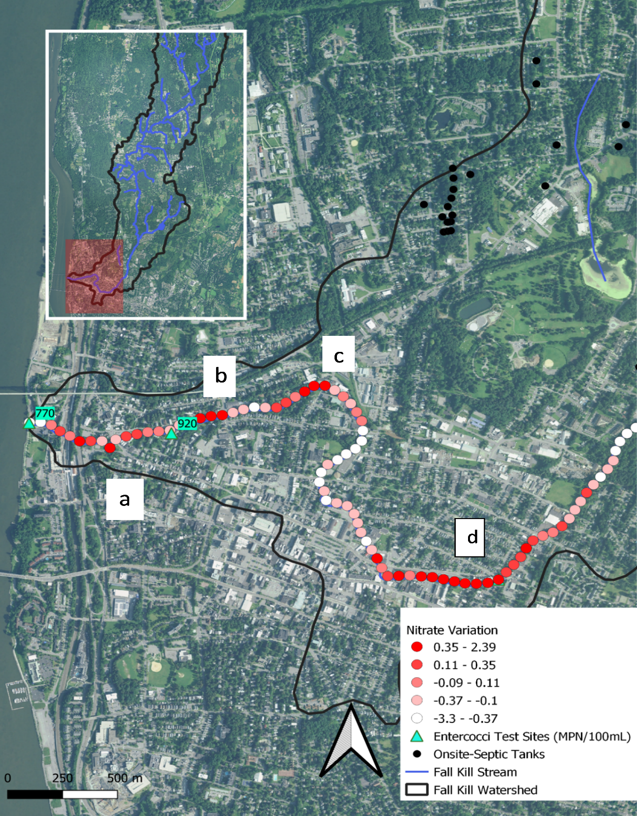
Figure S1. The Fall Kill stream restricted by high rock walls within the City of Poughkeepsie. Map depicting nitrate variation and enterococci values collected in July 2021.

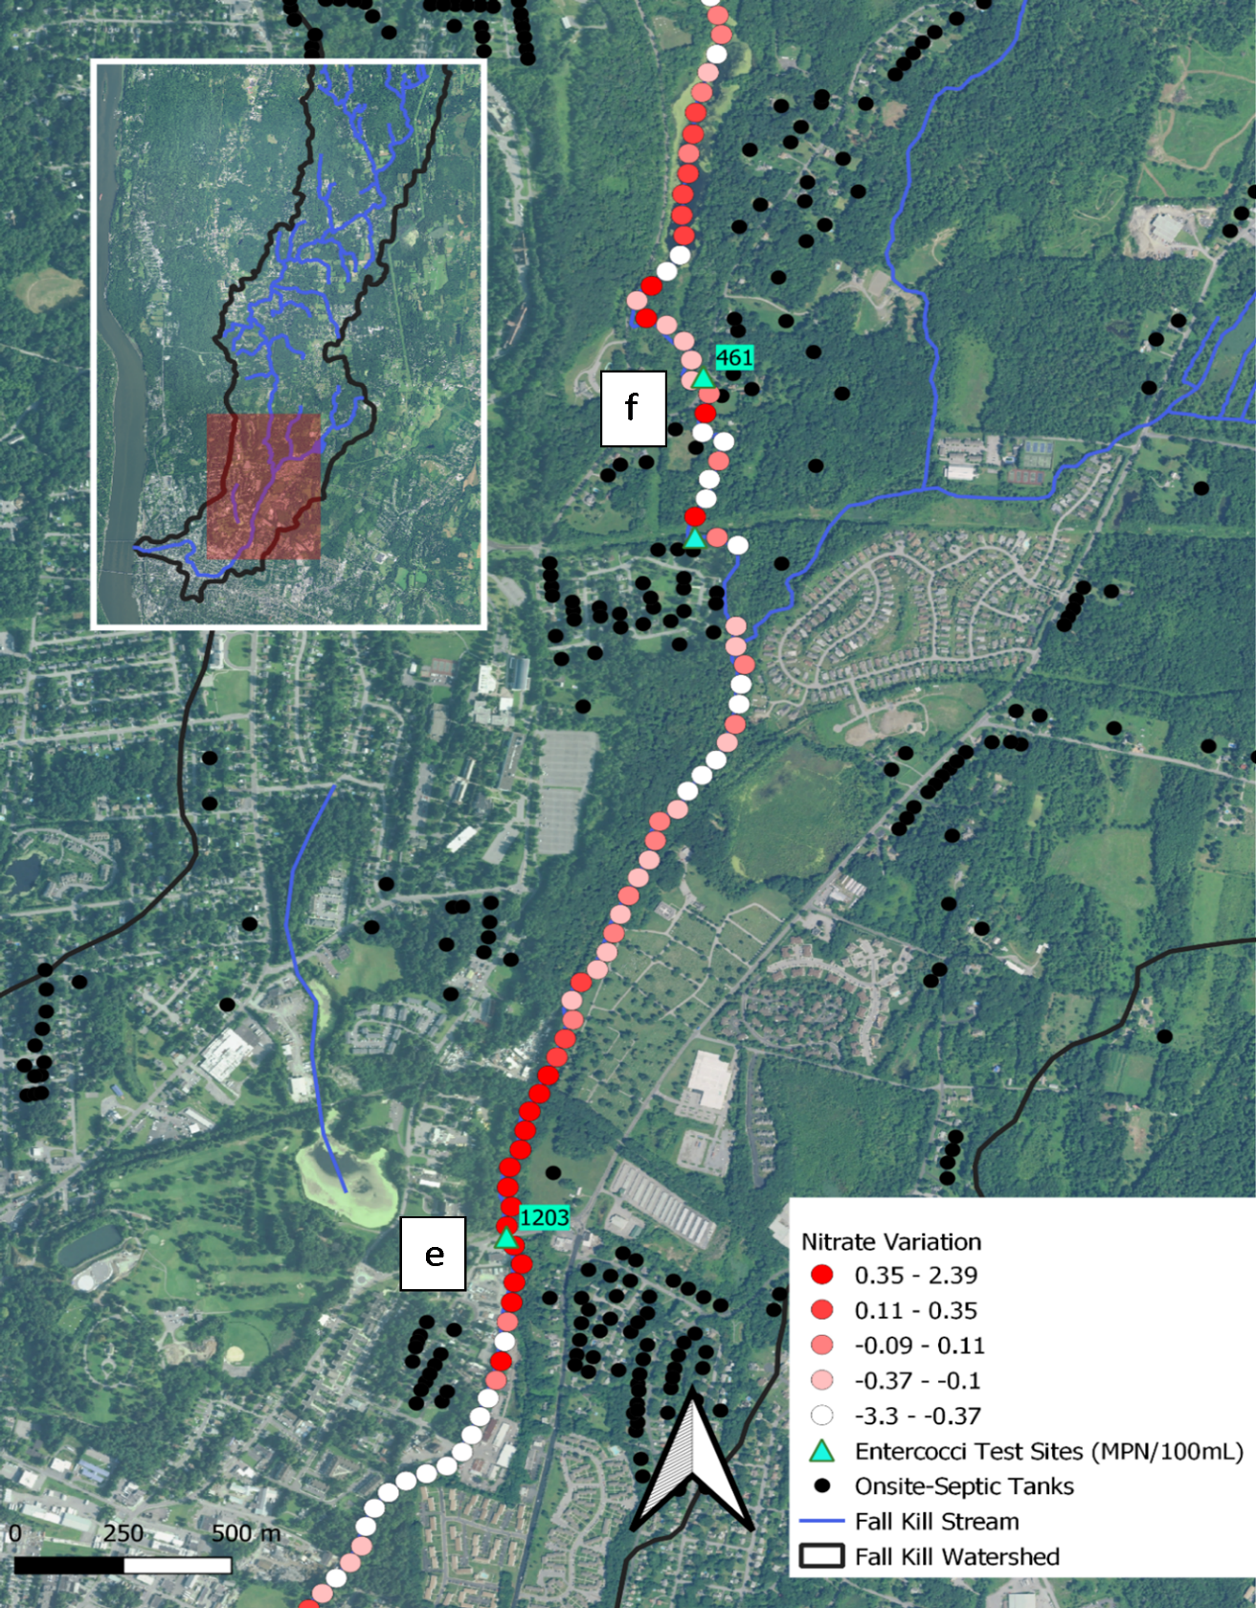
Figure S2. The Fall Kill stream adjacent to a golf course and downstream from a cemetery depicting nitrate variation, enterococci values and on-site septic systems collected July 2021.
e
f
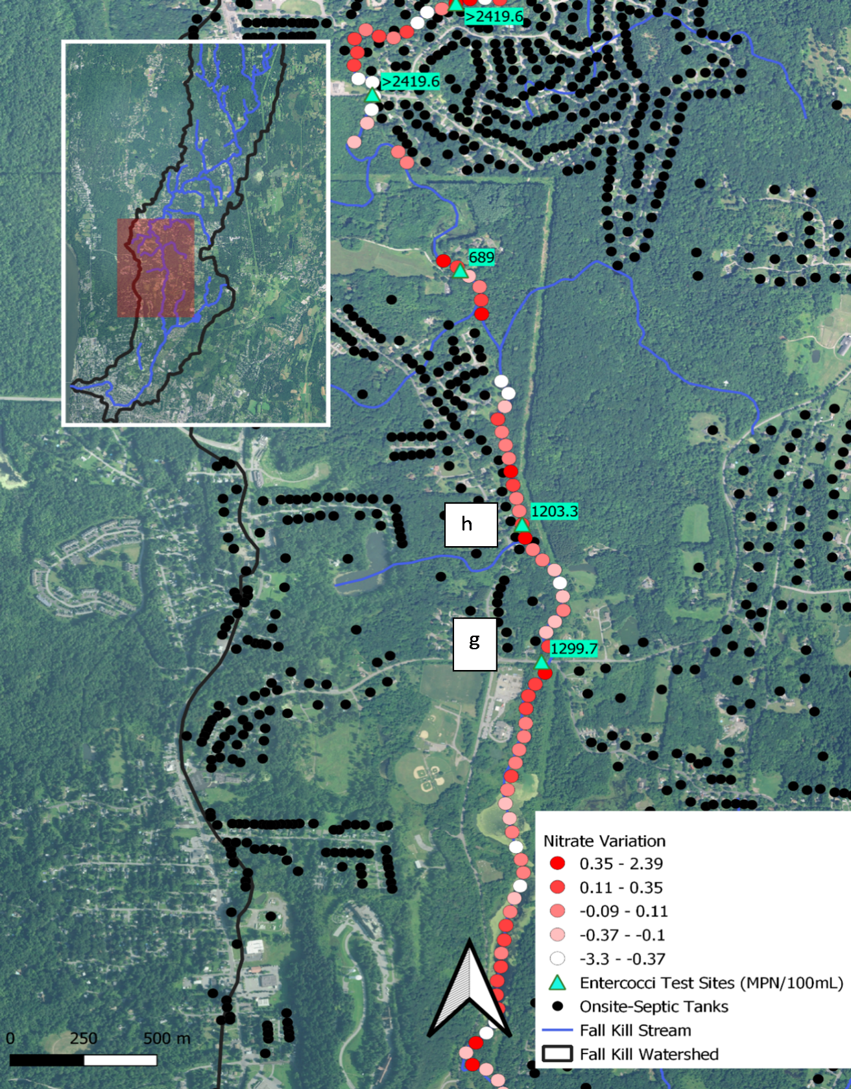
Figure S3. The Fall Kill stream flowing through Hyde Park depicting nitrate variation, enterococci values and on-site septic systems collected July 2021.

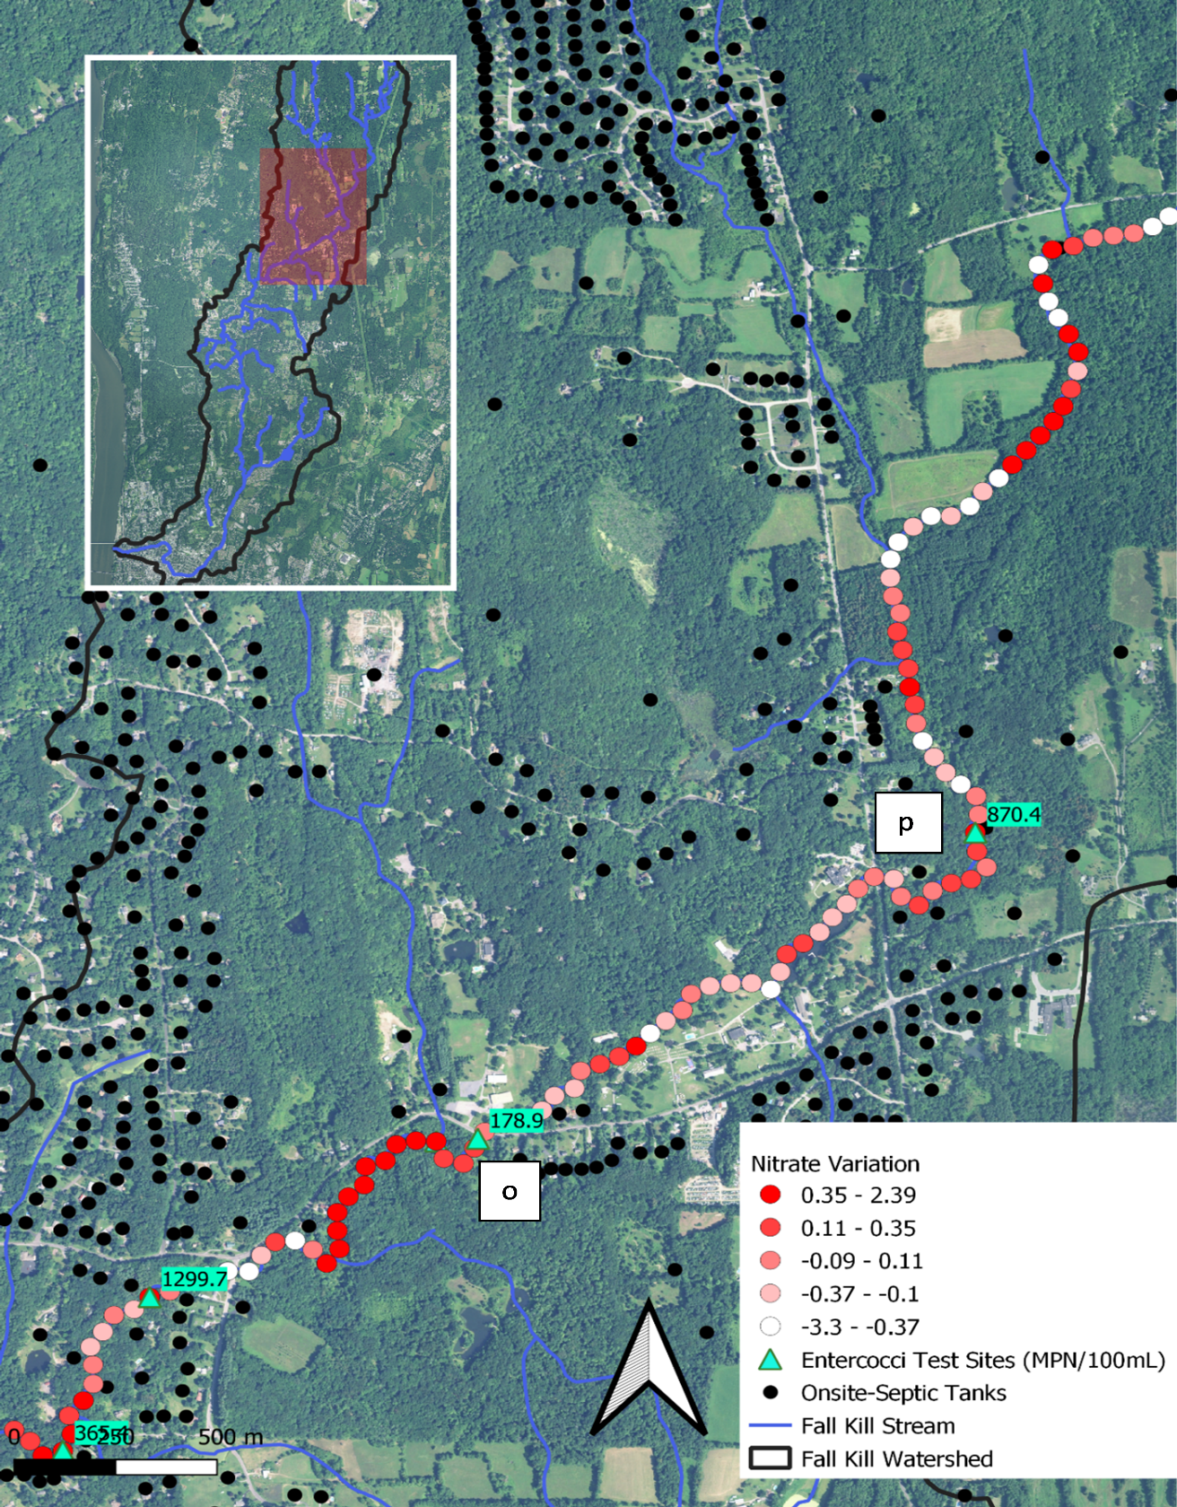
Figure S4. The Fall Kill stream flowing through forested areas with low population of residential properties depicting nitrate variation, enterococci values and on-site septic systems collected July 2021.

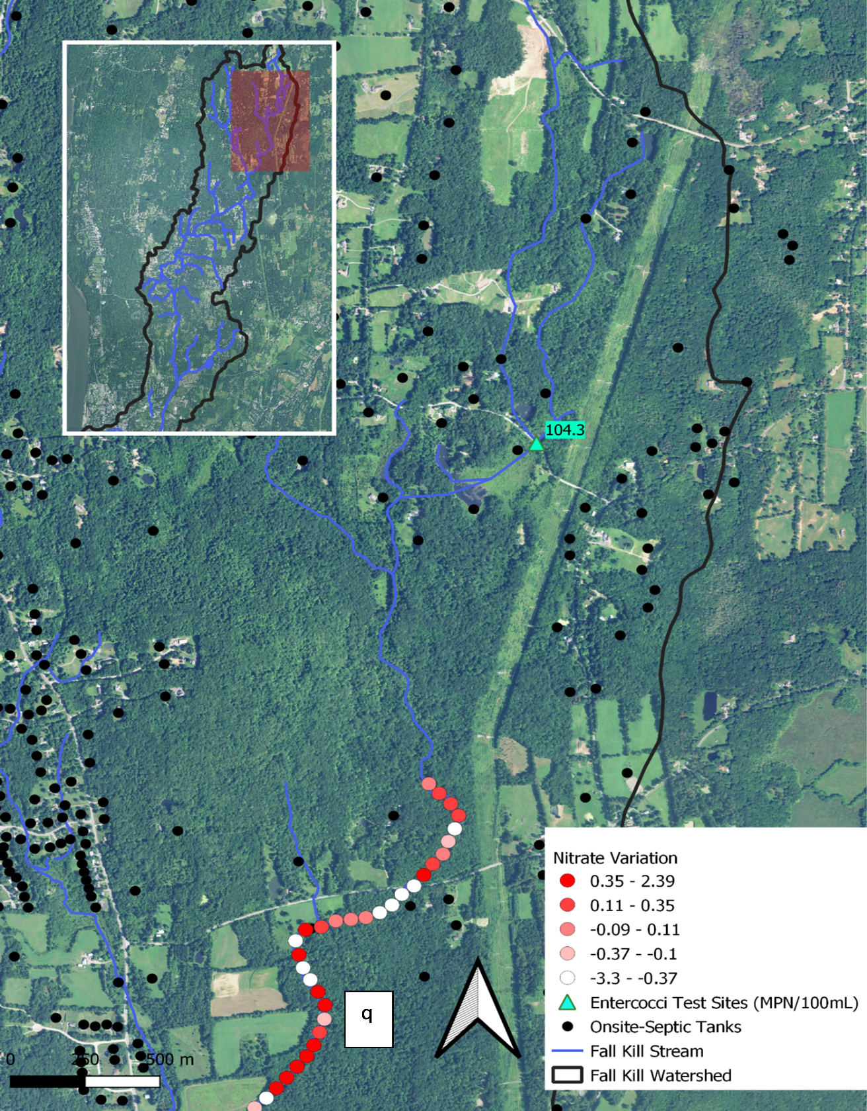
Figure S5. The head waters of the Fall Kill stream flowing through forested areas with fields depicting nitrate variation, enterococci values and on-site septic systems collected July 2021.

