Supplementary Information
Recent increase in tree damage and mortality and their spatial dependence on drought intensity in Mediterranean forests
Pedro Rebollo, Daniel Moreno-Fernández, Verónica Cruz-Alonso, Antonio Gazol, Marta Rodríguez-Rey, Julen Astigarraga, Miguel A. Zavala, Lorena Gómez-Aparicio, Enrique Andivia, Sofía Miguel-Romero, Paloma Ruiz-Benito
Correspondence: prebollo@ucm.es phone number: (+34) 636877806
Landscape Ecology

Appendix A. Further information about tree damage and mortality in Mediterranean forests of the Iberian Peninsula.

Appendix B. Further details of the Spanish Forest Inventory used.

Appendix C. Detailed information about the goodness of fit of the models.
Appendix A. Further information about tree damage and mortality in Mediterranean forests of the Iberian Peninsula

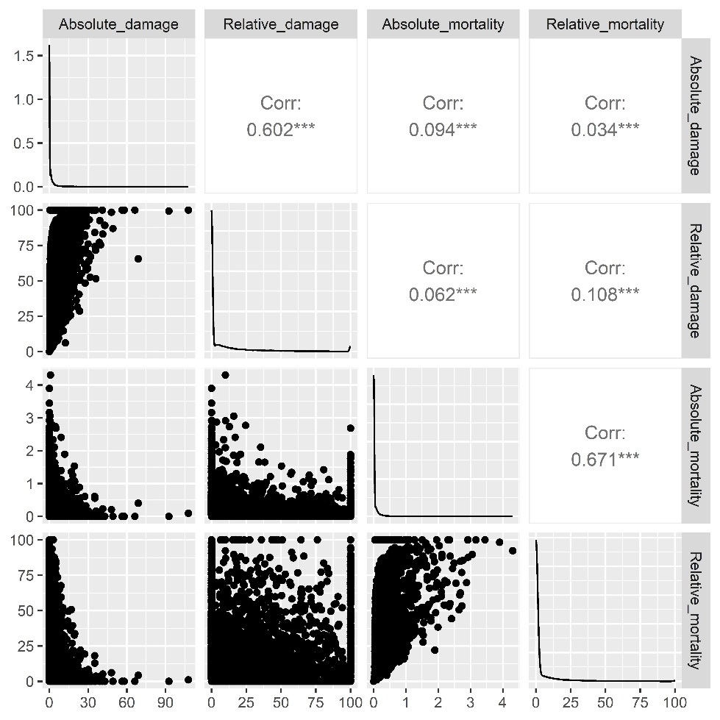
Figure A.1. Relationships between the absolute and relative tree damage and mortality in the permanent plots between the second and third Spanish Forest Inventory.
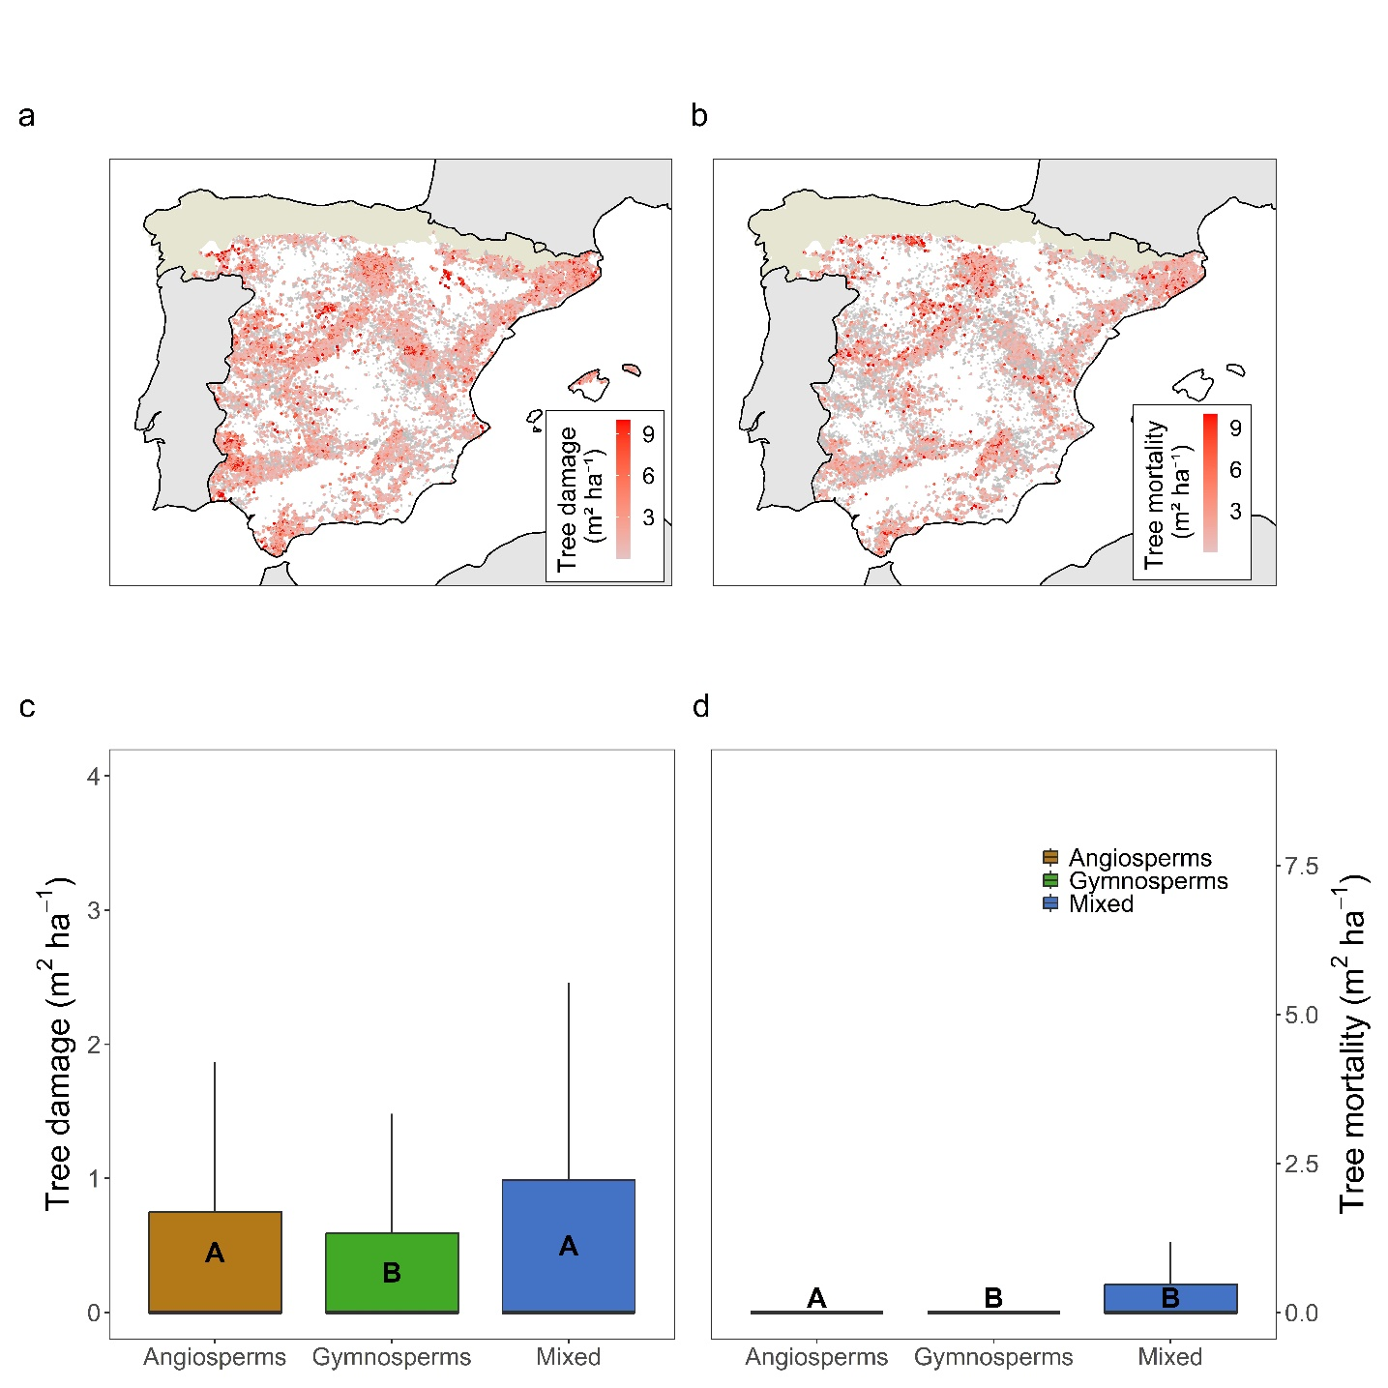
Figure A.2. (a) Tree damage (m² ha⁻¹) and (b) standing tree mortality (m² ha⁻¹) distribution across Mediterranean forests in the Iberian Peninsula.

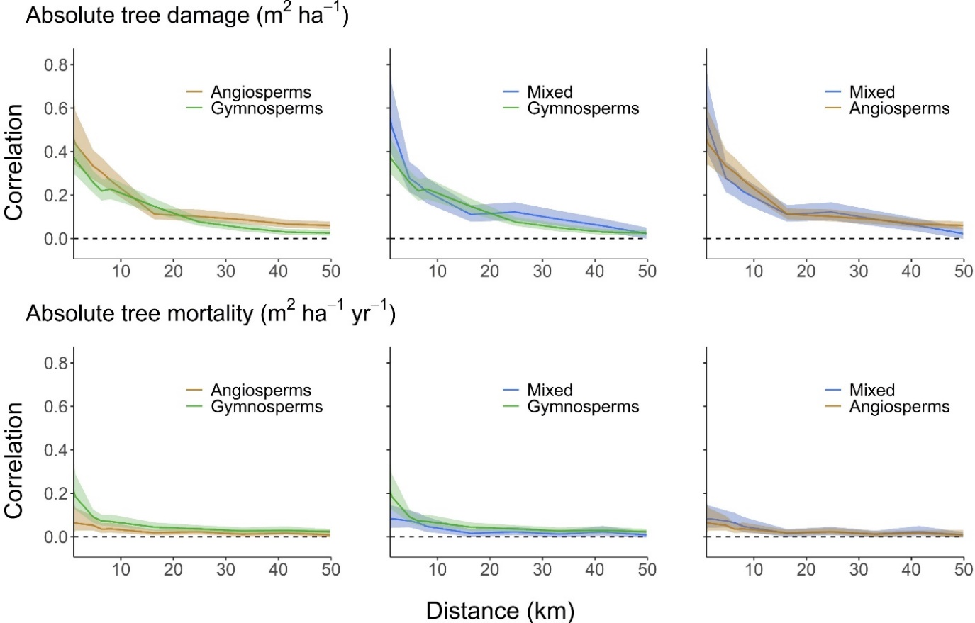
Figure A.3. Spatial autocorrelation pairwise comparation of absolute tree damage (m² ha⁻¹) and mortality (m² ha⁻¹ yr⁻¹) in gymnosperm forests (green), angiosperm forests (brown) and mixed forests (blue). Solid lines and filled area represent the mean correlation and 95% confidence intervals, respectively.
Appendix B. Further details of the Spanish Forest Inventory used.

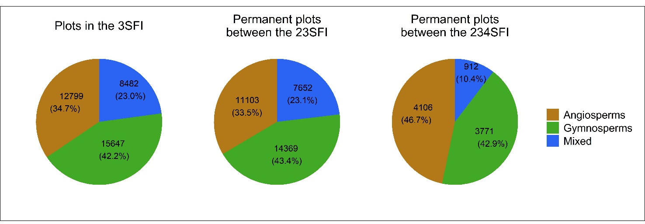
Figure B.1. Total Number (and percentage) of plots in the third Spanish Forest Inventory (3SFI) and permanent plots between the second and the third (23SFI) and between the second and the fourth (234SFI) inventories.

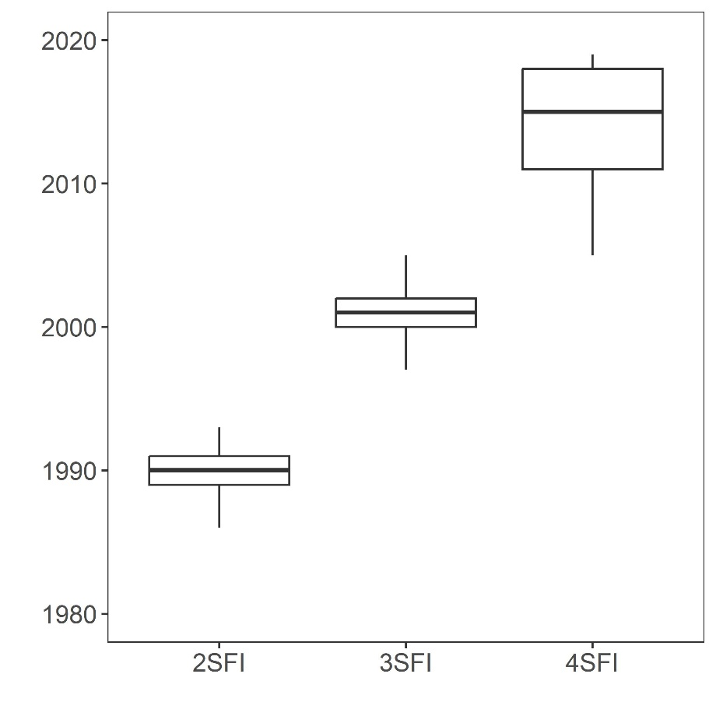
Figure B.2. Boxplot with the timeframe of the three censuses of the Spanish Forest Inventory (second, third and fourth as 2SFI, 3SFI and 4SFI).
Appendix C. Detailed information about the goodness of fit of the models.

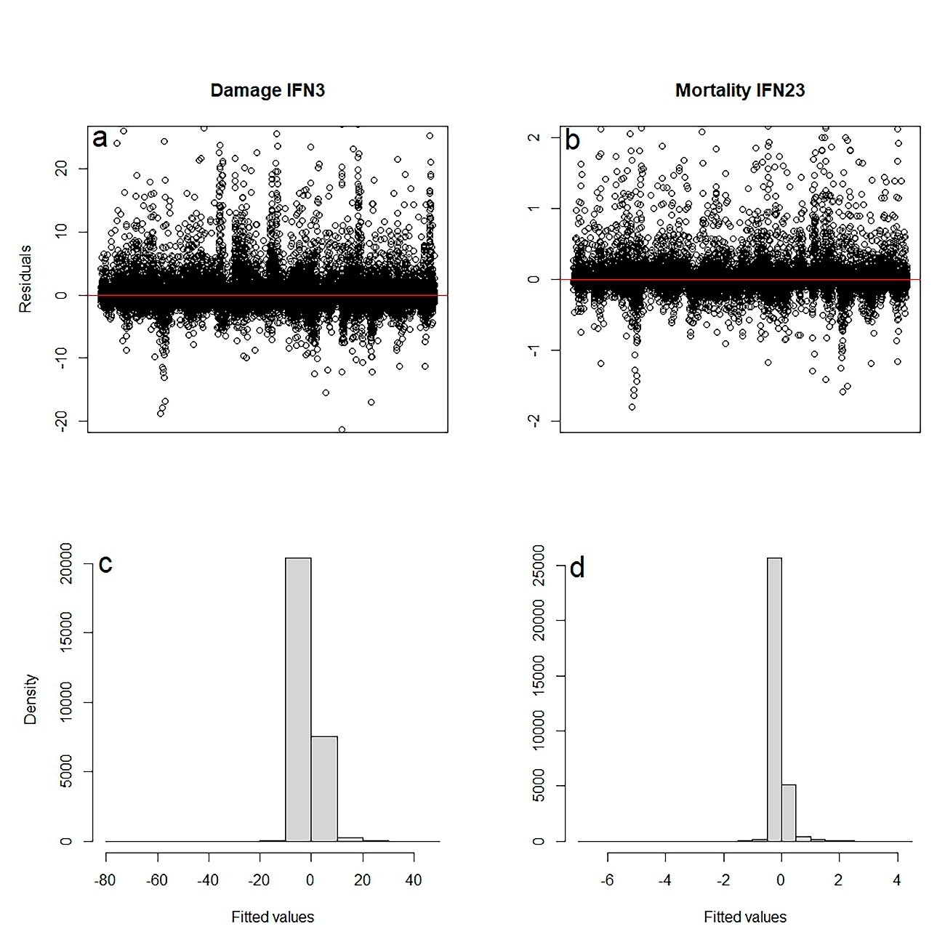
Figure C.1. Scatterplot of residuals versus predicted values (a, b) and histogram of the residuals (c, d) for the best models selected to predict the effects of forest structure and climate in tree damage and mortality of the spatial analyses.

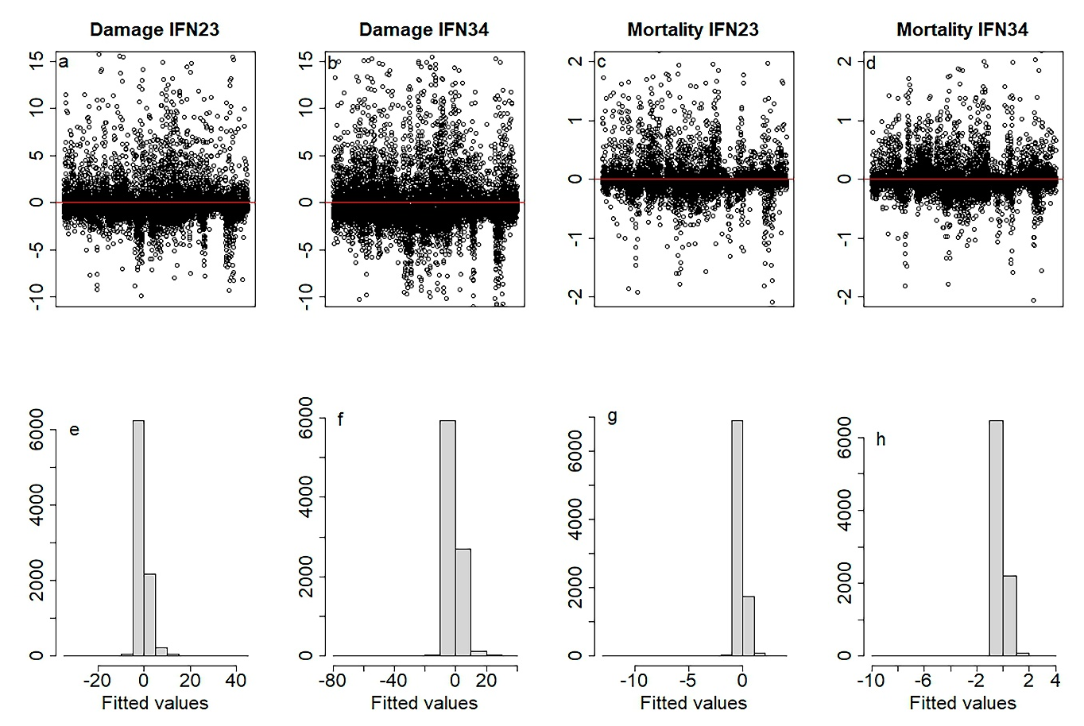
Figure C.2. Scatterplot of residuals versus predicted values (a, b, c, d) and histogram of the residuals (e, f, g, h) for the best tree damage and mortality models performed for 3 and 4SFI; 23SFI and 34SFI considering consecutive inventories from the Spanish Forest Inventory.

